**FORM ONE CHEMISTRY END TERM 2 –MARKING SCHEME**

1.The diagram below shows the physical state of matter

S

R V

SOLID

GAS

LIQUID

U W

T

1. Name the processes represented by letters
2. **R melting**
3. **V evaporation**
4. **T deposition**
5. **S sublimation** (4mks)
6. Name two substances which undergo process T.
7. **Ammonium chloride**
8. **iodine**
9. **iron(iii)chloride**
10. **aluminium chloride**
11. **solid carbon (iv) oxide (dry ice)** (2mk)

2. Complete the following table to show the colour of the following indicators in acidic and basic solution (6mks)

|  |  |  |
| --- | --- | --- |
| indicator | Colour in |  |
|  | Acidic solution | Basic solution |
| Phenolphthalein | **colourless** | **pink** |
| Methyl orange | **red** | **yellow** |
| Litmus solution | **red** | **blue** |

3. The diagram below shows the heating curve of a pure substance. Study it and answer the

questions that follow:

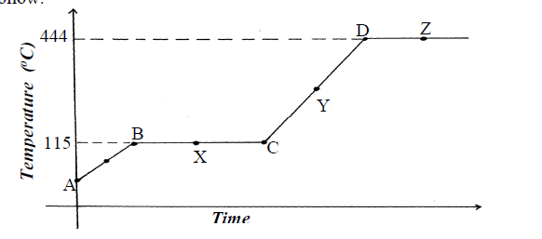

(a) What physical changes are taking place at points X and Z? (2mks)

**X-melting**

**Z-evaporation/vaporisation**

(b)what happens to the melting point when sodium chloride added to this substance. (1mks)

**-boiling point rises**

(c) In terms of kinetic theory, briefly explain why there is no rise in temperature in region BC despite continued heating of the substance. (2mks)

**-heat energy supplied is used to overcome the forces of attraction holding the solid particles together and the solid melts.**

4. The diagram below shows a set – up used by a student to find out what happens

when Copper (II) sulphate crystals are heated

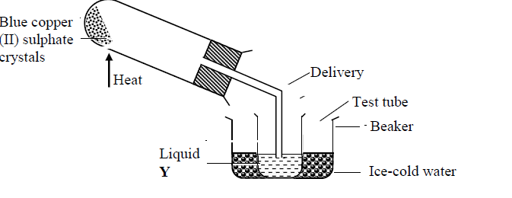

(i) State the observations made when the blue copper (II) sulphate crystals are heated. (2mks)

**-blue copper(ii)sulphate turns to white anhydrous copper(ii) sulphate**

(ii) What is the purpose of ice-cold water in the above set up? (1mk)

**-to condense all the vapours produced**

(iii) Identify liquid Y and write an equation for its formation. (2mks)

**-water**

**Hydratedcopper(ii)sulphate 🡪anhydrous copper(ii)sulphate + water**

(iv) How can purity of liquid Y be confirmed? (1mk)

**-checking the MP and BP which should be sharp**

5. The setup below was used to separate two miscible liquids Q and T

(Boling points; Q =98°C, T=78°C)

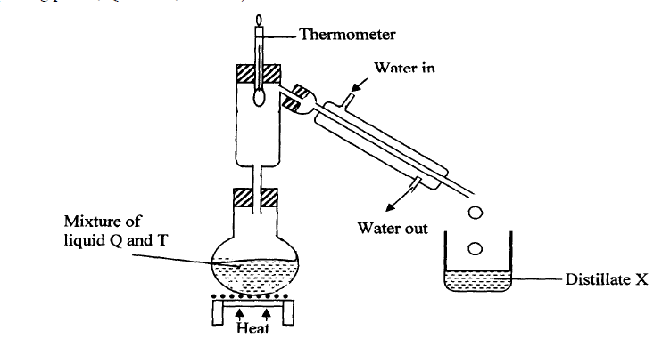

(a) Identify the mistakes in the setup above (2mks)

**-no glass beads in the fractionating column**

**-water in the liebig condenser is flowing in the wrong direction**

(b)Name the method of separating mixtures shown. (1mk)

**-fractional distillation**

(c)Identify Distillate X (1mk)

**T**

(d) What is the role of the thermometer in the above set up? (1mk)

**-to indicate the fraction that is distilling out**

6. The information below gives PH values of solutions V, W, X, Y Z

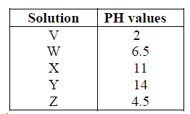

(a)Which solution is likely to be:

(i) Calcium hydroxide? ………………………………………………. (1mk)

**-X**

(ii) Rain water? ……………………………………………………… (1mk)

**W**

(iii) Lemon juice……………………………………………………... (1mk)

**Z**

(b) Which solution would react most vigorously with Zinc carbonate ? (1mk)

**V**

(c) Identify a substance that can:-

(i) be used to raise the soil pH (1mk)

**X**

(ii) react with sodium hydroxide to form salt and water. (1mk)

**V orZ**

(d) Select a pair that would react to form a solution with a pH of 7. (1mk)

**Vand Y ,XandZ Vand X**

7. The diagram below shows spots of pure substances A, B, and C on a chromatography

paper. Spot Dis that of a mixture

Solvent front

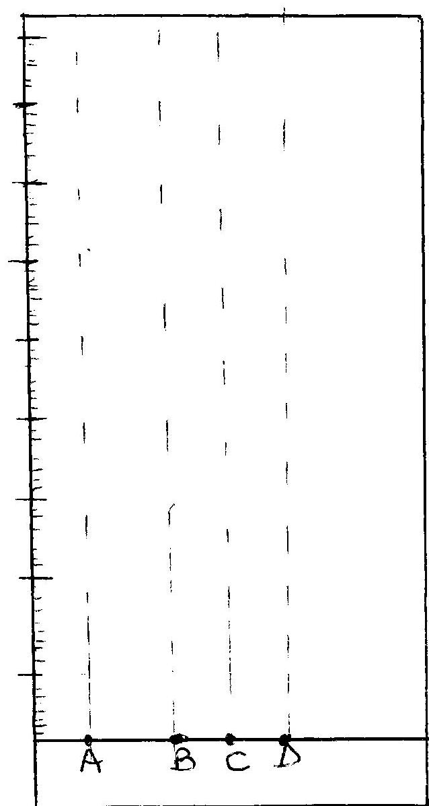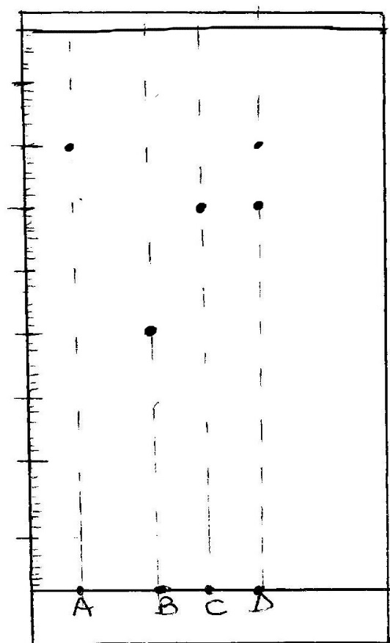

(a) After development A, B and C were found to have moved 8cm, 4cm and 6cm respectively.

D has separated into two spots which have moved 6cm and 8cm:-

On the diagram:-

I. Label the baseline and show the solvent front (1mk)

II. Show the position of all the spots after development (1mk)

III. Identify the substances present in mixture D (1mk)

**A and C**

IV. State one application of chromatography. (1 mark)

**-tests purity of drugs**

**-identify contaminants in foods and drinks**

**-identify banned substances in blood and urine e.g steroids**

8.State the method used to separate the following mixtures (3mks)

(i) Sodium chloride and iodine **- sublimation**

(ii) oil from groundnuts -**solvent extration**

(iii) components of crude oil **– fractional distillation**

9. (i) Define Chemistry. **– a branch of science that deal with composition, properties and reactions of matter. (1mark)**

(ii) Give three importance of studying Chemistry. (3marks)

* **career subject**
* **manufacturing**
* **purification**
* **extraction**

10. The diagram below shows the apparatus commonly used in a laboratory.

(i) Name the apparatus. (1mark)

**Bunsen burner**



Bunsen burner

............................................................................................................................................................

.........................................................................................................................................................

(ii) State the function of the parts labeled in the above apparatus.

a) Chimney. (1 mark)

**-laboratory gas mixes with air**

b) Collar (1mark)

-**regulates the amount of air entering the chinmney**

c) Air hole. (1 mark)

**-allows air into the chimney**

(iii)What is a flame? (lmark)

**-A mass of burning gases.**

iv) The following diagrams represent the two types of flames.

 Identify the flames (a) and (b) (2marks)

a) **–Non-luminous flame**

b**) -Luminous flame**

b) Which type of the flames identified above is preferred for heating?

Give a reason for your answer. (2marks)

* **Non-luminous; it’s hotter and does not produce soot**

c) Give two differences between the flames (a) and (b) above. (2marks)

|  |  |
| --- | --- |
| **Flame (a)** | **Flame (b)** |
| **Pale blue in colour** | **Yellow in colour** |
| **Does not produce soot** | **Produces soot** |
| **Short and steady** | **Large and wavy** |
| **Has three regions** | **Has four regions** |

11. Consider the following general reaction.

Acid + Base Salt + Water

(i) Name the type of reactions shown above. (1 mark)

**-Neutralisation**

(ii)Name one example of each of the following. (2 marks)

Acid **–hydrochloric acid,sulphuric acid, nitric acid etc**

Base: -**sodium hydroxide, potassium hydroxide,calcium hydroxide etc**

12.The follow set-up was used by some students to study some properties of air.



(a) State ONE observations made after a few minutes. (1 mark)

**-burning candle went off**

**-level of sodium hydroxide solution in the gas jar rose up**

(b) Name the gas that occupies the largest volume after the experiment (1 mark)

**-Nitrogen**

(c) The percentage of air used was calculated to be 19.375% while the approximate percentage of oxygen is 21%. State ONE source of error. (1 mark)

**-burning candle may have gone off before all oxygen is used up**

**-sodium hydroxide solution may not absorb all the carbon(iv) oxide gas**

(d) Why is sodium hydroxide solution preferred to water in this experiment? (1 mark)

**-it absorbs carbon (iv) oxide initially in the gas jar and that produced by burning candle**

(e) Why is it advisable to allow the apparatus to cool before the final volume is taken? (1 mark)

**-gases expand on heating hence may give the wrong reading when hot**

13. Complete the table below (8mks)

|  |  |  |  |
| --- | --- | --- | --- |
| element | symbol | element | Symbol |
| **Sodium** | Na | Mercury | **Hg** |
| Patassium | **K** | **Copper** | Cu |
| **Sulphur** | S | **Cobalt** | Co |
| iron | **Fe** | hydrogen | **H** |

14. Matyang a form one student was stung by a bee in the school apiary. The lab technician applied wood ash solution on her she was relieved off the pain. Explain why this was done. (2mks)

**-bee sting contains an acid. Wood ash being basic neutralizes the acid in bee sting hence relieving off the pain.**

15. Complete the word equations for the following reactions; (3mks)

(a) sodium carbonate + sulphuric acid = **sodium sulphate + carbon (iv)oxide + water**

(b) Zinc + hydrochloric acid = **Zinc chloride + hydrogen gas**

(c) Calcium hydroxide + nitric acid = **Calcium chloride + water**

16.State ONE laboratory rule to observe when preparation of gases. (1mk)

-**poisonous gases should be prepared in the fume chamber or in the open**

**-do not smell gases directly but waft the gas towards your nose with your hand**

17.Define the following terms and give an example of each (4mks)

(a) An atom

**-the smallest particle of an element that can take part in a chemical change.**

(b) -Molecule

**-the smallest particle of an element or a compound that can exist independently**

(c) Compound

**- a substance that consists of two or more elements chemically combined.**

-END-