APRIL HOLIDAY ASSIGNMENT 2023
CHEMISTRY FORM 1
1. state two branches of chemistry (2MKS)
2.Define each of the following terms (2MKS) a) Matter
b) Conductor
3 Differentiate between a pure substance and a mixture (2Mks)
4 State two factors that determine the choice of the method of separation of mixtures (2mks)
5 Describe how you can separate a mixture of iodine, salt and sand (3mks)
6 State the use of each of the following laboratory apparatus (3MKS)
- Pipette
- Deflagrating spoon
- Thistle funnel
7. James a form one student wants to measure accurate volume of a solution in the laboratory. State TWO apparatus that James could use. (2MKS)
8. a ) Name two laboratory apparatus that can be made of glass (2MKS)
b) State two advantages of apparatus made of glass in chemistry experiments (2MKS)
9. a ) Draw and name the regions of a luminous flame (3mks)

b) A wooden splint was slipped through a region of a particular flame in the laboratory and was burnt as shown in the diagram below.

- Name the type of flame the splint was slipped through (1mk)
- Stating the region explain why the splint was burnt the way it is shown in the diagram (2mks)
- State one disadvantage of using the above type of flame in the laboratory (1mk)
10.a) Define the term crystallization (1mk)

b) State two applications of crystallization (2mks)
11 a) What is solvent extraction (1mk)
b) Describe how oil is extracted from ground nut seeds (3mks)
12. For each of the following, state the type of change observed (4mks)
- Melting and cooling candle wax
- Heating and cooling zinc oxide
- Burning magnesium in air
- Heating hydrated copper (ii) sulphate
13.Study the diagram below and answer the questions that follow. (5mks)
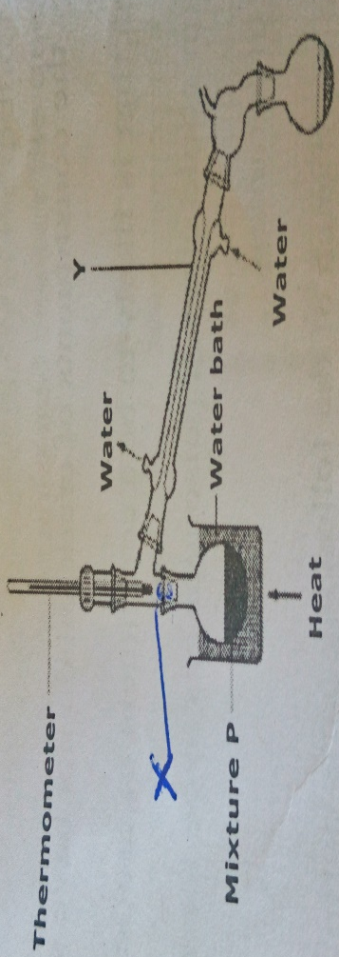
- Name each of the parts X and Y.
- What is the name given to the method used above for the separation of mixture P?
- State two industrial applications of the method mentioned above.
- Suppose the mixture P was paraffin and water, which apparatus could have been used to separate them?
14. State the effect of impurities on (2mks)
- Melting point
- Boiling point.
15. The diagram below shows the heating curve of pure water. On the same diagram, sketch the graph if water containing impurities was used. (1mks)
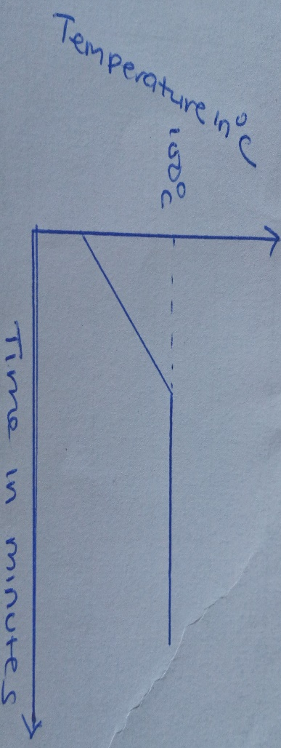
16 a) State the kinetic theory of matter (1mk)
- By use of a clear (theoretical model) diagram, explain the nature of particles in the three states of matter (3mks)

