NAME ……………………………………..…………………………DATE …………

ADM NO. …….. SIGNATURE …………

233
CHEMISTRY
FORM ONE
TIME: 2 HOURS

OPENER EXAMINATION TERM 3, 2022
Kenya Certificate of Secondary Education

INSTRUCTIONS TO CANDIDATES: -
  - Write your name, Admission number and class in the spaces provided above.
  - Answer all the questions in the spaces provided
  - Candidates should answer the questions in English.

- a) Define the following terms. 3mk
- Indicator

II) Neutralization

III) Alkali

b) The table below shows the pH values of some solutions. Study it and answer the questions that follow.
solution | PH
M | 9
R | 7
K | 3
D | 13
G | 6

Which solution is likely;

i) To produce bubbles/ effervescence with sodium carbonate solution. 1mk

Ii) To be sodium chloride solutions 1mk

c) Choose two solutions that can react to form a salt and water only. 1mk

d) Which color would solution M show when added methyl orange indicator. (1mk)

e. Give a reason why the flower extract indicator is not preferred. 1mk

f/. What is the advantage of the universal indicator over the other indicators. 1mk

2. a) Indicate whether each of the following is a mixture or a compound. (6mk)
I) Black ink-----------------
Ii) Sodium chloride------
Iii) Tea----------------------
Iv) Crude oil--------------
v ) sea water-------------
vi) Air--------------------

b) State any four differences between a permanent and a temporary change. (4mk.)
Permanent Temporary

C) A blue compound was heated in the lab in a boiling tube, droplets of a colorless liquid were seen on the cooler parts of the tube and the solid turned to white.
I) Name the type of change undergone by the substance above (1mk)

II) Identify; _ the white solid (2mks)
_the colorless liquid
3.(a)Name the following apparatus (2mks)
i) 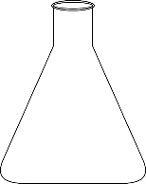 ii) 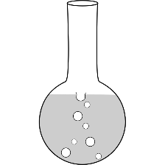

b) Draw the shapes of the following lab apparatus; (4mks)
i) Deflagrating spoon ii) Pipette

iii) Teat pipette iv) Filter funnel

c) State the function of the following lab apparatus; (2mks)
i) Dropping funnel

Ii) Desiccator

d) List two apparatus used to measure accurate but specific volumes of liquid. (2mks)

4. a) What is a flame? (1MK)

b) List any four differences between a luminous and a non-luminous flame. (4mks)

C) Explain why the luminous flame of the Bunsen burner produces a lot of light (1mk)

D) State the functions of the following parts of the Bunsen burner (2mks)
i)The collar---

ii) The base ------

e) Which type of flame is most preferred for heating and why? Give two reasons it’s preferred.
(3mk)

5. a) Choose the most suitable method to get the first substance from the following mixtures;
(3MK)
i) Water and salt----------------

ii) Sand and water ---------------------

iii) Oil and milk-------------------
b) A student was given a mixture of solution x and solution y which were miscible with boiling points of 84⁰c and 75⁰c. The student’s setup the set of apparatus as shown below to separate the two liquids. Study it carefully and answer the questions that follow
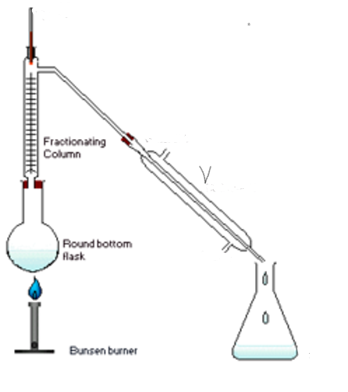
i) Name the method above that the student used (1mk)

ii) What name is given to apparatus V (1mk)

iii) Indicate on the diagram the direction of flow of water (1mk)

iv) State the function of each of the following; (2mks)
- Fractionating column-

- Thermometer –

v) Which of the two liquids was collected as the first distillate and why? (2mk)

6. Draw a well labelled diagram to show how a mixture of sodium chloride and iodine can be separated to acquire a pure sample of each. (3MK)

7. DESCRIBE how an oil sample can be extracted from ground nuts. (3mks)

8 (a). FILL in the table below. (8MK)
ELEMENT | SYMBOL
Calcium
 | Cu
 | K
Sodium
 | F
Helium
Silver
 | Mg
b) Identify the elements present in each of the following compounds;
i) Lead chloride (1mk)

ii) Zinc carbonate (1 ½ Mk)

iii) Aluminum sulphate (1 ½ Mk)

9. STATE and EXPLAIN the changes in mass that occurs when each of the following substances are strongly heated in a boiling tube in the lab. (2mk)
a) Copper Nitrate

b) Zinc oxide

10. Define the following terms; (6mks)
a) Chemistry

b) Drug

c) Drug abuse

d) Molecule

e) Atom

f) Element

11. Fill in the gaps in the chemical equations below.
a) Zinc + hydrochloric acid ------------------------------------- + Hydrogen
(1mk)
b) Copper ii oxide + Sulphuric (vi) acid -------------------------- + -------------------
(2mk)

