OPENER EXAMINATION TERM 3, 2022
CHEMISTRY EXAM - FORM 1
MARKING SCHEME
- a) Define the following terms. 3mk
I) Indicator
A substance that a definite colour in an acid and a definite colour in a base
Ii) Neutralization
A reaction btn an acid and a base to form a salt and water only
Iii) Alkali
A soluble base

b)The table below shows the pH values of some solutions. Study it and answer the questions that follow.
solution | PH
M | 9
R | 7
K | 3
D | 13
G | 6

Which solution is likely;

i) To produce bubbles/ effervescence with sodium carbonate solution. 1mk
K/G
Ii) To be sodium chloride solutions 1mk
R
c) Choose two solutions that can react to form a salt and water only. 1mk
M&K, or M&G,or D&K,or D&G
d) Which color would solution M show when added methyl orange indicator. (1mk)
yellow
e

f
2. a) Indicate whether each of the following is a mixture or a compound. (3mk)
I) Black ink----------------- mixture
Ii) Sodium chloride------ compound
Iii) Tea----------------------compound
Iv) crude oil-------------- mixture
v ) sea water------------- mixture
vi) Air-------------------- mixture
b) State any four differences between a permanent and a temporary change. (4mk.)
Permanent Temporary

-irreversible reversible
-new substance formed no new substance formed
- change in mass change in mass is negligible
- heat is evolved or absorbed during its no heat evolved or absorbed
formation

C) A blue compound was heated in the lab in a boiling tube, droplets of a colorless liquid were seen on the cooler parts of the tube and the solid turned to white.
I) Name the type of change undergone by the substance above (1mk)
Temporary chemical change
II) Identify; _ the white solid – anhydrous copper ii sulphate (2mk)
_the colorless liquid---- water
3.(a)Name the following apparatus (2mks)
i) 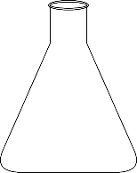 ii) 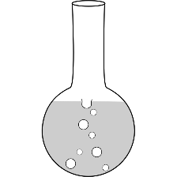

conical flask round bottomed flask
b) Draw the shapes of the following lab apparatus; (4mks)
i) Deflagrating spoon ii) Pipette

iii) Teat pipette iv) Filter funnel

c) State the function of the following lab apparatus; (2mks)
i) Dropping funnel
to deliver controlled amount of liquids into reaction vessels
Ii) Desiccator
To keep substances dry/ free of moisture
d) List two apparatus used to measure specific volume of liquids accurately (2mks)
pipette and volumetric flask
4. a) What is a flame? (1MK)
A mass of burning gases
b) List any four differences between a luminous and a non-luminous flame.(4mks)
luminous non luminous
long and weavy short and steady
yellow blue
four zones three zones
less hot fairly hot
sooty non sooty
produces a lot of light produces less light
C) Explain why the luminous flame of the Bunsen burner produces a lot of light (1mk)
The unburnt carbon particles when strongly heated glow white hot
D) State the functions of the following parts of the Bunsen burner (2mks)
i)The collar--- regulates the amount of air entering the chimney
Ii) The base ---- supports the BB
e) Which type of flame is most preferred for heating and why? Give two reasons it’s preferred. (3mk)
non-luminous flame
produces more heat 1mk does not produce soot 1mk
5. a) Choose the most suitable method to get the first substance from the following mixtures; (3MK)
i) Water and salt---------------- simple distillation
ii) Sand and water --------------------- filtration
iii) Oil and milk-------------------use of a separating funnel
b)Astudent was given a mixture of solution x and solution y which were miscible with boiling points of 84⁰c and 75⁰c .the students setup the set of apparatus as shown below to separate the two liquids. Study it carefully and answer the questions that follow
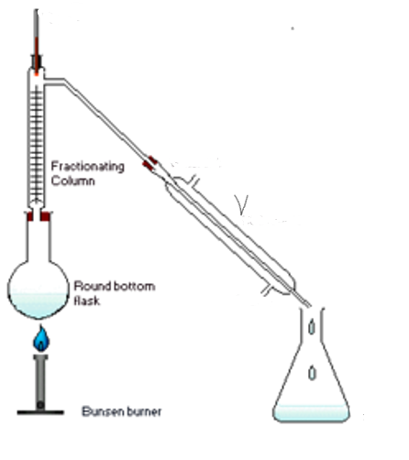
i) Name the method above that the student used (1mk)
fractional distillation
ii) What name is given to apparatus V (1mk)
liebig condenser
iii) Indicate on the diagram the direction of flow of water (1mk)
on the diagramme
iv) State the function of each of the following; (2mks)
I) Fractionating column- to enable liquid with a higher bp to condense and flow back to the flask
II) Thermometer – to record the bp values of the fraction distilling out.
v) Which of the two liquids was collected as the first distillate and why? (2mk)
liquid Y 1mk because it has a lower bp and will boil earlier 1mk
6. Draw a well labelled diagram to show how a mixture of sodium chloride and iodine can be separated to acquire a pure sample of each. (3MK)

7. DESCRIBE how an oil sample can be extracted from ground nuts. (3mks)
Place the nuts in a mortar ,Crush them using a pestle 1mk as you crush add a little propanone at a time , ½ mk decant, ½ mk place the solution in the sun for propanone to evaporate 1mk
8 (a). FILL in the table below. (8MK)
ELEMENT | SYMBOL
Calcium | Ca
Copper | Cu
potassium | K
Sodium | Na
Fluorine | F
Helium | He
Silver | Ag
magnesium | Mg
b) Identify the elements present in each of the following compounds;
i) Lead chloride (1mk)
lead ½ chlorine ½
ii) Zinc carbonate (1 ½ Mk)
zinc ½ , carborn ½ , oxygen ½
iii) Aluminium sulphate (1 ½ Mk)
aluminium ½ , sulphur ½ , oxygen ½
9. STATE and EXPLAIN the changes in mass that occurs when each of the following substances are strongly heated in a boiling tube in the lab. (2mk)
a) Copper Nitrate
the mass decreases, the gas released escaped to the air
b) Zinc oxide
the mass,does not change, only the colour changes
10. Define the following terms; (6mks)
a) Chemistry
the study of the structure, properties and composition of matter and the changes that matter undergoes.
b) Drug
a chemical substance which when taken alters the normal body functions
c) Drug abuse
use of a drug for a purpose not intended for.
d) Molecule

e) Atom
the smallest particle of an element that can take part in a chemical change
f) Element
a pure substance that can not be broken into simpler substances by any chemical means

11. Fill in the gaps in the chemical equations below.
a) Zinc + hydrochloric acid ---------------------------------------------- + Hydrogen (1mk)
b) Copper ii oxide + Sulphuric (vi) acid ------------------------------------------------------------ + ------------------------------------ (2mk)

