TOPICS COVERED Questions Answers
1 | Introduction to chemistry | 3 | 164
2 | Simple classification of substances | 5 | 165
3 | Acids, bases and indicators | 11 | 168
4 | Air and combustion | 14 | 169
5 | Water and hydrogen. | 19 | 172
6 | Structure of the atom and the periodic table | 22 | 174
7 | Chemical families | 28 | 179
8 | Structure and bonding | 29 | 179
9 | Slats | 34 | 184
10 | Effect of an electric current on substance | 37 | 187
11 | Carbon and its compounds | 41 | 188
12 | Gas laws | 45 | 191
13 | The mole | 47 | 196
14 | Organic chemistry 1 | 51 | 202
15 | Nitrogen and its compounds | 60 | 208
16 | Sulphur an dits compounds | 69 | 213
17 | Chlorine and its compounds | 74 | 217
18 | Acids, bases and salts | 77 | 219
19 | Energy changes in chemeical and physical reactions | 83 | 224
20 | Electrochemistry | 96 | 234
21 | Metals | 109 | 244
22 | Organic chemistry II (alkanoic acids an dalakanols) | 116 | 248
23 | Radioactivity | 123 | 254
24 | Praticals | 126 | 255

Introduction to chemistry
1. Wooden splints F and G were placed in different zones of a Bunsen burner flame.
The diagram below gives the observations that were made
G
F
Burnt parts
Burnt part

(a) Explain the difference between F and G
(b) Name the type of flame that was used in the above experiment
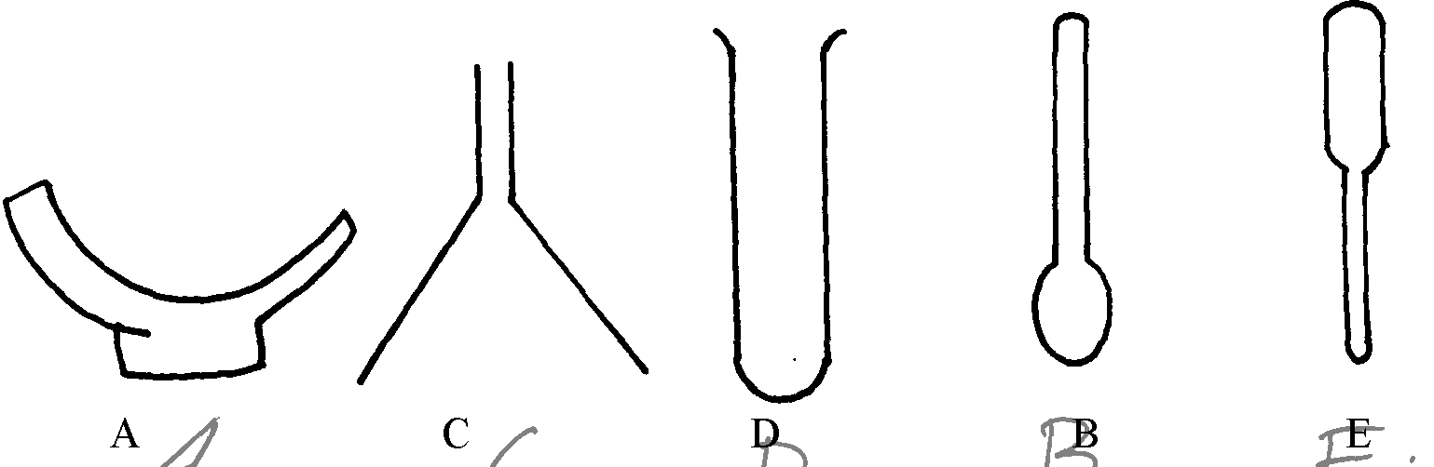
2. The diagrams below represent a list of apparatus which are commonly used in a chemistry laboratory:-

A B C D E

(a) Give the correct order of the apparatus, using the letters only, to show the correct arrangement
that can be used to prepare and investigate the nature of PH of a sample of onion solution
(b) Name one chemical substance and apparatus that is needed in this experiment

3. (a) When the air-hole is fully opened, the bunsen burner produces a non-luminous flame.
Explain
(b) Draw a labelled diagram of anon-luminous flame
4. (a) What is a drug?
(b) Give two drugs that are commonly abused by the youth.
5. The diagram below shows three methods for collecting gases in the laboratory

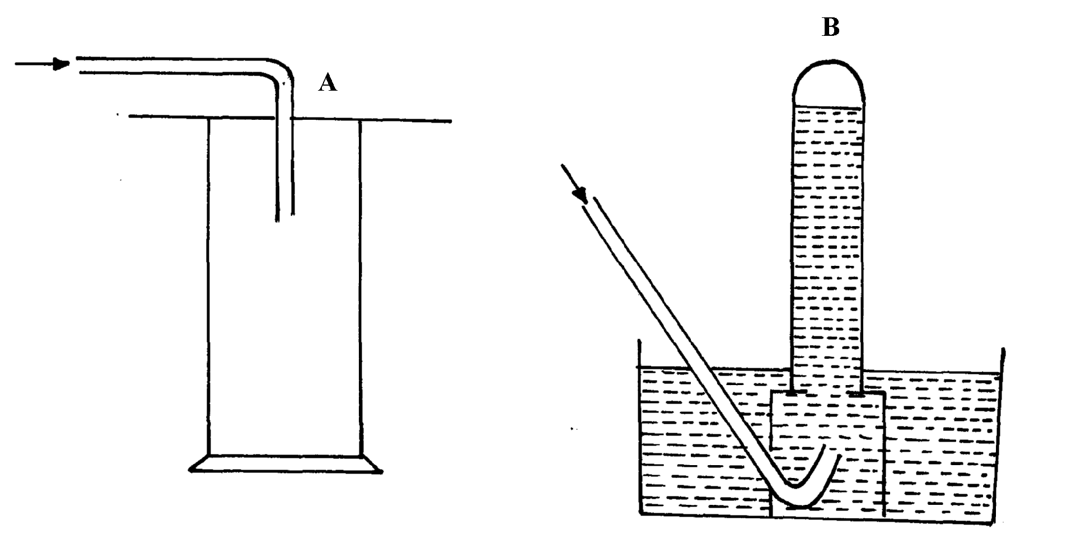

(a) Name the methods A and B
(b) From the methods above, identify one that is suitable for collecting sulphur (IV) oxide.
Explain

6. A mixture of hexane and water was shaken and left to separate as shown in the diagram below:
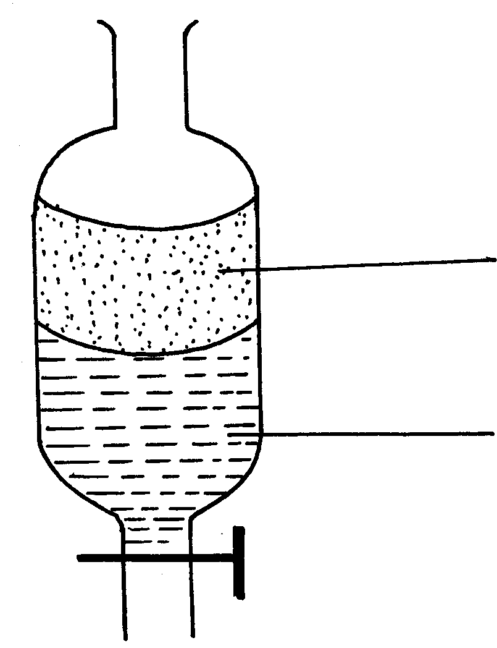
P
W

State the identity of;
(i) P ………………………………..…….. (ii) W ………………………………….….
7. The diagrams below are some common laboratory apparatus. Name each apparatus and
state its use

Diagram | Name | Use
 | (½mk ) | (½mk)
 | (½mk) | (½mk)

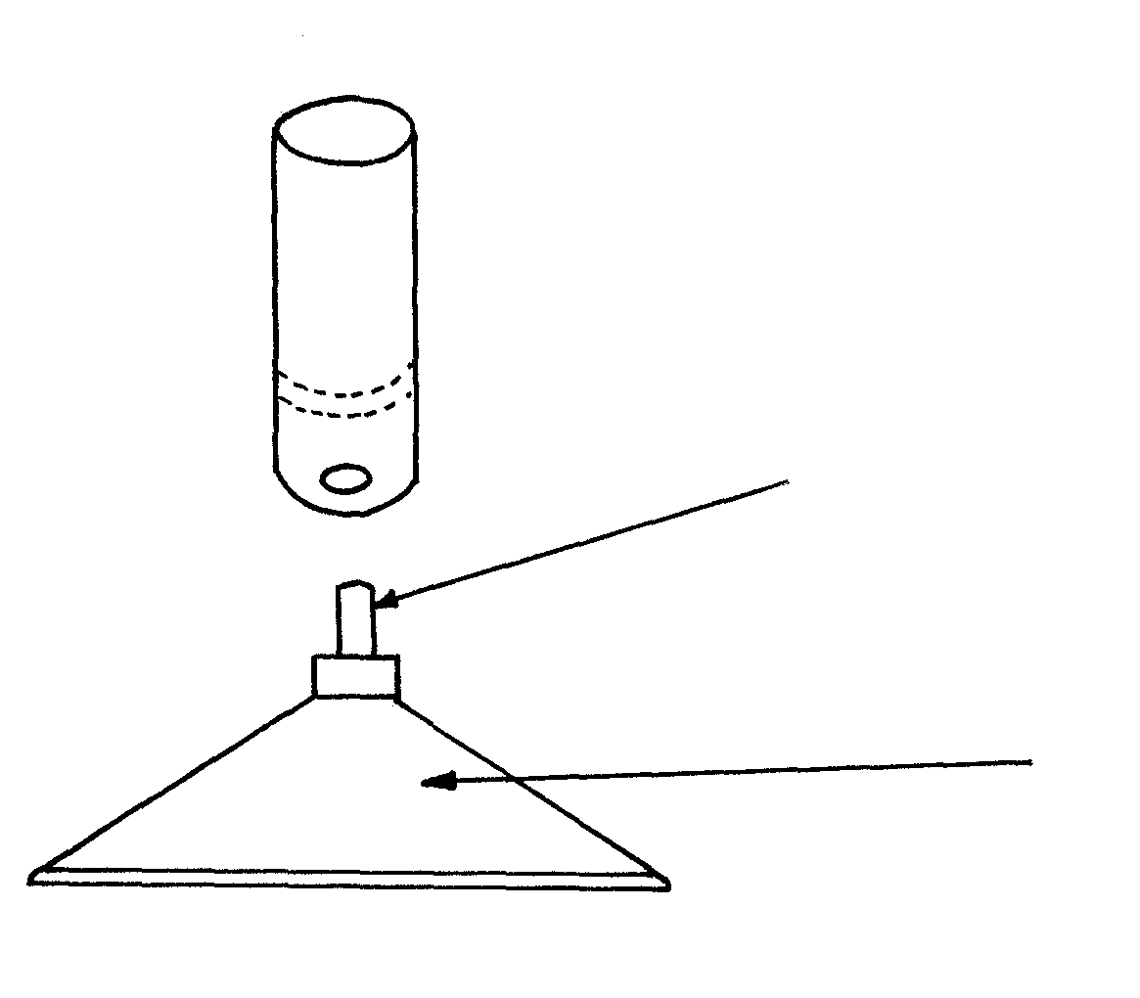
8. The diagram below shows some parts of a Bunsen burner

T

U

Explain how the parts labelled T and U are suited to their functions
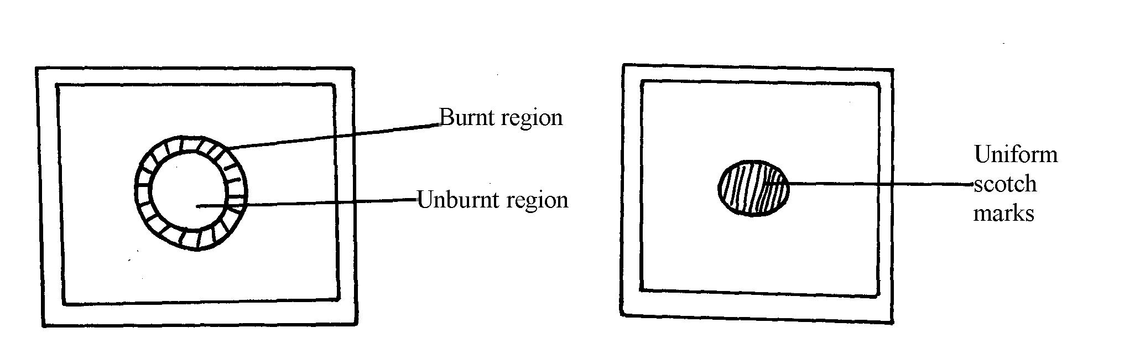
9. The diagram below shows the appearance of two pieces of paper placed in different parts of a
non-luminous flame of a Bunsen burner and removed quickly before they caught fire.

(a) What do the experiments show about the outer region of the flame?
(b) From the above experiment, which part of the flame is better to use for heating?Give a reason
10. A crystal of copper (II) sulphate was placed in a beaker of water. The beaker was left standing for
two days without shaking. State and explain the observations that were made.
11. Study the information in the table below and answer questions that follow.
(Letters given are not real symbols)
Ions | Electron arrangement | Ionic radius (nm)
A⁺  B⁺  C²⁺ | 2.8  2.8.8  2.8 | 0.95  0.133  0.065

Explain why the ionic radius of :-
(a) B⁺ is greater than that of A⁺
(b) _{C}²⁺ is smaller than the of A⁺

Simple classification of substances
1. The diagram below shows the heating curve of a pure substance. Study it and answer the
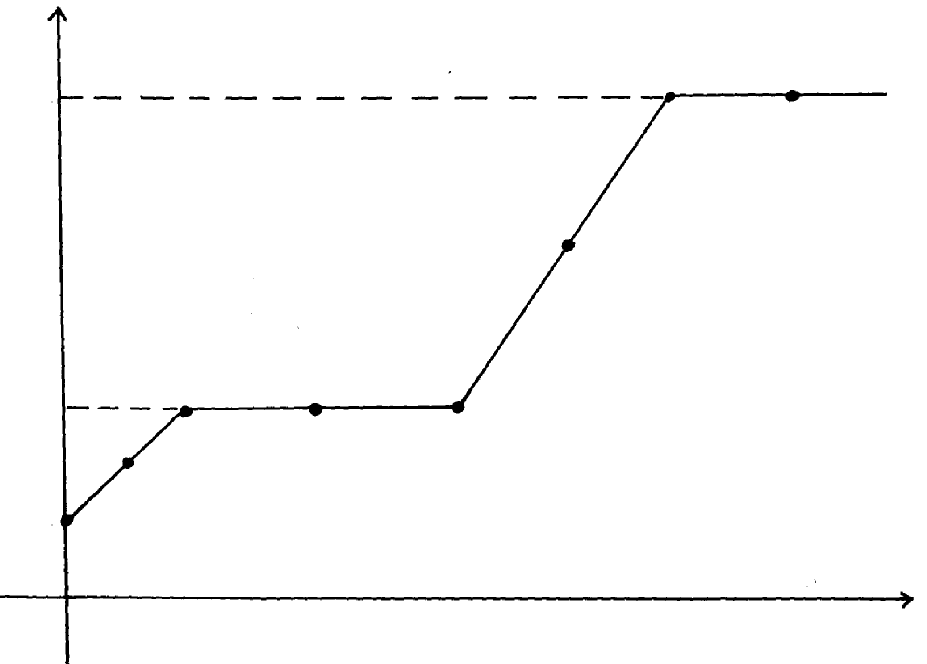
questions that follow:
Temperature (ºC)
B
X
C
Y
D
Z
444
115
A
Time

(a) What physical changes are taking place at points X and Z? (b)Explain what happens to the melting point of sodium chloride added to this substance

2. (a) State two differences between luminous flame and non-luminous flame
(b) It is advisable to set a Bunsen burner to luminous flame prior to an experiment.
Explain
3. The paper chromatography of a plant extract gave the following results:

Solvent | Number of spots
X | 6
Y | 2
Z | 3

(a) Which is the most suitable solvent for purifying the extract? Explain
(b) Ball pen cannot be used to mark solvent front in the above chromatography. Explain
4. Name the process which takes place when:
(a) Solid Carbon (Iv) Oxide (dry ice) changes directly into gas
(b) A red litmus paper turns white when dropped into chlorine water
(c) Propene gas molecules are converted into a giant molecule
5. A sample of copper turnings was found to be contaminated with copper (II) oxide. Describe
how a sample of copper metal can be separated from the mixture
6. Copper (II) oxide and charcoal are black solids. How would you distinguish between the
two solids?
7. a) What is chromatography?
b) Give two applications of chromatography
8. The two elements P and R were separately burned in air, the products gave the results
recorded in the table below:

ELEMENTS PHYSICAL STATE AT ROOM TEMPERATURE | P SOLID | R SOLID
Physical states of products | White solid powder only | Colourless gases L and M
Nature of solutions in water | Basic | L strongly acidic M slightly acidic

(a) Suggest the identity of element R. ……………………………………………..……..
(b) Describe how the nature of the solutions of the of the oxides were determined
9 The diagram below represents a paper chromatography for the three brands of soft drinks
containing banned artificial food additives.
4  1 | 6  2 | 7  5  3
 | A | B | C
BRANDS OF SOFT DRINKS
A and C found to contain the banned artificial food additives. Which numbers indicate the
banned artificial food additives?

10. Without using any laboratory chemical, describe a simple laboratory experiment to distinguish
between calcium hydrogen carbonate and sodium hydrogen carbonate
11. Substance Q has a melting point of 15ºC and boiling point of 70ºC.
(a) On the same axes, draw the melting point and boiling point graph for Q and the room
temperature
Temperature ºC
Time (minutes)

(b) State the physical state of substance Q at room temperature
12. Cooking oils comprise of a mixture of compounds which have a boiling point range
of 23ºC to 27ºC.
(i) What evidence is then to support the statement that cooking oil is a mixture?
(ii)Name another experimental technique that could be used to confirm your answer
in part (i) above

13. A form 1 student carried out the separation as shown in the set-up below:-

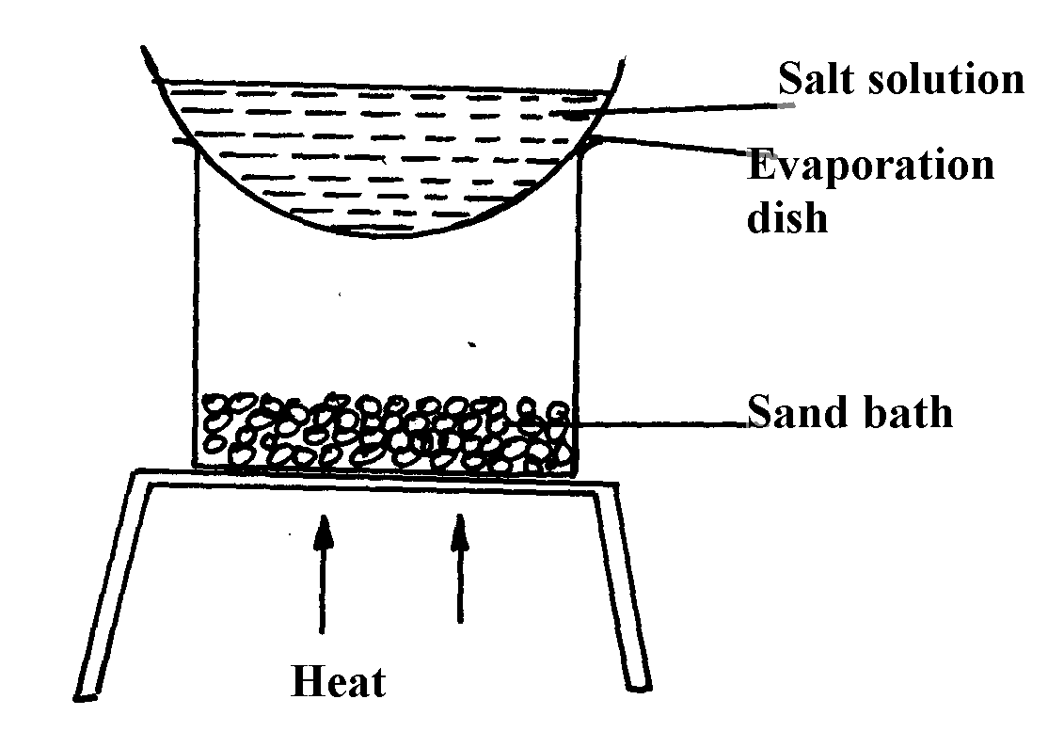

(i) Identify the method above.................................................................................
(ii) Give one of its disadvantages
(iii) Name a mixture which can be separated by the set-up above
14. What is meant by melting point and boiling point of a substance?

15. The apparatus below were used by a student to study the effect of heat on hydrated
copper II sulphate

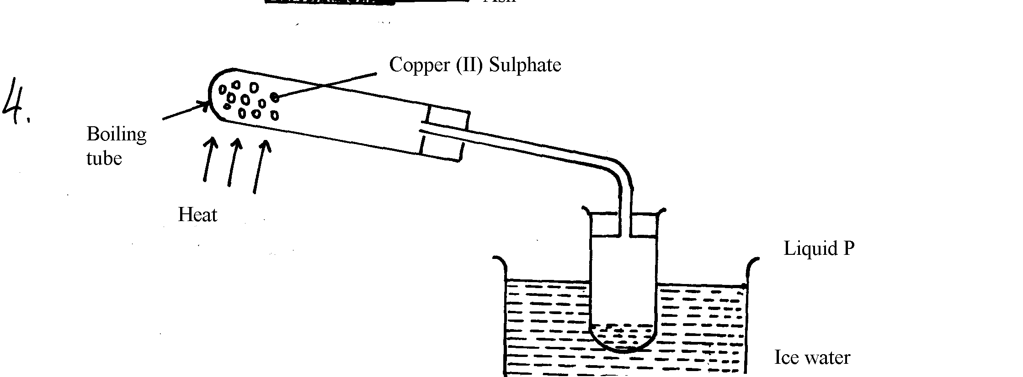

(a) What is the role of the ice cold water ……………
(b) Name liquid P …………………………………………………………
(c) What observation is made in the boiling tube

17. The diagram below shows chromatograms of blood samples obtained from three athletes.
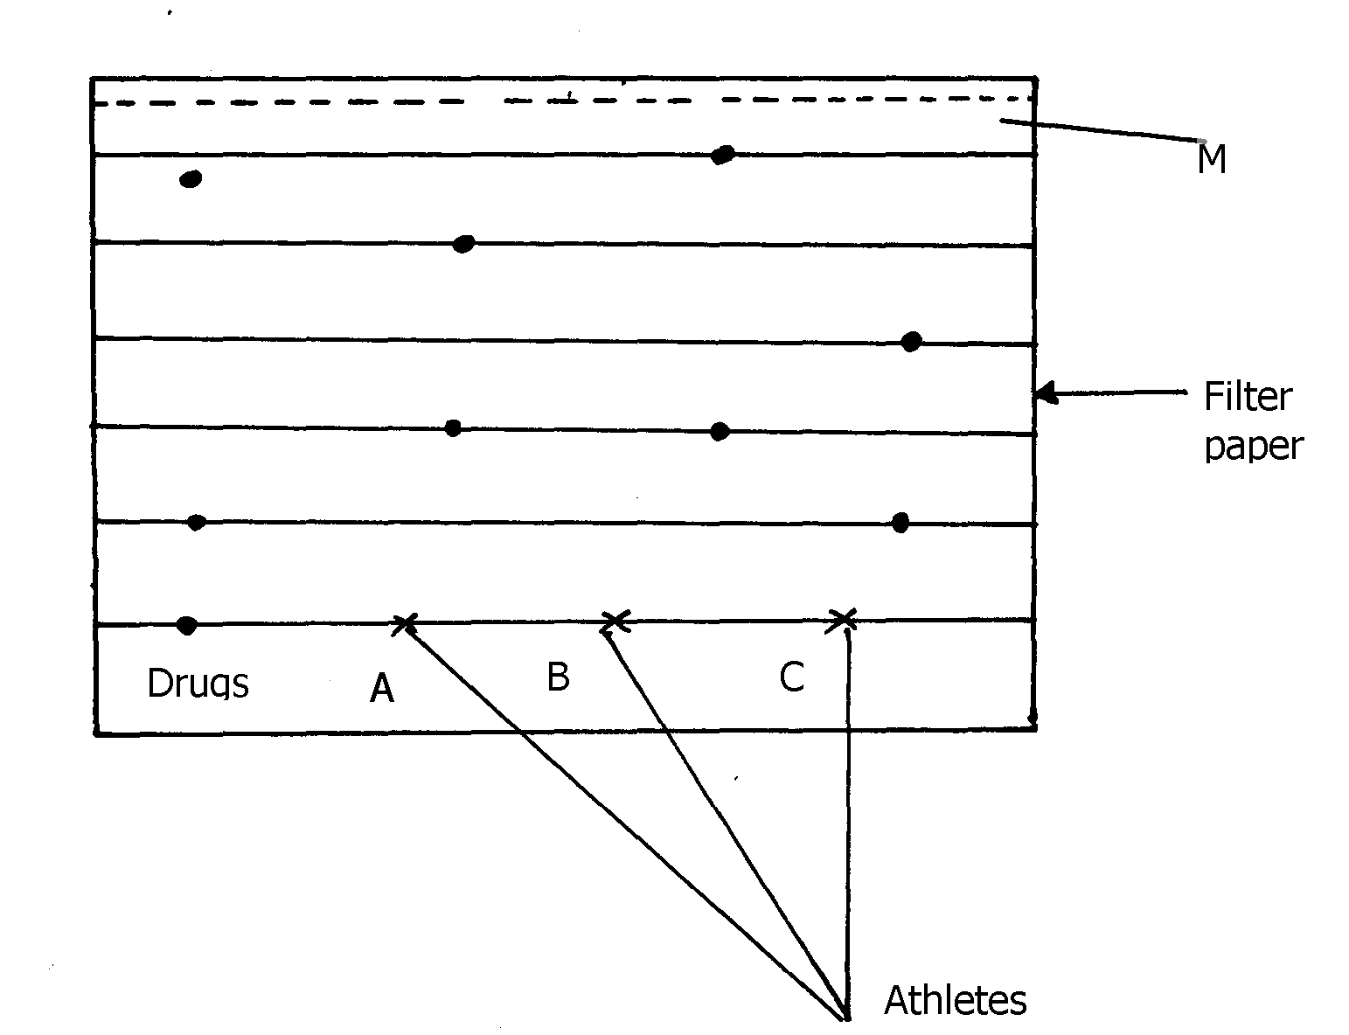
One athlete used illegal drug to improve performance in competition.

•
•

•

Drug

(a) Name the line marked M ………………………………………………….
(b)Identify the athlete who used illegal drug ……………... ……………………….
18. Classify the following processes as chemical changes or physical changes

Process physical or chemical
Neutralization ………………………………………
Sublimation ………………………………………
Fractional distillation ………………………………………..
Displacement reaction …………………………………………
19. Give two reasons why a luminous flame is not used for heating purposes
20. Classify the following processes as chemical changes or physical changes
Process physical or chemical
Neutralization ………………………………………
Sublimation ………………………………………
Fractional distillation ………………………………………..
Displacement reaction …………………………………………

21. Give two reasons why a luminous flame is not used for heating purposes
22. State two criteria for determining the purity of a substance

23. Study the information in the table below and answer the questions.
Substance | Water | Concentrated sulphuric(VI)acid | Concentrated sodium hydroxide
Ethene | Slightly soluble | Soluble | Insoluble
Ammonia | Very soluble | Very soluble | Very soluble
Hydrogen | Slightly soluble | Insoluble | Insoluble
i) A mixture contains ethene, Hydrogen and ammonia gases. Explain how a sample of
hydrogen gas can be obtained from this mixture.
24. a)i) The diagram below show spots of a pure substance A, B, and C on a chromatography
paper. Spot D is that of a mixture
●
●
●
●
A
B
C
D

After development A, B, and C were found to have moved 8cm, 3cm and 6cm respectively.
D had separated into two spots which had moved 6cm and 8cm
On the diagram above;
I. Label the baseline (origin)
II. Show the positions of all the spots after development
ii) Identify the substances present in mixture D
b) Describe how solid ammonium chloride can be separated from a solid mixture of
ammonium chloride and anhydrous calcium chloride
c) The table below shows liquids that are miscible and those that are immiscible
Liquid | L₃ | L₄
L₁ | Miscible | Miscible
L₂ | Miscible | Immiscible
Use the information given in the table to answer that questions that follow;
i) Name the method that can be used to separate L₁ and L₂ from a mixture of the two
ii) Describe how a mixture of L₂ and L₄ can be separated
25. A student left some crushed fruit mixture with water for some days. He found the mixture
had fermented. He concluded that the mixture was contaminated with water and ethanol with
boiling point of 100ºC and 78ºC respectively. The set-up of apparatus below are used to separate
the mixture.
A
Thermometer
B
Mixture
Conical
flask
Distillate
Apparatus W

(i) Name the piece of apparatus labelled W
(ii) What is the purpose of the thermometer in the set-up?
iii) At which end of the apparatus W should tap water be connected?……………………………
(iv) Which liquid was collected as the first distillate? Explain
(v) What is the name given to the above method of separating mixture?
(vi) State two applications of the above method of separating mixtures
(vi) What properties of the mixture makes it possible for the component to be separated
by the above methods?
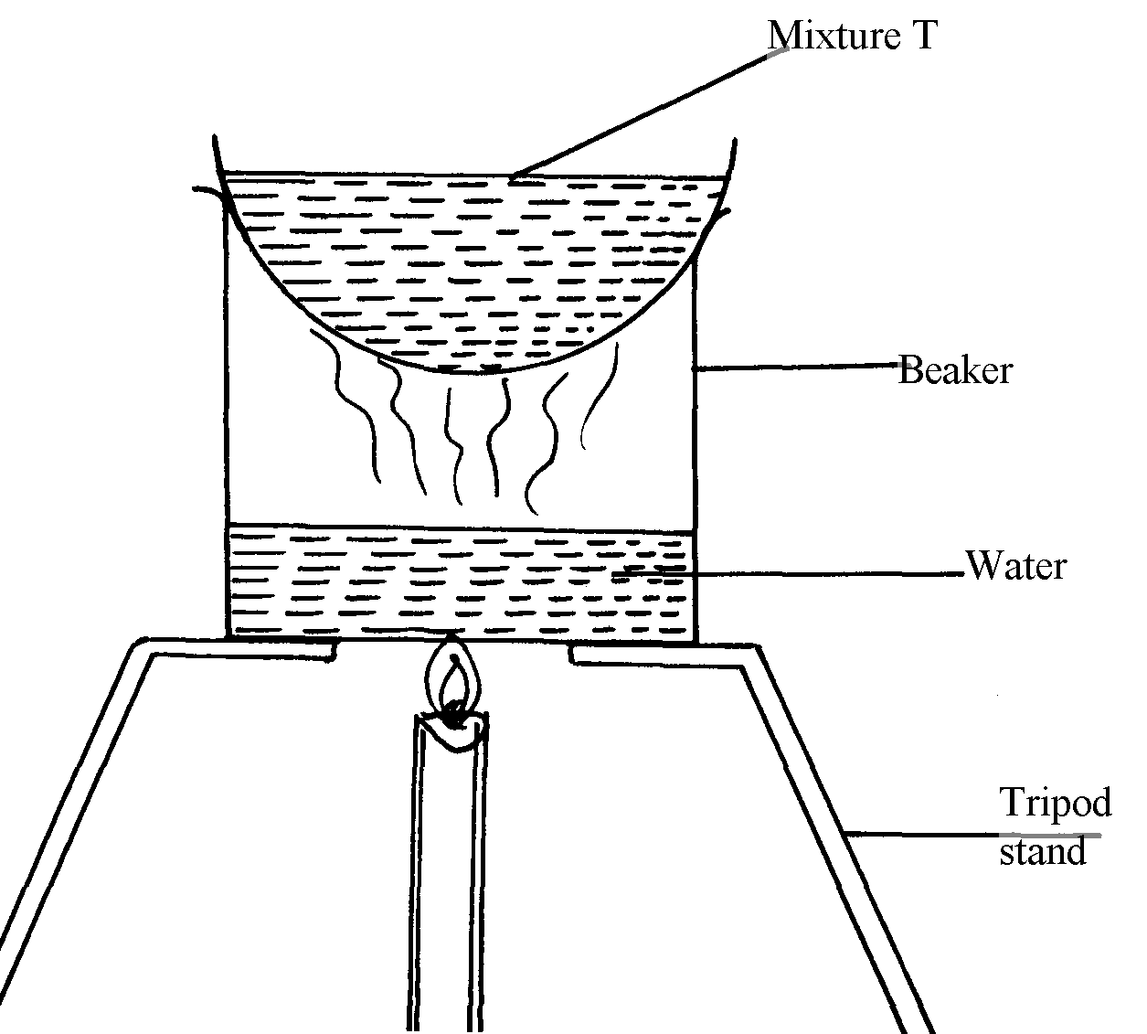
26. The set-up below was used to separate a mixture:-

(a) Name the apparatus missing in the set-up
(b) Give one example of mixture T
(c) What is the name of this method of separation

27. a) The diagram below shows a set – up used by a student to find out what happens
when Copper (II) sulphate crystals are heated.

Blue copper (II) sulphate
crystals
Heat
Delivery tube
Test tube
Beaker
Liquid Y

Ice-cold water

(i) State the observations made when the blue copper (II) sulphate crystals are heated.
(ii) Identify liquid Y and write an equation for its formation.
b) Pellets of sodium hydrogen and anhydrous Copper (II) sulphate were put in separate Petri-
dishes and left in the open for two hours. Explain the observation in each Petri-dish.

28. The chromatography below shows the constituents of a flower extract using an organic solvent:-
Yellow
Red
Blue
M
•
•
•
•

(a) (i) Name a possible organic solvent you can use for this experiment
(ii) State one property that makes the red pigment to move the furthest distance from M
(iii) Describe how one could get a sample of yellow pigment
(iv) On the diagram indicate solvent front
(b) Describe how Aluminium chloride can be separated from a mixture of aluminium chloride
and sodium chloride
29. Study the information below and answer the questions that follow:
Solid | Cold water | Hot water
R | Soluble | Soluble
V | Insoluble | Insoluble
S | Insoluble | Insoluble

Describe how the mixture of solid R, S, and V can be separated
30. Given a mixture of lead (II) oxide, ammonium chloride and sodium chloride, describe how this
mixture can be separated to obtain a sample of each.
31. The setup below was used to separate two miscible liquids Q and T
(Boling points; Q =98° C, T=78°C)
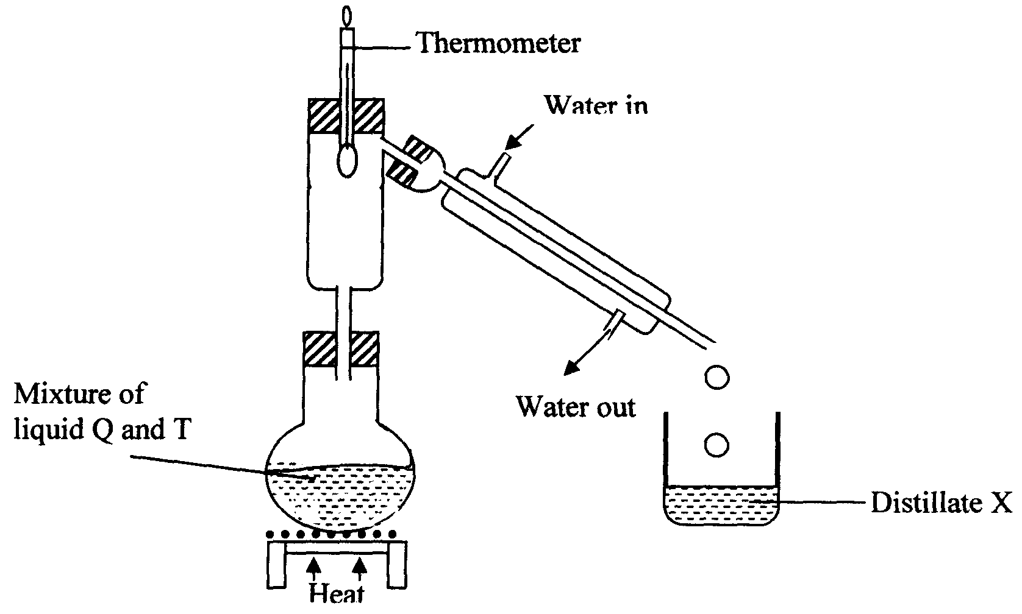

(a) Identify the mistakes in the setup above
(b)Identify Distillate X

32. Name the process which takes place when:
a) Solid Carbon (IV) oxide (dry ice) changes directly into gas.
b) A red litmus paper turns white when dropped into chlorine water.
c) Propene gas molecules are converted into a giant molecule.
33. The following diagram shows a paper chromatogram of substances A, B, C, and D which
are coloured
A
B
C
D
E
Χ
Χ
Χ
Χ
Χ

(a) Indicate the solvent front on the chromatogram
(b) Which substance is pure? ………………………………………..
(c) Substance E is a mixture of C and D. Indicate its chromatogram in the diagram
34. Study the information below and answer the following questions. A mixture contains three
solids A, B, and C. The solubility of these solids in different liquids is as shown below:-

Solid | Water | Alcohol | Ether
A | Soluble | Insoluble | Insoluble
B | Insoluble | Soluble | Very soluble
C | Soluble | Soluble | Insoluble
Explain how you will obtain sample C from the mixture
35. State and explain the observations made when iodine crystals is heated in a boiling tube?

Acids, bases and combustion
1. The table below shows solutions A, B and C are tested and observations records as shown:
Solution | Observations on indicator
A | Methyl orange turns yellow
B | Phenolphthalein turns colourless
C | Litmus turns purple

(a) Using the table above, name an acid
(b) How does the pH value of 1M potassium hydroxide solution compare with that of
1M aqueous ammonia? Explain
2. The information below gives PH values of solutions V, W, X, Y Z

Solution | PH values
V  W  X  Y  Z | 2  6.5  11  14  4.5
(a) Which solution is likely to be:
(i) Calcium hydroxide? ……………………………………………….
(ii) Rain water? ………………………………………………………
(b) Which solution would react most vigorously with Zinc carbonate

3. a) Complete the table below to show the colour of the given indicator in acidic and basic
solutions.
Indicator | Colour in
Methyl Orange | Acidic Solution | Basic Solution
Methyl Orange |  | Yellow
Phenolphthalein | Colourless

b) How does the PH value of 0.1M potassium hydroxide solution compare with that of 0.1M
aqueous ammonia? Explain.

4. Use the information given below to answer the questions that follow:
Solution | G | H | I | J | K
pH | 1.5 | 6.5 | 13.0 | 7.0 | 8.0

(a) Which of the solutions would be used to relieve a stomach upset caused by indigestion?
(b) Which solution is likely to be:
(i) Dilute sulphuric acid?
(ii) Sodium hydroxide solution?

5. Solid copper (II) oxide is a base although it does not turn litmus paper to blue. Explain

6. Below are the pH values of 4 types of medicine represented by letters P, Q, R and S
MEDICINE | pH VALUES
P  Q  R  S | 7.0  5.0  8.0  6.0
a) It is not advisable to use S when a patient has indigestion .Explain
b) What is the role of chemistry in drug manufacture

7. Explain why very little Carbon (IV) oxide gas is evolved when dilute sulphuric (VI) acid
is added to lead (II) carbonate
8 . State one commercial use of Calcium Oxide
9. The following data gives the pH values of some solutions
Solution | pH
P  Q  R | 14.0  6.8  2.5

(a) What colour change would occur in solution P on addition of two drops of
phenolphthalein indicator?
(b) State the pH value of a resulting solution when equal moles of solution P and R react

10. In an experiment, ammonia gas was prepared by heating ammonium salt with an alkali.
After drying, ammonia gas was collected at room temperature and pressure.
(a) What is meant by the term alkali?
(b) Explain using physical properties of the gas why ammonia is not collected by downward
delivery
11. The table shows the colours obtained when some indicators are added to solutions:-
Solution | Blue litmus paper | Indicator W
Distilled water | ………………….. | Colourless
Calcium hydroxide | Blue | Pink
Nitric acid | ………………………… | Colourless

(a) Complete the table by filling in the missing colours
(b) Identify indicator W

12. (a) Flower extracts can be used as Acid-base indicators. Give two limitations of such
indicators
(b) The diagram below shows spots of pure substances W, X, and Y on a chromatography
paper. Spot Z is that of a mixture
W
X
Y
Z
•
•
•
•

After development W, X, and Y were found to have moved 9cm³, 4cm³ and 7cm³ respectively.
Z has separated into two spots which have moved 7cm³ and 9cm³:-
On the diagram:-
I. Label the baseline and solvent front
II. Show the position of all the spots after development
III. Identify the substances present in mixture Z
13. A beekeeper found that when stung by a bee, application of a little solution of sodium
hydrogen carbonate helped to relieve the irritation of the affected area. Explain

14. 10g of sodium hydrogen carbonate were dissolved in 20cm³ of water in a boiling tube. Lemon
juice was then added dropwise with shaking until there was no further change.
(a) Explain the observation which was made in the boiling tube when the reaction was in progress
(b) What observations would be made if the lemon juice had been added to copper turnings in
a boiling tube?
15. (a) Complete the table below to show the colour of the given indicator in acidic and basic
solutions:
Indicator | Colour in acidic solution | Basic solution
Methyl orange | Pink
Phenolphthalein |  | Pink
16. Solutions can be classified as acids, bases or neutral. The table below shows solutions and their
pH values:-
Solutions | PH VALUES
K  L  M | 1.5  7.0  14.0
(i) Select any pair that would react to form a solution of PH 7
(ii) Identify two solutions that would react with aluminium hydroxide. Explain

Air and combustion

1. The set-up below was used to prepare a sample of oxygen gas. Study it and answer
the questions that follow.
H₂O₂
MnO₂

(i) Complete the diagram to show how Oxygen can be collected
(ii) Write a chemical equation of the reaction to produce oxygen

2. Air was passed through several reagents as shown below:
Concentrated sodium hydroxide solution
Air
Excess copper turnings hydroxide solution
Escaping
gases
Excess heated magnesium powder

(a) Write an equation for the reaction which takes place in the chamber containing
Magnesium powder
(b) Name one gas which escapes from the chamber containing magnesium powder.
Give a reason for your answer
3. (a) What is rust?
(b) Give two methods that can be used to prevent rusting
(c) Name one substance which speeds up the rusting process

4. 3.0g of clean magnesium ribbon 8.0g of clean copper metal were burnt separately in
equal volume of air and both metals reacted completely with air;
a) State and explain where there was greater change in volume of air
Mg =24 Cu = 64
b) Write an equation for the reaction between dilute sulphuric acid and product of burnt copper

5. Oxygen is obtained on large scale by the fractional distillation of air as shown on the flow
chart bellow.

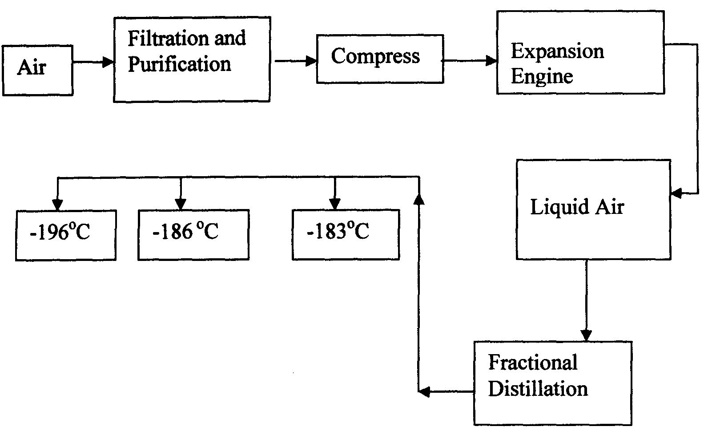

a) Identify the substance that is removed at the filtration stage
b) Explain why Carbon (IV) oxide and water are removed before liquefaction of air
c) Identify the component that is collected at -186°C

6. The set-up below was used to study some properties of air.
Moist iron wool
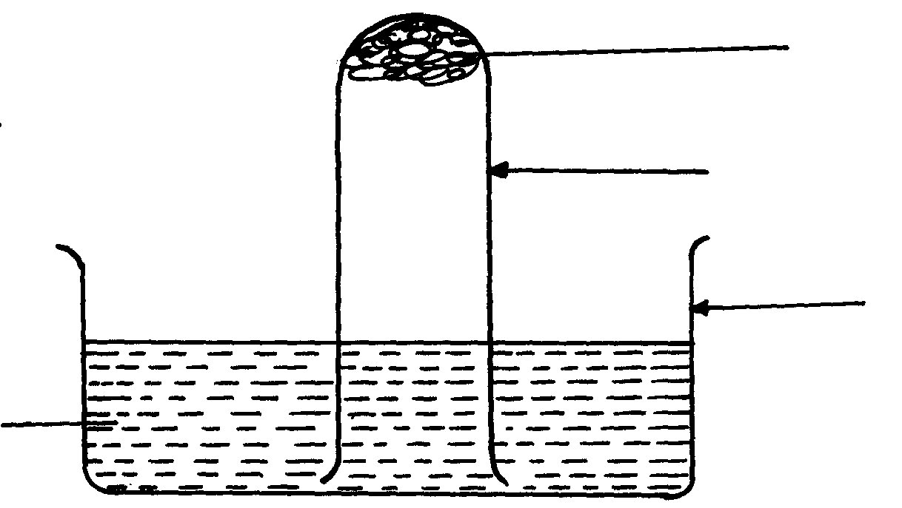
Test tube

Beaker

Water

State and explain two observations that would be made at the end of the experiment
7. A form two student in an attempt to stop rusting put copper and Zinc in contact with iron
as shown:-
Iron
Zinc
Copper
(i)
(ii)

(a) State whether rusting occurred after one week if the set-ups were left out
(b) Explain your answer in (a) above

8. In an experiment, a piece of magnesium ribbon was cleaned with steel wool. 2.4g of
the clean magnesium ribbon was placed in a crucible and completely burnt in oxygen.
After cooling the product weighed 4.0g
a) Explain why it is necessary to clean magnesium ribbon
b) What observation was made in the crucible after burning magnesium ribbon?
c) Why was there an increase in mass?
d) Write an equation for the major chemical reaction which took place in the crucible
e) The product in the crucible was shaken with water and filtered. State and explain the
observation which was made when red and blue litmus paper were dropped into the filtrate
9. In an experiment a gas jar containing some damp iron fillings was inverted in a water trough
containing some water as shown in the diagram below. The set-up was left un-disturbed for three
days. Study it and answer the questions that follow:
Water Trough
Inverted gas jar
Damp iron fillings
Water

(a) Why were the iron filings moistened?
b) State and explain the observation made after three days.
(c) State two conclusions made from the experiment.
d) Draw a labelled set-up of apparatus for the laboratory preparation of oxygen using
Sodium Peroxide
(e) State two uses of oxygen
10. In an experiment, a piece of magnesium ribbon was cleaned with steel wool. 2.4g of the clean
magnesium ribbon was placed in a crucible and completely burnt in oxygen. After cooling the
product weighed 4.0g
a) Explain why it is necessary to clean magnesium ribbon
b) What observation was made in the crucible after burning magnesium ribbon?
c) Why was there an increase in mass?
d) Write an equation for the major chemical reaction which took place in the crucible
e) The product in the crucible was shaken with water and filtered. State and explain the
observation which was made when red and blue litmus paper were dropped into the filtrate

11. The set-up below was used to collect gas F produced by the reaction between sodium
peroxide and water
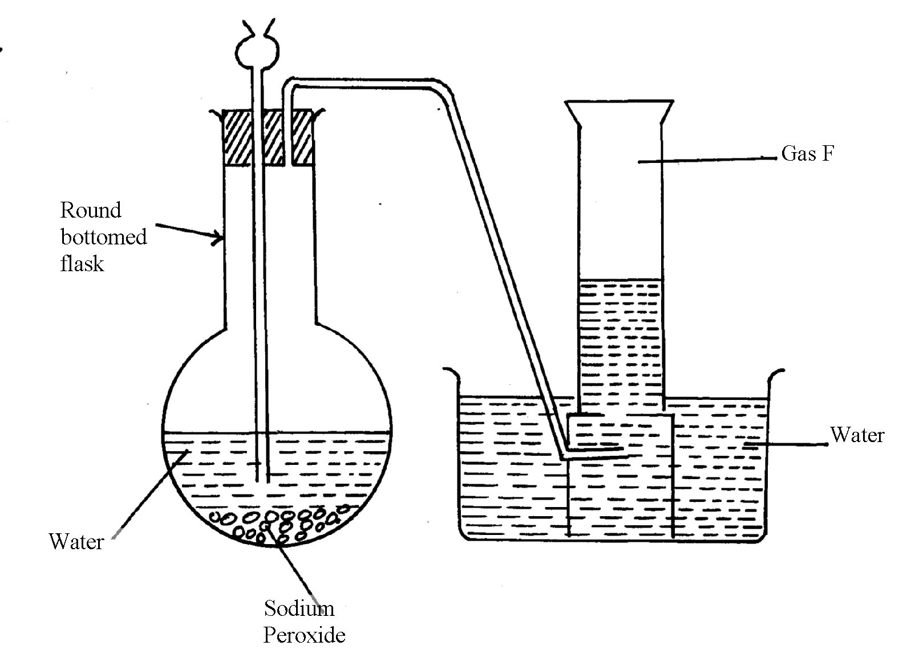

(i) Name gas F……………………………………………………………………………
(ii) At the end of the experiment, the solution in the round bottomed flask was found to be
a strong base. Explain why this was so
(iii) Which property of gas F makes it be collected by the method used in the set-up?
(iv) Give one industrial use of gas F

12. . The set-up below was used to investigate properties of the components of air:

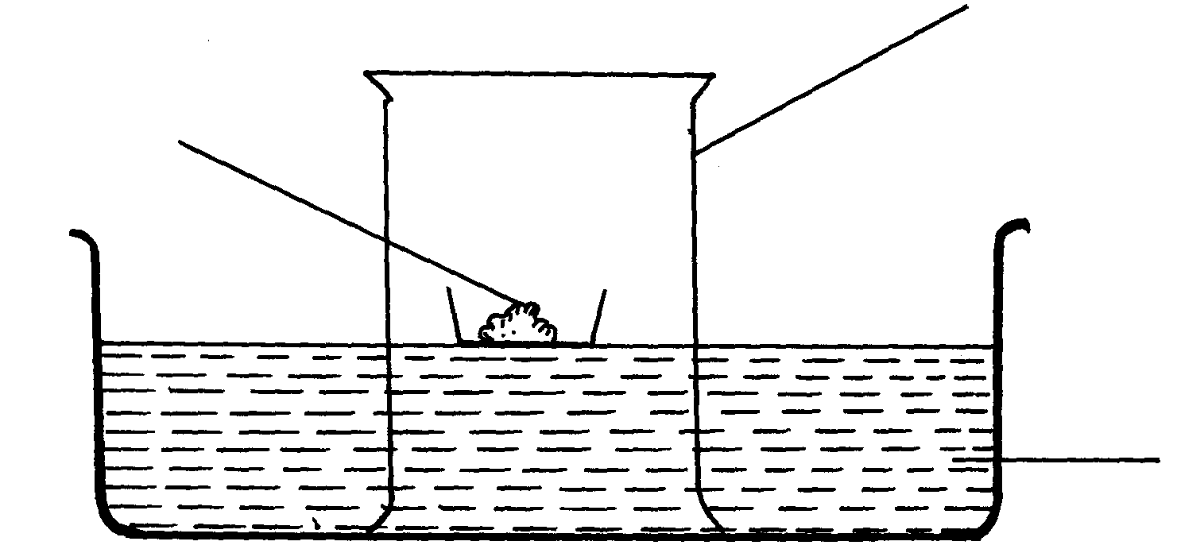
Phosphorous
Gas jar
Water

(i) State two observations made during the experiment
(ii) Write two chemical equations for the reactions which occurred
(iii) The experiment was repeated using burning magnesium in place of phosphorous.
There was greater rise of water than in the first case. Explain this observation
(iv) After the two experiments, the water in each trough was tested using blue and red litmus
papers. State and explain the observations of each case.
(a) Phosphorous experiment
b) magnesium experiment
(v) Briefly explain how a sample of nitrogen gas can be isolated from air in the laboratory
13. (a) A group of students burnt a piece of Mg ribbon in air and its ash collected in a Petri dish.
The ash was found to comprise of magnesium Oxide and Magnesium nitride
(i) Write an equation for the reaction leading to formation of the magnesium nitride
(ii) A little water was added to the products in the Petri dish. State and explain the
observation made.
(iii) A piece of blue litmus paper was dipped into the solution formed in (b) above.
State the observation made.
14. A form one class carried out an experiment to determine the active part of air. The diagram
below shows the set-up of the experiment and also the observation made.
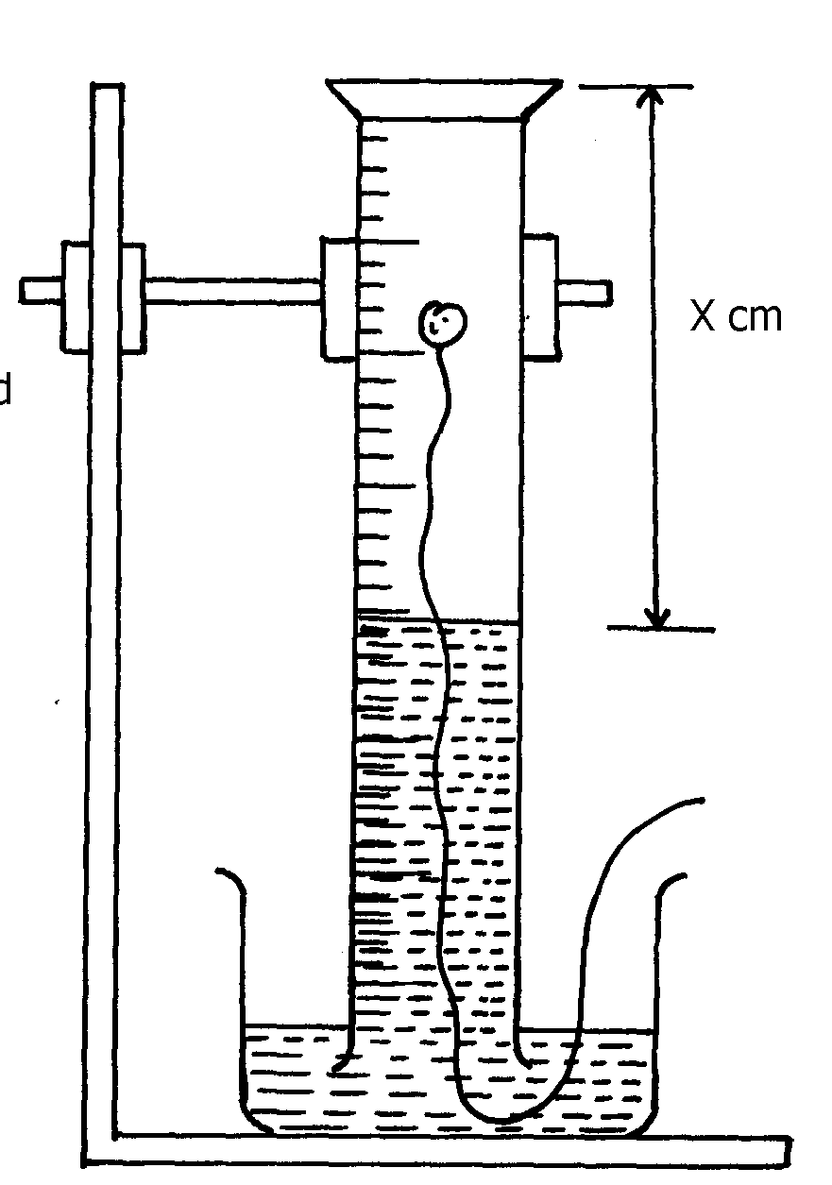
(i) At the beginning (ii) observation at the end of the experiment
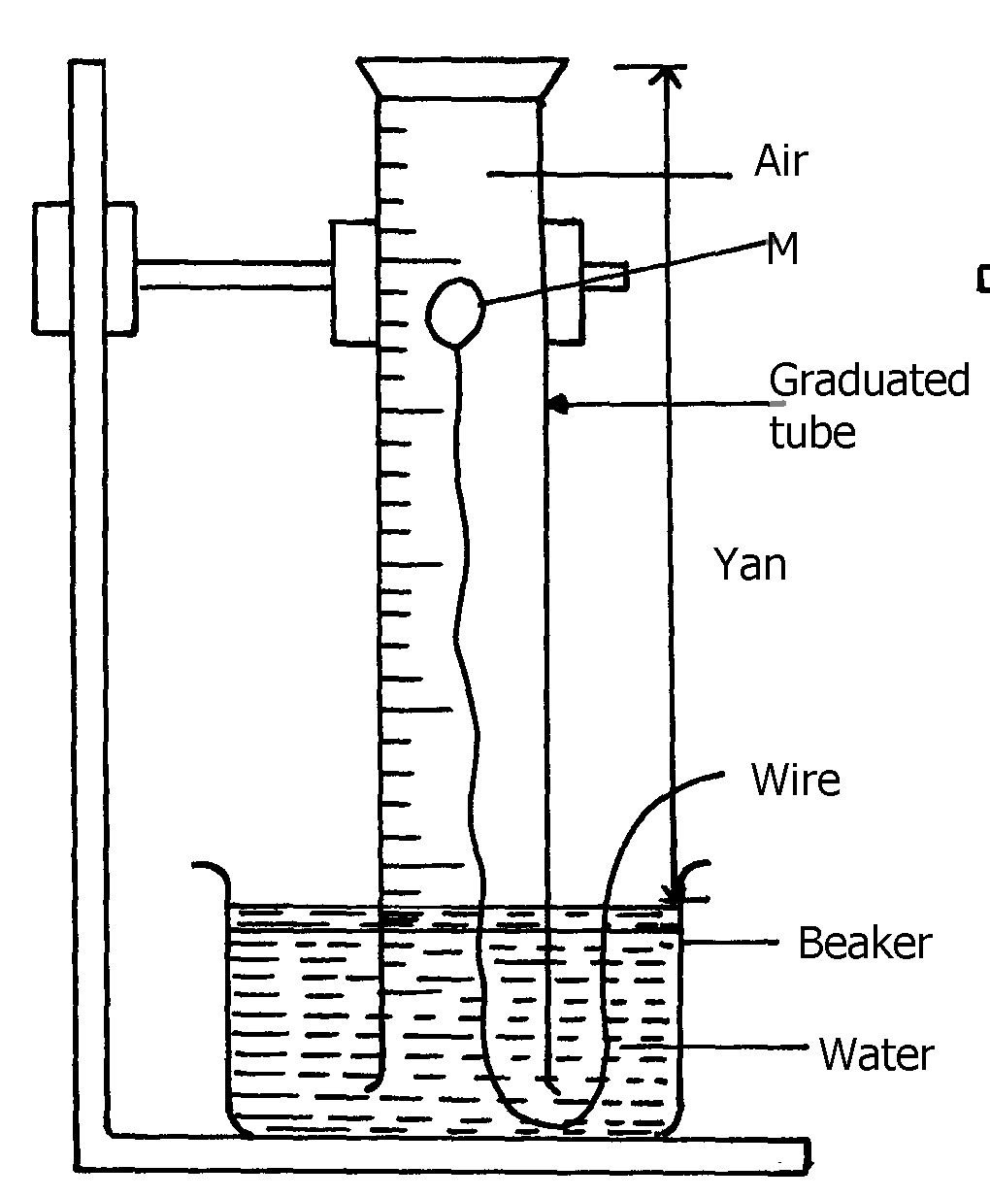

Ycm
Solid A
Air

(a) (i) Identify substance M ..................................................................................
(ii) State two reasons for the suitability of substance M for this experiment
(b) Write the equation for the reaction of substance M and the active part of air
(c) (i) Using the letters Y and X write an expression for the percentage of the active part of air
(ii) The expression in (c)(i) above gives lower value than the expected. Explain
(d) (i) Explain the observation made when litmus paper is dipped into the beaker at the end of the
experiment
(ii) Name the active part of air ................................................................................................
(iii) Suggest another method that can be used to determine the active part of air
15. A piece of phosphorous was burnt in excess air. The product obtained was shaken with a small
amount of hot water to make a solution
i) Write an equation for the burning of phosphorus in excess air
ii) The solution obtained in (b) above as found to have pH of 2. Give reasons for this
observation

16. Study the set-up below and answer the questions that follow:-
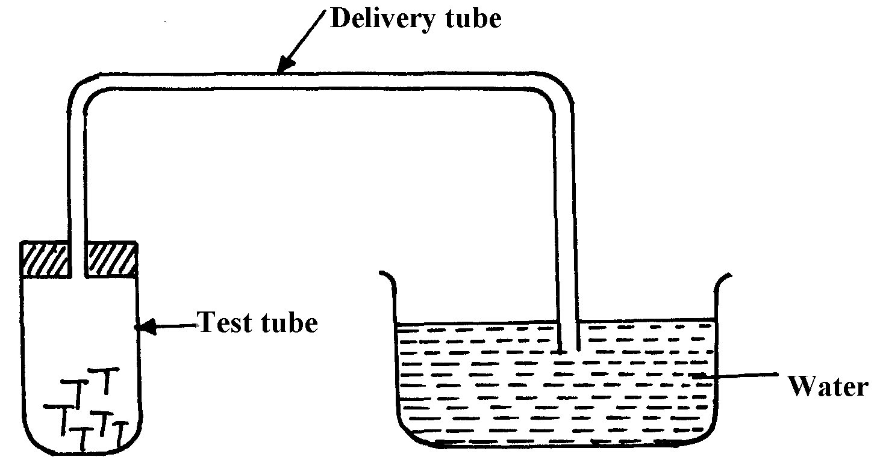

Iron nails

(a) State two observations that would be made after one week. Explain
(b) Write the equation of the reaction taking place in the test-tube
17. Fe₃O₄ and FeO are oxides of iron which can be produced in the laboratory
(a) Write chemical equation for the reaction which can be used to produce each of the oxides
(b) Wire an ionic equation for the reaction between the oxide, Fe₃O₄ and a dilute acid.

18. Below is a list of oxides.
MgO, N₂O, K₂O, CaO ans Al₂O₃
Select:-
a) A neutral oxide.
b) A highly water soluble basic oxide.
c) An oxide which can react with both sodium hydroxide solution and dilute hydrochloric acid.

19. The diagram below shows students set-up for the preparation and collection of oxygen gas
X
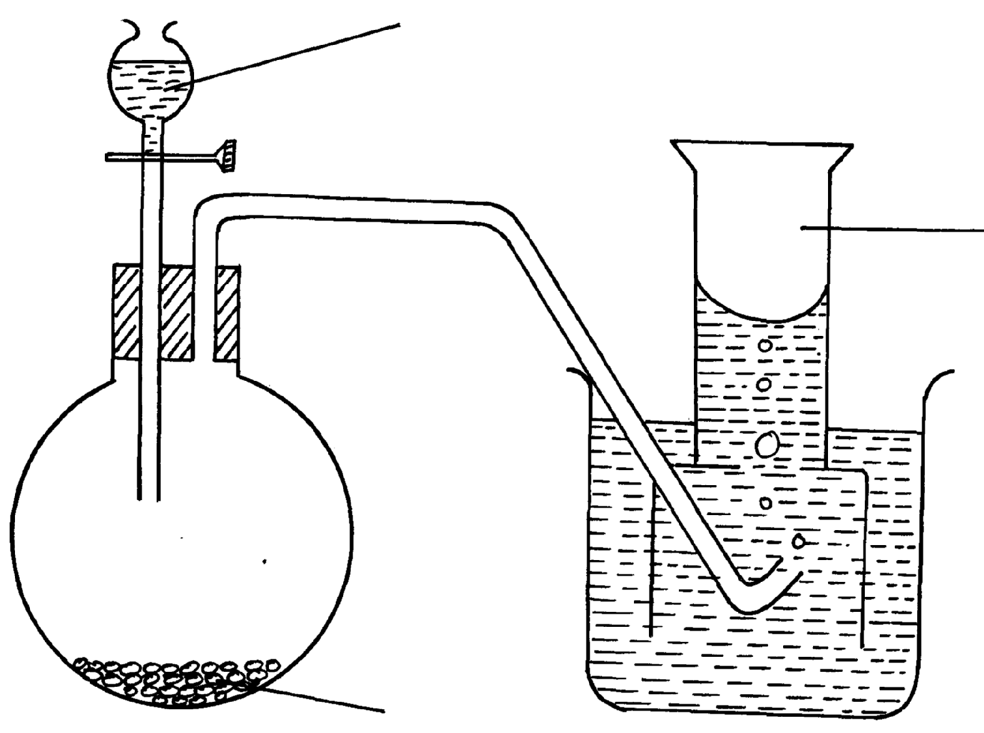

Oxygen gas

Sodium peroxide

(a) Name substance X used
(b) Write an equation to show the reaction of sodium peroxide with the substance named in 1(a)

5. Water and hydrogen
1. (a) Hydrogen can reduce coppers Oxide but not alluminium oxide. Explain
(b) When water reacts with potassium metal the hydrogen produced ignites explosively
on the surface of water.
(i) What causes this ignition?
(ii) Write an equation to show how this ignition occurs

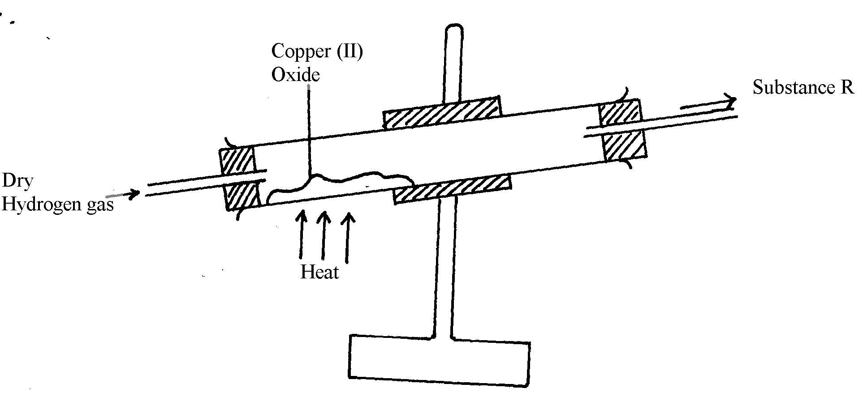
2. In an experiment, dry hydrogen gas was passed over hot copper (II) oxide in a combustion
tube as shown in the diagram below:-

(a) Complete the diagram to show how the other product, substance R could be collected
in the laboratory.
(b) Describe how copper could be obtained from the mixture containing copper (II) oxide
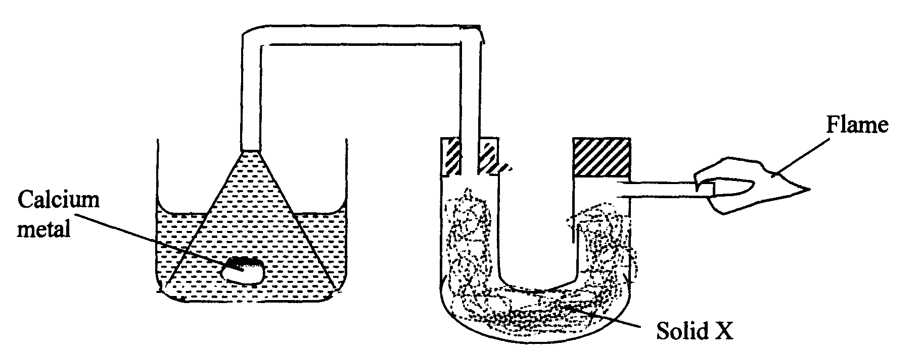
3. The setup below was used to investigate the reaction between metals and water.

(a) Identify solid X and state its purpose
Solid X ………………..………………………………………………………………………..
Purpose ………………………………………………………………………………………..
(b) Write a chemical equation for the reaction that produces the flame.
4. Gas P was passed over heated magnesium ribbon and hydrogen gas was collected as shown
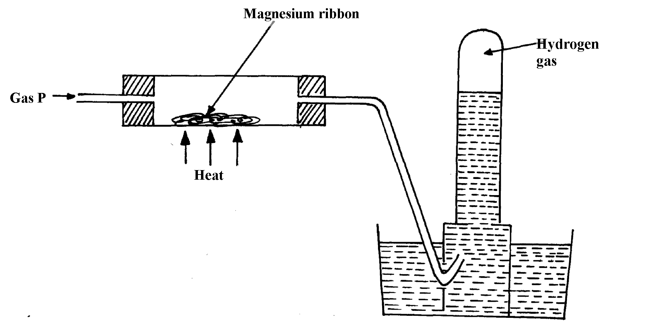
in the diagram below:

(i) Name gas P ...............................................................................................................
(ii) Write an equation of the reaction that takes place in the combustion tube
(iii) State one precaution necessary at the end of this experiment
5. When hydrogen is burnt and the product cooled, the following results are obtained as shown
in the diagram below:
Dry hydrogen
Liquid Y
Burning hydrogen
Ice cold water
Clamp
Clamp

(a) Write the equation for the formation of liquid Y
(b) Give a chemical test for liquid Y
6. Jane set-up the experiment as shown below to collect a gas. The wet sand was heated before
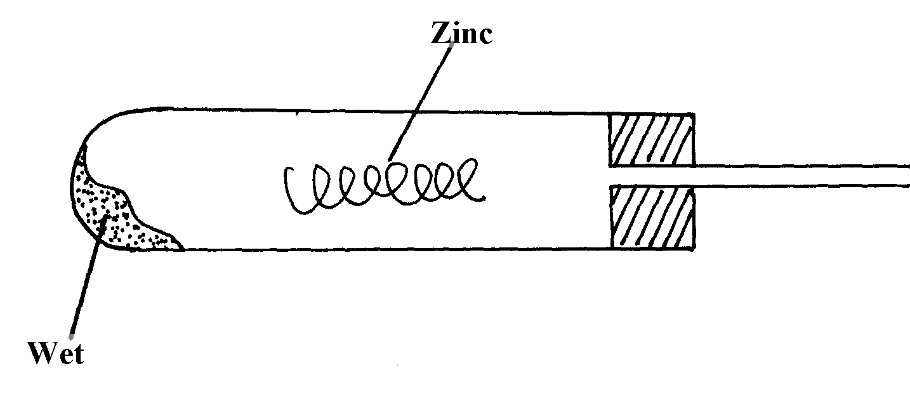
heating Zinc granules

Wet sand
(a) Complete the diagram for the laboratory preparation of the gas
(b) Why was it necessary to heat wet sand before heating Zinc granules?

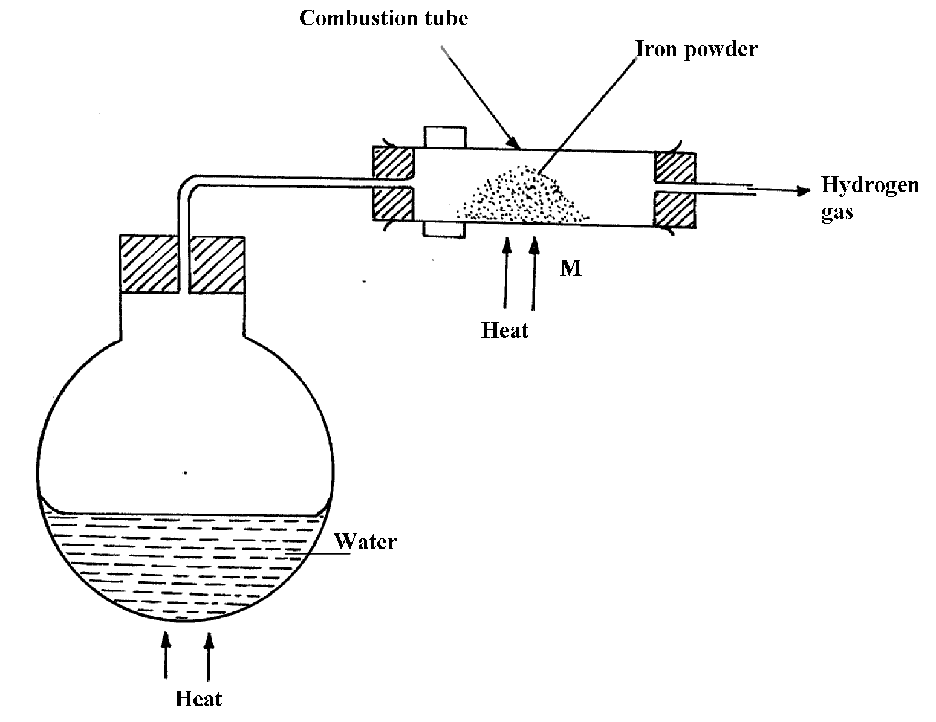
7.

N

(a) Between N and M which part should be heated first? Explain
(b) Write a chemical equation for the reaction occurring in the combustion tube.
8. The set-up below was used to investigate electrolysis of a certain molten compound;-

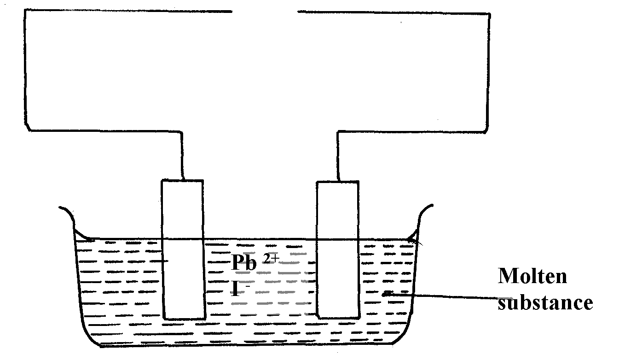

(a) Complete the circuit by drawing the cell in the gap left in the diagram
(b) Write half-cell equation to show what happens at the cathode
(c) Using an arrow show the direction of electron flow in the diagram above

9. Hydrogen can be prepared by reacting zinc with dilute hydrochloric acid.
a) Write an equation for the reaction.
b) Name an appropriate drying agent for hydrogen gas.
c) Explain why copper metal cannot be used to prepare hydrogen gas.
d) Hydrogen burns in oxygen to form an oxide.
(i) Write an equation for the reaction.
(ii) State two precautions that must be taken before the combustion begins and at the end of
the combustion.
e) Give two uses of hydrogen gas.
f) When zinc is heated to redness in a current of steam, hydrogen gas is obtained. Write an
equation for the reaction.
g) Element Q reacts with dilute acids but not with cold water. Element R does not react with
dilute acids. Elements S displaces element P from its oxide. P reacts with cold water. Arrange
the four elements in order of their reactivity, starting with the most reactive.
h) Explain how hydrogen is used in the manufacture of margarine.
10. a) The set-up below is used to investigate the properties of hydrogen.
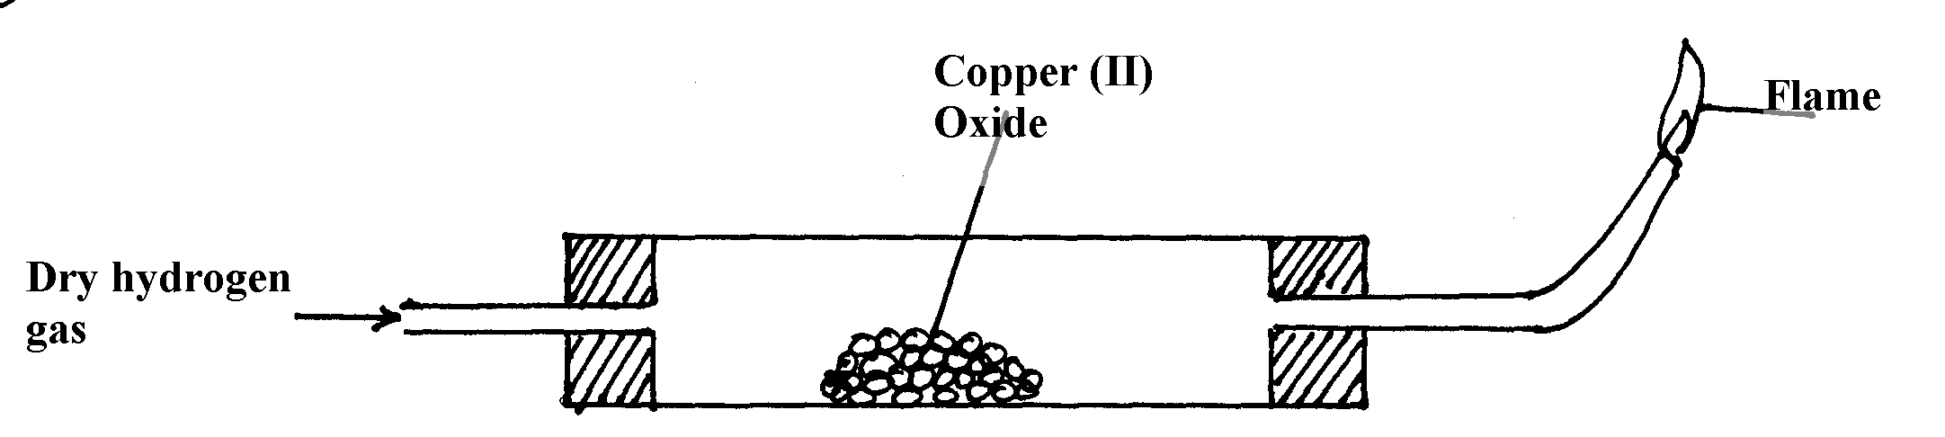

i) On the diagram, indicate what should be done for the reaction to occur
ii) Hydrogen gas is allowed to pass through the tube for some time before it is lit. Explain
iii) Write an equation for the reaction that occurs in the combustion tube
iv) When the reaction is complete, hydrogen gas is passed through the apparatus until they
cool down . Explain
v) What property of hydrogen is being investigated?
vi) What observation confirms the property stated in (v) above?
vii) Why is zinc oxide not used to investigate this property of hydrogen gas?
11. The set up below was used to collect gas K, produced by the reaction between water and
o
o
o
o
o
o
o

Water
Calcium metal
Gas K
calcium metal.

(a) Name gas K ……………………………………………………………..
(b) At the end of the experiment, the solution in the beaker was found to be a weak base. Explain
why the solution is a weak base

6. Structure of the atom and the periodic table
1. In an experiment an unknown mass of anhydrous sodium carbonate was dissolved in water and
the solution made up to 250cm³. 25cm³ of this solution neutralized 20cm³ of 0.25M nitric acid.
(Na = 23.0 C = 12.0 O = 16.0)
Calculate:
(a) Moles of Nitric acid used
(b) Moles of sodium carbonate in 25cm of the solution
(c) Mass of unknown sodium carbonate used
2. Element A has atomic mass 23 and element B has atomic mass 7 and also have 12neutorns and
4 neutrons respectively.
(a) Write the electronic arrangement of A and B
(b) Which element has higher ionization energy? Explain
3. The table below shows the relative atomic masses and the percentage abundance of isotope
M₁ and M₂ of element M.

 | Relative atomic mass | % abundance
M₁ | 62.93 | 69.09
M₂ | 64.93 | 30.91

Calculate the relative atomic mass of element M

4. (a) Element V has two isotopes. Two thirds of V and one third of V . What is the
relative atomic mass of element V?
(b) The following refers to element Y
Isotope | A | B | C
Isotope mass | 54 | 56 | 57
Given that isotope C contains 31 neutrons in its nucleus find the number of protons in isotope B
5. The table below shows the relative atomic masses and the percentage abundance of the isotopes
L₁ and L₂ of element L.
 | Relative atomic mass | % abundance
L₁  L₂ | 62.93  64.93 | 69.09  30.91
Calculate the relative atomic mass of element K.
6. An element M has two isotopes M and M . The relative atomic mass of the
naturally occurring is 63.55. Calculate the percentage of each isotope

7. An oxide of element G has the formula as G₂O₃
(a) State the valency of element G
(b) In which group f the periodic table is element G?
^{8.} The table below gives information about the ions T+ and Z2-
Ion | T⁺ | Z²⁻
Electron arrangement | 2.8 | 2.8.8
Number of neutrons | 12 | 16
(a) How many protons are there in the nucleus of ?
(i) Element T?
(ii) Element Z?
(b) Determine the relative formula mass of the compound formed between T and Z
(c) State two conditions under which the compound would conduct electricity

9. Carbon and silicon belong to the same group of the periodic table, yet Carbon (IV) oxide
is a gas while silicon (IV) oxide is a solid with a high melting point. Explain this difference

10. An ion of oxygen is larger than oxygen atom. Explain

11. Copper (II) oxide and charcoal are black solids. How would you distinguish between the
two solids?

12. (a) Element X is found in period III and group IV. It consists of two isotopes ²⁸X and ^{Q}X.
A sample of X was found to consist of 90% of ²⁸X.If the relative atomic mass of X is 28.3,
work out the number of neutrons in ^{Q}X
(b) Draw an electrochemical cell for the above cell
13. Study the table below and answer the questions that follows:- (Letters are not the actual
symbols of element)
Element | Electronic arrangement | Electrical conductivity
L1 | 2.8.2 | Higher electrical conductivity
L2 | 2.8.1 | High electrical conductivity
L3 | 2.8.3 | Highest electrical conductivity

L3 has the highest electrical conductivity. Explain
14. Define the term melting point of a substance
15. Use the information in the table below to answer the questions that follow.
(The letters do not represent the actual symbols of the elements).
Element | Q | P | R | S | T
Atomic number | 18 | 5 | 3 | 5 | 20
Mass number | 40 | 10 | 7 | 11 | 40
(a) Which two letters represent the same element? Give a reason
(b) Give the number of neutrons in an atom of element R

16. The table below gives some elements in the periodic table. Use it to answer the questions that
Follow. The letters do not represent the actual symbols of the elements.
Element | A | B | C | D | E
Atomic number | 12 | 13 | 14 | 15 | 16
Which of the above letters represent:
a) A metallic element which forms ions with the smallest ionic radius? Explain
b) A non metallic element with the largest bbatomic size? Explain
17. The grid below is part of the periodic table. Use it to answer the questions that follow:
(The letters are not the actual symbols).

A B

C D G E
F
a) Write down the formula of the compound formed between C and A.
b) Which element has the same electron arrangement as the stable ion of:
(i) F ……………………………. (ii) A ……………………..
c) Element Q has atomic number 15. Indicate its position on the grid.
d) Explain how the atomic radii of the following compare:
(i) C and F
(ii) C and D
e) Write the type of bond present in a compound formed between D and A.
f) Compound C and G were completely burned in oxygen.
(i) Write down equations to show the combustion of each of the elements.
(ii) State whether each of the oxides (i) above is basic or acidic.
18. The following flow chart shows the industrial manufacture of Nitric (V) acid.
a) Identify substance B, C, E and F.
Filter
Air
Compressor
Catalytic chamber
Nitric (V) acid
Absorption
chamber
Chamber D
F
E
B
b) Describe what happens in the catalytic chamber.

c) State what takes place in chamber D.
d) 60 – 65% nitric (V) acid is produced in the absorption chamber. Describe how the acid can be
concentrated.
e) State why nitric (V) acid is stored in dark bottles.
f) Copper reacts with nitric (V) acid and not hydrochloric acid. Explain.

19. The number of protons, neutrons and electrons in atoms A to F are given in the table below
the letters do not represent the actual symbol of the elements:-

Atoms | Protons | Neutrons | Electrons
A  B  C  D  E  F | 3  9  12  17  17  18 | 4  10  12  18  20  22 | 2  10  12  17  17  18

(a) Choose from the table the letters that represent:
(i) An atom of a metal ...........................................................................
(ii) A neutral atom of a non-metal .......................................................
(iii) An atom of a noble gas ...........................................................
(iv) A pair of isotopes ...............................................................................
(v) A cation ...............................................................................
(b) The grid below shows a part of the periodic table. The letters do not represent the actual
symbols.
Use it to answer the questions that follow:-
C
X
J
K
Y
M
U
Q
W
T
Z

(a) How do the atomic radius of element X and Y compare
(b) (i) Using crosses (X) to represent electrons, draw the atomic structure of element Q
(ii) State the period and the group to which element Q belong

(c) (i) The ionic configuration of element G is 2.8 G forms an ion of the type G⁻¹.
Indicate on the grid, the position of element G.
(ii) To which chemical family does element G belong?
(iii) State one use of element U
(iv) What is the nature of the compound formed between K and U
20. (a) Study the table below and answer the questions that follow.

Particle | Atomic number | Ionic configuration | Formula of oxide | Atomic radii | Ionic radii
P | 4 | ………….. | …………… | 0.110 | 0.031
Q | …………... | 2.8.8 | QO | 0.200 | 0.099
R | …………… | 2.8.8 | R₂O | 0.230 | 0.133
S | 17 | 2.8.8 | S₂O₇ | 0.099 | 0.181
T | 16 | …………… | ……… | 0.104 | 0.231

(i) Complete the table above
(ii) From the table, choose the most reactive metal. Explain
(iii) Which element is the most electronegative. Explain
(iv) Using dots (.) and crosses (x) to represent electrons, show the bonding in the chloride of Q
(v) Explain the solubility of element T in water
(b) (i) Why is aluminium used to make utensils yet it is a reactive metal?
(ii) Distinguish between valency and oxidation number

21. a) Work out the oxidation number of phosphorous in the following compound H₃PO₃
b) Study the equation below:
Mg_{(s)} + 2H₂O_{(l)} Mg(OH)_{2(aq)} + H_{2 (g)}
Which species has undergone oxidation .Explain
22. The grid below represents part of the periodic table. The letters do not represent the actual
symbols of the elements. Study it and answer the questions that follow:
L |  |  |  |  |  |  | L
M | P |  |  | T |  | J | U | X
N | Q |  | R | S |  |  | V | Y
 |  |  |  |  |  |  | W

(a) Explain why element L appears in two different groups in the grid above
(b) State the name of the chemical family to which P and Q belong
(c) Write the formula of the compound formed between P and V
(d) Compare the melting points of Q and S. Explain
(e) Identify an element whose oxide dissolves in both acids and alkalis
(f) Write the equation for the burning of T in excess air
(g) Using dots (•) and cross (x) to represent electrons, draw a diagram to illustrate bonding
in the sulphide of Q
(h) State one use of element X

23. The grid below represents part of the periodic table. Study it and answer the questions that follow:

S
Q
Z
R
E
M
X
T

V

(a) (i) Identify the element that gains electrons most readily
(ii) Which of the metal is most reactive? Explain
(iii) What name is given to the family of elements to which elements X and T belong?
(iv) Explain why:-
(I) Ionic radius of Q is larger than that of M
(II) Atomic radius of Q is greater than that of S
(v) Which of the element in the table does not have the ability to form an ionic or covalent
bond? Explain
(vi) Give the formula of the compound formed between R and Z

24. The grid below is part of the periodic table. The elements are not represented by their actual symbols. Use the information to answer the questions that follow.
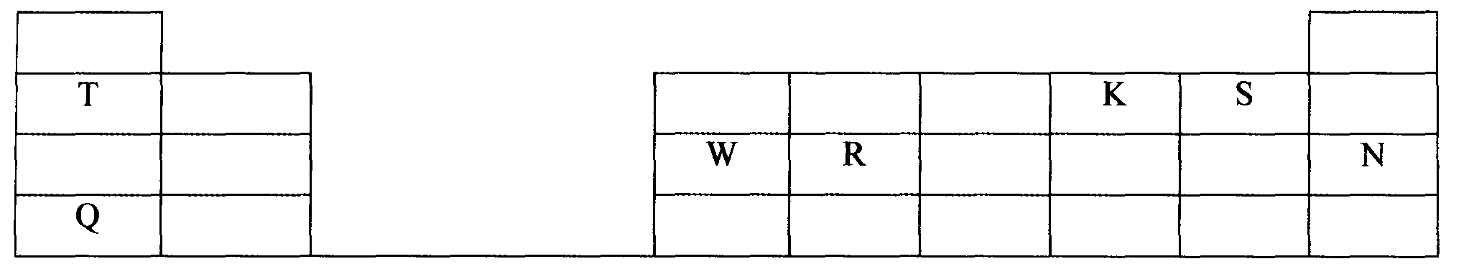

a) (i) Which is the most reactive
(I) Non — metal? *
Explain
(II) Metal?
Explain
(ii) Name the family to which elements T and Q belongs.
(iii) Write the formula of the compound formed when W reacts with S.
(iv) Name the type of bond and structure formed when elements R and K react.
(v) Explain why element N doesn’t form compounds with other elements.
(vi) Compare the atomic radii of T and Q. Explain.

25. Study the data given in the following table and answer the questions that follow. The letters
are not the actual symbols of elements.

Element | Number of protons | Melting point | Bpt ºC
A | 11 | 98 | 890
B | 12 | 650 | 1110
C | 13 | 60 | 2470
D | 14 | 1410 | 2360
E | 15 | 442  590 | 280
F | 16 | 113  119 | 445
G | 17 | -101 | -35
H | 18 | -189 | -186

(i) State and explain the trend in melting point in A B C
(ii) Explain why the melting point and boiling points of element D is the highest
(iii) Explain why the element represented by letter E has two melting point values
(iv) Write down the chemical formula between element C and sulphate ions
(v) Name the chemical family in which H belong and state one use of the element
(vi) What is the nature of the oxide of the elements represented by letters C and F?
26. An element W has an atomic number 13.
a) Write the electronic configuration of the most stable ion of W
b) Write the formula of the oxide of the element W

27. Identify the particles that facilitate the electric conductivity of the following substances
(i) Sodium metal
(ii) Sodium Chloride solution
(iii) Molten Lead Bromide
28. Compare with a reason the atomic radius of Sodium to that of Aluminum.

29. Study the information in the table below and answer the questions that follow:

Ion | No. of protons | No. of electrons
P³⁻  Q⁺  R²⁺ | 7  19  12 | 10  18  10

a) Write the electron arrangement of element P.
b) Give the group and period to which elements Q and R respectively.
Q ……………………………………………………
R ……………………………………………………

30. Ethanol is a liquid at room temperature but does not conduct electricity. Explain.

31. Electronic configuration for elements represented by P, Q, R and S are:-
P= 2.8.6, Q= 2.8.2, R= 2.8.1 D= 2.8.8.
- Select the element which forms
(i) A double charged ion
(ii) A soluble carbonate
32. The table below gives information on four elements by letters K, L, M and N. Study it
and answer the questions that follow. The letters do not represent the actual symbol of
the elements.
(a) Which two elements have similar properties? Explain
Element | Electron arrangement | Atomic radius (nm) | Ionic radius (nm)
K  L  M  N | 2.8.2  2.8.7  2.8.8.1  2.8.8.2 | 0.136  0.099  0.203  0.174 | 0.065  0.181  0.133  0.099
(b) What is the most likely formula of the oxide of L?
(c) Which element is non-metal? Explain
33. Study the information given below and answer the questions that follow:
Element | Atomic radius (nm) | Ionic radius (nm) | Formula of oxide | Melting point of oxide (ºC)
A | 0.364 | 0.421 | A₂O | -119
D | 0.830 | 0.711 | DO₂ | 837
E | 0.592 | 0.485 | E₂O₃ | 1466
G | 0.381 | 0.446 | G₂O₅ | 242
J | 0.762 | 0.676 | JO | 1054
(i) Write the formula of the compound formed when J combined with G
(b) Explain why the melting point of the oxide of E is higher than that of the oxide of G

Chemical families
1. Study the information in the table below and answer the questions that follow:
Element | Atomic radius (nm) | Ionic radius (nm)
W | 0.114 | 0.195
X | 0.072 | 0.136
Y | 0.133 | 0.216
Z | 0.099 | 0.181
(a) Would these form part of a metallic or a non-metallic group? Explain
(b) Suggest an element in the table above likely to be the most reactive. Explain

2 State the reason for using Argon in electric light bulbs
3. Study the information in the table below and answer the questions that follow. The letters
do not represent the actual symbols of the elements.
Element | Electronic configuration | Boiling point
X  Y  Z | 2.7  2.8.7  2.8.8.7 | -188ºC  -35ºC  59ºC

(a) What is the general name given to the group in which the elements X, Y and Z belong?
(b) Select two elements which are coloured gases
(c) Explain why Z has the highest boiling point
(d) Write an equation for the reaction of element Z with iron metal
(e) Element Y was dissolved in water and a piece of blue litmus paper was put into the resulting
solution. State and explain the observation that was made on the litmus paper
4. The table below shows elements A, B, C, E, F, and G. Elements in group X have a valency
of 2 while elements in group Y have a valency of 1. Use the table to answer the questions
that follow:-
 | GROUP X |  |  |  | GROUP Y
Element | A | B | C | E | F | G
Atomic radius (nm) | 14.0 | 19.5 | 19.7 | 5.2 | 7.9 | 11.3
Ionic radius (nm) | 7.6 | 10.5 | 12.4 | 12.6 | 16.1 | 19.6
(i) Atomic radius increases from A to C and from E to G. Explain
(ii) Explain the difference in the atomic and ionic radii of group X elements
(iii) Elements C and G belong to the same period. Explain why the atomic radius of C is
greater than that of G
(iv) Give the formula of the compound formed when B and F react
(v) What type of bonding is formed in the compound above? Explain
(vi) Starting with the least reactive, arrange the elements in group Y in the order of reactivity.
Explain:
5. The information in the table below relates to elements in the same group of the periodic table.
Study it and answer the question that follows.

Element | Atomic size (nm)
P | 0.19
Q | 0.23
R | 0.15

Which element has the highest ionization energy? Explain
6. Starting with Lead (II) carbonate explain how you would prepare a pure sample of
Lead (II) sulphate

7. a) What is an isotope?
b) An element Q consists of 3 isotopes of mass 28, 29, 30 and percentage abundance of 92.2,
4.7, 3.1 respectively. Determine the relative atomic mass of the element?

8. Study the information in the table below and answer the questions that follow.
(The letters do not represent the actual symbols of the elements)
Element | Electronic configuration | Ionization energy Kj/mol)
P | 2.2 | 1800
Q | 2.8.2 | 1450
R | 2.8.8.2 | 1150

(a) What is the general name given to the group in which elements P, Q and R belong?
(b) Explain why P has the highest ionization energy
(c) Write a balanced chemical equation for the reaction between element Q and water

Structure and bonding
1. Ethanol is a liquid at room temperature but does not conduct electricity. Explain.
2. a) Distinguish between a covalent bond and a co-ordinate bond.
b) Draw a diagram to show bonding in an ammonium ion. (N = 7, H = 1)
3. a) Explain why the metals magnesium and aluminium are good conductors of electricity.
b) Other than cost, give two reasons why aluminium is used for making electric cables while
magnesium is not.
4. Explain why the boiling point of ethanol is higher than that of hexane.
(Relative molecular mass of ethanol is 46 while that of hexane is 86).
5. a) What is meant by dative covalent bond?

6. Sodium and Magnesium belong to the same period on the periodic table and both are metals.
Explain why magnesium is a better conductor of electricity than sodium.
7. Using dots and crosses to represent electrons, draw the structures of the following:
(a) Phosphorous chloride (PCl₃)
(b) Hydroxonium ion (H₃O⁺)
8. Between aluminium and copper which one is a better conductor? Explain
9. Water has a boiling point of 100ºC while hydrogen chloride has a boiling point of -115ºC. Explain

10. Explain why luminous flame is capable of giving out light and soot
11. When blue litmus paper is dipped in a solution of aluminium chloride it turns red. Explain
12. Carbon and Silicon are in the same group of the periodic table. Silicon (IV) Oxide melts
at 2440ºC while solid Carbon (IV) Oxide sublimes at -70ºC. In terms of structure and
bonding, explain this difference

13. Element A has an atomic number of 6 and b has an atomic number of 9:
(i) Write the electron arrangements for elements A and B
(ii) Using dot (•) and cross (X )diagram, show how A and B combine to form a compound

14. (a) Explain why aluminium is a better conductor of electricity than magnesium
(b) Other than cost and ability to conduct, give a reason why aluminium is used for making
cables while magnesium is not
15. Explain how electrical conductivity can be used to distinguish between magnesium oxide and
silicon (IV) oxide
16. a) The diagram below represents part of the structure of sodium chloride crystal

The position of one of the sodium ions in the crystal is shown as;
i) On the diagram, mark the positions of the other three sodium ions
ii) The melting and boiling points of sodium chloride are 801C and 1413C respectively. Explain
why sodium chloride does not conduct electricity at 25C, but does not at temperatures
between 801C and 1413C
b) Give a reason why ammonia gas is highly soluble in water
c) The structure of ammonium ion is shown below;
H
N
H
H
H
+

Name the type of bond represented in the diagram by N H
d) Carbon exists in different crystalline forms. Some of these forms were recently discovered
in soot and are called fullerenes
i) What name is given to different crystalline forms of the same element
ii) Fullerenes dissolve in methylbenzene while the other forms of carbon do not. Given that soot is
a mixture of fullerenes and other solid forms of carbon, describe how crystals of fullerenes can
be obtained from soot
iii) The relative molecular mass of one of the fullerenes is 720. What is the molecular mass of
this fullerene
17. (a) Explain the following observations:-
(i) NaCl allows electric current to pass through them in molten state
(ii) Graphite is a non-metal yet it is a conductor of electricity
18. Study the table below and answer the questions that follow:-

Substance  Melting Point (ºC )  Boiling point (ºC) |  | A | B | C | D | E | F
 |  | 801 | 113  119 | -39 | 5 | -101 | 1356
 |  | 1410 | 445 | 457 | 54 | -36 | 2860
Electrical  Conductivity | Solid | Poor | Poor | Good | Poor | Poor | Poor
Electrical  Conductivity | liquid | Good | Poor | Good | Poor | Poor | Poor

I Identify with reasons the substances that:
(i) Have a metallic structure (1½mk)
(ii) Have a molecular structure and exist in the liquid state at room temperature and pressure(
(iii) Suggest a reason why substance B has two melting points
(iv) Substances A and C conduct electric current in the liquid state. State how the two substances
differ as conductors of electric current *

19. (I) Sodium metal tarnishes when exposed to the air where a white powder is formed on its
surface. A small piece of this sodium metal was dropped into 25g of ethanol and 1200cm³
of hydrogen gas was evolved at r.t.p. The unreacted ethanol was evaporated and a white
solid remained. (Na=23, molar gas volume at r.t.p = 24dm³, C=12, O =16, H=1)
(a) Write a chemical equation for the reaction between ethanol and sodium metal
(b) Determine the mass of sodium that reacted with ethanol
(c) What mass of ethanol evaporated?
(d) The ethanol was evaporated at 80ºC, while the white solid remained unaffected at this
temperature. What is the difference in structure of ethanol and the white solid?
(II) (a) Name an inorganic liquid which liberates hydrogen gas with sodium metal
(b) What two differences would you observe if similar pieces of sodium were dropped
separately into small beakers containing equal amount of ethanol and the liquid
named in (II)(a) above respectively
(III) (a) Give the name of the white powder formed on the original piece of sodium metal
(b) Explain how the white powder named in (III)(a) is formed
20. The grid below represents part of the periodic table. The letters do not represent actual
symbols of the elements. Study it and answer the questions that follow:-
F
N
Q
X - Z
P
J
K
G
L
N
M
I

(a) What type of bond would you expect in the compound formed between H and F. Explain
(b) (i) Which of the elements J and M will have a greater atomic radius? Explain
(ii) Elements F and N are in the same group of periodic table. How do their atomic
radius compare? Explain
(c) An element W has atomic number 15. Indicate the position it would occupy in the table above
(d) What is the name given to elements X – Z?
(e) Why is J used in electric cables where Q is not
(f) P and J are termed as metalloids. What does the term metalloid mean?
(g) How would you expect the reactivity of H and M to compare? Explain
21. (a) Part of the periodic table is given below study it and answer the questions that follow.
The letters do not represent the actual elements
Y
Z
B

A

(i) What type of bond is formed when Y reacts with Z. Explain
(ii) Explain the difference in the atomic radii of element A and B
(iii) Explain the difference in the reactivity of Z and B

(b) Study the information in the table below and answer the questions that follow:
(The letters do not represent the actual symbols of the elements)
Element | Electronic configuration | Ionization energy KJmol⁻¹
P | 2:1 | 519
Q | 2:8:1 | 494
R | 2:8:8:1 | 418

(i) What is meant by ionization energy?
(ii) Element R has the lowest ionization energy. Explain
(iii) When a piece of element Q is placed on water it melts and a hissing sound is produced
as it moves on the water surface. Explain these observations
(iv) Write the equation for the reaction between element Q and water

22. The table below shows the elements in the third period, the oxides of the third period and their properties. The letters are not the actual symbols of the elements. Study the information and answer
the questions that follow:

Element | Atomic number | Atomic radius(nm) | Oxide | State at RT | oxide melting point ºC
M | 11 | 0.191 | M₂O | Solid | 1132
N | …………… | 0.160 | NO | Solid | 2852
P | 13 | 0.130 | ……… | Solid | 2072
Q | 14 | 0.118 | QO₂ | ………. | 1610
R | ……… | 0.110 | ……… | Solid | 580
S | 16 | 0.102 | SO₂ | ……… | -75
T | 17 | 0.099 | TO₂ | Gas | -60
V | 18 | 0.095 | X | X | X

a) i) Complete the table above
ii) Explain the trend in the atomic radius across the period
iii) Explain why the oxide of element V does not exist
b) Name the type of structure and bond in the following oxide
Oxide | Structure | Bond type
NO
TO₂
ii) Using dots and crosses to represent electrons. Show the bonding in the oxide, QO₂
c) i)Explain why elements P conducts electricity but T does not
ii) The oxide of P reacts both acids and alkalis. Give the name of this kind of oxide

23. The table below gives information about elements A₁, A₂, A₃ and A₄

Element | Atomic number | Atomic radius (nm) | Ionic radius (nm)
A₁ | 3 | 0.134 | 0.74
A₂ | 5 | 0.090 | 0.012
A₃ | 13 | 0.143 | 0.050
A₄ | 17 | 0.099 | 0.181

(i) In which period of the periodic table is element A₂? Give a reason
(ii) Explain why the atomic radius of:
I. A₁ is greater than that of A₂
II. A₄ is smaller than its ionic radius
III. Select the element which is in the same group as A₃
IV. Using dots () and cross (x) to represent outermost electrons, draw a diagram to show
the bonding in the compound formed when A₁ reacts with A₄
24. The atomic number of element P is 11 and that of Q is 8
a) Write down the possible formula of the compound formed between P and Q
b) Using dots (·) and crosses(x) to represent electrons draw a diagram to represent the
bonding in the compound in (a) above
25. Name the type of bonding and structure found in: -
(a) Ice
(b) Magnesium chloride
26. Name the type of bonding and structure found in: -
(a) Ice
(b) Magnesium chloride

27. Use the scheme to answer the questions that follow:
Solid N changes from yellow to white
on standing
H₂SO_{4(aq)}
Solution Q
HCl _{(aq)}
Solution L

(a) Identify solid N ……………………………………………………………….
(b) Write a balanced equation for the formation of Q
(c) Write the formula of the complex ion formed when sodium hydroxide is added to
solution L in excess
28. (a) Using dots (•) and crosses (x) to represent electrons show bonding in:
NH⁻₂ ( N=7, H=1) S₈ (S = 16)
(b) Show bonding in Carbon (II) Oxide by use of (__) or ( ) to represent bonds.
29. In terms of structure and bonding, explain why diamond is the hardest naturally occurring
Substance

30. Identify the bond types in the diagram
31. Elements A, B, C, and D are not actual symbols, have atomic numbers 19, 9, 12 and 10 respectively.
(a) Which two elements represent non-metals
(b) Write the formula of the compound formed between elements B and C and identity the
bond present in the compound

32. (a) Distinguish between a covalent and dative bond
(b) Explain why nitrogen gas reacts with oxygen at very high temperature
33. Draw a dot ( ) and cross (x) diagram to show bonding in:-
(i) Ammonium ion (NH₄⁺
(N = 7.0, H= 1)
(ii) Silane (SiH₄)
(Si= 14, H = 1)
34. Below is a table oxides of some period three elements

Oxides | Na₂O | P₄O₆ | SO₂ | Cl₂O
State at room temp | Solid | Solid | Gas | Gas

(a) Give the systematic name of Cl₂O
(b) Explain why Na₂O exists as a solid whereas SO₂ is a gas at room temperature

35. The table below shows properties of period three chlorides
Formular of compound | NaCl | MgCl₂ | AlCl₃ | SiCl₄
Bp ºC | 1470ºC | 1420ºC | 180ºC | 60ºC
Explain why AlCl₃ solid has a much lower boiling point than MgCl₂ solid

Salts
1. Study the flow chart below and answer the questions that follow:
Copper
Step 1
Gas
Blue
solution
(1) Heat
(2) Reagent Z
Blue
Crystals
Step 2
Heat
Step 3
White Solid

a) Name reagent Z.
b) Describe the process which takes place in step 2.
c) Identify the white solid.
2. a) Starting from solid magnesium oxide, describe how a solid sample of magnesium hydroxide
can be prepared.
b) Give one use of magnesium hydroxide.
3. Starting with lead (II) oxide, describe how you would prepare a solid sample of
lead (II) Carbonate
4. Study the diagram below and answer the questions that follow:
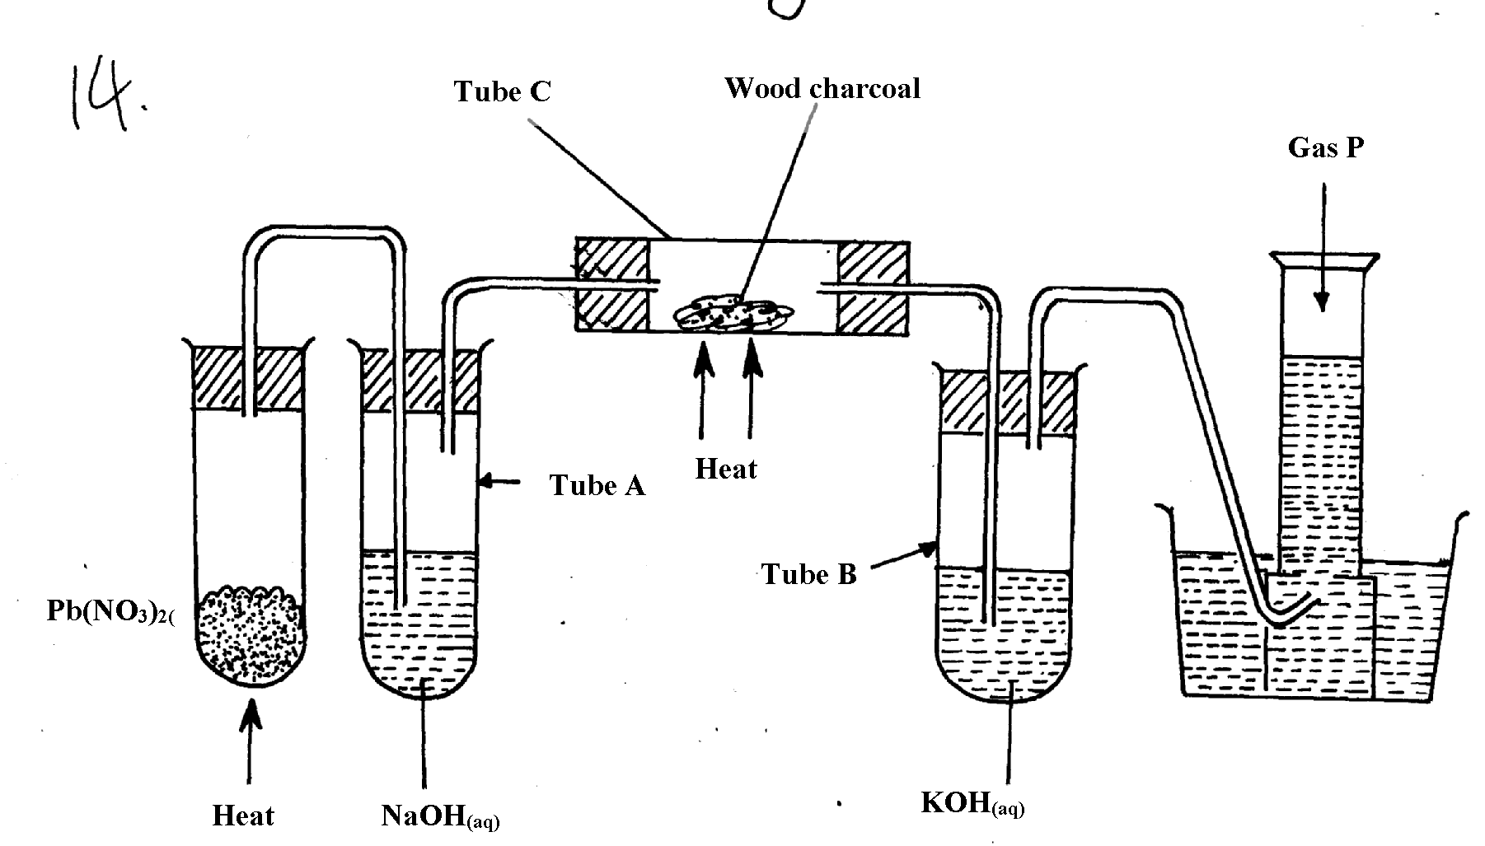

(a) Name the two salts formed in tube A
(b) State the observations made in tube C
(c) Name gas P

5. Study the information in the table below and answer the questions that follow:-

PARTICLE | MASS NUMBER | NUMBER OF PROTONS | NUMBER OF NEUTRONS | NUMBER OF ELECTRONS
E | 37 | 17 | (i) | 18
F | 32 | (ii) | 16 | 16
G | (iii) | 19 | 20 | 18
H | 40 | 20 | (iv) | 18

(a) Complete the table by filling in the blank spaces (i) , (ii) (iii), and (iv)
(b) Identify the particles which are electrically charged
6. Sodium Carbonate Decahydrate crystals were left exposed on a watch glass for two days.
a) State the observations made on the crystals after two days.
b) Name the property of salts investigated in the above experiment

7. Starting with sodium oxide, describe how a sample of crystals of sodium hydrogen carbonate
may be prepared
8. In an experiment, ammonium chloride was heated in test-tube. A moist red litmus paper
placed at the mouth of test first changed blue then red. Explain these observations:-

9. Using dots (•) and cross (x), show the structure of ammonium ion
10. a) Give the name of each of the processes described below which takes place when salts are
exposed to air for sometime
i) Anhydrous copper sulphate becomes wet
ii) Magnesium chloride forms an aqueous solution
iii) Fresh crystals of sodium carbonate, Na₂CO₃.10H₂O become covered with white powder
of formula Na₂CO₃.H₂O
b) Write the formula of the complex ion formed in each of the following reactions described
below;
i) Zinc metal dissolves in hot alkaline solution
ii) Copper hydroxide dissolves excess ammonia solution
11 (a) Write an equation to show the effect of heat on the nitrate of:-
(i) Potassium
(ii) Silver

12. (a) The scheme below shows some reactions starting with magnesium oxide. Study it and
answer the questions that follow:-

Magnesium Oxide
Water

STEP 1
Aqueous Magnesium hydroxide

STEP 2
Aqueous Magnesium hydroxide Carbonate
Boil

STEP3

Products

STEP 4
Aqueous Magnesium Chloride
Magnesium Carbonate

STEP 5

(i) Name the reagents used in steps 2 and 4
(ii) Write an equation for the reaction in step 3
(iii) Describe how a solid sample of anhydrous magnesium carbonate is obtained in step 5
13. In the preparation of magnesium carbonate, magnesium was burnt in air and the product
collected. Dilute sulphuric acid was then added and the mixture filtered and cooled. Sodium carbonate was added to the filtrate and the contents filtered. The residue was then washed and dried to give a white powder.
(a) Give the name of the product
(b) Write the chemical equation for the formation of the product
(c) (i) Name the filtrate collected after sodium carbonate was added.
(ii) Write down the chemical formula of the white powder
(d) Write a chemical equation for the reaction between product in (a) and the acid
(e) Write an ionic equation to show the formation of the white powder.
(f) Write an equation to show what happens when the white powder is strongly heated.
(g) Identify the ions present in the filtrate after addition of sodium carbonate.
(h) What is the name given to the reaction that takes place when sodium carbonate was
added to the filtrate?
(i)Explain the observations made when crystals of sodium carbonate decahydrate are left
exposed to the atmosphere for two days
14. a) Give the name of each of the processes described below which takes place when salts are
exposed to air for sometime
i) Anhydrous copper sulphate becomes wet
ii) Magnesium chloride forms an aqueous solution
iii) Fresh crystals of sodium carbonate, Na₂CO₃.10H₂O become covered with white powder
of formula Na₂CO₃.H₂O
15. You are provided with the following:- solid lead (II) nitrate, magnesium oxide powder,
dilute sulphuric (VI)acid and distilled water. Describe how you can prepare a dry sample
of lead (II) sulphate
16. Use the scheme to answer the questions that follow:
Solid N changes from yellow to white
on standing
H₂SO_{4(aq)}
Solution Q
HCl _{(aq)}
Solution L

(a) Identify solid N ……………………………………………………………….
(b) Write a balanced equation for the formation of Q
(c) Write the formula of the complex ion formed when sodium hydroxide is added to
solution L in excess

17. When exposed to air, crystals of hydrated sodium carbonate loses water of crystallizations;-
(i) Name this process
(ii) Write the formula of hydrated sodium carbonate

18. A student poured sodium iodide solution into a small portion of solution Q, a yellow
precipitate was formed.
(i) Which ion was most likely in solution Q?
(ii) Write an ionic equation leading to the formation of the yellow precipitate
 1
19. Calcium oxide can be used as a solid drying agent for some laboratory gases. Explain

20. A piece of marble chips was strongly heated in air for about 30 minutes. Some drops of water
were added drop by drop to the product when it was still warm.
Using equation, explain:
(i) What happens when the piece of marble chips is heated?
(ii) The reaction that takes place when water is added to the final warm product.
21. Study the flow chart below and answer the questions that follow
SOLID A
Heat
Brown gas B
Solid K
Colourless gas C
Dilute HNO_{3(aq)}
Colourless solution M
Yellow when hot
White when cold

a) Identify ;
i) gases C and B
ii) Ions likely to be presented in solid A
22. Potassium nitrate crystals in a test-tube were heated strongly for some time. State the
observation made:
(a) When a glowing splint is introduced into the test-tube during the heating
(b) At the end of the heating
23. Name the process which takes place when:
(a) Anhydrous iron (III) chloride absorb water vapour from the air to form solution
(b) Zinc chloride vapour changes directly to zinc chloride solid
24. (a) Starting form solid magnesium oxide, describe how a solid sample of magnesium
hydroxide can be prepared
(b) Give one use of magnesium hydroxide

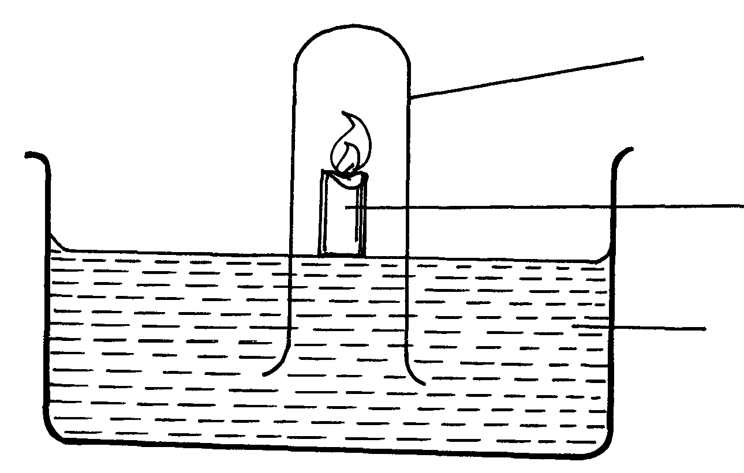
25. The diagram below represents a set-up that was used to show that part of air s used during burning
Gas jar
Burning candle
Sodium hydroxide

(a) State two sources of errors in this experiment

26. In an experiment the following solids were provided to form three students; Ca(NO₃)_{2(s),}
NaH₂PO_{4(s)}; Mg(OH)Cl_{(s)} and Fe(NH₄)₂(SO₄)₂. 6H₂O. They were then told to dissolve the
given solids in differently in 20ml of water.
(a) Classify the given salts accordingly
(b) (i) Explain the process which takes place when FeCl₃ is dissolved in water
(ii) A student placed a moist litmus paper on the product in (i) above. State and explain the
observation made

Effect of an electric current on substances
1. The set-up was used to electrolyse Lead (II) bromide. Study it and answer the questions
that follow;

Cathode
Anode
Molten Lead (II) briomide
Bulb
Carbon electrode

(a) Write an ionic equation for the reaction that occurred at the cathode
(b) State and explain what happened at the anode

2. When an electric current was passed through two molten substances E and F in separate
voltammeters. The observations recorded below were made:-
Substance | Observation | Type of structure
E | Conducts electric current and a gas is formed at one of the electrodes
F | Conducts an electric current and is not decomposed
Complete the table above
3. (a) Differentiate the following terms :-
Electrolyte and non-electrolyte
(b) The diagram below is a set-up used to investigate the conductivity of electric current
by some aqueous solution. Study it and answer the questions that follow;
Bulb
Graphite rods
Substance to be tested
Beaker

(i) State the observation made on the bulb when each of the following solution were put
onto the beaker
(a) Sugar solution
(b) (i) Salt solution
(ii) Classify the substance in (i) above as either electrolyte or non-electrolyte
(b) If in the above set-up of apparatus, the substance to be tested is Lead II Bromide,
what modification should be included in the set-up?
(c) Write an Ionic equation at the electrodes and state the observation:-
Anode

4. (a) The diagram below shows the set up used to investigate the effect of an electric current
on molten lead (II) bromide

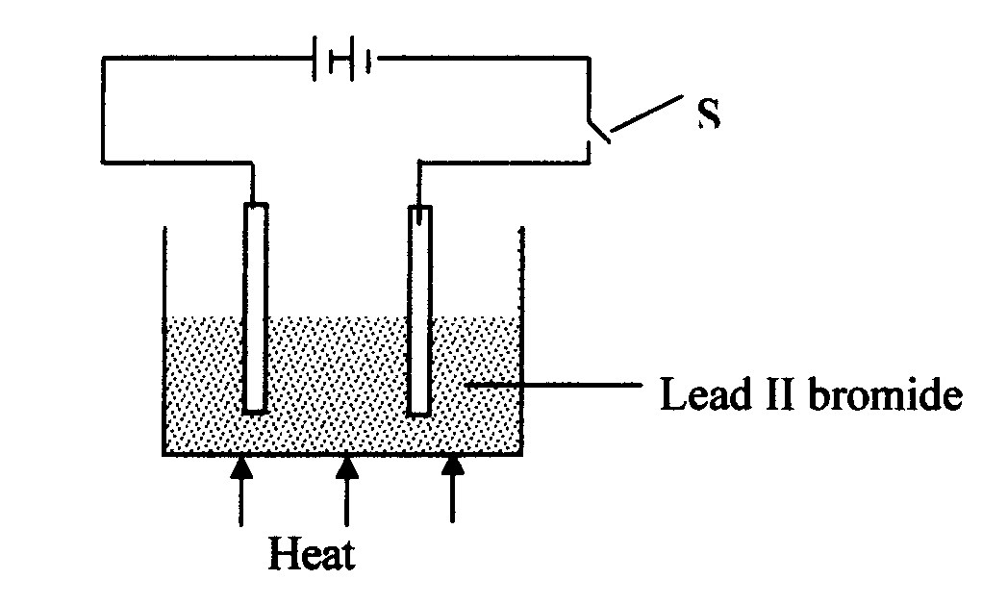

i. Explain what happens to the lead II bromide during electrolysis
ii. Why is it important to carry out the experiment in a fume chamber?
5. (I) Define the following terms:
(a) Crystallization
(b) (i) Salting out as used in soap making
(ii) Starting with barium carbonate solid, dilute sulphuric acid and dilute nitric acid,
describe how you would prepare dry barium sulphate solid

(iii) Study the scheme below and answer the questions which follow:
Colourless gas which relights glowing splint
Heat
T
Solid S
Water
Burn on nichrome wire
Lilac flame
Colourless solution

(a) Identify ;
(i) The cation present in solid S
(ii) The anion in solid S
(b) Write an equation to show how solid S is heated in process T
(iv) Copper II chloride solution dissolves in excess ammonia solution to form a deep blue
solution. Give the ion responsible for the deep blue solution
(v) A solution of hydrogen chloride is an electrolyte but a solution of hydrogen chloride in
methylbenzene in a non-electrolyte. Explain
6. (i) State Faraday’s first law of electrolysis
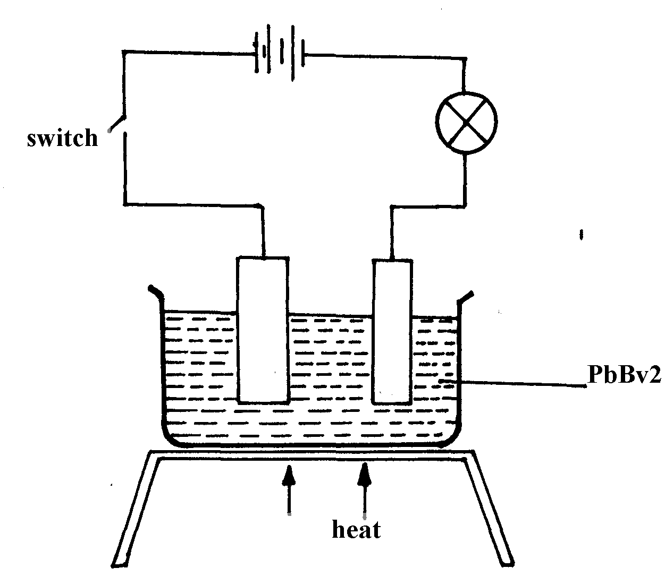
(ii) The diagram below shows a set-up used for the electrolysis of molten Lead bromide:-
Switch

PbBV₂

Heat

State the observations that would be made at the anode and cathode as the electrolysis progressed
7. (a) (i) Describe how you would prepare pure crystals of lead II nitrate in the laboratory from
lead II oxide
(ii) Write an equation for the reaction that takes place in (a)(i) above
(b) (i) State what happens when lead II nitrate is strongly heated
(ii) Write an equation for the reaction in b(i) above
(c) (i) State what is observed when ammonia solution is gradually added to a solution of
lead II nitrate until the alkali is in excess
(ii) Write an ionic equation for the reaction that takes place in (i) above
8. The diagram show an experiment for investigating electrical conduction in lead (II) fluoride. Study it and answer the questions that follow:
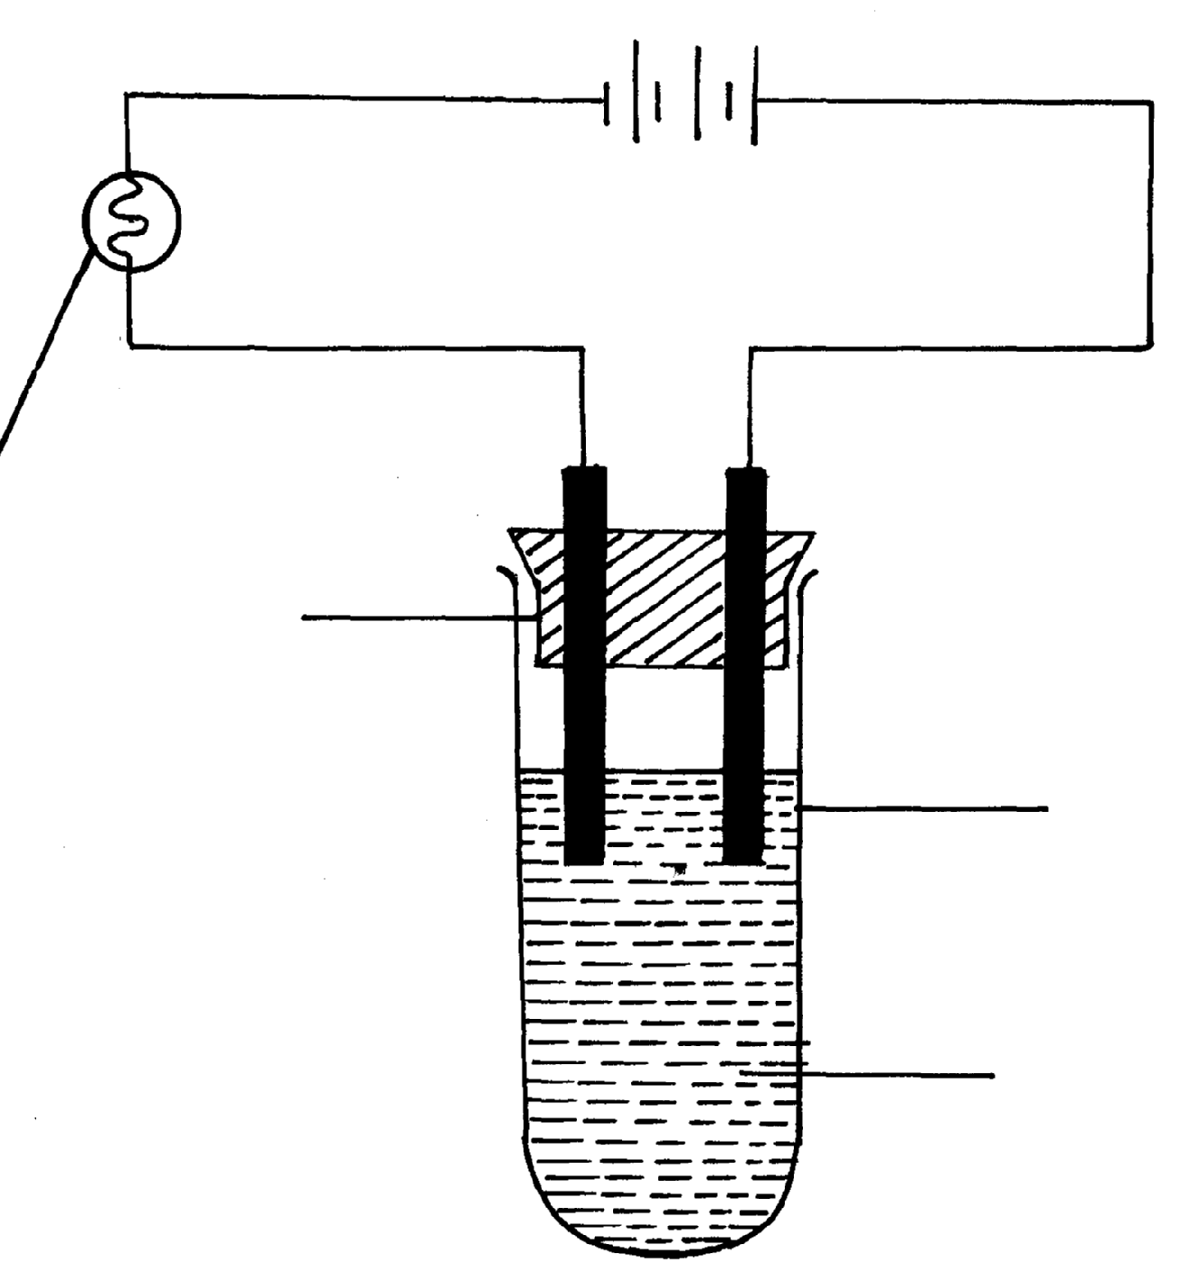
Bulb
Boiling tube
Gas
Flow of electrons

Lead (II) fluoride
(a) On the diagram
(i) Label the anode and the cathode
(ii) Show the direction of movement of electrons
(iii) Complete the diagram by indicating the condition that is missing but must be present for
electrical conduction to take place.
(b) Why is it necessary to leave a gap between the cork and the boiling tube?
(c) State the observations that are expected at the electrodes during electrical conduction and
at the experiment
(d) Write equations for the reactions that take place at the electrodes
(e) Why should this experiment be carried out in a fume chamber?
II. The table below shows the electrical conductivity of substance A, B and C
Substance | Solid state | Molten state | Aqueous solution
A | Conducts | Conducts | Not soluble
B | Doesn’t conduct | Conducts | Conducts
C | Doesn’t conduct | Doesn’t conduct | Not soluble

(a) Which one of the substance is likely to be plastic?
(b) Explain why the substance you have given in (a) above behaves in the way it does
(c) Which of the substances is likely to be sodium chloride? Explain
(d) Give the type of structure and bonding that is present in substance A

9. Study the diagram below and use it to answer the questions that follow:-
Lead (II) bromide
A
B
Heat

(a) Identify electrodes A and B
(b) Name the product formed at the anode
(c) Write the electrode half equation of reaction at electrode A
10. Explain the differences in electrical conductivity between melted sodium chloride and
liquid mercury

11. Below is part of a flow diagram for the contact process:
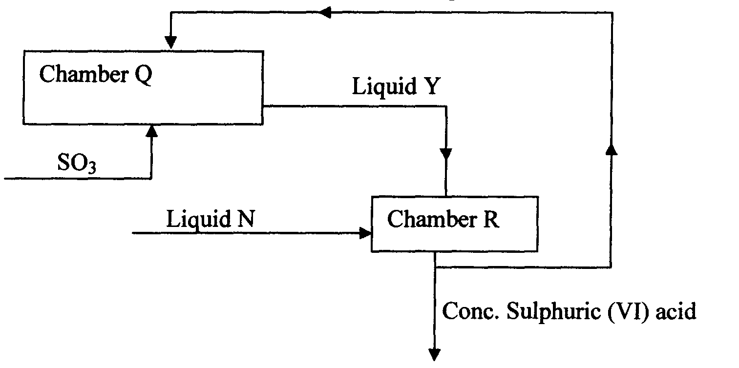

(a) Name :
I. Liquid Y ……………………………………………………….
II. Liquid N………………………………………………………….
(b) Write the equation for the reaction taking place in;
I. Chamber Q
II. Chamber R

12. In an experiment to investigate the conductivity of substances, a student used the set-up shown
below.
The student noted that the bulb did not light.
a) What had been omitted in the set up.
b) Explain why the bulb lights when the omission is corrected.
Carbon and its compounds
1. (a) State one use of graphite
(b) Both graphite and diamond are allotropes of element Carbon. Graphite conducts electricity
whereas diamond does not. Explain

2. Below is a simplified scheme of solvay process. Study it and answer the questions that follow:
Brine
PROCESS
I
PROCESS
II
PROCESS
III
Ammonia
solution
Gas R
Sodium
Carbonate

a) Identify gas R.
b) Write an equation for the process III.
c) Give one use of sodium carbonate.

3. A burning magnesium continues to burn inside a gas jar full of carbon (IV) oxide. Explain.
4. The diagram below shows a jiko when in use

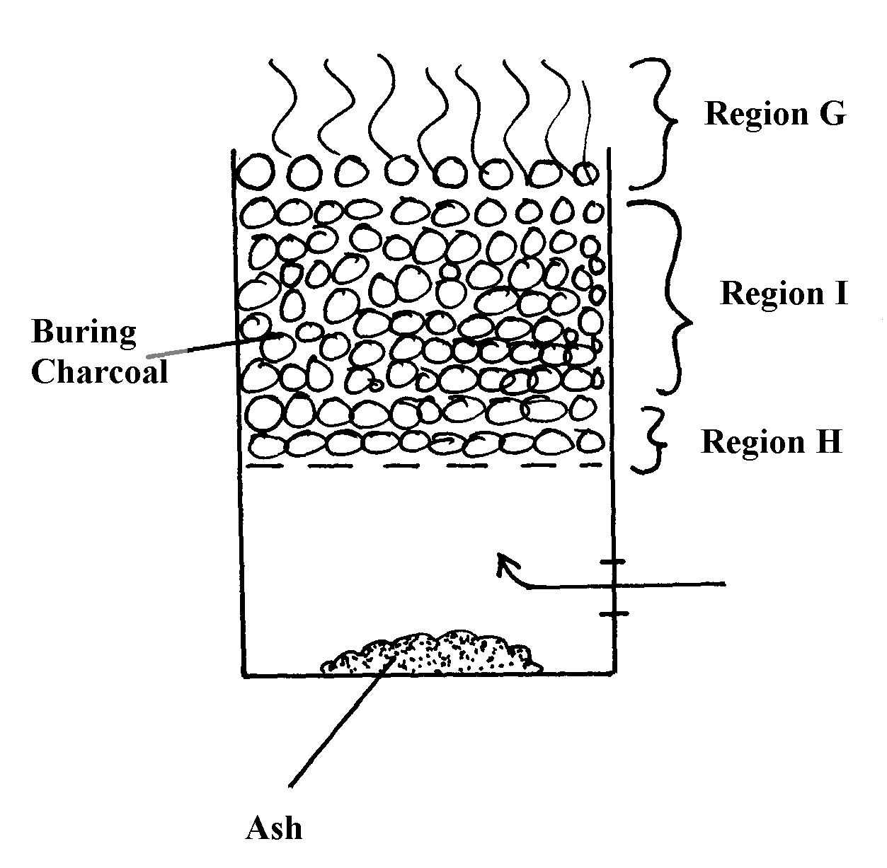

(a) Identify the gas formed at region H
(b) State and explain the observation made at region G
5. Study the diagram below and use it to answer the questions that follow.

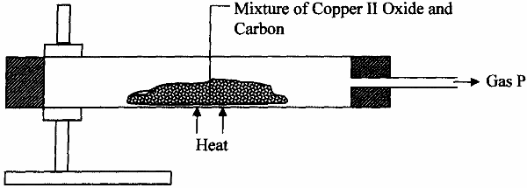

(a) State the observation made in the combustion tube.
(b) Write an equation for the reaction that took place in the combustion tube
(c) Give one use of P
6. (a) Identify two substance that are reacted to regenerate ammonia gas in the solvary process
(b) Write down a balanced chemical equation for the reaction above
7. When the oxide of element H was heated with powdered Carbon, the mixture glowed and
Carbon (IV) oxide was formed. When the experiment was repeated using the oxide of element J,
there was no apparent reaction
(a) Suggest one method that can be used to extract element J from its oxide
(b) Arrange the elements H, J and Carbon in order of their decreasing reactivity
8. (i) Diamond and silicon (IV) Oxide have a certain similarity in terms of structure and bonding.
State it
(ii) State one use of diamond
9. (a) What is allotropy?
(b) Diamond and graphite are allotropes of Carbon. In terms of structure and bonding
explain why graphite conducts electricity but not diamond
10. The diagram below shows a charcoal stove with different regions

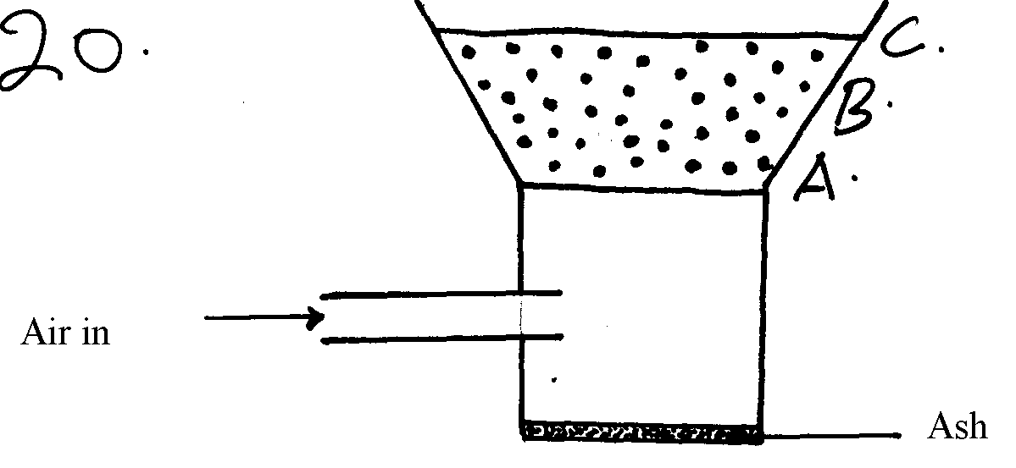

(a) Write an equation for the formation of the product in region B
(b) How would one avoid the production of the product at B? Give a reason for your answer

- Study the diagram below and answer the questions that follow:

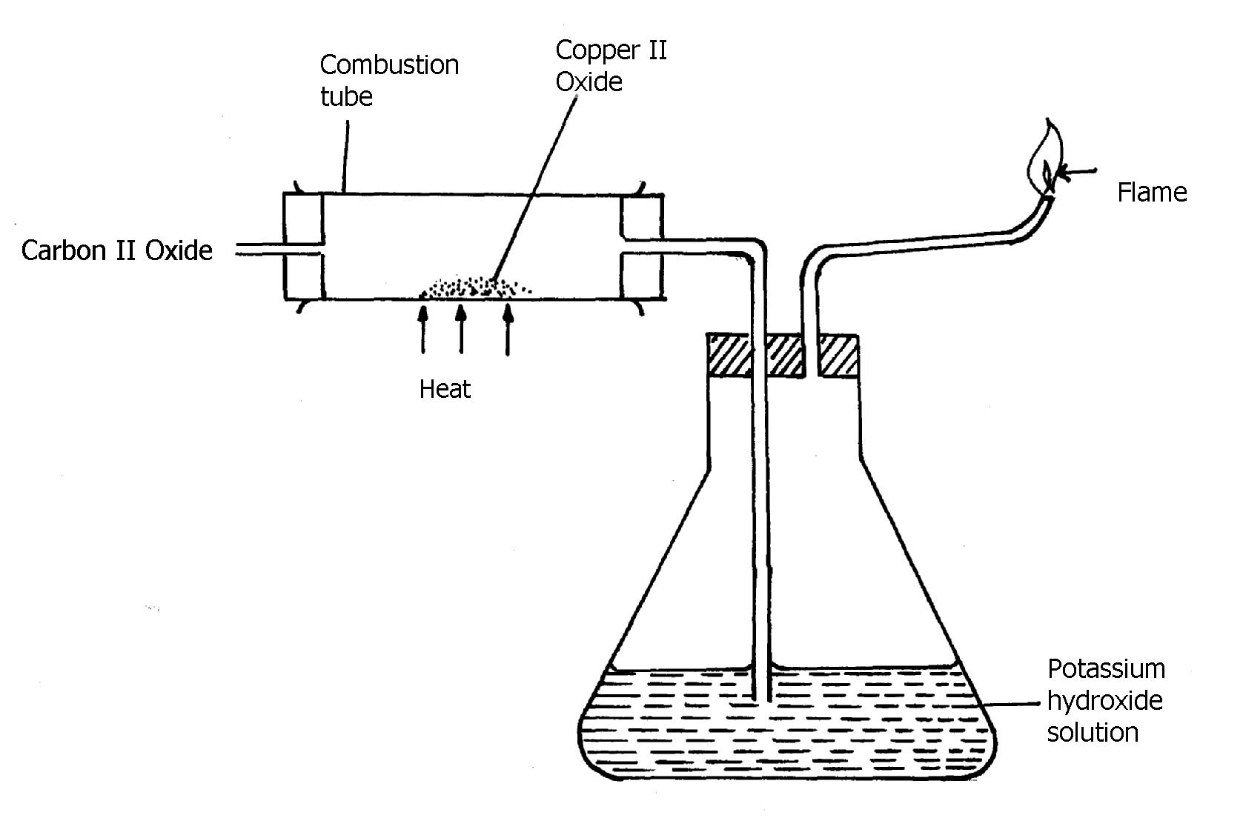

(a) Explain the observation made in the combustion tube during the experiment
(b) Write an equation for the reaction that takes place in the combustion tube
12. Diamond and graphite are allotropes of carbon:-
(a) What is meant by allotropes?
(b) How do they differ in their structure and bonding
13. Study the experimental set-up below:
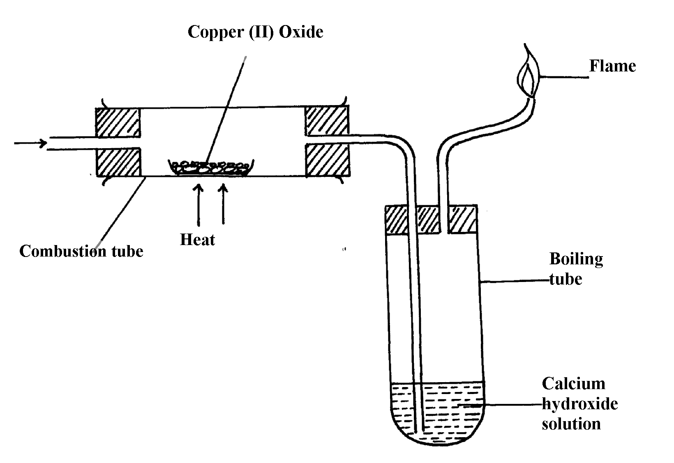
Carbon (II) Oxide

a) State two observations made in the set up as the experiment progressed
b) By use of a chemical equation, explain the changes that occurred in the boiling tube
c) Why was it necessary to burn the excess gas?
14. The diagram below shows the heating curve of a pure substance. Study it and answer the
questions that follow:

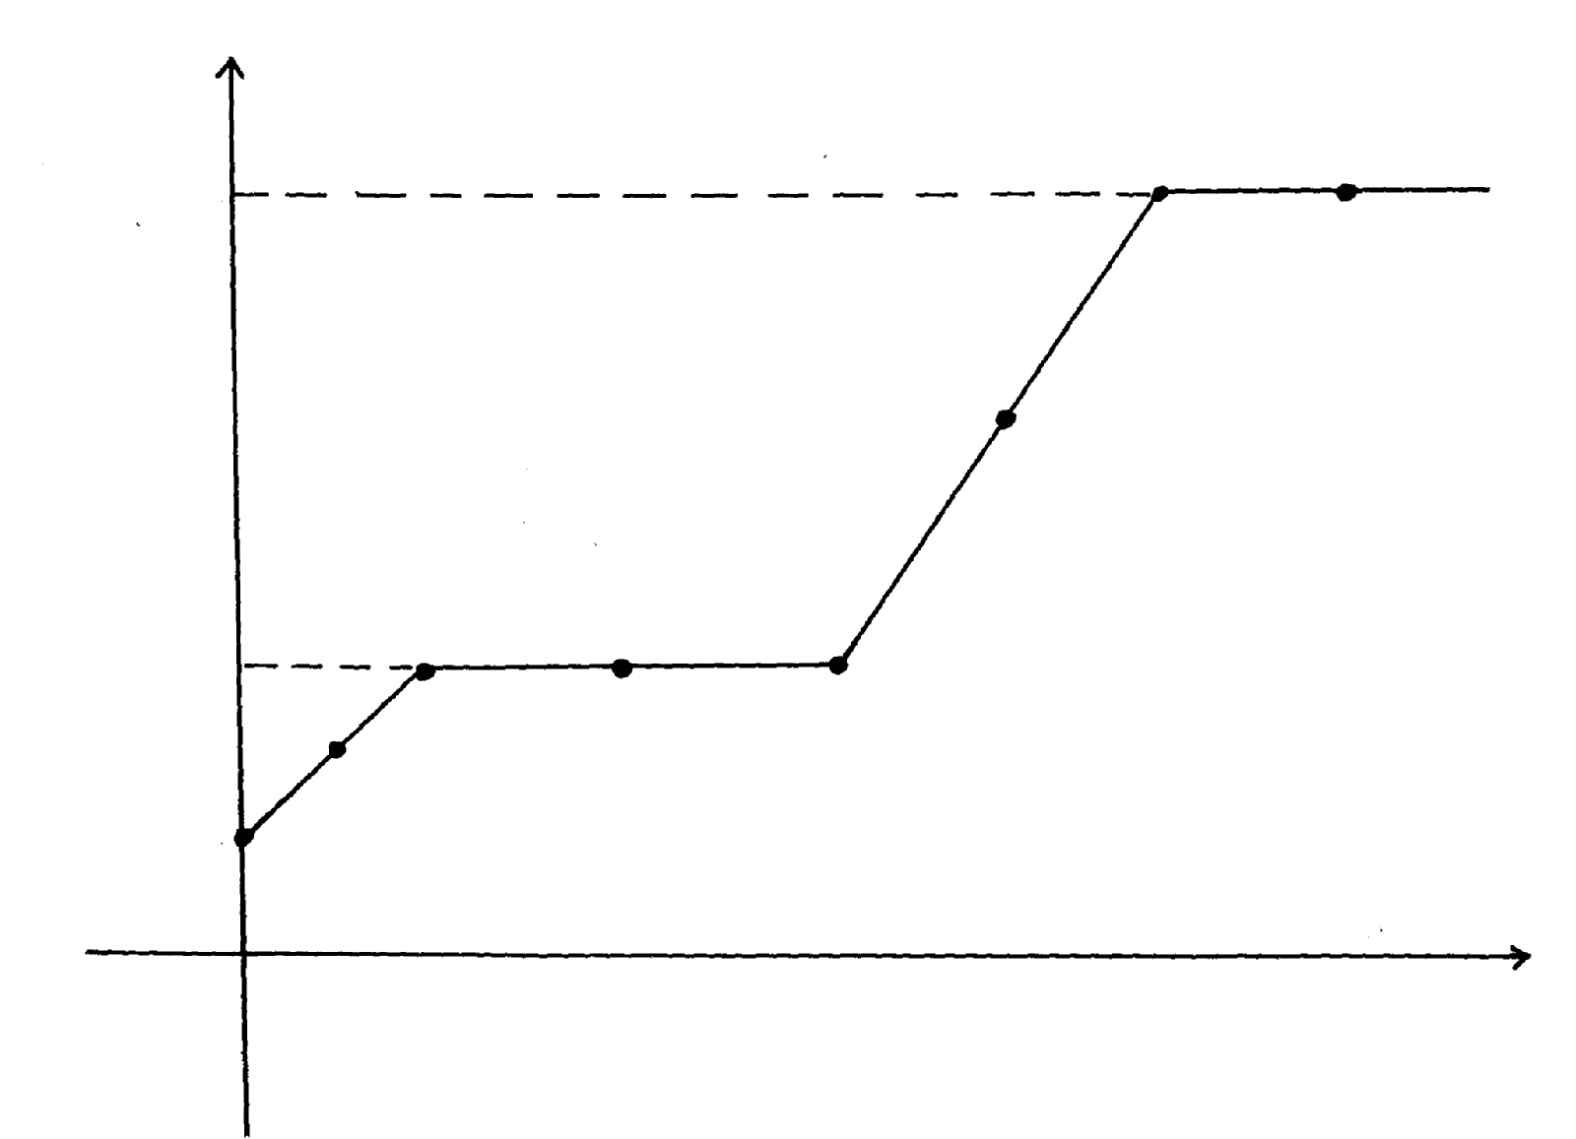
Time
A
Y
444
D
W
K
C
B
H
115
Temperature

(a) What physical changes are taking place at H and W?
(b) What are the physical states of the substance at Y and K?
(c) Using the simple kinetic theory of matter, explain what happens to the substance between

points A and C
(d) The substance under test is definitely not water; Give a reason for this
(e) What would happen to the melting point of this substance if it were contaminated
with sodium chloride?
(f) What happens to the temperature between points B and C?
15. Study the set-up below and answer the questions that follow:
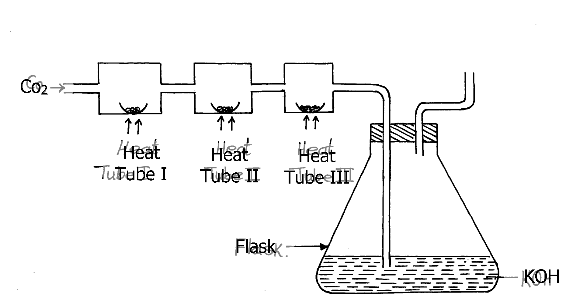

(a) (i) Name Gas X ………………………………………………………………
(ii) State the effect of releasing gas X to the environment
(b) Write down equations for the reactions taking place in;
(i) Tube I
(ii) Tube II
(iii) Flask
(c) State the observation made in tube III
(d) Write down an equation for the reaction which could be used to generate Carbon
(IV) Oxide for the above set up
(e) Name the reagents used to generate gas x in the laboratory
(f) Complete the diagram above to show how excess gas x can be collected

16. The figure below shows the stages in the manufacture of sodium carbonate. Study the diagram
below and use it to answer the questions that follow.

HEATING LIMESTONE
REACTION CHAMBER 2
REACTION CHAMBER 1
REACTION CHAMBER 3
Calcium chloride
Sodium carbonate
Solid V
Filtration
Liquid U
Carbon
(IV) Oxide
Ammonia
Brine

a) (i) Name three starting materials in the manufacturer of sodium carbonate.
(ii) Which substances are recycled in this process?
(iii) Identify the chambers in which the recycled substances are regenerated.
(iv) Name the substances U and V.
b) Give an equation for the reaction which occurs:
(i) In the reaction chamber 1
(ii) When solid V is heated.
(iii) In the reaction chamber 3.
c) State one commercial use for
(i) Sodium carbonate.
17. The set-up below was used to prepare dry carbon (II) Oxide gas. use it to answer the questions
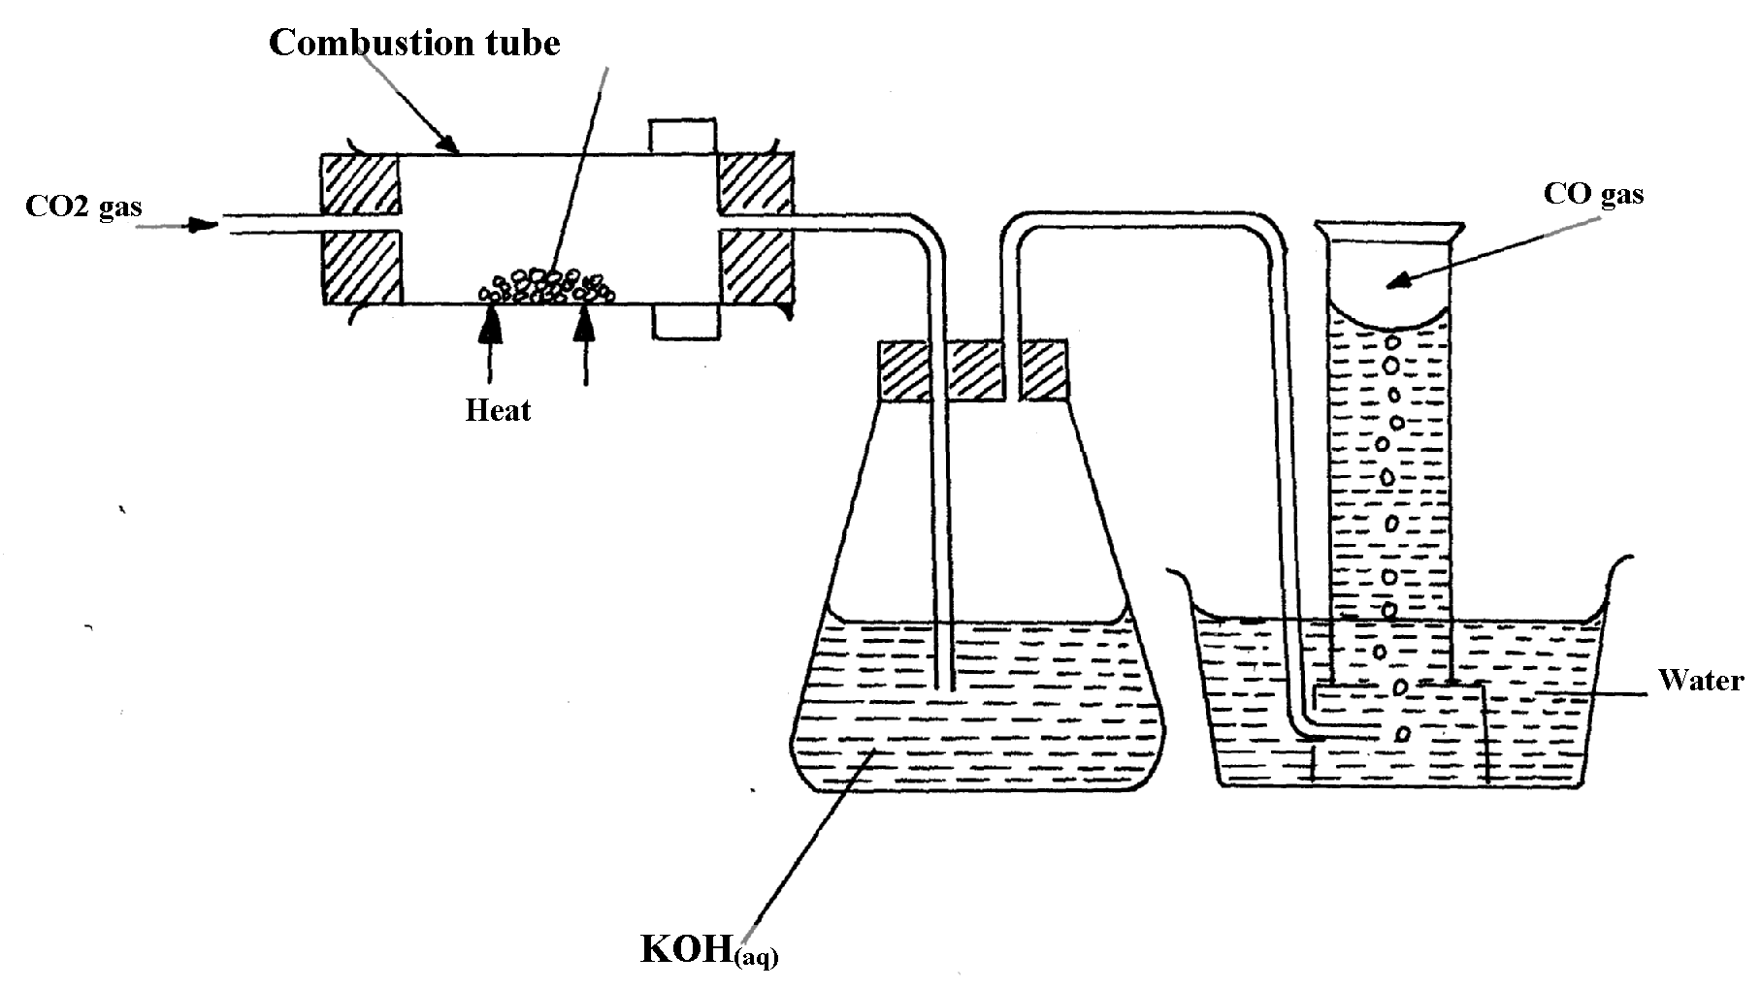
below it:
charcoal

(a) (i) State two mistakes committed in the set-up arrangement above

(ii) The student produced carbon (IV) oxide gas from the reaction between Lead (II) Carbonate
and dilute hydrochloric acid. The gas was produced for a short time and the reaction came
to a stop. Explain
(iii) Write the equation for the reactions taking place in the combustion tube and the conical
flask:
Combustion tube:…………………………………………………………………..
Conical flask ……………………………………………………………………..
(iv) State one use of carbon (IV) Oxide gas apart from fire extinguisher
(v) Give two properties that make carbon (IV) Oxide to be used as fire extinguisher
(b) PbO_{(s)} + CO_{(g)} Pb_{(s)} + CO_{2(g)}
Which property of carbon (II) Oxide is demonstrated by the above equation?
(c) Aluminium carbonate does not exist. Give a reason
(d) Ammonium carbonate decomposes when heated. Write a chemical equation to
represent this decomposition
18. State and explain the observation made when a piece of charcoal is dropped in a jar containing
concentrated nitric (V) acid

19. When Carbon (IV) oxide is passed through lime water, a white precipitate is formed but
when excess Carbon (IV) Oxide is passed, the white precipitate disappears;
(a) Explain why the white precipitate disappears
(b) Give an equation for the reaction that takes place in (a) above
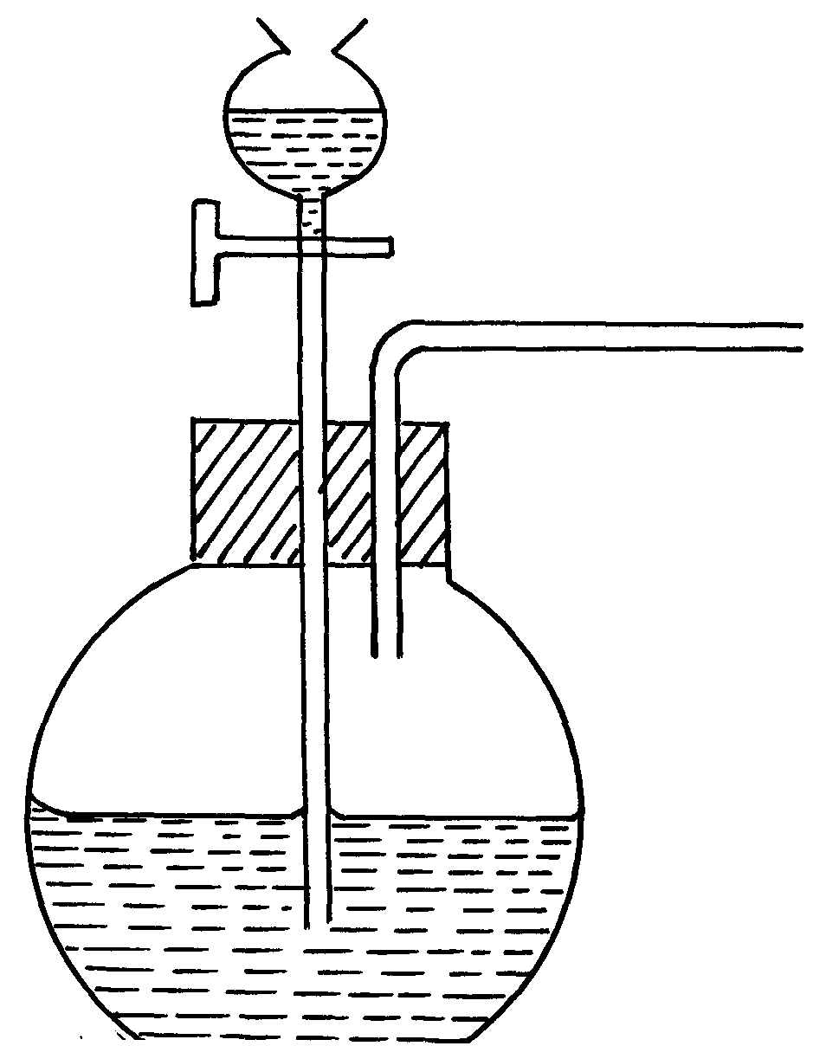
20. The set-up below was used to prepare a carbon (II) oxide gas.
A
Sodium methanoate solid

(a) Give the name of substance A ………………………………………………………….
(b) Complete the diagram to show how the gas can be collected
(c)Write the equation for the reaction

Gas laws
1. A sample of unknown compound gas X is shown by analysis to contain Sulphur and Oxygen. The
gas requires 28.3 seconds to diffuse through a small aperture into a vacuum. An identical number
of oxygen molecules pass through the same aperture in 20seconds. Determine the molecular mass
of gas X (O= 16, S= 32)

2. (a) State Graham’s Law of diffusion
(b) Gas V takes 10 seconds to diffuse through a distance of one fifth of a meter. Another
gas W takes the same time to diffuse through a distance of 10 cm. if the relative molecular
mass of gas V is 16.0; calculate the molecular mass of W
3. (a) State Charles’ Law
(b) The volume of a sample of nitrogen gas at a temperature of 291K and 1.0 x 10⁵ Pascals
was 3.5 x 10⁻²m³. Calculate the temperature at which the volume of the gas would be
2.8 x 10⁻²m³ at 1.0 x 10⁵pascals.

4. 60 cm³ of oxygen gas diffused through a porous partition in 50 seconds. How long would it take
60 cm³ of sulphur (IV) oxide gas to diffuse through the same partition under the sane conditions?
(S = 32.0, O = 16.0)
5. (a) State Graham’s law of diffusion
(b) 30cm³ of hydrogen chloride gas diffuses through a porous pot in 20seconds. How long
would it take 42cm³ of sulphur(IV) oxide gas to diffuse through the same pot under
the same conditions (H =1 Cl = 35.5 S = 32 O =16)
6. a) State Boyles law
b) Sketch a graph that represents Charles’ law
c) A gas occupied a volume of 250cm³ at -23ºC and 1 atmosphere. Determine its volume
at 127ºC when pressure is kept constant.
7. A factory produces Calcium Oxide from Calcium Carbonate as shown in the equation below:-
Heat
CaCO_{3 (s)} CaO _{(s)} + CO_{2 (g)}
(a) What volume of Carbon (IV) Oxide would be produced from 1000kg of Calcium
Carbonate at s.t.p (Ca = 40, C = 12, O = 16, Molar gas volume at s.t.p = 22.4dm³)
8. A fixed mass of gas occupies 200cm³ at a temperature of 23ºC and pressure of 740mmHg.
Calculate the volume of the gas at -25ºC and 780mmHg pressure
9. Gas K diffuses through a porous material at a rate of 12cm³ s⁻¹ where as S diffuses through
the same material at a rate of 7.5cm³s⁻¹. Given that the molar mass of K is 16, calculate the
molar mass of S
10. (a) State Gay Lussac’s law
. 11. (a) What is the relationship between the rate of diffusion of a gas and its molecular mass?
(b) A sample of Carbon (IV) Oxide takes 200 seconds to diffuse across a porous plug.
How long will it take the same amount of Carbon (II) Oxide to diffuse through the
same plug?(C=12, O=16)
12. Below are structures of particles. Use it to answer questions that follow. In each case only
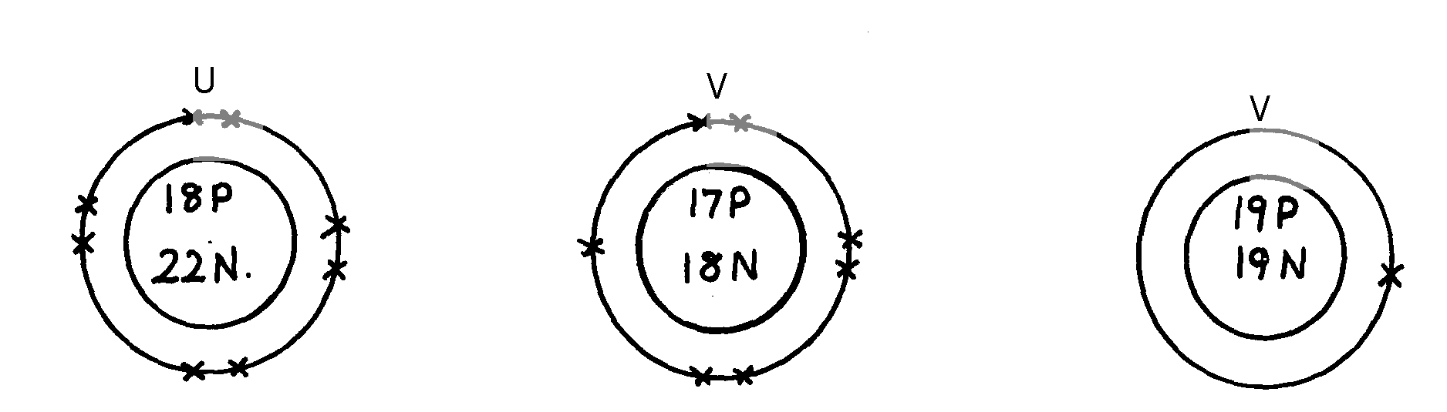
electrons in the outermost energy level are shown
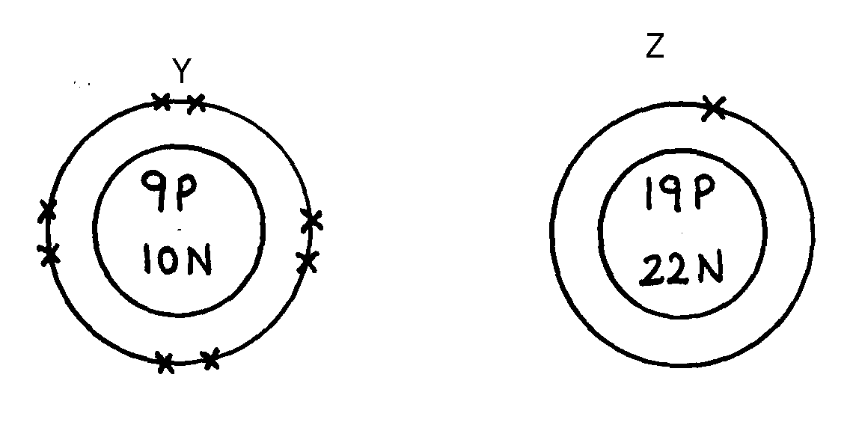
key
W
U
V
19P
20N
Z
Y
P = Proton
N = Neutron
X = Electron

(a) Identify the particle which is an anion
(b) Choose a pair of isotopes. Give a reason
13. The figure below shows two gases P and Q diffusing from two opposite ends 18 seconds after
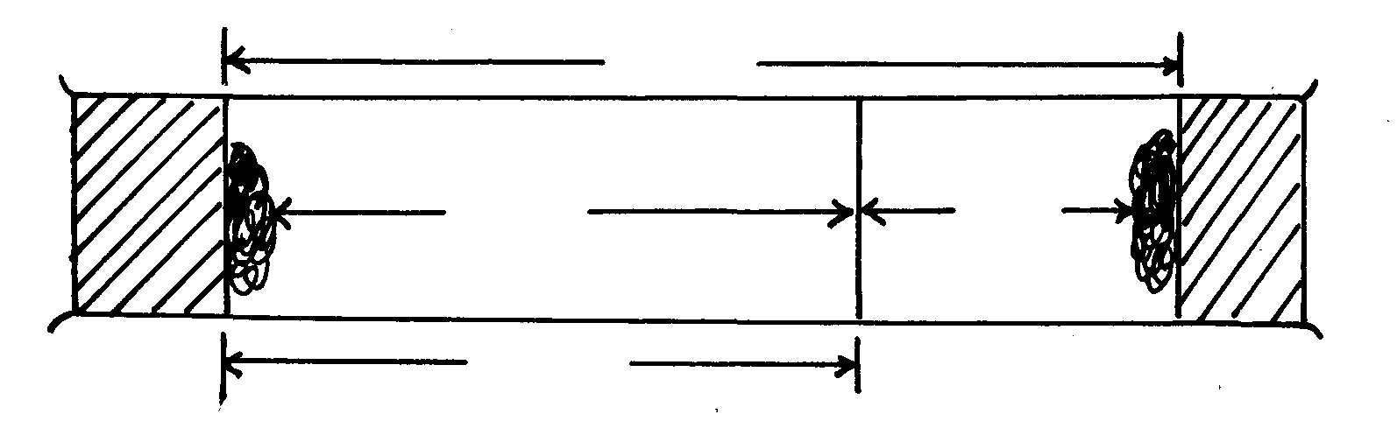
the experiment
72cm
P
Q
54cm

(a) Which of the gases has a lighter density?
(b) Given that the molecular mass of gas Q is 17, calculate the molecular mass of P

14. Identify the particles that facilitate the electric conductivity of the following substances
(i) Sodium metal
(ii) Sodium Chloride solution
(iii) Molten Lead Bromide
15. Gas B takes 110 seconds to diffuse through a porous pot, how long will it take for the
same amount of ammonia to diffuse under the same conditions of temperature and pressure?
(RMM of B = 34 RMM of ammonia = 17)
16. A gas occupies 5dm³ at a temperature of -27ºC and 1 atmosphere pressure. Calculate the
volume occupied by the gas at a pressure of 2 atmospheres and a temperature of 127ºC
17. A fixed mass of gas occupies 200 cm³ at a temperature of 23⁰c and a pressure of 740 mm Hg.
Calculate the volume of the gas at -25⁰c and 790 mm Hg pressure.

18. (a) State the Graham’s law
(b) 100cm³ of Carbon (IV) oxide gas diffused through a porous partition in 30seconds.
How long would it take 150cm³ of Nitrogen (IV) oxide to diffuse through the same
partition under the same conditions? (C = 12.0, N = 14.0, O = 16.0)

The mole
1. In an experiment magnesium ribbon was heated in air. The product formed was found to be
heavier than the original ribbon. Potassium manganate (VII) was on the other hand, heated in
air and product formed was found to be lighter. Explain the differences on the observation made
2. In a filtration experiment 25cm³ of a solution of Sodium Hydroxide containing 8g per
litre was required for complete neutralization of 0.245g of a dibasic acid. Calculate
the relative molecular mass of the acid (Na = 23.0, O = 16, H= 1)
3. D grams of Potassium hydroxide were dissolved is distilled water to make 100cm³ of solution.
50cm³ of the solution required 50cm³ of 2.0M nitric acid for complete neutralization.
Calculate the mass D of Potassium hydroxide (RFM of KOH = 56)
KOH_{(aq)} + HNO_{3(aq)} KNO_{3(aq)} + H₂O_{(l)}
4. When excess dilute hydrochloric acid was added to sodium sulphite, 960cm³ of sulphuric
(IV) Oxide gas was produced. Calculate the mass of sodium sulphate that was used.
(Molar gas volume = 24000cm³ and Molar mass of sulphite = 126g)
5. The equation of the formation of iron (III) chloride is
2Fe_{(s)} + 3Cl_{2(g)} 2FeCl₃
Calculate the volume of chlorine which will react with iron to form 0.5g of Iron (III) chloride.
(Fe = 56 Cl=35.5). Molar gas volume at 298K = 24dm³)
6. 15.0cm³ of ethanoic acid (CH₃COOH) was dissolved in water to make 500cm³ of solution.
Calculate the concentration of the solution in moles per litre
[C=12, H = 1, O = 16, density of ethanoic acid is 1.05g/cm³]
7. When 1.675g of hydrated sodium carbonate was reacted with excess hydrochloric acid,
the volume carbon (IV) oxide gas obtained at room temperature and pressure was 150cm³.
Calculate the number of moles of water of crystallization in one mole of hydrated sodium
carbonate:- (Na=23, H =1, C=12, O=16, MGV at R.T.P = 24000cm³)
8. How many chloride ions are present in 1.7g of magnesium chloride crystals?
(Avogadro’s constant = 6.0 x 10²³, Mg = 24, Cl = 35.5)

9. 0.84g of aluminium reacted completely with chlorine gas. Calculate the volume of chlorine
gas used (Molar gas volume is 24dm³, Al = 27)
10. 6.4g of a mixture of sodium carbonate and sodium chloride was dissolved in water to make
50cm³ solution. 25cm³ of the solution was neutralized by 40cm³ of 0.1M HCl_{(aq).} What is
he percentage of sodium chloride in the solid mixture?
11 An unknown mass, x, of anhydrous potassium carbonate was dissolved in water and the solution made up to 200cm³. 25cm³ of this solution required 18cm³ of 0.22M nitric (V) acid for complete neutralization. Determine the value of x. (K=39.0, C =12.0, O =16.0)

12. Calculate the volume of oxygen gas used during the burning of magnesium (O = 16, molar
gas volume = 24,000cm³ at room temperature)

13. A hydrated salt has the following composition by mass. Iron 20.2 %, oxygen 23.0%,
sulphur 11.5%, water 45.3%
i) Determine the formula of the hydrated salt (Fe=56, S=32, O=16, H=11)
ii) 6.95g of the hydrated salt in c(i) above were dissolved in distilled water and the total

volume made to 250cm³ of solution. Calculate the concentration of the resulting salt solution
in moles per litre. (Given that the molecula mass of the salt is 278)

14. (i) Lead (II) ions react with iodide ions according to the equation;
Pb²⁺_{(aq)} + 2I⁻_{(aq)} PbI_{2(s)}
300cm³ of a 0.1m solution of iodide ions was added to a solution containing excess lead II ions.
Calculate the mass in grams of lead II iodide formed
(ii) Identify the colour of the product formed in (d) (i)

15. a) The diagram below represents part of the structure of sodium chloride crystal

The position of one of the sodium ions in the crystal is shown as;
i) On the diagram, mark the positions of the other three sodium ions
ii) The melting and boiling points of sodium chloride are 801C and 1413C respectively. Explain
why sodium chloride does not conduct electricity at 25C, but does not at temperatures
between 801C and 1413C
b) Give a reason why ammonia gas is highly soluble in water
c) The structure of ammonium ion is shown below;
H
N
H
H
H
+

Name the type of bond represented in the diagram by N H
d) Carbon exists in different crystalline forms. Some of these forms were recently discovered
in soot and are called fullerenes
i) What name is given to different crystalline forms of the same element
ii) Fullerenes dissolve in methylbenzene while the other forms of carbon do not. Given that soot is
a mixture of fullerenes and other solid forms of carbon, describe how crystals of fullerenes can
be obtained from soot
iii) The relative molecular mass of one of the fullerenes is 720. What is the molecular mass of
this fullerene
16. Calculate the volume of oxygen gas used during the burning of magnesium (O = 16, molar
gas volume = 24,000cm³ at room temperature)
17. Study the information in the table below and answer the questions that follow
Number of carbon atoms per molecule | Relative molecular mass of the hydrocarbon
2  3  4 | 28  42  56
i) Write the general formula of the hydrocarbons in the table
ii) Predict the relative atomic mass of the hydrocarbons with 5 carbon atoms
iii) Determine the relative atomic mass of the hydrocarbon in (ii) above and draw its
structural formula (H=1.0, C=12.0)
18. A hydrated salt has the following composition by mass. Iron 20.2 %, oxygen 23.0%,
sulphur 11.5%, water 45.3%
i) Determine the formula of the hydrated salt (Fe=56, S=32, O=16, H=11) (3 mks)
ii) 6.95g of the hydrated salt in c(i) above were dissolved in distilled water and the total
volume made to 250cm³ of solution. Calculate the concentration of the resulting salt solution
in moles per litre. (Given that the molecula mass of the salt is 278)
19. a) Galvanized iron sheets are made by dipping the sheets in molten Zinc.
i) Explain how zinc protects iron from rusting
ii) Name the process applied in galvanization of iron with zinc
20. Calculate the percentage of copper in 1.0g of the alloy
(Cu = 63.5 Mg = 24)
21. A factory uses nitric acid and ammonia gas as the only reactant for the preparation of the
fertilizer if the daily production of the fertilizer is 4800kg. Calculate the mass of ammonia
gas used daily
(N = 14.0, O= 16.0, H = 1.0)
22. Calculate the volume of sulphur (VI) oxide gas that would be required to produce 178kg of
oleum in step 3 molar gas volume at s.t.p = 22.4 litres H = 1 O = 16 S = 32

23. Using the answer in d (ii) above, determine:
i) The volume of 1M nitric acid that would react completely with one mole of copper
(Cu = 63.5)
ii) The volume of Nitrogen (IV) oxide gas produced when one mole of copper reacts
with excess 1M nitric acid at room temperature
24. A sample of biogas contains 35.2% by mass of methane. A biogas cylinder contains 5.0kg
of the gas. Calculate:
(i) Number of moles of methane in the cylinder (Molar mass of methane = 16)
(ii) Total volume of carbon (IV) oxide produced by the combustion of methane in the cylinder
(Molar gas volume = 24.0dm³ at room temperature and pressure)
25. 0.84g of aluminium were reacted completely with chlorine gas. Calculate the volume
of chlorine gas used. (Molar gas volume is 24dm³, Al = 27)
26. 3.52g of Carbon (IV) Oxide and 1.40g of water are produced when a mass of a hydrocarbon
is completely burnt in oxygen. Determine the empirical formula of the hydrocarbon;
(H = 1 , C= 12, O = 16)

27. Calculate the number of water molecules when 34.8g Na₂CO₃ xH₂O is heated and 15.9g of
anhydrous Na₂CO₃ obtained (H=1, O=16, Na= 23, C = 12)
28. A weighed sample of crystallined sodium carbonate (Na₂CO₃nH₂O) was heated in a crucible
until there was no further change in mass. The mass of the sample reduced by 14.5%. Calculate
the number of moles (n) of water of crystallization (Na = 23, O = 16, C = 12, H = 1)
29. In a reaction 20cm³ of 0.1 M Sodium Carbonate completely reacted with 13cm³ of dilute
sulphuric acid. Find the molarity of the sulphuric acid used.
30. An organic compound P contains 68.9% carbon, 13.5% hydrogen and 21.6% oxygen.
The relative formula mass of p is 74. Determine its molecular formula. [C=12, H=1, 0=16]
31. Campers GAZ cylinder contains about 1.12dm³ of butane measured at 0º and 1atm. Given that
25% of heat is lost, what is the maximum volume of water at room temperature which can be
boiled to 100ºC in order to make some coffee?
C₄H_{10(g)} + 6 ½ O_{2(g)} 4CO_{2(g)} + 5H₂O_{(l)}; ΔH^{θ} = -3,000KJmol⁻¹
(Specific heat capacity of water = 4.2J g⁻¹C^{-0c}, density of water 1gcm⁻³ Molar gas volume 22.41 at s.t.p)
32. An aqueous solution containing anhydrous sodium carbonate was prepared by dissolving
19.6g of the salt in 250cm³ of distilled. Calculate the volume of 2M of magnesium chloride
solution required to precipitate all the carbonate ions in the solution.
(Na=23, C= 12; O = 16; Mg = 24; Cl =35.5)

33. 10.08g of ethanedioic acid (H₂C₂O₄.xH₂O) crystals were dissolved in water and made to
1dm³ solution. 25.0cm³ of this solution was completely neutralized by 20cm³ of 0.2M
sodium hydroxide solution.
Calculate
i) Molarity of the acid
ii)the value of x in H₂C₂O₄xH₂O acid
34. 1.6g of magnesium metal is reacted with excess hydrochloric acid. Calculate the volume
of hydrogen gas produced
(Molar gas volume at stp = 22.4dm³ Mg=24)
35. 60 litres of sulphur(IV) oxide were made to react with 40 litres of oxygen.
a) Which reactant was in excess and by how much?
b) What is the volume of the product?

36. During welding of cracked railway lines by thermite 12.0g of oxide of iron is reduced by
aluminium to 8.40g of iron. Determine the empirical formula of the oxide
(Fe= 56.0, O= 16.0)

Organic chemistry 1
1. Use the flow chart below to answer the questions that follow:
U
H₂O

Heat

CH₂BrCH₂Br
CH₂CH₂
CH₃CH₃
Process K
Process J
Nickel catalyst

Process T

H H H

C C C

H H H

n

(a) What observation would be made in process K?
(b) Name another conditions necessary for process J to take place
(c) Give the name of substance V
2. But-z-ene undergoes hydrogenation according to the equation given below

CH₃CH = CHCH₃ _{(g)} + H_{2(g)} CH₃CH₂CH₂CH_{3(g)}

(a) Name the product formed when but-z-ene reacts with hydrogen gas
(b) State one industrial use of hydrogenation
3. Write the structures of the following compounds:-
(a) But—2-yne
(b) 2,2-dimethylpropane
4. a)What is meant by Isomerism?
b) Draw and name two Isomers of butane.

5. Study the information in the table below and answer the questions that follow:

Ion | No. of protons | No. of electrons
P³⁻  Q⁺  R²⁺ | 7  19  12 | 10  18  10

a) Write the electron arrangement of element P.
b) Give the group and period to which elements Q and R respectively.
Q ……………………………………………………
R ……………………………………………………

6. Compound W reacted with chlorine to form compound X only. The structural formula of
X is shown below:
CH₃ - CH - CH - CH₃

Cl Cl
(a) Give the structural formula and name of compound W
(b) Name compound X ……………………………………………………………………
7. In petrol chemical industries, long chain alkanes are broken down in to simpler substances
in a process called cracking
a) Why is cracking necessary?
b) State the two conditions required in cracking
c) Draw the structure of 1-chloro-2, 2-dimethylpropane
8. In a reaction an alcohol K was converted to hex-1-ene
a) Name reagent and condition necessary for the reaction in 6 (a) above to occur
9. (a) Give the IUPAC systematic names of compounds Q and R
Q: CH₂CHClCHlCH₂CH₃
R: CH₃CHClCH₂ClCH₃
(b) The organic compounds Q and R in (b) above, are formed when one mole of hydrocarbon
N reacts with two moles of hydrogen chloride gas;
(i) Structural formula of N
(ii) The IUPAC systematic name of N
10. Distinguish between the isotopes and isomers
11. Polymerisation of ethene takes place as shown in the equation below
H H

C = C

H H
H H

CC

HH

High temperature
pressure
n
n

Name the type of polymerisation undergone by ethene in the reaction above
12. (a) State Gay Lussac’s law
13. 10cm³ of methane (CH₄) gas is exploded with 150cm³ of air containing 20% oxygen
and 80% nitrogen. The products were allowed to cool to room temperature. What will
be the total volume of the gases at the end of the reaction?

14. Give the open structures of:-
(i) 3-chlorohex-l-yne
(ii) CH₃OH
15. A fixed mass of gas occupies 105cm³ at -14ºC and 650mmHg pressure. At what temperature in
degrees Celsius will it have a volume of 15cm³ if the pressure is adjusted to 690mmHg pressure?
16. Write an equation for the reaction that takes place between ethene and concentrated
Sulphuric (VI) acid

17. Petroleum (crude oil) is a mixture of several compounds which are separated in a Changamwe refinery by means of apparatus as shown below:
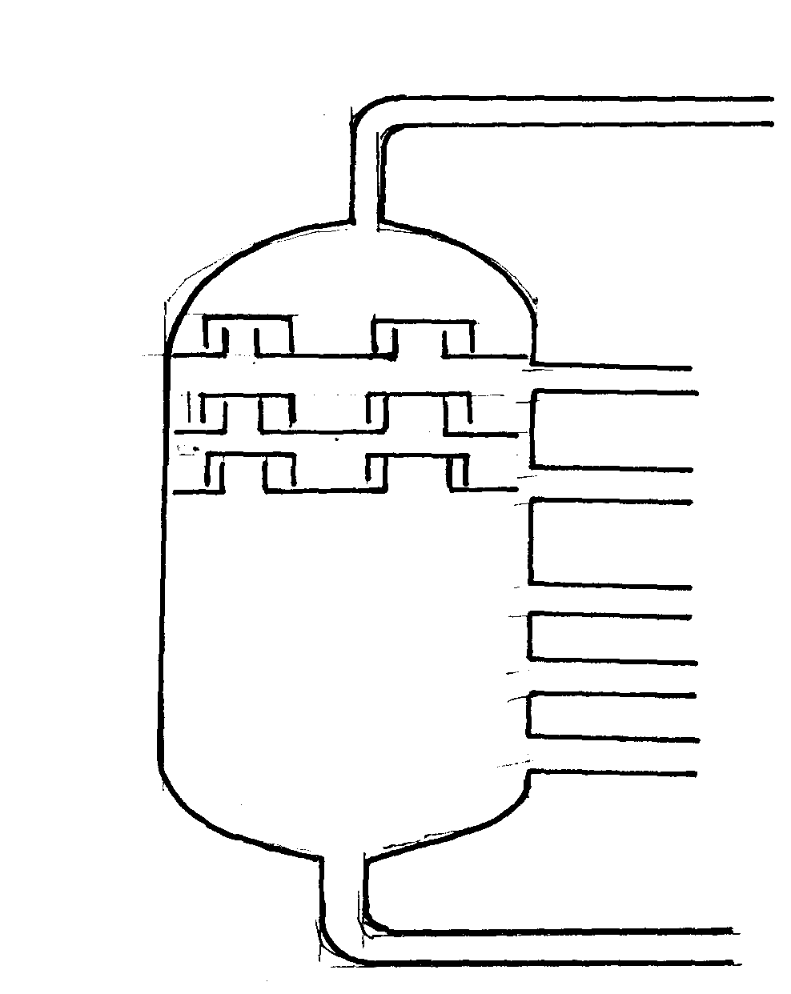
A

B
C
D
E

Crude oil
F

G

(a) (i) What is the name of the apparatus above
(ii) What is the name of the process which is used in separation of crude oil
(iii) What physical property of compounds in the mixture does the separation depend
(iv) Use the letter A to G to describe where the following could be formed:.
I. The fraction that represents gases
II. The fraction that represents the largest molecules
III. The fraction that represents liquids with the lowest boiling points
(b) State the use of product produce at
G………………………………………………………………………………………
C……………………………………………………………………………………….
(c) Draw apparatus for the separation of the product produce at D and water

18. Study the flow chart below and answer the questions that follow:-
A
H₂O + B
CH ≡ CH
CH₃CH₃
Br Br

H- C – C – H

Br Br
HCl
Step I
Step 2
O₂ excess
Br Br

H- C – C – H

Br Br

(i) Give the name of the substance CH ≡ CH …………………………………………
(ii) To which group of hydrocarbons does the substance in (i) above belong?
(iii) Give two reagents that can be used to prepare the substance named in (i) above
(iv) State two physical properties of the substances in (i) above
(v) Give the names to the process in step I and 2
(vi) Write an equation to show how substance A is formed
(iv) Identify substance B ……………………………………………………
19. The diagram below represents a large-scale fractional distillation plant used to separate
the components A, B, C and D in a mixture
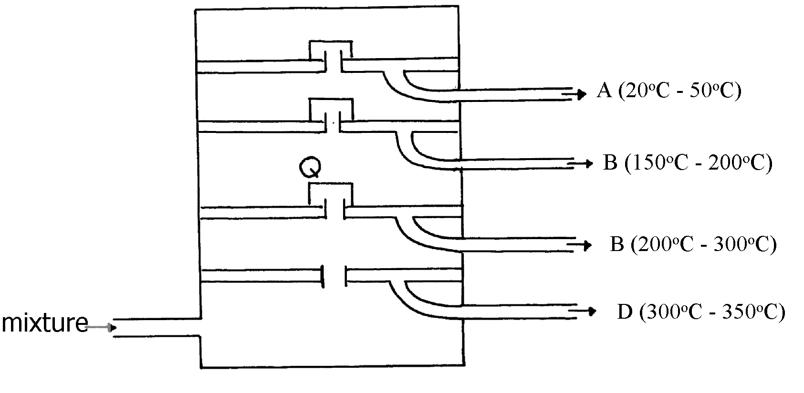
Heat


(a) The components have the following average relative molecular masses not necessarily in that
order; 282, 184, 44 and 128.
(a) (i) What is the physical state of B at the position marked Q?
(ii) Which component has an average relative molecular mass of 128? Explain
(iii) State with a reason whether C is pure or impure
(iv) Explain how the mixture is separated into its components
(v) Name two naturally occurring mixtures that are separated using this process
20. The diagram below represents a large-scale fractional distillation plant used to separate
the components A, B, C and D in a mixture
(a) The components have the following average relative molecular masses not necessarily in that
order; 282, 184, 44 and 128.
(a) (i) What is the physical state of B at the position marked Q?
(ii) Which component has an average relative molecular mass of 128? Explain
(iii) State with a reason whether C is pure or impure
(iv) Explain how the mixture is separated into its components
(v) Name two naturally occurring mixtures that are separated using this process
21. a) The table below gives information about the major constituents of crude oil. Study it and
answer the questions that follow:
Constituent | Boiling point ºC
Gases  Petrol  Kerosene  Diesel  Lubricating oil  Bitumen | Below 40  40-175  175-250  250-350  350-400  Above 400
i) Which of the constituents of crude has molecules with the highest number of carbon
atoms? Explain
ii) Name the process you would use to separate a mixture of petrol and diesel and explain how
the separation takes place
iii) Explain why the constituents of crude oil do not have a sharp boiling point
iv) Name the gas that is likely to be a constituent of crude oil and write its formula
b) i) What condition could cause a poisonous gas to be formed when kerosene is burnt.
Explain
ii) Give one use of bitumen
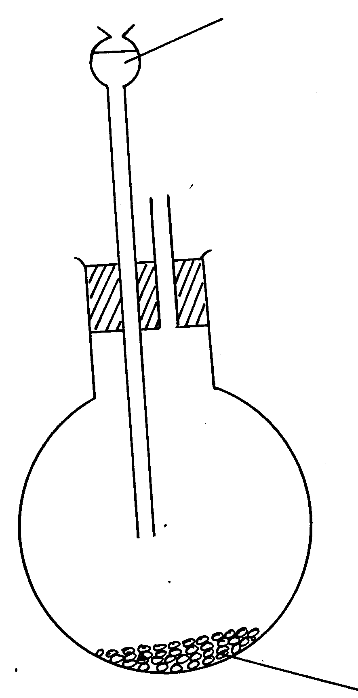
22. (a) The set-up below was used to prepare ethyne gas
Water
Solid E + sand

(i) Identify solid E
(ii) Complete the diagram to show how the gas can be collected
(iii) Write an equation to show how the gas is formed
(iv) Complete the equation below: )
C₂H₂ + 2I₂
(v) What is the role of sand in the experiment?
(b) (i) Explain the meaning of esterification
(ii) Complete the equation below :
CH₃COOCH₃ + H₂O
(iii) What type of reaction is occurring above
(c) Given the reaction:
Solid F
C₈H₁₈ N + C₂H₄
(i) Identify substance:
F………………………………… N………………………………
(ii) Name the process represented above?
(d) Give one use of substance N

Step II
Electrolysis Step I

Water

Nitrogen (IV) Oxide
Step 4 Air Platinum-rhodium catalyst at 900ºC
Step 5 Air
N₂
Ammonium Nitrate
Air

H₂

Ammonia
Colourless gas Q
Step 6
Nitric (V) acid
Step 7
Step III

23.

(i) Name another source of hydrogen apart from electrolysis of water
(ii) What conditions are necessary for step III to occur?
(iii) Write the equation for the formation of colourless gas Q
(iv) Give one use of nitric (V) acid
(b) State and explain the observations that would be made if a sample of copper metal is
heated with concentrated nitric (V) acid
24. (a) Give the systematic names of the following compounds:-
(i) CH₂ = C – CH₃ ..........................................................................

Br
(ii) CH₃CH₂CH₂C ≡ CH .................................................................
(b) State the observations made when buton-l-ol reacts with:-
(i) Acidified potassium dichromate (VI) solution
(ii) Potassium metal
(c) Ethanol obtained from glucose can be converted to ethene as shown below:-
Step I
Step II
C₆H₁₂O₆ C₂H₅OH C H₂ = CH₂

Name and describe the processes that take place in steps I and II
(d) Compounds A and B have the same molecular formula C₃H₆O₂. Compound A librates
Carbon (IV) Oxide on addition of aqueous sodium carbonate while compound B does not.
Compound B has a sweet smell. Draw the possible structures of:-
(e) Give two ways how the disposal of polymers such as polychloroethene by burning pollutes
the environment

25. (a) Name the following compounds (CH₃)₃ C CH₂ CH₂ CH₃
Use the flow chart below to answer the questions that follow:-
L
Polymer K
Substance M
R
Gas P
Sodium Metal

Concentrate H₂SO_{4(l)}
H⁺_{(aq)} / KMNO_{4(aq)}
Step II
Step I

N₁/H₂
High temperature

High pressure
J
CH₃CHCH₂
HBr
Q
Substance N
NaOH
Step II
Soda lime
Heat
Step III
CH₃CH₂CH₂Cl
Gas S

(b) (i) Name the following :-
I. Gas S ……………………………………………………………….……. ( )
II. Gas P …………………………………………………………………
III. J ……………………………………………………………………….
(ii) Name the processes involved in the following steps:
I. Step I …………………………………………………………………………..
II. Step II …………………………………………………………………………….
III. Step III …………………………………………………………………………….
(iii) Write a chemical equation for the complete combustion of substance M
(iv) Name the condition and reagent in step III
Condition ……………………………………………………………………………………
Reagent …………………………………………………………………………………….
(v) Calculate the mass of salt R that would be formed by using 21.9 tonnes of N when it reacts
with excess sodium hydroxide ( C= 12.0 H= 1.0 Na = 23)
(vi) Draw the structure of polymer K
II. State one use of the above polymer
………………………………………………………………………………………………….
(c) (i) Name the class to which the following cleansing agents belong:-
R – COONa⁺
i) ……………………………………………………

(ii) ……………………………………………………….
R – O-SO₃ Na
O

II. Which cleaning agent above is not environmental friendly? Explain

26. The molecular formula of a hydrocarbon is C₆H₁₄. The hydrocarbon can be converted into two
other hydrocarbon as shown by the equation below:
C₆H₁₄ C₂H₆ + X
(i) Name and draw the possible structural formula of X
(ii) State and explain the observations that would be made if a few drops of bromine water
were added to a sample of X
(iii) Write an equation for the complete combustion of C₃H₈

27. (a) Give the names of the following
(i) CH₃CH₂CH₃
(ii) CH₃CCCH₃
(b) Ethene is used in making polyethene bag in a process called polymerization
(i) Name the type of polymer that is formed when ethane polymerise
(ii) Describe a simple chemical test that can be used to identify ethane gas in the laboratory
(c) Study the information in the table below and answer the questions that follow:-
No. of carbon atoms | R.M.M of the Hydrocarbon
2  3  4 | 28  42  56
i. Write the general formula of the hydrocarbons in the table above
ii. Determine the molecular of a hydrocarbon with 5 carbon atoms and draw its structural formula
Molecular formula
Structural formula
(d) Study the scheme below and answer the questions that follow
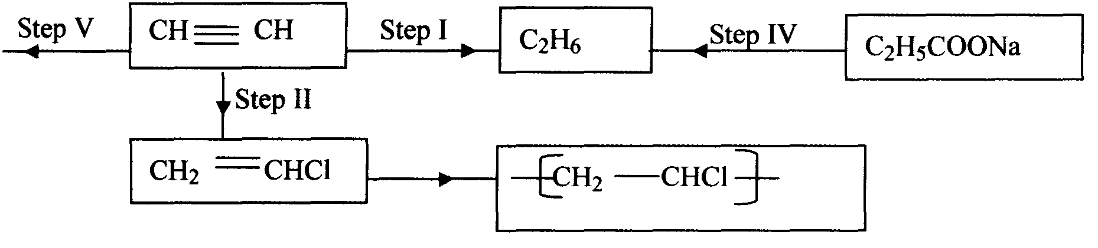

(i) Name the reagents in
Step I ……………………………
Step II ……………………………
Step IV ………………
(ii) Write an equation for the complete combustion of CH ≡CH
(iii) Give two uses of CH₄
28. Give the systematic names of the following compounds;
i)CH₃ = C-CH₃

CH₃
ii)CH₃CH₂CH₂C≡ CH

29. Study the data given in the following table and answer the questions that follow. The letters
are not the actual symbols of elements.

Element | Number of protons | Melting point | Bpt ºC
A | 11 | 98 | 890
B | 12 | 650 | 1110
C | 13 | 60 | 2470
D | 14 | 1410 | 2360
E | 15 | 442  590 | 280
F | 16 | 113  119 | 445
G | 17 | -101 | -35
H | 18 | -189 | -186

(i) State and explain the trend in melting point in A B C
(ii) Explain why the melting point and boiling points of element D is the highest
(iii) Explain why the element represented by letter E has two melting point values
(iv) Write down the chemical formula between element C and sulphate ions
(v) Name the chemical family in which H belong and state one use of the element
(vi) What is the nature of the oxide of the elements represented by letters C and F?

30. a) The table below gives information about the major constituents of crude oil. Study it and
answer the questions that follow:
Constituent | Boiling point ºC
Gases  Petrol  Kerosene  Diesel  Lubricating oil  Bitumen | Below 40  40-175  175-250  250-350  350-400  Above 400
i) Which of the constituents of crude has molecules with the highest number of carbon
atoms? Explain
ii) Name the process you would use to separate a mixture of petrol and diesel and explain how
the separation takes place
iii) Explain why the constituents of crude oil do not have a sharp boiling point
iv) Name the gas that is likely to be a constituent of crude oil and write its formula
b) i) What condition could cause a poisonous gas to be formed when kerosene is burnt.
Explain
ii) Give one use of bitumen
31. Study the information in the table below and answer the questions that follow
Number of carbon atoms per molecule | Relative molecular mass of the hydrocarbon
2  3  4 | 28  42  56
i) Write the general formula of the hydrocarbons in the table
ii) Predict the relative atomic mass of the hydrocarbons with 5 carbon atoms
iii) Determine the relative atomic mass of the hydrocarbon in (ii) above and draw its
structural formula (H=1.0, C=12.0)
32. Substance “M” with a general formula C₂Hy burnt in chlorine gas with a red flame producing
a cloud of black specks and colourless gas G.
(a) State the collective name for compounds which ‘M’ belongs
(b) With reason, state the identity of the black specks and colour gas “G”.

33. 2.63g of a solution of sodium chloride at 20.0ºC was reacted with silver nitrate. After filtration,
washing and drying, 2.36g of silver chloride was obtained. Determine the solubility of sodium
chloride at 20.0ºC . (Na=23, Cl= 35.5, Ag = 108)
(b) Determine the number of moles of carbon (IV) Oxide gas produced when sodium
carbonate reacted with dilute sulphuric (VI) acid (Molar gas volume =24dm³)
34. Write down all the isomers of but-z-ene and give their IUPAC names
35. (a) A hydrocarbon compound Z decolourizes bromine liquid in the presence of light but
does not decolourize acidified potassium manganate (VII). Name and draw the structural
formula of the eighth member of this homologous series
36. (a) What is meant by isomerism?
(b) Draw and name two isomers of Butyne

Nitrogen and its compounds
1. The apparatus below was set-up to show the catalytic oxidation of ammonia. Study the diagram
and answer the questions that follow:-
Hot nichrome wire
Dry NH₃ _{(g)}

(i) Write an equation for the reaction that takes place
(ii) Why is it necessary to have a hot nichrome wire in the gas jar?
(iii) Write the formula of the complex ion formed when excess ammonia gas is passed through
a solution containing Zn²⁺ ions

2. The diagram below shows the catalytic oxidation of ammonia gas. Use it to answer the
questions that follow:-

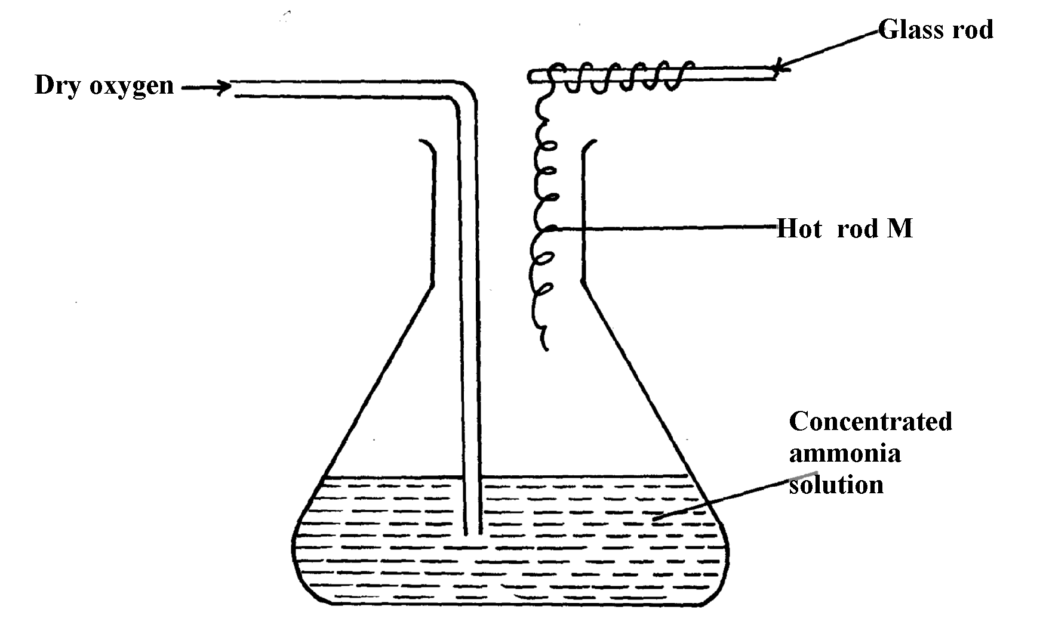

(a) What metal could rod M be made of?
(b) State and explain two observations made inside the conical flask

3. Ammonia gas is prepared in the laboratory by the action of an alkali on an ammonium salt.
A student wanted to prepare a sample of ammonia gas in the laboratory.

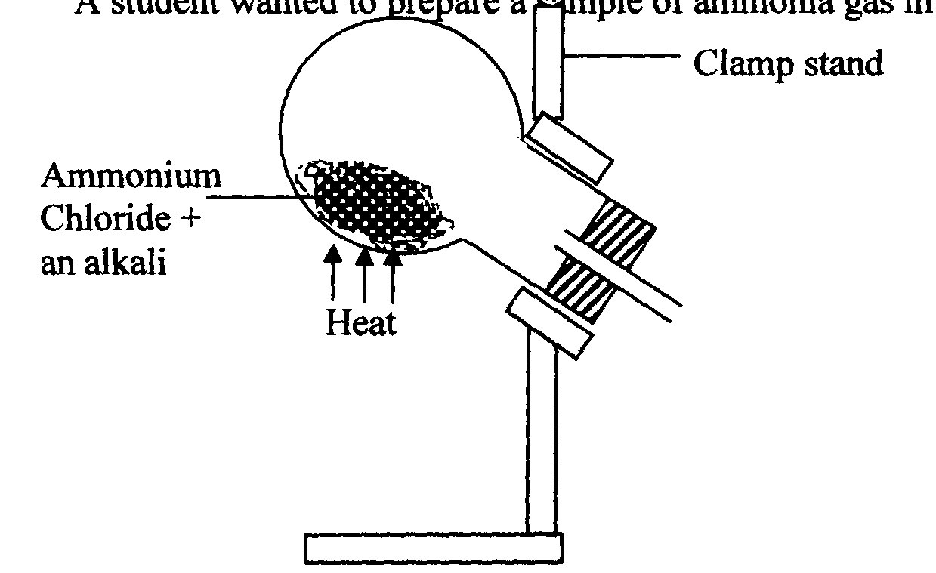

(a) Give one alkali that can be used in the above experiment
(b) Write an equation for the reaction that takes place in the above experiment

4. (a) Explain the importance of the high percentage of nitrogen in air
(b) Why is nitrogen used for storage of semen in artificial insemination?

5. The diagram below is used in preparation of a gas in the laboratory. Answer the questions
that follow;
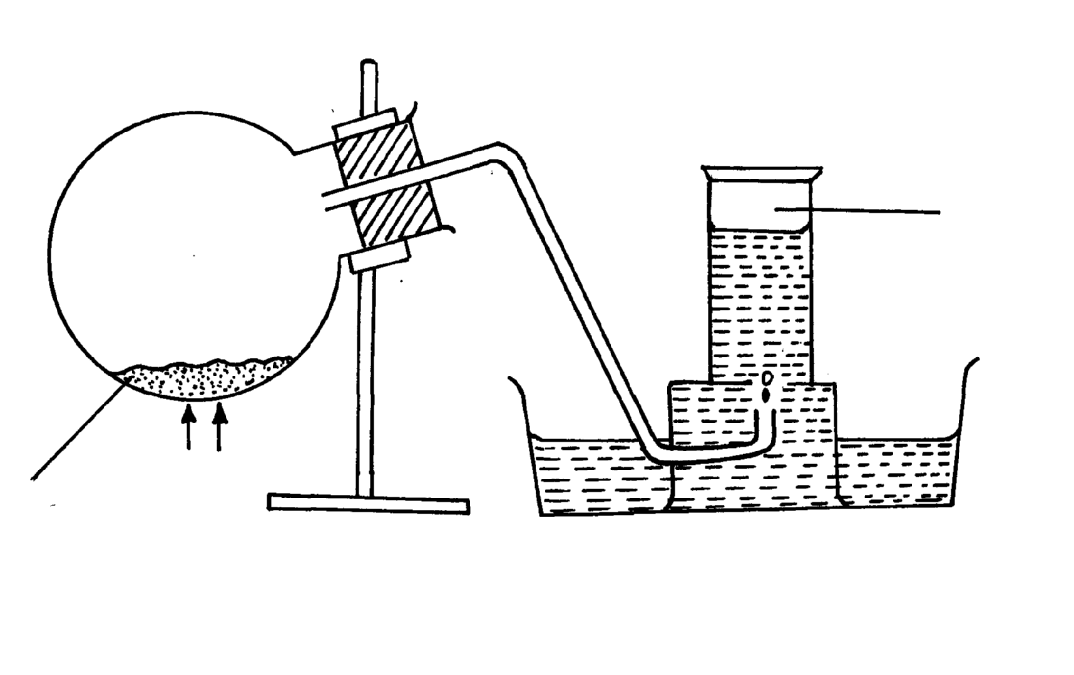

Gas X

Ammonium
nitrite
heat
Water
Heat

(a) Name gas X …………………………………………………………………………..
(b) State one physical property which makes it possible for the gas to be collected as shown*
(c) State one commercial use of gas X

6 Study the flow charts below and use them to answer the questions that follow:
Solution A
Solution B
White precipitate A
White precipitate
White precipitate B
No White precipitate
NH_{3(aq)} in excess
H₂SO_{4(aq)}
NH_{3(aq)} in excess
H₂SO_{4(aq)}

(a) Identify possible cations present in:
(i) Solution A
(ii) Solution B
(b) State and explain the observations made when a sample of dry white precipitate B is
heated in a test-tube
7. The set-up below is an arrangement showing how metals react with nitrogen (IV) oxide.
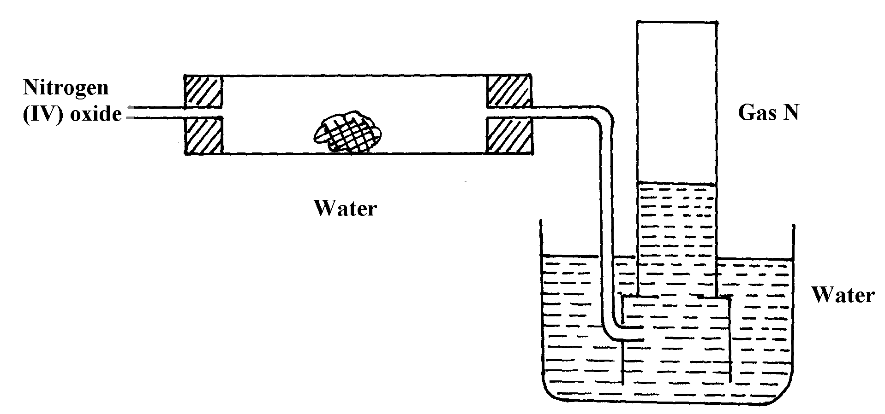
Study it and answer the questions that follow:-
Copper metal

Heat

(a) Nitrogen (IV) oxide is passed through the combustion tube before copper is heated.
Give a reason for this
(b) State the observations that would be made at the end of the experiment in the combustion
tube
(c) Name gas N ……………………………………………………………………..
8. (a) In haber process hydrogen and nitrogen react in the presence of finely divided iron catalyst.
Explain why the catalyst is finely divided
(b) A mixture of N_{2,} H₂ and NH₃ was bubbled through 0.2M hydrochloric acid solution.
The final concentration of the acid was found to be 0.1M. Give explanation

9. In an experiment, a few drops of concentrated nitric acid were added to aqueous iron II sulphate
in a test-tube. Excess ammonia solution was then added to the mixture
(a) State the observations that were made when:-
(i) Concentrated nitric acid was added to aqueous iron (II) sulphate
(ii) Excess ammonia was added to the mixture
(b) Write an ionic equation for the reaction which occurred in a (ii) above

10. The chart below shows a summary for the preparation of nitrogen gas from air
Sodium Hydroxide solution
Heated Copper
Nitrogen gas
Air
I
II
III

(a) What is the purpose of the sodium hydroxide?
(b) Write an equation for the reaction taking place in chamber II
(c) The nitrogen gas obtained is not pure. Explain
11. Dilute nitric acid is added to excess green solid. Effervescence occurs and a blue solution is formed.
When excess ammonia solution is added to a sample of the solution a deep blue solution is formed
(a) Identify the anion and cation in the green solid:
(b) Write an ionic equation for the reaction forming deep blue solution

12. The diagram below is a set-up for preparation and collection of a gas. Study it answer the
questions that follow:

Gas X
water
Ammonium Nitrate
Heat

(i) Identify gas X ………………………………………………………….
(ii) Write an equation for the formation of gas X
(iii) What precaution should be observed when preparing gas X by the above method?
(iv) Describe the suitable drying agent for gas X
(v) How can one confirm that the gas collected is gas X?
(vi) State two physical properties of gas X

(b) The diagram below is a set-up used in preparation of ammonia solution. Study it and answer
the questions that follow
Inverted funnel
Ammonia gas
Beaker
Water

(i) What is the purpose of the filter funnel in the set-up above?
(ii) What would happen if a delivery tube was used in place of the filter funnel?
(iii) What observation would be made on litmus paper placed into the solution in the beaker
at the end of the experiment?
13. The following flow chart shows the industrial manufacture of Nitric (V) acid.
a) Identify substance B, C, E and F.
Filter
Air
Compressor
Catalytic chamber
Nitric (V) acid
Absorption
chamber
Chamber D
F
E
B
b) Describe what happens in the catalytic chamber.

c) State what takes place in chamber D.
d) 60 – 65% nitric (V) acid is produced in the absorption chamber. Describe how the acid can be
concentrated.
e) State why nitric (V) acid is stored in dark bottles.
f) Copper reacts with nitric (V) acid and not hydrochloric acid. Explain.

14. The flow chart below illustrates two industrial processes, Haber process and the Contact process:
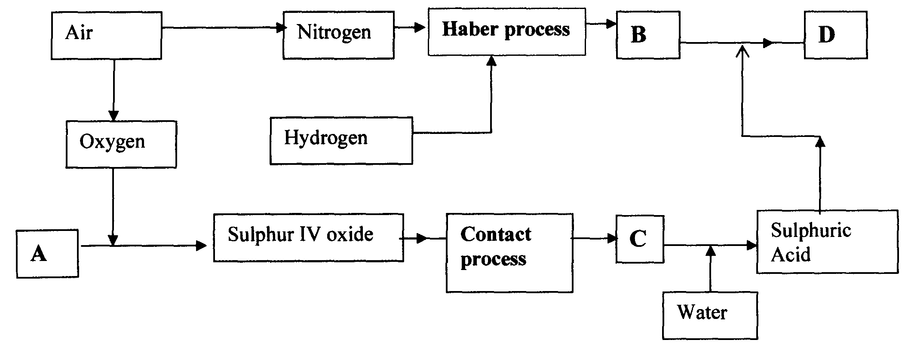

(i) Give the name of the process by which air is seperated into oxygen and nitrogen
(ii) Apart from oxygen and nitrogen gases produced from process (a)(i) Name
one other gas produced
(b) Name the substances represented by the letters A, B, C and E
(c) Name the catalysts used in:
(i) Haber Process ……………………………………………………………………..
(ii) Contact Process ……………………………………………………………………..
(d) Explain the role of the catalysts in both the Haber and the Contact processes
(e) Write a chemical equation for the formation of compound B
(f) Calculate the percentage by mass of the nitrogen present in compound D
(g) Give one major use of compound E

15. The diagram below represents a set-up used to obtain nitrogen from air. Study it and
answer the questions that follow:-
Nitrogen gas

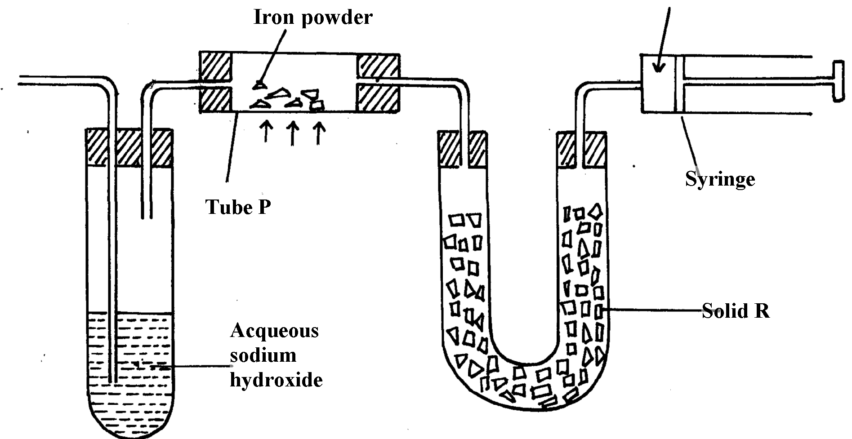
Solid Q

HEAT

(i) Name solid Q ............................................................................................................
(ii) What is the purpose of sodium hydroxide
(iii) Write an equation for the reaction which took place in tube “P”
(iv) Give the name of one impurity in the nitrogen gas obtained
(v) Give a reason why liquid nitrogen is used for storage of semen for artificial insemination

(b) The set-up below was used to prepare nitric acid.
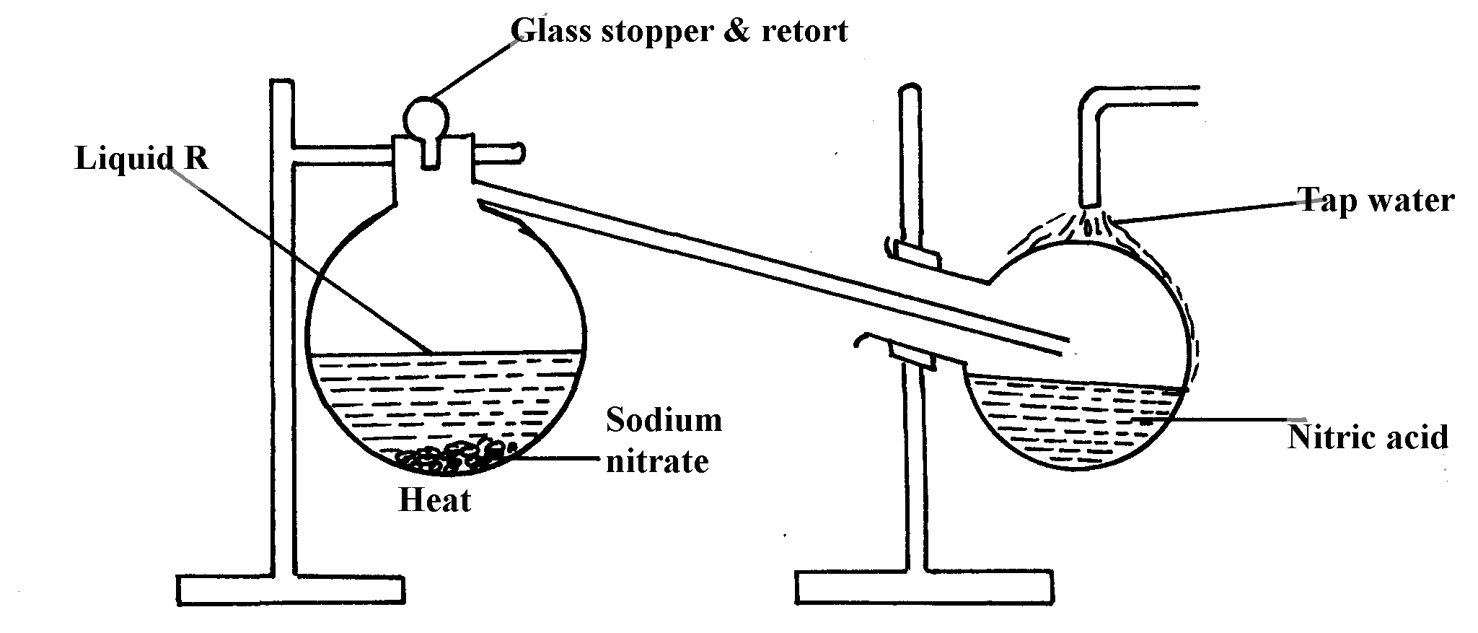

(i) Give the name of liquid ‘R’ ....................................................................................
(ii) Explain the following:-
(a) Nitric acid is stored in dark bottles
(b) The reaction between copper metal with 50% nitric acid in an open tube gives brown fumes

16. Study the flow chart below and answer the questions which follow:

Nitrogen
Hydrogen
Ammonia
II
Air

III Air
Catalyst P (700ºC)
Absorption tower
Liquid F
Gas M
NO₂+
Air
Nitric acid
IV
I

(i) Give one source of the following raw materials (s)
(a) Nitrogen gas ………………………………………………………………………………..
(b) Hydrogen gas …………………………………………………………………………………..
(ii) State three conditions required in process I
(iii) Name: catalyst P…………………………………………………………………
Gas M……………………………………………………………………..……
(iv) Write chemical equations for;
(a) Formation of gas M
(b) The reaction in the absorption tower
(v) Give two reasons why step IV is necessary
(vi) Describe how you would test if a given liquid is a nitrate
(vii) Give three uses of nitric acid
17. The diagram below shows the apparatus for the laboratory preparation of one of the oxides
of Nitrogen

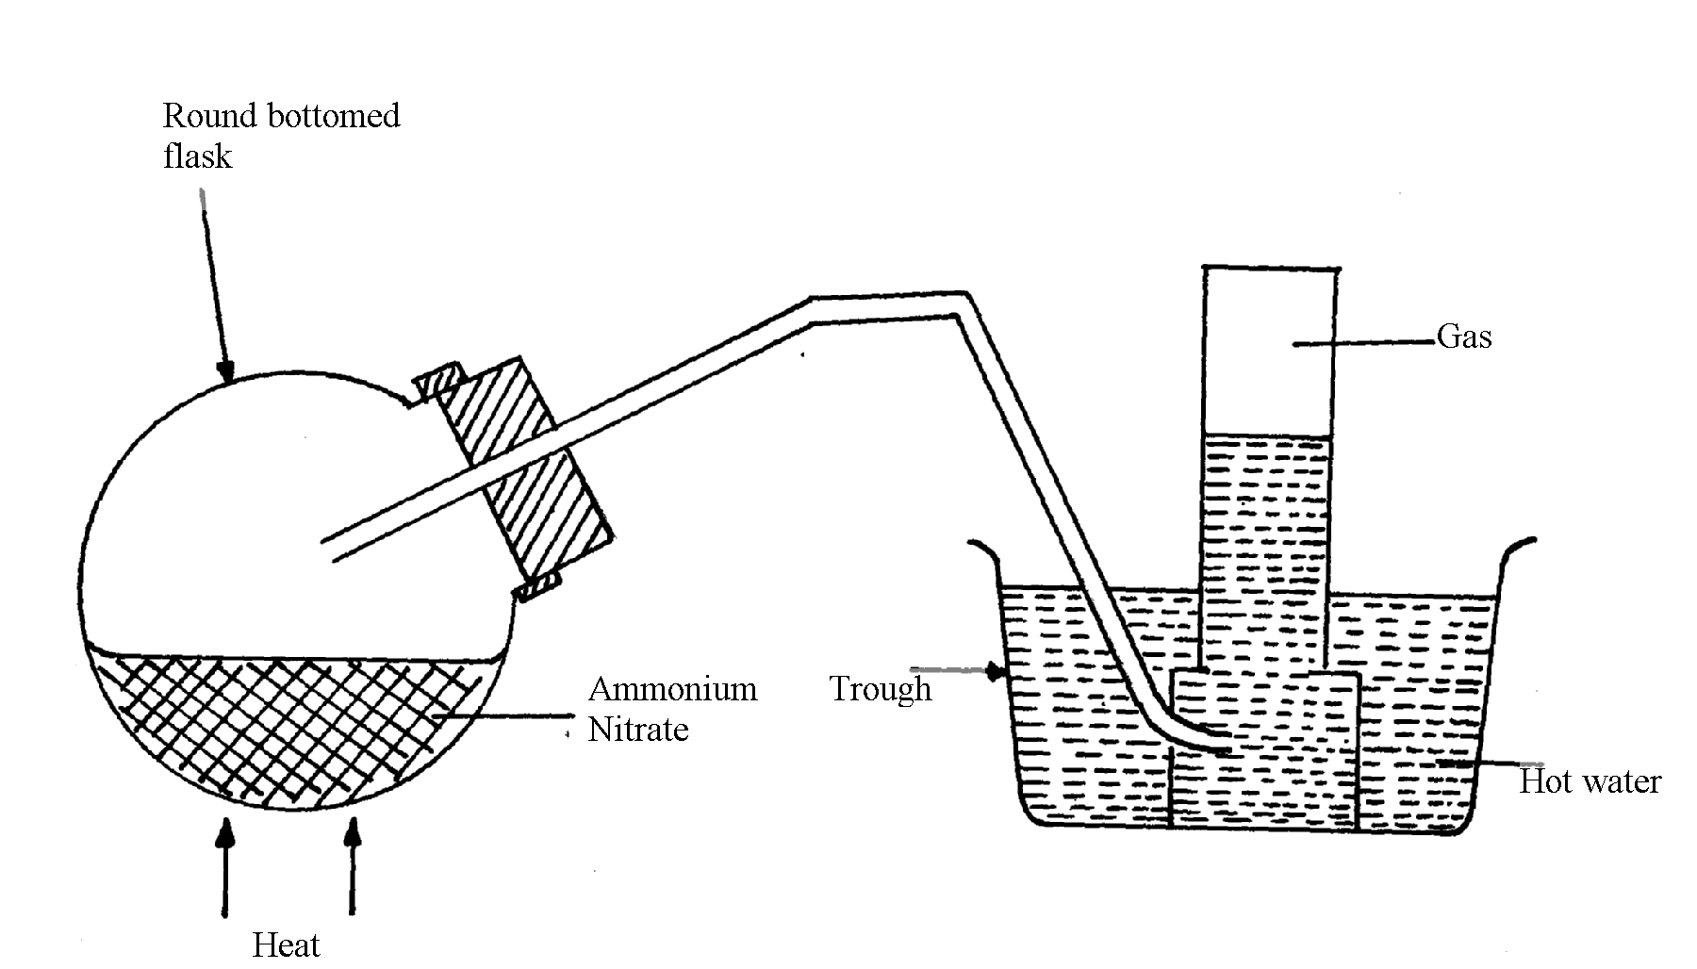

a) (i) Name the gas being produced
(ii) Write the equation for the thermal decomposition of ammonium Nitrate
(iii) The gas is being collected over hot water. Explain
(iv) State and explain the observations made when burning sulphur is lowered into a
gas jar containing the gas
(b) (i) Name the catalyst used during catalytic oxidation of ammonia
(ii) Nitrogen (IV) oxide is the final product during catalytic oxidation of ammonia.
Write a chemical equation for its formation
(iii) State two physical differences between Nitrogen (I) oxide and Nitrogen (IV) Oxide
(c) Nitric acid is prepared in the laboratory by action of concentrated sulphuric (VI) acid
on a suitable Nitrate and distilling off the Nitric acid, in all glass apparatus.
(i) Why must the apparatus be made of glass?
(ii) Hot concentrated Nitric acid reacts with sulphur in the equation below:-
S_{(s)} + 6HNO_{3(aq)} H₂SO_{3(aq)} + 6NO_{2(g)} + 2H₂O_{(l)}
(I) Identify the species :-
Oxidised ………………………… Reduced …………………………………
(II) Pure nitric acid is colourless but the product during its preparation is usually pale yellow.
Explain

18. a) Describe the process by which oxygen can be obtained from air on large scale
b) The flow chart below shows the industrial manufacture of nitric (V) acid
X
Y
D
Purifier
Catalytic
chamber
Heat
exchanger
Absorption tower

Y
Y
Nitric (V) acid

i) Identify substances X and Y
ii) Write an equation for the reaction taking place in the absorption tower
iii) The concentration of the acid obtained is about 60%. How can this concentration be increased
to about 65%?
iv) A factory uses nitric (V) acid and ammonia as the only reactants for the production of a fertilizer.
If a mass of 9600kg of fertilizer was produced, calculate the mass of ammonia gas needed
(N = 14, H = 1, O = 16)

1.9
AIR
Filter
Step I
Sodium hydroxide solution
Step II
Cool to -25ºC
Step III
Air compressed and expanded
Process X
Step IV
Ar
-186ºC
N₂
-196ºC
O₂

(a) Name another substance which can be used instead of sodium hydroxide
(b) What is the function of filters?
(c) Identify the substance removed at step III
(d) At what temperature does liquid oxygen distil?
(e) Identify process X
(f) Describe how process X occurs
(g) I. State one industrial use of Nitrogen
(II) Air is a mixture but not a compound. Give two reasons
20. Using chemical equations show the bleaching actions of chlorine and sulphur(IV)oxide
21. The diagram below represents an in complete set-up for preparation of a dry sample of gas R
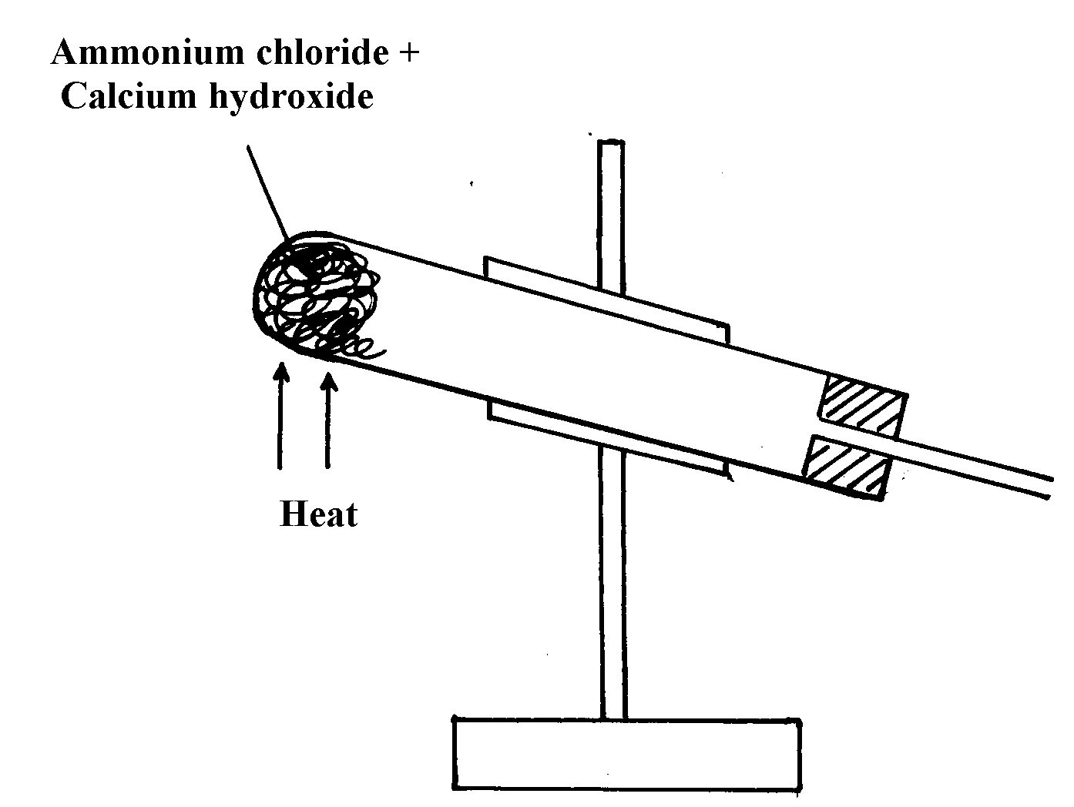

a) Complete the set-up to show how a dry sample of gas R is collected
b) Write a chemical equation for the reaction that produces gas R
22. The diagram below was used to investigate the reaction between nitrogen(I)oxide and copper
turnings. Study it and answer the questions that follow:
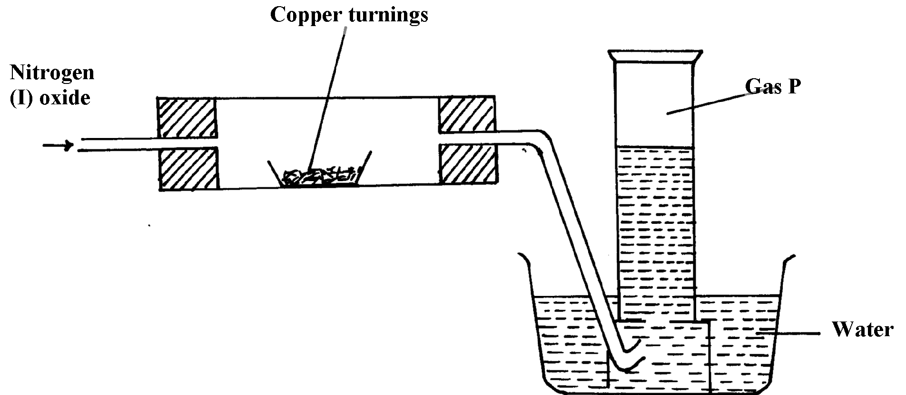

a) What has been omitted in the set-up? (show it on the diagram)
b) Write a chemical equation for the reaction that took place in the combustion tube
c) State one use of gas P

23. When sulphur powder is heated to over 400ºC the following changes are observed:-
At 113ºC it melts into light brown liquid. The liquid then darkens to become reddish-brown
and very viscous at 160ºC. Above 160ºC the liquid becomes almost black. At the boiling point
the liquid becomes mobile. Explain these observations
24. Concentrated sodium chloride (Brine) was electrolysed using platinum electrodes.
What would be the difference in terms of products at each electrode if dilute sodium chloride
solution was used in place of brine. Explain

25. (i) Nitrogen (I) Oxide supports, combustion of burning charcoal. Write an equation
to show this reaction
(ii) Ammonium nitrate can be heated to give off nitrogen (I) Oxide. However, a mixture
of NH₄Cl and NaNO₃ is preferred. Explain
(iii) Ammonia turns wet red litmus paper blue. Which ion is responsible for this reaction
26. Study the scheme below and answer the questions that follow:
Solid E + Ca(OH)₂ paste
Ammonia gas
Solid F
Step II
Pass through aluminium sulphate solution and filter
Step I
Warm

(a) Name solids E and F
(b) Write down a balanced equation for the reactions that lead to formation of solid F

27. When a few drops of aqueous ammonia were added to a colourless solution X, a white
precipitate was formed. On addition of more aqueous ammonia, the white precipitate
dissolved to a colourless solution Q
(a) Name the white precipitate formed
(b) Write formula of the complex ion present in the colourless solution Q
(c) Write an ionic equation for the formation of the white precipitate
28. The first step in the industrial manufacture of nitric cid is the catalytic oxidation of ammonia
gas.
a) What is the name of the catalyst used?
b) Write the equation for the catalytic oxidation of ammonia gas.
c) Nitric acid is used to make ammonium nitrate. State one use of ammonium nitrate.
29. Explain what is observed when ammonia gas is bubbled into Copper (II) sulphate solution
till in excess.
30. (a) State the conditions under which nitrogen react with hydrogen to form ammonia during
Haber process
(b) When dry ammonia gas is passed over hot copper (II) Oxide, a shinny brown residue
and a colourless droplets are formed. Explain these two observations
31. Study the flow chart below and answer the questions that follow
NH_{3(aq)}
Gas A
Liquid B
Heated
Copper (II) Oxide

(a) State the observation made when ammonia is passed over heated Copper (II) Oxide
(b) Identify:-
(i) Gas A ………………………………………….………
(ii) Liquid B ………………………………..…………………

Sulphur and its compounds
1. Sulphur is extracted from underground deposits by a process in which three concentric pipes are
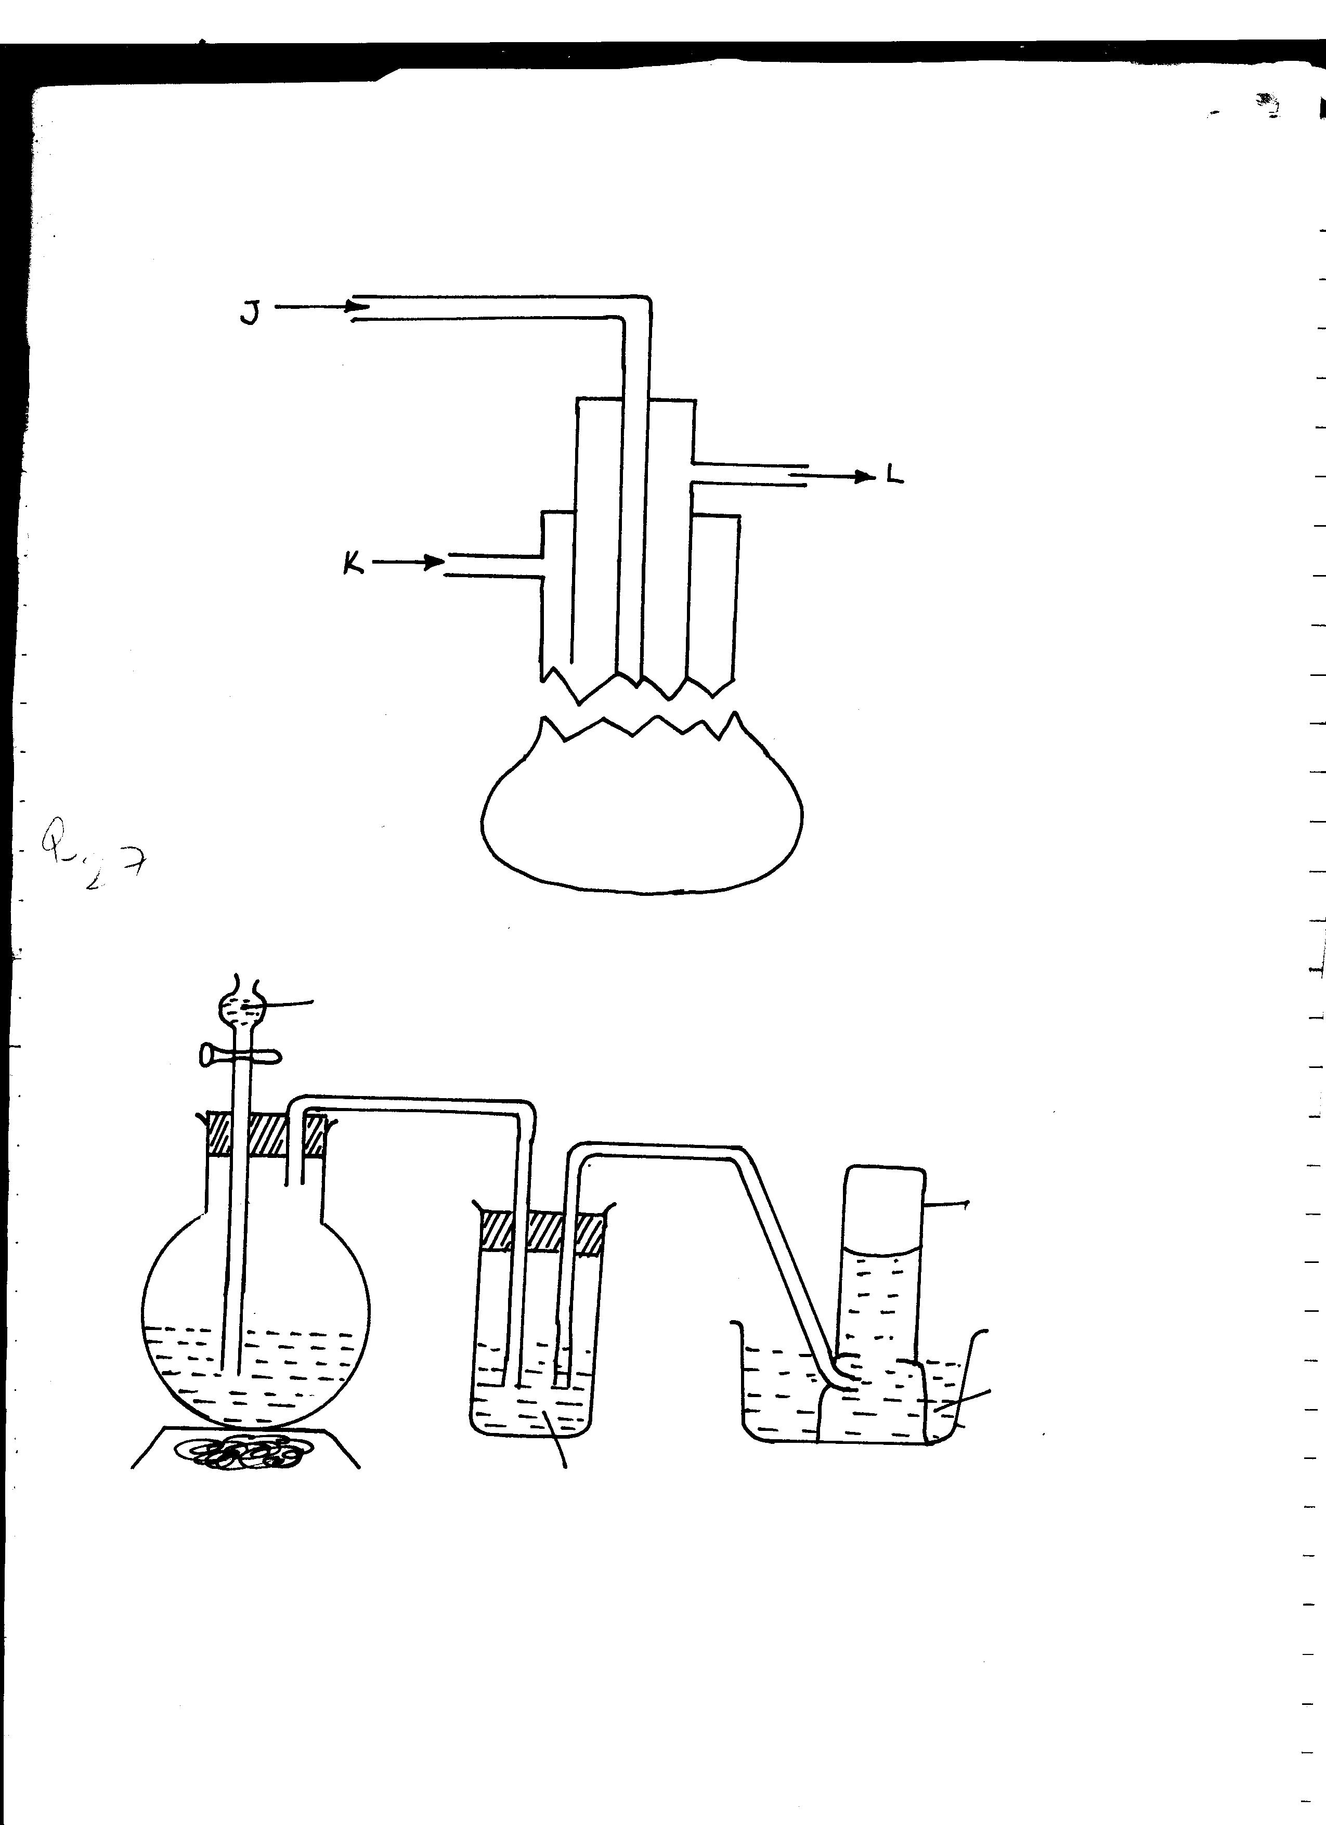
sunk down to the deposits as shown below
J
K
L

(a) Name the process represented above
(b) What is passed down through pipe J?
(c) Name the two allotropes of sulphur

2. Commercial sulphuric acid has a density of 1.8gcm³.
(a) Calculate the molarity of this acid
(b) Determine the volume of commercial acid in (a) above that can be used to prepare
500cm³ of 0.2M H₂SO₄ solution
3. Oleum (H₂S₂O₇) is an intermediate product in the industrial manufacture of sulphuric acid
(a) How is oleum converted into sulphuric (IV) acid?
(b) Give one use of sulphuric acid
4. Differentiate between the bleaching action of chloride and sulphur (IV) oxide gas.

5. (i) Is concentrated sulphuric acid a weak acid or a strong acid?
(ii) Explain your answer in (i) above.
6. In the manufacture of sulphuric acid, sulphur (IV) oxide is oxidized to sulphur (VI) oxide.
a) Name the catalyst used
b) Write the equation representing the conversion of sulphur (IV) oxide to sulphur(VI)oxide
c) Explain using equations how dilute sulphuric acid is finally obtained from sulphur (VI) oxide
7. When a mixture of concentrated sulphuric acid and copper turnings is strongly heated,
a colourless gas and solid mixture of white and black solids are formed. When this solid
mixture is treated with distilled water, and filtered, a blue solution and black solid residue
are collected. Explain the observations on the solid mixture formed in the above experiment
8. The set-up below is used to prepare dry sulphur (IV) Oxide in the laboratory. Answer questions
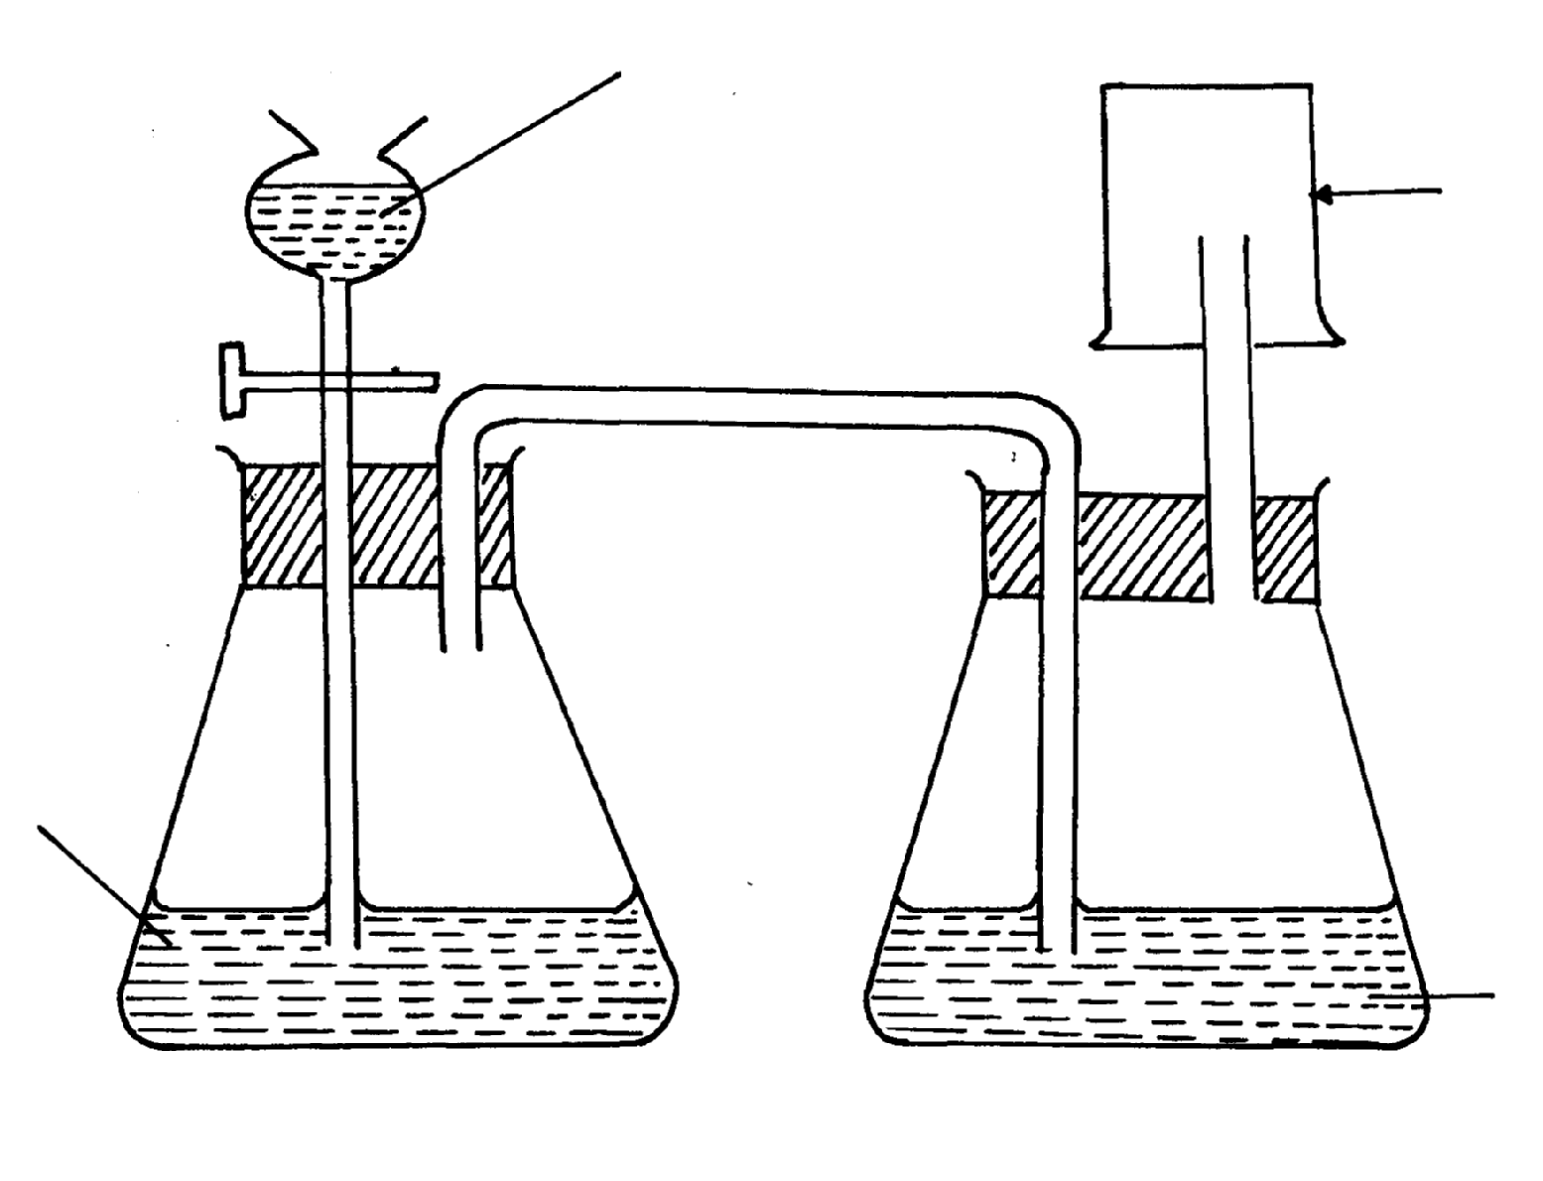
that follow:
dilute H₂SO₄
Gas jar

Sodium Sulphite

Conc.H₂SO₄

(a) Identify the mistake in the set-up
(b) Write an equation for the reaction in the set-up
(c) State how the polluting effects of the gas on the environment can be controlled
9. (a) State the observation made at the end of the experiment when a mixture of iron
powder and sulphur are heated in a test-tube
(b) Write an equation for the reaction between the product in (a) above and dilute
hydrochloric acid
(c) When a mixture of iron powder and sulphur is heated it glows more brightly than
that of iron fillings and sulphur. Explain this observation
10. (a) Name one reagent that can be reacted with dilute hydrochloric acid to produce
Sulphur (IV) oxide
(b) What would be observed if moist blue litmus paper is dropped into a gas jar of
sulphur (IV) oxide? Explain your answer with an equation
11. (a) State two properties that vulcanized rubber posses as a result of vulcanization
(b) During Frasch process molten sulphur flows out through the middle pipe but not
through the outer pipe. Give a reason
12. (a) Give two reasons why during the manufacture of sulphuric (VI) acid, sulphur (VI) Oxide,
is dissolved in concentrated Sulphuric (VI ) acid instead of dissolving in water
b) State one use of sulphuric (VI) acid
13. The diagram below may be used to react hydrogen sulphide and sulphur (IV) oxide.
Study it and answer the questions that follow:-
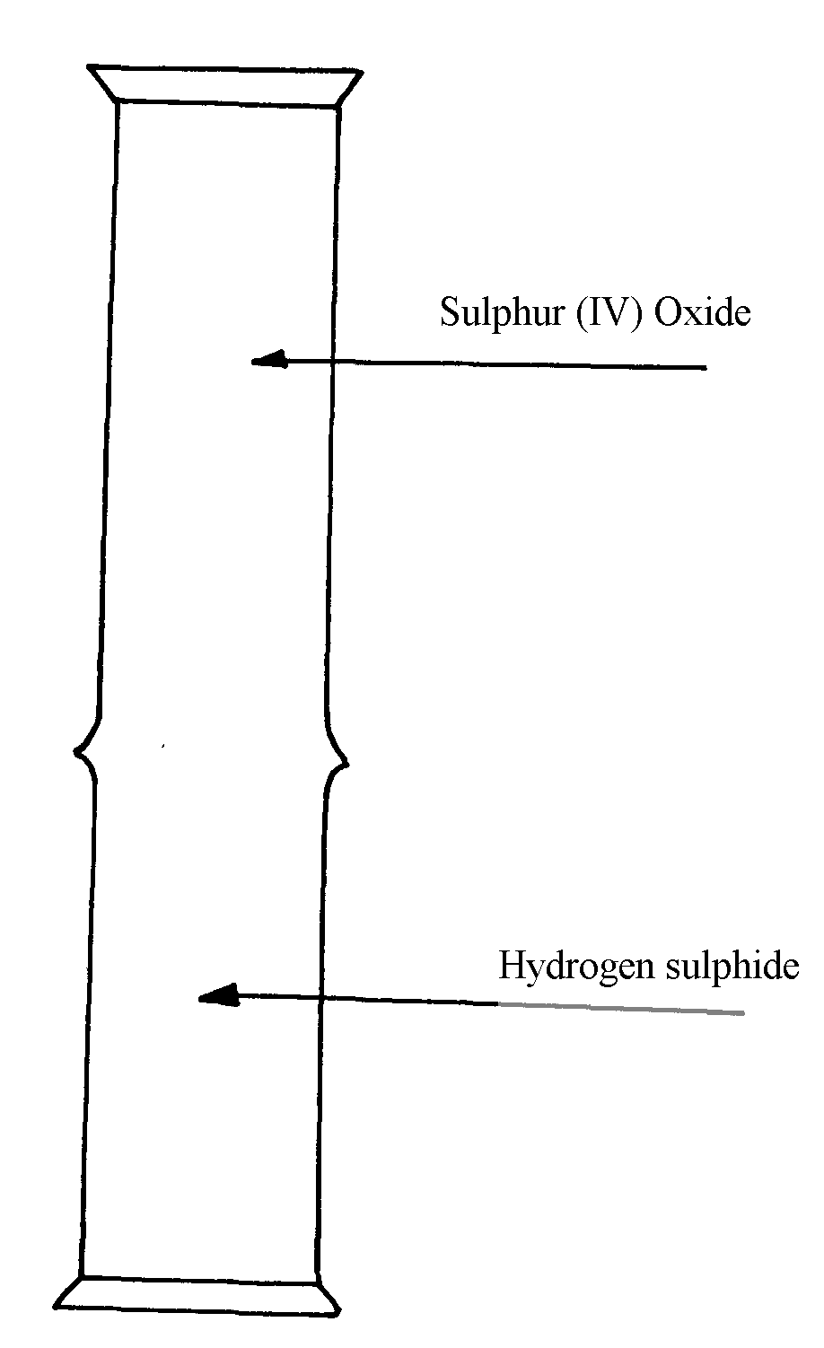

(a) What is observed in the jars
(b) Write an equation for the reaction
(c) What is the role of sulphur (IV) oxide in the reaction
1 4. The diagram below shows the extraction of sulphur by Frasch process.
A
B
C
Ground level
Sulphur beds

a) State the uses of pipes A, B and C.
b) Give two crystalliric allotropes of sulphur.
c) Write an equation for the combustion of sulphur.
d) Name the product formed when a mixture of sulphur and Iron is heated.
e) Give two uses of sulphur.
f) 6.0 dm³ of sulphur (IV) oxide were oxidized by oxygen to sulphur (VI) oxide.
(i) Write an equation for the reaction.
(ii) Calculate the number of moles of sulphur (IV) oxide and oxygen used at R.T.P.
(iii) Determine the volume of oxygen used.
(Molar volume of a gas at R.T.P. is 24.0 dm³)
15. The diagrams below represent two allotropes of Sulphur. Study them and answer the questions
which follow:-
Y
X

(i) Name the two allotropes labelled X and Y
(ii) (I) Explain why a piece of burning magnesium continues to burn in a gas jar of Sulphur
(IV) Oxide
(II) Explain how one of the products formed in (I) above can be obtained from the mixture
16. (a) (i) Name the two crystalline forms of sulphur
(ii) Briefly explain how plastic sulphur is formed

(b) The scheme below represents the steps followed in the contact process. Study it and answer
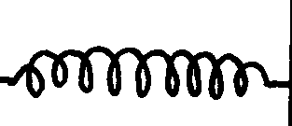
the questions that follow:-
Burner
SO₂
Air
Purifier
Dry SO₂ and air
Heat exchanger
Cooler
Absorption Tower
SO₃
Diluter
Catalytic converter
SO₃
SO₂
Air
Oleum
Conc. H₂SO₄
Conc. H₂SO₄
Solid A
Air

(a) Name two possible identities of solid A
(b) Name one impurities removed by the purifier
(c) Why is it necessary to remove impurities?
(d) Write down the equation of the reaction taking place in the converter
(e) (I) Name the two catalysts that can be used in the converter
(II) What is the function of heat exchanger?
(f) Sulphuric (VI) Oxide is not dissolved directly into water? Explain
(g) (I) Name the main pollutant in the contact process.
(II) How can the pollution in (g) (I) above be controlled?
(h) Give one use of sulphuric (VI) acid

7. The set-up below was used to prepare dry sample of hydrogen sulphide gas
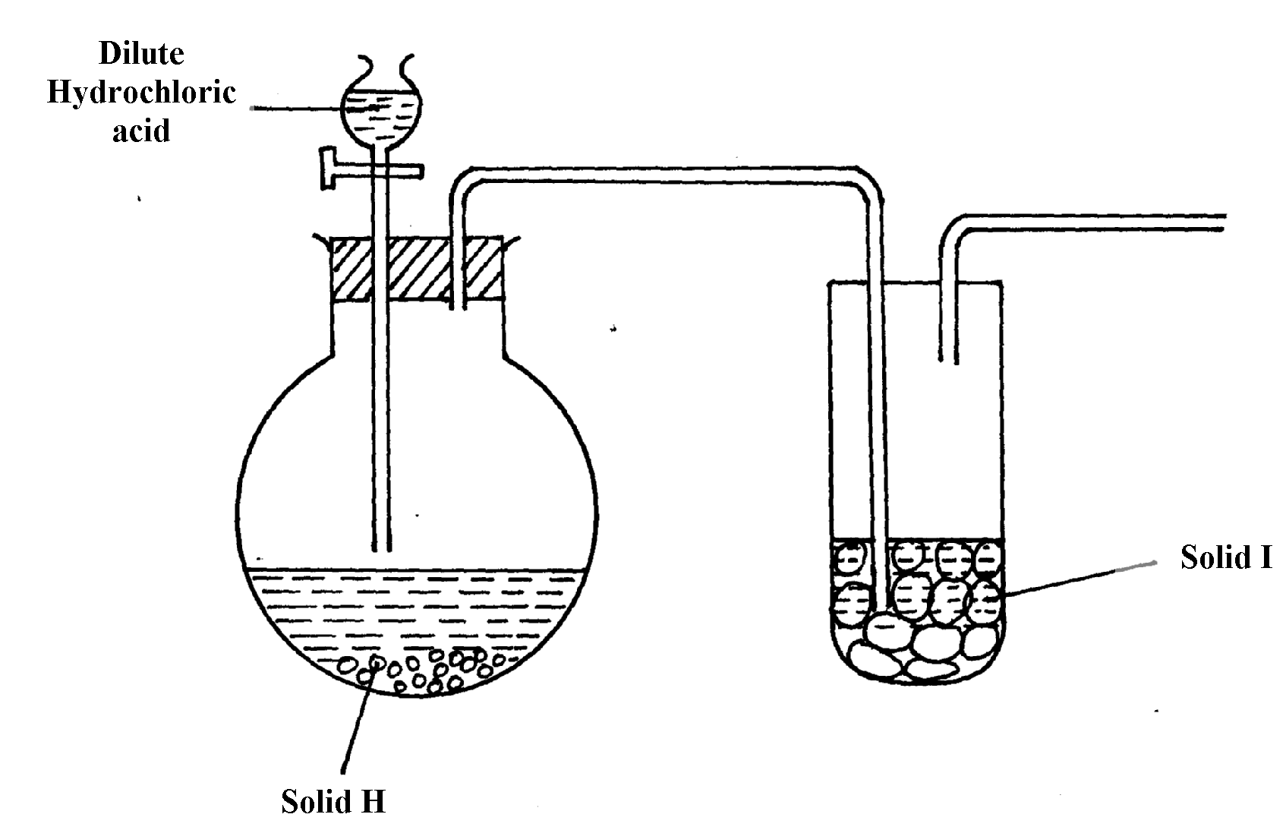

(a) (i) Complete the diagram to show how the gas was collected
(ii) Identify the following:-
I. Solid H ………………………………………………………………………………
II. Solid I ……………………………………………………………………………..
(iii) Write an equation for the reaction that occurred in the flask between solid H and dilute
Hydrochloric acid
(b) When hydrogen sulphide gas was passed through a solution of Iron (III) chloride, the following
observations were made:-
(i) the colour of the solution changed from reddish-brown to green and
(ii) a yellow solid was deposited
Explain the observation
(c) In the manufacture of Sulphuric (VI) acid by contact process sulphur (IV) oxide is made to
react with air to form sulphur (VI) oxide as shown:-
2SO_{2(g)} + O_{2(g)} 2SO_{3(g)} ΔH = -196KJ
(i) Name the catalyst in this reaction
(ii) State and explain the effect of the following changes on the yield of sulphur (VI) oxide
I. Increasing the pressure
II. Using a catalyst
(iii) Explain why sulphur (VI) oxide gas is absorbed in concentrated sulphur (VI) acid before
dilution

18. The flow chart below shows a sequence of chemical reactions starting with sulphur.
Study it and answer the questions that follow:-

S(s)
Solution A
+ gas C
Cu²⁺_{(aq)}
Cu(OH)_{2(s)}
CuO_{(s)}
Step3

Heat
Step2

NaOH_{(aq)}
CuO_{(s)}
Step1

Hot
nitric acid

Step 4 Hcl_{(aq)}
Cu⁺²
Step 5

Metal Q
Cu_{(s)}

(a) (i) State one observation made when the reaction in step 1 was in progress
(ii) Explain why dilute hydrochloric acid cannot be used in step 1
(iii) Write the equation for the reaction that took place in step 1
(iv) Name the reactions that took place in step 4
(v) Name solution A ……………………………………………………………….
(vi) State and explain the harmful effects on the environment of the gas C produced in step 1
19 a) Sulphur occurs naturally in two different forms called allotropes;
i) What are allotropes
ii) the two allotropes of sulphur are stable at different temperatures, as shown in the
equations below.
below 95.5º
above 95.5º

Rhombic sulphur monoclinic sulphur

Give the name to the temperature 95.5ºC
b) below is a flow diagram for the contact process for manufacture of sulphuric acid(VI)
Z
SO₂
Dust precipitator
Drying tower
X
Concentrated H₂SO₄

Sulphur
air (Oxygen)
Step 1
air
SO₂
air
Pure SO₂
air
SO₃
Step 3
Step 4
Concentrated H₂SO₄
Step 2
SO₃
Convertor
Y
Y

i) Give the name of the chambers labelled (1½mks)
ii) State the three conditions in the converter (1½mks)
iii) Explain why the gases are passed though:
I. The dust precipitator and drying power
II. The chamber labeled Y
(iv) Write the balanced equations for the reactions in : Step 2
Step 3
Step 4
20. Study the figure below:

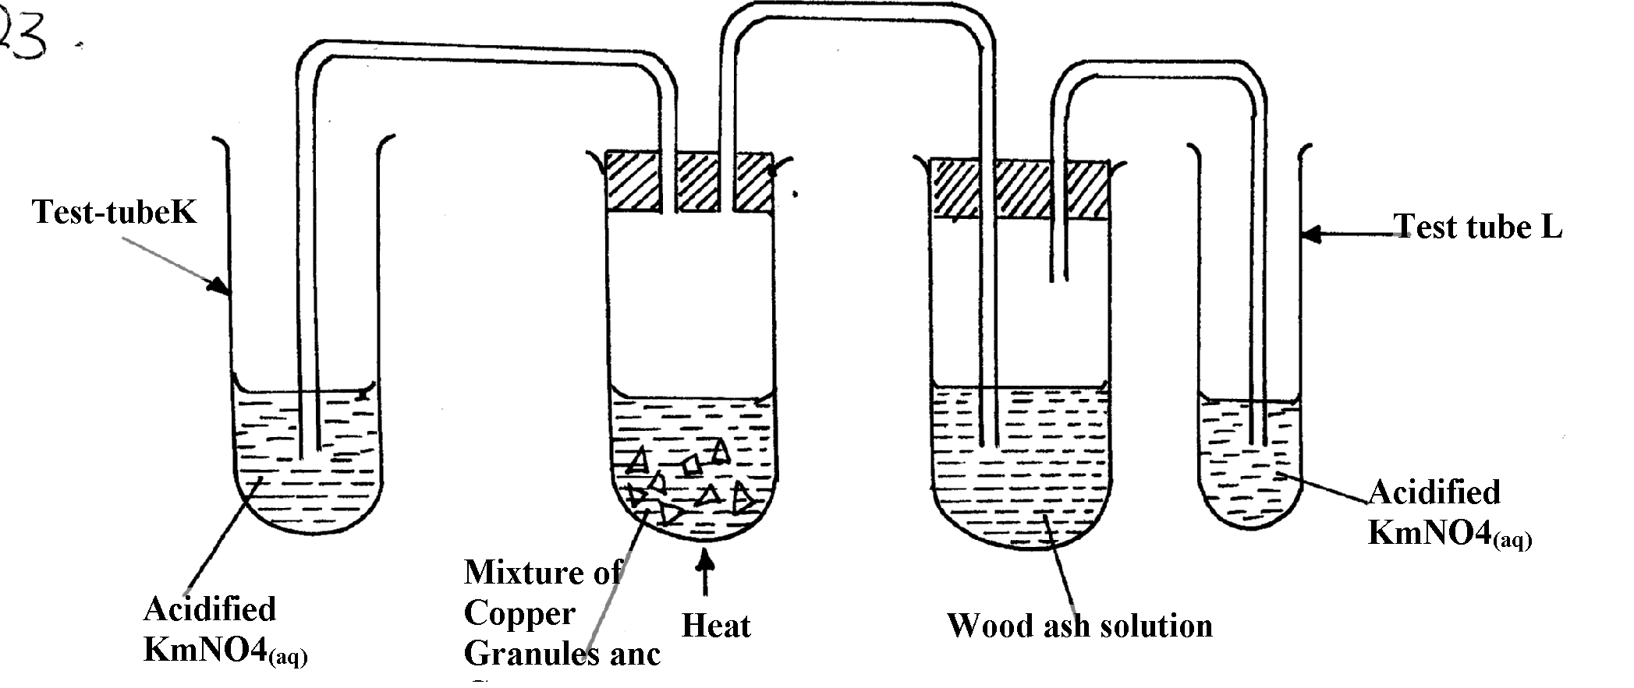

KMnO_{4(aq)}

KMnO_{4(aq)}
and conc. H₂SO₄

State and explain the observations made in:
Test tube L ………………………………………………………………..
Test tube K ………………………………………………………………………..
21. The set-up below was used to prepare and collect hydrogen sulphide gas. Study it and answer
the questions that follow:-

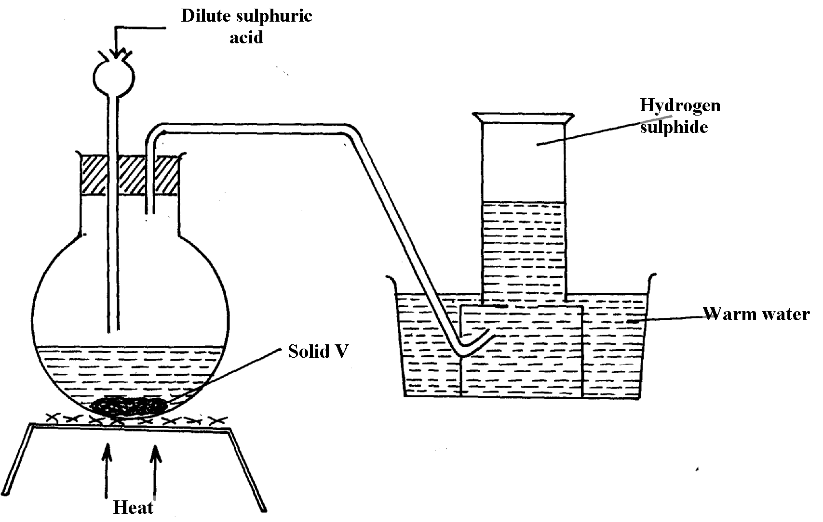

(a) Name solid V
(b) Give a reason why warm water is used in the set-up

22. Sulphur (IV) oxide and nitrogen (II) oxide are some of the gases released from internal
combustion engines. State how these gases affect the environment

23. When hydrogen sulphide gas was bubbled into an aqueous solution of Iron (III) chloride, a
yellow precipitate was formed.
a) State another observation that was made.
b) Write an equation for the reaction that took place.
c) What type of reaction was undergone by hydrogen sulphide in this reaction?

24. In an attempt to prepare Sulphur (IV) Oxide gas, dilute Sulphuric acid was reacted
with barium carbonate. The yield of Sulphur dioxide was found to be negligible.
Explain

Chlorine and its compounds
1. (i) State one observation made in this experiment
(ii) Identify the substances formed in the above reaction
2. Hydrogen chloride gas was passed into water as shown below:
Water
Inverted funnel
Dry hydrogen chloride gas

(a) When a blue litmus paper was dropped into the resulting solution, it turned red. Give a reason
for this observation
(b) What is the function of the funnel?
3. A group of compounds called chlorofluoro-carbons have a wide range of uses but they also have
harmful effects on the environment. State one:-
a) Use of chlorofluoro carbons
b) Harmful effect of chlorofluoro carbons on the environment.
4. a) Water from a town in Kenya is suspected to contain chloride ions but not sulphate ions.
Describe how the presence of the chloride ions in the water can be shown.
5. In an experiment, chlorine was passed into moist hydrogen sulphide in a boiling tube as
shown below:
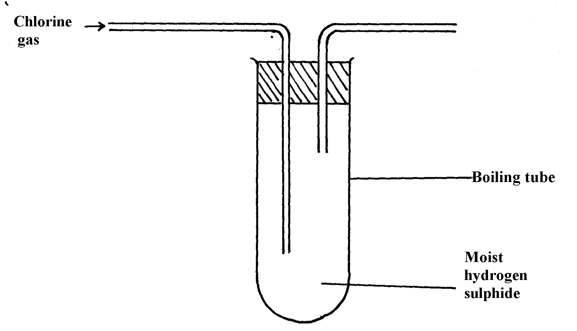

(a) What observation was made in the boiling tube?
(b) Write an equation of the reaction that took place in the boiling tube
(c) What precaution should be taken in carrying out this experiment? Give a reason
6. Heated iron can react with both chlorine gas and hydrogen chloride gas
i) Write equations for the reactions
ii) Chlorine gas has no effect on dry blue litmus paper. Explain
7. The following diagram represents a set-up that can be used in the laboratory to prepare and
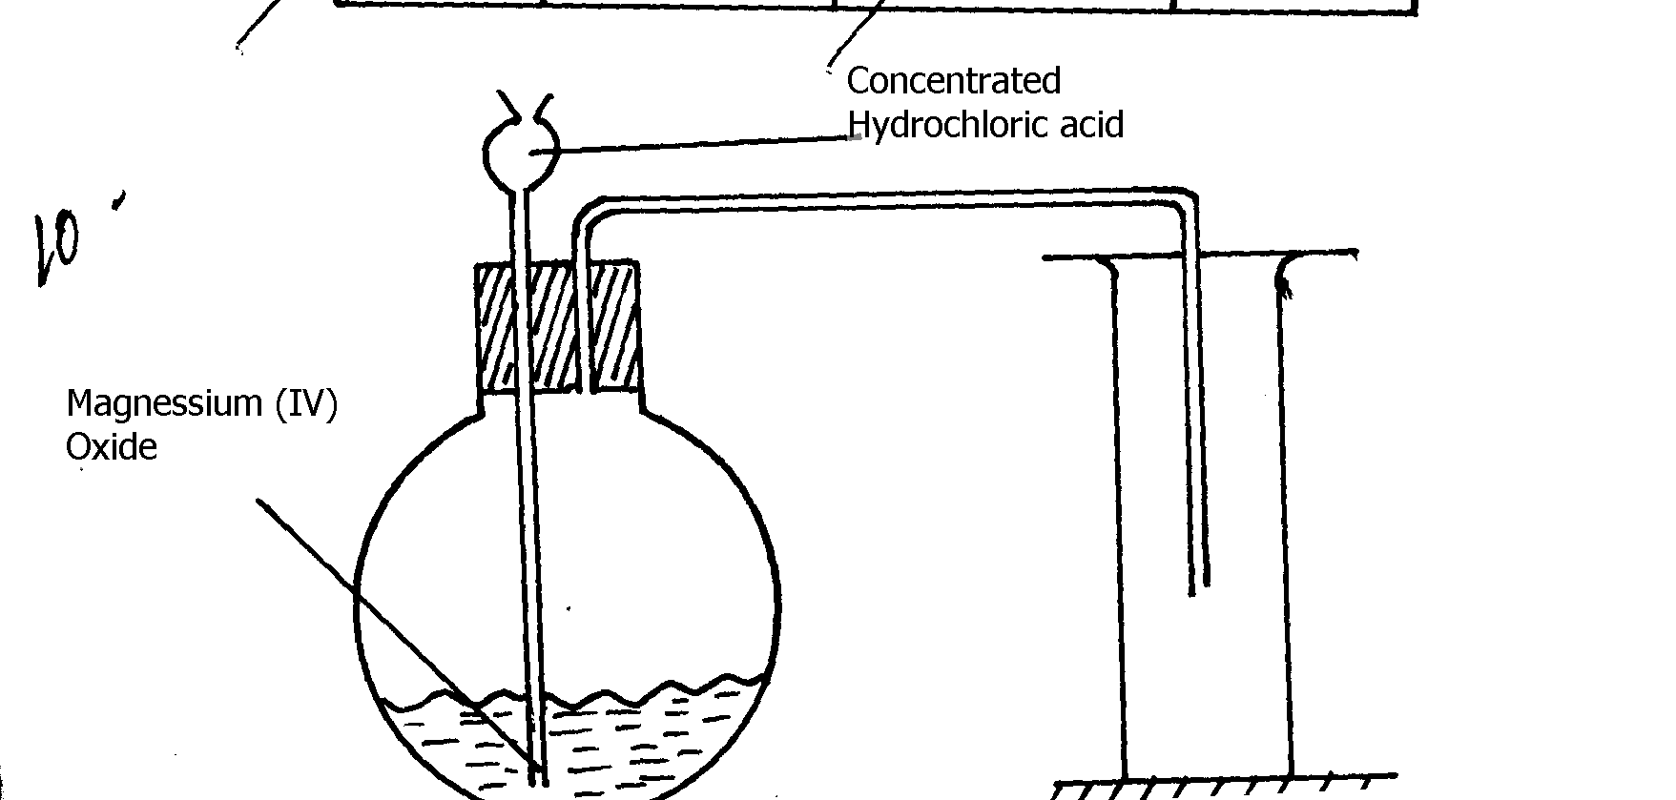
collect a sample of chlorine gas:

Manganese (IV) oxide

(a) No gas bubbles were produced in the above experiment. Explain the observation
(b) Complete the following equation
Cl₂O_{(g)} + H₂O_{(l)}
(c) Describe the bleaching property of chlorine water
8. Study the flow diagram below and answer the questions that follow:
HCl _{(aq)}
MnO₂
Gas L
Cold dilute NaOH
Salt M
NaCl_{(aq)}

(a) Name gas L ……………………………………………………………
(b) Write a balanced equation for the reaction between hydrochloric acid and manganese
(IV) oxide
(c) Explain what happens to coloured petals when dropped into a solution of M
9. Carbon (IV) Oxide, methane, nitrogen (I) Oxide and trichloromethane are green house gases
(i) State one effect of an increased level of these gases to the environment
(ii) Give one source from which each of the following gases is released to the environment;
(i) Nitrogen (I) Oxide
(ii) Tricholomethane

10. (a) Two reagents that can be used to prepare chlorine gas are manganese (IV) oxide and
concentrated hydrochloric acid.
(i) Write an equation for the reaction
(ii) Give the formula of another reagent that can be reacted with concentrated hydrochloric acid
to produce chlorine gas
(iii) Describe how the chlorine gas could be dried and collected in the laboratory

(b) In an experiment, dry chlorine gas was reacted with aluminium as shown in the diagram below

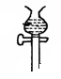
Dry Chlorine gas
Aluminium
Calcium Chloride
A
Heat

(i) Name substance A
(ii) Write an equation for the reaction that took place in the combustion tube
(iii) State the function of the calcium chloride in the set-up above
11. The figure below was set by a student to investigate the reaction between chlorine gas and hydrogen gas:
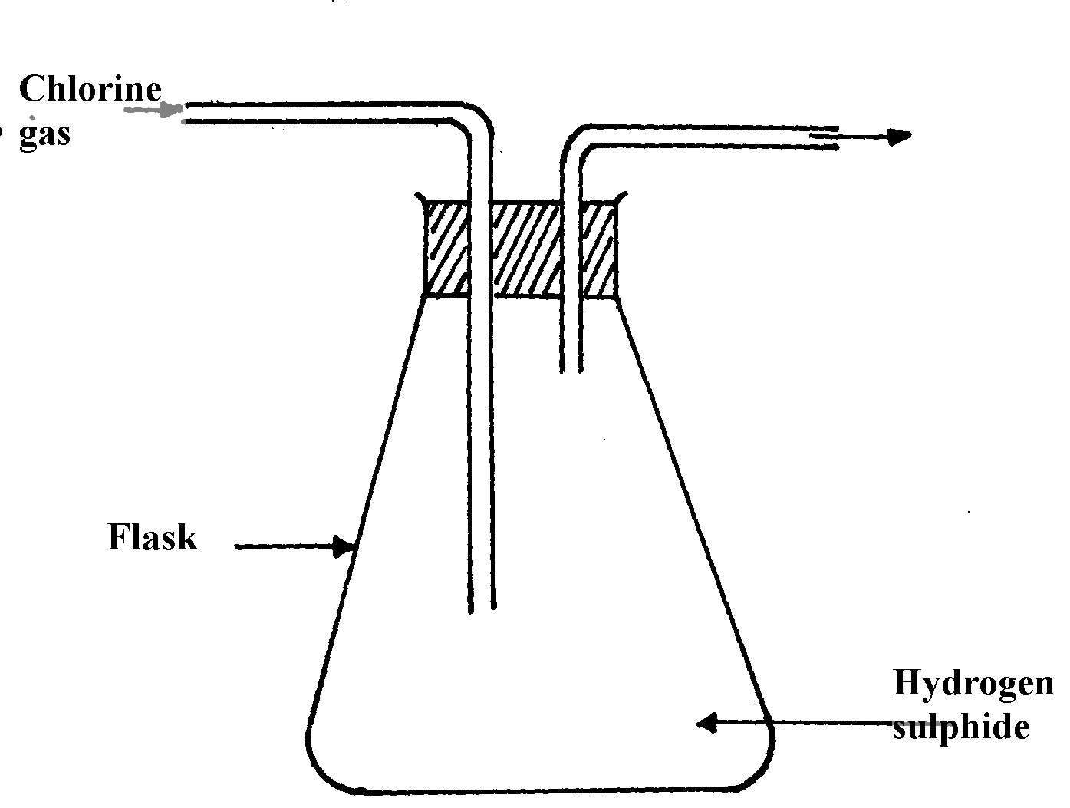
Chlorine gas

Flask
Hydrogen sulphide gas

(a) Write an equation for the reaction that took place in the flask
(b) What observation was made in the flask?
(c) What precaution should be taken in carrying out the experiment?
1
12. In an attempt to prepare a gas, Sabulei added concentrated hydrochloric acid to Potassium manganate. The products were then passed through two wash bottles containing water and concentrated sulphuric acid
(a) Name the gas prepared…………………………………………………………………………
(b) Name the purpose of wash bottle:
(i) Containing water?
(ii) Containing concentrated sulphuric acid?

13. Study the scheme below and answer the questions that follow.
FeSO4 (aq)

Step I
Cl _{2(g)}

Step II
Add NaoH_{(aq)}
and filtrate
Yellow solution F
Brown solid
Solid
+
water
Step III
Heat

(a) Write the formula of the cation present in the yellow solution F
(b) What property of chlorine is shown in Step II?
(c) Write an equation for the reaction in step III

14. (i) Name one drying agent for hydrogen Chloride
(ii) State and explain the observation that would be made when hydrogen Chloride
gas is bubbled into a solution of Silver nitrate

Acids, bases and salts
1. Study the reaction below and answer the questions that follow
NH₃ _{(g)} + H₂O _{(l)} NH₄⁺ _{(aq)} + OH⁻_{(aq)}
(a) Define the term acid
(b) Identify an acid in the above reaction
(c) Explain your answers in (b) above
2. A student mixed equal volumes of Ethanol and butanoic acid. He added a few drops of
concentrated Sulphuric (VI) acid and warmed the mixture
(i) Name and write the formula of the main products
Name………………………………….
Formula……………………………………..
(ii) Which homologous series does the product named in (i) above belong?

3. A sample of water from a village in Trans Mara East District was divided into equal portions
and each mixed with equal volume of soap solution. The observations made are tabulated below:

Sample of water | Treatment before adding soap | Observations made on shaking with soap
I | Boiled | Lather form immediately
II | No treatment | Slight lather form slowly
III | Treatment with washing soda | Lather formed immediately

(a) What type of hardness is present in water from the village. Explain
(b) State one advantage of hard water
4. The solubility of Iron (II) Sulphate crystals are 22ºC is 15.65g per 100g of water. Calculate
the mass of iron(II) sulphate crystals in 45g of saturated solution at the sae temperature

5. Hardness of water may be removed by either boiling or addition of chemicals:
(a) Write an equation to show how boiling removes hardness of water
(b) Name two chemicals that are used to remove hardness of water

6. State one advantage of drinking hard water rather than soft water.

7 Given this reaction;
RNH₂ + H₂O RNH₃⁺ +OH⁻
a) Identify the acid in the forward reaction .Explain
b) Dilute nitric acid can react with a solution of sodium carbonate. Write an ionic equation
for the reaction
8. Magnesium hydrogen carbonate is responsible for the temporary hardness of water.
This type of hardness can be removed by addition of ammonia solution
(a) Describe how temporarily hard water is formed
b) Write an equation to show the softening of temporarily hard water by the addition
of aqueous ammonium solution

K
³⁹
¹⁹

9. When 2M potassium hydroxide solution was added to solution R, a white precipitate T was
formed which dissolved in excess potassium hydroxide solution to form solution L. solution
R forms a white precipitate with sodium chloride solution:
(a) Identify the cation in solution R ......................................................................
(b) Name precipitate T ..............................................................................
(c) Write the molecular formula of the compound in solution L

10. Below is a table showing the solubilities of salts Q and R at different temperatures.
Temperature ºC |  | 0 | 10 | 20 | 30 | 40 | 50
Solubilities in grammes per 100g of water | Salt Q | 3.0 | 5.0 | 7.4 | 10.0 | 14.0 | 19.0
Solubilities in grammes per 100g of water | Salt R | 15.0 | 17.0 | 20.7 | 25.7 | 28.7 | 33.0

(a) Define the term “Solubility of salt”
(b) If both salts Q and R are present in 100cm³ of saturated solution at 50ºC, what will
be the total mass of crystals formed if the solution was cooled to 20ºC?
11. The following results were obtained during an experiment to determine the solubility of potassium
chlorate(V)in water at 30ºC.
Mass of evaporating dish =15.86g
Mass of evaporating dish + saturated solution at 30ºC = 26.8g
Mass of evaporation dish +solid potassium chlorate (v) after evaporation to dryness=16.86g
Calculate the mass of the saturated solution containing 60.0g of water at 30ºC
12. (a) What is meant by the term solubility of salts?
(b) Calculate the solubility of salt given that 15g of the salt can saturate 25cm³ of water
(c) The table below gives the solubility of salt X in grams per 100g of water at different
temperatures
Temp ºC | 10 | 20 | 30 | 40 | 50 | 60 | 70 | 80 | 90 | 100
Solubility (g/100g) water | 5.0 | 7.5 | 10.5 | 14.0 | 18.5 | 24.0 | 30.0 | 38.0 | 46.0 | 50.1

(i) Plot a solubility curve for salt X (solubility in g /100g water Y- axis) (temp ºC (X –axis)
(ii) What is meant by the points plotted in (i) above?..................................................................
(iii) From your graph determine the solubility of salt X at the following temperatures
I 44ºC ………………………………………….
II 62ºC ………………………………………. .
(iv) What mass of crystals of the salt will be formed if the solution was cooled from
62ºC to 44ºC
(v) Name two areas where knowledge of solubility curves is applied
13. You are given a mixture of Lead (II) Chloride, Iodine, ammonium chloride and sodium chloride.
Explain how you would separate all the four solids using methylbenzene, a source of heat and
water
14. (a) The table below shows the solubility of potassium chlorate at different temperatures

Temperature (ºC ) | 10º | 20º | 30º | 40º | 50º | 60º | 70º
Solubility g/100g water | 27 | 30 | 36 | 55 | 80 | 110 | 140
(i) Plot a graph of solubilities of potassium chlorate against temperature
(ii) Using your graph:
(I) Determine the solubility of potassium chlorate at 47ºC
(II) Determine the concentration in moles per litre of potassium chlorate at 47ºC
(K= 39, Cl = 35.5, O= 16) density of solution = 1g/cm³
(III) Determine the mass of potassium chlorate that would crystallize if the solution
is cooled from 62ºC to 45ºC
(b) In an experiment to determine the solubility of sodium hydroxide, 25cm³ of a saturated
solution of sodium hydroxide weighing 28g was diluted in a volumetric flask and the
volume made to 250cm³ mark. 20cm³ of this reacted completely with 25cm³ of 0.2M
hydrochloric acid according to the equation.
NaOH_{(aq)} + HCl_{(aq)} NaCl_{(aq)} + H₂O_{(l)}

Calculate:
(i) The number of moles of hyrdrochloric acid used
(ii) The number of moles of sodium hydroxide in 20cm³
(iii) The moles of sodium hydroxide in 250cm³ of solution
(iv) The mass in grams of sodium hydroxide in 250cm³ of solution
(v) The solubility of sodium hydroxide in g/100g water
15. a) Define the term solubility of a substance
b) The table below shows the solubilities of two salts L and M at different temperatures.

Temperature(ºC) |  | 10 | 20 | 30 | 40 | 50
Solubility in g/100g  of water. | L | 11.0 | 14.0 | 20.1 | 28.0 | 36.0
Solubility in g/100g  of water. | M | 15.0 | 17.0 | 19.0 | 21.2 | 25.0
i) Name the method that can be used to separate the two salts
ii) Plot on the same axes a graph of solubilities of L and M against temperature
iii) From the graph determine:-
The temperature at which solubilities are equal
The solubility at the temperature mentioned above
iv) If the relative formula mass of M is 132, determine the concentration of M in moles per litre
in (iii) II above

16. The graph below shows the changes in conductivity when 50cm³ of 0.1M Nitric (V) acid
is titrated with potassium hydroxide (curve I) and when 50cm³ of 0.1M methanoic acid is
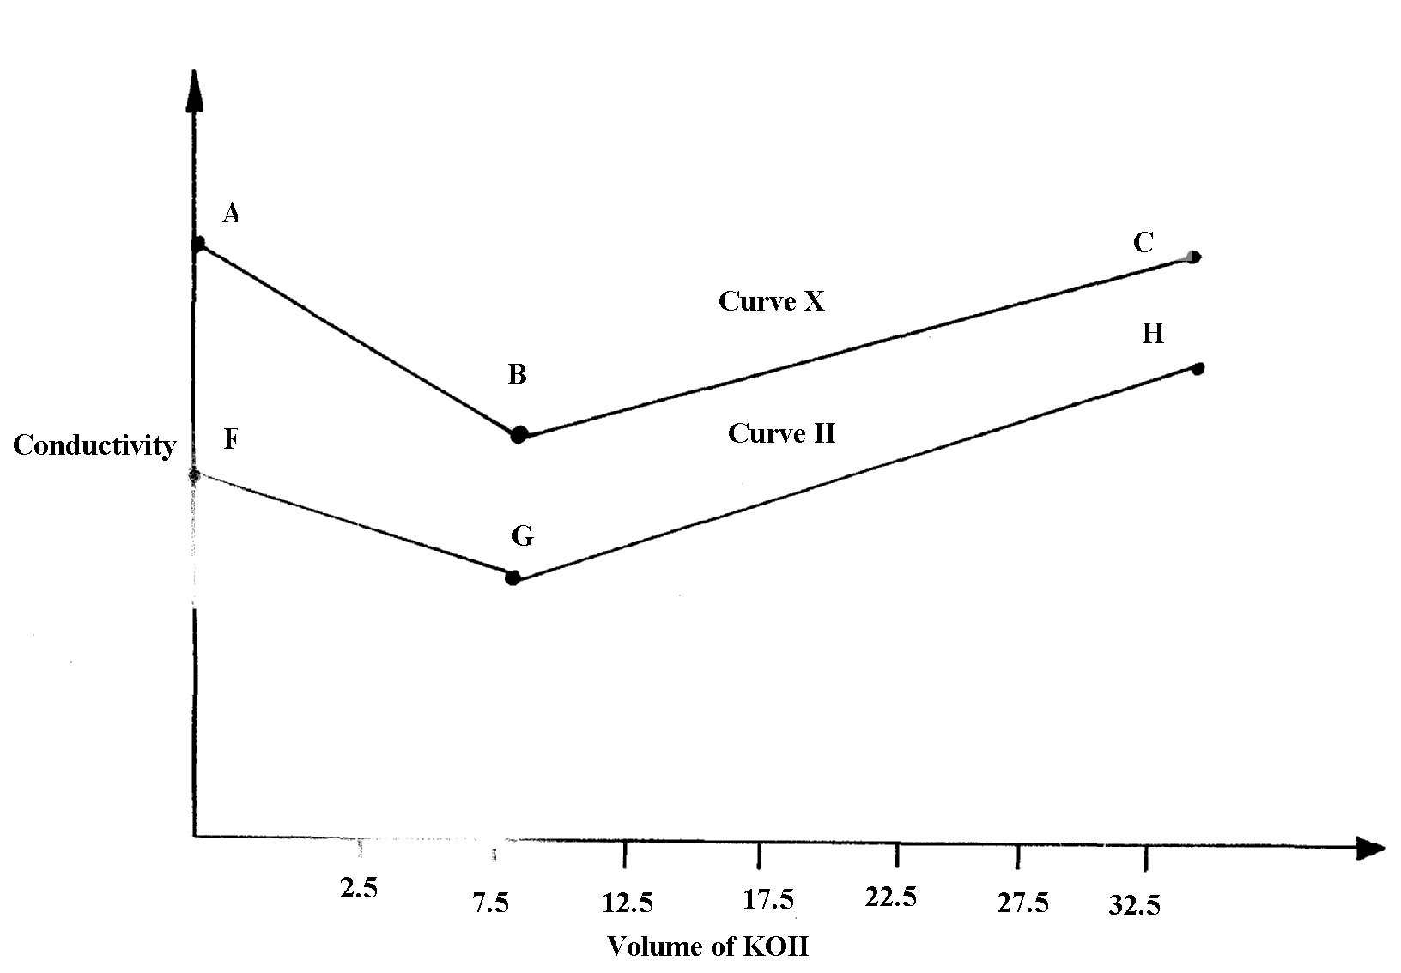
reacted with the same potassium hydroxide solution (curve II)

I

0

(a) (i) Explain the changes in conductivity in the regions:
AB…………… BC………………………………………………….
(ii) Using curve (I), explain why the conductivity does not have a value of zero
at end-point
(iii) Calculate the concentration of KOH with reference to curve II
(iv) Explain why the two curves shows different trends in conductivity
(b) 50cm³ of 0.1M methanoic acid was reacted with 20cm³ of a solution of sodium
carbonate of unknown concentration. Work out the concentration of the carbonate

17. The flow charts below show an analysis of a mixture R that contains two salts. Study the
analysis and answer the questions that follow:-
(a)
Mixture R
Step I
Residue
Two metallic oxides, H₂O_{(g),} CO_{2(g),} NO_{2(g),} O_{2(g)}
Step II
Add HCl_{(aq)}

Add HCl(aq)
Colourless solution
Add excess NaOH_{(aq)} to a portion of X

Filtrate X
Step III
Add excess NH₃ _{(aq)}

to a portion of X
Colourless solution

(i) State:-
(I) The condition in step I
(II) The process in step II
(ii) A small portion of mixture R is added to dilute nitric (V) acid in a test-tube. What would be
observed?
(iii) Write an equation for the reaction between the cation in filtrate X and sodium hydroxide
solution
(iv) Explain how water vapour in step I could be identified
Mixture R
Step IV
Add water
then filter

Add HCl(aq)
Residue U
Filtrate W

Step VI
Colourless solution
Step V
Add H₂SO_{4(aq)}
Add excess NH_{3(aq)}
to apportion of Z
Add excess NaOH_{(aq)}
to a portion of Z
Solution Z + CO₂
White precipitate
(b)

(i) State and explain the conclusion that can be made from step IV only
(ii) Name the anion present in residue U. Explain

(iii) From the flow chart in (a) and (b);
(I) Write the formulae of cations present in mixture R

18. a) Define the term solubility of a substance.
b) The table below shows the solubilities of two salts L and M at different temperatures.

Temperature (ºC) | Type of salt | 10 | 20 | 30 | 40 | 50
Solubility g/100g of water | L | 11.0 | 14.0 | 20.1 | 28.0 | 36.0
Solubility g/100g of water | M | 15.0 | 17.0 | 19.0 | 21.2 | 25.0

(i) Name the method that can be used to separate the two salts.
(ii) Plot on the same axes a graph of solubilities of L and M against temperature
(iii) From the graph, determine:
I. The temperatures at which solubilities are equal
II. The solubility at the temperature mentioned above (iv) If the relative formula mass of M is 132, determine the concentration of
M in moles per litre in (iii) II above.
v) A solution contains 38g of L and 22g of M at 50°C. Calculate the total mass of crystals
obtained in cooling this solution to 30°C.

19. a) Define:
(i) A saturated solution.
(ii) Solubility of a solute.
b) In an experiment to determine solubility of sodium chloride, 10.0 cm³ of a saturated solution of
sodium chloride weighing 10.70g were placed in a volumetric flask and diluted to a total of 500
cm³. 25.0 cm³ of the diluted solution of sodium chloride reacted completely with 24.0 cm³ of
0.1M silver nitrate solution. The equation for the reaction is
AgNO₃(_{aq}) + NaCl (_{aq}) AgCl (_{s}) + NaNO₃ (_{aq})
I. Calculate;
(i) Moles of silver nitrate in 24.0 cm³ of solution.
(ii) Moles of NaCl in 25.0 cm³ of solution.
(iii) Moles of NaCl in 500 cm³ of solution.
(iv) Mass of NaCl in 10.0 cm³ of saturated sodium chloride (Na = 23, Cl = 35.5)
(v) Mass of water in 10.0cm³ of saturated solution.
(vi) The solubility of NaCl in g/100g of waters.

20. Describe how you would prepare a dry sample of crystals of potassium sulphate starting with
100cm³ of 1M sulphuric (VI) acid.
21. The table shows solubility of potassium chlorate V
Temp (ºC) | 45ºC | 80º
Solubility | 39 | 63
(a) Calculate the mass of solute and solvent in 90g of the saturated solution of the salt at 45ºC
(b) A solution of the salt in 100g water contains 63g at 95ºC. At what temperature will the
solution start forming crystals when cooled
22. Two samples of hard water C and D were boiled. When tested with drops of soap, sample
D formed lather easily while C did not:-
(a) Name the possible salt that caused hardness in sample D
(b) Explain how distillation can remove hardness in sample C
(c) Give one advantage of hard water
23. A student attempted to prepare a gas using the set-up below. She could not collect any gas

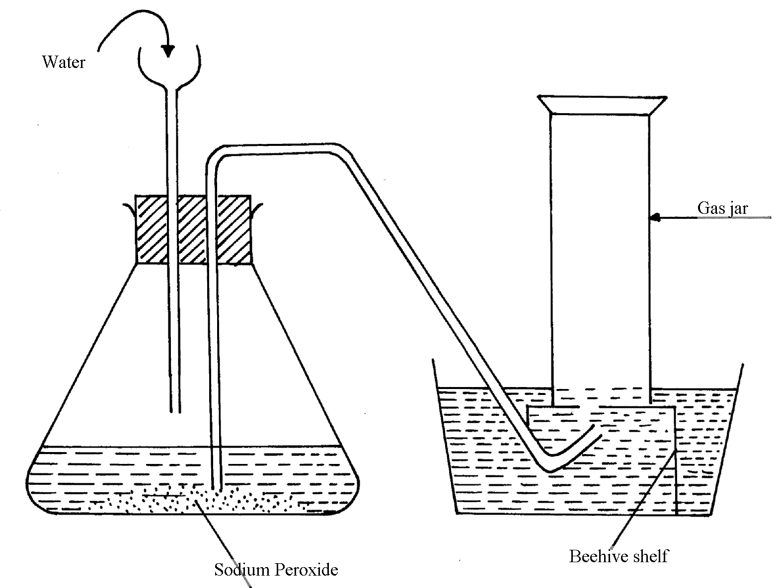

(a) Give two reasons why no gas was collected
(b) Which gas did the student intend to prepare?
24. Water from a town in Kenya is suspected to contain chloride ions but not sulphate ions.
(a) Describe how the presence of chloride ions in the water can be shown
(b) State one advantage of drinking hard water rather than soft water
25. Study the following tests and observation and answer the questions that follow:-
 | TEST | OBSERVATION
I | - Add few drops of acqueous ammonia to copper (II) nitrate solution | - Light blue precipitate is formed
II | - Add excess of ammonia to copper (II) nitrate | - Deep blue solution
III | - Add cold dilute hydrochloric acid to substance E1 and warm gently | - Gas evolved, smells of rotten eggs and blackens lead acetate paper
Identify:-
(a) Substance responsible for:
I. Light blue precipitate…………………………………………………………………
II. Deep blue solution …………………………………………………………….
(b) Gas evolved in test III above …………………………………………………………

26. (i) What is meant by the term solubility of salts?
(ii) Calculate the solubility of a salt given that 15g of the salt can saturate 25cm³ of water.
27. (a) Draw a well labeled diagram to show how to prepare an acqueous solution of hydrogen
chloride gas
(b) Name one other gas whose aqueous solution can be prepared in the same way
28. In an experiment to determine the solubility of solid Y in water at 30ºC the following results
were obtained; *MAT
Mass of empty evaporating dish = 26.2g
Mass of evaporating dish + saturated solution = 42.4g
Mass of evaporating dish + dry solid Y = 30.4g
(a) Use the data to calculate the solubility of solid Y at 30ºC
(b) State one application of solubility curves and values

29. Study the table below showing the solubility of substance K at various temperatures
Temperature (ºC ) | Solubility (g/100g water)
0  30  70  100 | 30  24  19  14

(a) What would happen if a sample of a saturated solution of the substance at 30ºC is
heated to 70ºC. Explain.
(b) What is the most likely state of substance K..................................................................
30. In the equilibrium given below:-
Fe³⁺_{(aq) +} SCN_{(aq)} [Fe(SCN)]²⁺ _{(aq)}
Brown Red
What would be observed when Iron (III) Chloride is added to the equilibrium mixture. Explain
31. Sodium Carbonate Decahydrate crystals were left exposed on a watch glass for two days.
a) State the observations made on the crystals after two days.
b) Name the property of salts investigated in the above experiment

32. The label on a bottle of mineral; water had the information below.
Ions present | Concentration (g/litre)
Ca²⁺  Mg²⁺  Na+  K+  SO₄  HCO₃ | 0.10  0.20  0.01  0.01  0.14  0.26
²⁻
⁻

(a) Name the compound that causes temporary hardness in the mineral water.
(b) Using an equation, describe how the water can be made soft by adding sodium
carbonate solution.
(c) Give one advantage of drinking mineral water such as the one above

33. A solution of hydrogen chloride gas in methylbenzene has no effect on calcium carbonate.
A solution of hydrogen chloride in water reacts with calcium carbonate to produce a gas. Explain
34 (i) Is concentrated sulphuric acid a weak acid or a strong acid?
(ii) Explain your answer in (i) above.
35. When water reacts with potassium metal the hydrogen produced ignites explosively
on the surface of water.
(i) What causes this ignition?
(ii) Write an equation to show how this ignition occurs
36. In an experiment, soap solution was added to three samples of water. The results below
show the volume of soap solution required to lather with 500cm3 of each water sample
before and after boiling
 | Sample 1 | Sample 2 | Sample3
Volume of soap used before water boiled | 26.0 | 14.0 | 4.0
Volume of soap after water boiled | 26.0 | 4.0 | 4.0
(i) Which water samples are likely to be soft?
(ii) Explain the change in volume of soap solution used in sample 2
1
37. How does the pH value of 0.25M KOH_{(aq)} compare with that of 0.25M ammonia solution

Energy changes in chemical and physical processes

1. 6g of Potassium nitrate solid was added to 120cm³ of water in a plastic beaker.
The mixture was stirred gently and the following results were obtained.
Initial temperature = 21.5ºC
Final temperature = 17.0 ºC
(a) Calculate the enthalpy change for the reaction
(Density =1g/cm³, C= 4.2jg⁻¹K⁻¹)
(b) Calculate the molar enthalpy change for the dissolution of potassium nitrate
(K=39, N= 14, O =16)

2. (a) The heat of combustion of ethanol, C₂H₅OH is 1370KJ/mole.
(i) What is meant by heat of combustion?
(ii) Calculate the heating value of ethanol
(H = 1.0, C = 12.0, O = 16.0)
3. Use the information below to answer the questions that follow:-
Ca_{(s)} + ½ O_{2(g)} CaO_{(s)} ΔH =-635KJ/mol
C_{(s)} + O_{2(g)} CO_{2(g)} ΔH= -394KJ/mol
Ca_{(s)} + C_{(s)} + ³/₂O_{2(g)} CaCO₃ ΔH = -1207KJ/mol
Calculate the enthalpy change for the reaction:
Ca_{(s)} + CO_{2(g)} CaCO_{3(s)}
4. 0.92g of ethanol were found to burn in excess air producing a temperature rise of 32.5ºC
in 200cm³ of water.
C=12.0 H=1.0 O=16.0
Density of water 1g/cm³
Specific heat capacity of water 4.2kj kg⁻¹k⁻¹
a) Write the equation for combustion of ethanol
b) Determine the molar heat of combustion of ethanol
5. Study the information in the following table and answer the questions that follow. The letters
do not represent the actual chemical symbols of the elements.
ELEMENT | U | V | W | X | Y | Z
NUMBER OF PROTONS | 18 | 20 | 6 | 16 | 19 | 17
NUMBER OF NEUTRONS | 22 | 20 | 8 | 16 | 20 | 20
Which of the above elements are:
(i) Likely to be radioactive?
(ii) Able to form a compound with the highest ionic character?

6. The diagram below shows energy levels for the reaction

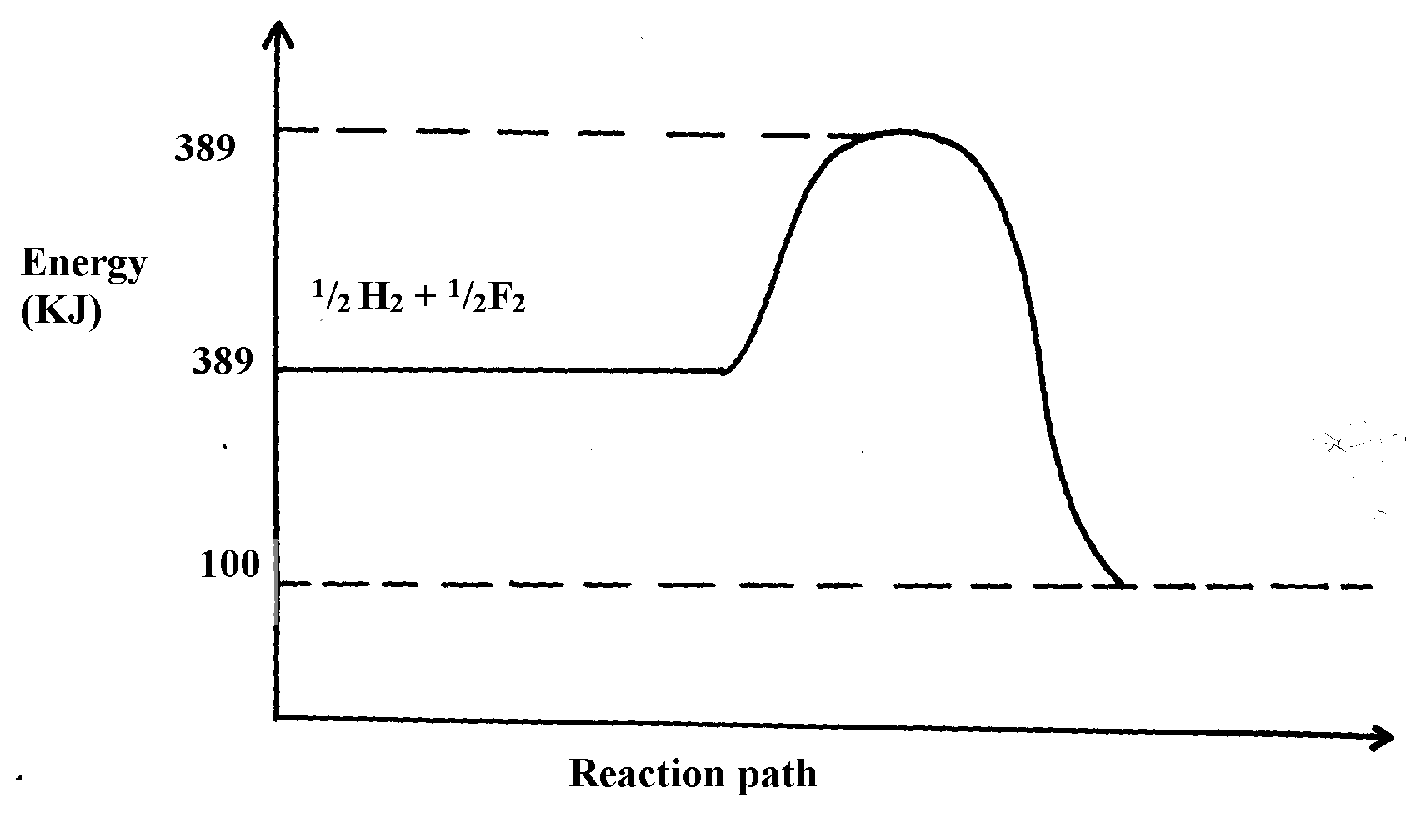
½ H_{2(g)} + ½ F_{2(g)} HF_{(g)}

(a) Work out the activation energy for the reaction
(b) Calculate the heat of formation of HF
(c) Is the reaction endothermic or exothermic?
7. Using the heats of combustion of the following substances, calculate the heat of formation
of ethanol
C_{(s)} + O_{2 (g)} CO_{2 (g)}; ΔH = -393KJmol⁻¹
H_{2 (g)} + ½ O_{2 (g)} H₂O_{(l)};ΔH = -286KJmol⁻¹
CH₃CH₂OH_{(l)} + O_{2 (g)} 2CO_{2 (g)} + 3H₂O _{(l)} ;ΔH = 1386KJmol⁻¹

8. Nitrogen and hydrogen react reversibly according to the equation:-
N_{2(g)} + 3H_{2(g)} 2NH_{3(g); Δ}H = -92kjmol⁻¹
The energy level diagram for the above reaction is shown below:-
N_{2(g)} + 3H_{2(g)}
2NH_{3(g)}
Reaction path
Energy
(KJ)

(a) How would the yield of ammonia be affected by:
(i) A decrease in temperature
(ii) An increase in pressure
(b) How does a catalyst affect reversible reaction already in equilibrium?
(c) On the above diagram, sketch the energy level diagram that would be obtained when
iron catalyst is added to the reaction

9. Study the table below and answer the questions that follow
Bond type bond energy kJmol⁻¹
C-C 346
C = C 610
C-H 413
C-Br 280
Br-Br 193
a) Calculate the enthalpy change for the following reaction
C₂H_{4(g)} + Br_{2(g)} C₂H₄Br_{2(g)}
b) Name the type of reaction that took place in (a) above

1 mark
10. Bond energies for some bonds are tabulated below:-
BOND | BOND ENERGY KJ/mol
H – H | 436
C = C | 610
C- H | 410
C - C | 345

Use the bond energies to estimate the enthalpy for the reaction
C₂H_{4(g)} + H_{2(g)} C₂H_{6(g)}

11. The able shows the results obtained when 20.2g of potassium nitrate was added in
50cm³ of water.
Time in (min) | 0.0 | 0.3 | 1.0 | 1.3 | 2.0 | 2.3 | 3.0 | 3.3 | 4.0
Temperature (ºC ) | 25.0 | 25.0 | 25.0 | 25.0 | 17.0 | 17.0 | 20.0 | 20.0 | 20.0
(i) Draw the graph of temperature against time
(ii) Using the graph, determine the temperature change
(iii) Calculate the heat change
(iv) Find the molar heat of solution of potassium nitrate
12. When 1.6g of ammonium nitrate were dissolved in 100cm³ of water, the temperature
dropped by 6ºC. Calculate its enthalpy change. (Density of water = 1g/cm³,
specific heat capacity is 4.2kJ kg⁻¹K⁻¹)

13. Sodium hydrogen carbonate was strongly heated.
a) Write an equation for the reaction
b) The grid below shows part of the periodic table. Use it to answer the questions that follow. The
letters are not the actual symbols.
A
B
L
F
G
C
H
K
D
J
E

i) Write the equation for the reaction that occurs between elements L and D
ii) The oxide of G reacts with both hydrochloric acid and sodium hydroxide. What is the nature of
the oxide of G?
iii) Explain why elements H has a higher boiling points than element D.
iv) State one use of element E
v) Compare and explain the atomic radius of B and C
vi) 11.5g of L was completely burnt in oxygen .Calculate the volume of gas that was used.
(L = 23, molar gas volume at room temperature is 24dm³)
14. A student has been provided with sodium hydroxide solution of 2M and hydrobromic acid
of 4M. He was asked to investigate the equation for the reaction between these two substances and
hence determine the molar enthalpy of neutralization. He carried out the reaction and obtained the
following results:-

Vol. of 4M Hydrobromic acid added to 20cm³ of 2M NaOH | Temperature of the mixture (ºC)
4.0 | 26.8
6.0 | 30.0
8.0 | 33.2
10.0 | 36.0
12.0 | 35.2
14.0 | 34.4
20.0 | 30.8

(a) Draw a graph of the temperature of the mixture (vertical axis against the volume of the
acid added) *
(b) Using the graph estimate the temperature of the mixture when 17cm³ of the acid was added
(c) Both solutions were at room temperature at the start of the experiment. Use your graph to
estimate the room temperature (½mk)
(d) What is the significance of the highest temperature of the solution mixture? *
(e) The temperature of the mixture increased during the first additions of the acid. Why did the
temperature increase? *
(f) Suggest a reason why the temperature decreased during the latter part of the experiment
(g) Use your graph to determine the volume of 4M Hydrobromic acid which just neutralize
20cm³ of 2M NaOH *
(h) How many moles of Hydrobromic acid are present in your answer in (g) above? *
(i) How many moles of NaOH are present in 20cm³ of 2M of NaOH solution? *
(j) Use your answers in (h) and (i) above to write an equation of the reaction taking place
in the experiment. Explain clearly how you have used your answers (1½mks)
(k) Determine the molar enthalpy of neutralization of hydrobromic acid (1½mks)

15. (a) The following results were obtained in an experiment to determine the enthalpy of solution
of sodium hydroxide
Mass of plastic beaker = 8.0g
Mass of plastic beaker + distilled water = 108.15g
Mass of plastic beaker + distilled water + sodium hydroxide = 114.35g
The table below shows the temperature at fixed times after mixing
Time/seconds | 0 | 30 | 60 | 90 | 120 | 150 | 180 | 210
Temperature ( ºC) | 15 | 21 | 29 | 28 | 27 | 26 | 26 | 25
(i) Plot a graph of temperature (y-axis) against time (x-axis)
(ii) From your graph, determine the maximum temperature attained
(iii) Determine the temperature change of the reaction
(iv) Calculate the number of moles of sodium hydroxide used in the experiment
(Na = 11, H = 1, O = 16)
(v) Use your results to determine the molar enthalpy solution of sodium hydroxide. (Density of
solution is 1g cm⁻³ , specific heat capacity of solution = 4.18 KJ⁻¹K⁻¹)
(b) Below is an energy level diagram of the exothermic reaction
CH_{4(g)} + 2O_{2(g)} CO_{2(g)} + 2H₂O_{(l)} ΔH = -890KJ
ΔH = -890KJ

CO_{2(g)} + 2H₂O_{(l)}
CH_{4(g)} + 2O_{2(g)}

Examine the energy level diagram below and use it to answer the questions that follow
2H_{(g)} + ½ O_{2(g)}
2H_{(g)} + O_{2(g)}
H_{2(g)} + ½ O_{2(g)}
ΔH₂
ΔH₁
ΔH₃
ΔH₄

H₂O_{(l)}
H₂O_{(gl)}

.

(b) (i) Which ΔH values will have negative sign?
(ii) What physical change is being represented where enthalpy change ΔH₄ is involved? ( ½mk)
(iii) In terms of ΔH₁, ΔH₂, ΔH₃ and ΔH₄, give the overall enthalpy change for the reaction:-
H_{2(g)} + ½ O_{2(g)} H₂O_{(l)}
(iv) Is the reaction in (iii) above exothermic or endothermic?
16. (I) Study the graph below and answer the questions which follow:
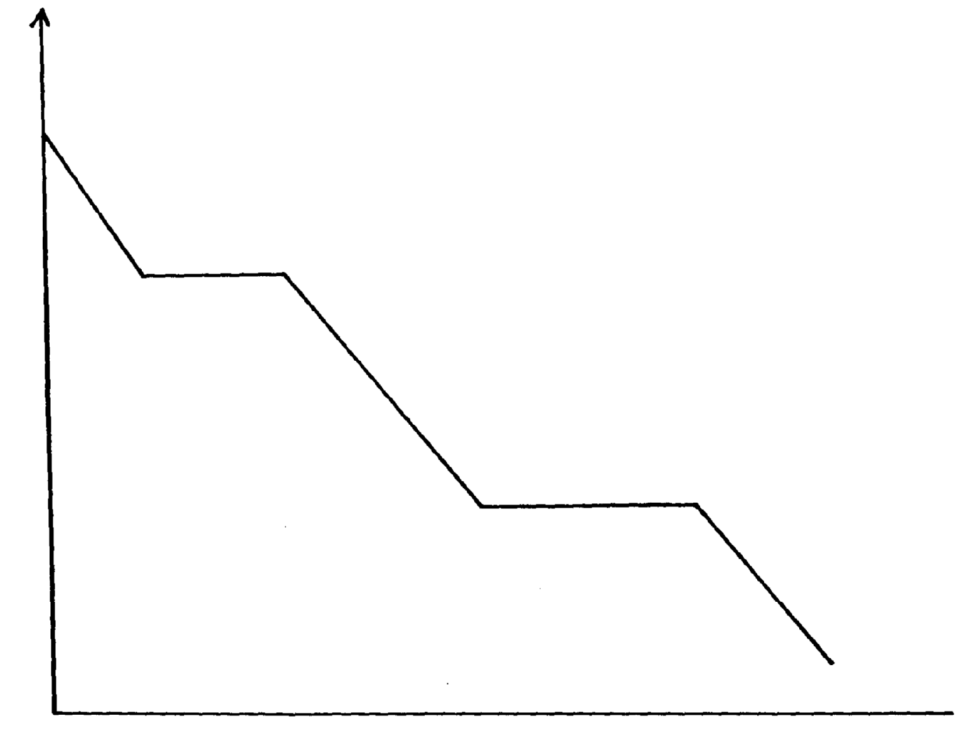

Energy – KJ/mol)

A
B
C
Time

D

E

(a) Distinguish between molar latent heat of fusion and molar latent heat of vaporization
(b) (i) Explain the changes occurring between points
BC ………………………………………… CD ………………………
(ii) In an experiment to determine molar enthalpy of neutralization of hydrochloric acid using
potassium hydroxide, the data below was obtained. The concentration of potassium hydroxide
used was 0.5M
Volume of 0.5M KOH (cm³) | 0 | 5 | 10 | 15 | 20 | 25 | 30 | 35
Total volume of acid + Base | 20 | 25 | 30 | 35 | 40 | 45 | 50 | 55
Temperature (ºC) | 24 | 26 | 27 | 28 | 29 | 29 | 28 | 27
(i) Plot a graph of temperature (y-axis) against volume of potassium hydroxide used

(ii) From your graph:
(a) Determine the temperature change
(b) Find the volume of potassium hydroxide which completely neutralized 20cm³ of the acid
(iii) Calculate the heat change for the reaction (C = 4.2Jg⁻¹K⁻¹ density of solution = 1g/dm³)
(iv) Calculate the molar enthalpy of neutralization of hydrochloric acid with potassium hydroxide
17. A typical electrolysis cell uses a current of 40,000 amperes. Calculate the mass
(in Kg of aluminium produced in one hour). (Al = 27) (Faraday = 96500Coloumbs )
18. (a) Biogas is a mixture of mainly Carbon (IV) Oxide and methane.
(i) Give a reason why biogas can be used as a fuel
(ii) Other than fractional distillation, describe a method that can be used to determine the
percentage of methane in biogas
19. Consider the following equilibrium reaction.
H₂(g) + Cl₂(g) 2HCl(g) ΔH= -74.4KJ
a) State and explain the effect of formation of hydrogen chloride if pressure was increased
in the equation above

20. Turning of fossil fuels has adverse environmental effects:-
a) Name two pollutants from the burning of petroleum products
b) Give one precaution taken to minimise the pollution by fossil fuels

21. (a) Define molar heat of neutralization
(b) The rise in temperature when 50cm³ of sodium hydroxide is reacted with two acids is given
in the table below:-
Acid | 50cm³ of HCl | 50cm of Oxalic acid
Temp rise (ºC) | 7 | 4
(i) Explain the difference in the temperature.
22. Calculate the latent heat of vaporization of water
H₂O_{(l)} H₂O_{(g)}
Given the following thermo chemical equations:-
H_{2(g)} + ½O_{2(g)} H₂O_{(g)} ΔH^{θ}= -242KJ/Mol
H_{2(g)} + ½O_{2(g)} H₂O_{(l)} ΔH^{θ}= -286KJ/Mol

23. (a) Define the term fuel
(b) State four reasons why wood fuel is chosen for domestic cooking

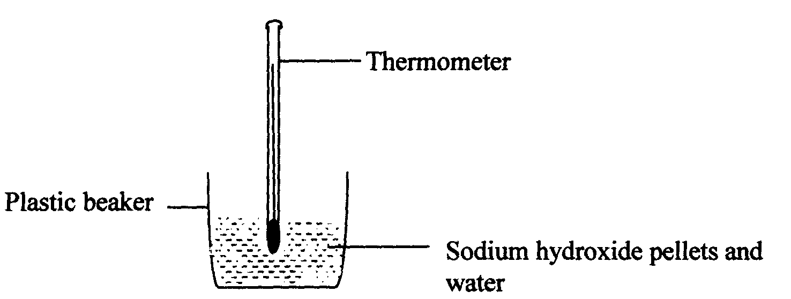
24. The setup bellow was used to investigate the changes that take place when sodium hydroxide
pellets dissolve in water.

a) Why is a plastic beaker used instead of a metallic beaker?
b) State and explain the observations made in the above reaction
25. (a) What is a fuel? (1mark)
(b)Other than the cost, state two other factors to consider when choosing a fuel.

26. The equation below represents changes in the physical state of ions metal:
Fe_{(s)} Fe_{(l)} DH= + 15.4kjmol⁻¹
Fe_{(l)} Fe_{(g)} DH=+354kjmol⁻¹
a) Calculate the amount of heat energy required to change 10kg of solid iron to gaseous iron
Fe = 56
b) Iodine can react with chlorine as shown below:-
I_{2(g)} + Cl_{(g)} 2lcl_{(s)} DH= -68kJ
Determine the molar enthalpy change for this reaction
c) Draw an energy level diagram for the reaction in (b) above
27. Study the diagram below and answer the questions that follow:

NH₄⁺(g) + Cl⁻(g)
∆H₂

NH₄⁺(_{aq}) + Cl⁻(_{aq})
∆H₃
∆H₁
NH₄Cl(_{s})
Energy
Reaction Co-ordinate
Reaction Co-ordinate

a) What do ∆H₁ and ∆H₂ represent?
∆H₁ …………………………………………………………………….
∆H₂ ……………………………………………………………………..
b) Write an expression to show the relationship between ∆H₁, ∆H₂ and ∆H₃.

Reaction rates and reversible reactions
1. Study the following equilibrium reaction and answer the questions that follow:-
HL_{(aq)} + H₂O(_{l)} H₃O⁺(aq) L⁻(aq)
Red
Blue

Given that in an acid solution, H₃O⁺_{(aq)} act in place of hydrogen ions, H⁺, according to the
equation.
H₃O_{(aq)} + OH⁻_{(aq)} 2H₂O_{(l)}
Explain what would be observed when potassium hydroxide solution is added to the above equilibrium mixture

2. The scheme below shows the energy changes that take place between ice, water and steam.
Study it and answer the questions that follow:-
H₂O_{(s)} H₂O_{(l)} H₂O_{(g)}
ΔH₂
ΔH₁
ΔH₄
ΔH₃

(a) What name is given to the energy change ΔH₄?
(b) What is the sign ΔH₃, give a reason

3. The table below gives bond energies for three covalent bonds

Bond | Bond energy (KJmol-1)
H –H  Cl – Cl  H – Cl | 435  240  430

(a) Calculate the energy change for the following reaction:
H_{2(g)} + Cl_{2(g)} 2HCl_{(g)}
(b) Sketch an energy level diagram for the reaction in (a) above
4. The sketch below was obtained when 2g of magnesium was reacted with excess of 2M
hydrochloric acid. The volume of hydrogen evolved was then plotted against time as
shown below:
Volume of hydrogen (cm³)
B
C
x
x
x

A

Time (secs)

(a) On the same axis plot the graph that would be obtained if 1M hydrochloric acid
was used instead of 2M hydrochloric acid. Explain
(b) Explain the significance of the flat portion BC of the curve

5. In a closed system an equilibrium exists between Nitrogen (IV) Oxide and dinitrogen
tetraoxide as shown in the equation below:
N₂O_{4 (g)} 2NO_{2 (g);} ΔH = + 27.5KJ
Pale yellow
Reddish brown

(a) State and explain the observation when a glass syringe containing the equilibrium
mixture is immersed in ice-cold water
(b) If the piston of the syringe is pushed, state the effect on the position of the equilibrium
6. The table below gives the volumes of the gas produced when different volumes of 2M hydrochloric acid were reacted with 1.0g of a lump of an alloy of Magnessium and copper at room temperature
Volume of 2M hydrochloric acid (cm³) | Volume of gas (cm³)
0  10  20  30  40  50 | 0  240  480  600  600  600
(a) Write an equation for the reaction that occurred
(b) On the grid provided below, plot a graph of the volume of the gas produced (vertical axis)
against the volume of acid added (Note that before the reaction comes to completion, the
volume of the gas produced is directly proportional to the volume of the acid added)
(c) From the graph, determine:
(i) The volume of the gas produced if 13.0cm³ of 2M hydrochloric acid had been used
(ii) The volume of 2M hydrochloric acid required for the reaction to go to completion
(d) State and explain the effect on the rate of production of the gas if:
(i) 1.0g of the lump of the alloy were replaced by 1.0g powder of the alloy
(ii) The reaction was carried out at 35ºC.
7. In a series of experiments in which magnesium ribbon of uniform width reacted with 2.0M
Hydrochloric acid, the rates of evolution of hydrogen gas were found to be as follows:-
Length of ribbon (cm | 1.0 | 2.0 | 3.0 | 4.0 | 5.0 | 6.0 | 7.0
Rate of Evolution of hydrogen (cm³/min) | 1.1 | 1.8 | 2.7 | 3.6 | 4.6 | 5.4 | 6.1
(I) (a) Draw a graph of rate of evolution of hydrogen gas against length of ribbon *
(b) What conclusion can you make from this graph? *
(c) Determine the rate of evolution of hydrogen gas from a piece of magnesium ribbon
12cm long under the same conditions *
(d) With dotted line, sketch on the same axis the graph that would be obtained if all the
ribbons were ground into powder *
(II) (a) The curves below represent the changes in concentration of substances E and F with
Curve I
Curve II
Time in minutes (t)
Concentration (mol/dm³)
time in reaction
E_{(g}) F_{(g)}

(i) Which curve represents the change in the concentration of substance F? Give a reason *
(ii) Give one reason for the shapes of the curves after two minutes *

8. A typical electrolysis cell uses a current of 40,000 amperes. Calculate the mass (in Kg of aluminium produced in one hour). (Al = 27) (Faraday = 96500Coloumbs )
9. The table below shows the volumes of nitrogen (IV) oxide gas produced when different
volumes of 1M nitric acid were each reacted with 0.635g of copper at room temperature.
Volume of 1M nitric acid (cm³) | Volume of Nitrogen (IV) oxide gas(cm³)
5 | 60
15 | 180
25 | 300
35 | 420
45 | 480
55 | 480
a) Give a reason why hydrochloric acid can not be used instead of nitric acid
b) Explain how the rate of the reaction between copper and nitric acid would be affected
if the temperature of the reaction mixture was raised
c) On the grid provided below, plot a graph of the volume of the gas produced (vertical axis)
against volume of acid
d) Using the graph, determine the volume of:
(i) Nitrogen (IV) oxide produced when 30cm³ of 1M nitric acid were reacted with 0.635g
of copper
(ii) 1M nitric acid which would react completely with 0.635g of copper

10. The graph below represents the volume of gas collected against time when dilute sulphuric acid
is reacted with Zinc granules:-

1
0
100
200
300
400
2
3
4
5
6
7
Time (minutes
Volume (cm³)

(a) Determine the rate of reaction between the 1st and 3rd minute
(b) When did the reaction stop?
(c) Give a possible reason for the reaction to stop

11. The equation below represents a reaction that takes place in an industrial process
4NH_{3(g)} + 5O_{2(g)} 6H₂O_{(g)} + 4NO_{(g)}
(a) Name the catalyst used
(b) What are the other conditions for the reaction?
(c) Why are the products cooled before being oxidised?
12. Nitrogen reacts with hydrogen according to the equation below:-
N_{2(g)} + 3H_{2(g)} 2NH_{3(g)} ΔH = -92KJ
(a) How would the yield of ammonia be affected by increase in :-
(i) Pressure
(ii) temperature
(b) The ammonia produced is isolated form the other gases from time to time. How does
this affect the equilibrium?

13. Explain how you would obtain an insoluble salt XSO₄ when you are provided with the following :-
(i) Distilled water
(ii) Solid YSO₄ which is soluble in water
(iii) Solid salt X(NO₃)₂
14. Metal R and S were used to form a cell. The following half equations show the standard electrode
potentials of the half cells. (R and S are not actual symbols of the element)
R²⁺ + 2e⁻ R_{(s)} E^{θ} = ⁻2.04V
S²⁺_{(aq)} + 2e⁻ S_{(s)} E^{θ} = ⁻0.47V
Write the full equation for the cell and calculate the e.m.f
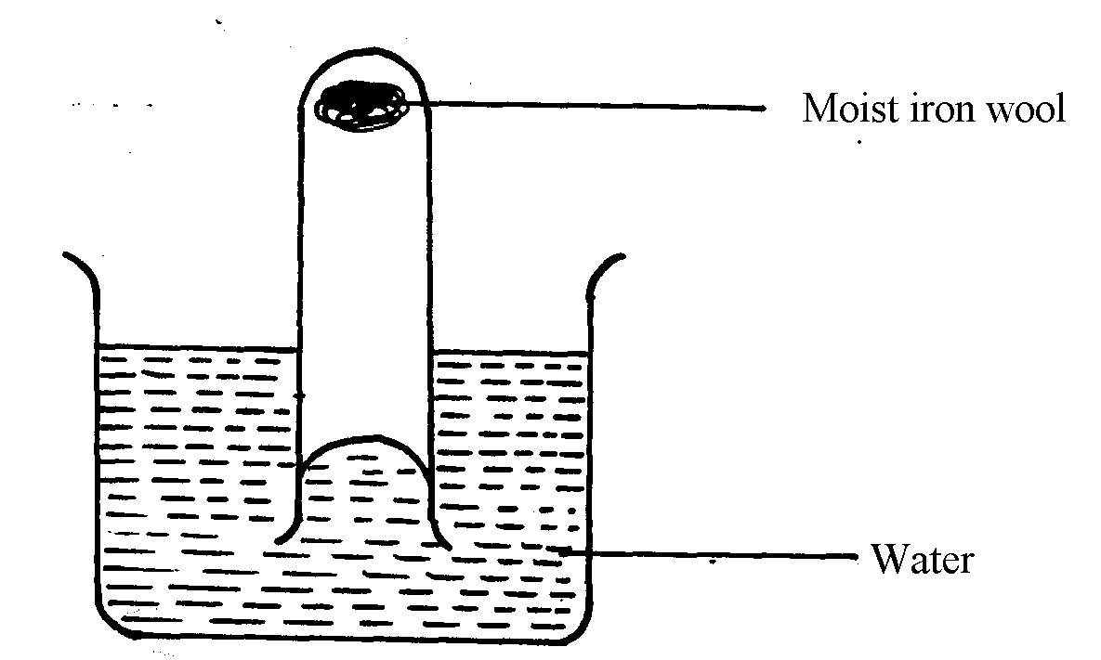
15. The apparatus below were used to study the properties of air

(a) State two observations made at the end of the experiment
(b) Give one simple method that can be used to prevent rusting
16. Equal volumes of 1M monobasic acids K and L were each reacted with excess zinc granules.
The table below shows the volumes of the gas produced after two minutes
Acid | Volume of gas (cm³)
K | 40
L | 100
(a) Explain the difference in the volumes of the gas produced
(b) How can the production of the gas be increased?

17. The following is a thermochemical equation for the reaction between hydrogen and oxygen
H_{2(g)} + O₂(_{g)} H₂O_{(l)} ΔH = -287kJmol⁻¹
Calculate the bond energy between the elements in water given that:
O = O = +496kJmol⁻¹ H-H = + 435kJmol⁻¹
18. AgClO_{2(s)} Ag_{(s)} + ½ Cl_{2 (g)} + O_{2 (g)} ΔH = 0.00KJ/mol
What is the effect on the position of equilibrium of the above system if temperature is
decreased? Give a reason
19. Sodium carbonate was reacted with dilute sulphuric (VI) acid at 25ºC. The volume of
carbon (IV) Oxide gas liberated was recorded at 10seconds interval. Below is a graph of
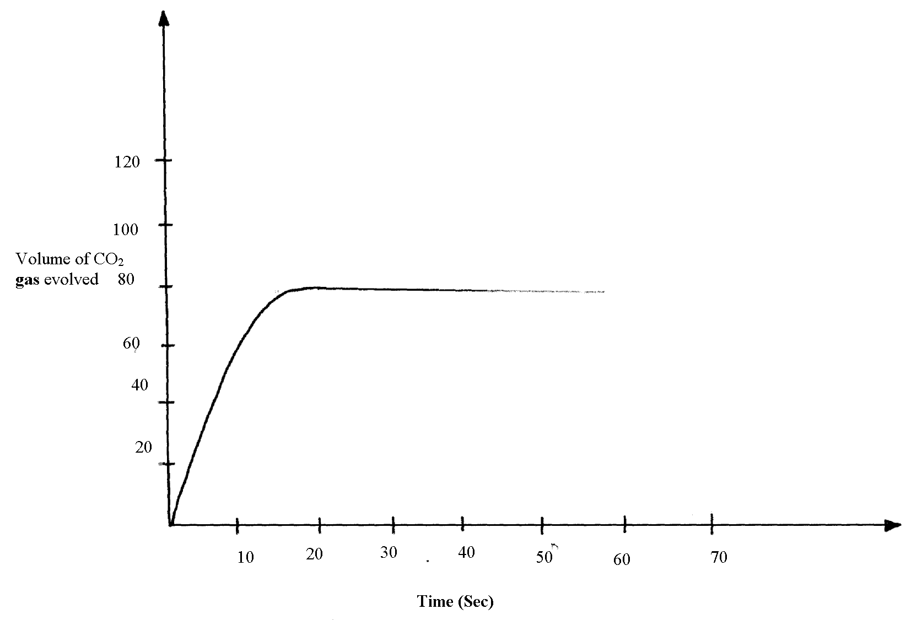
the volume of carbon (IV) Oxide gas evolved against time.

(a) On the same axes, sketch the curve labelled V that would be obtained if Barium carbonate
was used instead of sodium carbonate. (All conditions remain constant)

20. (a) What is meant by activation energy?
(b) A certain mass of unground compound X1 reacted with excess dilute hydrochloric acid.
The volume of carbon (IV) oxide gas liberated was measured after every 20 seconds.
The results were presented as shown in the graph below:-
Volume of Carbon (IV)
oxide gas (cm³)
0
0
20
40
60
80
100
5
10
15
20
25
Time (s)

(i) On the same axis, sketch the curve that would be obtained if the experiment was repeated
using ground compound X1
(ii) Explain the shape of your curve in (b) (i) above
22. The sketch below shows the rate at which substance T is converted into U. Study it and
answer the questions that follows:-
T
U
Concentration
Time

When the equilibrium has been established the two curves become horizontal after sometime.
Explain the effect of the amount of the two reactants and products

23. Elements A, B, C, and D are not actual symbols, have atomic numbers 19, 9, 12 and 10 respectively.
(a) Which two elements represent non-metals
(b) Write the formula of the compound formed between elements B and C and identity the
bond present in the compound

24. An equilibrium is established between nitrogen tetra -oxide and nitrogen (IV) oxide as shown below: State and explain what happens when temperature is increased
N₂O_{4(l)} 2NO_{2(g)}
Pale yellow Red-brown fumes
25. The graph below shows the amount of calcium carbonate and calcium chloride varying
with time in the reactions:
CaCO_{3 (s)} + 2HCI _{(aq)} CaCl_{2 (aq)} + H₂0 _{(g)} + CO_{2 (g)}
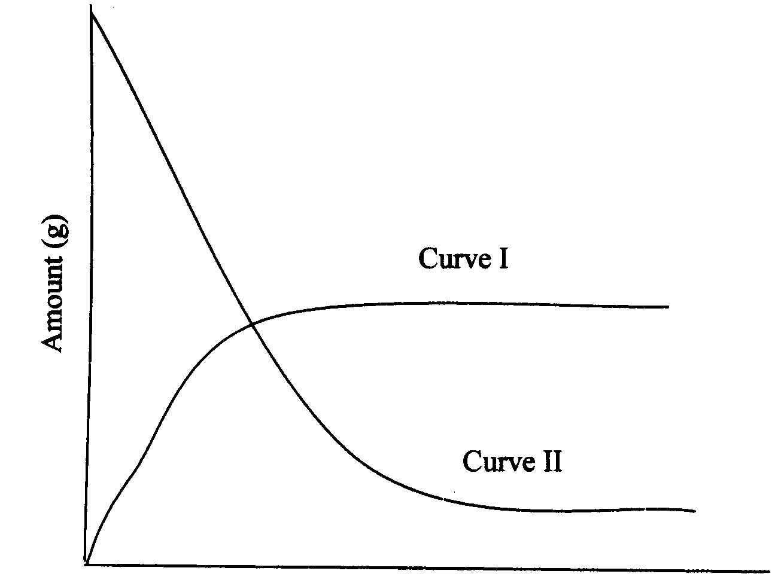

(a) Which curve shows the amount of calcium chloride varying with time? (lmk)
(b) Explain why the two curves become horizontal after a given period of time. (lmk)
(c) Sketch on the graph how curve II would appear if the experiment was repeated using a
more dilute hydrochloric acid solution (lmk)
26 State the effect on the equilibrium when;
a) Pressure is increased
b) Oxygen gas is added
6. An equilibrium is established between CrO₄ and H⁺ ions as shown below:
²⁻
²⁻
²⁻
2CrO_{4 (aq)} + 2H⁺_{(aq)} Cr₂O_{7(aq)} + H₂O_{(l)}
(Yellow) (Orange)
27. State and explain and explain the observation made when aqueous sodium hydroxide is added
to the equilibrium mixture

28. Two experiments were carried out as follows and the volume of hydrogen gas evolved
measured at intervals of 10seconds for 100seconds.
(i) 8cm of magnesium ribbon was added to 1M hydrochloric acid
(ii) 8cm of magnesium ribbon was added to 0.5M hydrochloric acid
Graphs of volume of hydrogen evolved against time were plotted
B
A
Volume of hydrogen (cm³)
Time (Sec)

(a) Which of the graph was obtained for reaction (i) above? Explain
(b) Explain the general shape of the graph

29. Bromine dissolves in water forming a brown solution, according to the dynamic
equation below.
Br₂ _{(aq)} + H₂O _{(l)} 2H⁺ _{(aq)} + Br⁻_{(aq)} + OBr⁻_{(aq)}

State and explain the observation that could be made if a solution of sodium hydroxide
is added to the system

Electrochemistry
1. The setup below was used to carry out the electrolysis of Magnesium sulphate solution using
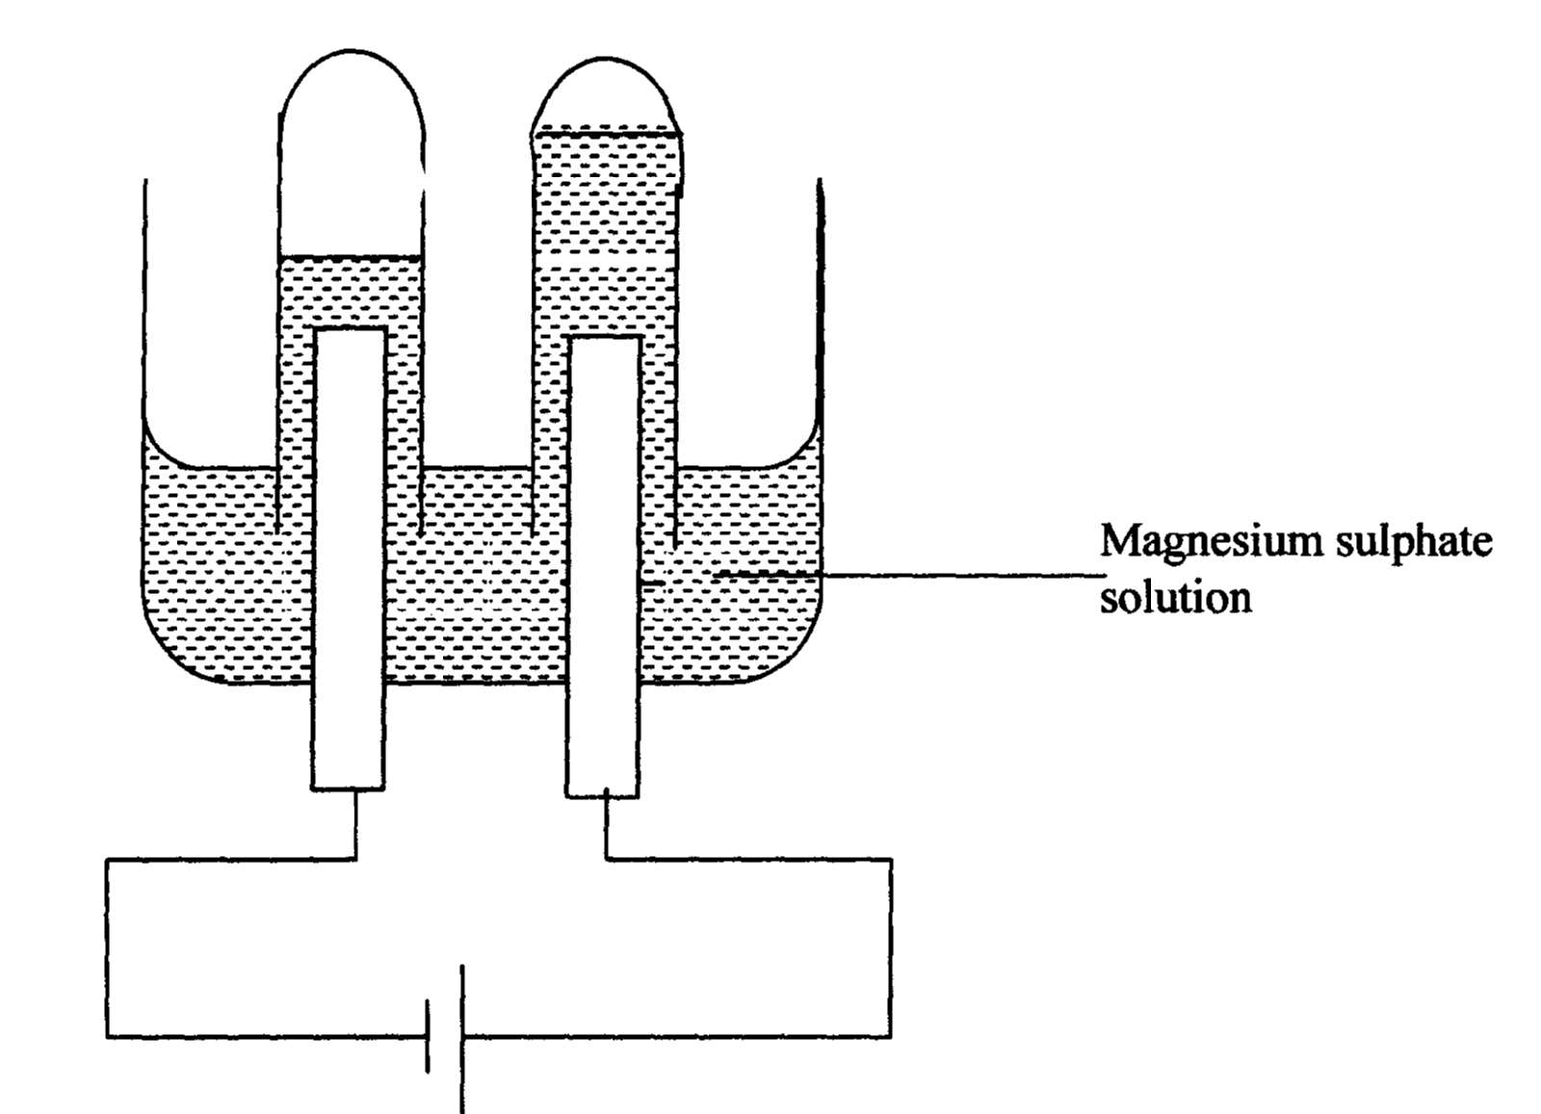
inert electrodes.

(i) Name a suitable pair of electrode that can be used in the above process.
(ii) State and explain the changes on the concentration of magnesium sulphate solution as
the process proceeds.
2. During purification of copper by electrolysis, 1.48g of copper were deposited when a
current was passed through aqueous copper (II) sulphate for 2 ½ hours. Calculate the
amount of current passed.
(Cu = 63.5 1Faraday = 96500C)
63
29
65
29
3 The diagram below represents a set-up that can be used for the electrolysis of dilute sulphuric acid
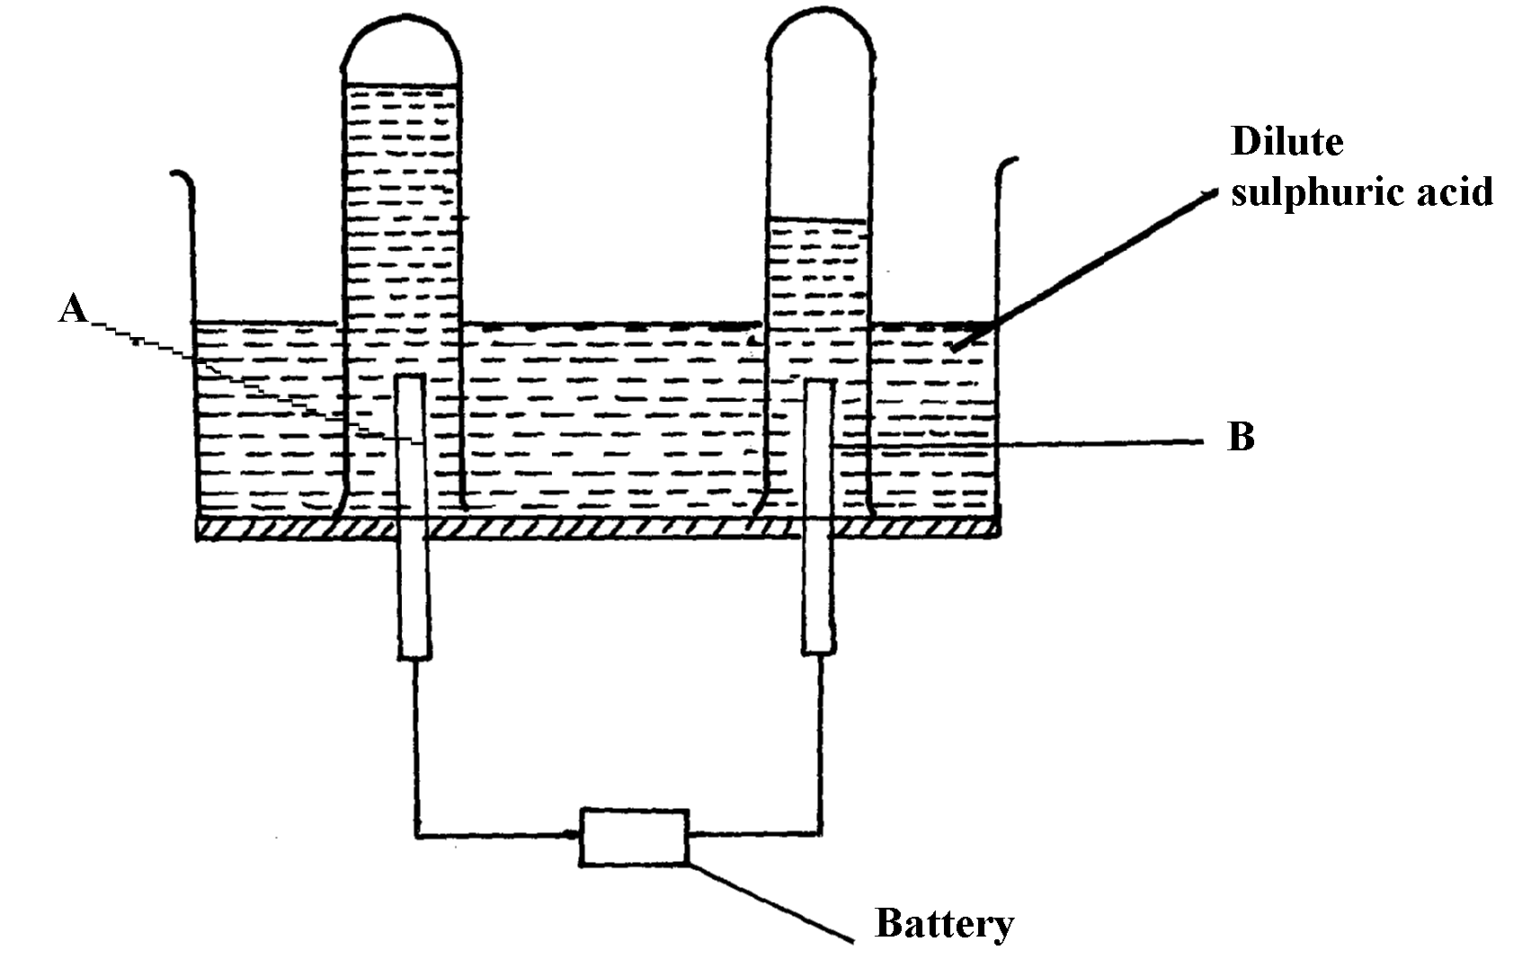

(a) Name the electrodes A and B
(b) Write an equation for the reaction taking place at electrode B
(c) What happens to the concentration dilute sulphuric acid as the reaction continues?

4. In an electrolysis, a current of 200A was passed through molten oxide of metal Q
for 58 minutes and 64.8g of the metal deposited. Determine;
i) Charge on metal Q
ii) The volume of oxygen gas produced at standard temperature and pressure
Q = 27 IF = 96500C, molar gas volume stp =22.4dm³
5. Consider the reduction potentials below.
Pb²⁺_{(aq)} + 2e Pb_{(s)} = -O.13V
Mg²⁺_{(aq)} + 2e Mg_{(s)} = -O.76V
a) Write the overall Redox reaction that takes place when the above half cells are connected.
b) Determine the E^{θ} value of the above cell.
(c) Calculate which group of the periodic table is element F?

6. An oxide of element F has the following formula:- F₂O₅
(a) Determine the oxidation state of F

Element | Sodium | Magnesium | Aluminium
Atomic number | 11 | 12 | 13

7. The table below gives elements and their atomic numbers. Answer the questions that follow:
Compare the electrical conductivity of sodium and aluminium. Explain
8. What mass of Zinc will be deposited from a solution of Zinc (II) Chloride when a current
of 3A is passed through the Zinc (II) Chloride solution during electrolysis for 50minutes?
(Zn= 65, 1 Faraday = 96500C)
9. Study the flow chart below and answer the questions that follow:
Copper Pyrites
CuFeS₂
Step (I)
Froth floatation,
Air
Gas Q
Gas Q
Step (II)
Cu₂S_{(s)}
Cu₂O
Cu_{(s)}
Pure Copper
Air
Step (III)
Cu₂S
Step (IV)
FeO
Step (V)

(a) Name gas Q …………………………………………………………… .
(b) With the help of diagram, describe how step (V) is carried out
10. Nitrogen and hydrogen react reversibly according to the equation:-
N_{2(g)} + 3H_{2(g)} 2NH_{3(g); Δ}H = -92kjmol⁻¹
The energy level diagram for the above reaction is shown below:-
N_{2(g)} + 3H_{2(g)}
2NH_{3(g)}
Reaction path
Energy
(KJ)

(a) How would the yield of ammonia be affected by:
(i) A decrease in temperature
(ii) An increase in pressure
(b) How does a catalyst affect reversible reaction already in equilibrium?
(c) On the above diagram, sketch the energy level diagram that would be obtained when
iron catalyst is added to the reaction

11. Study the electrode potentials in the table below and answer the question that follow:
(Letters are not the actual symbols of elements)
(E^{θ} /Volts)
H²⁺ _{(aq)} + 2 e⁻ H_{(s)} +0.34
Z²⁺ _{(aq)} + 2e⁻ Z_{(s)} -2.38
G⁺_{(aq)} + e⁻ G _{(s)} +0.80
T²⁺ + 2e⁻ T_{(s)} - 2.87
(a) Which one is the strongest reducing agent?
(b) Write the ionic equation for the reaction that takes place when Z is dipped in a solution
of G⁺ ions
(c) Calculate the E^{θ} cell value of the reaction in 22.(b) above
12. When a hydrocarbon was completely burnt in oxygen, 4.2g of Carbon (IV) oxide and 1.71g
of water were formed. Determine the empirical of the hydrocarbon. (H=10 C=12.0 O=16.0)
13. During electrolysis of aqueous copper (II) sulphate 144,750 coulombs of electricity were used.
Calculate the mass of copper metal that was obtained (Cu =64 1Faraday = 96,5000 coulombs)
14. Sodium metal reacts with oxygen according to the following equation:-
Heat
6Na_{(s)} + 2O_{2(g)} Na₂O_{2(s)} + 2Na₂O_{(s)}
State one physical and one chemical difference between Na₂O₂ and Na₂O
Physical difference ……………………………………………
Chemical difference……………………………………

15. The diagram below shows an electrochemical cell:
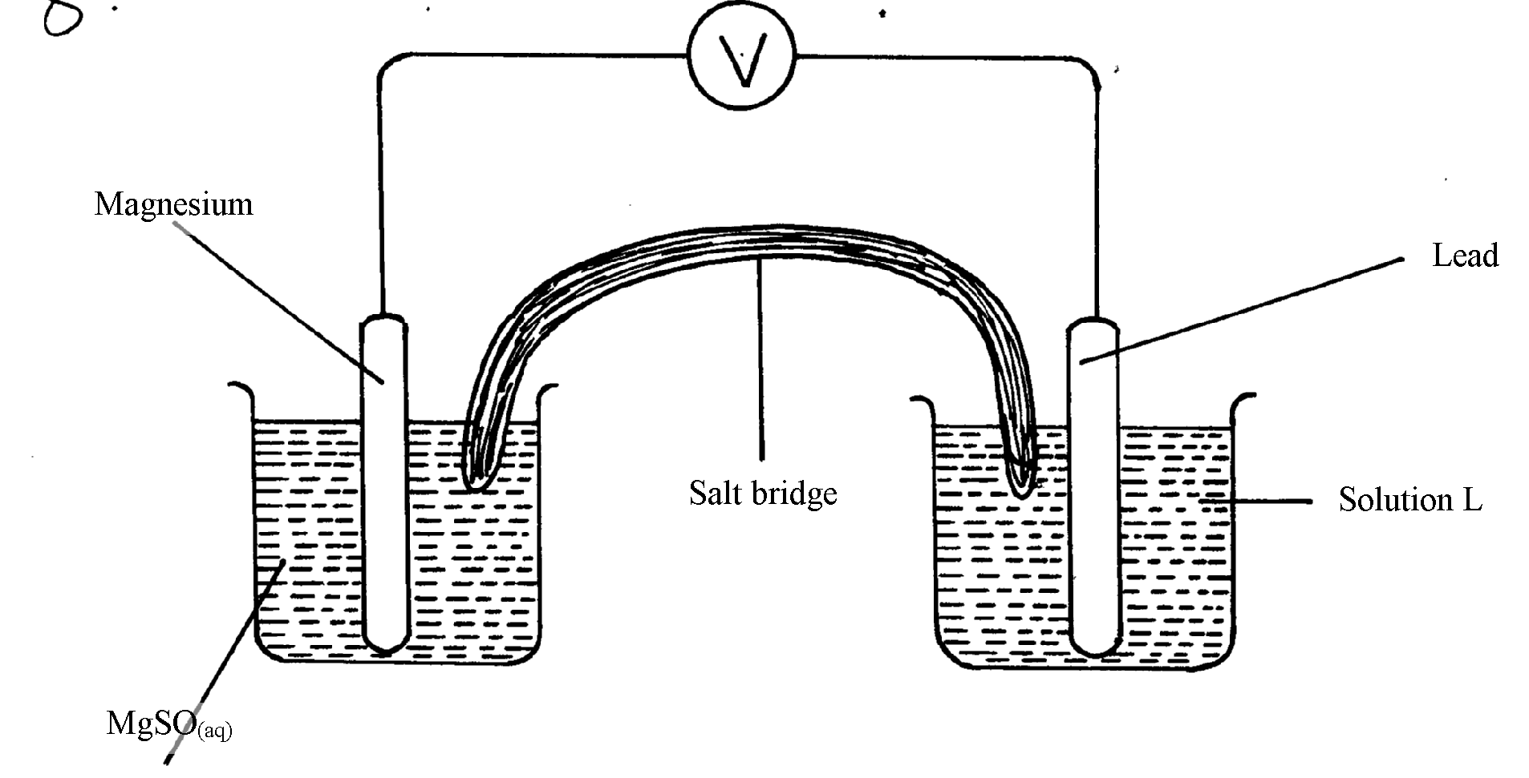
MgSO_{4(aq)}

- Give the formula of the possible salt L
(b) On the diagram show the direction of movement of electrons
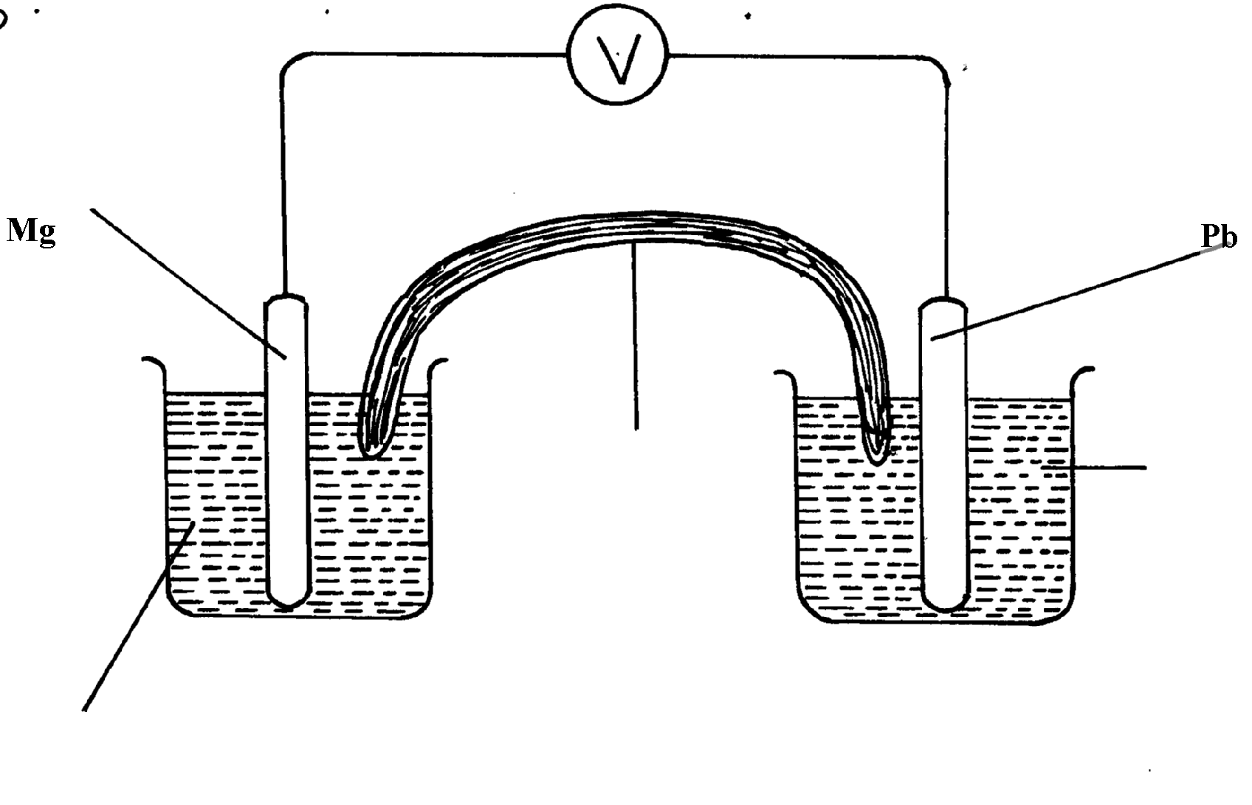
(c) Write the cell representation

6. The reaction blow is a redox reaction

MnO₄⁻_{(aq)} + 8H⁺_{(aq)} + 5Fe²⁺_{(aq)} ₎
(a) Identify the species reduced. Explain
(b) Write the equation for the oxidation reaction
17. Consider the cell diagram below
Cr_{(s)}/Cr³⁺_{(aq)} // Fe²⁺_{(aq)/}Fe_{(s)} E^{θ} = + 0.30V
i) Write the overall cell reaction for the above electrochemical cell
ii) Given that E^{θ} value for Fe²⁺_{(aq)} /Fe_{(s)} is -0.40V,calculate the E^{θ} value for Cr³⁺_{(aq)}/Cr_{(s)}
18. (a) Describe the process by which Trichloro fluoromethane Nitrogen is obtained from
air on a large scale

(b) Study the flow chart below and answer the questions that follow
Products
Ammonia
Gas J
Nitrogen (IV) Oxide
Copper (III) Oxide

Step VI Heat
Nitric (V) acid
Ammonia

Step IV
Ammonium nitrate
Step V
Nitrogen gas
Copper
Water
Water, air

Step III
Step I
Air
Platinum-Rhodium
High temperature
Step II Air

(i) Identify gas J
(ii) Using oxidation numbers, show that ammonia is the reducing agent in step VI
(iii) Write the equation that occurs in step V
(iv) Give one use of ammonium nitrate
(c) The table below shows the observations made when aqueous ammonia was added to
cations of elements E, F and G until in excess

Cation of | Addition of a few drops of aqueous ammonia | Addition of excess aqueous ammonia
E | White precipitate | Insoluble
F | No precipitate | No precipitate
G | White precipitate | Dissolves

(i) Select the cation that is likely to be Zn²⁺ ………………………………
(ii) Given that the formula of the cation of element E is E²⁺, write the ionic equation for the
reaction between E²⁺ and aqueous ammonia

19. a) Study the standard electrode potential for the half-cells given below and answer the questions that follow.(The letter do not represent the actual symbols of the elements)
E^{θ} Volts
N⁺_{(aq)} +e⁻ N(s) ; -2.92
J⁺_{(aq)} + e⁻ J_{(s)} ; +0.52
K⁺_{(aq)} + e⁻ ½ K_{2(g)} ; 0.00
½ G_{2(g)} + e⁻ G-_{(aq)} ; +1.36
M²⁺_{(aq)} + 2e⁻ M_{(s)} ; -0.44
i) Identify the strongest oxidizing agents. Give a reason for your answer
ii) Which two half-cells would produce the highest potential difference when combined?
iii) In the space below draw a complete electro chemical cell of the two-half cells mentioned
in (ii) above

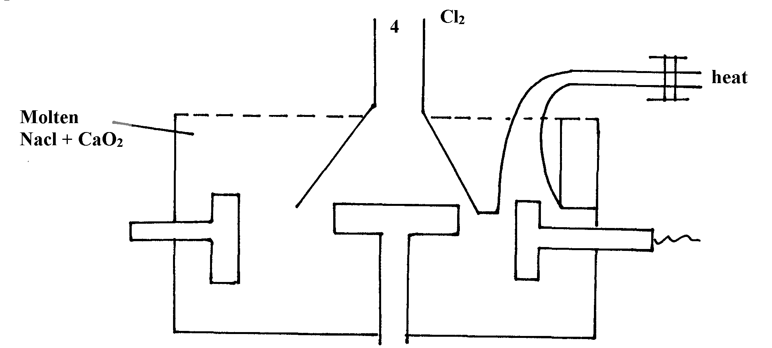
20. Below is a simplified diagram of the Down’s cell for the extraction of sodium. Study it
and answer the question that follow:-

Sodium

Molten
NaCl + CaCl₂

-

(i) From which substances are the electrodes made?
thode…………………………………………………………….
Anode……………………………………………………………………
(ii) State and explain why sodium chloride is mixed with calcium chloride
(iii) What is the role of the iron gauze
(iv) Write equations for the reaction at :-
cathode
anode
(v) Which property of sodium makes it possible to collect it as shown?

(b) When a current of 6.42 A was passed through an electrolyte Y²⁺ ions for 10minutes,
2.74 of Y were deposited
(i) Calculate the quantity of electricity passed in the experiment
(ii) Determine the relative atomic mass of Y (1Faraday = 96000 coulombs)

21. (a) The table gives the standard redox potentials for a number of half reactions. Use it to answer
the questions that follow:-
(E^{θ}/Volts)
Zn²⁺ _{(aq)} + 2e⁻ Zn_{(s)} -0.76
Fe²⁺ _{(aq)} + 2e⁻ Fe_{(s)} -0.44
I²⁺ _{(l)} + 2e⁻ 2I⁻ _{(aq)} +0.54
Fe³⁺ _{(aq)} + e⁻ Fe²⁺_{(aq)} +0.77
Ag⁺ + e⁻ Ag_{(s)} +0.88

(i) Relative to which half-cell reaction are the above electrode potentials expressed?
(ii) Calculate the e.m.f of the cell made up by combining the I_{2(l)} /2I⁻_{(aq)} electrode and
Zn²⁺_{(aq)}/Zn_{(s)} electrode
(ii) Which of the substances listed in the above table is :-
I. The strongest oxidising agent
II. The strongest reducing agent
(iv) Which substances could be used to convert iodide ions to iodine? Write balanced equations
for any possible conversions

22. a) The standard electrode potential for the elements chlorine and magnesium are:-
Cl_{2(g)} + 2e⁻ 2Cl⁻_{(aq)} E^{θ} + 1.36V
Mg²⁺_{(aq)} + 2e⁻ Mg_{(s)} E^{θ} - 2.36V
i) Which one of the two elements will act as an oxidizing agent? Explain.
ii) Calculate the electromotive force of a cell where the overall reaction is:-
Cl_{2(g)} + Mg_{(s)} MgCl_{2(s)}
b) The table below gives the reduction standard electrode potentials for divalent metals.
The letters are not their actual symbols. Use them to answer the questions that follow:-
Metal E^{θ} (volts)
P +1.50
Q - 0.44
R +0.34
S +0.76
i) Select two metals whose half cells can produce the highest voltage when connected.
ii) Draw a well labelled diagram of electrochemical cell formed by half-cells of metals P and Q
iii) Calculate the voltage produced by the cell in (ii) above
c) When nitrate solution of a certain metal X was electrolysed, 1.174g of metal X was
deposited by a current of 4 amperes flowing for 16minutes. Determine the formula of
the metal nitrate. (1F= 96,500, R.A.M of X= 59)
23. Study carefully the information given below and answer the questions that follow:-
Substance | Physical state at e.t.p | Solubility in water | Other information
A | Solid | - Soluble  - Blue solution | - solution conducts electricity forming two products B and C  - B is solid and C is a greenish –yellow gas
D | Gas | - Soluble  - Colourless solution | - Solution forms pale blue precipitate with A and then deep blue solution in excess
E | Solid | - Insoluble | - With a solution of A forms B and a colourless solution at E²⁺ions
(a) Identify the substances represented by the letters
- Give equations for the reactions in which:-
(i) Substance B is formed from the solution of A on electrolysis
(ii) Substance B is formed from solution A when reacted with E
(c) Give one use of gas C
(d) Name the ion responsible for the deep blue solution
24. (a) Study the standard electrode potentials for the elements given below and answer the questions
that follow. The letters do not represent the actual symbols of the elements
E^{θ}
Q + 2e⁻ 2Q- _{(aq)} +2.87
_{2(g)}
R_{2(g}) + 2e⁻ 2R-(aq) +1.36
S²⁺ _{(aq)} + 2e⁻ S (s) + 1.23
2T⁺_{(aq)} + 2e⁻ T₂(g) 0.00
U²⁺_{(aq)} + 2e⁻ U(s) -0.13
V²⁺_{(aq)} + 2e⁻ V(s) -0.76
(i) What is the E^{θ} value of the weakest reducing agent?
(ii) Which element is likely to be hydrogen? Give a reason for your answer
(iii) Draw a diagram for the cell that would be obtained when the half cell of elements
S and V are combined
(iv) Calculate the e.m.f of the electrochemical cell in a (iii) above

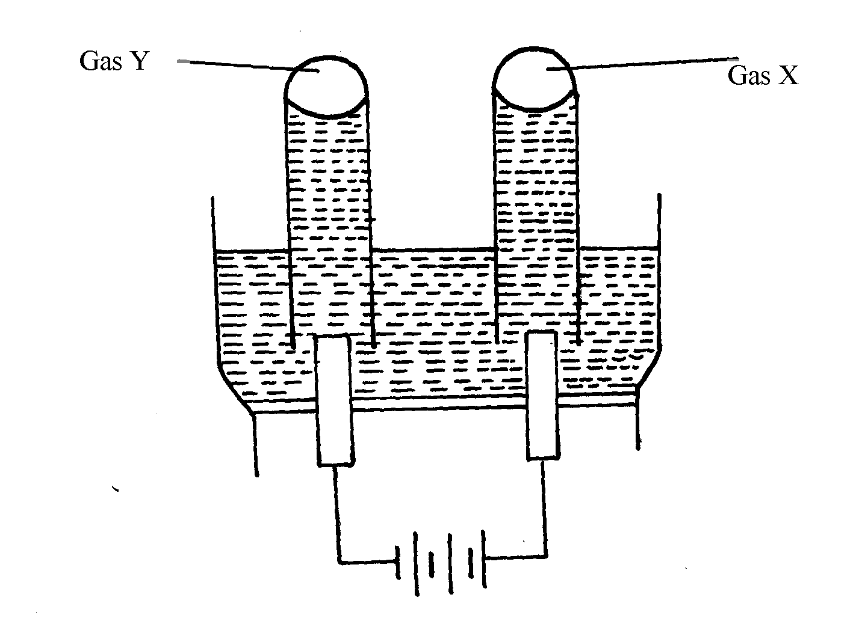
(b) The diagram below represents the electrolysis of dilute sulphuric (VI) acid

(i) Name the gases X and Y
(ii) Write ionic equation for the formation of gas X
(iii) At what electrode does reduction take place? Explain your answer
(iv) Name the most suitable electrodes for this experiment. Explain your answer

25. The flow chart below shows an analysis of mixture R that contains two salts. Study it
and answer the questions that follow:-

Mixture R
Residue V
Two metal oxides + CO₂ + NO₂ + O₂ +H₂O
Divide into two portions Step I
Filtrate W
Solution Z + CO₂
Step V
Add HNO₃
Filtrate X
Colourless solution
Colourless solution
Colourless solution
Step II
Add dil. H₂SO₄
White precipitate
Add excess NH₄OH to portion of Z
Add excess NaOH to portion of Z
Add excess
NH₄OH
Step III
Add excess
NaOH
Add water then filter
Step IV

Residue

(i) Write two ionic equations for the reactions between the cation in filtrate X and aqueous
ammonia (Ammonium hydroxide)until in excess
(ii) What conclusion can be drawn from Step IV only? Explain
(iii) What observation would indicate the presence of a NO₃⁻ ion in step I?
(iv) Write the formula of the anion in residue V. Explain
(v) Suggest the identity of the cation present in solution Z
(vi) Name the two salts present in mixture R

26. (a) The set-up below was used in the electrolysis of copper II nitrate solution:
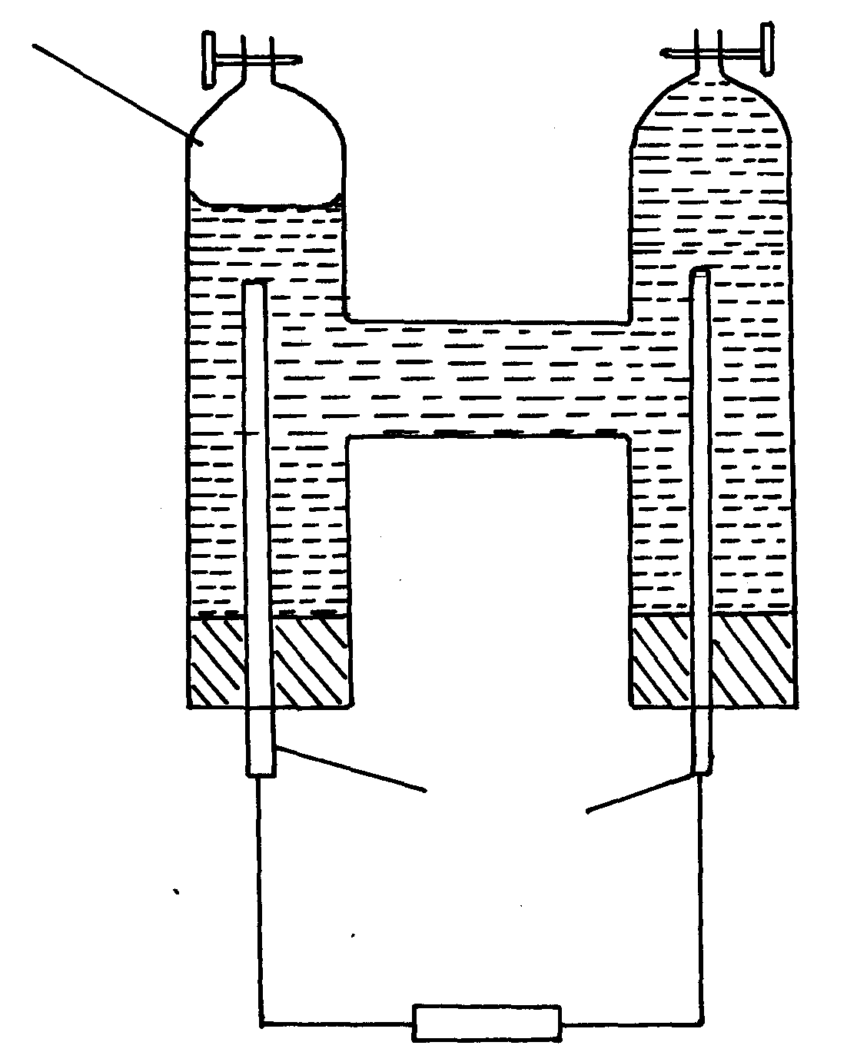
Gas P
Platinum rods

(i) What is electrolysis?
(ii) Show the anode and cathode on the diagram
(iii) Explain how you would confirm gas P
(iv) Write the equation for the reaction occurring at
(a) Anode
(b) Cathode
(v) State two changes that occur on the electrolyte after the experiment
(b) Below are the standard electrode potentials for electrodes B and D

B^{2t}_{(aq)} + 2e⁻ B_{(s)} – 2.92V
D^{2t}_{(aq)} + 2e⁻ D_{(s)} + 0.34V

(i) Identify the electrode which is ;
(a) The least reducing agent
(b) The strongest oxidizing agent
(ii) Calculate the e.m.f of the cell formed when the two electrodes are connected
(iii) Write a cell representative for the cell above
27. A typical electrolysis cell uses a current of 40,000 amperes. Calculate the mass (in Kg of aluminium produced in one hour). (Al = 27) (Faraday = 96500Coloumbs )

28. A strip of copper metal was immersed into a nitrate solution of metal Q overnight. Use the
information below to answer questions that follow
 | E^{θ} (Volts)
Q_{(aq)} + e⁻ Q_{(s)}  Cu²⁺ _{(aq)} + 2e⁻ Cu_{(s)} | +0.80  + 0.34

(a) State the observations made at the end of the experiment
(b) Give a reason for the observations made in (a) above
(c) Calculate the e.m.f of the cell above
29. (a) Excess marble chips (Calcium carbonate) was put in a beaker containing 150cm³
of dilute hydrochloric acid. The beaker was put on a weighing balance and the total
loss in mass recorded after every two minutes as shown in the table below:
Time (min) | 0 | 2 | 4 | 6 | 8 | 10
Total loss in mass (g) | 0 | 1.8 | 2.45 | 2.95 | 3.2 | 3.3

(i) Why was there a loss in mass?
(ii) The average rate of reaction was faster between 0 and 2 minutes than between
6 and 8 minutes. Explain why
(iii) State one way in which the rate of reaction can be increased
(iv) When aqueous sodium sulphate was added to contents of the beaker, a white precipitate
was formed;
(I) Identify the white precipitate ………………………………………………………
(II) Name one use of the substance named in (iv) (I) above
b) A student performed the following experiment with an intention to extract calcium metal

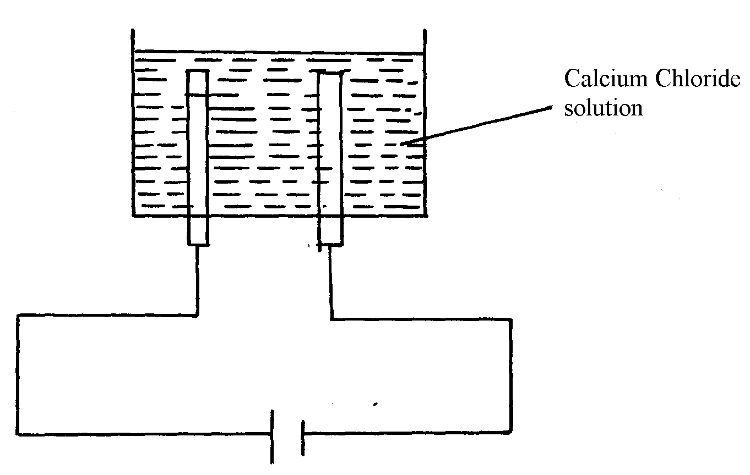

(i) The student was surprised that no calcium was produced in the experiment. Explain
why no calcium was produced
(ii) Write the equation for the reaction that occurred at the anode if the solution was concentrated
(iii) The electrolysis involved passing an electric current of 4A for one hour. Calculate the mass of
the product at the anode. (1Faraday = 96500C, Cl =35.5, H = 1.0, O =16, Ca = 40)

30. Cheptoo set-up some apparatus as shown in the diagram below:-
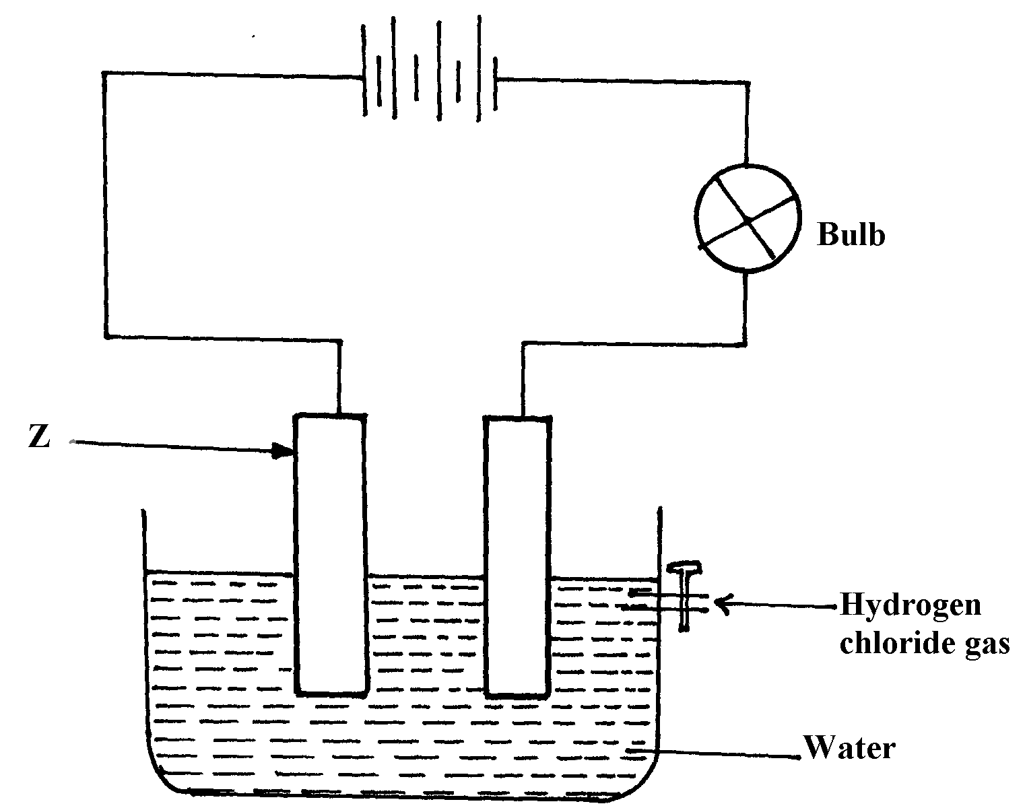

At the start of the experiment, the bulb did not light:-
(a) State and explain the observation made when the tap was opened to allow the hydrogen
chloride gas through the water for about 20 minutes
(b) Write the chemical equation for the reaction that took place at the cathode

31. Metals K and N were connected to form a cell as shown in the diagram below. Their reduction
potentials are as shown below:
K⁺_{(aq)} / K_{(s)} ≡ - 0.17V
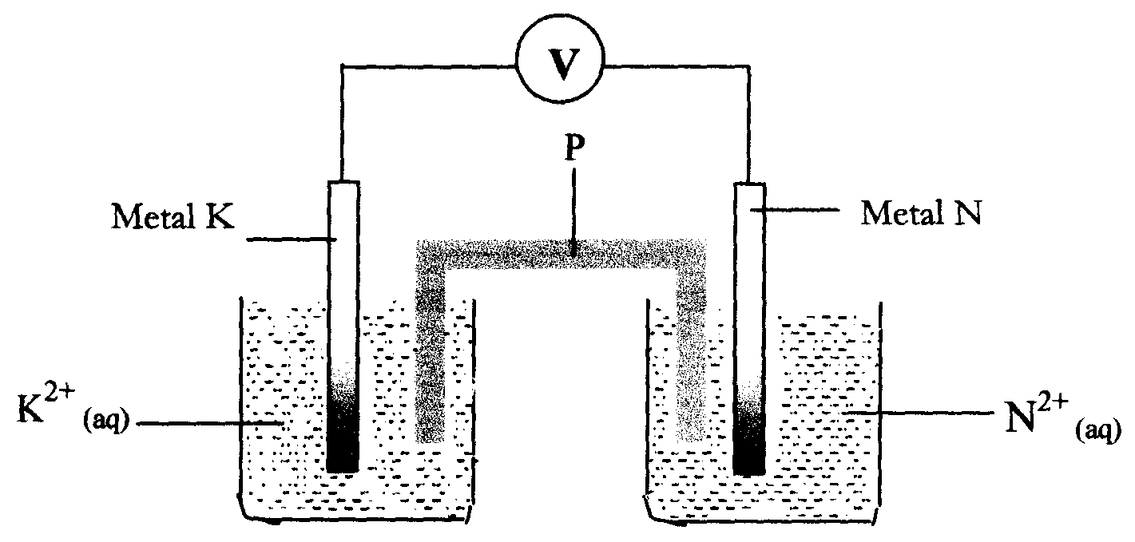
N⁺_{(aq)} / N_{(s)} = + 1.1 6V

I. Write the equation for the half-cell reaction that occurs at
Metal K electrode
Metal N electrode
II Identify P and state its role in the above setup
(i). Identity of P
(ii) . Role of P in the setup.
III. On the diagram, show the flow of
I. Electrons
II. Current.
IV Calculate cell potential (E) for the cell represented in the setup above
32. (a) The diagram below shows a Zinc –copper cell.
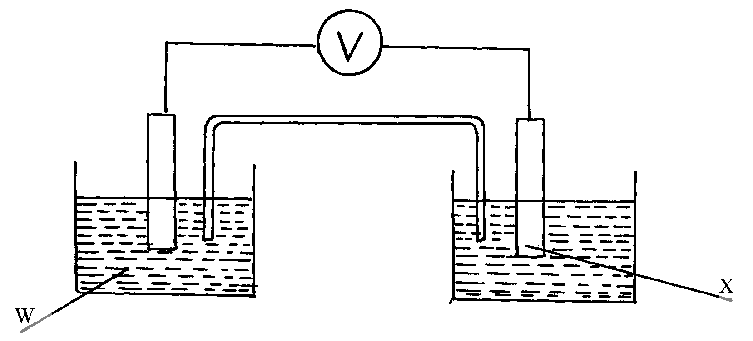

(i) Given the standard electrode potential of Zinc is -0.76V and that of copper is +0.34V, suggest;
(i)The identity of W …………………………………………………………………....
(ii) The identity of X …………………………………………………………………… .
(iii) The equation for the overall cell reaction
(iv) The reading on the voltmeter
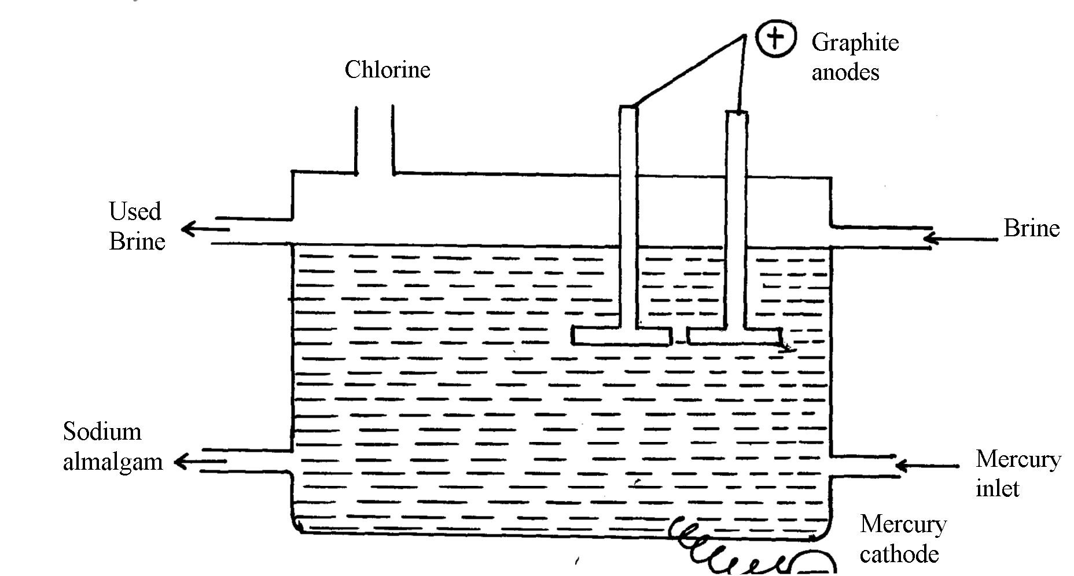
(b) Sodium hydroxide may be manufactured by the electrolysis of brine as in the diagram below:-

(i) State the chemical name of brine
(ii) Write the equations for the reactions are the electrodes
Anode
Cathode
(iii) Explain how sodium hydroxide is obtained from the product of this process

33. A typical electrolysis cell uses a current of 40,000 amperes. Calculate the mass (in kilograms)
of aluminium produced in one hour (Al=27, 1Faraday=96,500 coulombs)
34. The reaction between ammonia and oxygen to form Nitrogen (II) oxide is highly exothermic
4NH_{3(g)} + 5O_{2(g)} 4NO_{(g)} + 6H₂O_{(g)}
The reaction is carried out in presence of platinium-rhodium catalyst at 1173k and a pressure
of 911.952k pa.
i) Explain how each of the following would affect the yield of Nitrogen(II) oxide gas:
a) Reduction in pressure
b) Using a more efficient catalyst
35. The following table shows the standard reduction potentials of some half cells. Study the
table and refer to it to answer the questions that follow;
Half reaction E^{θ} volts
P⁴⁺_{(aq}) + e⁻ P³⁺_{(aq)} +0.61

Q³⁺_{(aq)} + e⁻ Q²⁺_{(aq)} +0.77

R_{2(g)} + 2e⁻ 2R⁻_{(aq)} +0.54

S²⁺_{(aq)} + 2e⁻ S_{(s)} -0.44

T²⁺_{(aq)} + 2e⁻ T_{(s)} -0.74

a) Identify the strongest oxidizing agent
b) Which substance would be used to oxidize R⁻ ion to the atom R
c) Study the cell represented below;
T_{(s)} / T²⁺_{(aq)}// S²⁺_{(aq)}/ S_{(s)}
i) Identify the electrodes
ii) Write equations for the reaction taking place in each half- cell
iii) Determine the cell equation and the electromotive force (e.m.f) of the cell represented in
(c) above
iv) In which direction does the electrons flow in the external circuit of the cell whose e.m.f
is determined in (iii) above
d) A steady current of 2.5A was passed for 15 minutes through a cell containing divalent ions
M²⁺. During this process 0.74g of metal M was deposited (IF = 96500C)
i) Calculate the quantity of electricity passed in this cell
ii) Determine the relative atomic mass of M
36. The following table shows the standard reduction potentials of some half cells.
Study the table and refer to it to answer the questions that follow;
Half reaction E^{θ} volts
P⁴⁺_{(aq}) + e⁻ P³⁺_{(aq)} +0.61

Q³⁺_{(aq)} + e⁻ Q²⁺_{(aq)} +0.77

R_{2(g)} + 2e⁻ 2R⁻_{(aq)} +0.54

S²⁺_{(aq)} + 2e⁻ S_{(s)} -0.44

T²⁺_{(aq)} + 2e⁻ T_{(s)} -0.74

a) Identify the strongest oxidizing agent
b) Which substance would be used to oxidize R⁻ ion to the atom R
c) Study the cell represented below;
T_{(s)} / T²⁺_{(aq)}// S²⁺_{(aq)}/ S_{(s)}
i) Identify the electrodes
ii) Write equations for the reaction taking place in each half- cell (2 mks
iii) Determine the cell equation and the electromotive force (e.m.f) of the cell represented
in (c) above
iv) In which direction does the electrons flow in the external circuit of the cell whose e.m.f
is determined in (iii) above
d) A steady current of 2.5A was passed for 15 minutes through a cell containing divalent ions
M²⁺. During this process 0.74g of metal M was deposited (IF = 96500C)
i) Calculate the quantity of electricity passed in this cell
ii) Determine the relative atomic mass of M
37. In the equation below identify the reagent that acts as an acid in the forward reaction.
Give a reason for your answer.
NH₄⁺_{(aq)} + H₂O_{(l)} NH_{3(aq)} + H₃O⁺_{(aq)}

38. A student set up the experiment shown below. Study it and answer the questions that follow.
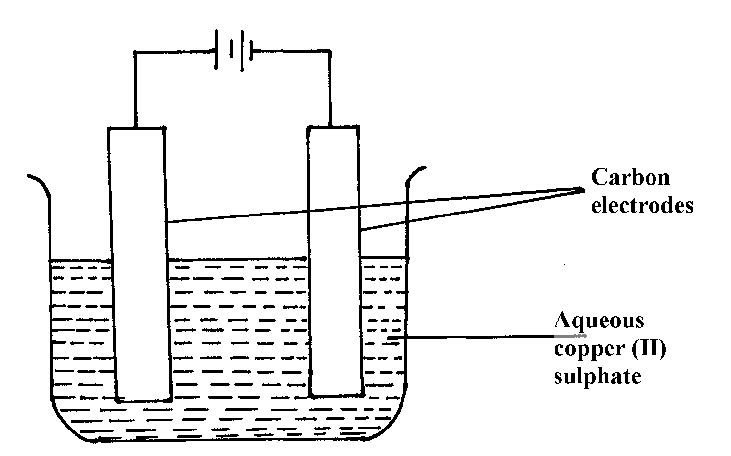

a) State any two observations the student made during the experiment
b) Explain what happens to the pH of the resultant solution at the end of the experiment
39. Copper (II) sulphate solution was electrolysed using copper electrode. A Current of 0.5A was
passed for 64.3 minutes and a mass of 0.64g of copper was deposited. (Cu = 63.5)
a) Which electrode decreased in mass during electrolysis? Explain
b) Calculate the quantity of charge needed to deposits 1 mole of copper
40. State and explain what is observed when crystals of iodine are heated gently
41. (a) State Faradays First Law of Electrolysis
(b) Calculate the volume at s.t.p of hydrogen evolved when 2A of electricity are passed
through dilute sulphuric acid for 2hours.
(Molar gas volume at s.t.p = 22.4dm³, one Faraday= 96500coulombs)
42. The following is an equation for the reaction between ammonia and water
NH_{3(g)} + H₂O_{(l)} NH⁺_{4(aq)} + OH⁻(_{aq)}
(a) Name the base in the backward reaction
43. The common ores of Zinc are zinc blende and calamine:-
(i) Give the chemical formula of Zinc blende
(ii) Explain how the pollution caused by large scale extraction of Zinc can be reduced by
having a fertilizer plant close to it
44. The oxides of calcium and phosphorous react as shown below:-
6CaO_{(s)} + P₄O_{10(s)} 2Ca₃(PO₄)_{2(s)}
(i) Give a reason why these substances react and yet both are oxides
(ii) Work out the oxidation state of phosphorous in P₄O₁₀
(iii) State one use of Ca₃(PO₄)₂
45. The standard hydrogen electrode is used as the reference electrode. Some of the difficulties in
using hydrogen gas as an electrode are:
- Hydrogen is a gas at 25ºC
- Hydrogen does not conduct electricity
-The half-cell reaction, 2H⁺_{(aq)} + 2e⁻ H_{2(g)} is slow and takes long to reach equilibrium.
Explain how these difficulties are solved in the standard hydrogen electrode
46. The following are electrode potentials of the half cells
Half cell E^{θ} volts

²⁺
M_{(aq)} /M_{(s)} -0.76
C²⁺_{(aq)} / C_{(s)} – 0.34
(a) Calculate the potential difference of the following cell.
M_{(s)}/M^{2t}_{(aq)} // C^{2t}_{(aq)}/C_{(s)}
47. (a) Name two types of isotopes of phosphorous
(b) Explain why phosphorus is stored in water and not in oil like sodium
48. Use the cell representation below to answer the questions that follow:-
X_{(s)} /X³⁺_{(aq)} //W²⁺_{(aq)} /W_{(s)}
(a) Write the equation for the cell reaction above
(b) If the e.m.f of the cell is 0.30V and E^{θ} value for W²⁺/W is -0.44volts, calculate
the E^{θ} for X³⁺_{(aq)} /X_{(s)}

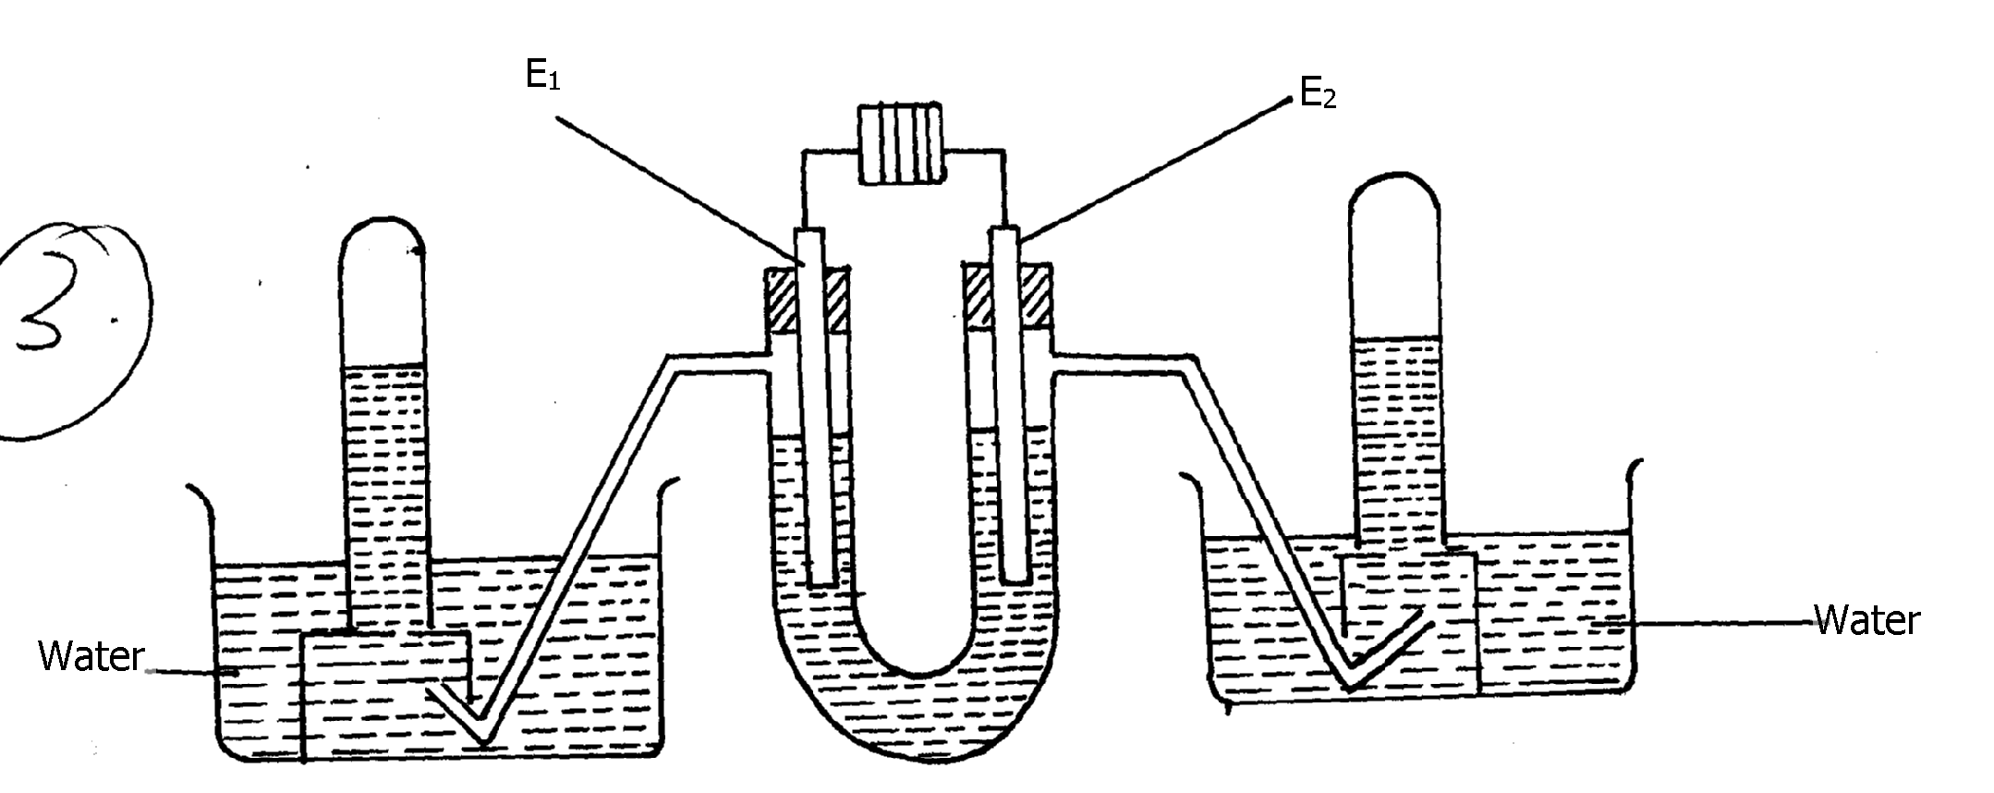
49. The following diagram represents the electrolysis of dilute sodium chloride solution using inert
electrodes

Dilute sodium chloride

Determine the electrode at which different electrolytic products would be produced if the
solution is electrolysed for several hours. Explain

50. Complete the following redox equations by adding the correct number of electrons on either
reactant or product side of the redox equations:-
(a) ClO⁻_{3(aq)} + 6H⁺(aq) Cl_{2(g)} + 3H_{2(l)}
(b) NO⁻_{2(aq)} + H₂O_{(l)} NO⁻_{3(aq)} + 2H⁺_{(aq)}

51. The following are standard reduction potentials;
Half-cell | E^{θ}/Volts | Using iron
Al_{(s)} / Al³⁺_{(aq)} | -1.66
Zn_{(s)} / Zn²⁺_{aq)} | -0.76
Fe_{(s)} / Fe²⁺_{(aq)} | 0.44
Ni_{(s)} / Ni²⁺_{(aq)} | 0.25

Rewrite the E^{θ} values of the above half-cells using iron as a reference electrode

52. Calculate the mass of metal J that would be dissolved at the anode when a solution of J (III)
nitrite is electrolysed using a current of 1.5amperes for 15minutes (1 Faraday = 96,500C; J = 52)

53. Consider the following standard electrode potentials:
Sn²⁺_{(aq)} + 2e- Sn_{(s)} +0.144v
Fe²⁺_{(aq)} + 2e- Fe_{(s)} - 0.44v
Zn²⁺_{(aq)} + 2e- Zn_{(s)} - 0.76v

Some modern cars are made from steel coated with other metals. Using this data above state
and explain the best suited metal for coating steel
Metals
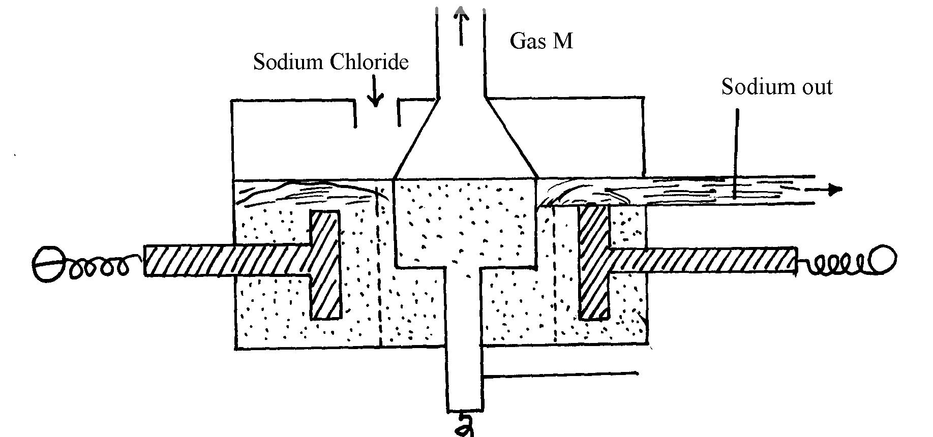
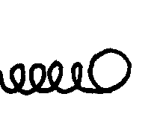
1. The following diagram represents extraction of sodium by the Down’s cell
+

(a) Why is the anode made of graphite in this case instead of steel which is a better conductor
of electricity?
(b) How are the electrolytic products separated from reacting?
(c) Give reasons why large quantities of electricity is required for this process
2. a) Give one environmental hazard associated with the extraction of zinc metal
b) Suggest one manufacturing plant that can be set up near zinc extraction plant. Give
reasons for your answer
c) What properties of aluminium and its alloys make it suitable for use in making aircraft parts
3. Aluminium is used in making overhead cables. State two properties of aluminium that
makes it suitable for this use
4. The stages shown in the following diagram can be used to extract zinc from its oxide:-
Name the stage and the process taking place in it:-
stage 3
C_{(s)} + O_{2(g)}
ZnO_{(s)} + CO_{(g)}
Zn_{(s)}
CO_{(g)} + O_{2(s)}
stage 2
stage 1

Name each sage and the process taking place in it:
Stage 1............................................................................................................................
Stage 2............................................................................................................................
Stage 3...................................................................................................................................

5. Study the flow chart below and answer the questions that follow:

Copper Pyrites
CuFeS₂
Step (I)
Froth floatation,
Air
Gas Q
Gas Q
Step (II)
Cu₂S_{(s)}
Cu₂O
Cu_{(s)}
Pure Copper
Air
Step (III)
Cu₂S
Step (IV)
FeO
Step (V)

(a) Name gas Q …………………………………………………………… .
(b) With the help of diagram, describe how step (V) is carried out

6. Name the following compounds using IUPAC system
(i) CCl₄
(ii) HOCl
7. Study the information provided:-
Element | Atomic radius (nm) | Ionic radius (nm) | Melting point of oxide (ºC )
W  Y  Z | 0.381  0.733  0.544 | 0.418  0.669  0.489 | -117  849  1399

(a) Explain why the melting point of the oxide of W is lower than that of the oxide of Z
8. The flow chart below shows steps used in the extraction of zinc from one of its ores.
Lead (II) Carbonate ore
Crushing

Step I
Powdered Lead (II)
Carbonate ore
Step 3 Heat
Gas
Lead (II) Metal
Concentrated Lead (II) Carbonate ore
Lead (II) Oxide
Coke

Step 4

Step 2

(a) Name the process that is used in step 2 to concentrate the ore
(b) Write an equation for the reaction which takes place in step 3
(c) Name one use of lead
9. Name the chief ores from which the following metals are extracted
a)Aluminium ……………………………………………………………………
b) Copper ………………………………………………………………………
10. The diagram below represents the second stage in extraction of aluminium metal

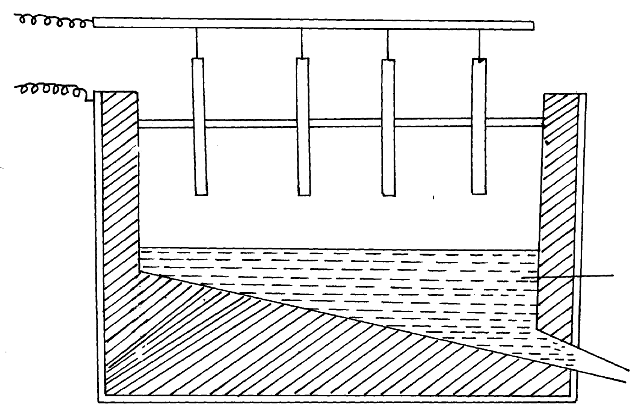
Aluminium

i) On the diagram label the: Anode, cathode and the electrolyte region (s)
ii) The melting point of aluminium oxide is 2054ºC, but the electrolysis is carried out at between
800-900ºC
a) Why is the electrolysis not carried out at 2054ºC
b) What is done to lower the temperature?
iii) The aluminium which is produced is tapped off as a liquid .What does this suggest about its
melting points?
11. The extraction of aluminium from its ore takes place in 2 stages. Purification stage and electrolysis stage. Below is set-up for the electrolysis stage:-

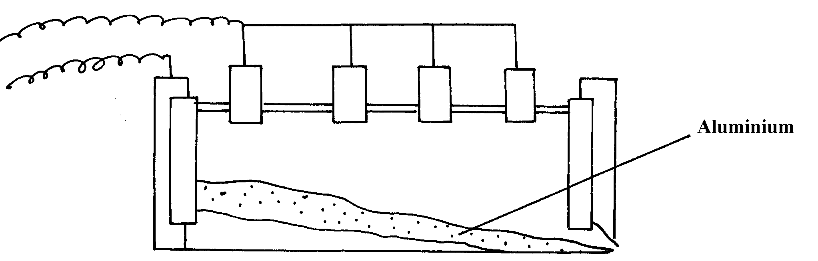

(a) (i) Name the chief ore from which aluminium is extracted
(ii) Name one impurity which is removed at the purification stage
(b) (i) Label on the diagram each of the following:-
I – Anode
II- Cathode
III- Region containing electrolyte

(ii) The melting point of aluminium oxide is 2054ºC but the electrolysis is carried out at between
80ºC and 900ºC
I. Why is not carried out at 2050ºC
II. What is done to lower the temperature
12. Aluminium is the most abundant metal in the earth crust and it is widely extracted for
its wide range of uses.
(i) Name one major ore of aluminium and give its formula
(ii) Name two main impurities found in the ore
(iii)Aluminium oxide is heated first before it is electrolysed. Explain
(iv) Electrolysis of aluminium oxide is done as shown below:
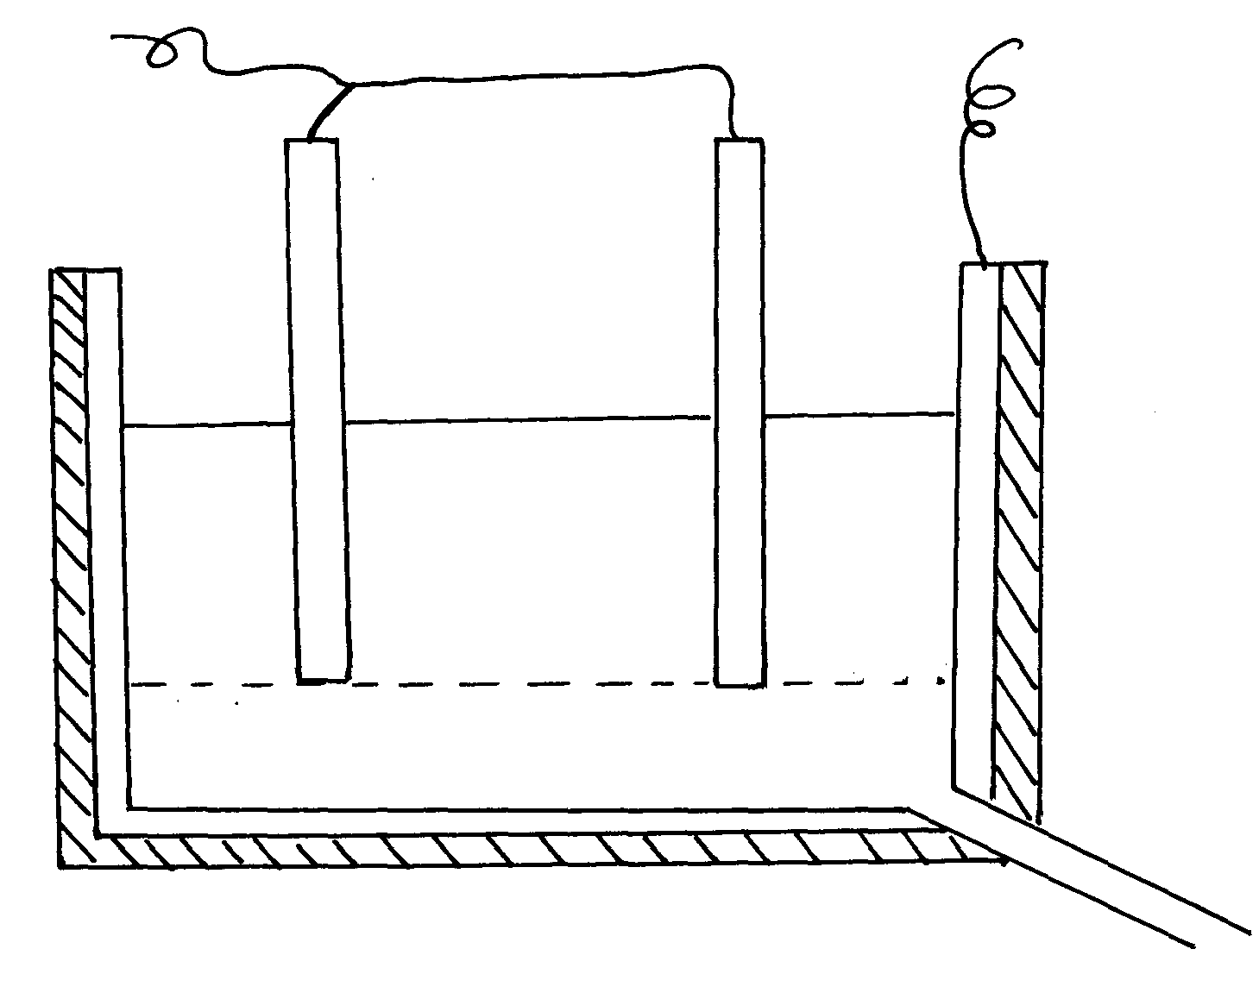

Molten aluminium oxide with cryolite

(a) Identify the anode and cathode on the diagram
(b) What is the role of electrolyte in the extraction ?
(c) Write half equations for the reactions that occur at the anode and cathode
(d) State two uses of aluminium
13. The diagram below is a flow chart for the extraction of copper. Study it and answer the questions
that follow:
Ore
Crushed
I
Powdered Ore
Mixed with water, oil & air
II
Concentrated Ore
Copper (I) Sulphide
Roasted in presence of sand
IV
Copper (I) Sulphide and iron (II) Oxide
Liquid Copper
Cooled
VI
Blister Copper
Pure Copper
Electrolysis
VII
Heated in a converter
Slag
Roasted in air

SO₂
III

SO₂

(a) Write the formula of the major ore of copper metal
(b) Name process II
(c) Give an equation for the reaction that occurs in stage III
(d) Explain what happens in stage IV
(e) Write half cell equations occurring at the anode and cathode in stage VII
(f) Draw a simple diagram showing the set-up that is used in electrolytic purification
of copper
(g) A green rocky materials suspected to be the ore malachite CuCO₃. Cu (OH)₂.
14. The flow chart below illustrates the extraction of Zinc. Study it and answer the questions that follow:
Sulphide ore
Roaster
Mixer
Reaction chamber 1
Cooling chamber
Zn⁺ impurities
Air
Reaction chamber II
Filtration chamber
Crystallization chamber
ZnSO₄. XH₂O
Residue S
Liquid R
Separation chamber
ZnO
SO₂
Coke
Gas Q
Zn_{(s)}
Zn_{(s)}

Zn_{(s)}

a) Name:-
i) Gas Q .............................................................................
ii) Liquid R .....................................................................................................................
(iii) Residues S ..............................................................................................................
b) Name the sulphide ore used
c) Before the ore is roasted, it is first concentrated;
(i) Explain why it is necessary to concentrate the ore
(ii) Explain briefly the process of concentrating the ore
d) Write an equation for the reaction that takes place in the:-
(i) Roaster
(ii) Reaction chamber
(e) (i) Name one major impurity present in the sulphide ore used
(ii) Write an equation to show how the impurity in (e)(i) above is removed
f) Given that the sulphide ore contains only 45% Zinc sulphide by mass, calculate :
(i) The mass in grams of Zinc sulphide that would be obtained from 250kg of the ore.
(ii) The volume of Sulphur (IV) oxide that would be obtained from the mass of sulphide
ore at room temperature and pressure
(Zn = 65.4, S = 32.0, O= 16.0, I mole of gas occupies 24.0 liters at r.t.p)
15. The flow chart below represents the extraction of zinc from its ore and a by-product used in the
manufacture of sulphuric (VI)acid. Study it and use it to answer the questions that follow:-

Zinc Ore
Concentration
Roasting furnace
Hot air blast
Reduction chamber
Solid A

SO_{2(g)}
Cleaners and driers
Chamber L
Molten Zinc
Catalytic chamber
Air
Chamber N
H₂SO₄
W
M
Z
P

a) Name;
i) The suitable zinc ore used.
ii) The main impurity in the ore
b) Describe how zinc ore is concentrated
c) Write an equation for the reaction taking place in the roasting furnace
d) Describe what happens in the reduction chamber
e) Identify substances:-
W…………………………………(½mk) M………………… (½mk)
f) Write the equation for the reaction that occurs in chamber N.
g) Explain why sulphur (VI) oxide is not dissolved directly in water
h) Explain the danger caused by this process to the environment
(2 marks)
16. The diagram below is for extraction of Aluminium from its ore. It takes place in stages.
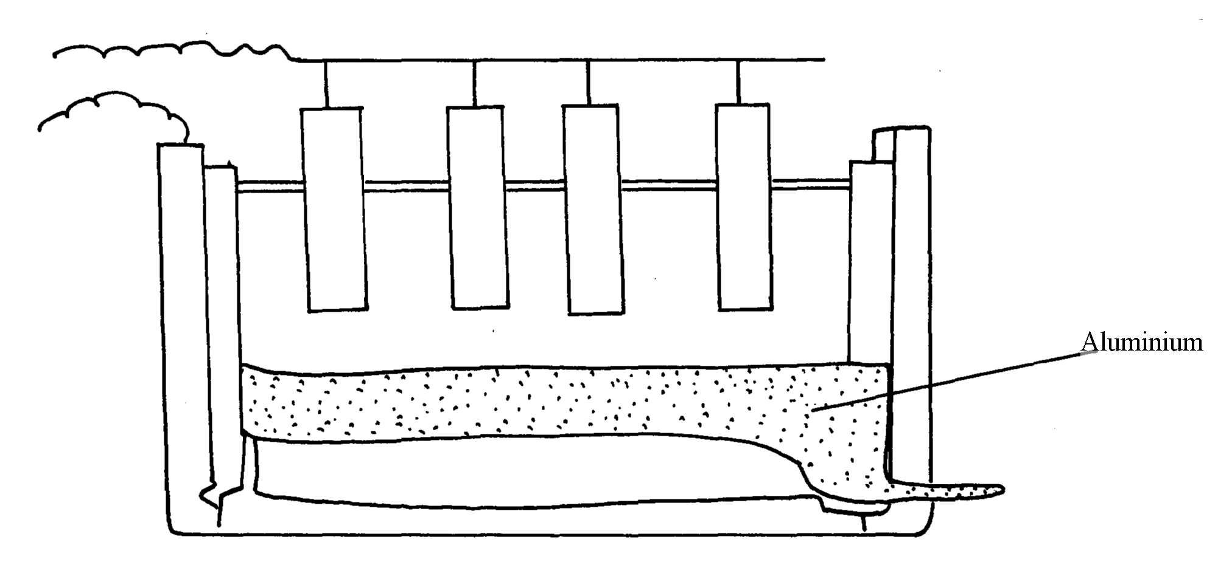
Use it to answer the questions that follow:-

(a) Name the two stages mentioned above *
(b) Name:-
(i) The ore from which Aluminium is extracted
(ii) The impurities removed during the extraction of Aluminium *
(c) On the diagram label:-
(i) The electrodes *
(ii) The region containing the electrolyte *
(d) Molten cryolite is added to Aluminium Oxide during extraction. Explain *

17. A current of 3A was passed through fused aluminium oxide for 10minutes. Calculate
the mass of Aluminium obtained at one electrode (Al = 27.0, IF = 96500C) *

18. (a) Name one ore that can be used to commercially extract Zinc metal
(b) The flow chart below illustrates the extraction of zinc and preparation of zinc sulphate
crystals.

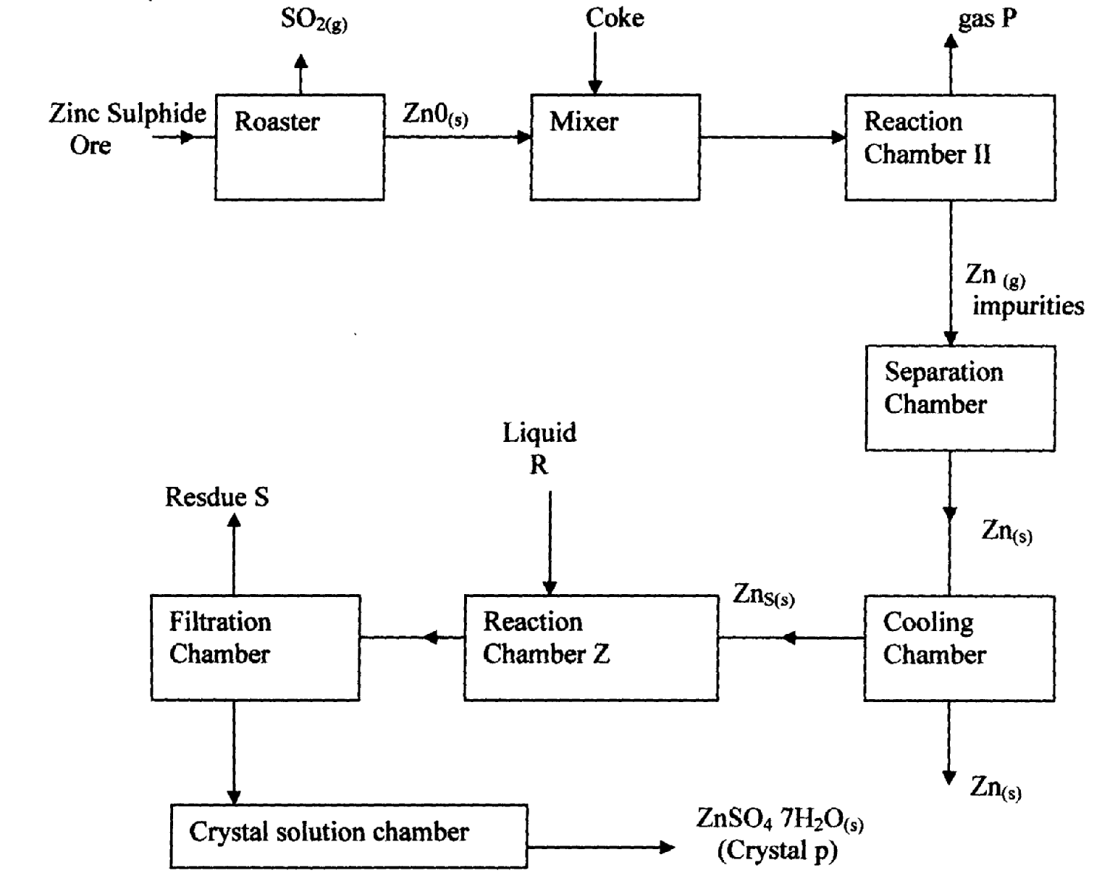

Zn_{(s)}

(i) Name :
(1) Gas P …………………………………………………………………………………..
(11) Liquid R ………………………………………………………………………………..
(III) Residue S ………………………………………………………………………………..
(ii) What is the role of coke in the above process?
(iii)Name the main impurity removed in the separation chamber
(iv) Write an equation for the reaction that takes place in ;
(1). Roaster

(11). Reaction chamber II
(v) Write an equation for the reaction that takes place between Zinc metal and liquid R
(vi) Given that zinc Suiphide ore contains only 45% of zinc Suiphide by mass, calculate
the mass in grams of zinc Sulphide that would be obtained from 250kg of the ore .
(vii) Give one commercial use of Zinc metal

19. The flow chart below shows a sequence of chemical reactions starting with Zinc.
Study it and answer the questions that follow:-
Zn_{(s)}
Step 1
Zn²⁺_{(aq)}
Step 2

NaOH_{(aq)}
Zn(OH)_{2(s)}
Step 3

Heat
Zn_{(s})
Zn²⁺_{(aq)}
Step 5

Metal T
Step 4 H₂SO_{4(aq)}
ZnO_{(s)}
Dilute hydrochloric acid

a) In step 1, excess 3M hydrochloric acid was added to 0.5g of Zinc powder
i) State two observations which were made when the reaction was in progress
ii) Explain why hydrogen gas is not liberated when dilute nitric acid is used in step 1
iii) a) Write the equation for the reaction that took place in step 1
b) Calculate the volume of 3M hydrochloric acid that was needed to react completely with
0.5g of Zinc powder (Zn = 65.0)

20. The diagram below is a simplified apparatus for extraction of sodium. Study it and answer the
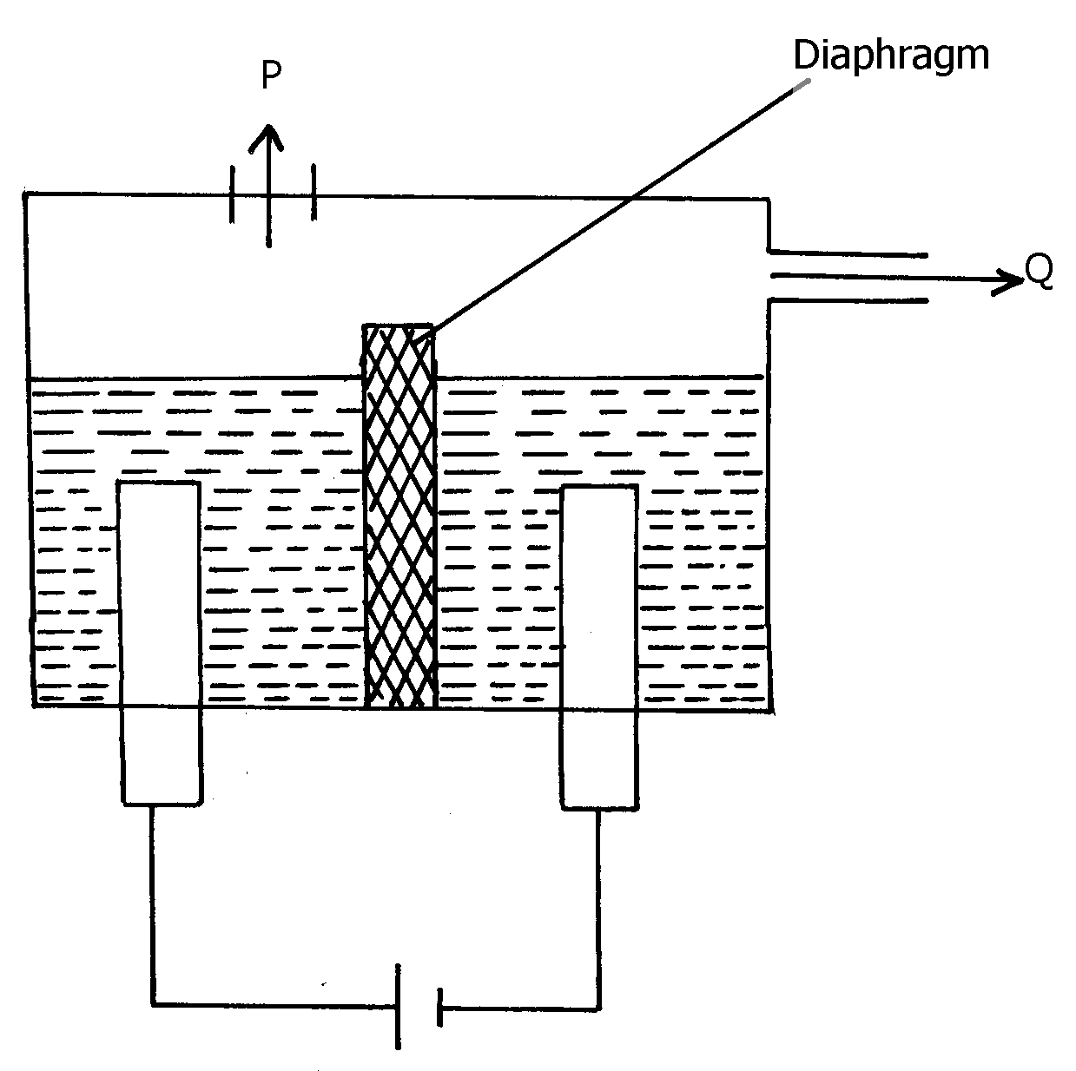
equations that follow:-

(a) Which substances come out at:- P & Q
(b) What is the role of the diaphragm
(c) Write the equation of the reaction forming sodium
21. The set-up below was used to investigate electrolysis of a certain molten compound;-

(a) Complete the circuit by drawing the cell in the gap left in the diagram
(b) Write half-cell equation to show what happens at the cathode
(c) Using an arrow show the direction of electron flow in the diagram above

22. (a) Name two ores from which Zinc metal is mostly extracted
(b) One of the steps in the extraction of Zinc metal from its ore is roasting of the ore in excess
oxygen. Write equations for the reactions that take place when the ore in (a) above is roasted
23. Aluminum metal is mainly extruded from molten Bauxite by electrolysis.
a) Name the main impurity in this ore.
b) Briefly describe how the impurity is removed from the ore before electrolysis process. (2 mks)
24. (a) In the extraction of aluminium form its ore by the use of electrolysis, explain the
following observations:-
(i) the graphite anode is replaced from time to time
(ii) the steel tank which can also serve as an electrode is also lined with graphite cathode
(b) Sodium and aluminium metals both conduct electricity, but aluminium is a better
conductor of electricity than sodium. Explain

Organic chemistry II (alkanoic acids and alkanols)
1. A student mixed equal volumes of Ethanol and butanoic acid. He added a few drops of
concentrated Sulphuric (VI) acid and warmed the mixture
(i) Name and write the formula of the main products
Name………………………………….
Formula……………………………………..
(ii) Which homologous series does the product named in (i) above belong?

2. The structure of the monomer phenyl ethene is given below:-
HC = CH₂
O

a) Give the structure of the polymer formed when four of the monomers are added together
b) Give the name of the polymer formed in (a) above
3. Explain the environmental effects of burning plastics in air as a disposal method
4. Write chemical equation to represent the effect of heat on ammonium carbonate
5. Sodium octadecanoate has a chemical formula CH₃(CH₂)₆ COO⁻Na⁺, which is used as soap.
Explain why a lot of soap is needed when washing with hard water
6. A natural polymer is made up of the monomer:
O

CH₃CH₂CH C OH

NH₂

(a) Write the structural formula of the repeat unit of the polymer
(b) When 5.0 x 10⁻⁵ moles of the polymer were hydrolysed, 0.515g of the monomer
were obtained.
Determine the number of the monomer molecules in this polymer.
(C = 12; H = 1; N = 14; O =16)
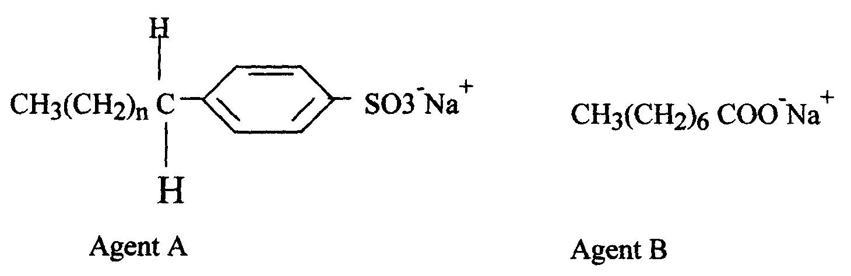
7. The formula below represents active ingredients of two cleansing agents A and B

Which one of the cleansing agents would be suitable to be used in water containing magnesium
hydrogen carbonate? Explain
8. Study the polymer below and use it to answer the questions that follow:
H H H H

CCCC

O H OH n

(a) Give the name of the monomer and draw its structures
(b) Identify the type of polymerization that takes place
(c) State one advantage of synthetic polymers
9. Ethanol and Pentane are miscible liquids. Explain how water can be used to separate a mixture
of ethanol and pentane

10.
GLUCOSE SOLUTION
CRUDE ETHANOL
95% ETHANOL
ABSOLUTE ETHANOL
G
H

(a) What is absolute ethanol?
(b) State two conditions required for process G to take place efficiently

11. (a) (i) The table below shows the volume of oxygen obtained per unit time when hydrogen
peroxide was decomposed in the presence of manganese (IV) Oxide. Use it to answer
the questions that follow:-
Time in seconds | Volume of Oxygen evolved (cm³)
0  30  60  90  120  150  180  210  240  270  300 | 0  10  19  27  34  38  43  45  45  45  45
(i) Plot a graph of volume of oxygen gas against time
(ii) Determine the rate of reaction at time 156 seconds
(iii) From the graph, find the time taken for 18cm³ of oxygen to be produced
(iv) Write a chemical equation to show how hydrogen peroxide decomposes in the presence
of manganese (IV) Oxide
(b) The diagram below shows how a Le’clanche (Dry cell) appears:-
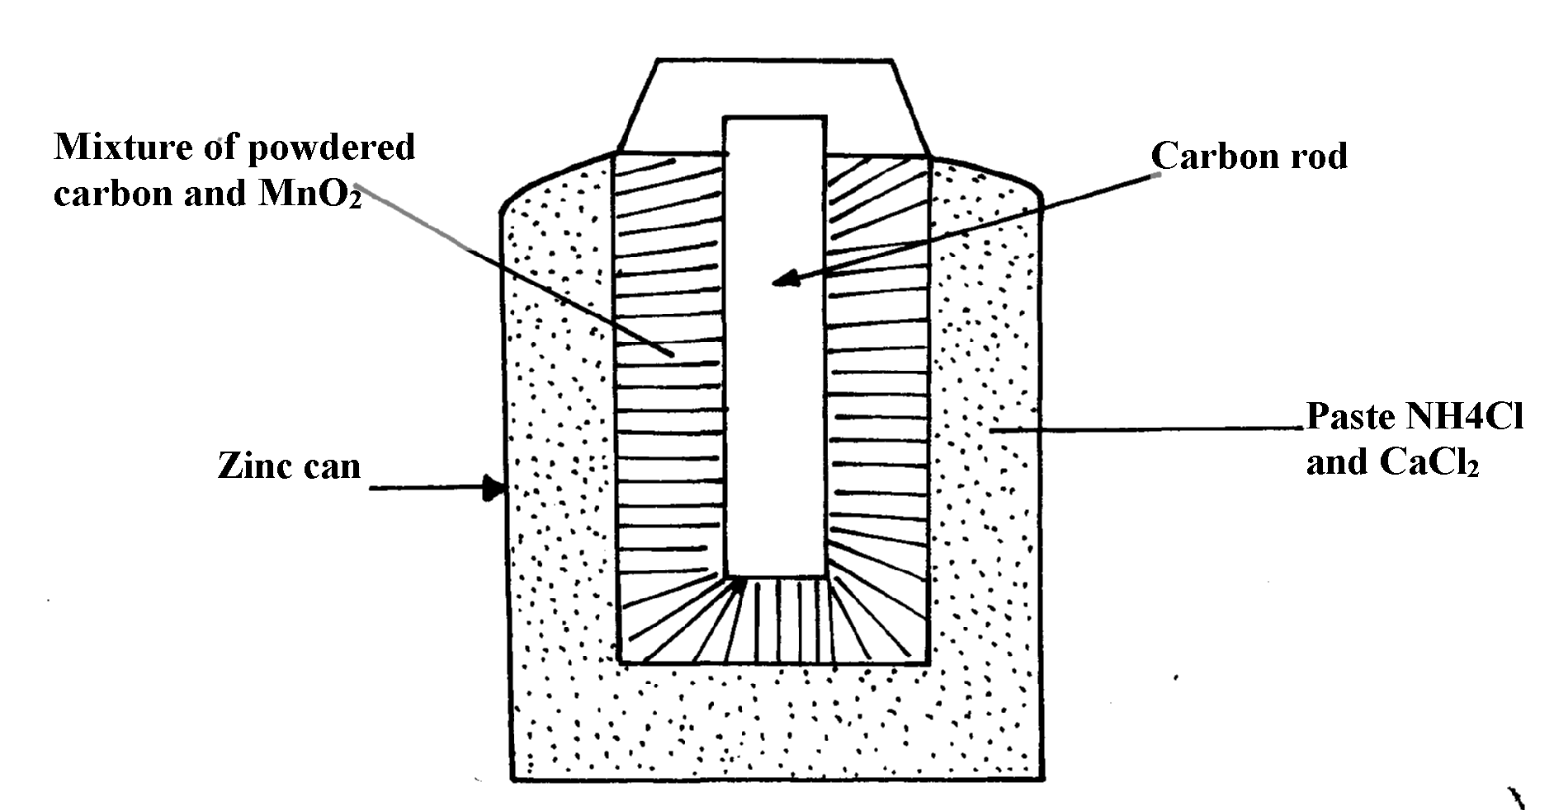

(i) What is the function of MnO₂ in the cell above?
(ii) Write the equation of a reaction that occurs at the cathode
(iii) Calculate the mass of Zinc that is consumed when a current of 0.1amperes flows
through the above cell for 30minutes (1F =96500c Zn =65)
12. (a) Give the IUPAC names of the following compounds:
(i) CH₃COOCH₂CH₃ *
CH₂ = C – CHCH₃

Br
(ii)

(b) The structure below shows some reactions starting with ethanol. Study it and answer
the questions that follow:
CH₃COOH
CH₃COONa
CH₃CH₂OH
CH₂=CH₂
CH₃CH₃
CH₂ CH₂
n
S
P
CH₄
T
Na Metal
Compound U
Step II
Step I
Step III
CH₃COOH

Drops of Conc. H₂SO₄
Reagent R
NaOH_{(aq)}
Heat
Excess Cl₂ /U.V

(i) Write the formula of the organic compounds P and S *
(ii) Name the type of reaction, the reagent(s) and condition for the reactions in the following steps :-
(I) Step I *
(II) Step II *
(III) Step III *
(iii) Name reagent R …………………………………………………………… *
(iv) Draw the structural formula of T and give its name *
(v) (I) Name compound U………………………………………………………..
(II) If the relative molecular mass of U is 42000, determine the value of n (C=12, H=1)
(c) State why C₂H₄ burns with a more smoky flame than C₂H₆ *
13. a) State two factors that affect the properties of a polymer
b) Name the compound with the formula below :
CH₃CH₂CH₂ONa

c) Study the scheme below and use it to answer the questions that follow:-
CH₃CH₂CH₃
P
Step

V
CH₃CH = CH₂
Step

W
CH₃CH₂CH₂OH
CH₃CH₂COOH
Step R
Gas F
CH₃CH₂COONa
NaOH

Step J
K₂CO₃
Step X
NaOH
Heat
CH₃CH₂COOCH₃
G
Product T
+ Na₂CO₃
H H

C – C

CH₃ H
n
K

i) Name the following compounds:-
I. Product T ………………………… II. K ………
ii) State one common physical property of substance G
iii) State the type of reaction that occurred in step J
iv) Give one use of substance K
v) Write an equation for the combustion of compound P
vi) Explain how compounds CH₃CH₂COOH and CH₃CH₂CH₂OH can be distinguished chemically
vii) If a polymer K has relative molecular mass of 12,600, calculate the value of n (H=1 C =12)
14. Study the scheme given below and answer the questions that follow:-

H_{2 (g)} Ni
High temp
Polymer Q
Polymerization
Compound P
CH₃CH₂CH₃
CH₃CH₂CH₂ONa + H₂

Na(s)
Propan-l-ol
Step I
Propylethanoate
CH₃CH₂COOH

Solution T + CO_{2 (g)}

Step III
Na₂CO_{3(aq)}
Conc. H₂SO₄ 180ºC
Step II

(a) (i) Name compound P ……………………………………………………………………
(ii) Write an equation for the reaction between CH₃CH₂COOH and Na₂CO₃
(b) State one use of polymer Q
(c) Name one oxidising agent that can be used in step II …………………………………..
(d) A sample of polymer Q is found to have a molecular mass of 4200. Determine the number of
monomers in the polymer (H = 1, C = 12)
(e) Name the type of reaction in step I …………………………………………………………..
(f) State one industrial application of step III
(g)State how burning can be used to distinguish between propane and propyne. Explain your
answer
(h) 1000cm³ of ethene (C₂H₄) burnt in oxygen to produce Carbon (II) Oxide and water vapour.
Calculate the minimum volume of air needed for the complete combustion of ethene
(Air contains 20% by volume of oxygen)
15. (a) Study the schematic diagram below and answer the questions that follow:-
CH₃CH₂COOCH₂CH₂CH₃
CH₃CHCH₂
CH₃CH₂CH₂ONa + Gas P
CH₃CH₂CH₂OH
X
V
HCl Step 5
Step 1 R
Na
Step2
H⁺
Step 3
Q + H₂O
MnO⁻₄
Step 4
Ni H₂

(i) Identify the following:
Substance Q ..............................................................................................................
Substance R...............................................................................................................
Gas P..........................................................................................................................
(ii) Name:
Step 1.................................................................................................
Step 4.................................................................................................
(iii) Draw the structural formula of the major product of step 5
(iv) State the condition and reagent in step 3
16. Study the flow chart below and answer the questions that follow
M
CO_{2 (g)}
KMnO₄/H⁺
CH₂CH₂
J
Ni/H_{2(g)}
Step 4
K
Reagent P
STEP 2
Ethyl Ethanoate
CH₂CH₂OH
Reagent Q
Step 3
KMnO4/H⁺_{(aq)}
L

(a) (i) Name the following organic compounds:
M……………………………………………………………..……..
L…………………………………………………………………..
(ii) Name the process in step:
Step 2 ………………………………………………………….….
Step 4 ………………………………………………………….…
(iii) Identify the reagent P and Q
(iv) Write an equation for the reaction between CH₃CH₂CH₂OH and sodium

17. a) Give the names of the following compounds:
i) CH₃CH₂CH₂CH₂OH ……………………………………………………………………
ii) CH₃CH₂COOH …………………………………………………………………
iii) CH₃C – O- CH₂CH₃ ……………………………………………………………………

18. Study the scheme given below and answer the questions that follow;
Step I
Products
C₂H₅COONa
Step V
Complete combustion
CH ≡CH
Step II
Step IV + Heat
CH₂ = CH₂
C₂H₆
Step III

CH₂ = CHCl
n
i) Name the reagents used in:
Step I: ………………………………………………………………………
Step II ……………………………………………………………………
Step III ………………………………………………………………………
ii) Write an equation to show products formed for the complete combustion of CH = CH
iii) Explain one disadvantage of continued use of items made form the compound formed
in step III
19. A hydrated salt has the following composition by mass. Iron 20.2 %, oxygen 23.0%,
sulphur 11.5%, water 45.3%
i) Determine the formula of the hydrated salt (Fe=56, S=32, O=16, H=11)
ii) 6.95g of the hydrated salt in c(i) above were dissolved in distilled water and the total
volume made to 250cm³ of solution. Calculate the concentration of the resulting salt solution
in moles per litre. (Given that the molecula mass of the salt is 278)
20. Write an equation to show products formed for the complete combustion of CH = CH
iii) Explain one disadvantage of continued use of items made form the compound formed
in step III

21. Give the IUPAC name for each of the following organic compounds;
i) CH₃ - CH - CH₂ - CH₃

OH
ii)CH₃ – CH – CH₂ – CH₂ - CH₃

C₂H₅
iii)CH₃COOCH₂CH₂CH₃

22. The structure below represents a cleansing agent.
O

R – S – O⁻Na⁺

O
a) State the type of cleansing agent represented above
b) State one advantage and one disadvantage of using the above cleansing agent.

23. The structure below shows part of polymer .Use it to answer the questions that follow.
CH₃ CH₃ CH₃
⎪ ⎪ ⎪
― CH - CH₂ – CH- CH₂ - CH – CH₂ ―
a) Derive the structure of the monomer
b) Name the type of polymerization represented above
24. The flow chart below represents a series of reactions starting with ethanoic acid:-
Ethanol
B
process I
Ethanoic acid

Na₂CO₃
Salt A + CO₂ + H₂O

(a) Identify substances A and B
(b) Name the process I

25. a) Write an equation showing how ammonium nitrate may be prepared starting with
ammonia gas
(b) Calculate the maximum mass of ammonium nitrate that can be prepared using 5.3kg of
ammonia (H=1, N=14, O=16)

26. (a) What is meant by the term, esterification?
(b) Draw the structural formulae of two compounds that may be reacted to form ethylpropanoate

27. (a) Draw the structure of pentanoic acid
(b) Draw the structure and give the name of the organic compound formed when ethanol
reacts with pentanoic acid in presence of concentrated sulphuric acid

28. The scheme below shows some reactions starting with ethanol. Study it and answer the questions
that follow:-
Q
P
CH₃COONa
Ethanol
CH₃CH₂ONa
C
H₂SO_{4(l)}

170ºC step 1
Cr₂O_{7(aq)} / H+_{(aq)}
Na_{(s)}
Step 2
Step 4
CH₃CH₂OH/H₂SO₄
Step 3
²⁻

(i) Name and draw the structure of substance Q
(ii) Give the names of the reactions that take place in steps 2 and 4
(iii) What reagent is necessary for reaction that takes place in step 3
29. Substances A and B are represented by the formulae ROH and RCOOH respectively.
They belong to two different homologous series of organic compounds. If both A and B
react with potassium metal:
(a) Name the common product produced by both
(b) State the observation made when each of the samples A and B are reacted with sodium
hydrogen carbonate
(i) A
(ii) B

30. Below are structures of particles. Use it to answer questions that follow. In each case only
electrons in the outermost energy level are shown
key
W
U
V
19P
20N
Z
Y
P = Proton
N = Neutron
X = Electron

(a) Identify the particle which is an anion
31. Plastics and rubber are extensively used to cover electrical wires.
(a) What term is used to describe plastic and rubbers used in this way?
(b) Explain why plastics and rubbers are used this way
32. The scheme below represents the manufacture of a cleaning agent X

R
Conc.

H₂SO₄
R

SO₃H
Cleaning agent X

(a) Draw the structure of X and state the type of cleaning agent to which X belong
(b) State one disadvantage of using X as a cleaning agent
33. Y grams of a radioactive isotope take 120days to decay to 3.5grams. The half-life period
of the isotope is 20days
(a) Find the initial mass of the isotope
(b) Give one application of radioactivity in agriculture
34. The structure below represents a polymer. Study and answer the questions that follow:-
H H

-C – C -

CH₃ H
n
n

(i) Name the polymer above..................................................................................
(ii) Determine the value of n if giant molecule had relative molecular mass of 4956
35. RCOO⁻Na⁺ and RCH₂OSO₃⁻Na⁺ are two types of cleansing agents;
i) Name the class of cleansing agents to which each belongs
ii) Which one of these agents in (i) above would be more suitable when washing with water
from the Indian ocean. Explain
iii) Both sulphur (IV) oxide and chlorine are used bleaching agents. Explain the difference
in their bleaching properties

36. The formula given below represents a portion of a polymer
H H H H

C C C C

O H O H
n

(a) Give the name of the polymer
(b) Draw the structure of the monomer used to manufacture the polymer

Radioactivity
1. Complete the following equation by determining the values of U and V.
u

v
234

90
0

-1
Th Pa + e

U……… V……………..

2. (a) Distinguish between nuclear fusion and fission
(b) Compete the nuclear equation below:-
230 230
90
91
+

3. Uranium -238 disintegrates by emitting an alpha particle to form substance Y.
Nuclide Y emits a beta particle to form substance Z. Write down nuclear equations to show how
substance Y and Z are formed (U=At No. 92)

4. (a) What is a nuclide?
(b) The graph below shows the radioactive decay of a certain nuclide. Determine the
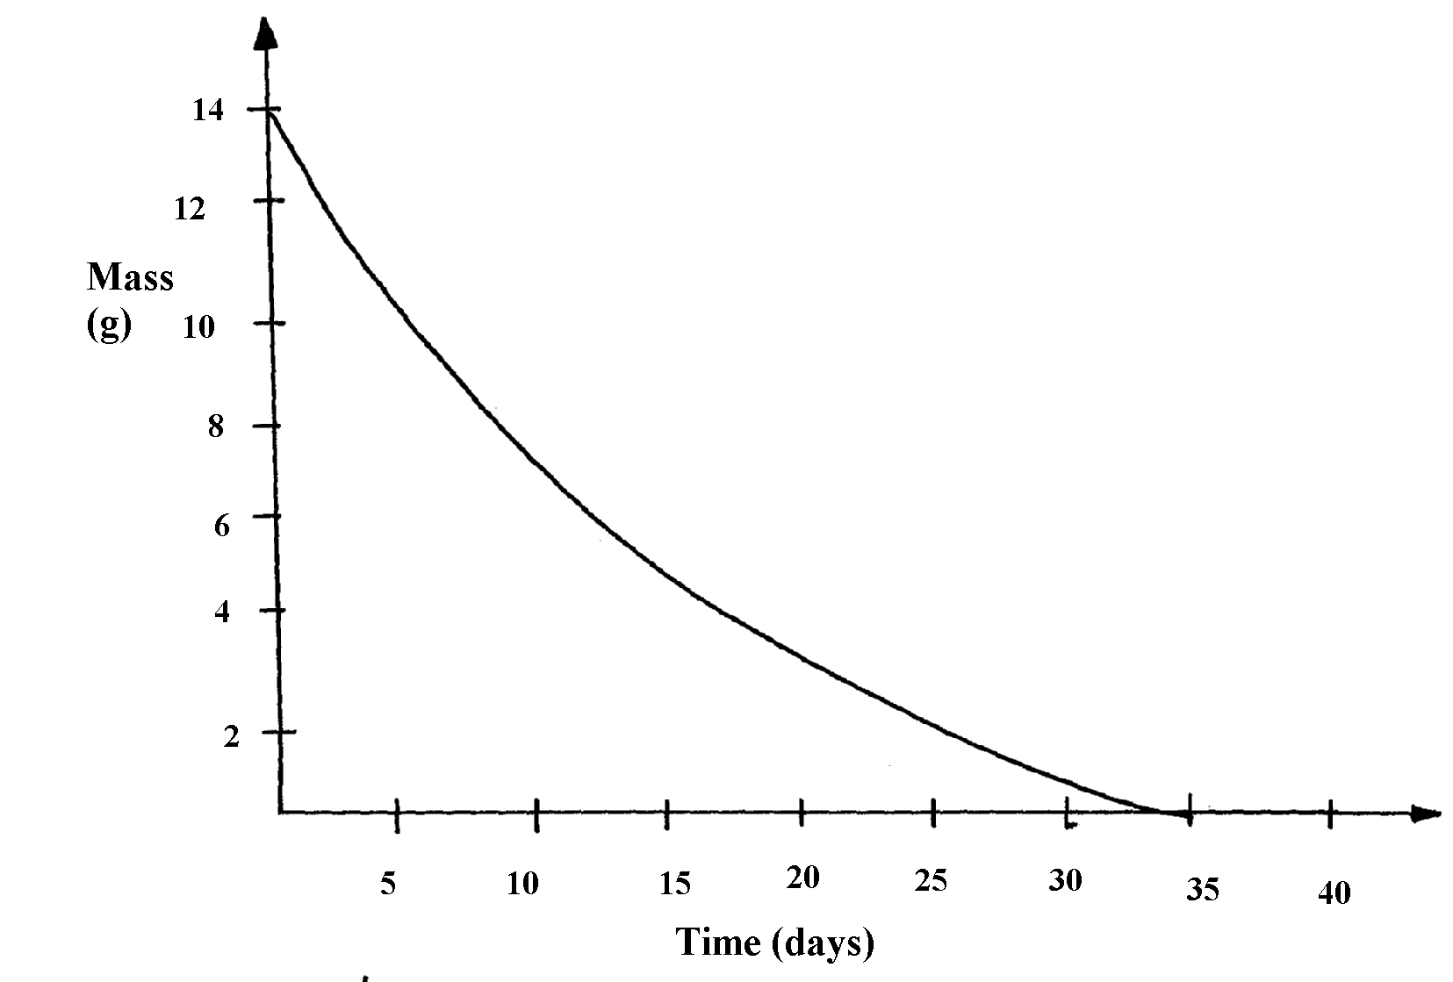
half-life of the nuclide

(e) What effect do excessful exposures of radiation have on metals?
5. (a) State one way in which nuclear reactions differ from ordinary chemical reactions
(b) The following is a part of Uranium decay series
238
U
92
234
Th
90
234
Pa
91
Z
X
A
Step I
Step II
Step III

(i) Which particles are emitted in step I and II
(ii) If a beta particle is emitted in step III, find Z and A
(iii) If the activity of Thorium -234 is reduced to 25% in 48hours, find its half life
6. Substances A and B are represented by the formulae ROH and RCOOH respectively.
They belong to two different homologous series of organic compounds. If both A and B
react with potassium metal:
(a) Name the common product produced by both
(b) State the observation made when each of the samples A and B are reacted with sodium
hydrogen carbonate
(i) A
(ii) B
7. Some two elements are represented as:
16 27
and
8 13

(a) How many protons does X have?
(b) How many neutrons does Y have?
(c) Draw the structure of the compound formed between X and Y
8. Y grams of a radioactive isotope take 120days to decay to 3.5grams. The half-life period
of the isotope is 20days
(a) Find the initial mass of the isotope
(b) Give one application of radioactivity in agriculture

9. Study the nuclear reactions given and answer the questions that follow:
¹²
⁶
Step I
¹⁴
⁶
Step II
¹⁴
⁷
X Y Z

(a) Write an equation for the nuclear reaction in step II (lmk)
(b) Give one use of Y (lmk)
10. Give two uses of radioactive isotopes in medicine.
11. Study the information in the following table and answer the questions that follow. The letters
do not represent the actual chemical symbols of the elements.
ELEMENT | U | V | W | X | Y | Z
NUMBER OF PROTONS | 18 | 20 | 6 | 16 | 19 | 17
NUMBER OF NEUTRONS | 22 | 20 | 8 | 16 | 20 | 20
Which of the above elements are:
(i) Likely to be radioactive?
(ii) Able to form a compound with the highest ionic character?

12. The isotope decays by Beta, β -emission to a stable nuclide. The half-life of the
²⁴
¹¹
isotope is 15hours 2.0g of is allowed to decay. Determine the mass of left after 90hours
13. (a) Complete the following nuclear equation
55

24
55

25
Cr Mn + ____________

(b) 100g of a radioactive substance was reduced to 12.5g within 15.6 years. Determine
the half-life of the substance

SECTION III PRATICALS

KAKAMEGA CENTRAL DISTRICT
CONFIDENTIAL
ACCESS TO:-
- 1M NaOH
- 1M NH₄OH
- 1M HCL
- 0.01m PB (NO₃)₂
- Source of heat
- pH chart (PH=1 to 14)
- 10ml of solution K
- Sodium hydrogen carbonate

PREPARATION OF SOLUTIONS:
1. Solution J
Dissolve 17g of ammonium iron (II) sulphate in 50cm³ of 2M H₂SO₄ dilute to 1dm³
2. Solution K KMnO₄
Dissolve 1.6g of potassium manganate vii in 20cm³ of 2 MH₂SO₄ dilute to 1dm³
3. Solution R
Dissolve 40g of sodium thiosulphate in 1dm³ of solution
4. Solution S
Dissolve 172cm³ of concentrated hydrochloric acid in 1dm³ of solution
5. Solid Y is aluminium sulphate
6. Solid Z is oxalic acid.

Each candidate will require:
Q1.
1. Solution J - 100cm³
2. Burette
3. Solution K- 100cm³
4. Pipette
5. 2 conical flasks
6. Filter funnel
7. Retort stand

1. You are provided with:
Solution J:xM ammonium iron(II)sulphate solution
Solution K: 0.02M potassium manganate (VII)solution
You are required to determine:
-The molarity, x of the ammonium iron (II) sulphate
- The amount of water of crystallisation, N in ammonium iron (II) sulphate
-The formula mass of ammonium iron (II)sulphate.

Procedure
The ammonium iron (II) sulphate, (NH₄)₂SO₄FeSO₄nH₂O solution provided was made by
dissolving 8.5g of the salt in 50.0cm³ of dilute sulphuric(VI)acid, then making the solution
to 250cm³ using distilled water.
Fill the burette with solution K. Pipette 25cm³ of solution J and release into a conical flask.
Titrate J against K until the solution becomes permanent pink. Repeat two more times and
complete the table below;-
Table 1
 | I | II | III
Final burrete racing (cm³)
Final burrete reading (cm³)
Volume of Solution K used (cm³)

a) Calculate the average volume of solution K used
b) The number of moles of solution K reacting
c) Given that equation for the reaction is:
-

MnO_{4(aq)} + 8H⁺_{(aq)} + 5Fe²⁺_{(aq)} Mn²⁺_{(aq)} + 5 Fe²⁺ _{(aq)} + 4H₂O_{(l)}
Determine:
i) The number of moles of iron (II) salt solution J in 25cm³ of the solution used
ii) The molarity of solution J
iii) The concentration of solution J in grams per litre
d) From your results in C (iii) above, determine:
i) the value of “n” in the formula (NH₄)₂SO₄FeSO₄nH₂O.
(N=14, H= 1, S=32, O=16, Fe=56)
ii) Correct formula of the iron (II) salt
iii) The formula mass of the iron (II) salt

Q2.
1. 120cm³ of solution R
2. 80cm³ of solutions
3. 250cm³ of tap water
4. 25ml or 50ml measuring cylinder
5. 100cm³ glass beaker
6 5 x 5cm piece of white paper
7. Stop watch or clock.

2. You are provided with:
i) Sodium thiosulphate containing 40g/dm³ solution R
ii) 2M hydrochloric acid solution S
You are to determine the rate of reaction between solution S and the thiosulphate

Procedure:
Measure 20cm³ of solution R into an empty 100cm³ breaker. Place it on a mark ‘X’ on a white
plain paper. Measure another 20cm³ of solution S. add into R and start off the stop watch. Then
record the time taken for the mark ‘X’ to become invisible from above. Repeat the procedure by
measuring 17.5cm³ of solution S and adding 2.5cm³ of water and complete the table;-
Table 2
Experiment | 1 | 2 | 3 | 4 | 5
Volume of solution R cm³ | 20 | 20 | 20 | 20 | 20
Volume of solution S cm³ | 20 | 17.5 | 15 | 12.5 | 10
Volume of water (cm³) | 0 | 2.5 | 5.0 | 7.5 | 10
Time taken for x to become invisible(seconds)
1/time (Sec⁻¹)
a) Draw a graph of reciprocal time (¹/_{t}) against volume of solution S
b) Explain the shape of the graph
c) From the graph determine the time taken for the cross ‘X’ to be invisible at 16.5cm³ of solution S Q3.
1. Solid Y-1spatulaful
2. Solid Z-1spatulaful
3. 6 test tubes
4. 1 red + 1blue litmus papers
5. Metallic spatula
6. pH paper

3. You are provided with solid Y and Z to carry out the tests below. Write your observations and
inferences in the spaces provided:-
a) i) Place all solid Y in a clean test tube. Add 10cm³ of distilled water and shake.
Divide the solution in a (i) above into 4 portions
ii) To the first portion add sodium hydroxide dropwise until in excess
iii) To the second portion add aqueous ammonia dropwise until in excess
iv ) To the third portion add 5 drops of dilute hydrochloric acid
v) To the fourth portion add 3 drops of lead (II) nitrate solution

b) i) Scoop a little solid Z on a metallic spatula and heat it over a bunsen flame
ii) Add all the remaining solid to 10cm³ of distilled water in a test tube and shake.
Divide the solution into 3portions
iii)to the first portion dip a pH indicator paper

iv) to the second portion add 3 drops of acidified potassium permanganate warm gently KKC*
v)to the third portion add ½ spatula full of sodium hydrogen carbonate

KAKAMEGA EAST DISTRICT
CONFIDENTIAL
INSTRUCTIONS
Each candidate should be provided with the following:-
- Burette
- Pipette
- Two conical flasks
- Funnel
- Phenolphthalein indicator
- Methyl orange indicator
- Universal indicator
- Solution a 100cm³
- Solution b 100cm³
- Solution c 100cm³
- Distilled water in wash bottle
- 0.2m CuSO₄ (solution Y)
- 0.7g zinc powder (solid Z)
- Thermometer
- 100ml plastic beaker
- Stop watch or wrist watch
- Tissue paper ½ metre
- 6 test tubes
- One boiling tube
- Solid P
- Solid Q
- Filter paper
- Means of heating
- 2m NaOH
- 2m H₂SO₄
- 0.1m bacl₂
- 0.1m pb(no₃)₂
- 2m HCl
- 2m NH_{3(aq)}
- Metallic spatula
- 0.5g NaHCO₃
Notes on preparation of solutions :-
  - Solution A 0.05M sodium Carbonate
  - Solution B = 0.1M of HCl
  - Solution C = 0.16g KOH + 1.94g KCl in 250cm³ solution
  - Solid P = CaCl₂ and MgCO₃
  - Solid Q = Carboxylic acid (oxalic)

1. You are provided with:-
- Solution A containing 0.05 moles in 1dm³ of solution of anhydrous Sodium Carbonate
- Solution B, monobasic acid, HX
- Solution C, 2.1g of a mixture of potassium hydroxide (KOH) and potassium chloride (KCl) dissolved in distilled water and made up to 250cm³ solution.
You are required to:
- Standardise the monobasic acid, solution B
- Determine the percentage of potassium chloride (KCl) in the mixture.
Procedure:
Fill the burette with solution B. Pipette 25.0cm³ of solution A into a clean dry conical flask
and titrate with solution B using methyl orange indicator. Record your results in table 1 below:-

 | 1 | 2 | 3
Final burette reading (cm³)
Initial burette reading (cm³)
Volume of solution B used (cm³)

(a) Calculate the average volume of solution B used
(b) Given that the equation for the reaction taking place is:-
Na₂CO_{3(aq)} + 2HX_{(aq)} 2NaX_{(aq)} + CO_{2(g)} + H₂O_{(l)}
Calculate the concentration of solution B in moles per litre
Procedure II
Fill the burette to the 0.0mark with solution B. Pipette 25.0cm³ of solution C into a clean
dry conical flask and titrate it against solution B using phenolphthalein indicator. Repeat the
titration and fill table II below:-
Table II
 | 1 | 2 | 3
Final burette reading (cm³)
Initial burette reading (cm³)
Volume of solution B used (cm³)

(c)What is the average volume of solution B used?
(d) Calculate the concentration of solution C in :-
(i) Moles per litre
(ii) Grams per litre (K=39, O=16, H=1)
(e) Calculate the percentage of potassium chloride in the mixture
2. You are provided with:-
  - Solution Y containing 0.2moles of copper (II) sulphate per litre of solution
  - Solid Z
You are required to:
Determine the heat evolved when 1 mole of solid Y reacts with solid Z
Procedure
- Measure 40cm³ of solution Y and place it into an insulated 100cm³ plastic beaker
- Stir the solution with the help of thermometer and record its temperature after every ½ minute
for 1½ minutes.
- After exactly 2 minutes, add all the solid Z provided and continue stirring the mixture while recording the temperature of solution and complete the table below:
Time (minutes) | ½ | 1 | 1½ | 2 | 2½ | 3 | 3½ | 4 | 4½ | 5 | 5½ | 6 | 6½ | 7
Temperature (ºC )

(b) (i) On the graph paper provided, plot a graph of temperature against time
(ii) From your graph, determine the maximum temperature change
(c) Given that the density of the solution is 1g/cm³, determine the quantity of heat evolved
when 40cm³ of solution Y is reacted completely with solid Z
(specific heat capacity of solution = 4.2jg⁻¹k⁻¹)
(d) (i) Given that solid Z is Zinc powder, write an ionic equation of the reaction which occurs
(ii) Determine the moles of copper ions used up in the reaction
(iii) Determine the amount of heat that would be evolved if one mole of Copper
(II) ions were used up
(iv) Explain why the value obtained in this reaction is lower than the actual value?
3. I. You are provided with solid P. Carry out the tests below and write the observations
and inferences in the spaces provided

(a) Heat about one third of solid P in a clean dry test tube
(b) Add 10cm³ of distilled water to the remaining solid P in a boiling tube and shake.
Filter and retain both the residue and the filtrate. Divide the filtrate into four portions
(i) To the first portion add aqueous Sodium hydroxide drop by drop till in excess
(ii) To the second portion add dilute sulphuric acid
(iii) To the third portion, add barium chloride solution
(iv) To the fourth portion, add Lead (II) nitrate solution
(c) (i) To the residue from (b) above in the test-tube, add dilute hydrochloric acid and retain
the mixture
(ii) To the mixture is(c)(i) above, add aqueous ammonia drop wise till in excess
II. You are provided with solid Q. Carry out the test below and write your observations and
inferences in the spaces provided

- Scoop a little of solid Q with a clean dry metallic spatula and ignite using a Bunsen flame.

- Place the remaining solid Q in a boiling tube. Add about 10cm³ of distilled water. Shake the
mixture until it dissolves. Divide the solution into 4 portions
(i) To the first portion, test the PH with PH paper.
(ii) To the second portion, add solid sodium Carbonate and shake

MIGORI – NYATIKE DISTRICT

CONFIDENTIAL
INSTRUCTIONS.
Apart from the normal fittings in the laboratory, each candidate will need the following chemicals and apparatus.
- 500ml of distilled water supplied in a wash bottle
- 50ml burette
- 25ml
- a pipette filler
- 2 conical flasks (250ml)
- Source of heat (means of heating)
- Stop watch/clock
- A ruler
- 100ml measuring cylinder
- 50ml measuring cylinder
- Complete retort stand
- 12cm long magnesium ribbon labelled C
- 100ml of solution A (sulphuric acid)
- 80ml of solution B (Sodium hydroxide soltn.)
- 100ml empty beaker
- Funnel
- Sand paper
- 3g of solid E
- 1g of solid F
- Means of labeling
- Six clean test tubes in a test tube rack
- 3 boiling tubes in a rack
- Metallic spatula
- About 0.2g of sodium hydrogen carbonate
- Glass rod.

Access
- 2M Ammonia solution supplied with a dropper
- 2M Sodium hydroxide solution supplied with a dropper
- 2M Lead (II) Nitrate supplied with a dropper
- 0.2M Silver Nitrate solution supplied with a dropper
- Acidified potassium dichromate (VI) supplied with a dropper
- Acidified Potassium Manganate (VII) supplied with dropper
N/B
- Solution A is prepared by accurately measuring 27.5cm³ of concentrated
Sulphuric acid, then adding it to 700ml of distilled water then topping it to one litre.
Density of acid 1.84g/cm³
- Solution B is prepared by accurately measuring 20g of NaOH pellets and dissolving
it in 800cm³ of distilled water then topping to one litre with distilled water.
- Solid E and F will be provided by the council. Solid E is highly deliquescent and
should be handled cautiously

QUESTION 1.
You are provided with:
- Sulphuric acid solution A
- 0.5M sodium hydroxide solution B
- Magnessium ribbon labelled C
You are required to:-
- Investigate the rate of reaction between solution A and metal C
- Determine the concentration of sulphuric acid in moles per litre

Procedure I
(i) Using a ruler, make 6 marks at 2cm length interval on the Magnesium ribbon provided.
(ii) Transfer 50cm³ of acid solution using a measuring cylinder into a clean dry 100ml beaker.
Place 2cm length piece of magnesium ribbon into the beaker with the acid and immediately
start the stop watch/clock. Shake gently and note the time taken for the piece of
magnesium ribbon to react completely.
(iii) Record in table I below. Place another piece of magnesium ribbon (2cm) to the same
solution and again note the time taken.
(iv) Repeat the procedure until all six pieces of magnesium ribbon have reacted with
the same solution initially placed in the beaker
(v) Complete the table I below:
Note: Keep the solution obtained in this experiment for use in procedure II
(a) Table I
Piece of magnesium added | 1 | 2 | 3 | 4 | 5 | 6
Length of magnesium added (cm) | 2 | 4 | 6 | 8 | 10 | 12
Time taken t(second)
Reciprocal of time ¹/_{t}^{(s-1)}

(b) (i) Plot a graph of total length of magnesium ribbon added against reciprocal of time (^{1/}_{t})
for the reaction to go to completion
(ii) From your graph, determine the time taken when 4.5cm length of magnesium ribbon
reacts completely. (Show parts on the graph)
(iii) Write a chemical equation for the reaction between magnesium and sulphuric acid
(iv) Given that the mass of solid V, which reacted was 0.12g and that atomic mass of
magnesium is 24.0g, determine the number of mole of sulphuric acid that were
used up during the reaction
(v) From your graph, state and explain the relationship between the length of magnesium
ribbon and the reciprocal of time (¹/_{t})

Procedure II
Place all the solution obtained in procedure I in a clean 100ml measuring cylinder.
Add distilled water to make 100cm³ of solution. Transfer all the solution into a beaker
and shake well. Label it solution D. Fill the burette with solution B. Pipette 25.0cm³
of solution D into a conical flask. Add 2-3drops of phenolphthalein indicator and titrate
with solution. Record your results in the table II below. Repeat the titration two more times

(f) Table II
Titration | I | II | III
Final burette reading (cm³)
Initial burette reading (cm³)
Volume of solution B (cm³) used

(c) (i) Determine the average volume of solution B used
(ii) Calculate the number of moles of sodium hydroxide solution B used
(d) Calculate:
(i) The number of moles of sulphuric acid in 25.0cm³ of solution D
(ii) The number of moles of sulphuric acid in 100cm³ of solution D
(e) Determine the total number of moles of sulphuric acid in 50cm³ of solution A
(f) Calculate the concentration of the original sulphuric acid solution A in moles per litre

2. You are provided with solid E. Carry out the following tests and write your observations and
inferences in the table below:
(a) Place all the solid E in a boiling tube. Add about 15cm³ of distilled water and shake
vigorously for about 2 minutes
b) (i) divide the solution into five equal portions in five different clean test tubes.
(i) To the first portion, add 2M ammonia solution drop wise until in excess
ii) To the second portion add 2M Sodium hydroxide solution drop wise until in excess
iii) To the third portion add 4 drops of 2M Lead (II) nitrate solution
iv) To the fourth portion, add 4 drops of 0.2M silver nitrate solution, then add 2M ammonia
solution drop wise, until in excess
(v) Clean one end of the glass rod provided. Dip the clean end of the glass rod in the fifth
portion.
Remove the end and heat it in the non-luminous part of a Bunsen burner flame. Note the
colour of the flame and record below:-
3. You are provided with solid F. Carry out the tests below. Write your observations and inferences
in the spaces provided
(a) Place about a half of solid F on a metallic spatula and burn it using a Bunsen burner flame
(b) Place the remaining of solid F in a boiling tube. Add about 10cm3of distilled water and
shake the mixture well.
(c) (i) Divide the mixture obtained into three portions.
(ii) To the first portion, add a small amount of solid sodium hydrogen carbonate
(iii) To the second portion, add about 1cm³ of acidified potassium dichromate (VI)
and warm
(iv) To the third portion, add two drops of acidified potassium magnate (VII)

NYAMIRA DISTRICT

CONFIDENTIAL
INSTRUCTIONS
Each candidate should be provided with:
- About 1g of malleic acid – solid P
- A clean metallic spatula
- Bunsen burner
- 500ml distilled water in a wash bottle
- Six test-tubes in a rack
- One test tube holder
- 2 boiling tubes
- About 1g of AlCl₃ – solid M
- One blue and one red litmus paper
- One volumetric flask (250ml)
- One pipette 25cm³
- One pipette filter
- One label
- Solid G – oxalic acid (exactly 3g) in a stoppered container
- 50ml or 100ml measuring cylinder
- 100cm³ beaker
- One thermometer
- One stopwatch/clock
- About 0.2g NaHCO₃ solid
- 100ml of solution H
- One burette (50ml)
- 2 conical flasks
Access to:-
- 0.2M Pb(NO₃) Solution supplied with a dropper
- 0.2M Ba(NO₃)₂ Solution supplied with a dropper
- 0.1M KI Solution supplied with a dropper
- 2M NaOH Solution supplied with a dropper
- 2M NH_{3(aq)} Solution supplied with a dropper
- Acidified K₂CV₂O₇ Solution supplied with a dropper
Preparation instruction
- Dissolve 6.4g of KMnO₄ in 400cm³ 2M H₂SO₄ and top to 1litre using distilled water

1. You are provided with:
- 0.0238 Moles (equivalent to 3g) of solid G
- Solution H, 0.04M acidified potassium manganate (VII)
You are required to:
I. Determine the enthalpy of solution of solid G
II. The number of moles of water of crystallization in solid G

Procedure I:-
Using a measuring cylinder place 50cm³ of distilled water into a 100cm³ of beaker.
Stir the water gently with a thermometer and take its temperature after every half-minute.
Record the reading in table I below. At exactly two minutes, add all solid G to the water
at once. Stir well and take the temperature of the mixture after every half minute up to
the fourth minute. Record your results in table I. Keep the solutions for procedure II below:
Table I
(a)
Time (min) | 0 | ½ | 1 | 1 ½ | 2 | 2 ½ | 3 | 3 ½ | 4
Temperature (ºC ) |  |  |  |  | X

(b) On the grid provided, plot a graph of time (x-axis) against temperature
(c) (i) On the graph, show the change in temperature ΔT
(ii) Calculate :
The molar enthalpy of solution (ΔH solution)
(Assume density of solution = 1g/cm³ and show the sign of ΔH solution specific heat
capacity of solution = 4.2jg⁻¹k⁻¹)
Procedure II
Transfer the contents of the beaker into a 250ml volumetric flask. Rinse both the beaker
and the thermometer with distilled water and add to the volumetric flask. Add more distilled
water to eh mark.
Label this solution G
Fill the burette with solution H
Using a pipette and pipette filter, place 25.0cm³ of solution G into a conical flask. Warm the
mixture to about 60ºC. Titrate the hot solution G with solution H until a permanent pink colour
persists (while shaking). Record your readings in table 2. Repeat the titration two more times
and complete table 2
Table 2.
Titre | I | II | III
Final burette reading
Initial burette reading
Volume of solution H used (cm³)

(e) Calculate the:
1. Average volume of H used
II. Number of moles of potassium manganate VII used
III. Number of moles of G in 25cm³ solution G given that 2moles of potassium manganate
(VII) reacted completely with 5moles of G
IV. Relative formula mass of G
(f) Formula of G has the form G. XH₂ Determine the value of X in the formula given
the relative formula mass for G is 90.0 and atomic mass of Oxygen is16 and that
of Hydrogen is 1.0

2. You are provided with solid M and carry out the tests below write your observations and
inferences in the spaces
(i) To a dry boiling tube, place all solid M and add 12cm³ of distilled water and use the
solution for the tests below:-
(ii) To 2cm³ of solution, add both litmus papers
(iii) To 2cm³ of solution, add aqueous sodium hydroxide drop wise until excess
(iv) To 2cm³ of solution, add aqueous ammonia drop wise until in excess
(v) To 2cm³ of the solution, add 2 drops of aqueous potassium iodide
(vi) To 2cm³ of solution, add 3 drops of aqueous lead (ii)nitrate
(vii) To 2cm³ of solution, add 3 drops of aqueous Barium nitrate solution

2. B. You are provided with solid P. Carry out the test below. Write your observations and
inferences in the spaces provided:-
(a) Place one third of solid P on a metallic spatula and burn it using a Bunsen burner
(b) Place the remaining of solid P in a test-tube . Add about 6cm³ of distilled water and shake
the mixture (retain the mixture for use in test (c)
(c) (i) To 2cm³ of the mixture in (b) above add a spatula end full of NaHCO₃ solid
(ii) To 2cm³ of the mixture, add 2cm³ of acidified potassium dichromate (VI) and warm
(iii) To 2cm³ of the mixture add two drops of acidified potassium manganese (VII) and shake well

SOTIK DISTRICT

CONFIDENTIAL
Requirements:
In addition to the equipment, apparatus and chemical found in the chemistry
laboratory each candidate will require the following:
- About 100cm³ of solution L
- About 100cm³ of solution N
- A burette
- A pipette
- 3 conical flasks
- 4.0g of solid K
- Thermometer
- Distilled water
- Test tube holder
- 3 boiling tubes
- Phenolphthalein indicator
- Filter paper
- Filter funnel
- Source of heat
- 1g of solid x
- 10ml measuring cylinder
- 2M HNOз
- Seven test tubes
- Stirring rod
- 2M NaOH
- 2M NH₄OH
- 2M HCL
- 0.5M lead (II) nitrate
- 0.5M barium chloride
NOTES
-Solution L is prepared by dissolving 5g of NaOH in a litre of distilled water
-Solution N is prepared by dissolving 9.84g of C₂H₂O₄.2H₂O in a litre of distilled water (oxalic acid)
-Solid K is potassium chlorate
-Solid X is a mixture of copper (II) oxide and zinc sulphate in the ratio 1:1

1. You are provided with:-
(i) Solution L containing 5g per litre of sodium hydroxide
(ii) Solution N containing 9.84g per litre of oxalic crystals of formula C₂H₂O₄.X H₂O
(iii) You are required to determine the number of moles of water of crystallization X in
one mole of oxalic acid (C₂H₂O₄. XH₂O)
(iv) You are required to determine the number of moles of water of crystallization X; in one
mole of oxalic acid (C₂H₂O4. XH₂O)
Procedure
(i) Fill the burette with solution N.
(ii) Pipette 25cm³ of solution L into 250cm³ conical flask and add 2 drops of phenolphthalein
indicator to it and titrate with solution N.
(iii) Record your results in the table below
(iv) Repeat the experiment twice to obtain consistent readings and complete the table

Table 1
Titration | 1 | 2 | 3
Final burette reading (cm³)
Initial burette reading (cm³)
Volume of solution N used (cm³)

(a) Calculate the average volume of solution N used
(b) Determine:-
(i) The concentration of sodium hydroxide in one litre of solution L
(Na =23, O= 16, H= 1)
(ii) Write the equation of the reaction taking place
(iii) The number of moles of anhydrous carbohydrates oxalic acid in one litre of the
solution N
(iv) The relative formula mass of anhydrous oxalic acid, solution N (C = 12, H=1, O = 16) (v) The number of moles of water of crystallization in one mole of oxalic acid

2. You are provided with solid K, a boiling tube and a thermometer. You are required to determine the solubilities of solid K, at various temperatures.
Procedure:-
- Carefully transfer all the 4.0g of solid K into a clean boiling tube and add 10cm³ of distilled water from a burette.
(b) Heat the boiling tube and its contents gently with shaking until all the solid dissolves.
(Do not spill the solution during heating.) Stop heating when all the solid dissolves.
See the diagram below:-

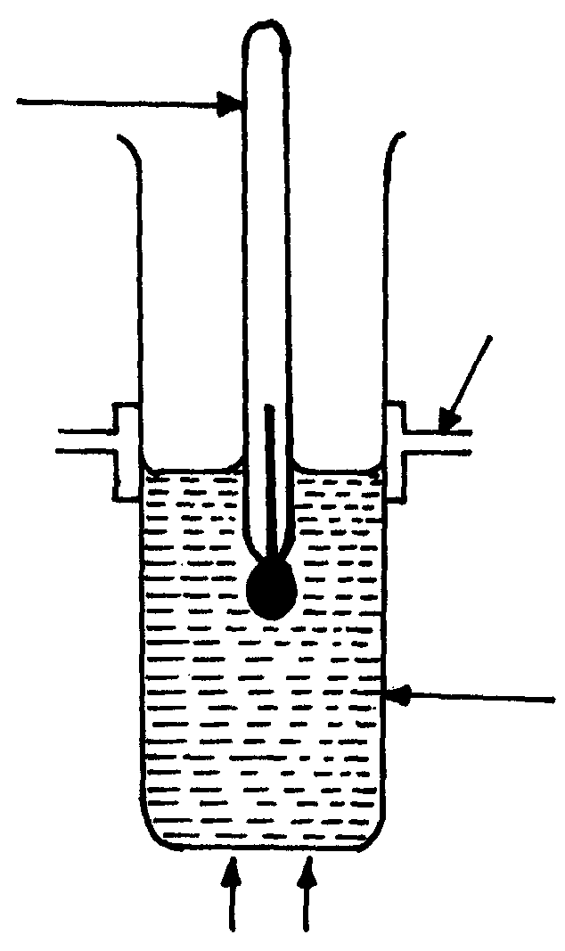
Boiling tube
Thermometer
Heat
Test-tube holder

(c) Gently stir the solution using the thermometer and record the temperature at which
crystals appear. (The crystals appear as small shining particles)
(d) Using a burette add 2.5cm³ of water to the solution and heat until all the solid dissolves.
Repeat procedure(c)
(e) Repeat the experiment each time adding 2.5cm³ of distilled water from a burette.
Record the results in the table below:-
Total volume of water (cm³) | 10.00 | 12.50 | 15.00 | 17.50 | 20.00 | 22.50
Mass of solid K (g) | 4.00 | 4.00 | 4.00 | 4.00 | 4.00 | 4.00
Solubility of K in g/100g of water | 40.00 |  |  | 22.90 |  | 17.78
Temperature at which crystals appear ( ºC)
(i) Complete the table by filling in the row for solubility of K and temperature at
which crystals appear
(ii) On the grid provided, draw the graph of solubility of K versus temperature
(iii) At which temperature is solubility 24/100g of water?
(iv) If a solution containing 30g of K at 85ºC is cooled to 60ºC
(a) At which temperature will crystals first appear?
(b) What would be the total mass of the crystals obtained when the solution finally
cools to 60ºC
(c) What is the solubility of K at 75ºC
3. You are provided with solid X which is a mixture of two solids. Carry out the following tests
to identify the cations and anions present in the mixture.
(a) Add about 10cm³ of water, stir and then filter. Keep both the residue and the filtrate for
further reactions.

(b) Place the residue in a boiling tube and add dilute nitric acid and warm. Divide the solution
into two portions
(c) To the 1st portion add NaOH_{(aq)} till in excess
(d) To the 2nd portion add aqueous ammonia till in excess
(e) Divide the filtrate into 5 portions. To the 1st portion add dilute HCl
(f) To the 2nd portion add lead (II) Nitrate solution
(g) To the third portion add Barium Chloride solution
(h) To the 4th portion add sodium hydroxide solution till in excess
(i) To the 5th portion add aqueous ammonia till in excess

UGENYA –UGUNJA DISTRICTS

CONFIDENTIAL
IDENTITIES OF SOLIDS
M- Potassium manganate (VII) crystals, KMnO₄
N – Ammonium Ferous sulphate hexahydrate, (NHa)₂ .Fe(SO₄)₂. 6H₂O
S – Oxalic acid H₂C₂O₄.2H₂O
Q- Hydrated Barium Chloride, BaCl₂. 2H₂O
R- Oxalic acid
Note: S and R are the same substances
INSTRUCTIONS
In addition to the apparatus and chemicals found in the chemistry laboratory, each
candidate will require the following:
- 150cm³ of solution M
- 100cm³ of solution N
- 100cm³ of solution S
- One 50cm³ burette
- One 25cm³ pipette and pipette filter
- One thermometer (-10ºC – 110ºC)
- One filter funnel
- Two conical flasks
- Tripod stand and wire gauze
- Source of heat
- 8 clean dry test tubes in a rack
- 2 boiling tubes
- 1 metallic spatula
- 250ml of distilled water in a wash bottle
- About 1g of solid R
- About 1g of solid Q
- 1 red and 1 blue litmus paper

Access to:
- 2M NaOH supplied with a dropper
- 0.5M Na₂SO₄ supplied with a dropper
- 0.1M Pb(NO₃)₂ supplied with a dropper
- Methyl orange indicator
- 0.5M Ba(NO3)2 supplied with a dropper
Notes:
      - Solution M is prepared by dissolving 3.16g of solid M in 400cm³ of 2M H₂SO₄ and making it up to 1 litre of solution with distilled water.
      - Solution N is prepared by dissolving 23.5g of solid N in 200cm³ of 2M H₂SO₄ and making it up to 1 litre of solution with distilled water.
      - Solution S is prepared by dissolving 5g S in 600cm³ of distilled water and making it up to 1 litre of solution with distilled water
- QUESTION 1
You are provided with:
- Acidified aqueous Potassium manganate (VII) KMnO₄, solution M(to be used also in question 3).
- Solution N, containing 23.5g of ammonium iron (II) sulphate, (NH₄)₂ Fe(SO₄)₂ . 6H₂O, per litre.
- Solution S, containing 5.0g of a dibasic acid, H2X.2H2O per litre

You are required to:-
  - Standardize the potassium manganate (VII), solution M, using the ammonium
- iron (II) sulphate, solution N.

- Use the standardized potassium manganate (VII), solution M to determine the
concentration of the dibasic acid H₂ X•2H₂O, solutions S and then the formula mass of X.

Procedure I
Fill the burette with solution M.
Pipette 25.0cm3 of solution N into a conical flask. Titrate solution N with solution
M until a permanent pink colour just appears. Record your results in table I below.
Repeat this procedure to complete table I

(a) Table I
 | I | II | III
Final burette reading (cm3)
Initial burette reading (cm3)
Volume of solution M used (cm3)

(b) Determine the average volume of solution M used,
(c) Calculate the concentration of the ammonium iron (II) sulphate, solution N, in moles
per litre. (RFM of (NH₄)₂ Fe(SO₄)₂ .6H₂O = 392 )
(d) Calculate the number of moles of iron (II) ions in the 25.0cm³ of solution N
(e) Using the ionic equation for the reaction between manganate (VII) and iron (II) ions, given
below, calculate the concentration of manganate (VII) in solution M in moles per litre.
MnO⁻_{4 (aq)} + 5Fe²⁺ _{(aq)} + 8H⁺_{(aq)} Mn²⁺ _{(aq)} + 5Fe³⁺_{(aq)} + 4H₂O_{(l)}

Procedure II
Pipette 25.0cm³ of solution S into a conical flask. Heat this solution to about 70ºC and titrate
the hot solution S with solution M until a permanent pink colour just appears. Shake thoroughly
during the titration. Record your results in table II. Repeat this procedure to complete the table II
(f) Table II
 | I | II | III
Final burette reading (cm3)
Initial burette reading (cm3)
Volume of solution M (cm3)

(g) Record the average volume of solution M used (show how you arrive at the answer)

V₂=…………………………………………………………………………………
(h) Calculate the number of moles of the manganate (VII) ions in volume V₂
(i) Given that 2 moles of the manganate (VII) ions react with 5 moles of the dibasic acid,
H₂X•2H₂O, calculate the number of moles of the dibasic acid, H₂X . 2H₂O in 25cm³
of solution S
(j) Calculate the concentration of the dibasic acid H₂X . 2H₂O, in moles per litre
(k) Calculate the formula mass of X in the dibasic acid, H₂X . 2H₂O. (H= 1.0, O = 16.0

2. You are provided with solid Q. Carry out the following tests and write your observations and
inferences in the spaces provided
(a) Place about one-half of solid Q in a dry test tube. Heat strongly and test any gas produced
using litmus papers
b) Place the remaining solid Q in a boiling tube. Add about 10cm³ of distilled water and shake well.
i) To about 2cm³ of the solution in a test tube add sodium hydroxide solution till in excess
ii) To about 2cm³ of solution Q in a test tube add about 2cm³ of 0.5M sodium sulphate solution
iii) To about 2cm³ of solution Q in a test tube, add about 4cm3 of barium nitrate solution
(iv) To about 2cm³ of solution Q in a test tube, add 3 drops of lead (II) nitrate solution and
heat the mixture to boiling

3. You are provided with solid R. Carry out the following tests and write your observations and inferences in the spaces provided
(a) Place a little of solid R in a clean metallic spatula and ignite with a bunsen flame
(b) Place all the remaining solid R in a boiling tube. Add about 6cm³ of distilled water
and shake well. Use 2cm³ portions to carry out the test below:
(i) Add 2cm³ of solution obtained by diluting 1cm³ of solution M with 5cm³ of distilled water to 2cm³ of solution R.
© SIJE- 2010 Form 4 Chemistry 233/3 End
5
© SIJE- 2010 Form 4 Chemistry 233/3 End
5
© SIJE- 2010 Form 4 Chemistry 233/3 End
5
© SIJE- 2010 Form 4 Chemistry 233/3 End
5
(ii) Add 3 drops of methyl orange to 2cm³ of solution R
© SIJE- 2010 Form 4 Chemistry 233/3 End
5
© SIJE- 2010 Form 4 Chemistry 233/3 End
5
© SIJE- 2010 Form 4 Chemistry 233/3 End
5
© SIJE- 2010 Form 4 Chemistry 233/3 End
5

MATUNGU DISTRICT
CONFIDENTIAL
INSTRUCTIONS.
In addition to the apparatus and fittings found in the laboratory each candidate should have:
- One 25ml pipette
- One 3-way pipette filler
- One 0-50m/s Burrette
- Two 250 m/s conical flask
- One stop watch /clock
- One 250ml glass beaker
- One 100ml measuring cylinder
- One 100ml glass beaker
- One thermometer (-10 to 110ºC)
- One label
- One piece of white paper
- One measuring cylinder (10mls)
- Six dry clean test tube on test-tube tack
- One boiling tube
- One clean dry metallic spatula
- 250cm³ distilled water in wash bottle
- One filter paper (dry)
- One filter funnel
- One glass rod
- About 0.5g sodium hydrogen carbonate supplied in a stoppered bottle
- 0.5g of solid F (accurately measured)
- About 130cm³ of sodium thiosulphate (0.25M sodium thiosulphate, solution D)
- About 30cm³ of 2.0M HCl (solution E)
- About 0.5g solid T
- About 0.5g solid X
- About 180cm³ of solution B
- About 80cm³ of solution A

Access to:
- Phenolphthalein indicator supplied with a dropper
- Bunsen burner (source of heat)
- Acidified potassium manganate (VII) solution
- Concentrated sulpuric acid
- Ethanol in a stoppered bottle

NOTE:
- Solid X – Oxalic acid
- Solid T – Calcium Chloride
- Solution A – 0.5M NaOH
- solution B – 0.5M HCl
- Solid F – ZnCO₃ (Zinc carbonate)
Question 1.
You are provided with:
- Solution A, sodium hydroxide
- Solution F, 0.2g of a carbonate (MCO₃)
- Solution B, 0.5M Hydrochloric acid
- Phenolphthalein indicator

You are required to:
(a) Standardize solution A with solution B
Using a pipette and a pipette filler place 25.0cm³ of solution A into a 250ml conical flask
Add 2-3 drops of phenolphthalein indicator
Record your results in table 1 below
Repeat the procedure two more items and complete table 1
Table 1
 | I | II | III
Final burette readings (cm³)
Initial burette readings (cm³)
Volume of solution B used (cm³)

(a) Calculate the average volume of solution B used
(b) (i) Determine the moles of sodium hydroxide used
(ii) Calculate the molarity of Sodium hydroxide
Procedure II
- Place all the 0.2g of solid F into a 250cm³ beaker.
- Measure 100cm³ of the 0.5M hydrochloric acid solution using 100cm³ measuring cylinder and add it to the solid in the beaker.
- Shake well until effervescence stops; label this solution C
- Pipette 25.0cm³ of solution C into a 250cm³ conical flask
- Add 2-3 drops of Phenolphthalein indicator
- Titrate solution C against solution A
- Repeat the procedure and complete table II below:
Table II

 | I | II | III
Calculate the:
(a) Average volume of solution A used
(b) Number of moles of hydrochloric acid that was in the 25cm³ of solution C used
(c) (i) Number of moles of the Carbonate in 0.2g
(ii) Relative formula of the carbonate solid F
QUESTION 2
You are provided with:
  - Solution D, 0.25M Sodium thiosulphate
  - Solution E, 2.0M Hydrochloric acid

You are required to:
Determine the effect of temperature on rate of reaction.

Procedure:
-Place 50cm³ of solution D in 100ml glass beaker provided and record its steady temperature.
- Mark a cross (x) on a piece of white paper and place the beaker containing the thiosulphate on it.
- Measure 5cm³ of solution E and add it to the beaker with the thiosulphate and swire
carefully not to pour the content.
- Start a stop watch immediately the last drop of acid is added
- Look through the solution and note the time taken for the mark to become invisible
- Repeat the procedure with the thiosulphate heated to 30ºC, 40ºC, 50ºC and 60ºC

Record your results in table III below:
Table III
Volume of thiosulphate used (cm³) | Volume of solution E used (cm³) | Temperature (ºC) | Time (secs) | ¹/_{t}
25  25  25  25  25 | 5  5  5  5  5 | Initial tempº  30  40  50  60

(a) Use your results to plot a graph of ¹/_{t} against temperature
(b) From your graph, determine the time taken if the temperature of the solution is 318K
(c) Explain how the rate of reaction changes with increase in temperature

QUESTION 3
Procedure 1:
You are provided with solid T.
Place a spatula full of solid T in a clean boiling tube then add about 10cm³ of distilled water.
Shake the mixture for about 1 minute then filter. Divide the filtrate into 4 portions.
(a) To the first portion add about 2cm³ of sodium hydroxide (solution A)
(b) To the second portion add about 2cm³ of 2.0M hydrochloric acid
(c) To the third portion, add a few drops of phenolphthalein indicator
(d) To the fourth portion dip a clean glass rod and place the soaked end of the glass rod
onto a non-luminous flame

Procedure 2:
You are provided with solid X. Carry out the tests below and record your observation and
inferences in the table below:
Place one spatula end full of solid X in a boiling tube and add about 10cm³ of distilled water.
Shake well and use for the tests below:
(a) To the 2cm³ of solution in a test-tube, add one spatula end full of sodium hydrogen carbonate
(b) To 2cm³ of solution, add three drops of acidified potassium manganate (VII) solution
(c) Place about 5cm³ of ethanol in a test tube and add drops of concentrated sulphuric acid
then add a spatula end full of solid X. warm the mixture carefully. Shake well and pour
the mixture into 20cm³ of water in a beaker

CONFIDENTIAL Requirements:-
- Solution X₁, acidified potassium manganate (VII) solution. It is prepared by dissolving
3.16g of KMnO₄ in 400cm³ of 2M H₂SO₄. add distilled water to make it up to 1litre solution
- Solution X₂, 0.1M Iron (II) Sulphate
–It is prepared by dissolving 20.8G of Iron (II) Sulphate in1litre of distilled water, add
a few drops of concentrated sulphuric (VI) acid, to avoid oxidation.
- Solution X₃ contains 3.45g of sodium nitrite in 1 litre of solution
- Solid M – Potassium nitrate
- Solid Y - (Oxalic acid)
1. You have been provided with:
(i) Solution X₁, acidified Potassium manganate (VII) solution
(ii) Solution X₂, 0.1M FeSO₄
(iii) Solution X₃, Sodium Nitrite

You are required to:
- Standardize solution X₁, using X₂
- Use experimental results to write ionic equation for the reaction between manganate
(VII) ions and nitrate ions

Procedure I:-
- Fill the burette with solution X₁
- Pipette 25cm³ of solution X₂ into 250ml conical flask
- Titrate solution X₂ with solution X₁ until a pink colour just appear
- Record your results in table 1:
TABLE 1
Final burette reading (cm³) | I | II | III
Initial burette reading (cm³)
Volume of X₁ used cm³

Calculations:
(a) Calculate the average volume of solution X₁ used
(b) Calculate the number of moles of Fe²⁺ in 25cm³ of solution X₂ used
(c) If the ratio MnO₄-: Fe²⁺ is 1:5, calculate the concentration of MnO₄ ions in moles per dm³
Procedure II:

- Rinse the conical flask and refill the burette with solution X₁
- Pipette 25cm³ of X₃ into a clean conical flask
- Warm this solution to about 50ºC (Note: Be accurate with temperature)
- Titrate the solution in (iii) above against solution X₁ from the burette to a pink colour
- Record your results in table II.

Calculations:
- Calculate the average volume of X₁ used
- Calculate the number of moles of :
(i) Sodium nitrite in one litre of solution (Na = 23, N = 14, O = 16)
(ii) Nitrite ions in 25cm³ of solution X₃ used
(iii) Moles of solution X₁ used
(c) (i) Work out the approximate ratio Mno₄-: NO⁻₂
(ii) Write down the ionic equation for the reaction between acidified manganate
(VII) ions and nitrite ions
2. You are provided with solid M. You are required to:
(i) Carry out test on solid M
(ii) Record your observations and inferences accordingly.

Procedure:-
1. (i) Dissolve solid M in 15cm³ of distilled water. Divide the resulting solution into six portions.
Record your observations
(ii) Add 3-4 drops of Lead nitrate to the first portion
(iii) Add 3-4 drops of Barium nitrate solution to the second portion
(iv) Add 3-4 drops of sodium hydroxide solution to the third portion
(v) Dip a glass rod into the fourth portion. Heat the end of glass rod dipped into the solution
in a non-luminous flame
(vi) Add 4 drops of acidified manganate (VII) to the fifth portion and warm the mixture

Q3.
1. Solid Y-1spatulaful
2. Solid Z-1spatulaful
3. 6 test tubes
4. 1 red + 1blue litmus papers
5. Metallic spatula
6. pH paper
3. (a) You are provided with solid Y

You are required to:
- Carry out the test described below on solid Y
- Record your observations and inferences
- Test for any gas (es) produced

Procedure-
- Place a spatula of solid Y into a boiling
- Add about 15cm³ of distilled water and shake well
- Divide the resulting solution into five portions
- Use a universal indicator paper to test portion one of the solution
(v) Add a spatula of sodium carbonate to the second portion
(vi) Add three drops of Potassium manganate (VII) solution to the 3rd portion
(vii) Add three drops of bromine water to the 4th portion. Warm the mixture if necessary
© SIJE- 2010 Form 4 Chemistry 233/3 End
5
© SIJE- 2010 Form 4 Chemistry 233/3 End
5
© SIJE- 2010 Form 4 Chemistry 233/3 End
5
© SIJE- 2010 Form 4 Chemistry 233/3 End
5
(viii) Place 2cm³ of ethanol in a test-tube. Add 2 drops of concentrated Sulphuric (VI) acid
and then a spatula end full of solid Y. Shake well and warm the mixture carefully, pour
the warm mixture into 25cm³ of cold water in a beaker and note the smell

MUMIAS DISTRICT

CONFIDENTIAL
INSTUCTIONS.
In addition to the apparatus and fittings found in the laboratory each candidate should have:
- One 25ml pipette
- One 3-way pipette filler
- One 0-50m/s Burrette
- Two 250m/s conical flask
- One 100ml measuring cylinder
- One 100ml glass beaker
- One thermometer (-10ºC to 110ºC)
- One stop watch / clock
- One label
- One 10m/s measuring cylinder
- White tile
- 250ml beaker
- Stand and clamp
- 10cm³ of solution A
- 80cm³ of solution B
- 160cm³ of solution C
- 200cm³ distilled water supplied in wash bottle
- 10cm³ Potassium manganate
- 250cm³ 1.0M sulphuric acid
- 75cm³ of solution X
- About 0.5g of solid K
- About 0.5g of solid F
- One blue and one red litmus papers
- One metallic spatula
- Six dry and clean test-tubes
- One boiling tube
- About 0.5g Sodium hydrogen carbonate

ACCESS TO:
- Source of heat (Bunsen burner)
- Phenolphthalein indicator supplied with a dropper.
- Solution Q (aqueous sodium sulphate) supplied with a dropper
- Acidified lead II nitrate supplied with a dropper
- Ethanol
- Conc. H₂SO₄

NOTE:
- Solution A is 4.0m hcl
- Solution B is 0.1m H₂C₂O₄.2H₂O
- Solution C is 0.2m NaOH
- Solution X is made by dissolving 5g of sugar (sucrose) in 100m/s distilled water
- Potassium Manganate (VII) solution D is made by dissolving 3.16g of the solid in
600cm³ of distilled water and diluting to 1 litre.
- Solid K is Zinc chloride
- Solid F is oxalic acid

Question 1
You are provided with:
- Aqueous Hydrochloric acid solution A
- Solution B containing 6.3g of dibasic acid, H₂C₂O₄2H₂O in 500cm³ of solution.
- Aqueous sodium hydroxide solution C
- Phenolphthalein indicator

You are required to:
(a) Standardize the sodium hydroxide solution C
(b) Use the standardized solution C to determine the concentration of solution A

Procedure 1
- Fill the burette with solution B
- Using a pipette and pipette filler, place 25.0cm³ of solution C into a 250ml conical flask.
- Add 2-3 drops of Phenolphthalein indicator
- Titrate solution B against solution C
- Repeat the procedure and complete table 1 below:

Table 1
 | I | II | III
Final burette readings (cm³)
Initial burette readings (cm³)
Volume of solution B used (cm³)

(a) Calculate the average volume of solution B used
(b) Calculate the concentration of the dibasic acid ( C = 12, H = 1, O = 16)
(c) Calculate the molarity of solution C
Procedure 2
- Using a 100cm³ measuring cylinder, measure 90cm³ of distilled water and place
it into a 250cm³ beaker.
- Add 10cm³ of aqueous hydrochloric acid solution A
- Using a 10cm³ measuring cylinder, mix the solution well and label it solution D
- Fill a burette with solution D.
- Pipette 25.0cm³ of the solution C into a 250cm³ conical flask
- Titrate using phenolphthalein indicator
Record your results in table 2

Table 2
 | I | II | III
Final burette readings (cm³)
Initial burette readings (cm³)
Volume of solution D used (cm³)

(a) Calculate the average volume of solution D used
(b) How many moles of hydrochloric acid were present in 100cm³ of solution D
(c) Calculate the molarity of the original solution A used

Question 2
You are provided with:
- 1.0M sulphuric acid
- Potassium manganate (VII) solution D
- Aqueous glucose, solution X

You are required to:
Determine the rate of reaction between acidified potassium manganate (VII) and aqueous
glucose at different temperatures.

Procedure
- Place 2cm³ of solution D into a 250ml beaker. Using a 100ml measuring cylinder,
add 50cm³ of 1.0M Sulphuric acid to the beaker containing solution D.
- Heat the mixture to about 65ºC, add 15cm³ of solution X and start a stop watch immediately.
- Stir the mixture using a thermometer and note the time and temperature at which the
colour of the mixture changes from purple to colourless.
- Clean the beaker and repeat the procedure at temperatures, 60ºC, 55ºC, 50ºC
and 45ºC to complete table 3 below:-

Table 3
Temperature before mixing (ºC) | 60 | 55 | 50 | 45
Temperature when solution becomes colourless (ºC)
Time (seconds)
¹/_{time} (s⁻¹)

(a) Plot a graph of ¹/_{t} (y-axis) against the temperature at the point when the solution becomes
colourless
(b) From your graph, determine the time that the reaction would take if the temperature at
which the solution becomes colourless is 42.5ºC
(c) Explain the shape of your graph
Question 3.
You are provided with:
- Solid K
Procedure
Carry out the tests below. Record your observations and inferences in the spaces provided.
(a) Heat about half spatula end full of solid K in a clean test tube, heat gently then strongly.
Test any gas produced using blue litmus papers.
(b) Dissolve the remaining solid K in a boiling tube in about 10cm³ of distilled water and
use the solution for the tests below:
(i) To about 2cm³ of solution K, add aqueous potassium hydroxide dropwise until in excess
(ii) To about 2cm³ of solution K, add about 5cm³ of solution Q (aqueous sulphate)
(iii) To about 3cm³ of the solution K, add about 6cm³ of acidified lead II nitrate

You are provided with:
  - Solid F
Procedure
Add about 10cm³ of distilled water into half spatula end full of solid F in a boiling tube
and shake thoroughly.
(c)To about 2cm³ of solution F, add the whole of sodium hydrogen carbonate
(d) To about 2cm³ of solution F, add about 5 drops of acidified potassium manganate (VII) then
warm the mixture.
(e) Place about 5cm³ of ethanol in a test-tube and add drops of concentrated sulphuric acid then
add the remaining solid F. Warm the mixture carefully. Shake well and pour the mixture into
20cm³ of water in a beaker

KISUMU DISTRICT

CONFIDENTIAL
INSTRUCTIONS.
In addition to ordinary apparatus in the laboratory each candidate will require;
- 2g Solid A
- 100cm³ solution B - Hydrochloric acid
- 200cm³ solution C - Sodium hydroxide
- Burette
- Pipette
- Two 250ml conical flask
- Methyl orange indicator
- 100ml measuring cylinder
- 10ml measuring cylinder
- Distilled water
- Means of labelling
- 30cm³ solution S
- 50cm³ solution S- Hydrochloric acid
- 50cm³ solution T-Sodium hydroxide
- Ten test tubes
- Rack
- 100ml
- Thermometer
- Source of heat
- Solid U
- Spatula
- Red and blue litmus paper
- Filter funnel
- Filter paper

Access to the following:-
  - 2M Sodium hydroxide
  - 2M potassium iodine
  - 2M Nitric acid
  - 2M Ammonia hydroxide
  - Solid A – Per student measure [0.32g CaCO₃ + 1.68NaCl]
  - Solution B - [0.5M HCl]
  - Solution C - [0.4M NaOH]
  - Solution S -[1.0M HCl]
  - Solution T - [1.0M NaoH]
  - Solid U - [One spatula CuCO₃ + one spatula Pb(NO₃)₂
QUESTION 1.
You are provided with:
- 2g of an impure calcium carbonate, solid A
- Hydrochloric
- Hydrochloric acid, solution B
- 16g per litre solution of sodium hydroxide, solution C

You are required to determine;
- Concentration of solution B in moles per litre
- Percentage of the carbonate in mixture A
PROCEDURE I:
Pipette 25.0cm³ of solution C into a 250ml flask. Add 2-3 drops of methyl orange indicator.
Titrate solution C with the hydrochloric acid solution B. Repeat this procedure two more times
and record your results in table I below:-

Table I:-
Titration | I | II | III
Final burette reading (cm³)
Initial burette reading (cm³)
Volume of solution B (cm³) used

Calculations:-
(a) (i) Calculate the average volume of solution B used
(ii) Calculate the number of moles of sodium hydroxide solution C pipetted
(iii) Calculate the number of moles of hydrochloric acid solution B that reacted
with sodium hydroxide in (a) (ii) above
(iv) Calculate the molarity of hydrochloric acid solution B

PROCEDURE II:
(a) Place all the 2g of solid a provided into a conical flask and add 25.0cm³ of hydrochloric
acid solution B to it using a clean pipette. Swirl the contents of the flask vigorously until
effervescence stops. Using a 100ml measuring cylinder, add 175cm³ of distilled water to
make up the solution up to 200cm³ of solution. Label this solution D. Using a clean pipette,
transfer 25.0cm³ of solution D into a conical flask and add 2-3 drops of methyl orange indicator. Titrate solution D with sodium hydroxide solution C. Repeat the procedure two more times and record your in the table II below:-
table II:
Titration | I | II | III
Final burette reading (cm³)
Initial burette reading (cm³)
Volume of solution C (cm³) used

(b) (i) Calculate the average volume of solution C used
(ii) Calculate the number of moles of sodium hydroxide solution C present in the average volume
(iii) Calculate the number of moles of hydrochloric acid present in the original 200cm³
of solution D
(iv) Calculate the number of moles of hydrochloric acid solution B contained in the original
25.0cm³ of solution B used
(v) Calculate the moles of calcium carbonate that reacted with hydrochloric acid solution D
(vi) Calculate the mass of calcium carbonate in 2g of solid A
(vii) Calculate the percentage of calcium carbonate present in the mixture (solid A)
2. You are provided with :-
- Solution of hydrochloric acid, S
- 1.0M solution of sodium hydroxide, solution T
You are required to:
(i) Calculate the heat of molarity of hydrochloric acid, solution S
(ii) Determine the heat of reaction for mole of hydrochloric acid with sodium hydroxide.

PROCEDURE
- Place six test tubes on a test tube rack. Using a 10ml measuring cylinder, measure and
pour 5cm³ of solution T into each of the test tubes
- Measure 20.0cm³ of solution S and pour into a 100ml beaker. Measure the temperature
of this solution and record in table III below.
- Pour the first portion of the 5cm³ of solution T into the beaker containing the 20.0cm³
of solution S. Stir the mixture carefully using a thermometer and record the highest
temperature reached in table III.
- Pour the second portion immediately into the mixture in the beaker, stir carefully and
record the highest temperature in table III continue this procedure with the remaining
portions of solution T to complete table III.
Table III:
(a)
Titration | 0 | 5 | 10 | 15 | 20 | 25 | 30
Volume of solution T added (cm³)
Volume of solutions S + T (cm³)
Temperature of mixture (ºC)
(c) From the graph, determine:-
(i) The volume of solution T required to react completely with solution S
(ii) The highest temperature change, ΔT
(d) Calculate the heat change for the reaction ;
(Heat change = M x 4.2Jg⁻¹ ºC ⁻¹ x Δt, assume the density of the solution to be 1g/cm³)
(e) Calculate the number of moles of the sodium hydroxide solution T used in the experiment
(f) Calculate the number of moles of the hydrochloric acid, solution S used in the experiment
(g) Determine the heat of reaction per mole of hydrochloric acid, solution S
3. You are provided with solid U, carry out the test below. Record your observations and
inferences in the table. Identify any gas(es) evolved .

(a) Heat a spatula end full of mixture U in a test tube.
(b) (Dissolve a part of mixture U in abort 10cm³ of distilled water
(c) Filter the mixture and retain both filtrate and the residue. Divide the filtrate into two portions.
(i) To the first portion, add sodium hydroxide drop wise until in excess
ii) To the second portion, add Potassium iodide solution

(d) Divide the residue into two parts:-
(i) Put one part in a test tube and add dilute nitric acid until the residue just dissolves
(ii) Divide the resulting solution into two parts. To part one, add dilute sodium hydroxide solution
drop wise until in excess
(iii) To part two, add aqueous ammonia drop wise until in excess

RACHUONYO DISTRICT

CONFIDENTIAL
INSTRUCTIONS .
In addition to common fittings, apparatus and chemicals found in the school laboratory.
Each candidate requires:-
- 50.0ml burette
- 250ml pipette
- Pipette filler
- Two 25.0ml conical flasks
- A clean metallic spatula
- One boiling tube
- A white tile/plain paper (white)
- Eight clean dry test-tubes on a rack
- 1.5g of carbonate A- accurately weighed and placed in a stoppered test-tube
- 75cm³ of 0.1M sodium hydroxide labeled C
- 75cm³ of 1M hydrochloric acid labeled solution B
- 10ml measuring cylinder
- One filter paper
- A filter funnel
- A glass rod
- 45cm³ of 0.42M glucose, labeled X
- 130cm³ of 2.0M H₂SO₄ labelled Z
- 10ml of 0.04M KMnO₄ labelled Y
- Stop watch/stop clock
- Thermometer (-10ºC – 110ºC)
- 100ml measuring cylinder
- Solid K (about 2g)
- Distilled water in a wash bottle
- A 250ml volumetric flask (one)
- Means of labeling (one)

Access to the following:-
- Bunsen burner
- Phenolphthalein indicator solution supplied with a dropper
- Tripod stand and a wire gauze
- 2.0M NaOH supplied with a dropper
- 2.0M HCl
- 2.0M HNO₃ supplied with a dropper
- 0.5M BaCl₂ supplied with a dropper
- Calcium hydroxide solution in a stoppered container
- 2.0M ammonia solution supplied with a dropper
- 0.05M potassium iodide solution supplied with a dropper

Preparation of chemicals
- Solid A – Calcium Carbonate
- Solid K – Mixture of Lead (II) carbonate and sodium sulphate in the ratio 1:1
1. You are provided with:
- 1.5g of metal Carbonate A
- 75cm³ of 1M hydrochloric acid labelled B
- 75cm³ of 0.1M sodium hydroxide labelled C
You are required to determine the molar mass of the carbonate

Procedure I
Transfer carefully all solid A into a clean 250ml volumetric flask. Add 50cm³ of the acid labelled
B into the flask containing the carbonate. Wait until the reaction is complete
(No more effervescence takes place)
Question 1.
(a) Find the moles of hydrochloric acid present in 50cm³ of solution B
Procedure II
When the reaction is complete, add 100cm³ of distilled water to the contents of the flask and shake.
Add more distilled water to top the solution to the mark. Label it as solution D. Pipette 25cm³ of solution D into a 250cm³ of conical flask and titrate with solution C using 1 to 2drops of phenolphthalein indicator. Record your results in table 1 below. Repeat this procedure to obtain
accurate values:

 | I | II | III
Final burette reading (cm³)
Initial burette reading (cm³)
Volume of solution C used (cm³)

(b) Determine the average volume of solution C used

(c) (i) Calculate the volume of sodium hydroxide that would react with 250cm³ of the diluted acid
(ii) Calculate the moles of sodium hydroxide solution C in the volume obtained in c(i)
Above
(d) Write down equation for the reaction between hydrochloric acid and sodium hydroxide
(e) How many moles of hydrochloric acid are left after the reaction with the metal carbonate A
(f) Calculate the moles of hydrochloric acid that reacted with 1.5g of the metal Carbonate A
(g) (i) Write down the ionic equation between carbonate and hydrochloric acid
(ii) Calculate moles of carbonate A
(iii) Calculate the molar mss of the carbonate A
2. You are provided with:-
- 2.0M sulphuric (VI) acid solution, solution Z
- 0.42M glucose, solution X
- 0.04M potassium manganate (VII) solution Y
You are required to determine the rate of reaction between aqueous glucose solution and
acidified potassium manganate (VII) at different temperatures.
Procedure
Place 1cm³ of solution Y into a conical flask. Using a 100cm³ measuring cylinder add
25cm³ of solution Z to the conical flask containing solution Y. Warm the mixture to
about 70ºC. Stop warming and allow the mixture to cool. When the temperature is exactly
65ºC add 7.5cm³ of solution X and start the stop watch immediately. Stir the mixture with a thermometer and measure the time taken for the colour of the mixture to change from purple to colourless. Record the time in table 2 below also record the temperature at which the mixture turns colourless. Clean the conical flask and repeat the procedure at temperature of 60ºC, 55ºC 50ºC
and 45ºC instead of 65ºC.

(a) Calculate 1/_{time} and complete the table
Table 2 (6mks)
Temperature before mixing (ºC) | 65 | 60 | 55 | 50 | 45
Temperature when solution becomes colourless (ºC)
Time in seconds
¹/_{time}(s⁻¹)

(b) Plot a graph of ¹/_{time} (y-axis) against the temperature at the point when the solution becomes
Colourless
(c) From your graph, determine the time that the reaction would take if the temperature at
which the solution becomes colourless is 52.5ºC
(d) From your graph, determine the rate of reaction if the temperature at which the solution
becomes colourless is 47ºC
(e) Explain the shape of your graph
3. You are provided with mixture K. You are required to perform tests on the mixture in order to
determine its composition. Record your observations and inferences in their spaces provided:-
- Place a spatula of K on a white tile and observe its appearance:-
(b) Place the remaining portion of K in a boiling tube and add 10cm³ of distilled water.
Shake vigorously, filter and retain both the residue and filtrate
(i) Divide the filtrate into 3 portions. To the first portion sodium hydroxide drop-wise until excess
(ii) Dip one end of a metallic spatula in 2M HCl and heat it in a Bunsen burner flame for a few
seconds and allow it to cool. Scoop a little of the solution from the second portion with the
heated end of the spatula and place it as the hottest part of the non-luminous flame.
(iii) To the third portion add 3-4 drops of dilute HNO_{3(aq)} followed by 3-4 drops of BaCl_{2(aq)}
(c) Scrap the residue from the filter paper and place a half of it in a clean dry test tube.
Add about 3cm³ of 2M HNO₃. Test for any gas produced by use of calcium hydroxide
solution on a glass rod. Preserve the solution for use in procedure (d) below:-
(d) Add about 3cm³ of distilled water to the solution obtained in (c) above and shake to mix.
Divide the solution into 3 portions
(i) To the first portion, add sodium hydroxide drop-wise until in excess
(ii) To the second portion, add ammonia solution drop-wise until in excess
(iii) To the third portion, add 2-3drops of potassium iodide solution

KAKAMEGA NORTH DISTRICT

CONFIDENTIAL
INSTUVTIONS.
You are provided with:
- 25cm³ of 0.2M Copper(II) sulphate solution
- 0.5g of metal A
- 0.5g of metal B
- One thermometer of -10 to 110ºC range
- Two 100cm³ plastic beakers
You are required to determine the molar enthalpy change for metal A and B and arrange them in order of reactivity

Procedure
1. a) Using the thermometer provided, take the initial temperature of copper (II) sulphate solution
and record your results in table A below
b) Add all the 0.5g of metal A into copper (II) sulphate solution; stir the mixture for about 5 minutes.
Using a thermometer and record the final temperature (highest temperature) in table A below:
TABLE A;
Initial temperature of CUSO_{4(aq)} (C)
Final temperature of CUSO_{4(aq)} (C)
Temperature change T (ºC )

Question 2;
2. a) Using a thermometer take initial temperature of another 25cm3 fresh sample of copper(II)
sulphate solution in the plastic beaker and record your results in table B below;
TABLE B;
Initial temperature of CUSO_{4(aq)} (C)
Final temperature of CUSO_{4(aq)} (C)
Temperature change T (c )

a) i) State and explain whether the reactions above between metals A and B
with copper (II) sulphate are endothermic or exothermic
ii) Calculate the moles of copper ions present in 25cm³ of 0.2M copper (II) sulphate
solution
b) i) Calculate the enthalpy change that occurs when 25cm³ of copper (II) solution
reacts with metal A. (Specific heat – capacity of the solution = 4.2Jg⁻¹K⁻¹,
Density of the solution = 1g/cm³
ii) Determine the molar enthalpy change for the reaction of copper (II) sulphate
solution with metal A

c) i) Explain the significance of using powdered metals A and B in this experiment
ii) Record the colour of the powdered metals A and B
d) State and explain major observations made when metal A reacts with copper (II)
sulphate solution
e) i) Determine the molar enthalpy change for the reaction of metal B with 25cm³ of 0.2 M copper
(II) sulphate solution (C = 4.2^{J}g⁻¹K⁻¹, Density of solution = 1g/cm³, RAM of metal B= 65)
ii) Arrange metals A and B in order of reactivity beginning with the more reactive one. Give a
reason for your answer
Question 2
You are provided with;
- Solution C, 0.1 M hydrochloric acid
- Solution D, MOH_{(aq)} solution of unknown concentration
- Phenolphthalene indicator
You are required to standardize solution D using solution C and to determine the value of M in the formula MOH_{(aq)}
Procedure
1. a) Pipette 25cm³ of solution D into the conical flask. Using a dropper, add 2 drops
of phenolphthalene indicator to solution D
b) Fill the burette with solution C and correct to the “O” mark
c) Titrate solution C against solution D

2. Repeat procedure 1(a), (b) and (c) twice and record your results in a table of results below;
Table of results
Experiment | I | II | III
Final volume of solution C (cm³)
Initial volume of solution C (cm³)
Volume of solution C used (cm³)

a) Volume of pipette used ___________________________ cm³
b) Calculate the average volume of solution C used in this experiment
c) Calculate the number of moles of solution C used in this experiment
d) Given that solution C is hydrochloric acid while solution D is MOH (the base),
i) Write a chemical equation to show the reaction of solution C with D
ii) Write the ionic equation for the reaction of solution C with D in d (i) above
iii) From the reaction equation written in d(i) above, determine the moles of solution D that
reacted with solution C
e) i) Determine the molarity of solution D (i.e. MOH_{(aq)}) used in this experiment

ii) Given that 6016g of solid MOH_{(s)} were dissolved in distilled water and made to 1 litre, calculate
the relative molecular mass of MOH_{(s)}
iii) From your answer in e (ii) above, determine the value of M in the formula MOH
Question 3.
You are provided with solid E. Carry out the following tests on solid E so as to try and find out the ions present in solid E

Complete the table below to show your observation and inference (conclusions)
Experiment | Observation | Inference
a) Observe solid E and record your findings
b) Dissolve solid E in about ¾ of distilled water in a
boiling tube and divide the solution into 5 portions in 5 test tubes
i) To portion 1 add NaOH_{(aq)} drop wise to excess
ii) To portion 2 add NH_{3(aq)} drop wise to excess
iii) To portion 3 add a few drops of Ba(NO₃)₂ followed by few drops of dilute HNO₃(_{aq})
iv) To portion 4 add lead (II) Nitrate drop wise followed by dil. HNO_{3(aq})
v) To portion 5 dip a looped nichrome wire to it and put the wire in the Bunsen flame

BUTERE DISTRICT
CONFIDENTIAL
INSTRUCTIONS
Each student should be provided with:
- 100 cm³ of solution M₂
- 80 cm³ of solution M₁
- 50 cm³ of solution M₃
- Pipette (25 ml)
- Burette (50 mls)
- Methyl Orange indicator with a dropper
- Two conical flasks
- Filter funnel
- Measuring cylinder (10 mls)
- Measuring cylinder (50 mls)
- Thermometer (-10 to 110⁰c)
- 100 mls plastic beaker
- 3 test tubes in a test tube rack
- 1 Boiling tube
- Solid W. (One spatula full)

Access to:
- 2M NaOH(_{aq}) with a dropper
- 2M NH₃ (_{aq}) with a dropper
- 1M BaCl₂ with a dropper
- 2M HNO₃ with a dropper
- Distilled water in a wash bottle

Note:
- Solution M₁ is prepared by mixing 53g of Sodium Carbonate and 42g of Sodium Chloride solid and dissolved to make one litre solution.
- M₂ is 1M Hydrochloric acid.
- M₃ is 1M Sodium Hydroxide.
- Solid W is Aluminium Nitrate

1. You are provided with the following solutions:-
- M₁ containing 95g of a mixture of sodium carbonate and sodium chloride per litre of solution.
- M₂ which is 1M HCL.
You are to determine the percentage of sodium chloride in the mixture.

Proceed as follows:
Pipette 25 cm³ of M₁ and titrate with M₂ from burette using 3 – 4 drops of methyl orange
indicator. Stop titrating when a permanent pink colour appears. Repeat the experiment and
complete the table below.
TABLE 1
 | I | II | III
Final burette reading (cm³⁾
Initial burette reading (cm³)
Volume of M₂ used (cm³)
a) Determine the average volume of M₂ used. Show your workings.
b) Determine the number of moles of M₂ used.
c) Write down an ionic equation for the substances that react.
d) Determine the number of moles of the base used.
e) Calculate the concentration of sodium carbonate.
f) Determine the mass of sodium carbonate in 1 litre of the solution.
(Na = 23, C = 12, O = 16)
g) Determine the percentage of sodium chloride in the mixture.
2. You are provided with the following solutions:-
- 1 M HCl solution M₂
- 1 M NaOH solution M₃
You are expected to determine the molar heat of neutralization of hydrochloric acid.
Proceed as follows:
Measure 23 cm³ of M₂ and put in a 100 ml beaker. Measure its temperature and record in the
table below under first column. By use of a measuring cylinder measure 5 cm³ of M₃ and to M₂ in
the beaker. Stir with the thermometer and record the final steady temperature. Continue adding
5 cm³ at a time and recording the temperature till 35 cm³ has been added, complete the table
below.
a) TABLE II
Volume of M₂ added (cm³) | 0 | 5 | 10 | 15 | 20 | 25 | 30 | 35
Temperature (⁰c)

b) Plot a graph of temperature (vertical axis) against volume of NaOH added.
c) From your graph determine:-
(i) Volume of 1M NaOH needed to neutralize 23 cm³ of 1M HCl
(ii) Rise in temperature ∆T.
d) Calculate the amount of heat evolved in the above reaction. Take specific heat capacity of
solution to be 4.2. J/g/k, density of solution. 1g/cm³.
e) Calculate the number of moles of HCl used.
f) Hence determine the Molar heat of neutralization of hydrochloric acid.
3. You are given solid W. Carry out the tests below and answer accordingly.
a) Take a spatula endful of W and put in a boiling tube. Add about 8cm³ of water and shake.
Keep the mixture for the tests below.
b) To about 2 cm³ of solution of W add sodium hydroxide (2M NaOH) drop wise till in excess.
c) To about 2 cm³ of solution W, add Ammonia solution (2M NH_{2aq}) drop wise till in excess.
d) To about 2 cm³ of solution W, add about 5 drops of Nitric acid (HNO_{3 (aq)}) followed by 2 drops
of Barium chloride.

CONFIDENTIAL
REQUIREMENTS
In addition to the equipment, apparatus and chemical found in the chemistry laboratory, each candidate will require the following:
- Solution P: about 100cm3
- Solution Q: about 50cm³
- Solution R: about 100cm³
- Distilled water
- 100ml measuring cylinder
- One filter funnel
- One 25cm³ pipette
- A clamp and stand
- Aphenolphalein indicator
- 3 conical flasks
- White tile
- Solution F: about 30cm³ of 1.0M sodium hydroxide solution
- A 10ml measuring cylinder
- A 100ml plastic beaker
- Means of labeLling
- A 110ºC thermometer
- Solid D, 0.5g Zinc Sulphate crystals
- Metallic spatula
- 1 boiling tube
- 5 clean dry test tubes
- Test tube holder
- Bench solutions supplied with droppers
- Dilute nitric acid solution, 2
- 2M sodium hydroxide solution
- 2M aqueous ammonia solution
- 0.5M Barium nitrate solution
- 0.5M Lead (ii) Nitrate solution
NOTES
(a) (i) Solution P is prepared by dissolving 17.2cm³ of concentrated hydrochloric acid in
about 250cm³ of distilled water and adding water to make 1litre of solution
(ii) Solution Q is prepared by dissolving 64g of sodium hydroxide pellets in about 250cm³
of distilled water and making it to 1litre of solution
(iii) Solution R is prepared by dissolving 13.75cm³ of concentrated sulphuric acid in about
250cm of distilled water and making it to 1litre of solution

(b) Solid D is 0.5g of Zinc Sulphate crystals
1. You are provided with:
- Solution P, 0.2 M hydrochloric acid
- Solution Q, sodium hydroxide solution
- Solution R, containing 49g/Litre of a dibasic acid, H₂A
You are required to:
Dilute solution Q with distilled water
Standardize the diluted solution Q with solution P
Determine the relative formula mass of A

Procedure 1:
Pipette 25cm³ of Q into a clean dry 250ml volumetric flask. Measure 175cm³ of distilled water
using a 100cm³ measuring cylinder and add it to solution Q in the flask. Shake well. Label
this as solution S and keep it for further tests in procedure I and II. Pipette 25cm³ of solution S
into a clean dry conical flask. Add 2 to 3drops of Phenolphthalein indicator and titrate with
solution P. record your results in the table I below. Repeat the procedure to obtain accurate
results.
Table I
Titration number | I | 2 | 3
Final burette reading (cm³)
Initial burette reading (cm³)
Volume of solution P used (cm³)

(a) Determine the average volume of solution R used
(b) (i) Find the moles of solution P used to react with 25cm³ of the diluted solution S.
(ii) Find the moles of solution S in 25cm³ of the diluted solution.
(iii) Determine the number of moles of sodium hydroxide contained in the
100cm³ of solution S
(c) Using your results in b (ii) above determine the concentration in moles per
litre of the original sodium hydroxide solution Q

Procedure II
Pipette 25cm³ of the standardized solution S into a clean, dry conical flask. Empty your
burette completely of solution P and rinse it with some water. Now, fill your burette with
solution R and titrate with solution S in the conical flask containing 2 to 3 drops of
Phenolphthalein indicator.
Record your results in table II below. Repeat the procedure to obtain accurate results.

Table II
Titration number | I | 2 | 3
Final burette reading (cm³)
Initial burette reading (cm³)
Volume of solution R used (cm³)
(d) Determine the average volume of solution R used …………………………………………………………………………………
(e) Determine the number of moles of Sodium hydroxide in 25cm³ of solution S and
hence the moles of solution R used
(f) Find the number of moles of R contained in one litre of solution
(g) Given that H= 1.0 :
(i) Find the relative formula mass of the dibasic acid H₂A
(ii) Determine the relative formula mass of A in the formula H₂A

2. You are provided with:
1.0M Sodium hydroxide solution F
0.6M solution of acid labelled G
You are required to determine the molar heat of neutralization of Sodium hydroxide
with acid G

Procedure:
(a) Place six test tubes on a test rack. Using a 10cm³ measuring cylinder measure 5cm³
portions of solution G and place them in each of the tubes.
Measure 25.0cm³ of solution F using a measuring cylinder and place it into a 100cm³ beaker.
Measure the temperature of this solution F to the nearest 0.5ºC and record in table III.
Pour the first portion of the 5cm³ of solution G from the test tube into the beaker containing
25.0cm³ of solution F. Stir the mixture carefully and record the highest temperature of
the mixture in table III.
Pour the second portion of solution G immediately into the mixture in the beaker. Stir carefully and record the highest temperature of this mixture in table III. Continue this procedure using the remaining portions of solution G to complete table III.
Table III
Volume of G added (cm³) | 0 | 5 | 10 | 15 | 20 | 25 | 30
Volume of F (cm³) | 25 | 25 | 25 | 25 | 25 | 25 | 25
Temperature (ºC)

(b) On the grid provided, plot a graph of temperature (vertical axis) versus volume
of solution G added
(c) From the graph, determine:
(i) The volume of solution G required to react with the 25cm³ of sodium hydroxide
solution F
(ii) The highest temperature change
(d) Calculate the heat change for the reaction
(Heat change = Mass x temperature change x 4.2jg^{-1o}C. Assume density of each
solution to be 1gcm⁻³)
(e) Calculate the volume of sodium hydroxide solution F, used
(f) Calculate the molar heat of neutralization of sodium hydroxide solution F

3 You are provided with substance D, which contains two cations and one anion.
Carry out the test below on the substance. Enter your observations in the table below.
Write your observations and inferences in the spaces Provided
(a) Place a spatula end full of D in a boiling tube. Add about 5cm³ of distilled water and shake.
Divide the resultant mixture into 4 portions
i) To the first portion, add Nitric acid followed by Barium nitrate solution.
ii) To the second portion, add Nitric acid, followed by lead (II) Nitrate solution
iii) To the third portion, add a few drops of sodium Hydroxide solution until in excess
iv) To the fourth portion, add aqueous ammonia drop wise till in excess solution

TRANS MARA DISTRICT
CONFIDENTIAL
INSTRUCTIONS
Each candidate should have :

- 80 cm³ of solution T
- 100 cm³ of solution S
- Exactly 1.5g of solid V
- 250cm³ beaker (glass)
- 1 label
- 1 pipette
- 1 burette
- 100cm³ measuring cylinder
- 1.2g
- 120cm³ plastic beaker
- A stop clock /watch
- About 1.0g of solid J
- 1 boiling tube
- 1 metallic spatula
- 1 glass rod
- 5 test tubes
- 1 filter paper

Access to:
- Phenolphthalein
- 2m lead (II) nitrate
- 0.05 M sodium thiosulphate
- Distilled water
- 20% volume hydrogen peroxide
- Source of heat ( Bunsen burner)

Notes:
  - 20% 20 volume peroxide is prepared by diluting 20cm³ of 20v hydrogen peroxide
to make 100cm³
  - solution T is 1.0 hydrochloric acid and is made by dissolution 86cm³ of 35-37% hydrochloric acid diluted to 1litre of solution
  - solution S is 0.5m sodium hydroxide
  - solid V is exactly 1.5g of sodium carbonate ( anhydrous)
  - solid J is potassium iodide
  - solid M is 1.2g magnesium powder
  - solution K is 0.02m copper (II) sulphate

1. You are provided with the following :
- 1.0M Hydrochloric acid; solution T.
- 0.5M sodium hydroxide; solution S
- Anhydrous sodium carbonate of unknown mass: solid V.
You are required to determine the mass of sodium. Carbonate that was used in the experiment.

Procedure
Measure 60cm³ portion of 1m hydrochloric acid using a measuring cylinder and transfer
it to 100cm³ beaker. Add all sodium carbonate (solid V) to the acid in the beaker and
stir gently. Leave the mixture for 3 minutes until there is no effervescence transfer
the mixture into a clean 100ml measuring cylinder and add distilled water to make
100cm³ of the solution. Transfer all the solution into 250cm³ beaker and shake
well, label this solution W.
Fill the burette with solution S.
Pipette 25.0cm³ of solution W and transfer to a conical flask. Add 2-3 drops of phenolphthalein indicator and titrate with solution S. Records your results in table I below.
Repeat the titration to get two more concordant values.

Table I
Experiment | I | II | III
Final burette reading (cm³)
initial burette reading (cm³)
Volume of solutions S used

Transfer the mixture into a clean 100ml- measuring cylinder and add distilled water to
make 100cm³ of the solution.
(a) Determine the average volume of solution S used.
(b). Calculate the number of moles of sodium hydroxide (solution S) used.
(c). Find the number of moles of hydrochloric acid in 25cm³ of solution W.
(d). Determine the number of moles of hydrochloric acid in 100cm³
(e). Calculate the number of moles of hydrochloric acid in the original 60cm³ of solution.
(f). Calculate the number of moles of hydrochloric acid that reacted with sodium
carbonate.
(g). Determine the mass of sodium carbonate that reacted with the acid. (Na= 23, C= 12, 0= 16).

2. You are provided with the following.
(i). 1.2g Magnesium powder, solid M
(ii). 0.02M copper (ii) sulphate, solution K
You are required to determine the molar enthalpy of displacement for the reaction
between
magnesium powder and copper (II) sulphate solution.
Procedure
Measure out 100cm³ of solution K into a plastic beaker.
Measure the temperature of this solution at every minute for four minutes. Add the entire amount of solid M to the contents of the plastic beaker at the fourth minute. Stir with the thermometer. Record the temperature after every half-a- minute in table II below.

Table II

Time (min) | 0 | ½ | 1 | 1 ½ | 2 | 2¹/₆ | 3 | 3 ½ | 4 | 4 ½ | 5 | 5½ | 6 | 6½
Temp.(ºC)

(a). Draw the graph of temperature (ºC) against time, t (in minutes) ) Use your graph to
get the temperature rise.
(b). Calculate the heat lost by the solution
(Specific heat capacity of solution = 4..2Jg ⁻¹K^{-I,} density of solution = 1g/cm³)
(c). Write an ionic equation for the reaction.
(d). Calculate the number of moles of :
(i). Copper (ii) ions in the original solution.
(ii). Magnesium added to the copper (ii) sulphate solution
(iii). Copper (II) ions displaced by magnesium powder.
(Mg = 24, Cu = 63.5, S = 32, O = 16)
(e). Calculate the molar heat of displacement of copper (II) ions by magnesium powder.
(f). Comment on the value of the molar heat if ion powder had been used instead magnesium
powder . Explain.
(a). (i)You are provided with solid J.
(ii). To the filtrate above, dip a clean metallic spatula and burn a drop of the filtrate
on it with a non-luminous flame.
(iii). Divide the filtrate into two equal populations.
I. To the 1st portion add 2m lead (ii) nitrate.
II. To the second portion add 3 -5 drops of 20% 20 – Volume hydrogen peroxide
(iv). To the resulting mixture in (ii) above, add about 1cm³ of sodium thiosulphate
solution Q. From the tests carried out above identify.
(i). Cation
(ii). Anion

TRANSNZOIA WEST DISTRICT
CONFIDENTIAL
INSTRUCTIONS
ACCESS TO
- 1M NaOH
- 1M NH₄OH
- 1M HCL
- 0.01m PB (NO₃)₂
- Source of heat
- PH chart (PH=1 to 14)
- 10ml of solution K
- Sodium hydrogen carbonate
Question 1.
- Solution J 100cm³
- Burette
- Solution K100cm³
- Pipette
- 2 conical flasks
- Filter funnel
- Retort stand

PREPARATION OF SOLUTIONS
1. Solution J - Dissolve 17g of ammonium iron (ii) sulphate in 50cm³ of 2M H₂SO₄ dilute to 1dm³
2. Solution K-KMnO₄ ₋ Dissolve 1.6g of potassium manganate vii in 20cm³ of 2 MH₂SO₄ dilute to 1dm³
3. Solution R - Dissolve 40g of sodium thiosulphate in 1dm³ of solution
4. Solution S - Dissolve 172cm³ of concentrated hydrochloric acid in 1dm³ of solution
5. Solid Y is aluminium sulphate
6. Solid Z is oxalic acid.

1. You are provided with:
- Solution M₁ aqueous solution of a monobasic acid, HB containing 1.62425, of the acid dissolve in 250cm³ of the solution
- 0.208M sodium hydroxide solution.
You are required to determine
a) The molarity of the acid
b) The RFM of the acid and the RAM of B in HB (H=1, C=12, O=16)
Procedure
Pipette 25cm³ of solution M1 into a clean dry conical flask. Add 2 drops of phenolphthalein indicators. Fill the burette with solution Q and titrate against solution M₁
Repeat the procedure two more times and complete the table below:
 | I | II | III
Final burette reading(cm³)
Initial burette(cm³)
Volume of solution Q used (cm³)

a) Determine the average volume of solution Q used
b) Write an equation for the reaction between solution M₁ and Q
c) Calculate:
i) The number of moles of Q used
ii) The number of moles of M₁ used
iii) The molarity of solution M₁
d) Determine;
i) The RFM of acid
ii)The RAM of element B

2. You are provided with:
- 2M hydrochloric acid, solution M₂
- Magnesium ribbon.
You are required to determine;
i) The rate of the reaction between Hydrochloric acid and magnesium
ii) The mass of 2cm of magnesium ribbon
Procedure II
Using a clean measuring cylinder, measure 60cm³ of 2M hydrochloric acid, solution M₂ and
place it into a clean conical flask. Cut a 2cm piece of magnesium ribbon provided and place
into the conical flask containing 2M hydrochloric acid and immediately start the slop- watch.
Measure and record the time taken for the magnesium ribbon to completely react with the
hydrochloric acid in table II below. Repeat the procedure using 50, 40, 30 and 20cm3 portions
of 2M hydrochloric acid adding distilled water and complete the table below:
a) Table II
Experience | 1 | 2 | 3 | 4 | 5
Volume of 2M HCl | 60 | 50 | 40 | 30 | 20
Volume of distilled water added | 0 | 10 | 20 | 30 | 40
Time taken for the ribbon to disappear(sec)
1/time (sec⁻¹)

b) Plot a graph of ½ against volume of 2M hydrochloric acid used
c) From your graph determine the time taken for the ribbon to disappear when 36cm³ of 2M
hydrochloric acid were used
d) In terms of rate of reaction, explain the shape of your graph
3. You are provided with solids. You are required to carry out the tests shown below and write
your observations and inference in the spaces provided. Identify any gases given out.
a) Place a small amount of solid S in a dry test tube and heat strongly
b) Place a spatula end- full of S in a boiling tube. Add about 5cm³ of distilled water and shake.
Divide the resultant mixture into 4 portions
i) to the first portion, add nitric acid followed by Barium nitrate solution
ii) To the second portion, add nitric acid followed by lead (II) nitrate solution. Warm the mixture
iii) To the forth portion, add aqueous ammonia drop wise until excess

3. b) You are provided with solid F. Carry out the texts below. Write your observations and
inferences in the space provided.
Dissolve a spatula full of solid F in about 4cm³ of distilled water and divide it into three parts.
i) To 2cm³ of solution, add 5 drops of bromine water
ii) To the second portion add a spatula full of sodium hydrogen carbonate

SOTIK DISTRICT
CONFIDENTIAL
1. You are provides with;
- Solution M (HCl)
- Solution N (0.1M NaOH)
- Solution P prepared by dissolving 14.3g/dm³ of Na₂CO_{3.} x H₂O.
- Phenolphthalein inidicator
- Methyl orange indicator

You are required to:
- Standardize HCl solution M
(b) Determine the value of X in Na₂CO₃. XH₂O
Procedure I
Fill the burette with HCl solution M. pipette 25cm³ of NaOH solution N into a conical flask.
Add 2 drops of phenolphthalein indicator and titrate until you obtain a permanent colour change. Record your results in table I below. Repeat the titration two more times and complete the table.
Table 1
Titration | 1 | 2 | 3
Final burette reading (cm³)
Initial burette reading (cm³)
Vol. of solution M used (cm³)

(i) What is the average volume of solution M used
(ii) Calculate the number of solution N used
(iii) Write the equation for the reaction that took place
(iv) Calculate the number of moles of solution M in the titre volume
(v) Find the concentration of solution M in moles per litre
(vi) Calculate the concentration of solution M in grams per litre
Procedure II
Fill the burette with HCL solution M. pipette 25cm³ of solution P into a conical flask.
Add 2 drops of methyl orange indicator and titrate against solution M. repeat the titration
two more times and complete the table.
Table II
Titration | 1 | 2 | 3
Final burette reading
Initial burette reading
Vol. of solution M used (cm³)

(a) What is the average volume of solution M used?
(b) Calculate the moles of HCl in the titre volume of solution M
(c) Write the equation for the reaction that took place
(d) Calculate the moles of solution P used
(e) Find the concentration of Na₂CO₃. XCH₂O in solution P in moles per litre
(f) State the concentration of Na₂CO₃.XH₂O in solution P in grammes per litre
(g) Find the R.F.M of Na₂CO₃.XH₂O
(h) The value of X in Na₂CO₃. XH₂O

2. You are provided with;
- 1.0M potassium iodide
- 1.0M lead (II) nitrate

You are required to use the two to determine the height of precipitate and the volume
of Pb(NO₃)₂ solution used.

Procedure
- Take six test-tubes of equal volume and label them 1to 4
- Run 5cm³ of 1.0M Potassium iodide solution from a burette into each one of them.
- Add 1.0cm³ of 1.0M Lead (II) nitrate solution to the test-tube labeled 1and stir the mixture well with a glass rod.
- Add about 5 drops of ethanol to the mixture, stir and place it in test-tube rack.
- Add 1.5cm³, 2.0cm³, 2.5cm³, 3.0cm³ and 3.5cm³ of the 1.0M lead (II) nitrate to the test-tubes labeled 2, 3, 4, 5 and 6 respectively.
- Add about 5 drops of ethanol to each test-tube, stir and allow to settle
- Measure the height of the precipitate in each tube in (mm) and record the measurements in the table below:

Test tube number | 1 | 2 | 3 | 4 | 5 | 6
Volume of 1M lead (II) nitrate (cm³) | 1.0 | 1.5 | 2.0 | 2.5 | 3.0 | 3.5
Height of precipitate (mm)
(a) Plot a graph of the heights of the precipitate against the volume of lead (II) nitrate
solution added
(b) Calculate the;
(i) Number of moles of KI in 5cm³ of 1.0MKI solution
(ii) Number of moles of Pb(NO₃)₂ solution which reacted completely with 5.0cm³ of 1.0M KI
(c) How many moles of KI would react with one mole of lead (II) nitrate?
(d) Write a balanced chemical equations or the reaction between lead (II) nitrate and
potassium iodide
(e) Give the ionic equation for the reactions
(f) What was the purpose of adding ethanol to the mixture?

Answers section I & II
1. Introduction to chemistry
1. a) F is place in the middle of the flame while G is placed at the upper region of the flame
b) Non- luminous flame

2. . A,D,C,B, and C all correct
A,D,C,D correct answers are exclusive
A,D,C ½ mk otherwise penalize
3. a) The laboratory gas burns in excess oxygen
OR burns completely or produces CO₂ and H₂O only
- No unburnt carbon remains
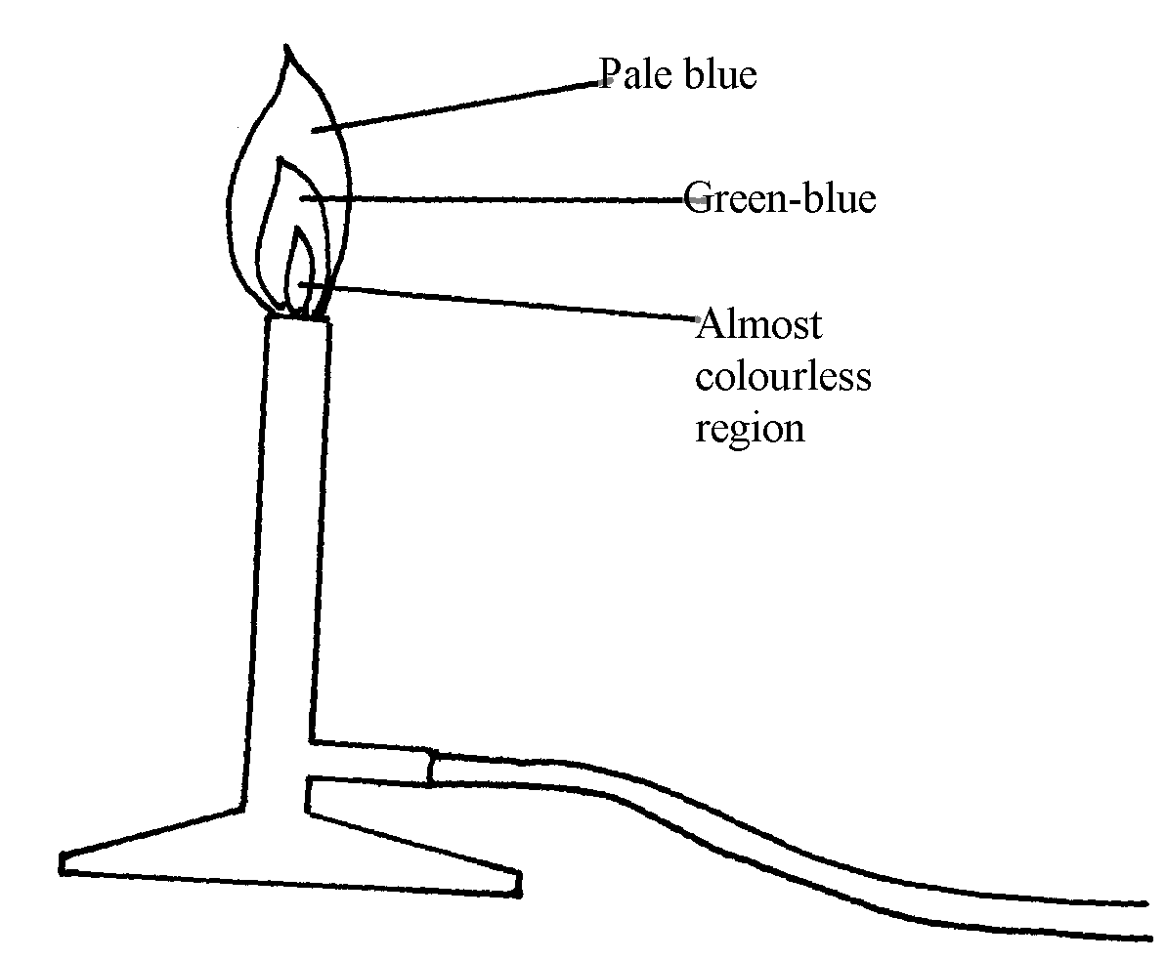
OR No soot is formed// Produced.
b)

4. a) a substance which when taken alters the body chemistry

b) - alcohol
- Tobacco
5. (a) A- Downward delivery /upward displacement of air
 ½
B – Over water
(b) A – Denser than air
6. (i) P – Haxane
(ii) W – Water

7. Name – Mortar. ^{√½}
Use – Holding solid substances being crushed. ^{√½}
Name – Crucible ^{√½}
Use – Holding solid elements being heated strongly. ^{√½}
8. T – has a very small hole which releases the gas in small quantities /in form of a jet.
 1
U – It is heavy for stability
9. (a) It is very hot. (1 mk) √1
(b) The upper√1 part. Because all the gases undergo complete √1 combustion. √1 (2 mk) 3
10. The crystal dissolved√ ½ . Blue colour spreads in water √ ½ . The crystal broke up into
smaller particles of copper (ii) sulphate and diffused in all direction
11. (a) W has more energy levels than S. √1
(b) C has got (12) protons pulling the 10 electrons while A has 11 protons
2 pulling 10 electrons. √1

2. Simple classification of substances
1. a) X – melting point √ ½
Z – Boiling point √ ½ b) Its melting point is lowered and becomes less sharp due to the introduction of an impurity √1

2. Luminous flame produces soot while non- luminous flame does not√1
Luminous flame is yellow in colour while non- luminous flame is blue in colour
OR accept any correct answer

b) The luminous flame is moderately hot and is clearly visible hence no danger is posed
3. a) X
Gives the greatest number of spots hence the greatest number of pure substances √ 1
b) The ink is made of more than one pure substance hence will also undergo chromatography
4. (a) sublimation
(b) Bleaching action
(c) Polymerization
5. Adds excess dilute hydrochloric acid/ sulphuric (vi) acid
Filter to obtain copper metal
Wash with distilled water
6. To separate samples of CUO and charcoal in test tubes, dilute mineral acid is added with
shaking CUO black dissolves to form blue solution√ ½
Charcoal does not dissolve in dilute mineral acids
7. a) Is the process for the separation of a mixture of solutes by their different rates of movement
over a porous medium caused by moving solvent
b) - Separation of dyes
- To analyse and identify mixtures of substances which are difficult to separate by
other means
- Used to analyze dyes in food colouring (Any two each one mark)
8 a) Element R – Sulphur
b) Mix solid P oxide with water
put blue and litmus paper, Blue litmus paper remains blue, red litmus paper changes to blue.
Put blue and red litmus papers in water
Blue changes to red, red remain red.
9. 5 and 4 BOTH MUST BE CORRECT
10. EITHER
- In separate test tubes, boil about 5cm³ of each solution.
- Sodium hydrogencarbonate solution remains colourless forms no precipitate
- Calcium hydrogencarbonate solution changes from colourless to white precipitate
OR
2NaHCO_{3aq} Na₂CO₃ + CO_{2(g)}n + H₂O_{(e)}
Ca (HCO₃)₂ _{(aq)} CaCO_{3(s)} + CO₂ _{(g)} + H₂O_{(e)}
HEAT must be mentioned or implied.

* both axes labelled
with units
11. a)
70
Boiling point ½

Temperature / ^{O}C
25
Room temperature
Melting point
15

Time (minutes)

b) Liquid
12. (i) Range of boiling points / no sharp boiling points
 1
 1
(ii) Carry out fractional distillation
13. (i) Evaporation

(ii) Uses a lot of fuel

(iii) Any soluble salt and water
14. Melting points is the specific √ ½ constant temperature√ ½ for a particular substance when a solid √ ½
change to a liquid√ ½
16. (a) To cool/condense vapour. √1 (1 mk)
(b) Water. √1 (1 mk) 3
(c) Blue solid √1 changes to white solid. √1 (1 mk)
17. (a) Solvent front √
(b) C √
18. a) Chemical √ ½
b) Physical √ ½
c) Physical √ ½
d) Chemical √ ½

19. - Smoky/ sooty √
- Not hot enough √

20. a) Chemical √ ½
b) Physical √ ½
c) Physical √ ½
d) Chemical √ ½

21. - Smoky/ sooty √
- Not hot enough √

22. - Boiling point
- Melting point
- Density
- Refractive index

23. i) Pass the mixture of gases through concentrated sulphuric (vi) acid √ ½ . Ammonia and
ethane will dissolve √ ½
- Hydrogen √ ½ being insoluble √ ½ is then obtained

24. a) i)

ii) A and C

b) Since NH4CL sublimes but CaCL2 does not, sublimation process would do. Heat the
mixture, NH4CL sublimates into vapour and condences on the upper cooler parts of the test
tube. CaCL2 remains at the bottom of the heating tube

c) i) Fractional distilation
ii) Separating funnel method 8
Since the two liquids are immiscible pour the mixture into the separating funnel and
allow to settle. The denser liquid will settle down and the less dense one will form
the second layer on top. Open the tap and run out the liquid in the bottom layer leaving
the second layer in the funnel
25. (i) Condenser
(ii) To indicate when a liquid is boiling, a thermometer reads a constant temperature
(iii) A
(iv) Ethanol


Reason:- It has a lower boiling of 78ºC compared to water with a boiling point of 100ºC
or - The liquid with the lower boiling point boils first and its vapours are condensed

and the condenser to be collected as the first distillate

(v) Fractional distillation
(vi) - To separate components of crude oil
- To isolate O₂ and N₂ from air
- To manufacture spirits

(vii)- They are immiscible liquids
- They have different but close boiling points

26. (a) Wire gauze
(b) Sodium chloride solution (or any named slat solution)
(c) Evaporation

27. a) i) – Colourless liquid is seen on the cooler parts of the test tube. 1 mk.
- Blue crystals change to a white powder. 1 mk

ii) Water 1 which was originally water crystallization.
CuSO₄ , 5H₂O(s) CuSO₄(s) + 5H₂O(l) 1

b) NaOH(s) absorbs water from the air and forms a solution. It is a deliquescent substance. 1 Anhydrous CuSO₄ absorbs water from air to form hydrated Copper (II) sulphate which is blue
but no solution is formed 1 it is hygroscopic
28. a)i)Ethanol, acetone (any organic solvent)
ii) Its most soluble in the solvent and less sticky
iii) - Cut out the yellow pigment
- put in organic solvent to dissolve the pigment
- filter and evaporate the filtrate to get the pigment
iv)Above the red pigment and below the edge.

b)-Heat the mixture aluminum chloride sublime and collect be cooler part of the tube
and sodium chloride left at bottom of the tube
- Scratch the condense alcl₃ place in a beaker
(c)Add cold water to the mixture, and stir to dissolve R. Filter to get solid S and V on residue . Evaporate the future to get R. put S and in no water and stir to dissolve and filter to get S as residue evaporate future to get V

29. Add cold water to the mixture, and stir to dissolve R. Filter to get solid S and V on residue . Evaporate the future to get R. put S and in no water and stir to dissolve and filter to get S as residue evaporate future to get V

30. Heat the mixture Ammonium chloride sublimes and is collected on the cooler parts. Add water
to the remaining mixture, stir and filter. Lead (ii) Oxide remains as residue. Evaporate the
filtrate to dryness to obtain sodium chloride

31. a) - Fractionating column must have beads
- Wrong cold water circulation in the condenser
b) T
32. a) Sublimation. 1 (3 mks
b) Bleaching 1
c) Polymerisation 1
33.
A
B
C
D
E
Χ
Χ
Χ
Χ
Χ
Solvent front

(a) See Diagram above
- Solvent front should be slightly above the furthest pigment
(b) C
 ½
- It contains only one pigment

34 . - Add either to the mixture. Stir and filter
- Add alcohol to the residue, stir and filter
- Evaporate to filtrate to obtain C


35. - Black crystals changes directly into purple vapour√1
- The iodine crystals (sublimes) changed directly into a purple vapour without passing
liquid state and changed back to black iodine crystals on the upper cooler parts of boiling
tube√ (Correct colour must be stated 2 mks

3. Acids, bases and combustion
1. a) B
b) PH of potassium hydroxide is higher than that of aqueous ammonia. KOH ions are
dissociated more than that of aqueous NH₃
2. (a) (i) X
(ii) W
 1
 1
(b) V
3. a) Methyl Orange Red/Pink ½
Phenolphthalein Colourless/Pink ½
b) The PH of 0.1M KOH is higher than of 0.1M aqueous ammonia 1
KOH is strongly dissociated in solution. 1
4. a) K
b)i) G
ii) I
5. Copper (II) oxide is insoluble in water hence there are no OH- ions in the mixture
6. a) S is acidic and would make the situation worse √ ½
b) Discovery of drugs processing and testing is the work of chemists. Chemists are professionals
who have studied chemistry √ ½

7. Its due to formation of insoluble Lead(II) carbonate hence preventing any further reaction.
8. CaO is used in correcting soil acidity. ^{√1}
9. (a) Pink
 1
 1
(b) 7.0
 1
10. (a) alkali is soluble base. √1
(b) Because it is lighter than air. √1

11. (a)
Solution | Blue litmus paper | Indicator W
 | BLUE
 | …RED………………………
(b) Phenolphthalein
12. a)-give inconsistent results√ ½
-expire shortly√ ½
W
X
Y
Z
•
•
•
•
•
•
•
•
•
b) I.
Solvent forms

Baseline (origin)

II. Maximum sports-award 1 ½ mks
Fail any one- award
III W√ ½ and Y√ ½
13. Sting of a bee is acidic ^{√1} and is neutralized by sodium hydrogen carbonate^{√½} into a salt, carbon IV) oxide and water. This gives pain relief. ^{√½}
14. (a) There was production of effervescence . The lemon juice contain an acid that reacts with
the carbonate to produce carbon (IV) oxide.
(b) No production of bubbles. Copper is below hydrogen in the reactivity
15. (a) Yellow
 ½
Colourless
 1
16. (i) K and M

(ii) K and M

Air and combustion

1.
Oxygen
Water

2. a) 3 M_{g} + N_{2 g} ________ M_{g 3} N_{2 g}
b) Argon
- It is inert

3. a) Rust is hydrated iron (III) Oxide
b) - Electroplating
- Painting
- Oiling
- Galvanization
c) - Salts
- Acids

4. a) Moles of copper ⁸/₆₄ = 0.125 moles of Mg ³/₂₄ = 0.125Mg reacts with both O2 and N2 gases in
the air while copper reacts with )2 only
There is greater change in the reaction with copper and smaller change in reaction with Mg

b) CUO_{(g)} + H₂SO_{4(q)} ___________ CUSO_{4(aq)} + H₂O_{(l)}
Balanced
Chemical symbols correct
State symbols correct

5. a) Dust particles
b) They readily solidify hence may block the pipes
c) Argon

6. - Water rose up the test-tube to occupy the space of active air ^{√½} which has been
used in resting. ^{√½}
- Iron wool turned reddish – brown ^{√½} due formation of red-oxide of iron ^{√½} which is rust.

7. a )i)rusting occurred√ ½
ii) No rusting√ ½
b) In (i) iron is more reactive than copper hence undergoes corrosion√1
in (ii) zinc is more reactive than iron hence undergoes corrosion in place of iron√1

8. a) To remove any magnesium oxide coating from the surface of magnesium// To remove any
oxide film on it

b) White solid which is magnesium oxide

c) Increase in mass was due to oxygen which combined with magnesium

d) 2Mg(s) + O_{2(g)} _______ 2MgO(s)
Penalize ½ for wrong or missing state symbols

e) The filtrate is magnesium hydroxide which is an alkaline
Red litmus paper changed blue, but blue litmus paper remained blue

9. (a) So that they may stick to the gas Jar to prevent them from falling into water when the
gas jar is inverted
(b) Iron filings turned to reddish brown because they reacted with oxygen in presence
of moisture to form rust.
- The level of water inside the gas jar rise so as to occupy the volume initially occupied
by part of air used up for rusting
(c) - Air is made up of two parts; - the active part that is necessary for rusting and the inactive
part that is not used for rusting

- oxygen is the active part of air

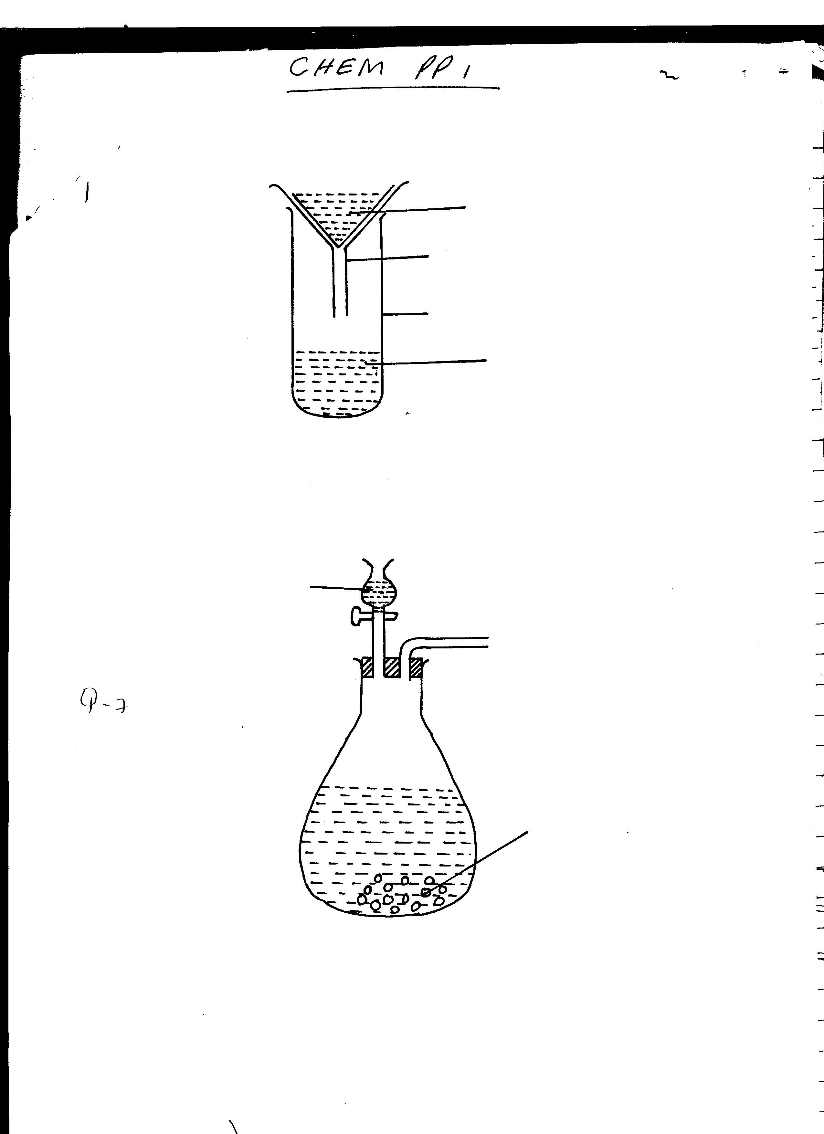
Water
Sodium Peroxide
Oxygen
(d)

- Neat diagram-
- correct method of collection
(e) - For cutting and welding metals
- Rocket fuel
- Mountain climbing
- Sea diving
- Used in explosions (any two)
10. a) To remove any magnesium oxide coating from the surface of magnesium// To remove any
oxide film on it

b) White solid which is magnesium oxide

c) Increase in mass was due to oxygen which combined with magnesium

d) 2Mg(s) + O2(g) _______ 2MgO_{(s)}
Penalize ½ for wrong or missing state symbols

e) The filtrate is magnesium hydroxide which is an alkaline
Red litmus paper changed blue, but blue litmus paper remained blue

11. (i) Oxygen
(ii) Sodium hydroxide is a strong base
(iii) Slightly soluble in water
12. (i) White fumes form in the gas jar which disappear after sometime.
- The level of water rises in the gas jar.
(ii) P_{(s)} + O_{2(g)} P₂O5_{(s)}
P₂O_{(s)} + 3H₂O_{(l)} 2H₄PO_{4(aq)}
(iii) Magnesium react with oxygen and nitrogen hence greater of fraction of air is used.
(iv) (a) Blue litmus changed to red as remained red. The solution was acid due to phosphoric
(b) Red litmus changed to blue as blue remained blue due to formation of basic magnesium
hydroxide ammonia solution.
(v) – Pass air over conc. KOH / NaOH to absorb CO₂
- Pass the remaining gases over hot copper solid which reacts with oxygen.
- Collect the remaining gas over water. The gas is mainly nitrogen.
13. a) i) 3Mg(s) + N₂(g) Mg₃N₂(s) √1
ii) Gas with√1 choking irritating smell.
Mg₃N₂ reacts with water to form ammonia √1 gas.
iii) It remains blue. √½ Ammonia gas is alkaline. √½
14. (a) (i) Phosphorous
(ii) - Do not react with water when being inserted into the tube
- reacts with oxygen when exposed to air.
(b) 4P(s) + 3O_{2(g)} 2P₂O_{3(s)}
or 4P(s) + SO_{2(g)} 2P₂O_{5(s)}

(c) (i) Y – X x 100
y
(ii) – Wrong reading of volume
- Phosphorous can go off before complete combustion
(d) (i) – Red litmus paper no effect
- Blue litmus paper turns red due to formation of phosphoric acid/phosphorous (V) Oxide whish is an acidic oxide
(ii) – Oxygen
(iii) – Burning of candle
- Use of pyrogallol
- Rusting of iron fillings
15. i) P_{4(g)} + 5O_{2(g)} ______________ 2P₂O_{5(s)}
// P_{4(s)} + 3O_{2(g)} ____________ 2P₂O_{3(g)} Anyone √ 1 mark

ii) Phosphorous (v) or (iii) oxide formed is an acidic Oxide which dissolves in water to
form a strong acidic solution of phosphoric acid whose PH is 2

16. (a) – Iron nails turns brown.
 ½
- Water rises up the delivery tube/water level drops in the trough ( any ½mk)
Explanation: Oxygen has been used up in rusting of iron nails hence water rises up to take
 1
the place of oxygen
 1
(b) 4Fe_{(s) +} 3O_{2(g)} + 2H₂O_{(l)} 2Fe₂O₃.2H₂O_{(s)}
(accept a balanced chemical equation)

17. a) FeCO₃ _{(s)} Fe O_{(s)} + CO_{2(g)}
Fe(s) + 4 H₂O_{(g)} Fe O₄ _{(s)} + 4H_{2 (g)}
Or
2 Fe_{(s)} + 20₂(_{g)} Fe₃ O_{4(s)}
b) Fe₃O_{4(s)} + 8H⁺ _{(aq)} 4H₂O _{(l)} + 2 Fe³⁺_{(aq)} + Fe²⁺_{(aq)}

18. a) N₂O 1 (Nitrogen (I) oxide) – Denitrogen Oxide.
b) K₂O 1 (Potassium oxide)
c) Al₂O₃ (Aluminium oxide)

19. a) water √1
b) 2Na₂O_{2(S)} + 2H₂o _{(L)} 4NaOH _{(aq)} + _{O2(g)} √1 mk
Penalize ½ - wrong missing state symbols

5. Water and hydrogen
1. (a) Aluminium is above hydrogen in the reactivity series of elements
(b) (i) The reaction is too exothermic that alot of heat is produced causing ignition of
hydrogen in presence of oxygen
(ii) K_{(s)} + H₂O_{(g)} KOH_{(aq)} + H_{2(g)}
H_{2(g)} + O_{2(g)} H₂O_{(g)}

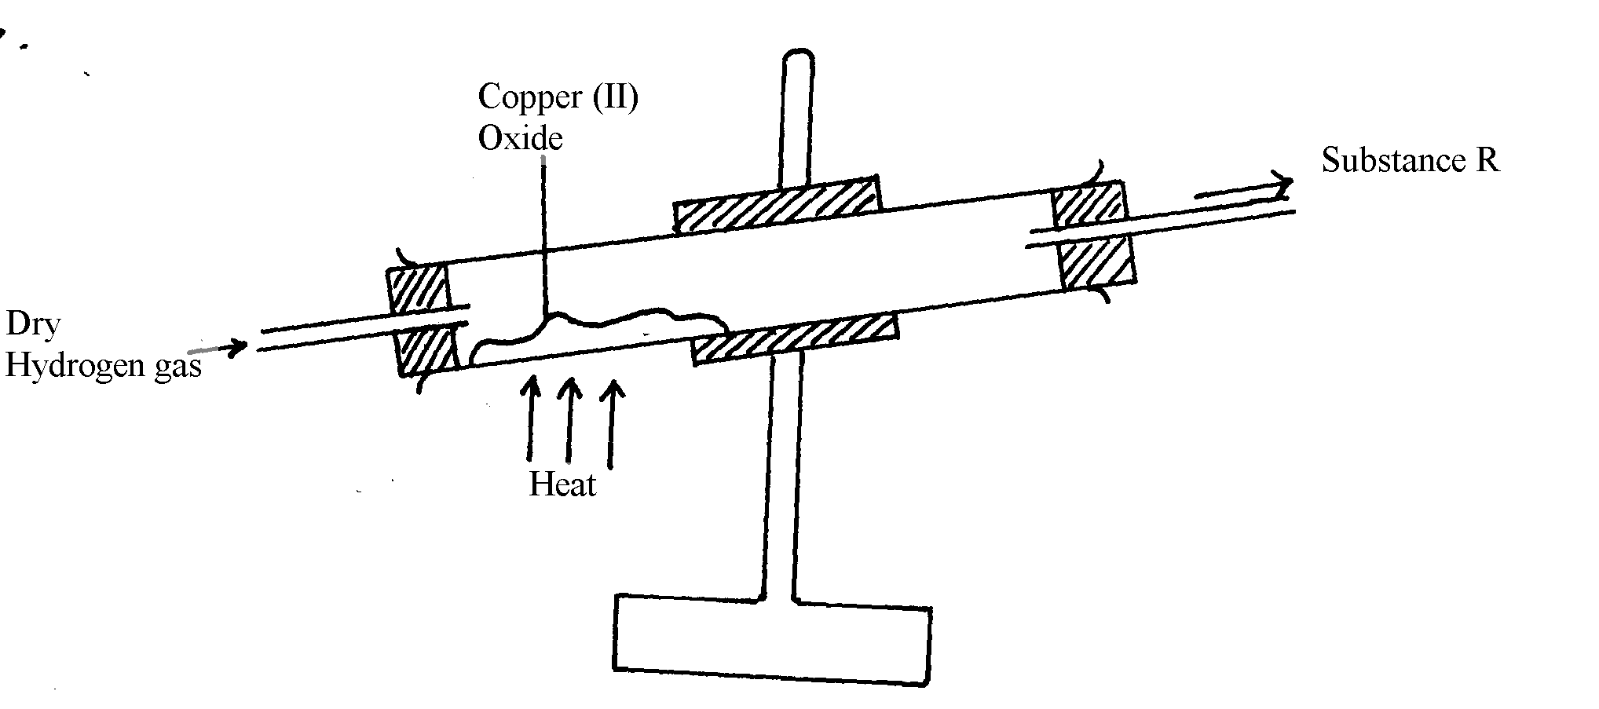
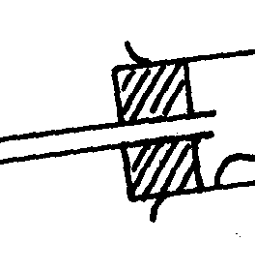
Cold water
Beaker
Substance R
2.

3. a) Calcium chloride
Drying agent

b) 2H_{2(g)} + O_{2(g)} __________ 2H₂O_{(g)}
4. (i) Steam
 1
(ii) Mg_{(s)} + H₂O_{(g)} MgO_{(s)} + H_{2(g)}
(iii) Gas P is passed through the combustion tube before heating is commenced
5. a) 2H_{2(g)} + O_{2(g)} 2H₂O_{(l)} ^{√1}
b) – Turns anhydrous white paper ^{√½} copper (II) sulphate into blue. ^{√½} Or
- Turns anhydrous blue ^{√½} cobalt (II) chloride into pink. ^{√½}
6. a)
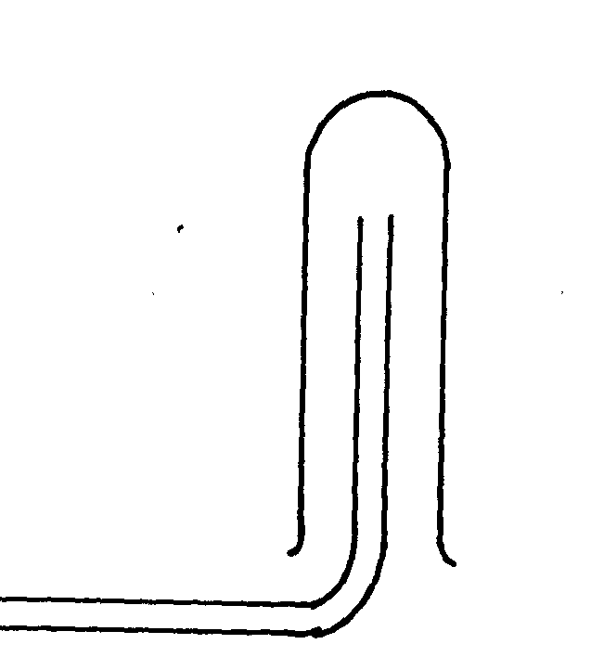
Hydrogen

x
x
x x
x x
•
x
• x
x •
x
•

A
B
B
x
x
x
x
x x
x
x
x x
x x
B

b)reverse steam√1

7. (a) N
(b) 4H₂O_{(g)} + 3Fe_{(s)} Fe3O4_{(s)} + 4H_{2(g)} (Not balanced 0mk)

8. (a)
B.E  ½
S.S  ½
(b) Pb^{2+ (l)} + 2e⁻ Pb_{(s)}
+
-
(c)
1

9. (a) Zn(s) + 2HCl(aq) ZnCl₂(aq) + H₂(g) 1
(b) Concentrated sulphuric (IV) acid or anhydrous calcium chloride. 1
(c) Copper cannot displace hydrogen from its solution. 1
(d) (i) 2H₂(g) + O₂(g) 2H₂O(l) 1
(ii) Before: Pass hydrogen / through the tube before lighting 1 to drive off air.
End: There should be a continuous flow of hydrogen after / putting off the flame
to avoid an explosion. 1

(e) – Filling balloons 1
- Manufacture of margarine.
- Manufacture of ammonia.
- Conversion of coal to synthetic petrol.
(f) Zn (s) + H₂O(g) ZnO(s) + H₂(g) 1
(g) S,½ P,  ½ Q,  ½ R, ½
(h) It adds to unsaturated oils and hardens them. 1
10. a) i) Heating of copper (ii) Oxide to be shown on the diagram
ii) To drive out air because mixture of air and hydrogen is explosive when lit
iii) CuO_{(g)} + H2_{(g)} __________ Cu_{(g)} + H2O_{(g)}
(penalize ½ mark for wrong S.S)
iv) To prevent re-oxidation of hot copper by the atmospheric oxygen
v) Reducing agent
vi) Black copper (ii) Oxide turns to brown showing that copper (ii) Oxide has
been reduced to copper
vii) Zinc is more reactive than hydrogen and therefore cannot be reduced by hydrogen

11. (a) Hydrogen gas

(b) - Calcium react with water forming calcium hydroxide solution
– Calcium hydroxide solution dissociates to produce calcium ion (Ca²+ions) and hydroxide

(OH⁻) ions responsible for basic properties.

6. Structure of the atom and the periodic table

1. Na₂CO₃ + 2HNO₃ ____ 2NaNO_{3 (L)} + CO_{(q)} + H₂O_{(C)}
Mole ration 1 : 2
a) Moles of HNO₃ in 20cm³ = 20/1000 x 0.25
= 0.005 moles

b) Moles of Na₂CO₃ in 25cm³ = ½ of 0.005 moles
= 0.0025

c) If 25cm³ = 0.0025 moles
in 250cm³ = ?
250 x 0.0025
25
= 0.025 moles

RFM of Na₂CO₃ = 106
I mole of Na₂CO₃ = 106g
0.025 moles = ?
0.025 x 106
1
= 2.65g of Na₂CO₃
2. (a) A= 2.8.1
B= 2.1

(b) B
Strong attraction of the outermost energy level electron to the nucleus make it difficult
to remove This is due to smaller atomic radius compared to A
Or - Outermost electrons are closer to the nucleus hence higher force of attraction
3. R.A.M = (62.93 x 69.09) + (64.93 x 3091)
100
= 4347.834 + 2006.99
100
= 63.5482
≈ 63.5
4. (a) R.A.M = (33 x 2) + (30 x 1)
 1
3
 1
99 = 33
3
(b) Number of electrons of C = 57-31 = 26
Number of electrons of B is the same as for C = No. of Protons
B = 26 protons
 ½
5. 69.09 x 62.93 + 30.91 x 64.93 1
100 100
43.4783 + 20.0698 1
= 63.548 ≃ 63.55 1
6. 63 x + 65 (100 – x) = 63.55
100
63x + 6500 – 65x = 6355
2x = 6355 – 6500
2x = -145
X = 72.5
% abundance of ⁶³ M = 72.5%
⁶⁵ M = 27.5%
7. a) Valency of G is 3
b) G is a group 3 element
8. a) i) 11 protons
ii) 16 protons
b) Formula of compound = T2Z
Mass number of T = 11+ 12 = 23
Mass number of 2 = 16+16 = 32
Formula Mass of T2Z = ( 23x2) + 32 = 78
c) – When molten
- When in aqueous solution
9. Silicon (iv) Oxide has giant atomic structure with strong covalent bond holding the atom
together. These require a lot of energy to break, hence it has high melting point. Carbon (IV) Oxide has simple molecular structure with weakVan Der Waals forces holding the molecules together which require little energy to break, hence sublimes at low temperature and is a gas at room temperature and pressure
10. O₂ 2.8 O 2.6
The oxide ions has 2 extra electrons that causes greater electron repulsion than in oxygen atom
11. To separate samples of CUO and charcoal in test tubes, dilute mineral acid is added with
shakingCuO black dissolves to form blue solution√ ½
Charcoal does not dissolve in dilute mineral acids
12. (90 x 8) + 10Q = 28.3 (½mk)
100
100 x 2520 + 10Q = 28.3 x 100
100
2520 + 10Q = 2830 (½mk)
10Q = 2830 – 2520
10Q = 310
Q = 31
Electron arrangement of X = 284 (½mk)
Atomic No. = 14 ( ½mk)
No. neutrons = 31 – 14 = 17 (½mk)
13. L₃ has delocalised electrons while the others has less
14. (a) Is a constant temperature at which a solid changed to a liquid/ A point at which a solid
changes to a liquid which a solid changes to a liquid without change in temperature.
15. (a) P ^{√ ½} and S ^{√ ½} √
They have the same atomic numbers. √ Both must be there to score 3
(b) 4 (7, -3) √

16. a) B√ ½ - its ion has a stronger nuclear charge than that of A√ 1
b) D√ ½ - has the weakest nuclear charge as compared to the other non- metals √ 1
17. (a) CA 1

(b) (i) E 1
(ii) B 1

(c) Period 3, ½ Group 2,  ½

(d) (i) The atomic radius of F is greater than that of C1 because F has more energy levels.
(ii) The atomic radius D is smaller than that of C 1 because of increased positive charge
in the nucleus which attracts the electrons more. 1

(e) (i) Electrovalent bond ½
(ii) Covalent bond ½

(f) (i) 4C + O₂ 2C₂O 1
G + O₂ GO₂ 1
(ii) C₂O is basic while 1
GO₂ is acidic. 1

18. (a) B – ammonia gas 1
C - nitrogen (II) oxide (NO) 1
E – water 1
F – unreacted gases 1

(b) The mixture of ammonia and air is passed through heated/ catalyst where ammonia (II) is
oxidized to nitrogen (II) oxide. 1

(c) Gases are cooled and air passed through heated/ catalyst where ammonia is further
oxidized to nitrogen(IV) oxide. 1

(d) Fractional distillation, ½
Water with a lower boiling point ½ than nitric (V) acid, distills left leaving the
concentrates acid.

19. (a) (i) C
 1
(ii) D or E
 1
(iii) F
(iv) D or E
 1
(v) A
(vi) D
 1
 ½
(b) Atomic radius of Y is smaller than that of X. The effective nuclear charger in Y is greater
 ½
than in X hence outer electrons strongly pulled to the centre reducing the radius.

(b) (i)
 ½
 ½
(ii) Period – 3 Group – IV
 1
(c) (i) On the grid (period 2 Group 7)
(ii) Halogen
 1
 1
(iii) – Used in hospitals with patients with breathing difficulties
- Used by mountain climbers and deep sea divers
 1
(iv) Basic

20. A (i) P – ionic configuration - 2
- Formula of oxide – PO
Q – Atomic number – 20
R- Atomic number – 19
T – Ionic configuration – 2.8.8
Formula of oxide – TO2
(ii) R – Has the largest atom with one outer electron hence easily loses it.
(iii) S – is the smallest atom of a non-metal with a deficit of only one electron hence
easily gains.
(iv)
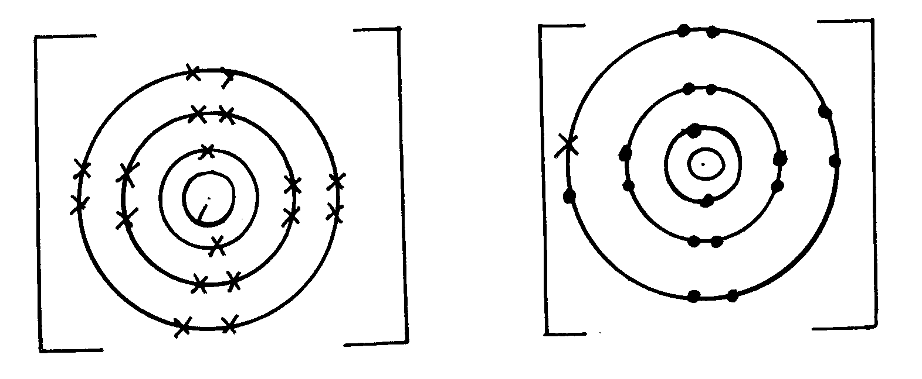
2⁺
-

2

Q ²⁺
2Cl⁻

(v) T is insoluble – It has a molecular structure/non-metal
(B)(i) It is coated with an un reactive layer of aluminium oxide which prevents it form reacting.
(ii) Valency – The number of electrons an atom gains or loses during a reaction.
Oxidation number – The resultant charge of an atom has after gaining or loosing electrons.

21. a) +3 + P = (-2x3)= 0
+3+P – 6 = 0
P = +3√
b) Mg- its oxidation state increases from Zero to +2 √ 1 mark
22. a) Group 1 – Because √½ it has 1 electron in its outermost energy level.
Group 7 – It requires √½ 1 electron to fill its outermost energy level.
b) Alkaline earth metals √1
c) PV₂ √1
d) Q has higher√½ m.p than J. Q has a giant metallic structure and strong metallic bonds. √½
While J has molecular structure and Vander
Waals forces which are easy to break. √½
e) R. √1
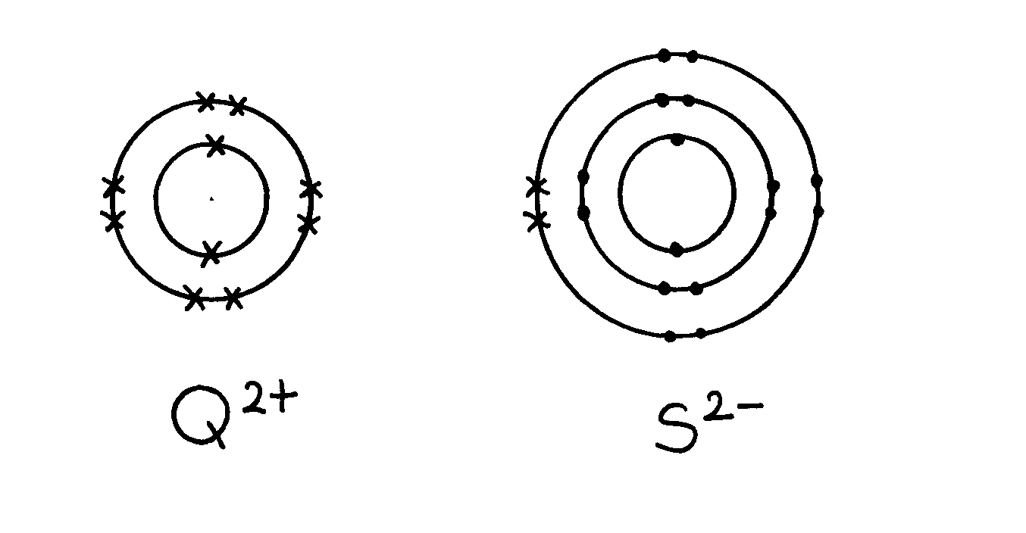
f) T(s) + O₂(g) TO₂(g) √1

g)

h) – Filling electric light bulb √1 accept any other correct one.

23. (a) (i) X Rj: If actual symbols are given.

(ii) Q. Rj. Actual symbols.
Explanation: It looses the outermost energy level most readily.

(iii) Halogens

(iv) I). Moving across a period there is increased nuclear charge.
II). Going down a group the energy levels increase in number.

(v) V- Explanation It has a complete outermost energy level/ Has a stable octet.

(vi) Z₂R Rej. Interchange of letters, RZ₂.
24. a) i) I S√ 1- It readily gain one electron on ionization√1
II Q - It readily give out one electron on ionization√1

ii) Alkali metals√1
iii) WS₃√1
iv) Bond - covalent√ ½
Structure – Giant atomic structure√ ½
v) It is stable. Cant remove nor add electrons on its outermost energy level
vi) T has a smaller radius than Q because it has fewer energy levels than Q
- The melting point increases from A to C this is due to increase in number delocalized electron
hence increase in the strength of metallic bond.
D forms a giant structure with strong covalent bonds. Hence high melting.
It exhibits allstrophy ie may exist as two different form in the same state.
C2 (SO₄)₃
Noble gases or inert
Used in filament bubls
Used to produce an inert atmosphere in high temperature inetallurgical processes e.g welding.
C is amphoteric oxide
F acidic it is non –metal oxide.

Ethene
^{H} ^{H}
C= C
_{H} _{H}
Acidified potassium Manganate VI abromine water it from a colourless solution

CH₂CH₂ + H₂ CH₃CH₃
Nickel catalyst

26. a) 2 : 8
b) W₂O₃
27. i) Delocalized electrons
ii) Mobile ions
iii) Mobile ions

28. - Sodium has a larger raius than aluminium
- Aluminium has more protons than sodium hence a more effective nuclear charge
than sodium
29. a) 2.5
b) Q Group 1 ½, Period 4 ½
R Group 2 ½, Period 3 ½
30. Ethanol contains molecules 1 which are not1 responsible for electrical conductivity. (2 mks)
31. a (i) Q
(ii) R
32. (a) K and N because they have the same number of electrons on their outermost energy level


(b) L₂O₇
(c) L₁ because it has 7 electrons on the outermost energy level or reacts by gaining electrons
or the ionic radius is larger than the atomic radius (½mk)

33. a) Formula; J₅G₂ √1
b) E form ironic structures due to ionic bonding in its oxide. While G form molecular
structure due to covalent bonding in it oxide

Chemical families

1. a) - Non- metallic group
- Ionic radius larger than atomic radius
b) X – has smallest atomic radius hence more electronegative
2. To prevent filament from burning out. Provides an atmosphere in which burning cannot occur
i.e. inert atmosphere
3. a) Halogens
(b) X & Y
(c) Z is the largest atom with the highest number of energy levels occupied by electrons.
The longer an atom is the higher the forces of attraction that hold the molecules of the
element together
(d) 3Z _{(g)} + 2Fe_{(s)} FeZ_{3(s)}

(e) The blue litmus paper turned red that bleached. This is because it dissolves in water to form\
an acid and bleaching solution of HO⁻¹
4. (i) Down the group an extra energy level is added
(ii) In group x elements form ions by ionizing the outer energy levels
(iii) A cross the period an extra proton is added which increased he nuclear attraction force
(iv) BF₂
(v) – Ionic /electrovalent
- Involves loosing & gaining of electrons
(vi) G, F,E
-E has smallest atomic radius hence protons can attract an electron easier than in G
5. R – has the smallest atomic √ ½ size hence its outermost electrons are more strongly held to the
nucleus resulting in high √ ½ value of ionization energy
6. - Add dilute nitric acid to lead (u) carbonate
PbCO₃(s) + 2HNO₃(aq) Pb(NO₃)₂(aq) + CO₂(g) + H₂O(l) ^{√1}
- React the resulting solution with solution of sodium sulphate i.e
Na₂SO₄(aq) + PB(NO₃)₂(aq) PbSO₄(s) + 2NaNO₃(aq) ^{√½}
- Filter to obtain lead (u) sulphate as residue. ^{√½}
- Dry the salt of lead (u) sulphate in between the filter papers or in sunshine. ^{√½]}

7. a) Is one of the atoms of the same element having a different mass number from the rest,
but same atomic number with others of the same element

b) 92.2 X 28 + 4.7 X 29 + 3.1 X 30 = 28.11√ ½
100 √ ½ 100√ ½ 100√ ½

8. a) Alkaline earth metals √1
b) P has the smallest atomic radius due to electrons of P are closest to the nucleus √1
c) Q_{(S)} + 2H_{2O(L)} Q(OH)_{2(aq)} + H_{2(g)}

Structure and bonding
1. Ethanol contains molecules 1 which are not1 responsible for electrical conductivity
2. a) A covalent bond is formed by equal contribution of the shared electrons by the atom. 1
Co-ordinate bond is where the shared electrons are contributed by one of the atoms.1

H
H
H
H
x
•
x •
•
x
x
•
x •
H

HN H

H
•
x
•
x
• x
• x
H

HNH

H

OR

3. a) Have delocalized valency electrons 1
b) Aluminium is a better conductor/Aluminium has three delocalized electrons while
magnesium has 2. 1 It is resistant to corrosion.
4. In addition to vander waals forces, strong hydrogen bonds exist in ethanol. These bonds
require  more energy to break.

5. a) Is a covalent bond in which the shared pair of electrons comes from the same atom
6. Magnesium has more delocalized electrons than sodium
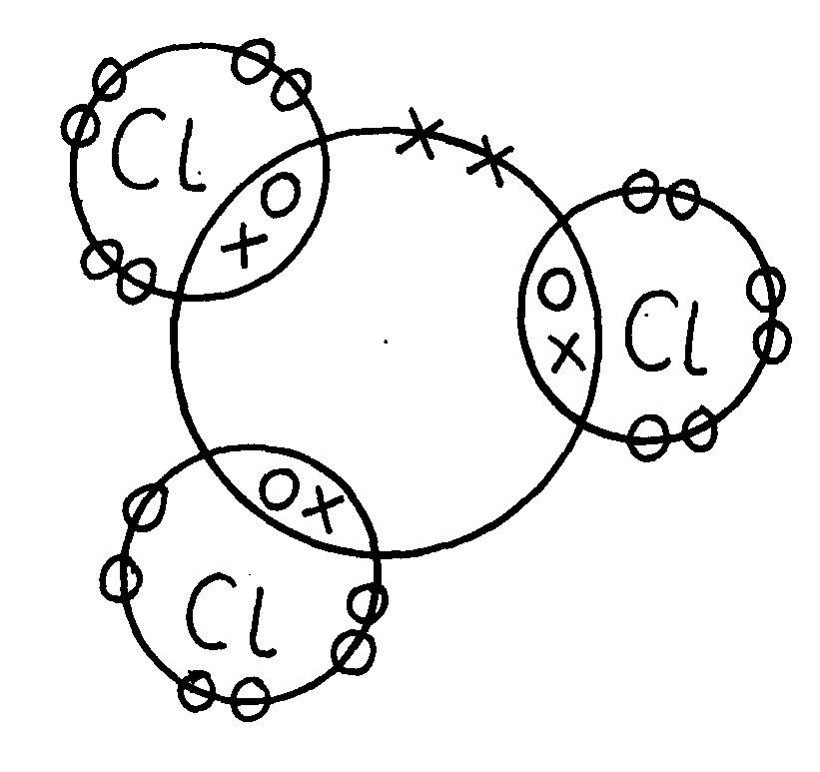
7. (a) Phsophorous chloride (PCl₃)

P

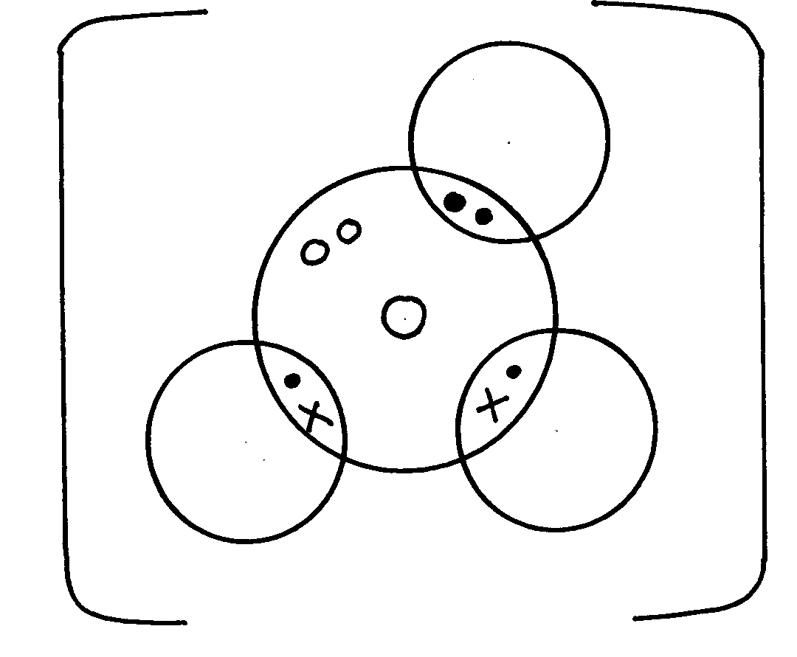
(b) Hydroxonium ion (H₃O⁺)
H

O

H
H

8. Aluminium – it has more delocalized (3) electrons than copper (2 e_)
9. Hydrogen chloride has got only Van der waal while water has H-bonds in
addition to Van der waal forces which are stronger
10. It contains white hoe carbon particles (½mk) that allow to give out light (½mk). When those
particles cool down (½mk) they turn black and settle down as soot.(½mk)
11. Aluminium chloride hdrolyses ^{√1} in solution producing hydroxonium ions ^{√½} which turn blue
litmus paper red. ^{√½}
12. Silicon (IV) oxide forms giant ^{√1} atomic structure of strong covalent^{√½} bonds having high
melting point. Carbon (IV) oxide is simple molecular substance of weak intermolecular ^{√½}
attraction forces^{√1} 9the Van der Walls’ forces) that have low melting point.
13. i)A: 2,4√ ½
B: 2,7√ ½
14. (a) Because aluminium √1 has more delocalized √1 electrons than magnesium.
(a) It does not corrode. √1
15. Magnesium oxide has a giant ionic √ ½ structure while silicon (iv) Oxide has a giant atomic
structure. Mg O in molten state √ ½ contains delocalized ions √ ½ which conduct electricity
while S₁O₂ has no ions present √
16. a) i)
ii) At 25C, sodium chloride is in solid form. Ions cannot move. Between 801 and
1413C sodium chloride is in liquid state, ions are mobile

b) Both ammonia and water are polar molecules and hydrogen bonds are formed

c) N _________ H // co-ordinate bond / Dative bond

d) i) Allotrope
ii) Add methylbenzene to soot in a beaker. Shake and filter. Warm the filtrate to
concentrate it. Allow the concentrate to cool for crystals to form. Filter to obtain
crystals of fullerene
iii) ⁷²⁰/₁₂ = 60
17. (a) (i) NACl has mobile ions in molten state and in aqueous solution
(ii) Graphite has delocalized electrons in the structure which carry electric current
18. (i) I) C Reason:- Good conductor of electricity in both molten and solid state..

II) D-Its melting point is below room temp. and boiling point above room temp.

(ii) It exist in allotropic form.
(iii) A conducts electricity by use of mobile ions while C conducts by use of delocalized
electrons.
Both must be correct for the 1 mk.
19. I (a) 2Na(_{s)} +2CH₃CH₂OH_{(l)} 2CH₃CHONa_{(aq)} + H_{2(g)}
(b) Mole ratio btn Na: H = 2:1
Mole of Holes H₂ = 1200cm³
2400cm³
= 0.05moles
Moles of Na = 0.05 x 2
= 0.1moles
Mass of Na = 0.1 x 23
= 2.3g of sodium

(c) Mole ration C₂H₅OH:H₂
Moles of C₂H₅OH = 0.05 x 2
= 0.1moles
mass of C₂H₅OH reacted = 0.1 x 46
= 4.6g
Mass evaporated = 50 - 4.6
= 45.4g of C₂H₅OH

(d) – Has molecular structure – with hydrogen bonds being molecules
While - C₂H₅ONa – has giant ionic structure with ionic bonds
(a) Water
(b) In ethanol – sinks in water and stream of bubbles observed /seen
While in water – floats on water and darts on water
- Hissing sound is heard (any two)
20. (a) ionic or electrovalent
F is metal and H is non metal.
b) (i) J atomic radius decrease a long a period from left to right nuclear change attraction
increase positive nuclear change increase due to increase in the number of protons.
(ii) F has a smaller atomic radius than N level down the grown.
c) W is group 5 period 3
d) Transition metals.
e) J has 3 valence electrons which and delocalizal whole Q has only 2 electron : hence J
has high electrical conductivity due to high number of decalized electron.
f) The reactions have both metallic and non metal properties
g) H is more reactive than M non metal reactivity increase up the group due to decrease
in electro negativity down the group.
21. (a) (i) Ionic bond
Y losses that is gained by Z
(ii) Atomic radius of A is larger than that of B has higher nuclear charge than A Electrons in B are drawn closer to the nucleus( ½mk)
(iii) Z is more reactive than B
Z has a smaller atomic radius so will readily attract extra electron
(b) (i) Energy needed to remove an electron from an atom in gaseous state
(ii) R has a largest atomic radius; (½mk)
Therefore the electron is easily lost
(iii) Reacts vigorously with water producing gas bubbles that give the hissing sound and
propels the metal
The metal floats on water as it is light
(iv) 2Q_{(s)} + H₂O_{(l)} 2QOH_{(aq)} + H_{2(g)}

22. a) i)
Atomic number | Oxide formula | State at RT
N-12 | P₂O₃ | Q - solid
R- 15 | R₂O₅ | S- Gas

ii) The atomic radius decreases across the period from M to V. Due to increasing
nuclear charge// increasing number of protons which pulls the outermost electrons
closer to the nucleus

iii) Element V is chemically stable// stable electronic configuration does not gain or
loss// share electrons with oxygen to form an oxide

b) i)
Oxide | Structure | Bond type
No | Giant ionic | Ionic/ electro valent
TO2 | Simple covalent/ molecular | Covalent
( ½ mark each – total 2 marks)
c) i) P is a metal with valency electrons free to move but T is a non- metal// molecular has
no free valency electrons// molecules are electrically neutral

ii) Amphoteric oxide

23. (i) Period 2 its electronic arrangement is 2,3, or it has two energy levels.
- Accept shells or orbitals in place of energy levels
(ii) I- Across a period nuclear charge increases from, left to right exerting greater
pull/attraction on available electrons
II-A₄ gains an electron and the incoming electron is repelled by other electrons or
electron cloud increases
(iii) A₂
A₄
A₁
•
x
+
_
x
•
x xx
x

(iv)
 1

24. a) P₂Q √ reject QP₂

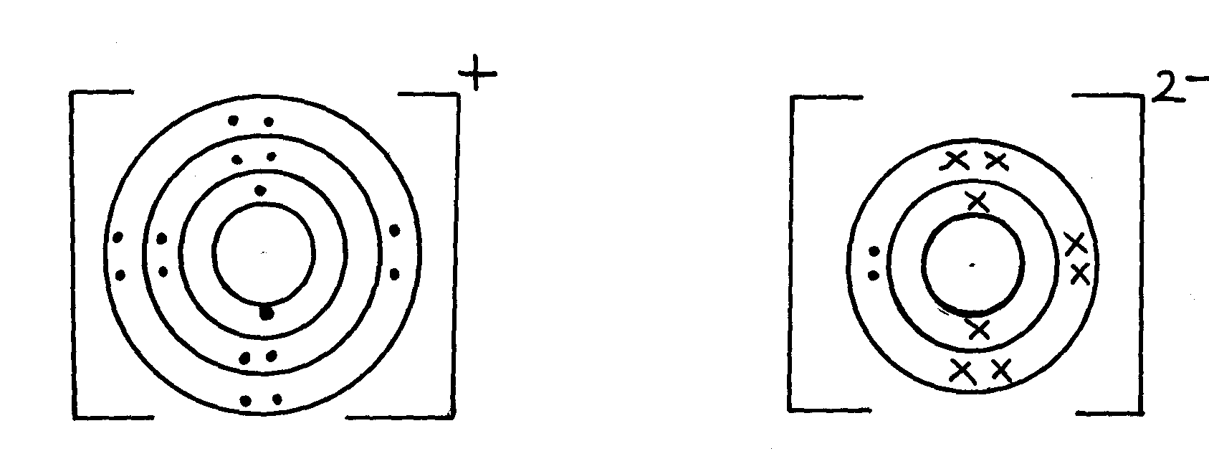
2

25. (i) Ice : Bonding : - Covalent ^{√ ½} ½ mk
Structure : - Simple molecular ^{√ ½} ½ mk 2
(ii) Magnesium chloride : Bonding : - Ionic ^{√ ½} ½ mk
Structure: - Giant ionic ½ mk
26. (i) Ice : Bonding : - Covalent ^{√ ½} ½ mk
Structure : - Simple molecular ^{√ ½} ½ mk 2
(ii) Magnesium chloride : Bonding : - Ionic ^{√ ½} ½ mk
Structure: - Giant ionic ½ mk

27. (a) Zinc oxide √1 ZnO (1 mk)
(b) ZnO_{(s)} + H₂SO_{4(aq)} √1 ZnSO_{4(aq)} + H₂O (1 mk)
3
2-
(c)
Zn (OH) √1 (1 mk)
4

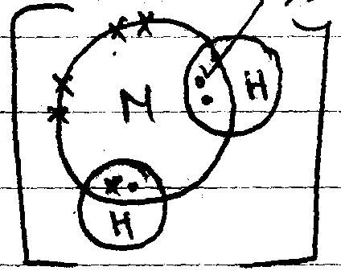
28. (a)

Electrons  ½
Charge  ½

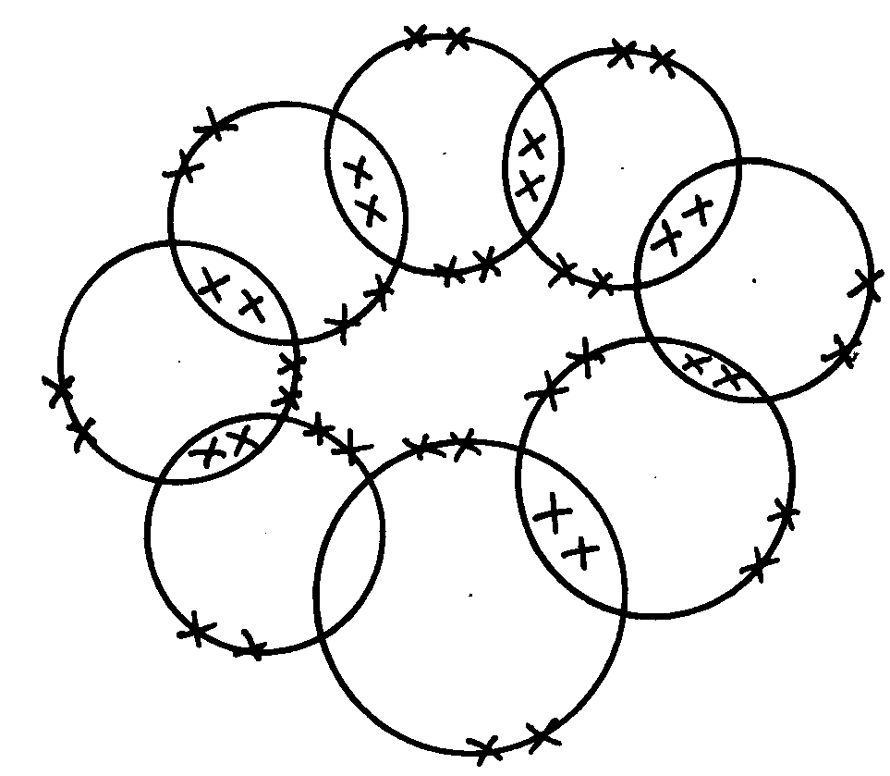

 1

 1
(b) C O
29. Diamond has giant atomic structure in each carbon atom√ ½ is bonded to four other √ ½
carbon atoms arranged in regular tetrahedron shape in all direction forming rigid (strong)√ ½
mass of atoms due to uniformity of covalent bonds between the atoms√ ½ (2mk)
30. 3 Covalent ^{√1} bonds and one dative ^{√1} bond
31. - CB₂
- Ionic bond
32. (a) Covalent bond is bond between non-metal atoms where shared electrons are donated
equally by all the atoms involved.
Dative bond is a bond in which shared electrons are donated by one atom.
 ½
(b) The presence of triple bond in nitrogen requires very high temperatures to break
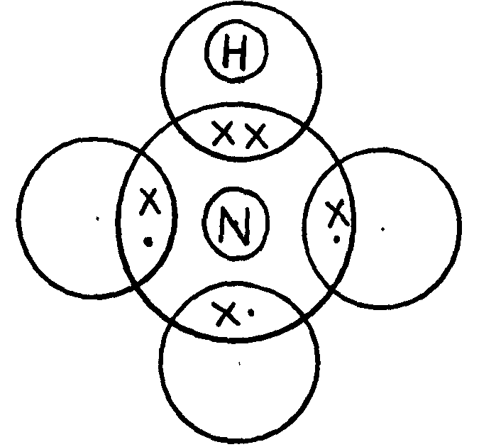
33. (i)
 1
- award 1mk if one Hydrogen two electrons donated by nitrogen
- 0mk if all hydrogen atoms shares electron with nitrogen

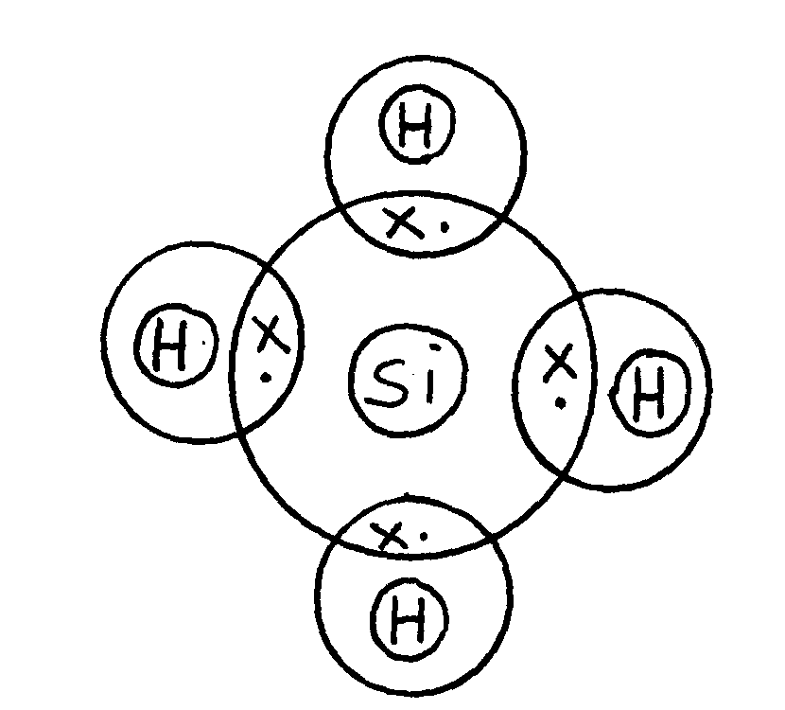
 1
- award full mark if Silicon and Hydrogen shares electrons

34. (a) Chlorine (I) Oxide
 ½
 ½
 ½
(b) - Na₂O has stronger ionic bond between ions in it, while SO₂ has a weak Van der walls bond
between its molecule
- ∴Na₂O requires more heat energy to weaken or break the ionic bonds than SO₂ requires
 ½
breaking Van der walls bonds
35. ALCL₃ has simple molecular structures with weak Vander waals between the molecules
M_{g}CL₂ has giant ionic structures with strong ionic bonds
Due to insoluble coating of aluminum oxide which prevents any reaction √1
4. Salts
1. a) Conc. H₂SO₄ / H₂SO4
b) Heat the solution to concentrate it.
Allow for crystals to form ½ Filter ½
c) Anhydrous Copper(II) sulphate/CUSO₄(s)
2. a) To MgO, add excess HNO_{3,}½ HCl or H₂SO₄ . Add NaOH or KOH or NH₄OH to the
mixture, ½ Filter  ½ and dry ½ the residue.
b) – Anti-acid (Treatment of acid indigestion)
- Making tooth past 1

3. Add excess lead (II) Oxide to dilute nitric (v) acid and filter to get lead (II) nitrate solution.
Add sodium carbonate solution to lead (II) nitrate to precipitate lead (II) carbonate and wash
with distilled water.
4. a) Sodium nitrate/ sodium nitrite
b) Black charcoal glows red
Grey ash formed
c) carbon (II) oxide

5. .a)
Particle | Mass number | Number of protons | Number of neutrons | Number of electrons
E | 37 | 17 | (i) 20 | 18
F | 32 | (ii) 16 | 16 | 16
G | (iii) 39 | 19 | 20 | 18
H | 40 | 20 | (iv) | 18

b) E,G and H
6. a) They became a white powder
b) Efflorescency
7. Add water to sodium oxide to form sodium hydroxide solution. Bubble excess carbon (IV) oxide
 ½
in sodium hydroxide solution to form sodium hydrogen carbonate. Heat sodium hydrogen
carbonate solution to evaporate water.
8. NH₄Cl decomposes on heating to produce NH₃ and HCl (g). NH_{3(g)} is lighter than HCl_{(g)}
hence diffuses faster and turns red-litmus to blue HCl is denser hence diffuses at a slower rate: changes blue litmus to red
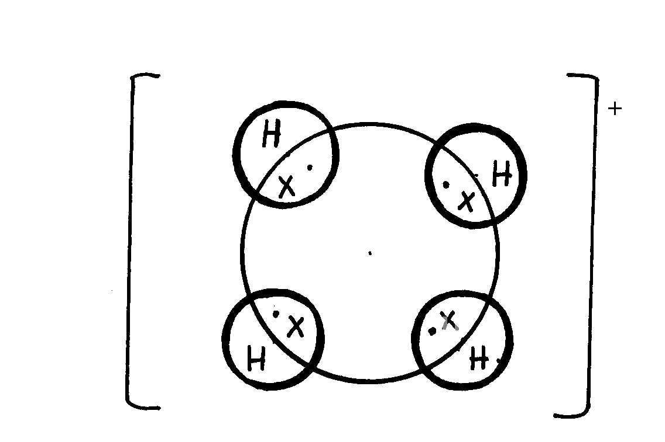
9.

10. a) i) Hydroscopy// hygroscopic
ii) Deliquescence// Deliquescent
iii) Efflorescence// Efflorescent

b) i) Zn(OH)₄²⁻
ii) Cu(NH₃)₄²⁺
11. (a) (i) 2KNO_{3(s)} 2KNO_{2(s)} + O2(g)- ½mk for wrong states
(ii) 2AgNo_{3(s)} 2Ag_{(s)} + 2NO_{2 (g)} + O_{2 (g)}
12. (a) (i) Carbon (iv) Oxide
Dilute hydrochloric acid
(ii) Mg(HCO₃)_{2(aq)} MgCO_{3 (s)} + H₂O_{(l)} + CO_{2(g)}
(iii) Add sodium carbonate/any soluble carbonate (named ) solution;
Filter
Dry the residue between two filter papers
13. a) magnesium Oxide
b) 2Mg_{(s)} + O2_{(g)} _________ 2MgO_{(s)}

c) i) Sodium sulphate
ii) MgCO₃

d) MgO_{(s)} + H₂SO_{4(aq)} ________ M_{g}SO_{4(aq)} + H₂O_{(L)}
e) Mg²⁺_{(aq)} + CO²⁻ _{3(aq)}________ M_{g}CO_{3(s)}
f) M_{g}CO_{3(g)} _________ M_{g}O_{(g)} + CO_{2(g)}
g) Na⁺ ions and SO₄²⁻ ions
h) Precipitation/ double decomposition
i) Crystals turn to a white powder. The salt is efflorescent hence it looses its water of
crystallization forming a powder
14. a) i) Hydroscopy// hygroscopic
ii) Deliquescence// Deliquescent
iii) Efflorescence// Efflorescent

b) i) Zn(OH)₄²⁻
ii) Cu(NH₃)₄²⁺
15.
- Dissolve lead (ii) nitrate crystal in a given amount of distilled water in a beaker
- To dilute sulphuric√ ½ (vi) acid in a beaker add magnesium√ ½ oxide powder
- React the two solutions obtained
- Filter the mixture
- Dry the residue between filter papers to obtain a dry sample of lead (ii) sulphate
16. (a) Zinc oxide √1 ZnO (1 mk)
(b) ZnO_{(s)} + H₂SO_{4(aq)} √1 ZnSO_{4(aq)} + H₂O (1 mk)
3
2-
(c)
Zn (OH) √1 (1 mk)
4
17. (i) Efflorescence
(ii) Na₂ Co₃.10H₂O (If letters are joined – no mark)
18. (i) Pb²⁺
 1
 1
(ii) White precipitate formed soluble in excess
19. Calcium oxide hygroscopic atmospheric water vapour ad becomes wet
Some laboratory gases are acidic
While calcium oxide is basic
Therefore calcium oxide reacts with the gas//calcium oxide would absorb the gas
20. A piece of marble chips was strongly heated in air for about 30 minutes. Some drops of water
were added drop by drop to the product when it was still warm.
Answers
i) It decomposes to give Calcium oxide/Lime and Carbon (IV) oxide
CaCO_{3(s}) CaO_{(s)} + CO_{2(g)}

ii) Alot of heat is evolved which makes the piece of lime swell hence the name quick lime and
Calcium hydroxide(slaked lime) is formed.  ½
CaO(s) + H₂O(l) Ca(OH)₂(aq) 1
21. a) i) Gas C O_{2(g)} √ ½ Gas B NO₂ √ ½

ii) Zn²⁺ and NO₃⁺√ ½

b) ZnO_{(g)} + 2HNO_{3 (aq)} ________ Zn(NO₃)_{2(aq)} + H₂O_{(l)}
Balanced
State symbols
Chemical symbols
22. (a) Glowing splint is relighted/rekindles
(b) Pale yellow solid

23. a) Deliquescence√1
b) Deposition √1
24. a)- To MgO add excess HNO₃ √ ½ (Or HCL or H₂ SO₄)
- Add NaOH or KOH or NH4 OH to the mixture √ ½
- Filter and dry the residue√1

b) Uses as
- Anti – acid or tooth paste √
25) - Dil NaOH may not absorb all the carbon (IV) oxide gas produced
- Candle may go off before all the oxygen is used due to build up carbon (IV) oxide
26 a) Acid salts NaH₂PO_{4(S)} √1
Basic salts – M_{g} (OH) CL_{(s)} √1
Normal salts – Ca (NO₃)_{2(S}) √1
Double salt – Fe(NH₄)₂ (SO₄)₂ 6H₂O√1

b) i) Hydrolysis – Reaction of water with a compound to form at least two products √1
ii) Moist litmus paper turns red due to the HCL gas produced √1
Or accept equation for the explanation
FeCL_{3(S)} + 3H₂O_{(L)} Fe (OH)_{3(S)} + 3HCl _{(g)}

Effect of an electric current on substances
1. (a) Pb²⁺_{(l)} 2e⁻n Pb_{(s)}
(b) - There is liberation of brown vapour
- The brown vapour is due to the formation of bromine molecule

2. E – Giant ionic structure
F – Giant metallic structure
 1

3. (a) - Electrolytes are melts or acqueous solutions which allow electric current to pass
through them and are decomposed by it while non-electrolyte are melts or acqueous
solution which do not conduct electric current
- Electrolytes contain mobrite ions while non-electrolyte contains molecules.
(c) (i) I bulb did not light when sugar solution was put into the beaker
II bulb light when slat solution was put into the beaker
(ii) Non- electrolyte I
Electrolyte II
(b) (i) heating
(ii) Cathode
Pb²⁴ + 2e⁻ Pb_{(s)} grey deposit metal is observed
(iii) Anode
2Br⁻_{(aq)} Br_{2(g)} + 2e⁻
A brown yellow gas is evolved

4. a) i) Decomposes to Pb²⁺ and ions which are later reduced to Pb and are oxidized to Br
ii) Br_{2(g)} produced is poisonous

5. I (a) Crystallization – The solidifying of a salt form a saturated solution on cooling.
(b) Addition of sodium chloride to soap-glycerol mixture in order to precipitate the soap.
II– to the nitric acid in a beaker, add barium carbonate solid as you stir until effervescence stops.
- Filter to obtain the filtrate
- Add dilute nitric acid to the filtrate and filter to obtain the residue
- Dry the residue under the sun or between filter papers.

III (a) (i) K⁺
(ii) NO₃
heat
(b) 2KNO_{3(s)} 2KNO_{2(s)} + O_{2(g)}
²⁺
(IV) Cu(NH₃)₄
(V) In water HCL ionizes into mobile into mobile ions which conduct because water is polar
while methyl is non-polar hence HCl does not ionize hence does not conduct electricity

6. (i) Faraday first low of electrolysis.
The mass of a substance dissolved on liberated in electrolysis is proportional to the quantity
of electricity which passes through the electrolyte.
(ii) (anode) – Brown/fumes of a gas were evolved (cathode) – grey beads.

7 a) (i) Place elilute nitric acid (HNO₃) in a beaker and warm.
- Add lead II oxide until no more dissolves
- Filter the un reacted lead II oxide
- Heat to evapourae & leave to crystallize.
(ii)Pbo_{s}+ 2HNO_{3aq} pb(No₃)_{2 aq} + H₂O_{n}
b)(i) Crystals crack and split because of the gas accumulating inside
- Brown gas of Nitrogen IV oxide.
- Solid resolute, lead II oxide which is orange when hot is yellow when cold.
(ii) 2 pb(NO₃)_{2s} 2 Pbo_{s} + o_{2(g)} + 4NO_{2(g)}

c) (iii) white precipitate which is incolible is excess ammonia
(iv) pb²⁴ _{aq} + 20H⁻_{aq} pb (oH) _{2 (s)}

8. (a)
- Cathode
A node
Heat

(b) To let the gas produce out, so that it does not explode due to pressure.
(e) At the anode a pale yellow gas is observed
Cathode – grey solid is formed.
(d) Anode 2F⁻_{(c)} F_{2(g),} e 2e⁻
Cathode pb²⁴ _{l} + 2e⁻ pb _{(s)}
(e) the gas produce is poisonous.

II a) C
b) Because it does not conduct electricity in solid state and not soluble.
c) B because it does not conducts electricity in solid state but in molten or aqueous solution
it conducts.
d) Metallic bond.
9. a) A is Anode ^{√1}
B is cathode. ^{√1}
b) Bromine gas. ^{√1}
c) 2Br⁻¹(l) - 2e⁻ Br₂(g) ^{√1}

10. B and D or F₂ and Ne

11. a) i) olcum
ii) Water

b) i) SO_{3 (g)} + H₂S)_{4(L)} _______ H₂S₂O_{7(L)}

ii) H₂S₂O_{7(L)} + H₂O_{(L)} ______ 2H₂SO₄₍

12. a) Source of heat. 1
b) The solid PbBr₂ melts to form Pb²⁺ ½ and 2 Br⁻½ that conduct electric current in the
circuit hence the bulb lights/Pb²⁺ and 2Br⁻ carry the current. 1

6. Carbon and its compounds
1. a) – making of pencil
- As a lubricant
b) Graphite has delocalized in its structure hence it conducts electricity. Carbon uses all
the four valency electrons to form covalent bonds hence do not have delocalized elect
conduct electricity

2. a) Carbon (IV) oxide (CO₂) 1
b) 2NaHCO₃(s) Na₂CO₃(s) + H₂O(l) + CO₂(g) 1
c) – Paper manufacture 1
- Manufacture of glass.
- Softening of hard water.

3. Magnesium has a higher affinity for combined oxygen that carbon./Mg is more reactive
than carbon thus displaces it from its oxide.

4 a) Carbon (iv) Oxide
b) Blue flame. Carbon (iv) oxide burns in air with a blue flame 1

5. a) A brown solid is formed

b) CuO_{(g)} + C_{(g)} ___________ Cu_{(g)} + CO_{(g)}

c) As a fuel in water gas
6. (a) Covalent bond is bond between non-metal atoms where shared electrons are donated equally
by all the atoms involved.
Dative bond is a bond in which shared electrons are donated by one atom.
 ½
(b) The presence of triple bond in nitrogen requires very high temperatures to break

7. (a) Reduction by using carbon
b) J, carbon and H
decreasing order of reactivity 7. Study the structures A and B:
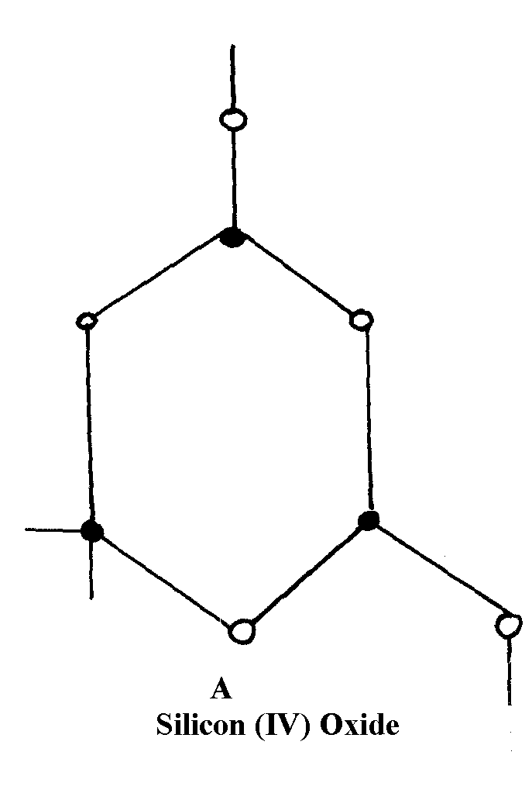
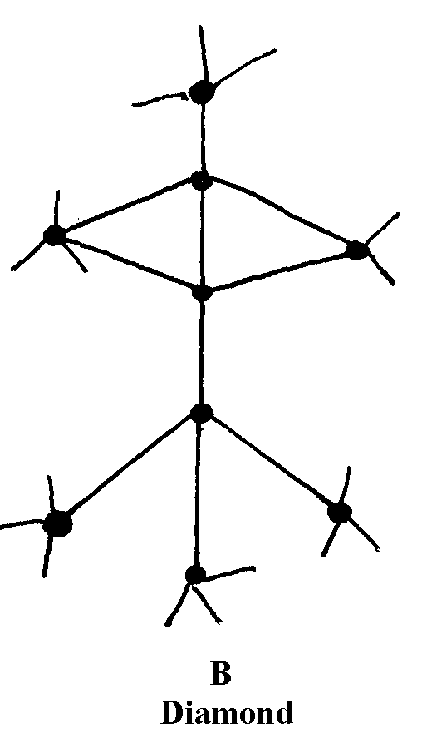

8. (i) Have giant atomic structure
1
(ii) To make drill bits or used in jewellery (any one)
1

9. (a) Allotropy is the existence of an element √1 in more than one form without change of state.
(b) Graphite contains delocalized √1 electrons between the layers while diamond has no
3 free √1 electrons. Its atoms are strongly bonded.

10. (a) C_{(s)} + CO_{2(g)} 2CO_{(g)} √1 (1 mk)
(b) Burn charcoal in sufficient √1 oxygen Carbon (II) oxide 3
(being a reducing agent) is easily oxidized to carbon (IV) oxide.√1 (1 mk)

11. (a) Black^{√ ½} solid changes to reddish brown^{√ ½}
(b) CuO_{(s)} + CO_{(g)} Cu_{(s)} + CO_{2(g)} √ (1 mk) 2

12. (a) Difference forms of a substance at the same physical state;
(b) In graphite each carbon is bonded to 3 others and there are Vander waals forces between
hexogous;
- In diamond each carbon atom is covalently bonded to four others making a rigid mass;

13. a) - Copper (ii) oxide changes √ ½ from black to brown/ reddish brown/ red brown√ ½
- A white ppt forms in the boiling tube √ ½
b) CO_{2(g)} + Ca(OH)_{2(aq)} _______ CaCO_{3(g)} + H₂O_{(l)} √ 1
c) Unreacted carbon (ii) Oxide is poisonous/ toxic/ pollutant it is converted to the less harmful
gas CO₂

14. a) A the substance is a gaining kinetic energy making it to vibrate vigorous up B,
at point B to C the kinetic energy a gained is used to beak down the particle in solid state at
this point the substance start melting and the temperature is constant.
d) It is not water because the melting of water is 100⁰c not 115⁰c.
e) The melting point will be lower because of the impurity Nacl.
f) The temperature is constant.
15. (a) (i) Carbon (II) Oxide or CO – (reject Carbon monoxide)
(ii) Combines with haemoglobin to form caborhaemoglobin which prevents carrying of
oxygen
(b) (i) CO(_{g)} + C_{(s)} 2CO_{(g)}
(ii) ZnO_{(s)} + CO_{(g)} Zn_{(s)} + CO_{2(g)}
(c) Orange/yellow Lead (II) Oxides turns grey
(d) CaCO_{3(s)} + 2HCl_{(aq)} CaCl_{2(aq)} + CO_{2(g)} + H₂O_{(l)}
(e) Methanoic acid and concentrated sulphuric acid
(f)
Gas X
Water

16. (a) (i) - Ammonia gas 1
- Calcium carbonate. 1
- Brine 1 or Concentrated sodium chloride.
- Coke (Any three materials)

(ii) - Carbon (IV) oxide. 1
- Ammonia gas. 1
- Water (Any two)

(iii) Chamber 3 1
Chamber 2 1

(iv) U – Ammonia chloride 1
V – Sodium hydrogen carbonate. 1

(b) (i) HN₃(g) + H₂O(l) + CO₂(g) + NaCl(aq) NH₄Cl(aq) + NaHCO₃(s)
OR
NH₃(g) + H₂O(l) + CO₂(g) NH₄HCO₃(aq)
NH₄HCO₃(aq) + NaCl(aq) NH₄Cl(aq) + NaHCO₃(s)

(ii) NaHCO₃ Na₂CO₃(s) + CO₂(g) + H₂O_{(l)}

(iii) Ca(OH)₂(s) + 2NH₄Cl(aq) CaCl₂ + 2NH₃(g) + 2H₂O(l)

c) - Manufacture of glass.
- Softening of hard water.
- Manufacture of papers.
- Manufacture of soap.
- Refining of metals.

17. (a) (i) – The gas is collected over water
- The gas is not passed through a drying agent
(ii) PbCl₂ is formed which is insoluble hence prevents contact between the carbonate and the acid
Heat
(iii) CO_{2(g)} + C(s) 2CO(g)
CO_{2(g)} + 2NaOH_{(aq)} Na₂CO_{3(aq)} + H₂O_{(l)}

(iv) – Solid CO₂ used as a refrigerant
    - Used in making aerated drinks
    - Solid CO₂ is used in cloud-seeding
    - CO₂ used as an ingredient/air material in solvary process
(v) – Denser than air
- Does not support combustion (burning)
(b) Reducing Property
Heat
(c)- Al₂(CO₃)₃ hydrolyses in water/moisture forming H⁺ ions which reacts with the carbonate
and dissolves
Heat
(d) (NH₄)₂ CO_{3(s)} NH_{3(g)} + CO_{2(g)} + H₂O_{(g)}

18. Brown fumes of a gas are produced as the charcoal dissolves in the acid. The charcoal
reduces nitric (V) acid to nitrogen (IV) oxide gas that is brown while the charcoal is oxidized
to carbon (IV) oxide.

19. (a) Due to formation of calcium hydrogen carbonate which is a soluble salt

(b) 2CaCO_{3(s)} + 2CO_{2(g)} + 2H₂O 23Ca(HCO₃)_{2(aq)}
(- Award 1mk if equation is correctly balanced
- Penalize ½ mk if equation if not balanced)
20. a) A – Concentrated sulphuric acid (vi) acid √1
b)
c) HCOONa_{(s)} + H₂SO₄ HCOOH _{(L)} + NaHSO_{4(S)}

Hence; HCOOH_{(l)} CO_{(g)} + H₂O_{(L)}
Accept conc H₂SO₄ (reject where concentrated is not mentioned)
Workability √1
Correct method of collection√1
Of the gas √1
The two equations should be mentioned 2 mks
Gas laws

1. X: t₁= 28.3sec RMM = ?
Q₂: t₂= 20.0sec RMM=32

T ∝ MM

T ₁ = X
T₂ 32
T ₁ ² = X
T ₂ 32


28.3 ² = X

T₂ 32

X = 28.3² x 32
400

X = 64

2. (a) The rate of diffusion of a gas is inversely proportional to the square root of its density under the same conditions of temperature and pressure
(b) Rate of gas V= ¹/₅ x 100cm
10sec
= 2cm/sec
 ½
Rate of W = 10cm
10sec
 ½
= 1cm/sec

RV = MW
= 2 = MW
1 16
RW MV

2 ² = MW
1 16

4 = MW ; = 4 x 16
1 16 1
MW = 64

3. (a) The volume of a fixed mass of a gas is directly proportional to its absolute temperature at

constant Pressure
(b) Apply combined gas law; P₁V₁= P₂V₂
T₁ T₂
V₁ = 3.5 x10⁻² m³ V₂ = 2.8 x 10⁻²m³
 ½
P₁ = 1.0 x 10⁵Pa P₂= 1.0 x 105Pa
T₁ = 291K T₂= ?
T₂ = P₂V₂T₁
P₁V₁
T₂ = 1.0 x 10⁵Pa x 2.8 x 10-²m³ x 291K
1.0 x 10⁵Pa x 3.5 x 10⁻²m³

T₂ = 232.8k

4. TsO₂ = R.M.N.SO₂ ½
TO₂ R.M.MO₂

SO₂ = 32 + (16 x 2) = 64 ½

O₂ = (16 x 2) = 32 ½

TsO₂ = 64 ½ = 70.75 ½
50 32

5. a) The rate of diffusion of a fixed mass of a gas is inversely proportional to the square root of it
density at constant temperature and pressure

b) RHCl = 30 cm ³ = 1.5 cm ³ see
20 se
RHCL = √MSO₂
RSO₂ =√MHCL
(1.5 ) ² √64
RSO₂ = √ 36.5
(RSO₂)² = 2.25 x 36.5
64
RSO₂ ₌ √ 2.25 x 36.5
64
1.133 cm/ sec
1.133 cm³ ____________ 1 sec
42 cm ³ = 42 x 1
1.133
= 37 sec

6. a) Boyles’ law For a fixed mass of a gas, volume is inversely promotional to pressure
at constant temperature
b)

c) P₁V₁ = P₂V₂ √ ½ V₂ = P₁V₁ X T₂ √ ½
T₁ T₂ T₁ P₂
250 X 273 – 23
273 + 127 √ ½
= 156.5cm³
7. a) RFM of CaCO₃ = 40 + 12 + 48
= 100kg. ^{√½}
∴ 100 kg of CaCO₃ ≡ 22.4dm³ of CO₂(g)
1000 kg ” ” ?
= 22.4 x 1000 ^{√1} = 224 dm³ ^{√½}
100

8. T₁ = 23+273 =296 T₂ = -25+273 = 248
V₁ = 200cm³ V₂ = ?
P_{I} = 740mmHg P₂ = 780mmHg
P₁V₁ = P₂V₂
T₁ T₂
740x200 √1=780x? √1
- 248
∴x = 740 x 200 x 248
296 x 780
= 158.974 cm³√ 1 (penalize ½ mark for units)

9. Rk = √Ms
Rs Mk
∴12 = √x√ ½
7.2 16
X = 12² x 16√ ½
7.2²
= 44.464√

10. (a) When gases combine they do so in volume which bear a simple ratio to one another and to
 1
the product if gaseous under standard temperature and pressure

11. a) Rate of diffusion is whereby proportional to molecular mass of a gas. √1
b) TCO₂ = MCO₂
TCO MCO ^{√½}
⇒ 200 = 44 = 44 ^{√½}
11
7
T 28 28
2
⇒ 200 = 11
T 7

⇒ T = 7
- 11

⇒ T = 200.0.79772^{√½} = 159.5 Seconds. ^{√½}
12. a) Y ^{√1}
b) Z and W ^{√1} have same atomic number but different mass number. ^{√1}
13. (a) Gas P
(b) RQ = RMMP
RP RMMQ
18 = x
54 17
²
1² = x
3² 17
1 = x
9 17
9x = 17
x = ¹⁷/₉
x = 1.88
Q = It
= 5 x 386 = 1930C

(b) Pb²⁺_{(l)} + 2e Pb_{(s)} (½mk)
If 2 x 96500C = 207 ( ½ mk)
1930C = 1930 x 207 ( ½ mk)
2 x 96500
= 399510 (½mk)
193000C
= 2.07g (½mk)
14. i) Delocalized electrons
ii) Mobile ions
iii) Mobile ions
15. TNH₃ MNH₃
TB MB √ ½
TNH₃ = 17
TB 34
TNH₃ = 17 √ ½
110 34

TNH3 = 110 X 17 √ ½ = 77.78 seconds √ ½
34
16. P₁ V₁ = P₂ V₂
T1 T₂
1x5 = 2 xV₂
246 400
V2 = 400 x1 x 5
2 x246
= 4.065 dm³
17. a) V₁ = 200 cm³ V₂= ?
T₁ = 296 K T₂ = 284K
P₁ = 740 mmHg P₂ = 780 mm Hg
P₁V_{I} = P₂V₂
T₁ T₂
V₂ = P₁V₁T₂ = 740 mm Hg x 200cm³ x 248K
T₁P₂ 296K x 780 mm Hg
= 158.97 cm³
b) 60 l 1

18. a) Grahams law states
Under the same conditions of pressure and temperature, the rate of diffusion of a gas is
inversely proportional to the square root of its density

b) Time CO₂ = √M_{r}CO₂
Time NO₂ M_{r}NO₂
Where 100cm³ of CO₂ takes 30 seconds
∴ 150cm3 of CO₂ takes ³⁰/₁₀₀ x 150
= 45 seconds√

45² = 0.975
TNO₂
45 = √44 ____ TNO₂ = 45
TNO₂ 46 0.978
TNO₂ = 46 sec
OR
RCO₂ = √M_{r}NO₂
RNO₂ M_{r}CO₂

But RCO₂ = 100cm³ = 3.33 cm³ per sec
30 s
3.33 = √46
RNO₂ 44
= 1.0225
RNO₂ = 3.33
1.0225
= 3.26 cm ³ per second

Time for No = 150 cm³
3.26cm sec ⁻¹ = 46 secs

1. When a magnesium ribbon is heated in air it combines with oxygen forming magnesium oxide.
When potassium manganate (VII) is heated it decomposes giving off oxygen which escapes in air

2. RFM of NaOH = 40

Moles of NaOH = 8 = 0.2M
40
Moles of NaOH in 25cm3

25 x 0.2 = 0.005
1000
Mole ratio 1:2
Moles of acid = 0.005
2
= 0.0025
1x 0.245 = 98

0.0025

3. No. Of moles of HNO₃ acid
50 x 2 = 0.1moles
1000

Mole ratio 1:1
The KOH will have 0.1moles; 0.1 X 100 = 0.2moles
50
Then D grams is 0.2 X 56
= 11.2g

4. Number of moles of Q = 960cm³ x 1mole
24000cm³
= 0.04moles
Equation:
Na₂SO_{3(s)} + 2HCL_{(aq)} 2NaCl_{(aq)} + SO_{2(g)} + H₂O_{(l)}
Mole ratio Na₂SO₃ : SO₂ is 1:1
∴No. of moles of Na₂SO₃ = 0.04moles
Mass of Na₂SO₃ = 126gmol⁻¹ x 0.04
= 5.04g
5. From the equation
- ( 3x24) litres of chlorine react with iron to produce [(56 x 2) + (35.5 X3)] g of Fecl₃.
325 g of Fecl₃ is produced by 72 litres of cl₂
Then 0.5g of fecl3 is produced by:
0.5 x72 =0.11078 litres
325
= 110.78 cm³

6. RMM (CH₃OOH) = 60
 ½
 ½
Mass of 15cm³ and = 1.05 x 15 = 15.75g
 1
Moles in 500cm³ solution = 15.75 = 0.2625
60
Molarity = 1000 x 0.2625
 ½
5000 = 0.525M

7. If 24000cm³ = 1mole

150cm³ = ?
150 x 1
24000 = 0.00625moles of CO₂
Since the ratio of Na₂CO₃; O₂ produced is 1:1 the mass of Na₂CO₃ = 0.00625 x 106 = 0.6625g
Na₂Co3 | H₂O
Mass 0.6625g  RFM 106  Mole 0.6625 = 0.00625  106  Ratio 0.00625  0.00625  = 1  Na₂CO₃.9H₂O | 1.0125g  18  1.0125 = 0.5625  18  0.05625  0.0.00625  = 9

8. MgCl₂ Mg²⁺_{(s)} 2Cl⁻

R.F.M of MgCl₂ = 24 + 71
= 95
Moles of Mass = 1.7
R.F.M 95
= 0.01789moles
I mole of MgCl₂ = 2moles of Cl-ions
0.01789moles of MgCl₂ = 0.01789 x 2
= 0.03478moles of Cl⁻ions
1mole = 6.0 x 10²³ions
0.03578moles = 0.03578 x 6.0x 10²³
1
= 2.1468 x 10²² ions of Cl⁻

12. Mass of O₂ = (4.0 – 2.4)= 1.6g
Moles of O₂ = ^{1.6}/₁₆ = 0.1

If 1 mol O₂ ________ 24000cm³
0.1 Mol Mg = 0.5 mol _{O2} = 1200cm³

OR
2mg : O2
2(24) 24000
^{2.4}/₂₍₂₄₎ = ^{x}/₂₄₀₀₀₀
X = 2.4 x 24000 = 1200cm3
2(2.4)

13. i) Fe S O H₂O
^{20.2}/₅₆ ^{11.5}/₃₂ ^{23.0}/₁₆ ^{45.3}/₁₈

^{0.36}/_{0.36} ^{0.36}/_{0.36} ^{1.44}/_{0.36} ^{2.52}/_{0.36}
1 1 4 7
Empirical formula: FeSO₄ + H₂O

ii) 6.95g = ^{6.95}/₂₇₈ = 0.025
∴ 0.05 moles in 250cm³ = 0.025 x ¹⁰⁰⁰/₂₅₀ = 0.1

14. R.F.M of pbI₂ = 207 + (127X2) = 461
2 moles of I⁻ions produces I mole of pbI₂
Moles of I⁻ions = 0.1 X 300 = 0.03 mole
1000
Mole ratio PbI₂: I⁻ mole of PbI2 formed = 0.03 = 0.05
I : 2 2
Mass of pbI₂ formed = 0.015 mole X 461
= 6.915 g

d(i) Yellow precipitate

15. a) i)
ii) At 25C, sodium chloride is in solid form. Ions cannot move. Between 801 and
1413C sodium chloride is in liquid state, ions are mobile

b) Both ammonia and water are polar moleculer and hydrogen bonds are formed

c) N _________ H // co-ordinate bond / Dative bond

d) i) Allotrope

ii) Add methylbenzene to soot in a beaker. Shake and filter. Warm the filtrate to
concentrate it. Allow the concentrate to cool for crystals to form. Filter to obtain
crystals of fullerene

iii) ⁷²⁰/₁₂ = 60

16. Mass of O₂ = (4.0 – 2.4)= 1.6g
Moles of O₂ = ^{1.6}/₁₆ = 0.1

If 1 mol O₂ ________ 24000cm3
0.1 Mol Mg = 0.5 mol O2 = 1200cm3
OR
2mg : O₂
2(24) 24000
^{2.4}/₂₍₂₄₎ = ^{x}/₂₄₀₀₀₀

X = 2.4 x 24000 = 1200cm3
2(2.4)

17. i) C_{n}H_{2n}, where n = No. of carbon atoms
ii) 70
iii) C_{s}H₁₀, CH₃CH=CHCH₂CH₃
OR CH₃CH₂CHCH₂= CH₂

18. i) Fe S O H₂O
^{20.2}/₅₆ ^{11.5}/₃₂ ^{23.0}/₁₆ ^{45.3}/₁₈
^{0.36}/_{0.36} ^{0.36}/_{0.36} ^{1.44}/_{0.36} ^{2.52}/_{0.36}
1 1 4 7

Empirical formula: FeSO₄ + H₂O

ii) 6.95g = ^{6.95}/₂₇₈ = 0.025
∴ 0.05 moles in 250cm³ = 0.025 x ¹⁰⁰⁰/₂₅₀ = 0.1
Concentration = ^{6.95}/₂₇₈ x ¹⁰⁰⁰/₂₅₀ = 0.1

19. a) Zinc is more reactive// higher reduction potential than copper it will react with//
get oxidized in preference to iron oxygen to form Zinc Oxide coat which protects iron
from rusting
ii) Sacrificial protection or cathodic protection

20. Mole of Mg that reacted = Answer in (c) (ii) x 2
1000 2
= 26 = 0.026 √½
1000
Mass of Mg in the alloy = 0.026 x 24
= 0.624g √½

Mass Cu in the alloy = (1.0 – 0.624)
= 0.376g √½
% of Cu = 0.376 x 100
1.0
= 37.6%√½

21. NH_{(g)} + HNO_{(g)} NH₄NO_{3(s)}
 1
RMM of NH₄NO₃ = 80
Moles of NH₄NO₃ = 4800 = 60moles
 1
80
RMM of NH₃ = 17
 1
Mass of NH₃ = 60 x 17 = 1020KJ

22. From the equation of step 3
SO_{3(g)} + H₂SO_{4(L)} ____________ H₂S₂O_{7(L)}
RFM of H2S2O7 = 2 + (2 X 32) + (7 X 16) = 178 √ ½ mark
178g of Oleum are produced by 22.4 liters of SO₃ √ ½ mark

178 kg “ “ “ “ “ “ 178 X 1000 X 22.4L √ 1 ½ mark
178g

= 22,4000 liters √ ½ mark
(Total 13 marks)

23. i) Moles of copper = 0.635 = 0.01 moles
63.5
Volume of 1M Nitric acid 40 = 4000cm3 √ ½ mark
0.01
- Use value in d(ii) above

ii) 480cm³ √ ½ mark = 48,000 cm³ √ ½ mark
0.01
OR 4000 X 480 = 48,000cm3 √ ½ mark
40cm³
i.e. Answer in e(i) X 480cm³
Answer in d(i) [Total = 11 marks]

24. (i) 35.2 x 1000
100 x 16
 ½
 ½
= 10Moles
 ½
Or mass of CH₄ = 35.2 x 5 = 1.76g
1000
 ½
Mass in g = 1.76 x 1000 = 1760kg
 ½
Moles of methane = 1760
16
 ½
= 110Moles

(ii) CH₄ + 2O₂ CO₂ + 2H₂O – (ignore states)
Volume = 110 x 24.0
= 2640dm³
Mark consequential from equation and b(ii) (Without equation max *TZM*)

25. Volume of Cl2 used
= 0.047 x 24
 1
= 1.128dm³
 ½

26. Mass due Carbon in CO₂ = ¹²/₄ x 35.2
= 0.96
Moles carbon = ^{0.96}/₁₂ = 0.08
Mass due Hydrogen in H₂O = 2/18 x 1.40
= 0.156
Moles hydrogen = 0.156 = 0.156
1
Mole ratio C:H = 1: 1.95
E.F = CH₂

27. Na₂CO₃ x H₂O Na₂CO₃ + H₂O √1
34.8g 15.9g 18.9g
106 18
0.15 √1 1.15 3
  - 0.15
x = 7 √1
28. % of H₂O lost = 14.5%^
5 of anhydrous Na₂CO₃ = 85.5% (½mk)
R.F.M of Na₂CO₃ = 106 (½mk)
RMM of H₂O = 18 (½mk)

NaCO₃ H₂O
85.5 14.5
106 18 (½mk)
0.8066 0.8055
0.8055 0.8055 (½mk)

n = 1 (Na₂CO₃.H₂O) (½mk)

29. Moles of Na₂CO₃ = 20 x 0.1 = 0.002 moles
1000

Na₂CO₃ + H₂SO_{4(aq)} _______ Na₂SO_{4(aq)} + H₂O_{(L)} + CO_{2(g)}
Mole ratio 1 : 1
Moles of H₂SO₄ = Moles of Na₂CO₃
= 0.002 moles
Molarity of H₂SO₄ = 10000 x 0.002 = 0.154 moles
13

30.
Element | C | H | O
% | 68.9 | 13.5 | 21.6
Molar mass | 12 | 1 | 16
Moles | ^{68.9}/₁₂  5.403 | ^{13.5}/₁  13.5 | ²¹⁶/₁₆  1.35
MR | ^{5.43}/_{1.33}  4 | ^{13.5}/_{1.35}  10 | ^{1.35}/_{1.35}  1
Ratio | 4 | 10 | 1

h (C₄H₁₀O) = 74
h (12x4) + (10x1) +16 = 74
74h = 74
H= 1
Formula C₄H₁₀O

31. Moles C₄H₁₀ = 1.12 = 0.05 mol
22.4
Heat produced + 0.05 X (3000) = 150 kj
Usefull heat = 75X150 = 112.5 kj
100
Let volume of water = V
Room temperature = 25ºC
Boiling point = 100ºC
Change in temperature, ΔT = 100-25 = 75ºC ½ mk
ΔT X mass X C Q 315V = 112500
= 75 X V X 4.2 =112.5 V = 112500 ½ mk
1000 1 315
V = 357.km³ ½ mk

32. RFM Na₂CO₃ = 43 + 12 + 48 = 106
Mol. Na₂ CO₃ = 19.6 = 0.8149057
106
Molarity of Na₂ Co₃ = 0.1849057 = 0.73962m
0.25
Na₂ Co_{3(aq)} + Mg Cl_{2(aq)} + MgCo_{3(s)}
Mole ratio Na CO₃ : Mg Cl₂ is 1:1
∴ mol. Mg Cl₂ Reacted = 0.1849
If 2.0 mol. = 1000cm3 solution mg cl₂
= 0.1849mol = 0.1849 X 1000
2
= 92.45 or 92.5 cm³

33. i) ACID BASE
1 2
½ 0.004 20cm³ X 0.2 moles
= 0.002 moles √ ½ 1000cm³ = 0.004 moles

25cm³ ________ 0.002 moles √ ½
1000cm³ ______ ?
1000cm³ X 0.002 moles = 0.08 M√ ½

ii) 0.08 moles ________________ 10.08_{g} H₂C₂O₄xH₂O √ ½
1 mole __________________ ?

1 mole X 10.08 = 126 √ ½
0.08 moles
126 _______ H₂C₂O₄xH₂O

18x = 126 – 90 √ ½
18x = 36
X = 2 √ ½

34. Mg _{(g)} + 2HCL _{(aq)} ___________ MgCl_{2 (aq)} + H_{2 (g)}
24g _________________________________ 22.4dm³
16g _____________________________________?

1.6 gx 22.4dm³ √ ½ = 1.4933 dm³

35. a) 2SO₂(g) + O₂(g) 2SO₃(g), SO₂ : O₂
2 1 2 60 : 30 ½
60 l 40 l Oxygen ½ by 10 litres

36. Mass of Oxygen = 12 – 8.4 = 3.5g

Element | Fe | O
Mass | 8.4 | 3.6
R.A.M | 56 | 16
No. of moles | 8.4  56  0.15 | 3.6   ½  16   ½  0.225
Mole ration | 0.15  0.15  1  2 | 0.225   ½  0.15  1.5 x2   ½  3

∴The empirical formula is Fe₂O₃

Organic chemistry 1
1. a) Bromine decolorized immediately in ethane gas √1
b) Temperature between150°C - 250°C or temperature of 180°C
c) Carbon (IV) oxide or CO_{2(g)} √

2. (a) Butane
(b) Manufactures of cooking fats and margarine

3. (a)
C
H
C
H
H
C
C
H
H
H
H
H

C
CH₃
CH₃
CH₃
H₃C
(b)

 1

4. a) Existence of cpds with the same molecular formula but different structural
formula/arrangement of atoms

b)
H H H H

C = C – C – C – H
H
H H
H H H

C - C – C = C – H

H H
H H

C = C – C – H
H
H – C - H

H

n – butane/ ½ 2 – butane/½
l – butane/ But-2-ene 2 - methyl
But-1-ene prop-1-ene

5. a) 2.5
b) Q Group 1 ½, Period 4 ½
R Group 2 ½, Period 3 ½

6. a) H H H H
W- H C - C = C C- H
H H

7. a) To produce simpler hydrocarbons of industrial importance e.g. ethane which is widely used
b) Elevated temperature / high temperature 900 C
Catalyst
c) HC - C CH₃

8. a) Reagent concentrated sulphuric acid
Condition temperature 180º C

9. a) H₂ CHCL CHCLCH₂CH₃
Name: 2, 3 dichloropentane
b) i) Structural Formula
H H H

H – C = C – C = C - C - H

H H H
ii) IUPAC name
pent – 1,3 – diene

10. Isotopes are atoms of the same element with same atomic number but different mass numbers
while isomers are compounds with the same molecular formula but different structural formula

11. Addition polymerization. ^{√1}

12. (a) When gases combine they do so in volume which bear a simple ratio to one another and to
 1
the product if gaseous under standard temperature and pressure

13. CH4 + 2O_{2(g)} CO_{2(g)} + 2H_{2(l)}
10cm³ 20cm³ 10cm³
 ½
Volume of O₂ = 20 x 150
100
 ½
= 30cm³
Remaining volume of O₂ = 30-20=10cm³
Total volume of the gases = 20+10+10
 ½
= 40cm³

H H H H
 1
14. (i) H – C ≡ C – C – C – C – C - H

Cl H H H
H
 1
(ii) H – C – O – H

H

15.
T₂ = 690 X 15 X 259√
650 X 105
= 39.3K√
= - 233.7° C√

16. CH₂ =CH_{2g} + H₂SO_{4(L}) ________ CH₃CH₂OSO₃H_{(aq)} √ 1 mark
water
separating
D

1 7 (a) i) Fractional Column.
ii) fractional distillation.
iii)different boiling points.
IV I A II F III B
b) G – road making or water proofing
C jet fuel or cooking and lighting.

18. (i) ethyne

(ii) Alkynes – because it has triple bond between the two carbon atoms
(iii) Water is calcium carbide
(iv) - Colourless, odourless

-less denser than air

- Insoluble in water but soluble in organic solvents
(v) Hydrogenation
(vi) Halogenations
H H H H

C ≅ C + 2HCl Cl – C – C - Cl

H H

(vii)


(viii) Carbon (IV) Oxide
(ix) Nitrogen I Oxide (N₂O)

19. (a) (i) Gas /vapour
 1
 1
(ii) B - It has the second lowest boiling point thus second lowest molecular mass
 1
(iii) C is impure since it boils over a range of temperature
 1
 1
(iv) It is boiled heated and the vapour of the components condense at different temperatures
 1
(v) - Liquid air
 1
- Crude oil

20. (a) (i) Gas /vapour
 1
 1
(ii) B - It has the second lowest boiling point thus second lowest molecular mass
 1
(iii) C is impure since it boils over a range of temperature
 1
 1
(iv) It is boiled heated and the vapour of the components condense at different temperatures
 1
(v) - Liquid air
 1
- Crude oil

21. a) i) Bitumen it has the highest boiling point
ii) Fractional distillation; during distillation petrol would distill off at 175C, while diesel
will distill at 350C
iii) Each component is a mixture of hydrocarbons which have different boiling points
iv) Methane, CH₄, EthaneC₂H₆ propane, C₃H₈, Butane C₄H₁₀

b) i) Burning in limited amount of air will produce carbon monoxide (carbon (II) Oxide)
which is poisonous
ii) Manufacture of Tar used in road tarmacking sealing of leakages on roofs
22. A. (i) Calcium carbide – CaC₂
(ii) Over water method
(iii) CaC_{2(s)} + 2H₂O_{(s)} + 2H₂O_{(l)} Ca(OH)_{2(aq)} + C₂H_{2(g)}
(iv) C₂H₂ + 2I₂ C₂H₂I₂
(v) The reaction if highly exothermic hence sand helps to absorb excess heat.

B. (i) A reaction in which an organism acid reacts with an alkanol to form a sweet smelling
compound called ester.
(ii) CH₃COOCH₃ + H₂O CH₃COOH + CH₃OH
(iii) Hydrolysis
C (i) F – Aluminium oxide – Al₂O₃
N – C₆H₁₄ – Hexane
(ii) Cracking
D. A fuel

23. i) Cracking of crude oil fractions. √1
ii) Temp – 400 – 500⁰c
Pressure – 200 – 500 atmospheric Any 2 = 1
Catalyst – Finally divided iron.
iii) 4NH₃(g) + 5O₂(g) 4NO(g) + 6H₂O(l)
iv) - Manufacture of nitrate fertilizers. √1
- Manufacture of explosives.
- Purification of metals.
b) - Red brown gas √1 with pungent irritating smell due to reduction of HNO₃ to NO₂
- Blue √1 solution due to formation of Cu (NO₃)₂
24. (a) (i) 2-bromo propene or 2- bromo prop-i-ene
(ii) Pent-i-ene
(b) (i) Changes form orange to Green
(ii) Effervescence//bubbles of gas produced
(c) Step 1
- Fermentation of glucose
Glucose broken down in obscene of oxygen using enzymes
- Dehydration of ethanol; using concentrated sulphuric (VI) acid and high temperature
of 170ºC
Step II
- Dehydration of ethanol; using concentrated sulphuric (VI) acid and high temperature of 170ºC
(d) Compound A
(e) – release chlorine gas which destroy ozone layer
- Chlorine gas combines with vapour in atmosphere to form acid rain which destroy vegetation
- Chlorine gas can cause respiratory diseases

25. (a) (i) 2,2 – dimethyl pentane
(b) I carbon IV oxide.
II Hydrogen gas.
III Propane.
- I Hydrogenation.
II Neutralization
III substitution
(iii) CH₃CH₂CH₂Ol + 902 _{(g)} 6 CO₂ _{(g)} + 8 H₂O_{(l)}
(iv) Condition Presence of U.u light
Reagents – Chlorine gas
(v) CH₃CH₂ CooH + NaoH CH₃ CH₂ COONa + H₂O_{(c)}
Mole ratio :
74 tones of acid 96 tones of salt
21.9 21.9 X 96 = 28.4 tones
74
Or 21.9 = 0.29 moles of salt
74
= 0.29 X 96 = 28.4 tones

(iv) I H CH

C C

H H n

(ii) use in making – Plastic crates plastic boxes plastic ropes

( c) I (i) soap detergent
(ii) Soap less detergent
II Soap less Detergent - non biodegradable.
H H H

H – C = C – C – C - H

H H H H
H H H

H – C – C – C – C - H

H H H
 ½
 1
 1
 1
 1

26. (i) But-i-ene Or (accept any 1)
 1

But-z-ene
 1
(ii) Bromine water is decolourised because X is unsaturated or has a (-C = C-) double bond.
 1
(iii) C₃H_{8(g)} + 5O_{2(g)} 3CO_{2(g)} + 4H₂O_{(l)}

27. a) i) Propane
ii) But- 2 –yne

b) i) Ploythene
ii) Bubble pass ethane gas in acidified KMnO4 or acidified K2Cr2OT

c) i) CnH2n
ii) @5H10

d) i) Step I – hydrogen
Step II – Hydrogen chloride
Step IV – Sodalime

ii) 2CH = CH(g) + O2(g) ________ 4CO2(g) + 2H2O(L)

- A fuel
- Manufacture of methanol
- Manufacture of methanol

28. i) 2 – Methylprop – l ene √ 1 mark
ii) Pent – L – yne √ 1 mark [Total 12 marks]

- The melting point increases from A to C this is due to increase in number delocalized electron
hence increase in the strength of metallic bond.
D forms a giant structure with strong covalent bonds. Hence high melting.
It exhibits allstrophy ie may exist as two different form in the same state.
C2 (so4)3
Noble gases or inert
Used in filament bubls
Used to produce an inert atmosphere in high temperature inetallurgical processes e.g welding.
C is amphoteric oxide
F acidic it is non –metal oxide.

Ethene
^{H} ^{H}
C= C
_{H} _{H}
Acidified potassium Manganate VI abromine water it from a colourless solution

CH₂CH₂ + H₂ CH₃CH₃
Nickel catalyst

30. a) i) Bitumen it has the highest boiling point
ii) Fractional distillation; during distillation petrol would distill off at 175C, while diesel
will distill at 350C
iii) Each component is a mixture of hydrocarbons which have different boiling points
iv) Methane, CH₄, EthaneC₂H₆ propane, C₃H₈, Butane C₄H₁₀

b) i) Burning in limited amount of air will produce carbon monoxide (carbon (II) Oxide)
which is poisonous
ii) Manufacture of Tar used in road tarmacking sealing of leakages on roofs

31. i) C_{n}H_{2n}, where n = No. of carbon atoms
ii) 70
iii) C_{s}H₁₀, CH₃CH=CHCH₂CH₃
OR CH₃CH₂CHCH₂= CH₂
32. (a) Hydrocarbon. √1
(b) Black specks is carbon
Colourless gas is steam √1 3
Hydrocarbon burn in air to form carbon √ ½ and water√½

33. NaCl_{(aq)} AgNO_{3(aq)} NaNO_{3(aq)} + AgCl_{(s)}
Moles of AgCl= Mass
R.F.M
= 2.36
143.5
 ½
= 0.016446moles
Mole ratio Nacl: AgCl
1 :1
 ½
Moles of NCl = 0.61446moles
Mass of NaCl = RFM x moles
= 58.5 x 0.016446
= 0.962091g
 ½
Mass of solvent (water) = 2.63 – 0.962091
= 1.667909g
 ½
1.667909g of water dissolves 0.962091g of NaCl
100g of water dissolves = 100 x 0.962091g
1.667909
 ½
= 57.68/100g of water

33. 24000cm³ = 1mol
80cm³ = 80x1
 1
2400
 1
= 0.00333moles

34.. (i) CH₃CH = CHCH₃ – But-z-ene
(ii) CH₃C = CH₂ ; 2– methyl 1 prop-I-ene

CH₃
(iii) CH₂ = CHCH₂CH₃ – But-I-ene

35. (a) Octane
or CH₃CH₂CH₂CH₂CH₂CH₂CH₂CH₃
 ½

36. a) Existence of same molecular formula but different structural formula √1
b) i)

Nitrogen and its compounds
1. (i) 4HN₃ (g) + 5O₂ _{(g)} 4NO_{(g)} + 6H₂O_{(g)}
(ii) Act as catalyst

(iii) Zn(NH₃)₄ ²⁺

2. a) Platinum/ copper

b) Brown fumes √
Hot rod m continues to glow red
- NO formed reacts with oxygen to form NO₂ (brown flames)
- Reaction highly exothermic

3. a) Calcium hydroxide
b) Ca(OH)_{2(g)} + 2NH₄CL_{(g)} ________ 2NH_{3(g)} + CaCL₂ + 2H₂O_{(L)}

4. (a) It neutralizes air to prevent violent combustion reaction from occurring.
(b) Its inert and have very low b.pt of -196ºC *MAT

5. a) X is Nitrogen. ^{√1}
b) It is less dense than air. ^{√½}
c) – In preservation of semen in artificial insemination. ^{√1}

6. a) (i) Solution A contains Pb²⁺(aq) ions ^{√½}
(ii) Solution B contains Al³⁺(aq) ions. ^{√½}
b) – A colourless liquid at cooler parts ^{√1} of test-tube is formed.
- A white reside remains in the test-tube. ^{√1}

7. a) to expel air that is in the combustion tube so that oxygen in it does not react with
hot copper√1
b)brown√ ½ copper metal will change to black√ ½
c)nitrogen √1

8. (a) To increase the surface area over which the reaction occurs hence increased rate
1
1
of reaction.
(b) NH₃ is basic and reacts with some moles of the acid hence reduction in concentration
1

9. (a) (i) The solution changes from green √1 to brown √1 (1 mk)
(ii) A brown √1 precipitate is formed. (1 mk) 3
(b) Fe³⁺_{(aq)} + 3OH⁻_{(aq)} Fe(OH)_{3(s)} √1 (1 mk)

10. (a) – Absorbs carbon (IV) oxide from√1 the air. (1 mk)
(b) 2 Cu_{(s)} + O₂ 2CuO_{(s)} √1 (1 mk) 3
(c) Because it has the rare gases. √1 (1 mk)

11. (a) Anion – CO₃
Cation – Cu²⁺
(b) Cu²⁺ + 4NH₃ {CuNH₃)₄}²⁺

12. (a) (i) NH₄NO₃ _{(s)} N₂O_{(g)} + 2H₂O₍g)
(ii) NH₄NO₃ should not be heated further if the quantity remaining is small because it may
explode
or A mixture of NH₄Cl & KNO₃ can be used instead of NH₄NO₃ leading to double
decomposition taking place safely without explosion


(iii) An hydrous calcium chloride in a u-tube
(iv) Reacts with oxygen to form brown fumes of Nitrogen (IV) Oxide
2N₂O_{(g)} + O_{2(g)} 2NO_{2(g)}
(v) – Has no colour

- Has a slight sweet smell

- Fairly soluble in water
- Denser than air

(b) (i) Provides a large surface area for the absorption of ammonia gas by the water or prevent

“bricking” back of water

(ii) Water would brick back into the hot preparation flask causing it to crack or
break /an explosion can occur
(iii) Red litmus paper would turn to blue, blue litmus paper remains blue each


13. (a) B – ammonia gas 1
C - nitrogen (II) oxide (NO) 1
E – water 1
F – unreacted gases 1

(b) The mixture of ammonia and air is passed through heated/ catalyst where ammonia (II) is
oxidized to nitrogen (II) oxide. 1

(c) Gases are cooled and air passed through heated/ catalyst where ammonia is further
oxidized to nitrogen(IV) oxide. 1

(d) Fractional distillation, ½
Water with a lower boiling point ½ than nitric (V) acid, distills left leaving the
concentrates acid.

14. a)i) Fractional distillation
ii) Argon

b) A Sulphur
B Ammonia gas
C Oteum
D Amonium sulphate

c) i) Finely divided iron
ii) Vanadium (v) Oxide

d) Speeds up the rate of reaction by lowering the activation energy

e) 2NH_{3(g)} + H₂SO_{4(aq}) _________ (NH₄)2SO_{4(aq)}
f) R.M.M of (NH₄) = 132
Mass of N = 28
% N = ²⁸/₁₃₂ x 100 = 21.212%

g) Used as a fertilizer

15. (a) (i) Fused calcium chloride /Cao (quick lime)
 1
(ii) To remove carbon (IV) Oxide
(iii) 4Fe⁺_{(s)} + 3O_{2(g)} 3Fe₂O_{3(s)}
 1
OR 3Fe_{(s)} + 2O_{2(g)} Fe₃O_{4(s)}
 1
(iv) Argon/Helium/Neon/Krepton
(v) Provide very low temperature so that the semen does not decompose /is not destroyed
 1
(b) (i) Concentrated sulphuric acid
 1
(ii) NaNO_{3(s)} + H₂SO_{4(l)} Na₂HSO_{4(aq)} + HNO_{3(aq)}
OR 2NaNO₃ + H₂SO_{4(l)} Na₂SO4 + 2HNO₃
(reject unbalanced chemical equation)
 1
(b) Copper reacts with 50% nitric acid to give nitrogen II Oxide which is colourless. Air oxidizes
Nitrogen II oxide to Nitrogen IV oxide which is brown.
2NO_{(g)} + O₂ 2NO_{2(g)}
 1
colourless Brown

16. (a) (i) Nitrogen – Fractional distillation of liquid air –( ½ mk)
Hydrogen – Cracking of alkanes
-Electrolysis of acidified water
(ii) Temperature – 400ºC – 500ºC
Pressure – 400atm – 500atm
Catalyst – kinely divided iron

(iii) Catalyst P – Nickel
Gas M – Nitrogen IV oxide
(iv) (a) 2NO_{(g)} + O_{2(g)} 2NO_{2(g)}
(b) NO_{2(g)} + H₂O_{(l)} HNO_{2(aq)} + HNO_{3(aq)}
(v) To a small portion of the nitrate liquid in a test tube add equal amount o freshly prepared
iron (II) sulphate followed by some drops of conc. H₂SO₄ slowly on the sides. If a brown ring forms on the boundary of the two solutions, a nitrate is confirmed.

(vii) – Manufacture of nitrogenous fertilizers
- Manufacture of synthetic fibres e.g nylon
- Manufacture of explosives e.g TNT
- Manufacture of textile dyes
- Manufacture of other acids e.g. phosphoric acid

17. (a) (i) Nitrogen (I) Oxides.
Rej. Dinitrogen oxides.

(ii) NH₄ NO_{3(s)} N₂O_{(g)} + 2H₂O_{(g)}
(iii) The gas is soluble in cold water.
(iv) An irritating choking smell of a gas.

(b) (i) Platinum wire.
(ii) 4NH_{3(g)} + 5O_{2(g)} 4NO_{(g)} + 6H₂O_{(g)}

2NO_{(g)} + O₂ 2NO_{2(g)}

(iii) Nitrogen (I) Oxide Nitrogen (IV) Oxide.
Colourless. Reddish brown.
Relights a glowing splint. Extinguishes a glowing splint.
Has a sweet smell. Irritating pungent smell.
Fairly soluble in water. Readily soluble in water.
(Accept any 1 correct comparative)
(c) (i) It corrodes/reacts with rubber and cork.

(ii) I) Oxidized : Sulphur /S
Reduced: Nitric (V) acid / HNO_{(aq)}

II) It decomposes by heat into NO₂ which dissolves in the acid.

18. a) Pass air through purifiers to remove dust particles by electrostatic precipitation. Then pass
it through conc. Sodium Hydroxide to absorb CO2. Then through condensers at 25C to
remove water vapour. It is further cooled to liquefy it. The liquefied air is then
fractionally distilled to obtain oxygen at – 183C

b) i) X – Ammonia// NH₃
Y- Air

ii) 4NO_{2(g)} + 2H₂O_{(s)} + O_{2(g)} _________ 4HNO_{3(aq)}
Accept
2NO_{2(g)} + H₂O_{(l)} ______________ HNO_{3(aq)} + HNO_{2(aq)}
2HNO_{2(aq)} + O_{2(g)} _____________ 2HNO_{3(aq)}

iii) Through fractional distillation

iv) HNO_{3(aq)} + NH_{3(g)} _________ NH4ND_{3(aq)}
RMM of NH₃ = 17 RFM of NH₄NO₃ = 80
If 80g NH₄NO₃ ___________ 17 g
960000 _________ 960000 x 17 = 2040kg
80 x 1000

19. (a) Potassium hydroxide solution
(b) To remove dust particles
(c) Water vapour Moisture
(d) -183ºC
(e) Fractional distillation of liquid air
(f) Liquid air and passed through fractionating column, where nitrogen with lowest B.P -196ºC
distils out first and liquid oxygen with highest distil out last.
(g) Nitrogen in liquid form is used as a refrigerant e.g. in storing semen for artificial insemination
- Used as a raw material in Haber process e.t.c
II. Air is a mixture because:
- It contains gases which are not chemically combined
- - The gases are not in fixed ratios.

20. HOCL_{(aq)} + Dye _________ HCL _{(aq)} + [ Dye + O]
Coloured Colourless √

H₂SO_{3(aq)} + [Dye +O] _________ H₂SO_{4 (aq)} + Dye
Coloured Colourless

21. a) Drying agent √ ½ which must be CaO
Method of collection √ - upward delivery
Workabillity √ ½

b) 2NH₄CL_{(g)} + Ca(OH)_{2(g)} ________ CaCL_{2(g)} + H₂O_{(l)} + 2NH_{3(g)} √

22. a) Heat
b) Cu_{(g)} + N₂O_{(g)} __________ CuO_{(g)} + N2_{(g)}
c) - Manufacture of ammonia
- In light bulbs
- As a refrigerant

23. – At 113ºC consists of S₈ rings that flow easily;
- Darkens due to breaking of S₈ rings and forming long chains consisting of thousands of atoms. The chains also entangle;
- The long chains consisting of thousands of atoms. The chains also entangle;
- The long chains break near b.p. to form shorter one;

24. Difference is at the cathode electrode where in concentrated sodium chloride sodium
is deposited while in dilute sodium chloride, hydrogen is liberated, because

25. (i) 2N₂O_{(g)} + C_{(s)} Co_{2(g)} + 2N_{2(g)}
 1
(ii) Ammonium chloride and sodium nitrate
(iii)The hydroxide ions√1 (Ammonia dissolves forming ammonia hydroxide.(1 mk)

26. (a) E - Ammonium chloride ( ½ mk)
F – Aluminium hydroxide ( ½ mk)
(b) Al₃+ + 3OH⁻_{(aq)} AL(OH)_{3(s)}

27.
- Zinc hydroxide
- [Zn (NH3)4 ] 2+
- Zn ²⁺_{(aq)} + 2OH _{(aq)} _________ Zn (OH) 2 _{(s})

28. a) Plantinum/platinum Rhodium 1
b) 4NH₃(g) + 5O₂(g) 4NO(g) 1 + 6H₂O(l)
c) – Fertilizers 1
- Preparation of Nitrogen (I) oxide.
- Explosives

29. Blue ppt1 is formed which dissolves in excess to form a deep blue 1 solution due to
formation of tetra amine Copper (II) ions

30. (a) - Finely divided iron impregnated by alumina (Al₂O₃)
- 200 atmosphere pressure
- Temperature of 450ºC
 ½

b) - CuO is reduced to Copper metal
- NH₃ is oxidized to water and nitrogen

31. (a) Colour of copper (II) Oxide changes from black to brown
(b) (i) Nitrogen /N_{2(g)}
(ii) Water/H₂O_{(l)}

5. Sulphur and its compounds
1. (a) Frasch process
(b) Hot compressed air

(c) Monoclinic / prismatic sulphur /beta sulphur

Rhombic/octahedral sulphur /alpha sulphur

2. (a) RFM of H₂SO₃ = 98 (no units)
Number of moles of H₂SO₄ = 1.8
98
= 0.01837moles

Molarity of H₂SO₄ = 0.01837 x 1000
1
 ½
= 18.37M

(b) Apply formular; M conc. X Vol conc. = Mdil. x Vdil.
18.37 x V conc: = 0.2 x 500 Vconc. = 0.2 x 500
18.37
= 5.44cm³ of conc. H₂SO₄
3. (a) By dissolving in water
(b) – Manufacture of fertilizers
- Manufacture of detergents
- Cleaning of metal surfaces
- As an electrolyte in car batteries
- In refining of petroleum
- Manufacture of synthetic fibre (e.g. rayon)
- Manufactures of paints, dyes and explosives (award 1mk any one)

4. Chlorine bleaches permanently by oxidation 1 while sulphur (IV) oxide bleaches
temporary by eduction. 1

5. (i) Weak acid 1
(ii) Has few free H⁺ (Hydrogen) ions

6. a) Vanadium (v) oxide V₂O_{S} √ ½

b) 2SO_{2 (g)} + O_{2 (g)} ________ 2SO_{3 (g)} √ ½

c) SO_{3 (g)} + H₂ SO_{4 (l)} _____ H₂S₂O_{7 (l)}

H₂S₂O_{7(L)} + H₂ O _{(L)} _________ H₂SO_{4(l)}
Student must explain Explanation 1 mark

7. – Concentrated sulphuric acid oxidizes copper turnings to copper(II) oxide black solid,SO₂
gas and water. ½ mk
- Then copper (II) oxide reacts excess conc. sulphuric acid to produce copper (II) sulphate mk
- Which is dehydrated by conc. Sulphuric acid to an hydrous copper (II) sulphate white solid 1½
Which dissolves in water to produce blue solution

8. a) Method of collection is wrong. ^{√½} Should be collected by downward delivery/upward
displacement of air ^{√½} since the gas is denser than air.
b) Na₂SO₃(s) + H₂SO₄(aq) Na₂SO₄(aq) + SO₂(g) + H₂O(l) ^{√1}
c) By passing it through calcium hydroxide in which the gas dissolves. ^{√1}

9. a) Dirty grey solids are formed. ^{√1}
b) FeS_{(s)} + 2HCl _{(aq}) FeCl_{2(aq}) ^{√1} + H₂S_{(g)}
c) Iron powder has high surface area hence the reaction is none vigorous than iron fillings
with low surface area.

10. a)a sulphate e.g. sodium sulphate√1
b)moist blue litmus paper turns to red√ ½ then after some minutes to white√ ½ .it is bleached by
sulphur(iv)oxide
SO_{2(g)} + H₂O_{(l)} +Dye H₂SO_{4(aq)} + (Dye-o)√1
(litmus) (white)

11. (a) – Flexible /elastic
 1
- Strong and tough
 1
 1
- Non-sticky (any two)
 ½
 ½
(b) Molten sulphur would have lost heat to the surrounding hence solidify/ in the middle pipe
 ½
sulphur cannot solidify since hot air in the inner pipe and hot water in the outer pipe
mountains high temperature.

12. (a) It dissolves in water releasing √1 a lot of heat which boils the acid which
can easily be spilt to the body. √1 (2 mks)
(b) - It is used in manufacture √1 of batteries/acid accumulators. Any 3
- Manufacture of soap, plastics, detergents. one

13. (a) Deposits of a yellow solid; and droplets of colourless liquid;
(b) 2H₂S_{(aq)} + SO_{(g)} 2H₂O_{(l)} + 3S_{(s)}
(c) Oxidizing agent

14. (a) A – takes in hot compressed air to force out molten sulphur to the surface.
B - takes out molten sulphur.
C – takes in super heated water to melt the sulphur.

(b) Rhombic, Monoclinic

(c) S(s) + O₂(g) SO₂(g)

(d) Iron (II) sulphide.

(e) – Vulcanization of rubber.
- Making chemicals
- Manufacture of matches and fire works.

(f) (i) 2SO₂(g) + O₂(g) 2SO₃(g)
(ii) 24 dm³ of SO₂ = 1 mole

6.0 dm³ 1 mol x 6 dm³  ½ = 0.25 mole  ½
24 dm³
From the equation :-
Moles of O₂ used = 0.25 ½ = 0.125 moles ½
2

(iii) 1 mole of O₂ = 0.125

0.25 mole = 24 dm³ x 0.125 mol 1
1 mol
= 3. dm³ 1

15. i) X – Rhombic √½
Y – Monoclinic √½
ii) I) Mg has a higher √1 √1 affinity for combined oxygen than S.
II) Add √1 dilute nitric acid to the mixture. It reacts with MgO√1 to form Mg (NO₃)₂
Filter √1 to obtain S as residue.

16. (a) (i) – Rhombic sulphur (½ mk)
(ii) Sulphur is heated until it boils. The boiling liquid sulphur is then poured into a beaker
containing water to form plastic sulphur ( ½ mk)
(a)
() – sulphur (½ mk)
- Iron (II) Sulphide (Iron pyrites)
- Zinc sulphide (Zinc blend)
- Dust or Arsenic compounds (½ mk)

(c) – Avoid poisoning of the catalyst (Avoid destruction of catalytic properties by impurities)
(d) 25O_{2(g)} + O_{2(g)} 2SO_{3(g)}

(e) (I) – Vanadinim (V) Oxide ( ½ mk)
(II) - Heat incoming air (SO₂ & Air)
- Cools the SO₃
(III) - The reaction between SO₂ and water is highly exothermic which makes the solution boil
to form a mist of dilute sulphuric (VI) acid which pollutes the environment

(g) I. – SO₂
II- Un reacted SO₂ is recycled
  - Absorbed by Ca(OH)₂ in tall chimneys
- Passed over hot carbon (IV) Oxide and sulphur which is recycled and Carbon (IV) Oxide released to the environment
(h) Manufacture of fertilizers

17. a) (i)
Con bond *TZM*
*TZM*

(ii) I ion II sulphide or copper II Sulphur
II anhydrous Calcium Chloride (zero of Calcium chloride)
III Fe s_{(l)} + Hcl_{(aq)} Fecl_{2(aq)} + H₂s

b) Fe³⁺ is reduced or Fe²⁺ or Fe²⁺_{(aq)} ions and formed
H₂S is oxidized to sulphur on sulphur is formed.
c) (i) Vanadium V oxide or platinised asbestos
(ii) I. The yield of SO₃ increase because increase in pressure favour the forward reaction
since less number of SO₃
II. The yield of SO₃ is the same because catalyst only speeds the rate at which equibrium.
(iii) Exothermic reaction occurs. When dissolved in water produce acid spray (fumes) cause
pollution.

18 (a) (i) Red-brown fumes
(ii) It is not an oxidizing agent
(iii) S_{(s)} + 6HNO_{3(l)} 2H₂O_{(l)} + 6NO_{2(g)} + H₂SO_{4(l)}
(iv) Neutralization
(v) Sulphuric acid
(vi) Forms acid rain / plant + yellowing corrodes metallic and stone works

19. a) i) They are different physical/ structural forms of an element

ii) Trausition temperature
b) i) X - Diluter
Y- Heat exchanger
Z- Roaster/ Burner

ii) Catalyst- Vanadium (v) Oxide, V₂O₅
Temperature – 450C
Pressure – 1 atmosphere

iii) I - They are purified not to poison the catalyst
II - The reaction in the convertor/ production of sulphur (vi) Oxide is exothermic/
heat is produced. Chamber Y is used to ensure temperature does not rise above 450ºC

iv) Step 2: 250_{2(g)} +O_{2(g)} ____________250_{3(g)} √ 1 mark
Step 3: 50_{3(g)} + H₂SO_{4(L}) __________ H₂5₂O_{7(l} √ 1 mark
Step 4: H₂S₂O_{7(L)} + H₂O_{(L)} _________ 2H₂SO_{4(L)} √ 1 mark

20. - Test tube L- Acidified KMnO₄ changed from purple to colourless (it is decolourized) – SO₂ is a
 1
reducing agent.
 1
 1
- Test tube K Hal⁺/KMnO4 was not decoloured – SO₂ was absorbed by ash solution hence did not reach the H⁺/KMnO₄.

21. a) Metal sulphide
b) Hydrogen sulphide is less soluble in warm water compared to cold water

22. SO₂ form acidic when it dissolves in atmospheric moisture. The acidic rain lowers soil PH/
corrodes stone building
No – disrupts the Ozone cycle hence causing depletion of Ozone layer which react with
oxygen in the atmosphere to form NO₂ gas

23. a) The solution changed from brown/yellow ½ to light/pale green ½
b) 2FeCl(aq) + H₂S(g) 2FeCl₂(aq) + 2HCl(aq) + S(s) 1 mk
c) Oxidation. 1 mk

24. Barium carbonate reacts with dilute sulphuric (VI) acid to form the insoluble Barium

sulphate (BaSO₄) which covers the reactant. Barium Carbonate preventing any contact
between the acid and the Carbonate salt.
Hence, the reaction is slow and stops after a very short time.
BaCO_{3(s)} = H₂SO_{4(aq)} BaSO_{4(s)} + CO_{2(g)} + H₂O_{(l)}

Chlorine and its compounds
1. (i) It catches fine or presence white fumes

(ii) PCl₃ // Phosphorous Trichloride
(iii) PCl₅ // Phosphorous Pentachloride


2. (a) - In water hydrogen chloride dissociates to form hydrogen (H+) and chloride (Cl₋) ions.
- The presence of H⁺ ions in aqueous solution of hydrogen chloride is responsible for acidic
properties which turns blue litmus paper red
(b) – To increase the surface area for the dissolution of the gas
- Prevent suck back (Award full 1mk for any one given)

3. a) – Refrigeration 1
- Maintains pressure in aerosol cans and enables sprays tobe sprayed in liquid form
b) – They deplete the ozone layer. 1
- They cause green house effect/Global warming.

4. a) Acidify water with nitric acid ½. Add aqueous lead nitrate/AgNO₃ ½
Formation of a white ppt. Show presence of Cl⁻¹ white ppt of PbCl₂ or AgCl formed.

5. a) Yellow solid deposit of sulphur on the wall of boiling tube

b) H₂S _{(g)} + CL_{2 g} ________ 2 HCl_{(g)} + S_{(s)}

c) - Done in fume chamber/ open air
-Poisonous gases

6. i) 2Fe_{(S}) + 3Cl_{2(g)} _____________ 2 FeCL_{3(g)}
Fe_{(s)} + 2HCl_{(g)} _____________ FeCL_{2(g)} + H_{2(g)}
N.B Must be balanced
State symbol must be correct
Chemical symbols must be correct

ii) In the absence of moisture, chlorine cannot form the acidic solution, hence no effect on the
blue litmus paper

7 a) Heat is necessary * REJECT high temperature ACCEPT, BOIL or if implied
  - MnO₂ is a weak oxidizing agent.
b) Cl₂O_{(g)} + H₂O_{(l)} 2HOCl _{(aq)} C.A.O

8. (a) Chlorine gas
(b) HCl_{(aq)} + MnO₂ MnCl_{2(aq)} + Cl_{2(g)} + 2H_{2(g)}
(c) The petals turn to white due to the bleaching effect of NaOCl(sodium hypochlorite)
10. (a) (i) MnO₂ _{(s)} + 4HCl_{(l)} MnCl_{2(aq)} + 2H₂O + Cl_{2(g)}
Penalize ½mk if state symbols are not correct
 1
 1
(ii) KMnO₄ or PbO₂
 1
(iii) The Chloride gas can be dried by passing it through a wash-bottle of concentrated sulphuric acid and is then collected by downward delivery.
 1
 1

(b)(i) A- Aluminium (III) Chloride
 1
(ii) 2Al_{(s)} + 3Cl_{2(g)} 2AlCl_{3(s)}
Penalize ½mk for wrong state symbols
(iii) Moles A₁ used from the equation in b(ii)
 ½
= 0.84 = 0.031Moles
27
Moles of Cl₂ used = 0.031 x 3 = 0.047
2
Mark consequently from the equation

11. (a) Cl_{2(g)} + H₂S_{(g)} HCl_{(g)} + S_{(s)}
(b) Yellow solid particles deposited in the flask
 ½
(c) Excess chlorine and hydrogen sulphide gas should not be emitted into the atmosphere
 ½
because they are pollutants /harmful
12. (a) Chlorine gas

(b) (i) Remove traces of hydrogen chloride gas
(ii) Drying agent
13. (a) Fe³⁺

(b) It is an oxidizing agent

(c) 2Fe(OH)₃ _{(s)} Fe₂O₃ _{(s)} + 3H₂O_{(l)}
14. (i) Anhydrous Calcium Chloride (½mks)
(ii) A white ppt is formed
HCl gas forms Cl⁻ ions solution which react with silver ions to form silver Chloride which is
insoluble OR
Hcl_{(aq)} + AgNO_{3 (aq)} HNO_{3(aq)} = AgCl_{(s)}

Cl⁻_{(aq)} + Ag⁺_{(aq)} AgCl_{(s)}

Acids, bases and salts
1. (a) Proton donor/electron acceptor/a substance which when dissolved in water
dissociates/break to hydrogen ions as the only positive ion.

( b) Water/ H₂O
(c) It is a proton donor/electron acceptor
2. (i) Ethylbutanoate
C – O – CH₂ – CH₃

O
(ii) CH₃CH₂CH₂
(iii) Esters
3. (a) Temporary water hardness . This is because hardness is removed by boiling
(b) - Provide Ca²⁺ ions needed in formation of strong teeth and bones
- Hard water form a layer of carbonate of lead which prevent water coming in contact with
lead which cause poisoning (award 1mk for any one)
 ½
4. Let x be the mass of FeSO4 crystals in saturated solution
 ½
∴ Mass of water = 45 – x
 ½
X g of FeSO₄ dissolves in (45-x)g of water
100x of FeSO₄ dissolves in 100g of water
45 - x
So, solubility is 100x = 15.65
 ½
45 – x
100x = 15.56 (45 – x)
100x + 15.65x = 15.65 x 45
115.65x = 15.65 x 45
 ½
x = 15.65 x 45
115.65
= 6.0895
So solubility = 6.09g of FeSO₄ in 100g of water
5 . (a) Ca(HCO₃)_{2(aq)} CaCO_{3(s)} + CO₂ + H₂O_{(l)}
heat
or:- Mg(HCO₃) MgCO_{3(s)} + CO_{2(g)} + H₂O_{(s)} (award 1mk for any)

(b) - Addition of Na₂CO₃(s)
- Addition of Ca(OH)₂(s)
- Addition of aqueous ammonia (award 1mk each for any two; Total =2mks)
6. – Provides essential minerals e.g. Ca²⁺ for strong bornes and teeth 1
- It has a better taste

7. a) The acid is water H₂O
Reason H₂O has donated a proton (H+)
b) 2H⁺_{(g)} + CO₃²⁻_{(aq)} ___________ CO_{2(g)} + H₂O_{(l)}
8. Magnesium carbonate reacts w ith rain water
  - Containing caborn (iv) oxide dissolved.
  - Forming magnesuin hydrogencarbonate
  - Or MgCO_{3(s)} + CO_{2(g)} + H₂O_{(l)} + Mg (HCO₃) _{2 (aq)}

9. (a) Lead ions
 1
(b) Lead (II) hydroxide
 1
 1
(c) [Pb(OH)₄]²⁻

10. a) Solubility of a salt is mass of a salt that dissolves in 100g of water at a given temperature. √1
b) Mass of Q that crystallizes out = 19.0 – 7.4 ^{√½} = 11.6 g.
Mass of R that crystallizes out = 33 – 20.7^{√½} = 12.3g.
Total mass of crystals = 12.3 + 11.6^{√½} = 23.9g ^{√½}

11. Mass of dry salt = 16.86 – 15.86 √ ½
= 1.00g √ ½
Mass of water = 26.86 – 16.86 = 10g√ ½
Mass of salt in 60g of water = 60x1 = 6 g √ ½
10
12. (a) This is the maximum mass of a salt that will dissolve in 100g of water of a given
temperature
(b) 15g dissolve in 25cm³ water
? dissolve in 2100cm³ water
= 15 x 100 = 60g/100gwater
25
(c) (i) in graph paper
(ii) Every point on the solubility curve is a saturated point of a solution which contains a
maximum amount of salt X at a graph temperature
(iii) I 16g


II 25g

(iv) 25 – 16 = 9g/100g water
(v) - Extraction of Na₂co₃ from Lake Magadi

- Extraction of Nacl from sea water

13. Add Methyl benzene to the mixture and stir to dissolve iodine. Filter and crystallize the
filtrate to obtain sodium chloride crystals.

14. (a) (ii) 72g /100g water ± 1.0
(iii) 100cm³ dissolve 72g
1000cm³ dissolve = (1000 x 72)
 ½
100
= 720g/l
 ½
KClO₃ = 39 + 35.5 + 3 x 16 = 122.5
 ½
molarity = 720g/l
122.5gmol⁻¹
 ½
= 5.878mol/l
(iv) Mass dissolved at 62º = 116g
 ½
 ½
1
Mass dissolved at 42º= 66g
mass crystallized out = 50g
 ½
(b) (i) (25 x 0.2M) = 0.005mol
1000
(ii) 0.005mol (mole ration Acid: Base = 1:1)
(iii) 20cm³ contain 0.005mol
 ½
25cm³ contain = (250cm³ x 0.005mol)
 ½
20cm³
= 0.0625mol
 1
(iv) Mass = (0.0625x 4ogmol⁻¹) = 2.5g
 1
 1
(v) Mass of solvent = 28g – 2.5g = 25.5g
solubility = (100 x 2.5)
 ½
25.5
 ½
= 9.804g/100g water
15. a) Solubility refers to the maximum mass of solute dissolving in a 100g of a solvent at a
particular temperature

b) i) Fractional crystallization
ii) Scale = 1 mk
Plotting = 1 mk
Curve L = 1 mk
Curve M = 1 mk
iii) I = Actual value from students curve + 1C
II = Actual value from students curve + 1

iv) Mass per litre = 1000 X Actual value in iii (II)
100
Concentration = Above answer
132
= _________ M
16. (a) (i) Conductivity decreases wince H⁺ ions form he acid are neutralized by OH⁻ions
from the base. This reduces the concentration of ions available for conductivity.
(ii) Conductivity increases since the OH⁻ ions accumulate after complete neutralization of the
acid OH⁻ increases conductivity.
(iii) Neutralization leads to the formation of a slat. The ions in the salt are responsible for
conducting of electricity.
(iv) They yield different concentration of H⁺ ions
For HNO₃ – dissociates completely hence more H⁺ ions
HCOOH – dissociates partially hence less H⁺ ions

(b) 2HCOOH_{(aq)} + Na₂CO_{3(aq)} 2HCOONa_{(aq)} + H₂O_{(l)} + CO_{2(g)}
moles of HCOOH = 50 x 0.1
1000
= 0.005moles
mole ration acid : base
2 : 1
moles of Na₂CO₃ = 0.005
2
= 0.0025
Molarity of Na₂CO₃ = 0.0025 x 1000
20
= 0.125M

17. a) i) I) Heating √1
II) Filtration. √1
ii) Effervescence √1 / Bubles.
iii) Zn²⁺(aq) + 2OH⁻(aq) Zn(OH)₂(s) √1
iv) Pass the water vapour over white anhydrous√1 Copper (II) suplhate. It turns blue. √½
b) i) R is a mixture of sulphur √½ and insoluble√½ salt. It forms √1 a filtrate and residue in
filtration of mixture
ii) Carbonate √1 / CO₃²⁻ √1
It produces CO₂ on reaction with H⁺
iii) Zn²⁺√1 Al ³⁺ √1
18. a) The quantity of a substance in grammes that can dissolve in 100g of water at a given
temperature

b) i) Fractioned crystallization
ii)
iii)
I 26C
II 18g

iv) 1 mole of salt M _______ 132g
^{18x1}/₁₃₂ = 0.13863636 moles
Concentration = 1000 x 0.13863636
100
= 1.386M
v) L = 20g M= 19g
38-20=18
22-19= 3+
Total 21 g
19. (a) (i) A saturated solution is one which cannot dissolve more solute at that particular temperature.
1 (1 mk)
(ii) Solubility of a soluble is the amount of grams of solute present in 100g of water at that
particular temperature. 1 (1 mk)

(b) (i) Mole = M x V
1000

0.1 x 24 1 = 0.0024 moles1 (2 mks)
1000

(ii) Moles of NaCl in 25cm³
Mole ratio is 1 : 1
Moles of NaCl = 0.0024 moles1 (1 mk)

(iii) Moles of NaCl in 500 cm³
If 25cm³ = 0.0024 moles
∴ 500 cm³ = ?
= 500 cm³ 1 x 0.0024 moles
25 cm³
= 0.048 moles 1 (2 mks)

(iv) Mass of NaCl in 10cm³
Mass = moles x R.F.M.
= 0.048 x 58.5 = 2.808g

(v) Mass of water = mass of solution – mass of NaCl
= (10.70 – 2.808)g 1
= 7.892 g 1 (2 mks)

(vi) If 7.892 of H₂O 2.808g 1
100g of H₂O ?
100g x 2.808 1
7.892g
= 35.6g /100g of H₂O1

20. Add 100cm³ of 2M √ potassium hydroxide or 200cm3 of 1M potassium hydroxide to the acid.
Heat the solution until it is saturated and cool to obtain crystals. Dry the crystals between
filter papers

21. (a) 139g of solution contains 39g solute
∴90kg of solution contains 39 x 90 = 25.25g
139
Mass of solvent = 90 – 25= 64.75g
(b) 80ºC

22. (a) Calcium hydrogen carbonate/Magnesium hydrogen carbonate;
(b) Water boils off and is condensed leaving the salt;
(c) Provides minerals used to strengthen bones

23. (a) Delivery tube should not dip into solution
- Thistle funnel should did into the solution
- Gas jar was no water/ little water in trough ( 1 each max 2)
(b) Oxygen

24. a) acidity water with Nitric add aqueous lead nitrate or
- silver nitrate formation of white precipitates shows presence
penalize fully for uric acid 1 ½ mk of chloride ions
b) provide essentials minerals e.g. Ca²⁺ ions

25. a) I- Cu (OH)₂ or copper (II)hydroxide√1
b) Cu(NH₃)₄ ²⁺√1
c)Hydrogen sulphide or H₂Sg√1

26. i)this is the maximum mass of a salt that will dissolve in 100g of water at a given temperature √1
ii)15g dissolve in 25cm³ water
xg dissolve in (15x100)g√1
25
= 60g/100g√1
27. (a) Diagrammatical presentation on how to prepare an aqueous solution of hydrogen
chloride gas
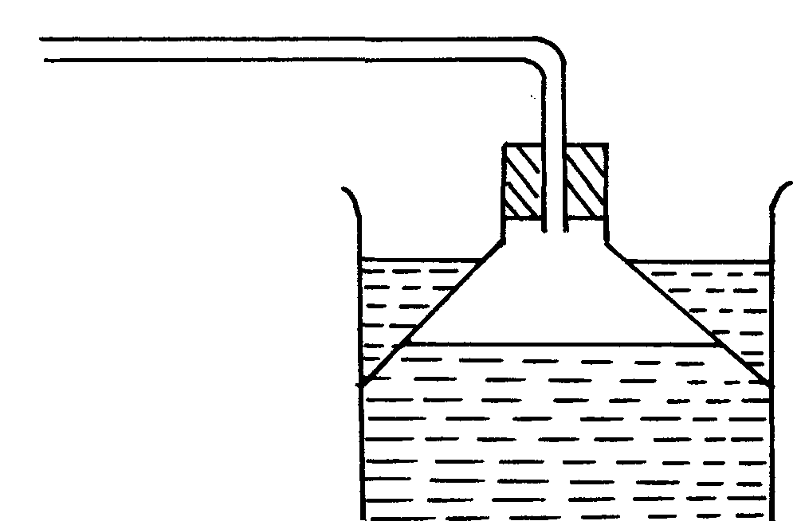
Inverted funnel
Trough
Water
HCl_{(g)}

(b) Ammonia gas *MAT

28. Mass of saturated soln. = 42.4 – 26.2 = 16.2
Mass of dry solid Y = 30.4 – 26.2 = ^{4.2g}/_{12.0}
Solubility of Y = 4.2 x 100
12.0
35g per 100g of water
(b) – Used is fractional crystallization of salt mixture.

29. (a) 24 -19 = 5g of substance K will be produced
Reason: Solubility decreases with increase in temperature
1
(b) Gaseous state
30. Deep red solution will be formed. Equilibrium shifts to the right/forward reaction is favoured since Fe³⁺ ions favours forward reaction.
 ½

31. a) They became a white powder
b) Efflorescency

32. a) calcium hydrogen carbonate/ magnesium hydrogen carbonate

b) Ca(LHCO₃) _{2(aq)} + Na₂CO_{3(aq)} ________ CaCO_{3(g)} + 2NaHCO_{3(aq)}

Mg(HCO₃)_{2(aq)} + Na₂CO_{3(aq)} ________ CaCO_{3(g)} + 2NaHCO_{3(a)}

c) Contains Ca2+ ions needed to harden teeth and bones

33. HCl g in water ionizes to produce H⁺ _{aq} and Cl – _{aq}
HCl _{(g)} in methylbenzene remain as moles hence no H⁺ ion

34. (i) Weak acid 1
(ii) Has few free H⁺ (Hydrogen) ions

35. (i) The reaction is too exothermic that alot of heat is produced causing ignition of
hydrogen in presence of oxygen
(ii) K_{(s)} + H₂O_{(g)} KOH_{(aq)} + H_{2(g)}
H_{2(g)} + O_{2(g)} H₂O_{(g)}

36. (i) Sample 1 and 2

(ii) Sample 2 contained ions that caused temporary hardness therefore required
large ( volume of soap solution before boiling, but after boiling the temporary hardness
was removed, hence requiring very little volume ( ½mk) of soap solution to lather.
37.- KOH has higher pH value than ammonia
 ½
- KOH is a stronger base; dissociates fully
 ½
- Ammonia solution is a weak base; dissociates partially
Energy changes in chemical and physical processes
1. (a) ∇H = 120 x 4.2 x 4.5 ( ½mk)
1000

= + 2.268KJ (½mk)

(b) RFM of KNO₃ = 39 + 14 + 48 = 101
6g 2.268KJ

101g 101 X 2.268 (½mk)
6

= +38.178KJ mol ⁻¹ (½mk
2. (i) Heat evolved when one mole of a substance is completely burnt in oxygen
(ii) RFM of C₂H₅OH = 46
 ½
Molar mass = 46g
Heating value = 1370 KJ
46g
 ½
= 29.78KJ/g (with units)
3. Ca(q) + C(q) + 3/2 O2 (g)
4. a) C₂H₆O_{(l)} + 3O_{(g)} ___________ 2CO_{2(g)} + 3H₂O

b) DH = MCDT
200 X 4.2 X 32.5 = -27.3Kj
1000
0.92g C₂H₆O __________ - 27.3Kj
46g “ __________ ?
46g X 27.3Kj = -1365Kj
0.92
DHC C₂ HSO₄ = -1365Kj mol

5. i) U,V,Y,Z All the 4 or nay 3 exclusively correct penalize ½ mk if wrong answer
ii) YZ is/are included any 2 correct ½ mk

6. (a) 611-389 = +222KJ
 ½
(b) H = +222 – (611 – 100)
1
= -289KJ
 ½
(c) Exothermic reaction

7. 2C(s) + 3H₂(g) + ½ O₂ (g) ∆ Hf CH₃CH₂OH(l)
O₂
∆H₁
∆H₃
∆H₂

2CO₂(g) + 3H₂(g)

2CO₂(g) + 3H₂O(l)
∆ Hf + ∆H₃ = ∆H₁ + ∆H₂
∴∆Hf = ∆H₁ + ∆H₂ - ∆H₃ ^{√½}
= -393 x 2 + -286 x 3 +1386 ^{√1}
= -786 – 858 + 1386
= -1644 + 1386 ^{√1}
∆Hf = -258 KJmol⁻¹ ^{√½}

8. a) i) the yield of NH₃ would be lowered √ ½ any supply of heat makes NH₃ to decompose to
N₂ and H₂
ii)the yield of NH₃ would be increased
b)a catalyst accelerate the rates of both forward and reverse reactions equally√ ½ . Equilibrium
position is not affected by a catalyst√ ½

c)
N_{2(g)} + 3H_{2(g)}
2NH_{3(g)}
Reaction path
Energy
(KJ)
Catalysed reaction

9. a) Breaking of ‘C = C’ = +610 KJ
Breaking of ‘Br – Br’ = +193
803√
Formation of 2C – Br = -560
Formation of c-c +243 Kj
-346
- 103KJ√ 2 marks
b) Addition reaction/ halogenation √

10. H H
C = C + H – H H – C – C – H
H H H H
Bond breaking Bond formation
4 C-H – 4x410 = 1640 6C – H 6x410
C = C – 1 x610 = 610 = 2460
H – H – 1x436 = 436 C – C – 3 45
2686 2805
H = 2686 – 2805
= -119 Kj/Mol
11. (i) Graph
labeling -*TZM*
plotting – *TZM*
scale – *TZM*
line – *TZM*
total 5mks
(ii) Shown on the graph -*TZM*
(iii) Heat change = MCT
= 50 x 4.2 x 10.2
100
= 2.142kJ
(iv) RFM of KNO₃ = 39 + 14 + 48
= 101
H = 2.142 x 101 = -10.71Kjmol⁻¹
20.2

12. MCT = 100 X 4.2 X 6 = 2.52 Kj
1000
Moles of NH4NO₃ = 1.6 = 0.02 moles
80
If 0.02 mol _________ 2.52 Kj
1 mol ______________ 1 X 2.52 = +126KJ/ mol
0.02

13. a) 2 NaHCO_{3 (g)} ________ Na₂CO_{3(g)} + H₂O₍₁₎ + CO_{2(g)}

b) i) 2L_{(g)} + D_{2(g)} ________ 2LD_{(g)}
ii) Amphoteric oxide
iii) Element H has a giant atomic structure with strong covalent bonds throughout its
structure while D has simple molecular structure with weak Vander wall forces (2 m)
iv) - Used in advertising signs (Advertisements)
- Used in florescent tubes (Any two correct use)
v) C has a smaller atomic radius than B because it has stronger nuclear charge// more
number of protons which attract the outer energy level electrons more firmly (2 mks)
vi) 4L_{(s)} + O_{2(g)} _________ 2 L₂O_{(g)}
Moles of L = 11.5 = 0.5 moles
23
Moles of O2 = 0.5 = 0.125 moles
4
Volume of O₂ = 0.125 mol X 24 = 3 dm³

4L _{(s)} + O_{2(g}) __________ 2L2O_{(s})
If 4 x23g _______________ 24dm³
11.5g of L ________ 11.5 x 24 = 3dm³
4x23

14. (a) Drawn on the graph A = ½ mk
S = ½ mk
P = ½ mk
C = ½ mk

b) 32.5ºC + 1 Read from the student’s correctly plotted graph.

c) 20ºC + O.5 Line is extrapolated downwards from the student’s correct graph.

d) It is end point/ complete neutralization.
e) The reaction is exothermic hence as reaction proceeded more heat was produced.
f) Reaction was complete hence solution lost heat through radiation to the surrounding.
g) 10.2 cm³ + 0.1. Read from the student’s correct graph.

h) Moles = M x V
1000
= 10.2 x 4 √ ½ = 0.0408 moles √ ½
1000

i) Moles = M x V
1000

= 2 x 20 √ ½ = 0.04 moles √ ½
1000

j) HBr : NaOH
0.0408 : 0.04
0.0408 : 0.04
0.04 0.04
1 : 1
HBr_{(aq)} + NaOH NaBr_{(aq)} + H₂O(l)

k) ∆H = MC ∆t
= -30.2g x 4.2J x 16.3
g⁰c
= -2067.49J √ ½

Ans. in (h) = -2067.49 J.
∴ 1 Mole = 1 x 2067.49J √ ½ e.g. 1 x 2067.49
Ans in “h” 0.0408
= -Ans. e.g 50673.82 J mol⁻¹
Or 50.67382KJ mol⁻¹ √ ½

15. a)(ii) Max. temperature attained : 29⁰c
(iii) Temperature change o the reaction = (29-115)⁰c
= 14⁰c
Mass of NaOH used = (114.35 – 108 .15)g
= 6.2g

R.F.M of NaOH = 40g
Moles of NaOH used = 6.2 moles
40
= 0.155moles
(v) Heat released = Mass X Specific X Temperature
Heat capacity change

Mass of water used = (108.15 – 8)g
= 100.15g
∴ Heat released = 100.15 X 4.18 X 14 kj
1000

=100.15kj
0.155 moles NaOH 5.861 kj
1 mole NaOH 1x 5.861 kj mole⁻¹
0.155

= -37.8 kjmol⁻¹
(b) i) ΔH₃ and ΔH₄
ii) Condensation
iii) ΔH = ΔH₁ + ΔH₂ + ΔH₃ + ΔH₄
iv) Exothermic.

16. I – a – Latent heat of fusion is the heat change that occurs when one mole of a solid substance
changes into liquid at constant temperature.
- Latent heat of vapourization is the heat change that occurs when one mole of liquid
substance changes into gas at constant temperature.
b – BC – The liquid loses heat as it cools hence decrease in kinetic energy of the particles
- CD - The liquid changes to solid as temperature remains constant at freezing point.

II. (i) Scale – *TZM*
Plot – *TZM*
Line
(ii) Should be shown on the graph – if not shown penalize ( ½ mk)

(iii) Heat change = m x c x ΔT
Where m = (vol. of acid (20cm³) + volume of bas in (b) above) x 1g/cm³
ΔT-as read form the graph
(iv) moles of acid
Moles of base = 0.5 x volume in (b) above
1000
Mole ratio acid: Base = 1:1
Moles of acid heat change in (iii)above
1mole ?
Molar heat change = 1 x heat in (iii)
Moles of acid

17. Q = 40000 x 60 x 60 = 144000000c
 1
Mass of Al = 144000000 x 27
3 x 96500
= 13.43kg
 1

18. (a) (i) Contains methane which is a fuel or contains methane which can burn
(ii) Pass a known volume of biogas through Sodium hydroxide (Potassium hydroxide) solution to absorb Carbon (IV) Oxide. Measure the volume of remaining gas
 1
% = Volume of methane x 100
Volume of Biogas

19. a) No effect – Reaction is not accompanied by volume changes/ similar volumes of
reactants and products

20. a) – carbon IV Oxide;
- Sulphur IV Oxide;
- Lead;
(b) Availed low sulphur diesel/ availed unleaded petrol

21. (a) Heat change that occurs when one mole of hydrogen combines with one mole of hydroxide
ions. //Heat evolved when one mole of water s formed during reaction of H⁺ and OH⁻ ions
(b) HCl produces a higher temperature rise than oxalic acid;
HCl is a stronger acid than oxalic acid;

22. H₂O_{(l)} ΔH₂ H₂O_{(g)}
H_{2(g)} + ½ O₂(g)
ΔH₁

ΔH₃

 ½
ΔH₂ = - ΔH₁ + ΔH₃
= ΔH₃ – ΔH₁
 1
= -242 - ⁻286
 ½
 1
= -242 + 286
 1
= +44KJ/mol (No units of sign = ½mk)

23. (a) Chemical substance that burns to produce useful amount of heat.
(b) (i) Its cheap
(ii) Its readily available (½mk)
(iii) It burns slowly (½mk)
(iv) Does not produce poisonous gas. (½mk)

24. a) Metallic beaker would make most of the heat be lost to the environment
b) - Thermometer reading increased
- The reaction is exothermic

25. a) A substance that produce heat energy when burnt

b) 1. Availability
2. ease of transport

26. a) 1 mole Fe (56) required _____________ 15.4 + 354
= 396.5Kj
10,000 (10 kg) ____________ ?
10,000g X 369.5 Kj
56g

= 6596.285Kj
b) - 68Kj = - 34 Kj √ ½
2

27. a) ∆H₁ – Lattice energy 1
∆H₂ – Hydrogen energy 1
b) ∆H₃ = ∆H₂ + ∆H₁ 1
Reaction rates and reversible reactions
1. colour changes from red to blue
H₃O⁺ions and L⁻_{(aq)} ions which form red solution.
2. (a) ΔH₄ – latent heat of fusion
(b) ΔH₃ - is negative particles lose hat/process is exothermic/heat is given out (any )

3. a) H-H(g) + Cl – Cl (g) 2H – Cl
Bonds broken bonds formed
∣H-H = 435 KJ 2 H – Cl = 430 x 2
∣ Cl – Cl = 240 KJ. = 860 KJ.
Total = 675 KJ.
∆H_{R} = 860 + 675 ^{√½}
= -185KJ ^{√½}
b)
Energy KJ/mol

H₂(g) + Cl(g) ^{√½}
^{√½}

∆H = -185KJ ^{√½}
2 HCl

Reaction path. ^{√½} for both axes named.

4.
1MHCl
2MHCl
B
Volume of Hydrogen
in cm³
Time (secs)
C
 ½

- Graph should be less steeper showing lower reaction rate since HCl is less concentrated. ^{√½}
b) Graph flattens out at BC showing that all the magnesium has been used up, hence, no reaction is taking place ^{√½} and there is therefore no evolution of hydrogen gas. ^{√½} The volume of the gas, therefore, remains constant. ^{√½}

5. a) Pale yellow liquid is observed. ^{√1} Backward reaction is favoured since ^{√½} it is exothermic.
Dinitrogen tetra oxide liquefies^{√½} at very low temperature to pale yellow liquid.
b) Pressure increase, and favours backward reaction ^{√½} which is at lower pressure; hence
equilibrium shifts to the right. ^{√½}

6. a) Mg(s) + 2 HCl(aq) MgCl₂(aq) + H₂(g) √1
b)
Volume of gas (cm³)
Volume of 2M HCL cm³
0
100
200
300
400
5000
6000
7000
10
20
30
40
50
60
70
80
A ½
S ½
P ½
G ½

c) (i) Showing on the graph. √½ Answer √½
X
(ii) Showing on the graph. √½ Answer √½
d) i) The rate of reaction increases. √1
The surface area of particles has been increased √½ thus increasing the area √½ of
contact of the reacting particles.
ii) The rate of reaction increases. √1
Increase in temperature results in crease in the kinetic energy of the particles. This makes
the particles move faster and collide more frequently with sufficient energy to cause more
effective collision per given time. √1

7. I a) Drawn on graph paper A = ½ mk
S = ½ mk
P = 1 mk
C = 1 mk
b) Rate of evolution of hydrogen gas increases with increase in length of magnesium ribbon.

c) Read from the student’s graph. 1 mk – showing on graph
1 mk – for answer.
d) Shown on the graph paper.

II a)(i) Curve I Reason: F increases as E decreases.

(ii) Equilibrium is achieved.

8. Q = 40000 x 60 x 60 = 144000000c
 1
Mass of Al = 144000000 x 27
3 x 96500
= 13.43kg
 1

9. a) Hydrochloric acid is a weaker oxidizing agent which cannot oxidize copper to form
Nitrogen (VI) Oxide gas
b) It increases √ 1 mark
Molecules/ particles acquire the necessary activation energy// Kinetic energy. This
increases the frequency of collisions hence the rate of reaction √ ½ mark
c) Graph - Scale 1 mark with axis well labeled
- Plotting + all points correct 1 mark
5 correct points ½ mark
Less than 5 points 0 mark
Correct smooth curve 1 mark
TOTAL 3 marks

d) i) 360cm³ Read correct value from graph + .05
-
ii) 40cm³ = Value from graph + .05
-
Read where it levels off

10. (a) 260 – 85 = 175 = 87.5cm₃/mn;
2 2
(b) 4 ½ min;
(c) Zinc was used up / H₂SO4 used up;

11. (a) Platinum / Platinum Rhodium
(b) Pressure -9atm ( ½ mk)
Temp – 700ºC – 900ºC ( ½ mk)
(c) Reaction is exothermic

12. (a) (i) Will increase;
(ii) Decrease;
13.
- Dissolve solid^{√ ½} YSO₄ to obtain^{√ ½} YSO₄ in solution,
- Dissolve ^{√ ½} X(NO₃)₂ in water to obtain ^{√ ½} X (NO₃)₂ solution. 3
- Mix the two above solutions
- Filter to obtain XSO₄ solid residue, rinse with water and dry by heating^{√ ½}
- under asbestos pad.

14. R_{(s)} + S²⁺_{(aq)} R²⁺_{(aq)} + S_{(s)} √1 (1 mk)
E.m.f = 0.47 – (-2.04)
= -0.47 + 2.04 2
= 1.57V √1 (1 mk)

15. (a) – Water level rises. √1 (1 mk)
Grey Iron wool changes to brown. √1 (1 mk) 3 (any one of these scores)
(b) – Oiling and greasing. √1 (1 mk)
- Painting.

16. (a) L is more ionized √1 than K hence reacts faster √1 producing higher
volume of a gas. Or L is a stronger acid therefore ionized faster than K a weaker acid 3
(b) Increasing the temeprature√1 using zinc powder/increasing the concentration of acid.

17. Energy of reaction = Bond breakage + Bond formation. √1
Bond formation = Energy of reaction – Bond Breakage
= -287 – 931 √1 3
= - 1218 K Joules per mole. √1 (3 mks)
18. – No effect on the position of the equilibrium
 1
- RXM is neither endothermic nor exothermic hence not affected by changes in temperature
enthalpy is zero.

19. (a)
 1

21. a)the minimum energy required by the reaction particles to cause a successful collision
to form product
b)i)
Ground compound x₁
Un ground compound x₁
½
Vol. of CO₂
(cm³)

½

NB. I) Sketch curve should be to the left and both flatten not at the same final volume
ii)curve is stop to the left due to the size of particles of ground compound x is reduced,√ ½ increasing surface area√ ½ of the particles thus increasing area of contact of
22 At equilibrium there will be very little of T that has reacted.√1At equilibrium there will be a lot
of T and very little V produced hence equilibrium lies to the left or forms the reactants√1

23. - CB₂
- Ionic bond

24. - Intensity of red-brown fumes increases.
- High temperature vapourizes liquid nitrogen tetra-oxide to form nitrogen (IV) oxide that
is red-brown.

25. a) Curve 1

b) After sometime, the rate of formation of CaCL₂ or rate of depletion of CaCO₃ become to low
that cant be evaluated

26. a) Equilibrium shifts o the left, more CO₂ formed
(Increase in pressure favors reaction producing fewer molecules)
b) Equilibrium shifts to the left, more CO_{2(g)} formed

27. The solution turns yellow. Equilibrium shifts to the left when NaOH is added, the
OH – ions react with H⁺ ions forcing more of cr2 O⁷²⁻ and H₂O to react forming more
H⁺ and crO4²⁻ ions the reaction particles causing higher rate of reaction and twice shorter time√ ½

28. (i) B ; The acid had higher concentration (½mk)
(ii) The rate of reaction is initially high (½mk) because of high concentration
of the reactant but decreases ( ½mk) steadily as the concentration also decreases.
29. Yellow/brown colour of bromine water ((½mk) fades or becomes colourless because
sodium hydroxide solution provides OH⁻ ions which reacts with H⁺ ions to form water ( ½mk)
shifts the equilibrium to the right


Electrochemistry
1. i) Carbon – carbon/ platinum – carbon
ii) - The concentration of magnesium sulphate increase
- Hydrogen and oxygen given off at the electrodes reduce the water content
2. Cu²⁺ + 2c- __________ Cu_{(s)}
Mass =
1.48 = 63.5 x I x 2.5 x 60
2 x 96500

I = 1.48 x 2 x 96500
63.5 x 2.5 x60
= 29.988 A
3. a) Anode is electrode A (1 mk)
B is cathode
b) 2H⁺ _{(aq)} + 2e- _________ H_{2 (g)}

c) The acid becomes more
4. i) 200 X 58 X 60 C _______________ 64.8g √ ½
9500C ____________________ 27g√ ½

27 X 200 X 58 X 60 √ ½ = +3 √ ½
64.8 X 96500

ii) 40H-_{(g)} __________________2H₂O_{(L)} + O²_{(g)} +4e⁻ √ ½

4 X 96500 ________________ 22.4dm³ √ ½

200 X58 X 60 X 22.4
4 X 96500 C
= 40.39dm³ √ ½
5. a) Mg_{(s)} + Pb²⁺_{(aq)} ________ Mg²⁺ _{(aq)} + Pb_{(s)}

b) 0.13 – (-0.76)
= +0.53V
6. (a) 2F = 10 ⇒ 2F – 10 = 0; 2F = 10 ∴F = +5
1
F = +5 (penalize -5)
1
(b) Group V

7. Aluminium has a higher electrical conductivity than sodium. ^{√1} Aluminium has three
delocalized ^{√½} electrons in its metallic structure while sodium has only one delocalized
electron in its structure. ^{√½}

8. Q = It ^{√½}
= 3 x 50 x 60 ^{√½}
= 9000 C ^{√½}
1 mole of Zn is liberated by a charge of 2 f.
i.e 96500 x 2 x 65g of Zn
9000C ?
= 65 x 9000 ^{√1} = 12.124g Zn ^{√½}
96500 x 2

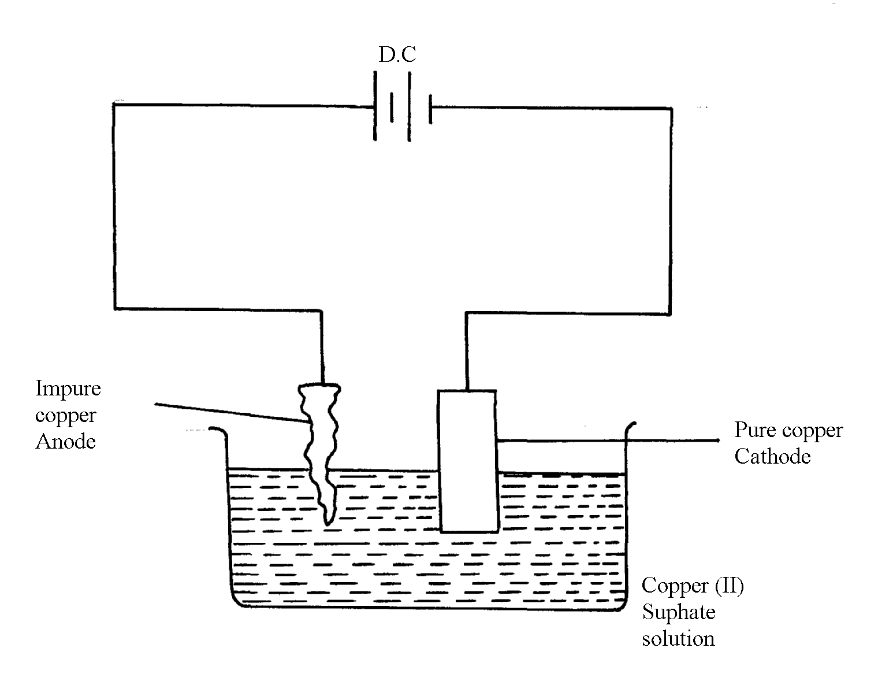
9. a) Q is sulphur (IV) oxide SO₂(g). ^{√1}

b)

- Impure copper is the while pure copper is cathode. During electrolysis impure copper is
purified and pure copper deposited on the cathode as shown in the half electrode reaction below;
CATHODE EQUATION:
Cu²⁺ + 2e Cu(s) ^{√½}
- The cathode is therefore removed and replaced after an interval.

10. a) i) the yield of NH₃ would be lowered √ ½ any supply of heat makes NH₃ to decompose
to N₂ and H₂
ii)the yield of NH₃ would be increased
b)a catalyst accelerate the rates of both forward and reverse reactions equally√ ½ . Equilibrium position is not affected by a catalyst√ ½
c)
N_{2(g)} + 3H_{2(g)}
2NH_{3(g)}
Reaction path
Energy
(KJ)
Catalysed reaction

11. a)T√
b)Z_{S} + 2G⁺ 2G_{(S)} + Z_{(aq)} ²⁺√1
c)E^{θ} cell = E - E
= 0.08 – (-2.38)√1
= + 3.18

12. Mass of due to C = 12 x 4.2 = 1.145√ ½
44

Mass of due to H = 2 X 1.71 = 1.889√ ½
18

Moles of C = 1.145 = 0.095√ ½
12
Moles of H = 0.1889 =0.1889√ ½
1
Moles ratio c: r
0.095: 0.1889√ ½
1: 2
E.F = CH₂√ ½ (accept alternative method)

13. 96,500 coulombs 1 faraday
144,750 ,, ?

144,750 faraday√ ½
96,000
= 1.5 faradays√ ½

Copper (II) ions = 2 faradays (penalize ½ mk for missing/wrong units)
2 faradays yield = 64g of copper
1.5 faradays yield = ?
= 1.5 x 64g√ ½
2
=48g of copper was obtained√ ½

14. Physical difference:-
Na₂O₂ – yellow while Na₂O is white
Chemical difference:-
 1
N₂O₂ reacts with water to form NaOH and O₂ while
 1
Na₂O reacts with water to form NaOH only

15. (a) Pb(NO₃)₂
(b)
(c) Mg_{(s)} / Mg²⁺ _{(aq)} // Pb²⁺ _{(aq)} / Pb_{(s)}

16. (a) MnO₄ is reduced;
Oxidation number of Mn is reduced from +7 to +2
(b)5Fe²⁺_{(g)} 5Fe³⁺_{(aq)} + 5e₋;

17. i) 2 Cr_{(S)} ____________ 2Cr³⁺_{(aq)} +6e

3Fe²⁺ _{(aq)} + 6e ____________ 3Fe_{(g)}

2Cr_{(g)} + 3Fe²⁺_{(aq)} _________ 2 Cr³⁺_{(aq)} +3 Fe _{(g)} √

ii) 0.30 = - 0.44 - E^{ǿ}_{R}
E^{ǿ}_{R} = - 0.44 – 0.30
= - 0.74V √

18. (a) – Filtration of air/electrostatic precipitation/purification
 ½
- Passing through sodium hydroxide/potassium hydroxide to absorb Carbon (IV) oxide gas
- Cool to remove water vapour as ice
 ½
-Cool remaining air to liquid by repeated compression and expansion of liquid air
 1
 1
- Fractional distillation of liquid air- Nitrogen collected at -196ºC
(b) (i) Nitrogen (II) Oxide
-3
+2
0
0
Reduction
Oxidation
(ii)
NH_{3(g)} + CuO_{(s)} N_{2(g)} + H₂O_{(l)} + Cu_{(s)}

OR - Oxidation number of N₂ in NH₃ increases from -3 to 0. Oxidation number of reducing
agent increases or oxidation number of Cu in CuO decreases from +2 to 0 hence is a reducing agent

(iii) NH₄NO₃ N₂O + 2H₂O
(iv) Fertilizer/expose
(c) (i) G or G
(ii) E²⁺_{(aq)} + 2OH⁻_{(aq)} E(OH)_{2(s)}

19. a) i) G// G_{2(g)} Not G⁻
It has the highest potential OR highest reduction potential √ 1 mark
ii) G and N or G_{2(g)} // N_{(g)} √ 1 mark
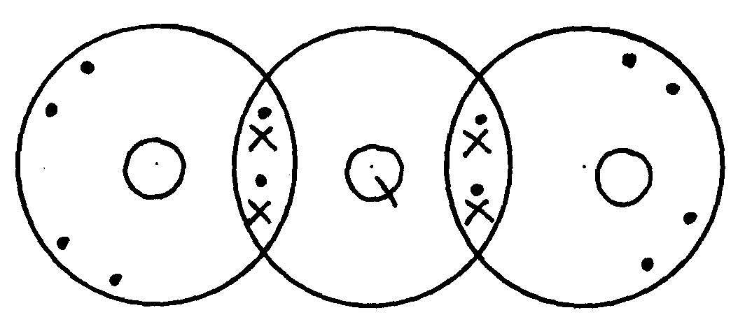
iii)

20. a) (i) Cathode – steel
Anode – Carbon / graphite
(ii) To lower the melting P⁺ hence reducing cost of heating the salt.
(iii) To prevent the two products from recombining.
(iv) Cathode
Na⁺_{(l)} + e⁻ Na_{(l)}
Anode
2 Cl⁻_{(l)} Cl 2_{(g)} + 2 e-
(v) less dense than electrolyte/ has low density
b) (i) quantity = 6.42 X 10 60 = 3852
(ii) 3852c province 2.74
2X 96000 “ (2 X 96000) X 2.74
3852
= 136.58

21. .a) i) H⁺_{(aq)} + e⁻ ½ H₂

ii) E cell = 0.76 + 0.54 = +1.3 volts

iii) I. Fe³⁺
II. Zn
IV. Fe³⁺ ion
2 Fe³⁺ + 2 e⁻ 2 Fe²⁺ E⁰ = + 0.77
2 I I_{2g} + 2e E⁰ = - 0.54
_{(aq)}
_{(aq)}
_{(aq)}
2 Fe³⁺ + 2I⁻ 2Fe²⁺ + I ₂ E⁰ = + 0.23

22. a) i) Chlorine Has a higher reduction potential
ii) +1.36 2.36 = +3.72

b) i) P and S
ii)
iii) +1.50 – 0.44 + + 1.94

c) Q = 4 X a6 X 60 = 3840C
1.17g ________ 3840
59 g _________ 59 X 3840 = 192981.261 C
1.174
If 96,500c ___________ IF
192891.261 _____ 192981.261 X 1
96500
Charge of X = +2
Formula X(NO₃)₂

23. (a) B – Copper metal
C – Chlorine gas
D – Ammmonia gas
E – Zinc
(b) (i) Cu²⁺_{(aq)} + 2e⁻ Cu_{(s)}
(ii) CuSO₄ + Zn_{(s)} ZNSO₄ + Cu_{(s)}
Cu²⁺ + Zn_{(s)} Cu_{(s)} + Zn²⁺_{(aq)}

(c) – Water treatment
-Manufacture of hydrochloric acid
(d) Tetra mine copper (II) ions

24. (a) (i) E^{θ} = 1.13V

(ii) T₂ because it’s standard electrode potential is zero. i.e. point of reference.
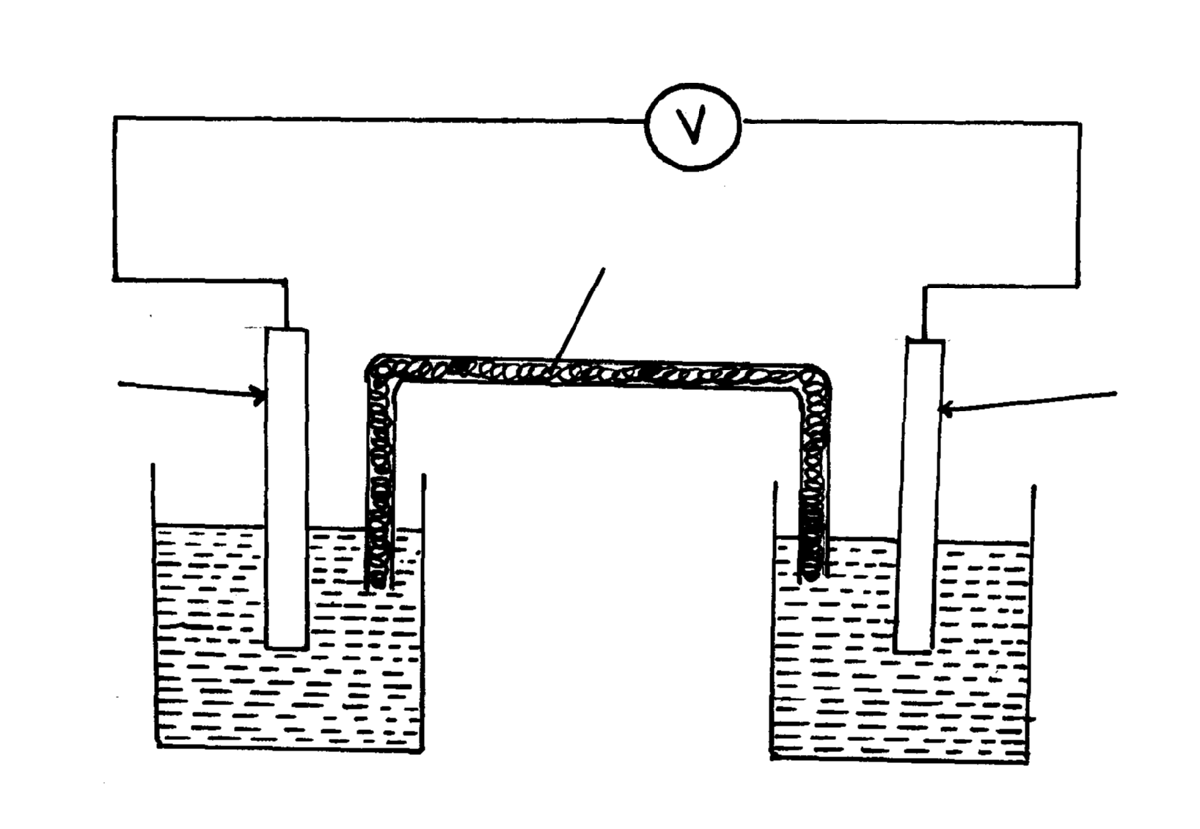

(iv) E.m.f = + 1.23 - - 0.76 = 1.99 V

(b) (i) x - Oxygen
y – Hydrogen

(ii) 4OH⁻_{(aq)} 2H₂O + O₂ + 4e

(iii) Reduction takes place at electrode Y. H⁺ ions gain electrons to form hydrogen gas.

(iv) Platinium / graphite/ Nickel because it is inert.

25. (i) Zn²⁺_{(aq)} + 2OH⁻_{(aq)} Zn(OH)_{2(s)}
Zn(OH)_{2(s)} + 4NH_{3(aq)} Zn(NH₃)4 ²⁺_{(aq)} + 2OH⁻_{(aq)}
(ii) The mixture consists of a soluble compound and an insoluble compound.
(iii) Evolution brown fumes of NO₂ gas
(iv) CO₃²⁻ - Because its reaction with HNO₃ produces CO₂ gas or 2H⁺_{(aq)} + CO₃2-_{(aq)} H₂O_{(l)} +CO_{2(g)}
(v) Pb²⁺ ion
(vi) Lead (ii) Carbonate
Zinc (II) Nitrate
26 A (i) Process by which an electrolyte is decomposed by passing an electric current through it.
(ii) Anode – left pt rod
Cathode – right pt rod
(iii) – Blue /pale green colour fades
- P solution becomes acidic

B (i) a. – D²⁺
b. – D²⁺
(ii) C
E _{cell} = E_{ordn} – E_{ordn}
= +0.34 –(-2.92) = +3.26V
(iii) B_{(s)} / B²⁺_{(aq)} // D²⁺_{(aq)} / D(_{s)}; E = + 3.26V

27 Q = 40000 x 60 x 60 = 144000000c
 1
Mass of Al = 144000000 x 27
3 x 96500
= 13.43kg
 1
28. a) Strip of copper metal dissolved forming blue solution. ^{√½}
b) Copper displaces ions ^{√½} of Q from solution since copper is more electropositive ^{√½} than Q.
c) E.m.f of cell = (0.80 - 0.34)V ^{√½}
= 0.46V ^{√½}

29 (a) (i) Carbon (IV) Oxide gas evolved was lost to the atmosphere
(ii) Concentration of reactants higher between O and R
Reaction rate faster
(iii) Grinding the marble chips
(iv) Calcium sulphate
(v) Plaster of Paris

(b) (i) Hydrogen ions discharged;
It takes less energy than calcium ions
(ii) 2Cl⁻_{(aq)} Cl₂ _{(g)} + 2e
(iii) Q = 1t = 4 x 1 60 x 60 ( ½ mk)
= 14400C
2 x 96500C = 2 x 35.5 (½mk)
14400C = 14400 x 2 x 35.5
2 x 95600 = 5.297g (½mk)

30. a) the bulb light√ ½
Hydrogen chloride gas ionized in water to give H⁺ and cl⁻(aq) that are responsible for
conduction of electric current√1
b)2H⁺(aq) +ze⁻ H₂(g)√1

31. Q = it IF = 69500C 2F ______ 206g of Pb
= 40x(5x60) = 1200x1 F = 0.01243 x 206
= 1200 C 96500 2F
= 0.01245 F = 1.280g
b) I K_{(s)} ________ K²⁺ _{(aq)} + 2e⁻

Na+ 2e ________ N_{(g)}

II 1. Salt bridge

2. Complete the circuit
Balance the ions in each half cell
III
IV E cell = E Red – E oxd
= +1.16 – (-0.17) = +1.33V
32. (a) (i) Zinc sulphate / Zinc chloride / Zinc nitrate solution
(ii) Copper
(iii) Zn_{(s)} + Cu²⁺_{(aq)} Zn²⁺_{(aq)} + Cu_{(s)}
(iv) E = 0.34 + 0.76
= 1.0V

. (b) (i)Concentrated sodium chloride solution
(ii) 2 Cl⁻(aq) Cl_{2(g)} + 2e
Na⁺(aq) + e N_{(l)}
(iii) Sodium amalgam is flown into water. It reacts forming sodium hydroxide solution

33. Quantity of electricity = (40,000 X 60 X 60) Coulumbus √ ½ mark
3 x 96,500 Coulumbus produce 27g of Al

჻ 40,000 X 60 X 60 X 27 Kg √ ½ mark
3 X 96,500 X 1000 √ ½ mark
= 13.43Kg √ ½ mark
Subtract ½ mark if units missing or wrong
[Total 12 marks]
34. i) Increased yield of NO/ √ 1 mark Equilibrium shifts to the right // favours the
forward reaction// reduced pressure favours forward reaction// increased volume
number of molecules
ii) It will not affect the yield // remains the same
Catalyst do not affect position of Equilibrium
35. a) R
b) T
c) i) T_{(g)} and S_{(g)}

ii) Half cell one Half cell two
T(s) – 2e-____ T2+ S2+(aq) + 2e _____ S(s)
OR: T(s) ____ T2+_{(aq)} + 2e-

iii) T_{(s)} _______ T²⁺ _{(aq)} + 2e, E = +0.74V

iv) From T(s)/ T2+ half cell to S2+/ S(s) half cell through conducting wires

d) i) Q = It
= 2.5 x (15x60)
= 2250C

ii) RAM = mass x valency x 96500
Q
= 0.74 x 2 x 96500
2250
= ¹⁴²⁸²⁰/₂₂₅₀
₌ 63.476
36. a) R
b) T
c) i) T_{(g)} and S_{(g)}

ii) Half cell one Half cell two
T(s) – 2e-____ T2+ S2+(aq) + 2e _____ S(s)
OR: T(s) ____ T2+(aq) + 2e-

iii) T_{(s)} _______ T²⁺ (aq) + 2e, E = +0.74V

iv) From T(s)/ T2+ half cell to S2+/ S(s) half cell through conducting wires

d) i) Q = It
= 2.5 x (15x60)
= 2250C

ii) RAM = mass x valency x 96500
Q
= 0.74 x 2 x 96500
220
= ¹⁴²⁸²⁰/₂₂₅₀
₌ 63.476
37. NH⁺₄√ 1, proton donor√
38. a) - Bubbles of colourless gas at the anode√ ½
- Brown deposits at the cathode √ ½
- Blue color of the solution fades Any 2 ½ mark each

b) The Ph decreases
Removal of OH⁻ ions leaves an excess of H⁺ hence the solution becomes more acidic√
39. a) Anode. Copper anode dissolves
b) Q = 0.5 X 60 X64.3 = 1929C
0.64g of Cu _______ 1929 C
჻ 63.5 of Cu
63.5 X 1929√ ½
0.64
= 191393 C √ ½

40. The grey-black solid changes to purple gas iodine sublimes at low temperature due to
weak Van der walls forces

41. (a) The mass of substance liberated during electrolysis is directly proportional to the quantity
of electricity passed
(b) Quantity of electricity = 2 x 2 x 36000 = 14400c (½mk)
Volume of gas evolved = 14400 x 22.4 = 1.671dm³
2 x 96500 (1 ½ mk)
42. (a) OH⁻ √1 (1 mk)

43. (i) ZnS- No mark if the letters are joined
(ii) SO₂ produced as a by-product is used in contact process to obtain H₂SO₄. This acid is used in making fertilizers e.g. ammonium sulphate
1

44. (i) CaO is basic and P₄O₁₀ is acidic
(ii) Let the ON of P be x
4x + (-2 x10) = 0
4x = +20
4 4
 ½
x = +5
1
(iii) Used as a fertilizer
1

45. Platinum electrode is used, H₂ is bubbled over the pt electrode immersed in 1M H+ i.e 1M HCl.
 1
The electrode is coated with finely –divided platinum catalyst

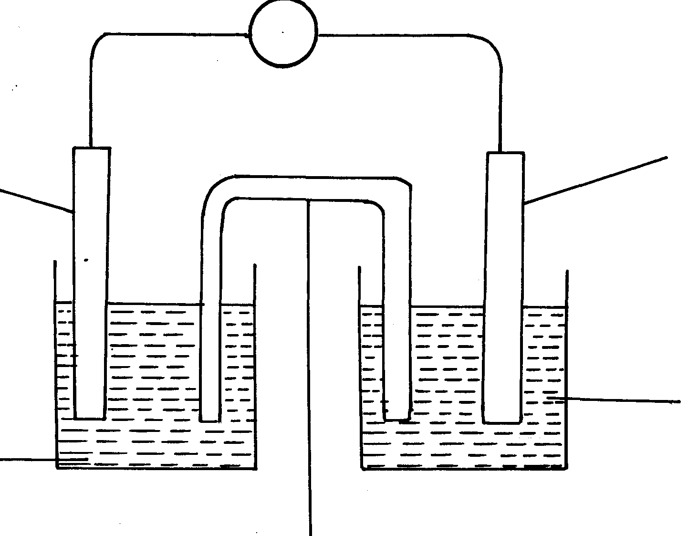
(b)electrochemical cell
V
(½mk)
C_{(s)}
M_{(s)}
(½mk)

C² _{(aq)}
(½mk)
M²⁺_{(aq)}
(½mk)
46. + 0.76 + 0.34 = 1.0Volts
47. (a) - Red- Phosphorous
- White – Phosphorous
(b) Phosphorous is insoluble in water because its non-polar while water is polar.
It cannot be stored in oil because oil is non-polar it will dissolve the phosphorous.
48. (a) 2X_{(s)} + 3W(aq) 2X³⁺_{(aq)} + 3W_{(s)}

(b) E^{θ}(X/X³⁺_{(aq)} + - 0.44 = 0.3V

E^{θ}(X_{(s)} /X³⁺_{(aq)} = +0.74V
H H H H H H H H

H – C – C – C – C – C – C – C – C - H

H H H H H H H H
E^{θ}(X³⁺_{(aq})/X_{(s)} = -0.74V

 ½
 ½

Salt bridge

49. Electrode - E₁ is the anode
Dilute electrolyte – OH⁻ ions are discharged.
4 OH⁻_{(aq)} 2H₂ O_{(e)} + O_{2(g)} + 4e⁻
Oxygen gas is produced.
Discharge of hydroxyl ion increases the concentration of sodium chloride.
Chloride, Cl⁻ are then discharged.
Chloride, Cl-, are then discharged
Chloride gas is produce
2Cl⁻_{(aq)} Cl_{2(g)} + 2e⁻

50. a) C10₃⁻ (=) Cl + 3(-2) = -1(=)Cl -6 =-1,Cl= + 5

⁺⁵
⁰
C10₃⁻ _{(aq)} 6H⁺_{(aq)}+5e⁻ Cl_{2(g)}+ 3H₂O_{(l)}

b) NO⁻₂ (=) N+2 (-2) = -1(=) N-4 = -1 (=) = N+ 3
⁺³
⁺⁵

NO⁻₂ +H₂O_{(l)} NO⁻_{3(aq)}+2H⁺_{(aq)} + 2e⁻

51.
Half Cell E^{θ}/_{V} | E^{θ}/_{V} using iron ref - electrode
Al_{(s)} /Al³⁺_{(aq)} - 1.66 | - 1.22
Zw_{(s)} / Zn²⁺_{(aq)} - 0.76 | +0.32
Fe _{(s)}/Fe ²⁺_{(aq)} - 0.44 | 0.00
Ni_{(s)} /Ni ²⁺_{(aq}) - 0.25 | + 0.19

52. θ = 1.5 X 60 X 15 = 1350
J³⁺_{(aq)} + 3e⁻ J_{(s)}
3F = 3 X 96500 = 289 500C
289500C deposit = 52g of J_{(s)}
= 1350 C deposit = 1350 X 52
289500 = 0.2 2425g

53. Tin (Sn) its oxidation potential is +0.144V. It is the least likely to combine/ react with elements
of weather

5. Metals
1. a) chlorine gas would react with steel anode
²⁴
¹¹

Na

Na
b) Hood and steel gauze prevent chlorine sodium, from anode and cathode from mixing
and reacting.
- Sodium metal is less dense, floats on motten brine where it is siphoned out.
c) -To Whom It May Concern: melt the ore, rock salt
- For electrolysis of the molten ore
2. a) SO_{2(g)} is produced as a by- product, this mixes with rain water producing acid rain which
may corrode buildings and affect plants √ ½
SO_{2(g)} is poisonous when inhaled √ ½
b) - H₂SO₄ manufacture – to make use of SO_{2 (g)}
- Manufacture of dry cells – make use of zinc
- Production of iron sheets which are galvanized using zinc (Any one with an explanation)
c) Low density, does not corrode easily, duchle, malleable (Any 2 each ½ mark)
3. Aluminium is lighter/low density. (any)
 1
It is a good conductor of electricity
4. Stage 1 – oxidation; Coke is oxidized to CO
 ½
 ½
Stage 2 – Reduction: zinc is reduced to Zinc metal
 ½
 ½
Stage 3;- Recycling stage; CO₂ is reduced to regenerate CO

5. a) Q is sulphur (IV) oxide SO₂(g). ^{√1}

b)

- Impure copper is the while pure copper is cathode. During electrolysis impure copper is purified and pure copper deposited on the cathode as shown in the half electrode reaction below;
CATHODE EQUATION:
Cu²⁺ + 2e Cu(s) ^{√½}
- The cathode is therefore removed and replaced after an interval.

6. (i) I-I-I-tetrachloromethane /Tetrachloromethane
(ii) Chloric (I) acid
 1

7. Oxide of W has simple molecular structure while that of Z has giant ionic structure

8. (a) Froth floatation. √1 (1 mk)
(b) PbCO_{3(s)} PbO_{(s)} + CO_{2(g)} (1 mk)
(c) Making of pipes/lead acid accumulators. √1 (any one) 3

9. a) bauxite√
b) Copper pyrites √

10. i)
ii) I It’s uneconomic// Expensive// a lot of energy is required to produce this
high temperature
II Addition of cryolite √ ½ mark

iii) The melting point is below 800 C √ ½ mark
11. (a) (i) Bauxite
(ii) Iron (III) Oxide
 1
Silica (any one)
(b)(i) On the diagram
 1
(ii) It is expensive /a lot of energy will be used
 1
(iii) The ore is dissolved in cryolite (NaAlF₆)
12. (i) Bauxite – Al₂O₃. H₂O
(ii) Iron II oxide
- Silica
(iii) Being ionic, it is only an electrolyte in its molten state. Heating helps to melt it.
(iv) (a) – The two rods represent the anode.
- Cathode is the inner lining of the wall.
(b) As an impurity, lowering the melting point of aluminium oxide.
(c) Anode 2O₂-(l) O_{2(g)} + 4e⁻
Cathode Al³⁺ + 3e⁻ Al_{(l)}
d) – manufacture of household utensils
- making cables for electricity transmission
- making foils used as wrappers
- extraction of some metals e.g. manganese
- Making aeroplane parts

Describe how you would establish the presence of copper in the ore
13. (a) CuFes₂
(b) Froth floatation
(c) 2CuFeS_{(s)} + 4O₂ _{(g)} + Cu₂S + 2FeO_{(s)} + 3SO_{2 (g)}
(d) Silica is added which reacts with iron (II) Oxide to form iron (II) silicate which forms
part of slag or SiO₂ is added

(e) Anode Cu_{(s)} Cu²_{+(aq)} + 2e⁻
Cathode Cu²⁺_{(aq)} + 2e- Cu_{(s)}

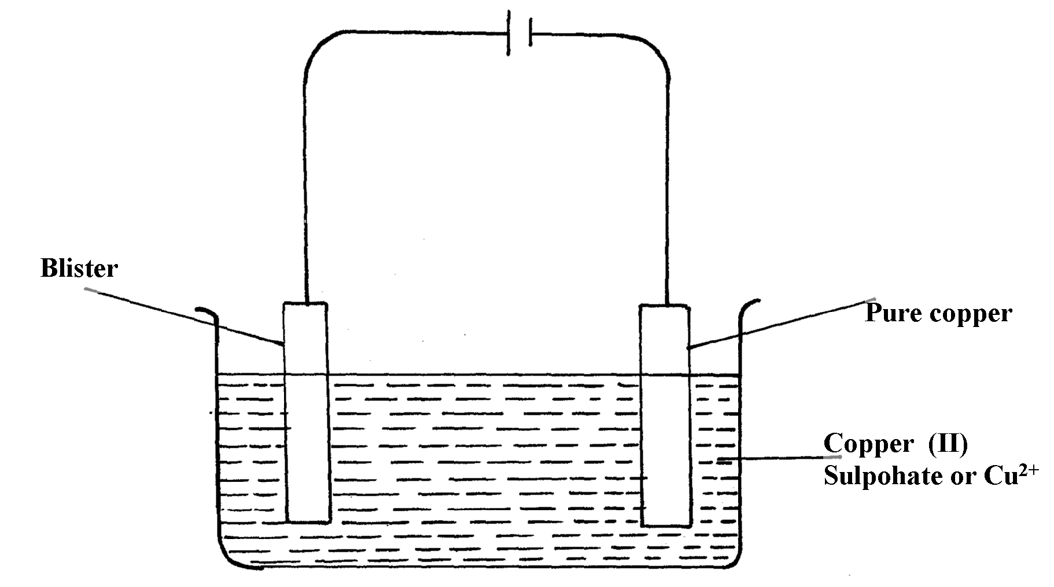

(g) – Add HNO₃ to the ore
- Filter and place small portion of the filtrate into a test tube
Add NH₄OH until in excess – deep blue solution confirms the presence of Cu²⁺ions
14. (a) (i) Gas Q- Carbon (II) Oxide
(ii) Liquid R- dilute sulphuric acid
(iii) Residue S – excess Zinc metal

(b) Zinc blende

(c) (i) To increase percentage of Zinc in the ore
(ii) The ore is crushed, mixed with water and oil and then air is blown into the mixture.

(d) (i) 2ZnS_{(s)} + 3O_{2(g)} ZnO_{(s)} + 2SO_{2(g)}
(ii) Zn_{(s)} + H₂SO_{4(aq)} ZnSO_{4(aq)} + H_{2(g)}

(e) (i) - Lead (II) sulphate //Pbs
- Silica //silicon (IV) oxide// SiO2
(ii) Lead (II) sulphide
2PbS_{(s)} + 3O_{2(g)} 2PbO_{(s)} + 2SO_{2(g)}

(f) (i) 45 x 250000
100
= 112,500g of ZnS

(ii) Rmm of ZnS = (65.4 + 32) – 97.4g
From the equation
The mole ration of Zn of ZnS: SO₂ = 1:1
97.4g of ZnS = 24dm³ of SO₂ at r.t.p
112,500g of ZnS = 112,500 x 24
97.4
= 27,720. 73920dm³ of SO₂

15. a) i) Zinc Blende (Penalize for formula only)
ii) Lead II Sulphide

b) It is concentrated by froth floatation where the ore is crushed or ground, a detergent
added and the mixture agitated. Zinc sulphide floats and is collected

c) 2ZnS_{(g)} + 3 O_{2(g)} __________ 2 ZnO_{(g)} + 2SO_{2(g)}

d) Zinc oxide is reduced by both carbon and carbon (ii) Oxide to zinc vapour. Lead (ii) Oxide is
also reduced by both carbon and carbon (ii) Oxide to lead liquid

Accept equations
ZnO_{(g)} + C_{(s)} ___________ Zn_{(g)} + CO _{(g)}

ZnO_{(g)} + CO_{(g)} __________ Zn_{(g)} + CO_{2(g)}

PbO_{(g)} + C_{(s)} ____________ Pb_{(L)} + CO_{(g)}

PbO_{(s)} + CO _____________ Pb_{(L)} + CO_{2(g)}

e) W = Sulphur (vi) Oxide // SO_{3(g)}
M= Conc. Sulphuric (Vi) acid // H₂SO_{4(L)}

f) H₂S₂O_{7(L)} + H2_{O(L)} ___________ 2H₂SO_{4(L)}
g) The process is highly exothermic and heat produced boils the acid leading to acid mist
which cannot be condensed easily because it is highly unstable
h) The sulphur (iv) Oxide dissolves in water to form acid rain which corrodes buildings and
affects aquatic life
16. (a) Purification and concentration.
(b) (i) Bauxite
(ii) Iron (III) Oxide /Silicon (IV) Oxide
(c) On diagram
(d) Lowers the melting point of the ore from 2015⁰c – 900⁰c.

17. ) Q = It = 3 x 10 x 60 = 1800
3F = 3x 96500c = 27g
∴1800c = 1800 x 27
3 x 96500
= 0.16788g

18. a) Zinc blende

b) i)
I- carbon IV oxide
II – Dil sulphuric acid
III – unreacted zinc

ii) To reduce zinc oxide to zinc metal

iii) Silica

iv)
I 2ZnS + 30 ________ 2ZnO(s) + 250 2(g)

II 2ZnO(q) + C(g) ________ 2Zn(q) + CO2(g)

v)Zn(g) + H2SO4(aq) ________ ZnSO4(aq) + H2(g)

vi) 45/100 x 250 = 112.5x1000 = 112500g
= 112.5 Kg

vii) – Used to make brass
- Used to make electrodes in dry cells
- Galvanize iron sheets

19. a) i) - Effervescence, a colorless gas is produced
- Grey solid dissolves, a colorless solution is formed
ii) Nitric acid is a strong oxidizing agent. It will oxidize the hydrogen gas formed to
form water instead

iii) I Zn_{(g)} + 2HCl_{(aq)} _________ ZnCl_{2(aq)} + H_{2(g)}
II Moles of Zn = 0.5g = 0.007692
65.0
Moles of HCL = 0.007692 X 2 = 0.015384
3 moles of HCl has 1000 cm³
0.015384 moles has 0.015384 X 1000cm³
3
= 5.182cm³
20. (a) P – Chlorine ( ½ )
Q – Sodium (½)
(b) Prevent reaction between sodium and chlorine
(c) Na⁺_{(l)} + e⁻ Na_{(l)}

21. (a)
B.E  ½
S.S  ½
(b) Pb^{2+ (l)} + 2e⁻ Pb_{(s)}
+
-
(c)
1

22. a) zinc blende√ ½
Calcium √ ½
b)2ZnS_{(s)} + SO_{2(g)} 2 ZnO _{(s)} + 2 SO₂ (g)√ 1 (penalize ½ if states are missing)

ZnCO₃ (s) ZnO _{(s)} + CO_{2(g)√}1 (penalize ½ if states are missing)

23. a) Iron III hydroxide
b) Concentrated sodium hydroxide is added at 4 atm pressure to the Bauxite at 160C
AL₂0₃ dissolves in the sodium hydroxide leaving the iron III oxide as a solid

24. a) i) The oxygen produced at the anode reacts with hot carbon to form carbon (iv) oxide hence
corrodes it therefore needs replacement
ii) Graphite is inert and a poor conductor of heat hence helps to conserve heat

b) Aluminum has more number of valency electrons which are delocalized

Organic chemistry II (alkanoic acids and alkanols)
1. (i) Ethylbutanoate
C – O – CH₂ – CH₃

O
(ii) CH₃CH₂CH₂
(iii) Esters
2. a) –CH- CH- CH₂ – CH – CH₂- CH – CH₂ - CH
b) Polypheny/ ethane
3. Plastics may contain chlorine or fluorine compounds apart from hydrogen and carbon when
burnt, fluorine and chlorine compounds are released into the air destroying Ozone layer
4. (NH₄)₂ CO_{3(s)} 2NH_{3(g)} + CO _{2(g)} + H₂O_{(l)}
5. The first amount of soap precipitates Ca²⁺_{(aq)} and Mg²⁺_{(aq)} ions and soften water.
Then additional soap dissolves oil from the fabric.
6. a) CH₃CH₂ O O CH₂CH₃ O

- NH – CH – C – NH – C – C – C –

H H
b) 0.00005mol. P = 0.515 g of monomer.
= 1.0 mole of poly mer = 1X 0.515 = 10300 g
0.0005
RFM ( C₄H₉ND₂)n = 48 + 9 + 32 = 103
= (C₄H₉NO₂) = 10300
103n = 10300
∴n = 100 molecules
7. Agent A – magnesium salt formed is soluble hence doesn’t form scum
8. (a) Styrene/Phenylethene
H H

C = C

O H

(b)Addition polymerization
(c) – can be made into different shapes easily
- are cheaper
Any 1 correct
- are not corroded by acids, alkalis or air
- are stronger and long lasting
- are water-proof
9. – Add water to the mixture and shake where ethanol dissolves in water while pentane is
immiscible. *MAT
- Transfer the mixture in a separating funnel and allow it to settle when pentane floats
on top of water-ethanol mixture. *MAT
- Turn on the tap to collect water-ethanol mixture while pentane remains in the separating
funnel.
- Separate ethanol from water by fractional distillation based on the differences in boiling
points.
10. (a) Is 100% ethanol/is pure ethanol without water in it
 1
(b) 30ºC and yeast
 1

11. (ii) R = Δv
Δ t
= 43 – 40.5
180 -150
= 25
30
= 0.0833cm³/s

(ii) 57seconds
MnO₂
(iv) 2H₂O_{2(l)} 2H₂O_{(l)} + O_{2(g)}

(b) (i) To oxidize H₂ produced to water
(ii) Z
(iii) Q = 1t
= 0.1 x 30 x 60
= 180C
96500c = 1F
180cc = 180 x 1
96500
= 0.001865F
Zn_{(s)} Zn²⁺_{(aq)} + 2e-
2F = 65g
0.001865F = 0.001865 x 65
2
= 0.0606g of Zn was consumed
12. (a) (i) Ethylethanoate.
(ii) 2 – bromobut – l – ene

(b) (i) P – CH₃COOCH₂ CH₃
S – CH₃CHONa

(ii) I. Step I -Type – dehydration.
Reagent – Concentrated sulphur acid.

II. Step II- Type – Oxidation
Reagent – acidified potassium magnate VII/ Potassium dichromate (VI)

III. Step III- Type – Hydrogenation
Reagent – Hydrogen
(iii) R – Soda lime
(iv) Cl
⎜
T Cl C Cl
⎜
Cl
Tetrechloromethane

(v) I – U – Polythene/Polyethene
II – 28n = 42000
n = 42000 = 1500
28
(c) – It is unsaturated.
13. a) - The length of the chain
- Intermolecular forces
- Cross linking of the molecules (Any two correct = 2 marks)

b) Sodium propoxide

c) i) I – T is ethane
II – K is polypropene
ii) has a sweet smell
iii) Neutralization
iv) - Used to make ropes √ 1 mark
- Used to make crates of bottles
- Used as surface for all weather football and hockey pitches (Any correct use)
v) CH₃CH₂CH₃ + SO₂ _______ 3CO₂ + 4H₂O
(N.B ignore state symbols)

vi) React a small sample of each of the two substances with sodium carbonate
separately. Bubbles// efferrescence are observed with CH₃CH₂COOH and no
reaction with CH₃CH₂CH₂OH

vii) RMM of monomer = 42 √ ½
42n = 12600
N = 12600 = 300√ ½
42
14. a) i) Propene √1
ii) 2CH₃CH₂COOH + Na₂CO₃√½ 2CH₃CH₂COONa
+ CO₂ + H₂O
b) Making packing materials √1
c) KMnO₄√½ ∣ K₂CrO₇
d) H H

H- C- C = C – H) √1 = 4200

H H _{n}

42n√ = 4200
n = 4200∕42
= 100 √
e) Esterification √1
f) Conversion of oils to fats. √1
g) Propane burns with a clear falme√1 while propyne burns with a sooty flame √1because propyne has a higher √1 C : H ration than propane.
h) C₂ H₄(g) + 3O₂(g) 2CO₂(g) + 2H₂O(l) √1
1 Vol. 3 vol
1 Vol. = 1000 cm³ √½
Vol of O₂ required = 3 x 1000 cm³ = 3000 cm³ √½
Vol of air required = 100 x 3000 cm³
20
= 15,000 cm³√½

15. (a) (i) Q - CH₃CH₂COOH (accept name (propanoic acid)
R – CH₃CH₂COOH (Propanoic acid)
 1
P- Hydrogen
 1
 1
(ii) Step I Esterification
Step 4 – Oxidation
 1
H H H

H – C – C – C – CH

H H Cl
H H H H H H H H

H – C – C – C – C – C – C – C – C - H

H H H H H H H H
(iii)

Reject

 ½
(iv) Condition – 180 – 250º
reagent – Conc. H₂SO₄
H H H

H – C – C – C – C - H

H H H
H H H

H – C = C – C – C - H

H H H H
 ½

16. (a) (i) M: Ethan – 1, 2- diol
L: Ethanoic acid
(ii) Polymerisation
Hydrogenation
(iii) Concentrated sulphuric acid
Ethanoic acid

17. a) i) Butan – 1 – 01// 1- Butanol// n-Butanol
ii) Propanoic acid
iii) Ethylethanoate

18. i) Step I: Hydrogen
Step II: Hydrogen chloride gas// HCL
Step III: Sodium hydroxide/ NaOH/ Sodalime
ii) 2C₂H_{2(g)} + 5O_{2(g)} _______ 4CO_{2(g)} + 2H₂O_{(g)}

iii) Environmental pollutant
It is not biodegradable/ Not decomposed by bacterial

19. i) Fe S O H₂O
^{20.2}/₅₆ ^{11.5}/₃₂ ^{23.0}/₁₆ ^{45.3}/₁₈

^{0.36}/_{0.36} ^{0.36}/_{0.36} ^{1.44}/_{0.36} ^{2.52}/_{0.36}
1 1 4 7
Empirical formula: FeSO₄ + H₂O

ii) 6.95g = ^{6.95}/₂₇₈ = 0.025
∴ 0.05 moles in 250cm³ = 0.025 x ¹⁰⁰⁰/₂₅₀ = 0.1
Concentration = ^{6.95}/₂₇₈ x ¹⁰⁰⁰/₂₅₀ = 0.1
20. i) Step I: Hydrogen
Step II: Hydrogen chloride gas// HCL
Step III: Sodium hydroxide/ NaOH/ Sodalime
ii) 2C₂H_{2(g)} + 5O_{2(g)} _______ 4CO_{2(g)} + 2H₂O_{(g)}

iii) Environmental pollutant
It is not biodegradable/ Not decomposed by bacterial
21. i) Butan – 2 – Ol √ ½
ii) 4 – methylhex – 2- ene √
iii) Propyl ethnoate √
22. a) Soap less detergent √
b) Non- biodegradable resulting in pollution √

23. a)
b) Addition
24. (a) A – Sodium ethanoate
B – Acidified KMnO₄ or K₂Cr₂O7
(b) Oxidation
25. (a) NH_{3(g)} + HNO_{3(aq)} NH4NO_{3(s)}

(b) 17kg ammonia ≡ 80kg NH₄NO₃ ( ½ )
∴5.3kg ≡ 80 x 5.3 = 24.94Kg (1½ kg)
17
26. (a) A reaction between an ethanol and alkanoic acid to form ester;
H H

H – C – C – OH;

H H
H H

H – C – C – C

H H
O
O
H

27. (a) H H H H 0
⎜ ⎜ ⎜ ⎜ ǁ
H C C C C C
⎜ ⎜ ⎜ ⎜ O H
H H H H √1

(b) H H H H H H
(i) ⎜ ⎜ ⎜ ⎜ ⎜ ⎜ √1
H C C C C C√ O C C H
⎜ ⎜ ⎜ ⎜ ǁ ⎜ ⎜
H H H H O H H 3

(ii) Ethylpentanoate . √1

28. i) ethylethanoate√ ½
CH₃ - H₂C- O-C-CH₃ √ ½
ii) step 2: oxidation √ ½
step 4: esterification √ ½
iii) sodium hydroxide ,or NaoH√1
29. a) Hydrogen. ^{√1}
b) (i) A No effervescence takes place. ^{√½}
(ii)B There is effervescence ^{√½} and the gas produced turns lime water into white precipitate.^{√½}
30. a) Y ^{√1}
b) Z and W ^{√1} have same atomic number but different mass number. ^{√1}
31. (a) Insulators
(b) Are non-conductor since they lack delocalised electrons

32. (a) Soapless detergent


(b) Non-biodegradable
33. (a) No. of half –lifes (n) = 120 = 6
20
 ½
Y x (½)⁶ = 3.5
 ½
Y = 3.5 x 2⁶
Y = 224g
 ½
(all steps for equation )
224
112.0
56.0
28.0
14.0
7.0
3.5
0
20
40
60
80
100
120
OR:

1
(b) – To study the rate of absorption of fertilizer by plants using radioactive phosphorous
1
- Tracing chemical and physiological processes such as photosynthesis
1
- Sterilizing equipment (1ny one )

34. (i) Polypropene
 1
(ii) (H₂C= CH – CH₃)_{n} = 4956
(12 x 3) + (6x1) = 36 + 6 = 42 (molecular mass of 1 unit)
 1
no. of units = 42n = 495
42n = 4956
42n = 4956
42 42
 1
n = 118
35. i) RCOONa⁺ Soapy detergent
R CH₂ OSO₃ Na⁺ soap less detergent
ii) RCH₂OSO₃ Na⁺ does not form scum. Its calcium and magnesium salts are soluble
iii) Chlorine bleaches by oxidation
SO₂ bleaches by reduction

36. (a) Polyphenylethene
(b)
C
H
C
H
H



C
CH₃
H
OH
H₃C
Radioactivity
1. u= 234 √ V = 91√

2. (a) Nuclear fusion is a process whereby smaller nuclei combine to form a larger one at high
temperatures;
Nuclear fission is whereby a large nuclide splits to form smaller one when hit by a neutron
230 230 4

90 91 2
(b)

3. 238 234 4
U Y + H_{e} √1 (1 mk)
92 90 2
2
234 234 0
Y Z + e √1 (1 mk)
90 91 -1

4. (a) Is an atom or atomic nucleus characterized by its atomic number and mass number
1
(b) 14 = 7 from the graph
2
1
∴half –life is 10days
1
(c) Destroys physical properties of metals e.g. lower tensile strength
1

5. a) nuclear reactions involve the nucleus of an atom but chemical reactions involved valence elections
- Nuclear reactions are independent of external factors but chemical reactions depend on external factors
- In nuclear reactions new elements are formed but no new elements are formed in chemical
reactions (any one of them
b) i)step I-Alpha√ ½
II- Beta√ ½
ii) Z = 234√ ½
A= 92√ ½
1st t^{1/2} 2nd t^{1/2}

II. 100% 50% 25%
2t ½ = 48hours
t^{1/2}=?
t^{1/2}=48 = 24hours
2

6. a) Hydrogen. ^{√1}
b) (i) A No effervescence takes place. ^{√½}
(ii)B There is effervescence ^{√½} and the gas produced turns lime water into white precipitate.^{√½}

7. (a) 8 (protons number same as atomic number)


(b) 27 -13 = 14
8. (a) No. of half –lifes (n) = 120 = 6
20
 ½
Y x (½)⁶ = 3.5
 ½
Y = 3.5 x 2⁶
Y = 224g
 ½
(all steps for equation )
224
112.0
56.0
28.0
14.0
7.0
3.5
0
20
40
60
80
100
120
OR:

1
(b) – To study the rate of absorption of fertilizer by plants using radioactive phosphorous
1
- Tracing chemical and physiological processes such as photosynthesis
1
- Sterilizing equipment (1ny one )

9. a) 14 Y ________ 14 Z + 0
6 7 -1

b) carbon dating

10. - Gramma rays are used to sterilize surgical equipment
- Detection and treatment of goiter

11. i) U,V,Y,Z All the 4 or nay 3 exclusively correct penalize ½ mk if wrong answer
ii) YZ is/are included any 2 correct ½ mk

12. No. of t ½ = 90 = 6
15
Remaining Fraction = (½ )⁶ = ¹/₆₄

Mass left = ^{1/}₆₄ X 2 = 0.03125g

13. a) -1 C

b) 100-50 -25 – 12.5
3t ½ = 15.6
T ½ = 15.6
3
= 5.2 years

KAKAMEGA CENTRAL DISTRICT

QUESTION 1 .
Table 1.
Titre number | I | II | III
Final burrette reading (cm³) | 22.0 | 44.1 | 26.9
Initial burrette reading (cm³) | 0.0
Vol. of soln. K used cm³ | 22.0 | 22.1 | 21.9

CT = 1
OP =1
AC =1
PA =1
FA = 1
5
(a) 22.0 + 22.1 + 21.9 = 22.0cm³
3
Marking points
Complete table (CT) ……….
The table should be completed.
Penalize the following errors if any occurs.
- Arithmetic error in subtraction.
- - Values recorded beyond 50cm3
- - Inversion of table
- Penalize ½ mk only on any one of these errors.

Decimal point (d.p) 1mk
All values to be recorded to 1d.p or
All values to be recorded to 2dp second decimal value being 0 or 5 only
Award 0-mark if whole numbers used or 2dp are used.

Accuracy mark (AC)…
Consider any one candidates’ titre if within ± 0.10cm³ of school value award 1mk.
If it is ± 0.11 to 0.20 award ½ mk. If beyond 0.20 award 1mk
Averaging principle (.A)….
Three titres to be averaged if within ±0.1cm³ to one another.
Two titres can only be arranged if they are consistent.
N/B- If a student averages two titres when three are consistent award 0mk.
Final answer (F. A)…..
If averaged titre is within 0.0 to 0.10cm³ of S.V award 1mk
0.11 to 0.2cm³ of s.v award ½ mk
If beyond 0.20cm³ award 0mk.
Summary
Complete table (CT) = 1mk
Correct use of decimals(dp) = 1mk
Accuracy (AC) = 1mk
Averaging (PA) = 1mk
Final answer (FA) = 1mk)
5mks
N/B – school vale (SV) teacher to perform practical to obtain school value.

Calculations
(b) 100cm³ has 0.02moles
22.0cm³ has- 22x 0.022 1 ½ mk
1000
= 0.00044moles ½ mk
(c) (i) mole ratio MnO₄ : Fe²⁺ = 1:5
1 mole MnO₄= 5 mol Fe²⁺ ^{½ mk}
= 0.00044 x 5
1
= 0.0022mol ½ mk

(ii) 25cm³ has 0.00022mol
1000cm³ has = 1000 X 0.00022
25
= 0.088moldm⁻³

(d) (i) RFM of soln has 8.5g
1000cm³ soln = 1000 x 0.85 ½ mk
250
= 34gdm⁻³ ^{½ mk}
(NH₄)₂ SO₄. FeSO4. nH₂O = 386.4
2(14+1x4) + 32 + 16x4+56 + 32 + 16 x 4 + n(1x2+16) = 386.4
36 + 32 + 64 + 56 + 32 + 64 + 18n = 386.4
284 + 18n = 386.4
28n = 386.4 – 284 ½ mk
n=102.4
18 ½ mk
N=5.6 ≈ 6 ½ mk

ii) (NH₄)₂SO₄. FeSO₄. 6H₂O
(iii) R.F.M of J = conc. in gdm⁻³
Molarity
= 3.4gdm⁻³ ^{½ mk}
0.0088mol
= 386.4 ½ mk

Question 2
Table II
Marking points
Complete table (T) ………. 2 ½ mk
Award 1.2 mk for each correct to up to 3 s.f otherwise award 0
Experiment | Time (sec) | ¹/_{time}
1
2
3
4
5
CT = 2 ½
DP = ½
AC = ½
Tr = ½
4
Decimal point (dp)……………………… ( ½ mk)
All values of time (t to be whole number or to 1d.p or 2d.p consistently otherwise award 0mk.

Accuracy (AC)………… ½ mk
Consider time for experiment only if 3 sec of school value (SV) award ½ mk if beyond 0mk.

Trend (Tr)…………… ½ mk
Values of t to be increasing if otherwise 0mk
Summary
Complete table CT = 2 ½
Decimal point DP = ½
Accuracy Ac = ½
Trend Tr = ½
4mk
- Graph
Labeled axes with correct units = ½ mk
Scale to cover ½ or more of space = ½
Plotting done correctly = 1
Straight line through 3 point = 1
3mks

- Straight line graph
Increase in concentration; there are more collisions leading to increase in rate of reaction
(c) To read correct value of 1/t from graph
T=1/t ½ mk = ans. ½ mk
Question 3
 | Observation | Inference
(a) (i) | Dissolves colourless solution ½ mk | Coloured ions absent, polar substance ½ mk
(ii) | White ppt forms ½ mk  soluble in excess ½ mk | Al³⁺, Pb²⁺, Zn²⁺ present  3 ions 1mk  2 ions ½ mk  1 ion 0mk
(iii) | No white forms ½ mk  Insoluble in excess ½ mk | Al ³⁺ or Pb²⁺ present ½ each if Zn²⁺ absent ½ mk
(iv) | No white ppt forms 1mk | Pb²⁺ absent pr Al³⁺ present 1 for any
(v) | White ppt forms 1mk | Cl-, SO²⁻₄, SO²⁻₃, SO²⁻₃  4 ions 1mk  3 ions ½ mk  2 or 1 ion 0mk
(b) (i) | Melts, ½ mk  Burns with non-smoky flame ½ mk | Saturated compounds ½ mk  C = C , or ⁻C ≡ C ⁻  Absent ½ mk
(ii) | Dissolves colour solution ½ mk | Polar organic compound ½ mk
(iii) | Solution has pH = 4 or 5 ½ mk | Weak acid -COOH present ½ mk
(iv) | Effervescence evoled ½ mk | -COOH present ½ mk
(v) | Decolourization occurs ½ mk | -COOH present ½ mk
N/B – Penalize for any contradictory ion ½ mk
2. (a)Working out average
Penalties
Wrong arithmetic penalize (- ½ mk)
Correct answer but no working shown ( - ½ mk)
- Value rounded up to 1 d.p ( - ½ mk)
- Accept rounding off of answer to 2d.p

(b) moles Na₂CO₃ = 0.05 x 25 = 0.00125 ( ½ mk)
1000
Moles HX = 2x 0.00125 = 0.0025 ( ½ mk)
Molarity of HX = 0.0025 x 1000 ( ½
Titre volume (Av.)
= ……………………

Table 2 and averaging
(c)To be marked as in table 1 bove 5mks
(d) (i) moles B = molarity of HX above x titre volume B
Moles C = moles B
Molarity of C = moles C x 1000
25
(ii) Molarity in d(i) x 56g

(c) Grams KOH in 250ml solution
= ans. In d(ii) ÷ 4……………………………x
Mass KCl in 2.1g = 2.1 – ans. In d(ii) 4
% KCl = 2.1 – x X 100
21

2. (a) TABLE
Constant temperature upto 1 ½ min
Then temperature rises slowly to a maximum.
Then remains constant
Lastly it drops slightly

(b) (i) Graph – scale 1mk ( ½ for each axis)
Plot 1mk (for all correct)
For more than ½
Correct ( ½ mk)
Curve 1mk

(ii) Read from graph
(c) Quantity of heat = 40 x 4.2 x temperature change
1000
= ….KJ
(d) (i) Cu²⁺ + Zn_{(s}) Zn²⁺_{(aq)} + Cu_{(s)}
(ii) Moles Cu²⁺ = 0.2 x 40 = 0.8
1000
= 0.008moles
(iii Ans. in c x 1
0.008
(iv) Some heat is lost into the environment by conduction and convection
Question 3.
I
(a)- Jelly solid changes to white solid ( ½ )
Gas evolved that puts off burning splint ( ½ )
P is deliquesent ( ½
(b) (i) White ppt insoluble 1mk
Mg ²⁺ or Ca²⁺ may be present ½
(ii) White ppt formed ½
Ca²⁺ present
(iii) No white ppt
Absence of SO²⁻₄ or SO²⁻₃ ( ½
(iv) White ppt ½
Cl⁻ present ½

(c) (i) Effervescence occurs/ bubbles (1) and hissing sound
Presence of CO²⁻₃ ½
(ii) White ppt insoluble in excess ½
Mg²⁺ or Ca²⁺ present ½

II
- Burns with yellow lame ½
Inflammable substance or organic
(b) (i) pH is 5-6
Weak acid (H⁺ ions in)
(ii) Effervescence
- H⁺ ions in Q

MIGORI –NYATIKE DISRTICT

1. (a)
Table 1
Piece of Magnesium added | 1 | 2 | 3 | 4 | 5 | 6
Length of Magnesium added (cm) | 2 | 4 | 6 | 8 | 10 | 12
Time taken t (second) | 150 | 190 | 225 | 295 | 430 | 500
Reciprocal of time 1 (S⁻)  t | 0.00667 | 0.00526 | 0.00444 | 0.0033 | 0.00233 | 0.002

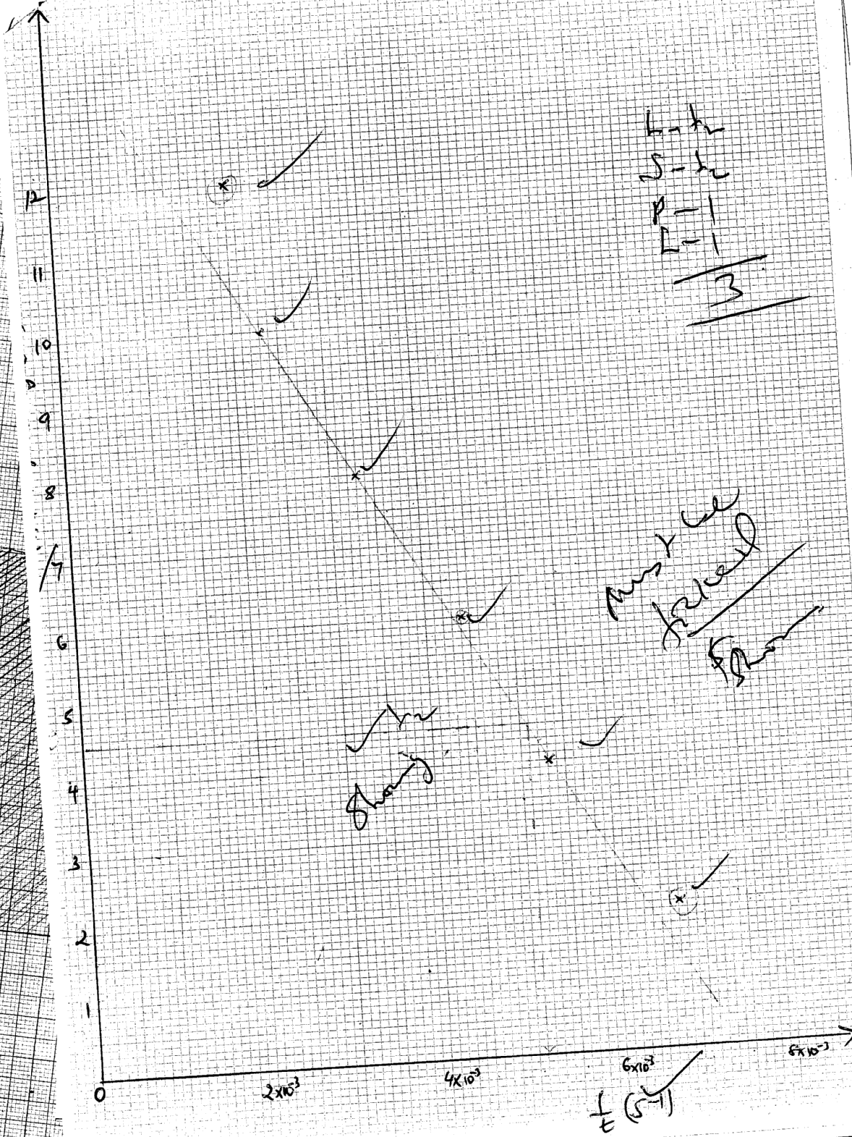

CT – 2
D – 1
A – 1
T – 1
S = ½
P = 1
C = 1

(ii) 1 = 0.00510 √½ From the graph and must be shown. Showing. √½
t
t = 1 √½ = 196.5 seconds. √½
0.00510
(iii) Mg_{(s)} + H₂SO_{4(aq)} MgSO_{4(s)} + H_{2(g)} √½
1 : 1 With correct physical state.
(iv) Moles of Mg = 0.12 √½ = 0.005 moles √½
- 1mk
Moles of H₂SO₄ used = 0.005 moles (1 : 1)
(v) Increase in length of M of ribbon results in decrease in 1
t √½
This is done to gradual decrease in the concentration of the acid. √½

Table II

Titration | I | II | III
Find burette reading (cm³) | 15.3 | 30.5 | 45.7
Initial burette reading | 0.0 | 15.3 | 30.5
Volume of solution B used (cm³) | 15.3 | 15.2 | 15.2
CT = 1
D = 1
AC = 1
PA = 1
TA = 1
5
(c) (i) T₁ + T₂ + T₃ √½ = C.A √½ 1 fall are consistent

3
OR
i.e 15..3 + 15.2 + 15.2 √½ = 15.233 cm³ √½
3

(ii) Moles of sodium hydroxide = 15.233 x 0.5 = 0.007617
1000
i.e. Ans in c (i) x 0.5 √½ = C.A. √½
1000 1 mk
(d) (i) Ans in c (ii) √½ = C.A. √½ i.e. 0.007617 = 0.003809 moles
2 1 mk
(ii) Ans. in d (i) x 4 = C.A.
i.e o.003809 x 4 = 0.015236 moles. 1 mk

(e) Ans in b (iv) + Ans. d(ii) √½ = C.A
0.005 + Ans. d (ii) = C.A
i.e. 0.005 + 0.015235 = 0.020236 moles. 1 mk

(f) Ans. in e x 1000 cm³ = C.A.
50 cm³
i.e. 0.020236 x 1000 = 0.40472 M
50

2. (a)Observations Inferences
Dissolves to form colourless solution . √½ Soluble salt or absence of coloured irons
i.e Fe³⁺, Fe²⁺, Cu²⁺ √½

1 mk

(b) (i) Observations Inferences
No white ppt. √½ Pb²⁺, Al³⁺ or Mg²⁺ absent
(½ mk) Or (½ mk)
NH⁺₄, Na⁺, or K⁺ may be present. √½

(ii) Observations Inferences
No white ppt. √½ NH⁺₄, Na⁺ √½ or K⁺ possibly present. √½
Or (1 mk)
(½ mk) Pb²⁺ Al³⁺, Zn²⁺ absent
1 ½ mks
(iii) Observations Inferences
White ppt. formed. √½ CO₃²⁻, SO₄²⁻ Or Cl⁻ present. √1
( ½ mk) (1 mk)

½ mks

(iv) Observations Inferences
White ppt. √ ½ dissolves in excess Cl⁻¹ present. √1
ammonia √ ½ solution to form
colourless solution. (1 mk)
2 mks
(v) Observations Inferences
Golden yellow flame. √½ Na⁺ present. √1
(½ mk) (1 mk)
1 ½ mks

3. (a) Observations Inferences
Burns with yellow flame - Long chain hydrocarbon
sooty /smoky flame. √½ - Unsaturated organic compound. √½
Or
- Hydrocarbon with high C – H ratio
or
C = C or

C ≡ C
(b) Observations Inferences
Dissolves to form Polar organic compound/ soluble salt/ soluble comp. √1
colourless solution. √1
(1 mk) (1 mk)
2 mks

(c) (i) Observations Inferences
Effervescence /bubbles Presence of H⁺ / H₃O⁺ - COOO. √½
/fizzing. √½
(½ mk) (½ mk)
1 mk

(ii) Observations Inferences
Orange colour remains Absence of R –OH. √½
the same / persists i.e
does not change green. √½
(½ mk) (½ mk)
1 mk

(iii) Observations Inferences
KMnO₄ decolourized i.e
changes from C ═ C Or - C ≡ C −
purple to colourless√1 Or
Unsaturated organic compound. √1
(1 mk)

NYAMIRA DISTRICT
1. (a)
Time (min) | 0 | ½ | 1 | 1 ½ | 2 | 2 ½ | 3 | 3 ½ | 4
Temperature (ºC ) | 19.0 | 19.0 | 19.0 | 19.0 | X | 16.0 | 15.0 | 15.0 | 15.0
C.T = 1
D.C = 1
A.C = 1
Tr = 1
4mks
Complete – 1mk
- 8 readings – 1mk- penalize – ½ of space not filled
- ½ for unrealistic values T 100 or 40
- ½ all constant t = 0 to t = 4
- ½ if T( T(2 ½ )
Decimal place – 1mk
- Accept whole number or to 1d.p of 0.5 or 0.0
Accuracy – 1mk S.V ± 2units
Trend – 1mk
Award ½ - where t = 0 – t – 1 ½ min = all constant
t = ½ - t ½ min – constant
Award ½ - t – 2 ½ to 4min –show a drop
(b) Graph
Ans – ½ - both axis correctly labelled
Scale = ½ - use more than ¾ big squares in both axis
Plotting -1
Labeling -1
3 mks
Penalize ½ inverted and scale to accommodate all plots
Plotting – all 8 points award 1mk
- 6pts & 7 award
- ≤ 5 award 0mk
Labelling – Award ½ for two straight lines.
- ½ for extrapolation

(b) (i) T = correct reading
(ii) Heat of solution = MCΔT
= 50g x 4.2Jg-1K-1 x 4.5K
= -50 x 4.2 x 45J
= -50 x 4.2 x 4.5 KJ
1000
ΔHsoln = ?
0.0238moles = -50 x 4.2 x4JKJ
1000
1mole= ?
= -50 x 4.2 x 4.5 KJ/mol⁻
1000 x 0.0238
= -Ans
Penalized if ΔH – sign is + and not –ve (total 3mks)

TABLE 2
Titre | I | II | III
Final burette reading | 24.4 | 24.5 | 24.3
Initial burette reading | 0.0 | 0.0 | 0.0
Volume of solution H used (cm³) | 24.4 | 24.5 | 24.3
Conditions:- A complete table ...
C.T = 1
D.C = 1
AC = 1
PA = 1
GFA= 1
5mks
3 consistent titrations 1ms
2 titrations done and are consistent...1mk
3 inconsistent titrations done and averaged 0mk
only 1 titration done................0mk
Penalty:
(i) Penalize ½mk for inverted table.
(ii) Penalize ½mk to unrealistic titre values e.g. volume cm3 unless explained.
(iii) Penalize ½mk for wrong arithmetic.

B- Use of decimals ....1mk
(Tied to 1st and 2nd rows)
Conditions
- Accept 1 decimal place / point if used consistently.
- Accept 2 decimal points , however the 2nd decimal point must be either 0.0 or 5.

Penalty
- Penalize fully if decimals are not used consistently

(C) Accuracy ....1mk
(i) Conditions (i) If any of the volume used is within ±0.1cm³ of the school value (S.V)...
(ii) If there is one value within ±0.2cm³ of the school value (S.V)... ( ½mk)

(D) Principles of averaging.....1mk
Conditions
- If 3 titrations done are consistent and averaged....
- If 3 titrations done and 2 are consistent and averaged ....1mk
- If 2 titrations done and are consistent and averaged....1mk
- If titration done ...1mk
- If 3 titrations done and are inconsistent and averaged ....0mk
- If 2 consistent titrations averaged...0mk
- If 3titrations are done and are consistent but are averaged .....0mk

(E) Final answer .....1mk
Conditions
- If the answer of the titre value is within ±0.1cm³ of the school value (S.V) award....1mk
- If the answer of the titre value is within ±0.2cm³ of the school value .... ½mk
- If the answer is not within ±0.2cm³of the school value (S.V) award....0mk

(e) Average volume of solution H used
½
½
24.5 + 24.4 + 24.3 = 24.4
3

II. 24.4 x 0.04 = 0.000976
½
½
1000
½
½

III. ⁵/₂ x 0.000976 = 0.00244 (penalize ½ for wrong units)

IV. 3
½
250 x 0.00244
25
= 3 = 122.95
0.0244
= 123(no units) penalize for units
½
(f) 123-90 = 33
16 + (2x1) = 18x = 33
x = ³³/₁₈ = 1.833
x = 2
½

2. (a) (i)
Observation | Inference
- Solid dissolves, yellowish solution.  - Colourless fumes/vapour are produced.  - boiling tube becomes warm.(1 mk) | - Soluble compound.  - Mix with water is exothermal heat is produced. (1 mk)
(ii)
Observation | Inference
- Blue litmus turns red.  - No effect on litmus paper. | - Presence of H⁺/H₃O in the solution.  - Solution is acid (1 mk)

Observation | Inference
- White ppt. soluble in excess. (1 mk) | - Pb^{2+,} Zn^{2+,} Pb³⁺ present. (1 mk)
(iii)

(iv)
Observation | Inference
- White ppt. persisted insoluble in excess | - Al³⁺ or Pb²⁺ probably present

(v)
Observation | Inference
- Mixture remains colourless/ No yellow ppt. seen. (1 mk) | - Pb²⁺ absent (1glim).  - Al³⁺ present

(vi)
Observation | Inference
- White ppt. seen. (1 mk) | - SO₄²⁻, CO₃^{2-,} SO₃²⁻ absent  - Cl- is present (probably present)

(B(b)
Observation | Inference
- Solid melts forming a colourless and ignites /burns with  Smoky / sooty flame. (1 mk) | - Low compound organic compound/presence  of  or –C ≡C  (accept absence of saturated organic compound). (1 mk)
C = C
Observation | Inference
- Dissolves in water forming colourless solution | - Solution compound /polar compound
(c) (i)

Observation | Inference
- Effervescence/ fizzling/bubbles of a colourless gas.  - No effect on litmus paper. | Presence of – COOH/ H⁺/H₃O⁺ ions.  Solution is acid . (1 mk)

(ii)
Observation | Inference
- The solution remained orange. | - Absence of R-OH. (1 mk)

(iii)
Observation | Inference
Solution turns from purple to colourless solution is decolourised (1 mk) | - Presence of of –C≡ C-

SOIK DISTRICT

1. TABLE I
a)Complete table penalize ½ for inverted table and arithmetic errors
b) Use of decimal tied to the 1st and 2nd rows
c) Accuracy ±0.2 s.v √ ^{½} ± 0.1 sv√1
d) Principles of averaging as shown below
e) Final answer ± 0.2s.v ± 0.1 s.v√1

a)T₁+T₂+T₃√ ^{½}
3
= correct answer√ ^{½} (2d.place) (transferred to the table)
b)i) 5 √ ^{½}
40
=0.125 moles per litre
ii)COOHCOOH_{(aq)} + 2 NaH_{(aq)} COONaCOONa_{(aq)} +2H₂O_{(l)√} ^{½} balanced
√ ^{½} s.symbols
OR
C₂H₂O_{4(aq)} +2 Na₂O_{4(aq)} +C₂Na₂O₄(aq) 2H₂O(l)

iii) Moles of NaOH = 25X0.125 √
1000
= 0.003125
Moles of C₂H₂O₄ = 0.003125 X 1
2
= 0.0015625
Ans in (a) 0.00015625

∴1000cm³ 1000x0.0015625 √^{½}
Ans in (a)
= Correct answer √^{½}
V) C₂H₂O₄ X H₂O = answer in (iv) √^{½}

18x = Ans (iv) - 90√^{½}
x = Ans (iv) – 90 √^{½}
18
= Correct answer √^{½} (whole number)
2. Table 1
- ½ mk each correct entry
- Penalize 1 mk if 1 d. place is not used consistently in the last row.
- Penalize ½ mark for temperature below 400c and 1000c to a maximum of 1mark.
- Penalize 1 mark if there is no trend.
(ii) Graph
- Labeling (½ mark) – Title, axes, correct units.
- Scale (½ mark) – more than on both axes.
- Plotting (1mark) – All points plotted correctly.
  - Curve(1mark) – Smooth curve passing through at least 3 correctly plotted points.
(iii) ½ mark
- 1 mark
- 1mark Read from candidates graph and credited only if within ± 0.1 the S.V
- 1 mark
3. (a)
Observations | Inferences
- Black residue √^{½}  - Colourless solution as filtrate √^{½} | X
(b)  - Blue solution formed√^{½}  - No effervescence √^{½} | CU²⁺ may be present √^{½}  HCO₃ , CO ₃ √^{½} absent the two
(c )  - Blue ppt √^{½}  - Insoluble in excess √^{½} | CU ²⁺ may be present √^{½}
(d)  - Blue ppt√^{½}  - Soluble to give a deep blue solution√^{½} | CU ²⁺ Present
(e) – No white ppt √¹ | Ag+ pb ²⁺ absent ( for two) CO₃ HCO ₃  ²⁻  ⁻
(f) – White ppt √^{½} | Cl ⁻, SO₄ may be present √¹  ²⁻
(g) – White ppt √^{½} | SO₄ present √^{½}
(h) – White ppt √^{½}  - Soluble in excess √^{½} | ²⁺  Zn, Al³⁺ may be present
(i) – White ppt √^{½}  - Soluble in excess | Zn ²⁺ Present.

UGENYA – UGUNJA DISTRICT

Q.1. a) Table 1
 | I | II | III
Final burette reading (cm³) | 20.0 | 40.0 | 20.0
Initial burette reading (cm³) | 0.0 | 20.0 | 0.0
Volume of solution M used (cm³) | 20.0 | 20.0 | 20.0

Complete table – 1 mk
Decimal - 1 mk
Accuracy - 1 mk
Principle of averaging – 1 mk
Final Answer - 1 mk

b) Average volume of solution M used V₁ = (20.0 + 20.0) cm³
2
= 20.0 cm³
c) Mass per litre = 23.5 √½ = 0.0599 √½
Molar mass 392

d) 25 x Answer (c) = 25 x 0.0599 √½
1000 1000
= 0.0014987 √½

e) 20 cm³ of solution M contains Answer in (d) x 1 moles of MnO⁻₄
5
= 0.0014987 x 1√½
5
= 0.0002997 moles. √½
∴ 1000 cm³ of solution M contains 1000 x Answer in (d)
- 5
= 1000 x 0.0002997 √½
20
= 0.014985 moles √½
f) Table II

 | I | II | III
Final burette reading (cm³) | 19.4 | 38.8. | 19.4
Initial burette reading (cm³) | 0.0 | 19.4 | 0.0
Volume of solution M used (cm³) | 19.4 | 19.4 | 19.4

Complete table – 1 mk
Decimal - 1 mk
Accuracy - 1 mk
Principle of averaging – 1 mk
Final Answer - 1 mk

g) Average volume of solution M used, V₂ = (19.4 + 19.4 + 19.4) cm³
3
= 19.4 cm³

h) Average volume x Answer in (e)
1000
19.4 x 0.014985√½ = 0.0002907 √½
1000

i) 1 Mole of MnO₄ reacts with 2.5 moles of S.
∴ Moles of MnO₄ in (h) reacts with 2.5 x moles in (h) of S.
∴ 25 cm³ of S will contain 2.5 x 0.0002907 √1 = 0.0007267 √1

j) 1000 x Answer in (i)
25
1000 x 0.0007267 √½ = 0.029068 M √½
25

k) Answer in (j) ⇒ 5.0g
1 Mole of S = 1 x 5.0
Answer in (j)
= 1 x 5.0
0.029068 √½
= 172.0g √½

H₂X∙2H₂O = 172.0
2(l) + X + 2(18) = 172.0 √1
X + 38 = 172.0
X = 172.0 – 38 √½
= 134.0 √½
Q. 2. a) Observations Inferences
- Colourless vapour condenses on the Hydrated salt / water crystallization√1
cooler parts of the test tube /OH⁻
- Moist blue litmus paper remains blue
and red litmus paper remains red.
- White powder.
Any 2 = 1 mk

b) Observations Inferences
Dissolve √½ to form a Soluble salt / substance / compound. √½
colorless√½ solution.

i) Observations Inferences
White precipitate √½ Ca²⁺, Mg²⁺, Ba²⁺
Insoluble√1 in excess 3 = 1 mk
2 = ½ 1 = 0 mk
ii) Observations Inferences
White precipitate √1 Ca²⁺, Ba²⁺ 2 = 1 mk
1 = ½ mk

iii) Observations Inferences
No white precipitate. √1 SO₄²⁻ √1 absent

iv) Observations Inferences
White precipitate dissolves √½
on boiling and re-appears √½ Cl⁻¹ √1
on cooling

Q.3 a) Observations Inferences
Burns with yellow √1 smoky/ C = C or -C≡C-, Long chain
sooty flame hydrocarbon, unsaturated
organic compound, hydrocarbon with high
C : H ratio. Any 1 = 1 mk

b) Observations Inferences
Dissolves√1 to form a Polar organic √1 compound / polar substance
colourless solution.

i) Observations Inferences
KMnO₄√1 decolorized / changes C = C -C ≡C-
from purple to colourless.
2 = 1 mk 1 = ½ mk

ii) Observations Inferences
O

Methyl Orange turns √1 √1 H⁺ / H₃O⁺ / - C
pink / red.
O - H

Question 1.
Table 1
Distributed as follows:
(i) Complete table
Values must be ±0.2 of each other
(ii) Decimal place
Values should be n 1d.p or 2d.p consistently used.
(iii) Accuracy
Compare the school value to any of the readings and award as follows:
If ±0.1 award 1mk
± 0.2 award ½mk
Outside 0.2 award 0mk
(iv) Principle of averaging
- Award 1mk for consistent value only.
- Penalize ½mk for rounding of the answer to 1d.p unless it divides exactly.
- In consistent values averaged award 0mk
(v) Final answer value to the school to compare the average value to the school value:-
If ±0.1 award 1mk
If ±0.2 award ½mk
If outside award 0mk

Calculations
(a) Titre 1 + Titre II + Titre III = Answer
3
(b) NaOH_{(aq)} + HCl_{(aq)} NaCl_{(aq)} + H₂O_{(l)}
Mole ratio 1 :1
0.5M 0.5M
25 x 0.5 = 0.0125 moles
1000

(c) Mole ratio
NaOH : HCl = 1 :1
∴Molarity of NaOH is 0.5M

Table II
Marking should be done as in table 1.
Calculations
(a) ) Titre 1 + Titre II + Titre III = Answer
3

(b) 1000 = 0.5moles
100cm³ = ?
100 x 5 = 0.05moles
1000
100cm³ = 0.05moles
∴25cm³ = ?
25 x 0.05
100
= 0.0125moles
(c) mole ration 1:2
∴Moles of carbonate = ½ x 0.0125 = 0.00625moles
(d) 125

Question 2
Table III
Marks should be distributed as follows :
(i) Complete table
- Incomplete table with more than 5value ½mk
(ii) Decimal
  - Accept whole numbers for time
- ¹/_{t} must be decimals not fractions
(iii) Trend in time
- Accept reducing values for time
(iv) Trend in ¹/_{t}
(b) The value given must shown on the graph
- Conversion of 318K to ºC is very important before reading form the graph.
GRAPH
- Labeleling ½ mk for both axes
- Scale ½ k (at least ¾ pg)
- Plotting 1mk
- Shape 1mk (should be a curve)
Temp ºC
Rate of
reaction ¹/_{t}

(c) As the temperature is increased the time taken for the reaction to take place is reduced
due to high collision of particles hence the rate of reaction will be high.
Rate of reaction is directly proportional to increase in temperature.
Question 3
Procedure 1
White precipitate | Ba^{2+,} Pb^{2+,} Ca²⁺ present  N/B (i) All 3 ions award 1mk  (ii) Any 2 ions award ½ mk  (iii) Only 1 ion given award 0mk
No white precipitate | Ba^{2+,} Ca²⁺ present  (i) Award 1mk for 2 ions  (ii) Award ½ mk or any ion of the two given
Pink solution s formed | OH⁻ ions present  Reject- solution is basic or allealine or a base
Brick- red flame | Ca²⁺ confirmed  N/B – Award 1mk if it appears in either (a) or (b) above otherwise give zero.

Procedure 2
(a) Effervescence of bubbles of gas | H⁺ present  R – COOH present
(b) Purple colour gets decolourized | C = C or – C ≡ C -  Present
(c) Fruity or sweet smell | R – COOH confirmed

MUMIAS DISTRICT
TABLE 1,,,,,,,,,,,,,,,,,,,,,,,,,,,,,,,,,,,,,,,,,,,,,,,,,,,,,,,,,,,,,,,,,,,,,,,,,,,,,, (5 mks)
Distributed as follows:
i) Complete table (1 mk)
Values must be ± 0.2 of each other.

ii) Use of decimal (1 mk)
Values should be in 1d.p or 2d.p consistently used

iii) Accuracy (1 mk)
Compare the school value to nay of the readings and award as follows
IF± 0.1 award 1 mk
IF ± 0.2 award ½ mk
Outside± 0.2 award 0 mk

iv) Principle of averaging (1 mk)
- Award 1 mk for consistent values averaged
- Penalize ½ mk for rounding off the answer to 1d.p unless it divides exactly
- Inconsistent values averaged – award 0 mk

v) Final answer 1mk
- Compare the averaged value to the school value
If ± 0.1 award 1 mk
If ± 0.2 award ½ mk
If outside ± award 0 mk

CALCULATIONS
a) Titre 1 + Titre II + Titre III = Answer
3

b) RFM of acid = 2 + 2 912) + 4(16) + 2(2 + 16)
= 126

If 500cm3 contains 6.3 g
1000cm3 contains ?
6.3 x 1000 = 12.6dm3
Concentration = 12.6g/dm3
Or 0.1 M

c) Molarity of solution C
Acid : Alkali
1 : 2

If 1000cm3 contains 0.1 moles
25cm3 contains ?

25x0.1 = 0.0025 moles
1000

From mole ratio: 25cm3 of alkali contains
0.0025 x 2 = 0.005 moles
If 25cm3 alkali contains 0.005 moles
100cm3 alkali contains 0.005x1000
25

= 0.2 moles
Molarity = 0.2 M

Procedure 2
TABLE 2
Marking should be done as in table 1

CALCULATION
a) Titre I + Titre II + Titre III = answer
3

b) 25cm3 of NaOH contains 0.005 moles
Mole ration 1 : 1
Moles of acid = 0.005 moles
If Titre in (a) of solution D contains 0.005 moles
1000cm3 of solution D contains:

0.005 x 1000 = answer in moles
Titre in a

c) 10cm3 of A contains moles in (b) above
1000cm3 of A contains
Ans in b x 100 = Answer
10

NB This answer should be close or equal to 4.0M
Question 2
TABLE 3 (5 mks)
Distributed as follows
i) Complete table (1mk)
- Award 1 mk for completely filled table (at least 8 values)

ii) Use of decimals (2 mks)
- Use of decimals for temperature readings award 1 mk
- Use of correct decimals for time readings award 1 mk

NB Penalize ½ mk if i/t is given as fraction

iii) Trends
Trend for temperature 1mk (i.e. should be decreasing)
Trend for time 1 mk(should be increasing)

GRAPH
Should be distributed as follows:
- Labelling the axes ½ mk for both axes
- Scale ½ mk (at least ¾ pg)
- Plotting I mk
- Shape (accept a curve and award 1 mk)

Question 3
Test for solid K
 | Observations | Inferences
a) | - colorless liquid condenses at the cooler parts of the test tube  - Cracking sound produced | - Presence of hydrated substance  - Contains water of crystallization
b)i) | - White precipitate soluble in excess | - Al3+, Zn2+ or Pb2+ ions present  3 stated 1mk, 2 stated ½ mk
ii) | No white precipitate formed | - Presence of AL3+ and Zn2+  - NB must have been correctly inferred in part b(i)
iii) | White precipitate formed  Test for solid F | Presence of SO2-4 or CL-  Award 1 mk for any 2  Award ½ mk for any 1 10n given
c) | Effervescence or bubbles produced | Presence of H+, H3O+, R-COOH
d) | Decolorises acidified KMnO4 or turns KMnO4 to colourless | Presence of reducing agent  C = C – C = C-  Or ROH, SO3
e) | Fruity or sweet smell | R- COOH confirmed

KISUMU DISTRICT

1.
 | 1 | 2 | 3
Final burette reading (cm³)
Initial burette reading (cm³)
Vol. of sol. C used (cm³) | 22.9 | 22.9 | 22.9

. (i) C. T
(ii) D.P ½ mk
(iii) Ac 1mk
(iv) AV 1mk
(v) F ½ mk
(a) (i) Average volume of B (above
(ii) Moles of NaOH solution C = 25 x 0.4 = 0.01
1000
(iii) Moles of HCl solution B
NaOH + HCl H₂O + NaCl
Ratio base : acid = 1: 1
HCl = 0.01

(ii) Molarity of HCl
= 0.01 x 1000 = ans, (a(iv)
Ans (a) (i)
Table 1
(b) (i) 1.2 + 12 + 12 = 12 (above)
3
(c) (ii) Moles of NaOH solution C
Ans (b) (i) x 0.4 = ans b(ii)
1000
iii) Calculate the number of moles of hydrochloric acid in 200cm³ solution D
NaOH_{(aq)} + HCl_{(aq)} NaCl +H₂O
Mole ratio Acid: base = 1:1
In 25.0cm solution of HCl = Ans b(ii)
Moles of hydrochloric acid solution B contained in 25.0cm³ of B
200 x ans (ii) = ans (iii)
25
iv) Moles o hydrochloric acid solution B contained in 25.0cm3 of B= 25 x ans a(iv)
1000
= ans. (b)(iv)
v) Moles of HCl that reacted with Calcium Carbonate
= ans (b) (iv) – ans (b)(iii) ( ½ mk)
CaCO₃ + 2HCl CaCl₂ + CO₂ + H₂O
Mole ratio Carbonate: acid = 2:1 ½mk
Mole of calcium carbonate = ans.(b)(iv) – ans. (b) (iii) ( ½ mk)
2 = ans. (b)(v)
(vi) RMM = 100g
Mass in mixture = 100 x ans (b) (v) ½
= ans. (b) (vi) ( ½ mk)
vii) % of calcium carbonate in the 2g mixture = ans (b) (vi) x 100 ½
2
= ans. (vii) ½
2.

Volume of T added (cm³) | 0 | 5 | 10 | 15 | 20 | 25 | 30
Volume of S + T (cm³) | 20 | 25 | 30 | 35 | 40 | 45 | 50
Temperature of mixture (ºC)

CT 1mk
DP1 1mk
AC 1mk
(b) Graph
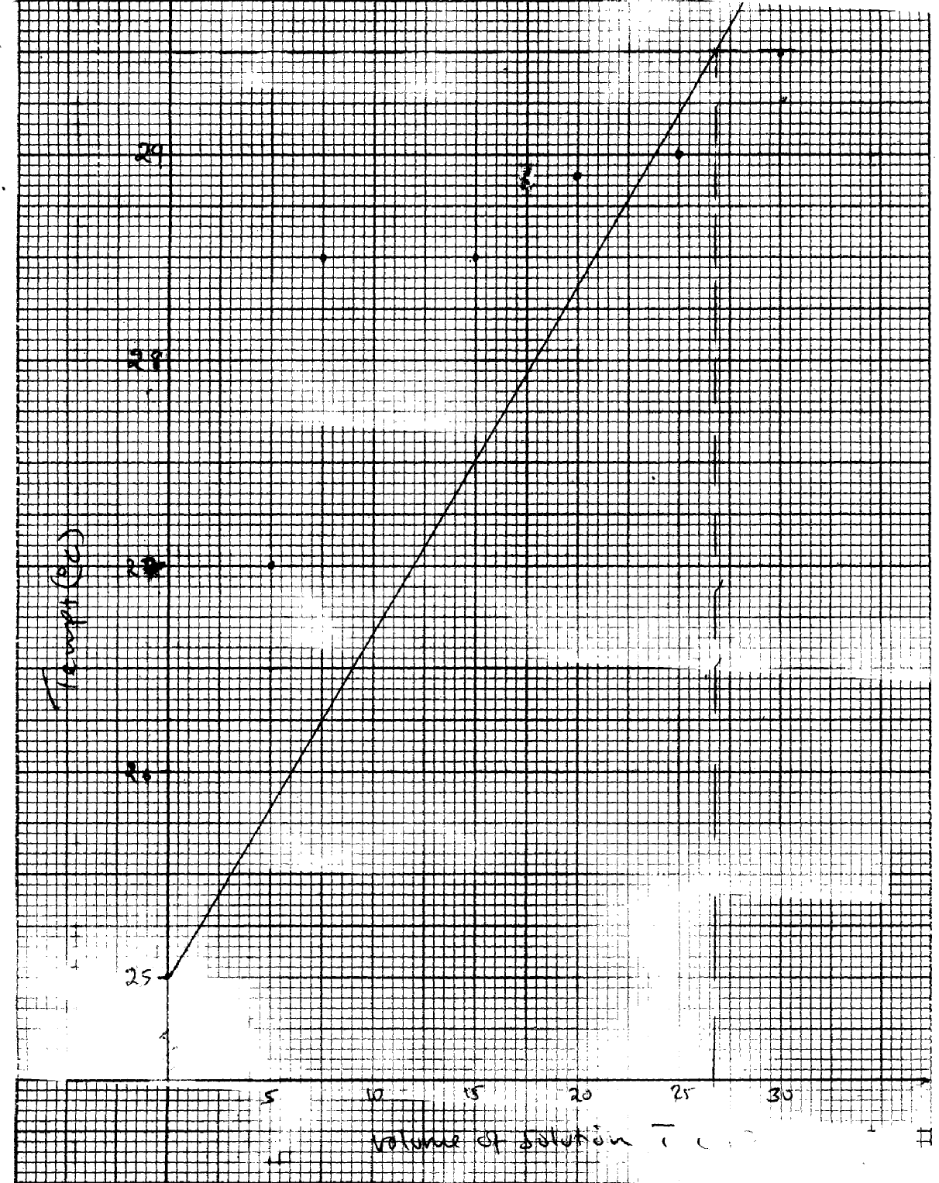
Label of axes ½
29
Scale ½
Plot 1 ½
Shape ½]

Temperature (ºC)
26
27
28

Volume of solution T cm³
5
10
15
20
25
30
0
25

c) (i) from graph ½
(ii) Highest temp- lowest temp (from graph)
(d) 50x{[ac(ii)] x 4.2 = ans. D
(e) No. of moles of T used = c(i) x 1
1000
= ans. (e)
(f) No. of moles used
NaOH + HCl NaCl + H₂O
Mole ratio 1:1
= ans (e) = ans (f)

(g) and (f) moles liberate (and d) J
1 mole and (d) x 1
Ans (f) x 1000
= -Ans (g) KJmole-1

3.
Observation | Inference
(a) _{B}rown gas formed ½  Blue litmus paper turns red/red litmus paper remains red | NO⁻₃ present ½
(b) Partly dissolves/blue ppt do not dissolve ½ | Soluble and insoluble salt
(c) (i) Partly soluble in excess  (ii) Yellow ppt | Al³⁺ / Pb²⁺/Zn²⁺  Pb²⁺
(d) (i) Effervescence  (ii) Blue ppt, insoluble in excess | CuO₃²⁻ suspected  Cu2+ suspected
(e) Blue ppt, dissolves ½  Deep blue solution | Cu2+ confirmed
½
½
½
½

RACHUONYO DISTRICT

1. a) Moles of Hcl present in 50cm³ = 50x1 = 0.05 moles
1000

i) Complete table (1 mark)
- 3 titrations done-
- 2 titrations done
- 1 titration done
NB: Penalise ½ mark to a max of ½ mark for;
- inverted table
- wrong arithmetic
- burette readings beyond 50 cm₃ except where explained
- Unrealistic (below 1 cm3)

ii) Use of decimals (1 mark)
- 1d.p or 2 d.p throughout
- for 2 d.p the 2nd digit is either 0 or 5 otherwise penalize fully

iii) Accuracy (1 mark)
- Compare to teachers values. If any is within;
0.1 of teachers value
0.2 0f teachers value
Beyond 0.2 of teacher value

iv) Averaging
If 3 averaged within 0.2 of each other
If 2 averaged within 0.2 of each other
If 3 or 2 averaged but outside 0.2 of each other

v) final answer ( 1 mark)
Compare to teachers average title. If within;
0.1 of teachers value
0.2 of teachers value
Beyond 0.2 of teachers value

c) i) Volume of NaOH = Title x 250
25
= correct ans ½

ii) Moles of NaOH = Ans c (i) x 0.1
1000
= correct ans ½

d) NaOH (aq) + HCL (aq) NaCL (aq) + H2O (s)

e) NaOH: Hcl = 1:1
Moles of HCL = Moles Of NaOH = Ans in C (ii)

f) Moles of HCl that reached with CO₃² = 0.05 – Ans ©, ½ mark
Correct aswer ½ mark

OR
Ans (a) – Ans (e) = correct Ans

g) i) CO₃²⁻ _{(aq)} + 2H+ Aq Co₂ + H₂ Oi

ii) Moles of CO₃²⁻ = Ans (f)
2
= correct Ans

iii) Molar mass = 1.5 = correct answer
Ans g (ii)
2. a) Table 2 (6 marks)
i) Complete table
ii) Accuracy 2.0 c of the teachers 1st value ½

iii) Use of decimals
Accept to 1 d.p or whole number for temp reading for ½
Award o mk if the 2nd decimal point is not zero or 5. Reject 2 d.p
iv) Trend- Temperature readings to decrease continuously
Time to increase continuously

b) Graph ( 3 marks)
i) Labelled axes ½
ii) Scale ½
NB Area occupied by the actual plots should be at least ½ of the total big squares along
the horizontal axis by at least ½ of the total big squares along the vertical axis

iii) Plots
iv) Curve
c) From the graph
d) From the graph

e) The higher the temperature the higher the rate of reaction
3 a)
Observation | Inferences
White powder ½ | Fe ^{2+,} Fe ³⁺ and Cu ²⁺
b)
Observation | Inferences
 | Mixture of soluble and insoluble salt
i)
Observation | Inferences
No white precipitate ½ | Zn^{2+,} Al³⁺, Pb²⁺, Mg²⁺,, Ca²⁺
ii)
Observation | Inferences
Yellow flame | Na⁺ ½ present
iii)
Observation | Inferences
White precipate | SO₄²⁻ present
c)
Observation | Inferences
- Effervescence/ hissing sound ½
- Colorless gas forms white precipitate with calcium hydroxide ½ | CO₃²⁻ present ½
- Solid dissolves to give colourless solution
d) i)
Observation | Inferences
White precipitate ½ soluble in excess | Pb²⁺, Zn²⁺ or Al³⁺
ii)
Observation | Inferences
White precipitate insoluble in excess | Pb²⁺ or Al³⁺
iii)
Observation | Inferences
Yellow precipitate | Pb²⁺ present

KAKAMEGA NORTH DISTRICT
Procedure;
TABLE A;
Initial temp of CuSo4(c ) | 25.5
Final temp of CuSO4 | 31.0
Temp change T(C ) | 5.5

TABLE B;
Initial temp of CuSo4(c ) | 25.5
Final temp of CuSO4 | 48.0
Temp change T(C ) | 22.5

a) i) Exothermic// there is temperature rise heat energy is released to the environment
ii) Moles of CuSO4(aq) = 0.2 x ²⁵/₁₀₀₀ = 0.005
b) i) ΔH = 25gx4.2Jg⁻¹K⁻¹ x5.5K (ORΔ T)
c) i) Powdered metals have increased surface are many metal particles with come in contact
with HCL acid and react
ii) Grey// metallic grey
d) - Metal A dissolves in CuSO4(aq) solution and a green/ pale green solution is formed
- The blue colour of copper (II) sulphate solution fades/ disappears. Brown solid deposited
- Metal A displaces copper; from its solution implying that A(q) is more reactive than Cu_{(s)}

e) i) Δ H = 25gx4.2Jg⁻¹K⁻¹ xΔ T (22.5) K = 2362JJ

If 0.5g _______ 2362.5J
∴65g _______ (65x2362.5) J = 307125J mol = 307.125KJmol
0.5

ii) B, A
_________ Decreasing reactivity

B gave higher Δ T// more heat energy was released when B reacted with CuSO4(aq)

Procedure;

Table of results
EXPERIMENT | I | II | III
Final Vol. of solution C (cm3)
Initial Vol.of solution C (cm3)
Vol.of solution C used (cm3)

1. a) Volume of pipette = 25cm3

b) Average volume of C = 38.5 + 38.5 + 38.5 = 115 = 38.5
3 3

c) Moles of solution C = 0.1 x ^{38.5}/₁₀₀₀ = 0.00385

d) i) HCL_{(aq)} + MOH _{(aq)} _________ MCL_{(aq)} + H₂O_{(L)}

Penalize ½ for wrong or missing s

ii) H⁺_{(aq)} + OH⁻_{(aq)} _______ H₂O_{(L)}

iii) HCL_{(aq)} : MOH_{(aq)}
1 : 1
0.00385 : 0.00385

e) i) M_{A}V_{A} = 1(MR) where A = HCL_{(aq)} B= MOH_{(aq)}
M_{B}V_{B} 1

Therefore M_{B} = 0.1x38.5x1 = 1.54
25x1

ii) R.M.M = mass per litre = 6.16 = 40
molarity 0.154

iii) MOH = 40
M+ 17 = 40
M= 40-17= 23
Observation | Inference
a) White fine crystal solid | Absence of coloured salts e.g. Cu²⁺, Fe²⁺ or Fe³⁺ absent
b) E dissolved to form a colourless solution | E is a soluble salt
i) No observable change No ppt | Absence of insoluble hydroxides
ii) No observable change No ppt | Absence of ions that form isol. Ppt with NH_{3(aq)}
iii) White ppt. insoluble in acid | SO4²⁻ ions present So₃²⁻ ions absent
iv) White ppt. insoluble in acid | Confirms the presence of SO₄²⁻ ions
v) Nichrome wire burns with a yellow flame | Confirms the presence of Na⁺ ions

BUTERE DISTRICT

TABLE 1
1. Complete table
Penalties
- Unrealistic burette reading.
- Arithmetic error
- Inverted table.
N/B Penalize ½ mk each to a max. of ½ mk

2. Use of decimal.
- Consistent 1 d.pt. or 2 d.pt. –
- If 2 d.pt. the last digit must be zero or five.
- Otherwise award 0
- Accept the consistency of zero.

3. Accuracy
- Tied to the school value.
- Check any of the titre readings.
(i) If any of them is within + 0.1 from S.V. award
(ii)If within + 0.2 unit award – (½ mk).
(iii) If outside + 0.2 unit award zero.

4. Principle of Averaging.
(i) 3 consistent values average –
(ii) 2 consistent values averaged – (½ mk)
(iii) Otherwise award 0.
Penalties
(i) Answer should be at least 2 d.p. unless divided exactly.

b) No. of moles M₂ = ans(a) x 1 1
1000
Correct ans. 1

c) 2H⁺ (aq) + CO₃²⁻(aq) H₂O(l) + CO₂(g)

- Balancing = ½ mk
- States (correct) = ½ mk

- Moles of base = ½ x ans. (b) 1 mk
= correct answer 1 mk

- Concentration = answer in (d) x 1000 1 mk
25
= Correct answer 1 mk
f) Mass of Na₂CO₃ = 106 x ans. (e) 1 mk
= Correct answer 1 mk
g) Mass of NaCl = 95 – ans. (f) (½)
% of NaCl = 95 – ans. (f) x 100
95
= Correct answer ½

2. a) TABLE 2
(i) Complete table 1 mk
(ii) Accuracy to S.V. 1 mk
(iii) Decimal 1 mk
(iv) Trend. 1 mk

b) Graph

Temp
Vol. of NaOH added

Labeling – 1 mk
Plotting – 1 mk
Scale – 1 mk
Shape – 1 mk

c) (i) - Shown in graph (½ mk)
- Correct reading (½ mk)
(ii) ∆T shown in graph - (½ mk )
Correct answer from graph - (½ mk)

d) ∆H = MC∆T = (23 + c(i) x 4.2 x c (ii) 1 mk
Correct answer

e) Moles = 1 x 23 ½ = 0.023 moles  ½
1000

f) Molar heat = 1 x ans. (d) 1
ans. (e)
= Correct answer. 1
 | Observation | Inferences
a) | Colourless solution forms 1 | Soluble salt/ Absence of coloured ions /Fe²⁺, Fe³⁺, Cu²⁺ absent 1
b) | White ppt 1 soluble 1 in excess | Ba²⁺, Pb²⁺, Zn²⁺, or Al³⁺ present.1
c) | White ppt. insoluble in excess. 1 | Ba²⁺, Pb²⁺, or Al³ present. 1
d) | No white ppt. // no ppt. 1 | SO₄²⁻ absent. 1

CALCULATIONS

b. (i) Moles of soltn P = average titre x 0.2 ½ mk
1000

= correct Ans. ½mk
b. (ii) NaOH_{(aq)} + HCL_{(aq)} Nacl _{(aq)} + H2O _{(l)}

Mole ratio= NaOH: HCl is 1:1

∴Moles of NaOH soln S = 1 x Ans. b(i) ½mk
1
= corr. Ans.

b. (iii) 25cm³ soltn. S = Moles in Ans. b(ii)
100cm³ soltn. S = ?
= 100 x Ans. b(ii) ½mk
25

=Correct Ans. ½mk

(c) 100cm³ soltn S Moles in Ans. b(iii)

200cm³ Soltn S 200 x moles in Ans. b(iii) ½mk
100
∴moles in 25cm³ NaOH = 200 x moles in Ans. b.(iii) ½mk
100

= 2 x moles n Ans. b(iii)

= Correct Ans. ½mk
(f) Moles of R in 25cm³ = Ans. (e)
Moles of R in 1000 = ?
= 1000 x Ans (e) ½mk
25
= corr. Ans. ½mk
(g) (i) Molar mass of H₂SO₄ = 49 x 1
Moles in (f)
= Corr. Ans.
(g) (ii) Let R.A.M of A be equal to a
∴ 2 + a = Ans. g(i)
a = Ans. g(i) – 2
= Corr. Ans.

2. (a) Table III............................................ .
- Distributed as follows:-
Complete table .....................
- All columns filled 1mk
- Any 4 correctly filled ½mk
- Otherwise penalize fully
Accuracy.................
Compare candidate’s initial temperature with S.V; if with ± 0.2 units award 1mk,
otherwise penalize fully.
Trend........................1mk
Award 1mk for, increase then constant

(b) Award 4mks distributed as follows
Correct labelling...............1mk
Correct plotting...............1mk
Curve/line.........................1mk
Appropriate scale............1mk
. 4mks
(c) (i) Award 1mk for correct reading
(ii) Highest temperature-initial temp = corr.ans.
(d) Heat change = MCΔT (½mk)

= corr Ans (½mk)
(e) No. Vol. from highest temp change

(f) Moles used = vol. in (e) x 10
1000
= Corr. Ans.

∴ Moles in (f) produce heat change (d)
I mole = ?
= 1 x Heat change in (d)
Moles in (f)

= Correct answer (½mk)
3. (a) Observations Inferences

- Dissolves ½mk to form a colourless - Absence of coloured ions e.g. Cu²⁺, Fe²⁺, Fe³⁺

Solution ½mk

i) To the first portion, add Nitric acid followed by Barium nitrate solution.
Observations Inferences
SO²⁻ ions present
4

½
½
White ppt, insoluble in nitric acid


ii) To the second portion, add Nitric acid, followed by lead(ii) Nitrate solution
Observations Inferences
SO²⁻ confirmed
4

White ppt, ½mk insoluble in nitric acid ½ mk



iii) To the third portion, add a few drops until in excess
N/B - All three mentioned - 1mk
Any two mentioned - ½mk
Only 1 mentioned - 0mk

Observations Inferences
White ppt, ½mk soluble in excess ½ mk

Al³⁺ , Pb²⁺ or Zn²⁺ present


iv) To the fourth portion, add a few drops until in excess
Observations Inferences
White ppt, ½mk soluble in excess ½mk

Zn²⁺ confirmed


TRANSNZOIA WEST DISTRICT

Q1. i) Complete table with 3 titrations done – 1 mark
ii) Incomplete table with 2 titrations done – ½ mark
iii) Incomplete table with 1 titration done – 0 marks

Penalties
- Wrong arithmetic
- Inverted table
- Unrealistic values

Penalize ½ mark for each to maximum of ½ mark

Decimals (1 mark)
Conditions
- Accept either 1 or 2 decimal point constitently.
- If 2 decimal point used the 2nd decimal point can only be 0 or 5

Accuracy 1 mark
Compare any litre values in the 3rd row with the school value (sv)

Conditions
i) If within I 0.1cm3 of S.V 1 mark
ii) If within I 0.2 of S.V ½ mark
iii) Beyond I 0.2 of SV 0 mark

N.B If there is wrong arithmetic in the table compare the SV with the correct value and credit accordingly

d) Principle of averaging 1 mark
Values averaged must be shown and must be within I 0.2cm3 of each other

Conditions
i) 3 values averaged and consistent - 1 mark
ii) 3 values done and only 2 possible averaged 1 mark
iii) 2 titrations done and averaged 1 mark
iv) 2 titrations done inconsistent ½ mark
v) 3 titrations done and possible but only two averaged 0 mark

e) Final answer 1mark
NB Compare the SV
i) If within I0.1 of SV 1 mark
ii) If within I 0.2 of SV ½ mark
If beyond I 0.2 of SV 0 mark
If the candidate has averaged wrong values, pick the correct value if any, average and
credit accordingly

B. HB_{(aq)} + NaOH_{(aq)} ___________ NaB_{(aq)} + H₂O_{(L)} 1 mark

C. i) 0.2075 X Volume = Moles 1 mark
1000
ii) Reacting ratio 1: 1
჻ Moles of T = answer in C (i) above

iii) Answer in b(ii) above X 1000
25

d) i) 1.62425g __________ 250cm3
6.497g/l __________ 1000cm3
M = g/l
Mm

჻ mm = 6.497
Answer in b(ii) above

ii) HB = answer in d(ii) - 1
B =
Question 2.
- 120cm³ of solution R
- 80cm³ of solutions
- 250cm³ of tap water
- 25 or 50ml measuring cylinder
- 100cm³ glass beaker
- 5 x5cm piece of white paper
- Stop watch or clock

Q2. Table II
Experiment | 1 | 2 | 3 | 4 | 5
Time for ribbon to disappear (sec) | 12 | 18 | 22 | 32 | 96
^{i}/_{t} | 0.083 | 0.0560 | 0.045 | 0.03125 | 0.0104

a) Table
Marking areas
i) Complete table

Penalties
- Penalize ½ mark for each space not filled
- Reject fractions for ^{i}/_{t} and award a max of 1 ½ for table
- If fractions appear followed by an extra column of decimals, ignore the fractions and award accordingly
- Penalize ½ mark each for wrong arithmetic in the value of ^{i}/_{t} not within an error of +-2 units in the 3rd decimal place unless it divides exactly
- Accept reciprocals given to at least 3 decimal places otherwise penalize ½ mark each for
rounding off to the 2nd decimal place to a max of 1 mark unless it divides exactly
- Penalize ½ mark for every reading < 5 and > 120 seconds in the time row
- Penalize ½ mark for each entry not in seconds

ii) Use of decimals
(Tied to the 4th row only)
- Accept a whole numbers or decimals up to the 2nd decimal place only used
consistently, otherwise penalize fully

iii) Accuracy
(Tied up to the 4th row only)
- Compare the candidates 1st reading to the S.V and if within +- 2 sec, award 1
mark, otherwise penalize fully
iv) Trend
(Tied to the 4th row only)
- Award 1 mark if time is continuously increasing otherwise penalize fully
b) Graph
i) Labeling of both axes
Condition
- Penalize ½ mark for wrong units used in any of the axis
- Penalize ½ mark for inverted axes
- Accept if units are not shown. Otherwise if shown they MUST be correct
- Both axes MUST be labeled

ii) Scale
- Area covered by the actual plots including the origin should be 2/3 more of the squares
provided in both axes
- The scale interval should be consistent
iii) Plotting
- Award 1 mark if 4 or 6 plots are correctly plotted
- Award ½ mark if 2 or 3 plots are correctly plotted
- Accept plots even if the axes are inverted
- Accept rounding off the values of i/t to the 3rd decimal point when plotting
iv) Line
- Accept a straight line passing through at least 2 points correctly plotted and through
the origin (0,0) for 1 mark or if extrapolated can pass through the origin

c) – Showing ^{i}/_{t} on the graph - Stating the correct reading of ^{i}/_{t} at 36cm³
- Applying the expression that time = ^{i}/_{t} correct reading - Correct answer
d) Rate decrease with decrease in concentration of hydrochloric acid or vice versa
OR
Rate and concentration are directly proportional
Condition
- Tied to the correct graph or trend in the table
- If volume is used in place of conc. Award ½ mark
3. a)
Observations | Inferences
a) White solid sublimes | Chloride of AL³⁺ or NH₊₄
b) White solid dissolves to form a colourless solution that turns blue litmus red | AL³⁺ ions
i) No white ppt formed | SO₄⁻² or SO₂⁻³
ii) A white ppt is formed which is insoluble in excess but dissolves on warming | CL present
iii) A colourless gas with a pungent smell and which turns moist red litmus blue is given off. A white ppt is formed which is soluble in excess NaOH | NH4+ present  AL3+ present
A white ppt is formed which is insoluble in excess aqueous ammonia | AL3+ confirmed

b)
Observations | Inferences
i) Brown colour of bromine water is decolourized
- Accept bromine water become colourless
Effervescence/ bubbles/ fizzing sound | H⁺ present  - COOH present
Orange colour of potassium dichromate VI remain unchanged | OH present
iii) To the third portion add a few drops of acidified potassium dichromate (VI)
Q 1. Table 1 (5 mks)
a) Complete table (1 mk)
- Penalize ½ mk for arithmetic error or unrealistic value to a maximum of ½ marks
b) Use of decimal (1 mark)
- Candidates to use 1 d.p or 2 d.p throughout in 1st and 2nd rows

c) Accuracy (1 mark)
± 0.2 the S.V √ ½ NB Any one value from the table
± 0.1 the S.V √ 1
d) Principles of averaging (1 mark)
- I + II + III √ ½
3
- Correct answer √ ½
e) Final answer
Average of the candidate compared with school value (S.V)
± 0.2 √ ½
± 01 √ 1
ii) Moles of N = 25 x 0.1 √ ½
1000
= 0.0025 √ ½
iii) HCL _{(aq)} + NaOH _{(aq)} NaCL _{(aq)} + H₂O _{(L)}
Balanced √ ½
State symbols√ ½
iv) HCL: NaOH √ 1
1 : 1
Moles of M = 1x0.0025 √ ½
1
= 0.0025 √ ½
v) Average titre 0.0025
1000 cm³ ?
= 1000x0.0025 √ ½
Average titre
= Correct answer √ ½
vi) Answer (V) x 36.5 √ ½
1
= Correct answer √ ½

Table II
- As in table I
b) Answer in (v) x Titre √ ½
1000
= Correct answer √ ½

c) 2HCL _{(aq)} + Na₂CO_{3 (aq)} 2NaCL _{(aq}) + H₂O _{(l}) + CO_{2 (g)}
Balanced √ ½
State symbol √ ½

d) HCL: Na₂CO₃
2 : 1√ 1
1x Answer in (b) √ ½
2
= Correct answer√ ½

e) 1000 x Answer in (d) √ ½
25
= Correct answer√ ½
f) 14.3g/litre √1

g) R + M = Mass in g/h
Molarity
= 14.3 √ ½
Answer in (e)
= Correct answer √ ½

h) Answer in (g) = 106 + 18x √ ½
18x = Answer in (g) – 106
x = Answer in (g) – 106 √ ½
18
= Correct answer √ 1(should be a whole number)
Q 2. Table
Each entry ½ mark
- Penalize ½ mark to a maximum of 1 mark for unrealistic values
- Penalize ½ mark mixing decimal numbers and whole numbers

a) i) Labeling ( ½ mark)
ii) Scale (½ mark)
iii) Plotting (2 marks)
iv) Line/ curve (1 mark)

b) i) 1. x 5 √ ½
1000
= 0.005 √ ½
c) Pb²⁺ : I⁻
0.0025: 0.005 √ 1
1 : 2 √ 1
d) Pb (NO₃)_{2(aq)} + 2KI _{(aq)} PbI _{(s)} + 2KNO_{3 (aq)}
Balanced √ 1
States symbol √1

e) Pb²⁺_{(aq}) + 2I⁻(aq) PbI_{2(s)}
Balance √ ½
States √ ½
f) To make the setting of precipitate faster√ 1

H H H

H – C = C – C – C - H

H H H H

