**MID TERM SERIES-TERM 1-2023**

**CHEMISTRY PAPER 3 (233/3)**

**FORM FOUR (4)**

**TIME: 2 1/2 HOURS**

**MARKING SCHEME**

1. Table 1.

|  |  |  |
| --- | --- | --- |
| Temperature(0C) | Time(Sec) | Reciprocal |
| Room | 30 | 0.0333 |
| 30 | 23 | 0.0435 |
| 35 | 18 | 0.0556 |
| 40 | 14 | 0.0714 |
| 45 | 11 | 0.0909 |
| 50 | 9 | 0.1111 |
| 55 | 8 | 0.125 |
| 60 | 5 | 0.1613 |

* Complete table(Time in secs and ) (3marks)
* Decimal consistency (1 mark)
* Accuracy against school value(room temperature) (1 mark)
* Trend (showing in time) (1 mark)
* Graph
* Scale ½ mark (3/4 of graph provided)
* Labelling (½ mark)
* Plots (1 mark)
* Line (1 mark)

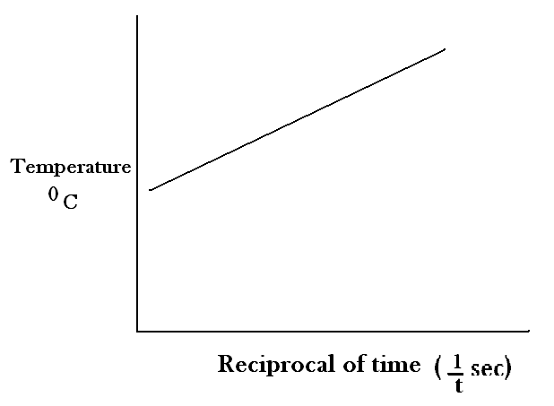

b) As the temperature increases, the rate of reaction between sodium thiosulphate and dilute hydrochloric acid increases✓ (1 mark)

c) i) ✓ ½ =5.8826 sec ✓ ½

ii) Temperature=34.50C (1 mark)

Table II

|  |  |  |
| --- | --- | --- |
| I | II | III |
| Final Burette Reading | 24.0 | 48.0 | 34.0 |
| Initial Burette Reading | 0.0 | 24.0 | 10.0 |
| Volume of Solution | 24.0 | 24.0 | 24.0 |

* **COMPLETE TABLE** (1 MARK)

-penalise1/2 a mark for inversion,wrong arithmetics,incomplete table

* **DECIMAL CONSISTENCY** (1 MARK)

-decimals MUST be consistent either 1d.p OR 2 d.p where 2nd is 0 OR 5

* **ACCURACY AGAINST SCHOOL VALUE** (1MARK)

-If within 0.1 **(1mark),** 0.2 **(1/2 mark**), Outside that range (**0 mark)**

* **PRINCIPLE OF AVERAGING** (1MARK)

-Titre values to be average should be within **+/-0.2** of each other and **must** be shown,otherwise award **zero mark**

* **FINAL ANSWER** (1 MARK)

-candidate average titre value compared to average school value: If within+/- 0.1(1mark), +/-0.2 (1/2 a mark)

d) i) principle average

✓ =24.0 ✓

ii) 2 moles=1000 cm3

✓ ½ =0.025 moles ✓ ½

0.025 moles in 250 cm3

In 24.0 cm3 we have

✓ ½ =0.0024 moles of HCL ✓ ½

iii) Moles of C

✓ ½ =0.0025 ✓ ½ moles of alkali used

iv) Reaction mole ratio of

Acid Alkali

0.0024=1✓ ½ 0.0025 =1✓ ½

0.0024 0.0024

1:1 ✓ ½

v) Ionic equation

H+(aq)+OH-(aq)  H2O(l) ✓ 1

2. a)

|  |  |
| --- | --- |
| Observation | Inferences |
| No white precipitate ✓ 1 | * ABSENCE OF Ca2+,Mg2+,Al3+,Pb2+,Zn2+ * ANY 4 OR 5 IONS 1MRK * ANY 3 OR 2 IONS ½ mark * ANY 1 ZERO MRK * NOTE: penalize ½ a mrk for any contradictory ion |

b)

|  |  |
| --- | --- |
| Observation | Inferences |
| * White precipitate ✓ 1 | PRESENCES OF CO32-,SO42-,SO32-  -ANY 3 IONS✓ 1  -ANY 2 IONS✓ ½  -ANY 1 ION (0MRK)   * NOTE; penalize ½ a mark for any contradictory ion |

c)

|  |  |
| --- | --- |
| Observation | Inferences |
| * WHITE PRECIPITATE✓ ½ * DISSOLVES IN NITRIC ACID ✓ 1/2 | * PRESENCES OF CO32-✓ ½ * ,SO32-✓ ½   NOTE: penalize 1/2 a mark for any contradictory ion |

d)

|  |  |
| --- | --- |
| Observation | Inferences |
| * PURPLE COLOUR OF ACIDIFIED POTASSIUM MANGANATE(VII) IS DICOLOURISED/TURN TO COLOURLESS✓ 1 | SO32- PRESENT✓ 1  -Award zero mark for any contradictory ion |

e)(i)

|  |  |
| --- | --- |
| Observation | Inferences |
| * WHITE PRECIPITATE SOLUBLE IN EXCESS✓ 1/2 | * -PRESENCES OF Al3+,Zn2+, Pb2+ ✓ 1/2   -penalise ½ for any contradictory ion |

(ii)

|  |  |
| --- | --- |
| Observation | Inferences |
| * WHITE PRECIPITATE INSOLUBLE IN EXCESS✓ 1/2 | * Al3+,Pb2+ PRESENT✓ 1/2   -penalise ½ for any contradictory ion |

(iii)

|  |  |
| --- | --- |
| Observation | Inferences |
| * YELLOW PRECIPITATE FORMED✓ 1/2 | * -Pb2+ PRESENT✓ 1/2   -Award zero mark for any contradictory ion |

3.(a)

|  |  |
| --- | --- |
| Observation | Inferences |
| * PURPLE COLOUR OF KMnO4 IS DECOLOURISED✓ 1 | * LONG CHAIN CARBON COMPOUND ✓ 1   OR   * UNSATURATED ORGANIC CPD **/** -CC- or   PPRESENT |

b)

|  |  |
| --- | --- |
| Observation | Inferences |
| BROMINE WATER IS DECOLOURISED✓1 | * -CC- or ✓ 1   PPRESENT |

c)

|  |  |
| --- | --- |
| Observation | Inferences |
| * BUBBLES/EFFERVESCENCES PRODUCED✓ 1 | H+,H3O+ or R-COOH/ -COOH present ✓ 1  -PENALISE FULLY FOR ANY CONTRADICTORY ION |

d)

|  |  |
| --- | --- |
| Observation | Inferences |
| pH 1 OR 2 ✓ 1 | STRONGLY ACIDIC✓ 1 |