Name _____________ Index No. ________________________

Candidate’s Signature _____________

Date __________________________

**233/2**

**CHEMISTRY**

**PAPER 2**

**THEORY**

**Kenya Certificate of Secondary Education**

**2 HOURS**

**INSTRUCTIONS TO CANDIDATES**

1. Write your name and index number in the spaces provided above.
2. Sign and write the date of examination in the spaces provided above.
3. Answer all the questions in the spaces provided.
4. Mathematical tables and silent electronic calculators many be used.
5. All working **must** be clearly shown where necessary.

**FOR EXAMINER’SUSE ONLY**

|  |  |  |
| --- | --- | --- |
| **QUESTION** | **MAXIMUM SCORE** | **CANDIDATE’S SCORE** |
| 1 | 10 |  |
| 2 | 14 |  |
| 3 | 12 |  |
| 4 | 12 |  |
| 5 | 11 |  |
| 6 | 11 |  |
| 7 | 10 |  |
| **Total score** | **80** |  |

***This paper consists of 11 printed pages. Turn Over***

1. (a) The set up below was used to collect gas F, produced by the reaction between water

and calcium metal.

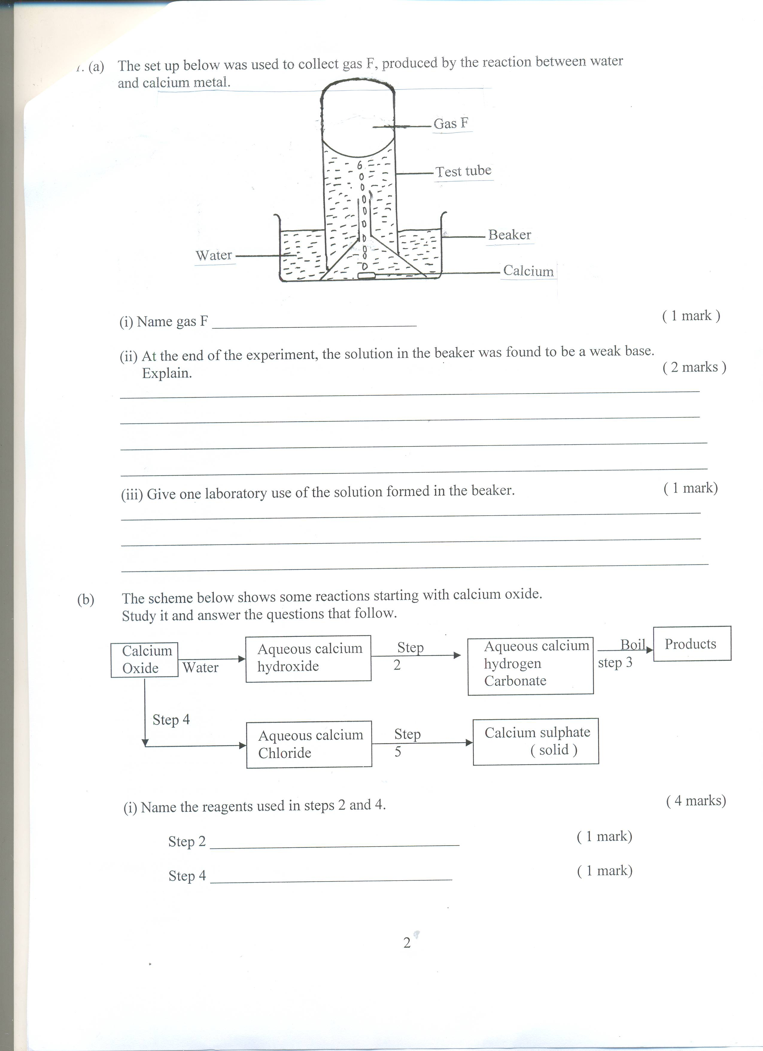

(i) Name gas F ( 1 mark )

(ii) At the end of the experiment, the solution in the beaker was found to be a weak base.

Explain. ( 2 marks )

(iii) Give one laboratory use of the solution formed in the beaker. ( 1 mark)

(b) The scheme below shows some reactions starting with calcium oxide.

Study it and answer the questions that follow.

Calcium Aqueous calcium Step Aqueous calcium Boil

OXIDE products

Water hydroxide 2 hydrogen Step3

Carbonate

Step 4

Aqueous calcium Step Calcium sulphate

Chloride 5 ( solid )

(i) Name the reagents used in steps 2 and 4.

Step 2 ________________ ( 1 mark)

Step 4 ________________________________ ( 1 mark)

(ii) Write an equation for the reaction in step 3. ( 1 mark)

(ii) Describe how a pure solid sample of anhydrous calcium sulphate is obtained in step 5. (3 marks )

2.The diagram below shows part of the periodic table. The letters used in it do not represent the

actual symbols of the elements. Study it and answer the questions that follow.

|  |  |  |  |  |  |  |  |  |
| --- | --- | --- | --- | --- | --- | --- | --- | --- |
|  |  | | | | | | |  |
|  | A | ------------------- |  |  |  |  |  |  |
|  | B | -------------------- | C |  | D |  | E |  |
|  |  | ------------------- |  |  |  |  |  |  |
|  |  | ------------------- |  |  |  |  |  |  |

(a) Compare the:

(i) Reactivity of elements A and B. ( 2 marks )

(ii) Atomic radii of elements C and D. ( 2 marks )

(b) What name is given to the elements in the same group as element E. ( 1 mark)

(c ) Write down the formula of the compound formed when D reacts with excess oxygen. (1 mark)

(d) An element F is found just above element D in the periodic table. Write down

the electronic configuration of element F. (1 mark)

(e) A sample of the chloride of C was dissolved in distilled water. Both red and blue

litmus papers were dipped into this solution. State and explain what was observed.

(2 marks )

(f) 2g of element B react with 0.6 dm3 of oxygen at r.t.p. From these results, calculate

the relative atomic mass of B. (Molar gas volume = 24.0dm3 at r.t.p ) ( 3 marks)

(g) Helium is used in filling weather study balloon. Name another gas which is used for

this purpose and explain which of the two is better suited for use for this purpose. (2 marks )

3. (a) Give the systematic names of the compounds with the structures below. ( 2 marks )

(i) CH2 CH CH2

Cl

(ii) CH3 CH CH2 OH

CH3

(b) Describe a chemical test that can be used to distinguish between ethanol and ethanoic acid. (2 marks )

(c ) Study the scheme below and answer the questions that follow.

H2 (g)

Na

CH2 CH2OH CH3 COOH

Product A

H2SO4 (l)  CH3OH

1600C Process A H2SO4(l)

warm

CH3CH3 H2 (g)  CH2 = CH2

Process B

Process Cl2 (g)  Process C

D

(CH2 – CH2) n Product B H2O(l)

HCl CH3CH2Cl

(i) Name product A ___________________________________ (1 mark)

(ii) State the industrial application of process B. ( 1 mark)

(iii) Write down the equation for the reaction that takes place in process A. (1 mark)

(iv) Explain why high pressure is necessary when carrying out process C. ( 1 mark)

(v) Give the condition necessary for process D to take place. (1 mark)

(d) When a hydrocarbon is burnt in excess oxygen 3.3g of carbon (IV) oxide and 1.8g of

Water are produced. Find the empirical formula of the hydrocarbon. (3 marks)

**4**. Use the standard electrode potentials for the elements RST and U given below to answer the

questions that follow. The letters do not represent the actual symbols of the elements.

Eθ volts

R+ (aq) + 2e (s) -0.76

S2+ (aq) + 2e S (s) -0.44

T2 (g) + 2e 2T- (aq) + 0.54

U4+ (aq) + e 3+ (aq) +1.61

(a) Which element is the strongest reducing agent? Explain. ( 1mark)

(b)(i) Draw a labelled diagram of the electrochemical cell that would be formed when half cells of elements R and S are combined. On the diagram show the direction of flow of electrons. (3 marks)

(ii) Calculate the e.m.f of the cell formed in b (i) above. ( 2 mark)

(c) In an experiment to electroplate iron with silver, a current of 0.5 amperes was passed through a solution of silver nitrate for one hour.

(i) Give two reasons why it is necessary to electroplate iron with silver. (2 marks)

(ii) Calculate the mass of silver that can be deposited on iron (Ag = 108, I faraday = 96500C) (3 marks)

5. (a)Briefly explain how nitrogen gas is obtained industrially from air. (3 marks)

(b) Study the flow diagram below and answer the questions that follows.

Ammonia Water

Air Purifier Catalytic NO Chamber NO2 Absorption

Chamber Air A Air tower

HNO3

Substance C Chamber B

Ca(OH)2

(i) Name the catalytic used in the catalytic chamber. (1 mark)

(ii) Name the process that takes place in chamber A. ( 1 mark)

(iii) Write down the overall equation of the reaction that takes place in the absorption tower.(1 mark)

(iv) State one use of substance C. (1 mark)

(c) Write down the equation for the reaction that takes place when silver nitrate is heated.

(1 mark)

(d) Urea (NH2 CONH2) is commonly applied to the soil as a fertilizer. Calculate the

Percentage of nitrogen by mass in urea. (2 marks)

(N = 14, H = 1, C = 12, O = 16)

(e) Name the process through which substance C is formed. (1 mark)

6. Aluminium is extracted using the electrolytic cell represented by the diagram **below**.

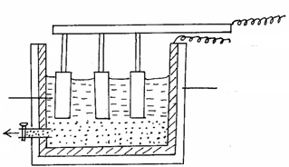

Electrode X

Electrode Y

Steel tank

Molten aluminium

Molten ore

(a)Why is aluminium extracted by electrolytic method? (1mk)

(b) Name the electrodes labeled.

**X** (1mk)

**Y** (1mk)

(c) The chief ore from which aluminium is extracted is bauxite.

(i)Name **two** main impurities present in bauxite. (2mks)

(ii) Aluminium oxide is the main component in bauxite with a melting point of 201 but electrolysis of molten aluminium oxide is carried out at 800°C. Explain how this is achieved.(2mks)

(d) Write the equations for the reaction taking place at the anode. (1mk)

(e) One of the electrodes is replaced periodically. Which one and why? (2mks)

(f) Duralumin (an alloy of copper, aluminium and magnesium) is preferred to pure aluminium

in the construction of aeroplane bodies. Give **one** property of duralumin that is considered.(1mk)

7. (a)In an experiment to study the rate of reaction a 10cm length of magnesium ribbon was

reacted with 50cm3 of 1M hydrochloric acid. The table below gives the data that was collected.

|  |  |  |  |  |  |  |  |  |  |  |
| --- | --- | --- | --- | --- | --- | --- | --- | --- | --- | --- |
| Time(sec) | 0 | 10 | 20 | 30 | 40 | 50 | 60 | 70 | 80 | 90 |
| Volume of hydrogen (cm3) | 0 | 60 | 90 | 105 | 112 | 116 | 118 | 120 | 120 | 120 |

(i) Plot a graph of volume of hydrogen against time. (3 marks )



(ii) From the graph find:

I) the volume of hydrogen that had been produced when time was 35 seconds. (1 mark)

II) The rate of reaction when time is 45 seconds. (2 marks)

(ii) Sketch on the diagram the curve you would obtain if the reaction is repeated

Using 0.5M HCl. Label this curve 0.5M HCl. (1 mark)

(b) Study the equilibrium equation below and answer the questions below it.

A2 (g) + B2 (g)  2AB (g)  ΔH = + 7 kJmpol-1

(i) Explain the effect of changing pressure on the equilibrium above. (2 marks)

(ii) What is the effect of raising the temperature of the equilibrium mixture? (1 mark)