233/2 CHEMISTRY
PAPER 2 FORM 3 2022
Time: 2 hours
END OF TERM 3 EXAMINATIONS 2022
Name: ……………………………………………………… Adm No. ……………………………
Class: ……………………………………………………. Date: …............................................

INSTRUCTIONS TO THE CANDIDATES:-

- Write your name and admission number on the spaces provided.
- Answer all the questions in the spaces provided.
- Mathematical tables and electronic used calculators may be
- All working MUST be clearly shown where necessary.

QUESTION | MAXIMUM SCORE | CANDIDATE’S SCORE
1-30 | 80

- The figure below represents a section of the periodic table. Study it and answer questions (a) to (h). Note that the letters do not represent the actual symbols of the elements.


(a) Consider elements D. H and I
i) Give the chemical family of these elements. (1 mk)
…………………………………………………………………………………………………………………..
ii) How do their ionic size compare. (1mk)
…………………………………………………………………………………………………………………..
iii) Compare and explain the reactivity of the three elements. (2mks)
………………………………………………………………………………………………………………………………………………………………………………………………………………………………………..

b) Write the electronic configuration of;
i) Element H (1mk)
…………………………………………………………………………………………………………………….

ii) The ion of element G. (1mk)
…………………………………………………………………………………………………………………….

c) A molecule of one of the elements is shown below. (2mks)

i) Identify this element from the section of the periodic table and give its actual symbol and name. (2mks)
………………………………………………………………………………………………………………………………………………………………………………………………………………………………………..
ii) Explain why this element has a higher boiling point compared to that of oxygen. (2mks)
………………………………………………………………………………………………………………………………………………………………………………………………………………………………………..
iii) Write an equation to show the reaction between the element named above with oxygen. (1mk)
………………………………………………………………………………………………………………………………………………………………………………………………………………………………………..
iv) Predict the pH of the oxide of the above element when in water. Explain. (2mks)

2. The flow chart below shows some reactions starting with copper (II) nitrate. Study it and answer questions that follow.
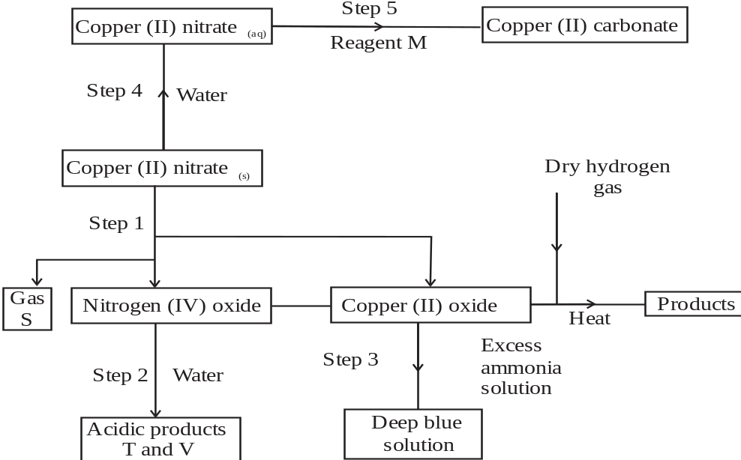

i) State the condition necessary in step 1. (1mk)
………………………………………………………………………………………………………………………………………………………………………………………………………………………………………..
ii) Identify: (4mks)
Reagent M …………………………………………………………………………………….
Gas S ………………………………………………………………………………………..

Acidic products T………………………………………………………………………………
V…………………………………………………………………………………………………

iii) Write the formula of the complex ion formed in step 3. (1mk)
………………………………………………………………………………………………………………..

iv) Write the equations for the reaction in (2 marks)
Step 1
………………………………………………………………………………………………………………….
Step 2
…………………………………………………………………………………………………………………..

3. a) The diagram below shows a set up that was used to prepare oxygen gas and passing it over a
burning candle. The experiment was allowed to run for some time.
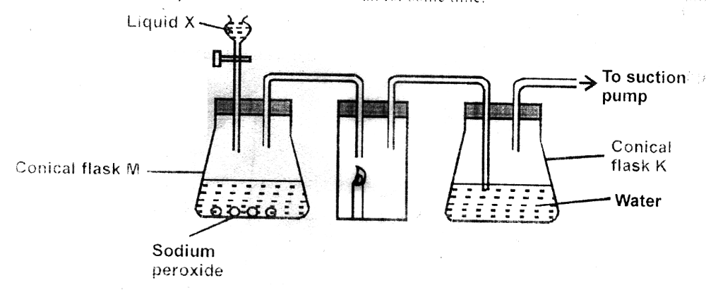

i) Name liquid X (1mk)
………………………………………………………………………………………………………………………………………………………………………………………………………………………………………..

ii) Suggest the pH of the solution in conical flask K. Explain (2mks)
………………………………………………………………………………………………………………………………………………………………………………………………………………………………………..

iii) Write an equation for the reaction taking place in the conical flask M. (1mk)
………………………………………………………………………………………………………………………………………………………………………………………………………………………………………..

b) State and explain the two observations made when hydrogen sulphide is bubbled into the solution containing iron (III) chloride. (2mks)
………………………………………………………………………………………………………………………………………………………………………………………………………………………………………..
c) i) Describe a simple chemical test that can be used to distinguish between carbon (IV) oxide and carbon (II) oxide gases. (3mks)
………………………………………………………………………………………………………………………………………………………………………………………………………………………………………..………………………………………………………………………………………………………………………………………………………………………………………………………………………………………..

ii) Give one use of carbon (II) oxide. (1mk)
………………………………………………………………………………………………………………………………………………………………………………………………………………………………………..

d) A form two student inverted a gas jar full of carbon (IV) oxide over water and sodium hydroxide solution as shown below.
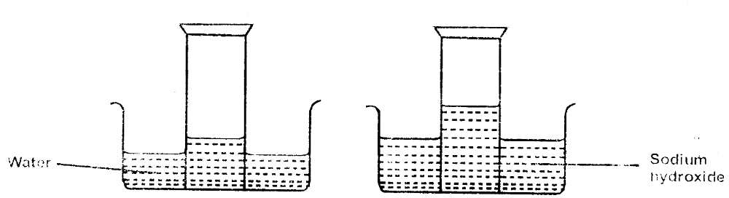

Explain the observations made. (2mks)
………………………………………………………………………………………………………………………………………………………………………………………………………………………………………..

4. (a) Name the two crystalline forms of sulphur (1 Mark)

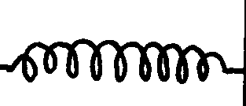
(b) The scheme below represents the steps followed in the contact process. Study it and answer the questions that follow:-
Burner
SO₂
Air
Purifier
Dry SO₂ and air
Heat exchanger
Cooler
Absorption Tower
SO₃
Diluter
Catalytic converter
SO₃
SO₂
Air
Oleum
Conc. H₂SO₄
Conc. H₂SO₄
Solid A
Air

(i) Name one impurity removed by the purifier. (1 mark)
……………………………………………………………………………………………………………………………………………………………………
(ii) Why is it necessary to remove impurities? (1 mark)
…………………………………………………………………………………………………………………………………………………………………………………………………………………………………………………………………………………………………………………………………………………..
(iii) Write down the equation of the reaction taking place in the converter (1 mark)
…………………………………………………………………………………………………………………………………………………………………………………………………………………………………………………………………………………………………………………………………………………..
(iv) Name the two catalysts that can be used in the converter (2 marks)
………………………………………………………………………………………………………………………………………………………………………… ………………………………………………………………………………………………………………………………………………………………………..
(v) What is the function of heat exchanger? (1 mark)
………………………………………………………………………………………………………………………………………………………………………… ………………………………………………………………………………………………………………………………………………………………………..
(vi) Sulphuric (VI) Oxide is not dissolved directly into water? Explain (1 mark)
………………………………………………………………………………………………………………………………………………………………………… ………………………………………………………………………………………………………………………………………………………………………
(vii) (I) Name the main pollutant in the contact process. (1 mark) ………………………………………………………………………………………………………………………………………………………………………… ………………………………………………………………………………………………………………………………………………………………………..
(II) How can the pollution in (g) (I) above be controlled? (1 mark)
………………………………………………………………………………………………………………………………………………………………………… ………………………………………………………………………………………………………………………………………………………………….
(vii) Give one use of sulphuric (VI) acid (1 mark) ………………………………………………………………………………………………………………………………………………………………………… ………………………………………………………………………………………………………………………………………………………………………..
5. The flow chart below shows industrial manufacture of sodium carbonate.
Study it and answer the questions that follow.
NaCl_{(aq)} Ca(OH)₂
NH_{3(g)}
Chamber 1
Chamber 3
D
Chamber 4
Chamber 5
A C
Chamber 2
Carbon(IV)oxide B Water

Na₂CO₃
(a) Name substances A, B, C and D. (4mks)
A ____________________________________________________________________ B ____________________________________________________________________
C ___________________________________________________________________
D ____________________________________________________________________

(b) Write equation for the reactions taking place in chamber 3 and 5. (2mks)
Chamber 3
_________________________________________________________________________
Chamber 5
_________________________________________________________________________
(c) Name the physical process in chamber 4 and 5. (2mks)
Chamber 4
_________________________________________________________________________
Chamber 5
_________________________________________________________________________

(d) Name one source of cheap carbon (IV) oxide for Solvay process. (1mk)
_________________________________________________________________________
6. a) A student set up the apparatus as shown in the diagram below to prepare and collect dry ammonia gas.
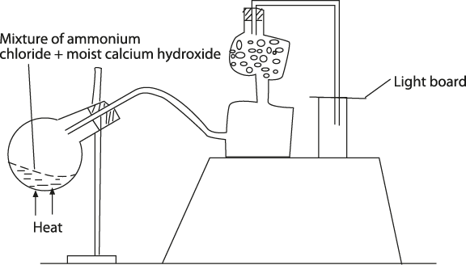
i) Identify three mistakes in the set up and give a reason why each is mistake. (3mks)
………………………………………………………………………………………………………………………………………………………………………………………………………………………………………..
……………………………………………………………………………………………………………………
ii) Name a suitable drying agent for ammonia. (1mk)
……………………………………………………………………………………………………………………
iii) Write an equation for the reaction that occurred when a mixture of ammonium chloride and calcium hydroxide was heated. (1mk)
_________________________________________________________________________________
iv) Describe one chemical test for ammonia gas. (1mk)
_________________________________________________________________________________
b) Ammonia gas is used to manufacture nitric (V) acid as shown below.
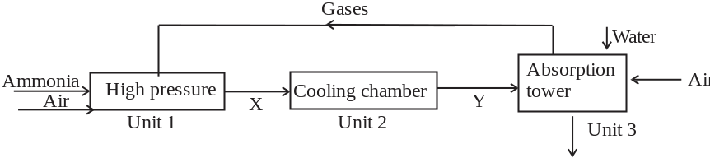
i) This process requires the use of a catalyst. In which unit is the catalyst used? (1mk)
_________________________________________________________________________________
ii) Identify compound X and Y. (2mks)
………………………………………………………………………………………………………………………………………………………………………………………………………………………………………..
iii) Ammonia reacts with nitric (v) acid to form ammonium nitrate fertilizer. Calculate the percentage
composition of nitrogen in ammonium nitrate. (N = 14, O = 16, H = 1) (3 marks)
………………………………………………………………………………………………………………………………………………………………………………………………………………………………………..

7. a) State Graham’s Law. (2mks)
………………………………………………………………………………………………………………………………………………………………………………………………………………………………………..
………………………………………………………………………………………………………………………………………………………………………………………………………………………………………..

b) The table below shows the relationship between the pressure and volume of a fixed mass of ozone gas.
Pressure (K pa) | 1 | 4 | 8 | 16 | 20 | 160
Volume (cm³) | 140 | 40 | 20 | 10 | 8 | 1

Inverse of volume 1/v (cm⁻³)

i) Complete the table by filling the inverse of volume. (3mks)

ii) Draw a graph of pressure against the reciprocal (inverse) of volume. (4mks)

(c) Using the graph, determine the volume of ozone if pressure is 12Kpa. (3mks)
………………………………………………………………………………………………………………………………………………………………………………………………………………………………………..
………………………………………………………………………………………………………………………………………………………………………………………………………………………………………..

