233/2
CHEMISTRY
PAPER 2
THEORY
Kenya Certificate of Secondary Education
CHEMISTRY

MARKING SCHEME

1. (a) (i) Hydrogen gas / H₂ √1
(ii) Calcium hydroxide √1 formed is slightly √1 soluble in water // Only a few OH⁻ ions are produced in solution.
(iii) - It is used for testing for presence of carbon (IV) oxide √1
- Used in preparation of ammonia.
- Used in preparation of calcium oxide.
Any one correct
- (i) Step 2 – Excess carbon (IV) oxide √1 CO₂
Step 4 – Dilute hydrochloric acid √1, HCl _{(aq)}
Accept formula
(ii) Ca(HCO₃)_{2 (aq)} CaCO_{3 (s)} + CO_{2 (g)} + H₂O _{(l)} √1
- Add an aqueous solution of sulphuric (VI) acid √ ½ / add aqueous sodium
sulphate / potassium sulphate √ ½ ( soluble sulphate ) filter √ ½ to obtain calcium
sulphate as residue. Rinse √1 the residue with distilled water to remove traces of
the filtrate. Heat √ ½ the residue to dryness.

2. (a) (i) B is more √1 reactive than A. The valence electrons in B are further from the nucleus than those of A. They therefore experience less nuclear attraction √1 they are lost more readily.
(ii) Atomic size of D is smaller √1 than that of C.
D has more nuclear charge than C hence stronger nuclear attraction √1 to the outermost energy level electrons.

- Halogens √1
- D₂O₅ √1 penalise fully for writing or including D₂O₃
- F : 2.5
-Red litmus paper remains red
-While blue litmus paper turned red √ 1 Both correct
Chloride of C hydrolyses in water to form an acidic solution (1mk)
- 2B_{(s)} + O_{2 (g)} 2BO _{(s)} equation √1
2g 0.6dm³
x 24dm³

x = 2 x 24
0.6
= 80 √ ½

R.A.M = ⁸⁰/₂ √ ½
= 40 √ ½ penalize ( ½ ) for including units for r.a.m

- Helium is preferred to hydrogen √1 since it is inert unlike hydrogen which is
Explosive when mixed with air.

3. (a) (i) 3-chloroethene √1
(ii) 2-methylpropan -1-ol √1

(b) - To each of the two substances placed in separate test tubes add some sodium carbonate √1
- Effervescence occurs in one of them confirming it is ethanoic acid.
- No effervescence with ethanol √ ½

(c ) (i) Sodium ethoxide √1
(ii) Hardening of oils to make fat / margarine √1
(iii) CH₃ COOH + CH3 OH H₂SO_{4 (l)} CH₃COOCH₃ + H₂O √1
Warm
Ignore / do not penalize for wrong states
(iv) To bring the reacting particles close to one another √1
(v) Sunlight / UV √1
(d) Mass of C = 12 x 3.3 = 0.9 g √ ½
44
Mass of H = 2 x 1.8 = 0.2 √ ½
18

C H
0.9 0.2

Moles 0.9 = 0.075 0.2 = 0.2 √ ½
- 1

Ratio of mole 1 2²/₃
Ratio of atoms 3 : 8 √ ½
E.F C₃H₈ √1

4. (a) R √ ½ , losses electrons √ ½ most readily, most electro - positive √ ½
(b) (i)

(ii) Ecell = E reduced - E oxidsed
= -0.44 – (– 0.76 ) √ ½
= + 0.32v √ ½

(c ) (i) Improve its appearance √1
Prevent it from rusting √1
(ii) Ag⁺ _{(aq)} + e¹ Ag _{(s)} √1
Q = 1t 0.5 x 1 x 60 x 60 = 1800C √ ½
108g requires 1 faraday ⁻¹ √ ½
∴ 108g requires 96500C
? 1 800C

108g x 1800C
96500 √ ½
= 2.01 g √ ½

5. (a) - Pass the air through filters √ ½
- Pass the gas through NaOH _{(aq)} √ ½
- Cool to -25⁰C √ ½
- Compress and cool the air to -200 % and 200 atmosphere. Liquid air is obtained √ ½
- Fractionally distil the liquid air √ ½
- Nitrogen gas is obtained at -196⁰C
NB: The steps should follow one another in that order. If one is wrong the rest after
it do not core.

(b) (i) Platinum √1 / Rhodium gauze catalyst
(ii) Cooling √1
(iii) 4NO_{2 (g) +} 2H₂O _{(l)} + O_{2 (g)} 4HNO_{3 (aq)} √1
(iv) Used as a fertilizer √1
(c ) 2 AgNO_{3 (s)} 2Ag _{(s)} + 2NO_{2 (g)} + O_{2 (g)}

(d) Molar mass = 60 √ ½
Mass of nitrogen = 28
% of nitrogen = ²⁸/₆₀ x 100 √ ½
= 46.66% √ ½

- Neutralisation √1

6.(a) Aluminium is very reactive metal hence extracted by electrolysis.

(b) X – Anode 1mk
V – Cathode 1mk

(c) (i) Iron (II) oxide 1mk
Silicon (IV) oxide 1mk

- Cryolite is added. 1mk This lower the temperature from 2015ºC to 800ºC. 1mk

(d) Anode 6O²⁻ → 6Og + 12e OR 6O²⁻ → 3O₂ + 12e 1mk

- The anode. The oxygen liberated at the anode reacts with carbon anode to
form carbon (IV) oxide hence its corroded.

- - Stronger than pure aluminium.
  - Harder than pure aluminium.
  - Has higher tensile strength than aluminium.
  - Not easily corroded compared to aluminium.
  - More durable. (Any 1mk)

7. (a)
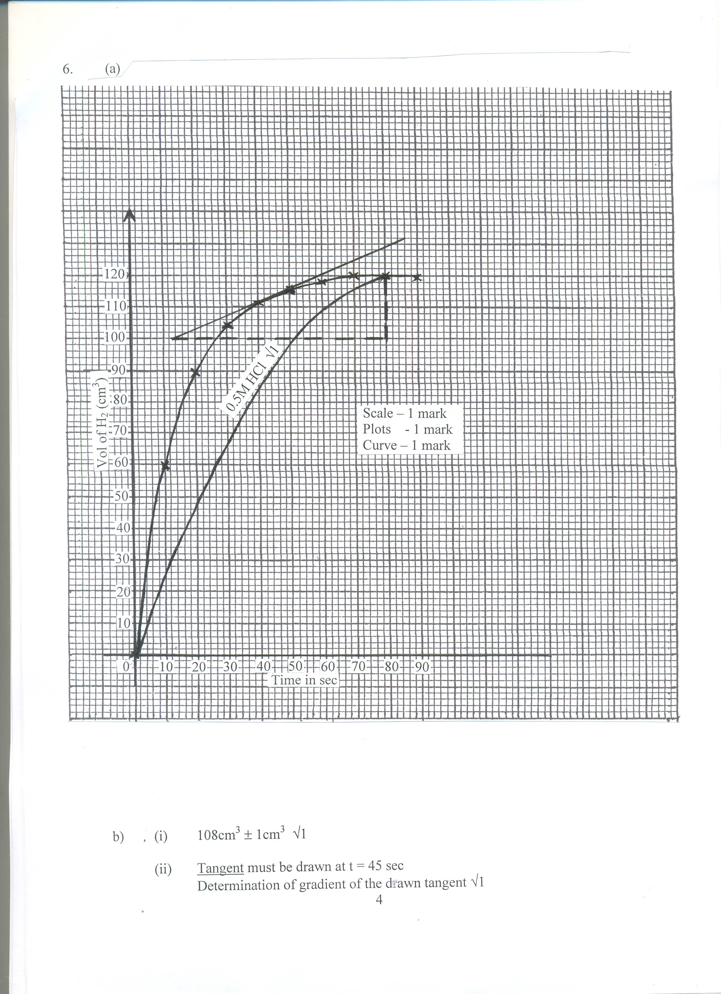

b) (i) 108cm³ ± 1cm³ √1

(ii) Tangent must be drawn at t = 45 sec
Determination of gradient of the drawn tangent √1

Rate of change = 129 – 100 √ ½
80 – 12

= ²⁹/₆₈
= 0.4265cm³ / second √ ½

(b)No effect on equilibrium √ pressure change has no effect on reactions where there is no
change in volume when change goes either way. √1
(ii) Equilibrium shifts to the right more products are formed √1

.

