Name: …………………………………………Class: …………Adm.No……………..

School: ……………………………………Date: ………………SIGN………………

**233/2**

**CHEMISTRY**

**Paper 2**

**SEPTEMBER, 2021**

**Time: 2 hours**

**AMUKURA PARISH J O I N T E X A M I N A T I O N - 2021**

**Kenya Certificate of Secondary Education**

**CHEMISTRY PAPER 2**

**TIME: 2 HOURS**

## INSTRUCTIONS TO CANDIDATES

1. Write your name and admission number in the spaces provided above.

2. Sign and write the date of the examination in space provided.

3. Answer ALL the questions in the spaces provided in the question paper.

4. All working MUST be clearly shown where necessary.

5. Mathematical tables and silent electronic calculators may be used.

6. This paper consists of 15 printed pages. Candidates should confirm this.

**FOR EXAMINER’S USE ONLY**

|  |  |  |
| --- | --- | --- |
| **QUESTION** | **MAXIMUM SCORE** | **CANDIDATE’S SCORE** |
| **1** | **14** |  |
| **2** | **10** |  |
| **3** | **14** |  |
| **4** | **11** |  |
| **5** | **10** |  |
| **6** | **10** |  |
| **7** | **11** |  |
| **TOTAL SCORE** | **80** |  |

1. The grid given below represents part of the periodic table. Study it and answer the questions that follow. The letters are not the actual symbols of the elements.

|  |  |  |  |  |  |  |  |  |
| --- | --- | --- | --- | --- | --- | --- | --- | --- |
|  |  |  |  | | | | | A |
| B |  |  | G |  | H | E |  |
|  | J | I | L |  |  |  | C |
| D |  |  |  |  |  | M |  |
| Y |  |  |  |  |  |  |  |
|  |  |  |  |  |  |  |  |

(i) What name is given to the family of elements to which A and C belong? ( 1 mark )

(ii) Write the chemical formula of the sulphate of element D. ( 1 mark )

(iii ) Which letter represents the most reactive ( 2 marks )

1. Metal
2. Non-metal

(iv) Name the bond formed when B and H react. Explain your answer. ( 2 marks )

(v) Select one element that belong to period 4. ( 1 mark )

(vi) Ionic radius of element E is bigger than the atomic radius. Explain.

( 2 marks )

(vii) The electron configuration of a divalent anion of element N is 2.8.8. Induce the

Position of element N on the periodic table drawn above. ( 1 mark )

(viii) The oxide of G has a lower melting point than the oxide of L. Explain. ( 1 mark )

(ix) How do the atomic radii of I and C compare. Explain. ( 2 marks )

(x)Explain the trend in the 1st ionization energies of the elements J, I and L.(1mark )

1. a) define the following terms
2. Saturated solution(1mk)
3. Fractional crystallization(1mk)

b) Solubility of salt X and Y were determined at different temperatures as shown in the following data.

|  |  |  |  |  |  |  |  |
| --- | --- | --- | --- | --- | --- | --- | --- |
| Temperature (ºC) | | 0 | 20 | 40 | 60 | 80 | 100 |
| Solubility of 100g of water | X | 12 | 30 | 75 | 125 | 185 | 250 |
| Y | 15 | 20 | 35 | 45 | 65 | 80 |

1. On the grid provided, plot a graph of solubility (vertical axis) against temperature. (4mks)



ii. From the graph determine the solubility of each at 50ºC.

X ……………………………………………………….. (1mk)

Y ………………………………………………………… (1mk)

iii. At what temperature was the solubility of both salts equal. (1mk)

b)i. What is permanent hardness of water? (1mk)

3. The flow chart below illustrates two industrial processes. Haber and contact processes each with air as one of the starting materials and other chemical reactions.

**AIR**

**Nitrogen**

**D**

**B**

**Harber process**

**Hydrogen**

**Oxygen**

**Sulphuric acid**

**C**

**Sulphur dioxide**

**A**

**Water**

**Contact process**

a) (i) Give the name of the process by which air is separated into oxygen and nitrogen. (1 mk)

………………………………………………………………………………………………………

(ii) Apart from oxygen and nitrogen gas produced from process a(i) name any other gas produced in the process above. (1 mk)

………………………………………………………………………………………………………

b) Name the substances which are represented by the letter. (4 mks)

A……………………………..

B……………………………………..

C …………………………………….

D………………………………………

c) Name the catalyst used in;

(i) The Haber process (1 mk)

……………………………………………………………………………………………………………

(ii) The contact process (1 mk)

……………………………………………………………………………………………………………

(iii) Explain the role of the catalyst in both the Haber and contact process. (2 mks)

……………………………………………………………………………………………………………

d) (i) Write a balanced equation for formation of compound D. (1 mk)

………………………………………………………………………………………………………

(ii) Calculate the percentage by mass of nitrogen present in compound D

(N = 14.0, H = 1.0, S = 32.0, O = 16.0) (2 mks)

………………………………………………………………………………………………………

(iii) Give one use of compound D. (1 mk)

………………………………………………………………………………………………

………………………………………………………………………………………………

4. A student set-up the arrangement below to prepare and collect dry hydrogen gas

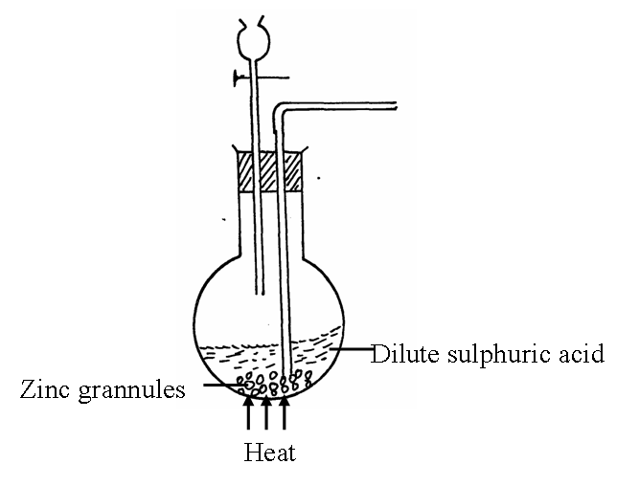

(a) Identify two errors from the section of the arrangement shown above (2mks)

I: …………………………………………………………………………………………………

II:……………………………………………………………………………………………………

(b) Complete the diagram to show how dry hydrogen gas can be collected. (2mks)

(c) (i) Explain why hydrogen was collected by the method shown above (1mk)

…………………………………………………………………………………………………………………………………………………………………………………………

(ii) Write a balanced chemical equation for the reaction that takes place when hydrogen gas is burnt in air. (1mk)

………………………………………………………………………………………………………………………………………………………………………………………………………………

(e) determine the relative atomic mass of zinc, given that when 6.54g of zinc was used, 2.4litres of hydrogen gas was produced. (Molar gas volume = 24 litres) (3mks)

………………………………………………………………………………………………

………………………………………………………………………………………………

………………………………………………………………………………………………

………………………………………………………………………………………………

………………………………………………………………………………

(c) State any **two non**-industrial uses of hydrogen gas (2mks)

………………………………………………………………………………………………………………………………………………………………………………………………

1. The diagram below shows an experiment set-up to investigate a property of carbon (ii) oxide. Study it and answer the questions that follow.

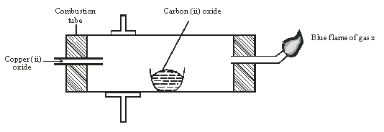

1. Name one condition that is missing in the set up that must be present if the experiment to proceed. **1mark**

………………………………………………………………………………………………………………………………………………………………………………………………………………………………

1. If the experiment was carried out properly. What observation would be made in the combustion tube? **1mark**

………………………………………………………………………………………………………………………………………………………………………………………………………………………………

1. Give an equation for the reaction that occurs in the combustion tube. **1 mark**

………………………………………………………………………………………………………………………………………………………………………………………………………………………………

1. Give an equation for the reaction that takes place as gas x burns. **1 marks**

………………………………………………………………………………………………………………………………………………………………………………………………………………………………

1. Why is it necessary to burn gas x? **1mk**

………………………………………………………………………………………………………………………………………………………………………………………………………………………………

1. Name the reducing and oxidizing agent. **2marks**
2. Reducing agent

………………………………………………………………………………………………………………

1. Oxidising agent

………………………………………………………………………………………………………………

1. Identify any other substance that would have the same effect on copper (ii) oxide as carbon (ii) oxide. **1mark**

………………………………………………………………………………………………………………………………………………………………………………………………………………………………

1. What would happen if copper (ii) oxide was replaced with sodium oxide? Explain **2mark**

………………………………………………………………………………………………………………………………………………………………………………………………………………………………………………………………………………………………………………………………………………

6. Dry chlorine was collected using the set up below.



1. Name a suitable drying agent for chlorine gas? (**1mark)**

…………………………………………………………………………………………………

1. State one property of chlorine gas which facilitates this method of collection. **1mark**

…………………………………………………………………………………………………………….

1. State the observations made on the moist blue litmus paper. (**2marks)**

………………………………………………………………………………………………………………………………………………………………………………………………………………………………

1. Chlorine gas was bubbled through distilled water. With aid of an equation show the formation of chlorine water. (**1mark)**

………………………………………………………………………………………………………………………………………………………………………………………………………………………..…….

1. Write the formula of the compounds formed when chlorine gas reacts with warm dry phosphorous. (**2marks)**

………………………………………………………………………………………………………………………………………………………………………………………………………………………………

1. Chlorine gas is mixed with moist hydrogen sulphide gas, state and explain the observations (**2marks)**

……………………………………………………………………………………………………………………………………………………………………………………………………

1. Give one use of chlorine gas. **1mark**

………………………………………………………………………………………………………………………………………………………………………………………

1. Fractional distillation of air is used in the industrial manufacture of oxygen. The diagram below shows the process.

A

B

M

Compressor

R

Fractional distillation

Y

Nitrogen boiling point- 1960C

Argon boiling point -1860C

Oxygen boiling point - 1960C

Substance T

Dry air

Sodium Carbonate solution

Dust particles

Liquid S

Air

D

X

1. What processes are taking place in chamber A,B,M and D **2marks**

A…………………………………………………………………………………………..……..

B…………………………………………………………………………………………….

M……………………………………………………………………………………………..….

D

…………………………………………………………………………….………………..…..

1. Name;
2. Liquid S(1mk)

……………………………………………………………………………………….……….…

1. Substance T(1mk)

…………………………………………………………………………….…….………………

1. Explain why part Y in chamber D is curved? **1mark**

…………………………………………………………………………………………………………………………………………………………………………………………………

1. Give two industrial uses of oxygen gas? (**2marks)**

………………………………………………………………………………………………………………………………………………………………………………………………

1. In the laboratory preparation of oxygen, manganese (iv) oxide and hydrogen peroxide are used. Write an equation to show how oxygen gas is formed. **1mark**

……………………………………………………………………………………………………………………………………………………………………………………………………

1. An investigation was carried out using the set-up below. Study it and answer the questions that follow.



1. State and explain what will happen in the three test-tubes R, S and T after seven days. **2marks**

………………………………………………………………………………………………………………………………………………………………………………………

1. Give one reason why some metals are electroplated. **1mark**

………………………………………………………………………………………………………………