**Name: ..................................................................................Adm No..................Class……….**

**233/2**

**CHEMISTRY.**

**Theory**

**Paper 2**

**Time: 2 Hours**

**CHOGORIA /MURUGI FORM 4 JOINT EXAMINATION, 2023**

*Kenya Certificate of Secondary Education.*

**233/2**

**Chemistry**

**Paper 2**

**Time: 2 Hours**

**INSTRUCTIONS TO CANDIDATES**

*(a)Write your* ***name, class*** *and* ***admission number*** *in the spaces provided above.*

*(b)Answer* ***ALL*** *the questions in the spaces provided in the question paper.*

*(c) KNEC Mathematical tables and electronic calculators may be used for calculations.*

*(d) All working* ***MUST*** *be clearly shown where necessary.*

*(e) This paper consists of* ***9*** *printed pages.*

*(f) Candidates should check the question paper to ascertain that* ***all the pages are printed*** *as indicated and that* ***no questions are missing.***

*(g) Candidates should answer the questions in English.*

**For examiners’ use only.**

|  |  |  |
| --- | --- | --- |
| **Questions** | **Max-score** | **Candidates score** |
| **1** | **13** |  |
| **2** | **10** |  |
| **3** | **08** |  |
| **4** | **14** |  |
| **5** | **11** |  |
| **6** | **13** |  |
| **7** | **11** |  |
| **Total score = 80** | |  |

1. The grid below represents part of the periodic table. Study it and answer the questions that follow. The letters do not represent the actual symbols of the elements.

|  |  |  |  |  |  |  |  |  |
| --- | --- | --- | --- | --- | --- | --- | --- | --- |
|  |  |  |  |  |  |  |  |  |
|  |  |  |  | **D** |  | **G** |  |  |
|  | **B** |  |  | **E** | **F** |  | **H** | **J** |
| **A** | **C** |  |  |  |  |  |  |  |
|  |  |  |  |  |  |  | **I** |  |

a) State the elements that can form ions with a charge of -1. Give a reason for your answer. …………………………………………………………………………………..(2 marks)

b) What type of structure exists in the oxide of A. Give a reason for your answer? (1 mark)

…………………………………………………………………………………………………..

c) How does the reactivity of I compare with that of H. Explain. (1 mark)

…………………………………………………………………………………………………..

…………………………………………………………………………………………………..

d) The oxide of D has a low melting point than the oxide of element C. Explain. (1 mark)

…………………………………………………………………………………………………

…………………………………………………………………………………………………

e) With a reason choose the most;

i) Electropositive element (2 marks)

…………………………………………………………………………………………………

…………………………………………………………………………………………………

ii) Electronegative element (2 marks)

…………………………………………………………………………………………………

…………………………………………………………………………………………………

f) Compare the atomic radius of;

i) B and H (1 mark)

…………………………………………………………………………………………………..

………………………………………………………………………………………………….

ii) D and E (1 mark)

……………………………………………………………………………………………...……………………………………………………………………………………………...

g) State and explain the observations made when concentrated Nitric (V) acid is added to turnings of copper. (2 marks)

…………………………………………………………………………………………………..…………………………………………………………………………………………………..

2. The flow chart below shows how nitric (v) acid is produced on a large scale. Study it and answer the questions that follow.

68% HNO3

Unreacted Gas B & air

Purifier

Gas A

Air

Compressor

Heat Exchanger

Catalytic Chamber

Reaction Chamber

Absorption tower

Hot water

Purified Air

Gas B

a) State the functions of:

(i) Purifier (1mark)

…………………………………………………………………………………………………

(ii) Heat exchanger (1mark)

………………………………………………………………………………………………….

1. Identify

(i) Gas A (½mark)

…………………………………………………………………………………………………..

(ii) Catalyst C (½mark)

…………………………………………………………………………………………………..

c) Write equations for the reaction that take place;

(i) in catalytic chamber. (1mark)

…………………………………………………………………………………………………..

(ii) in absorption tower. (1mark)

…………………………………………………………………………………………………..

d) Calculate the molarity of the commercial nitric (v) acid, given that it is 68% pure and has a density of 1.42g/cm3. (N=14, H=1,)=16) (3mark)

………………………………………………………………………………………………….

………………………………………………………………………………………………….………………………………………………………………………………………………….

(e).(i) State the observation made when concentrated nitric (v) acid is added to acidified

sulphur powder and warmed. (1mark)

…………………………………………………………………………………………………

ii) Give a reason for the answer given in c (i) above. (1mark)

…………………………………………………………………………………………………..

3. Study the flow chart below starting from iron metal.

Hot conc. H2SO4

Step 3

Sulphur & heat

Step 4

Step 9

Heat

Step 8

(i)NaOH

(ii) filter

Step 7

H2O2

Step 6

(i)NaOH

(ii) filter

Dil HCl step 5

Air & Moisture

Step 2

Steam

Step 1 Chlorine gas

Fe(s)

Compound B

Fe2O3.3H2O

Fe3O4(s) + Gas Q

Fe2(SO4)3(aq) + H2O(l)

+ gas D

Compound T

FeCl2 + Gas L

Solid X

Brown solution

**Solid** V

Solid A

(a) Name gases (1½mk )

D……….……………………………………………………………………………………

L……….…………………………………………………………………………………....

V……….…………………………………………………………………………….............

(b) Identify the following substances. (2 ½mk)

(i) Compound B……….……………………………………………………………………….

(ii) Compound T……….……………………………………………………………………….

(iii) Solid A……….……………………………………………………………………………..

(iv) Solid V……….……………………………………………………………………………..

(v) Solid X……….…………………………………………………………………...................

c) What name is given to the reaction in step 2? (½mk ) ……….………………………………………………………………………………………….

d) State the colour of solid X (½mk)

……….…………………………………………………………………………………. …..

e) Write balanced equations for the reactions that occurred in:- (2mks)

Step 1……….…………………………………………………………………………………...

Step 5……….…………………………………………………………………………………...

f) What property of hydrogen peroxide (H2O2) is indicated in step 7 of the flow chart? (1mk)

…………………………………………………………………………………………………..

4. The set up below was used to prepare hydrogen chloride gas and salt T.

Liquid M

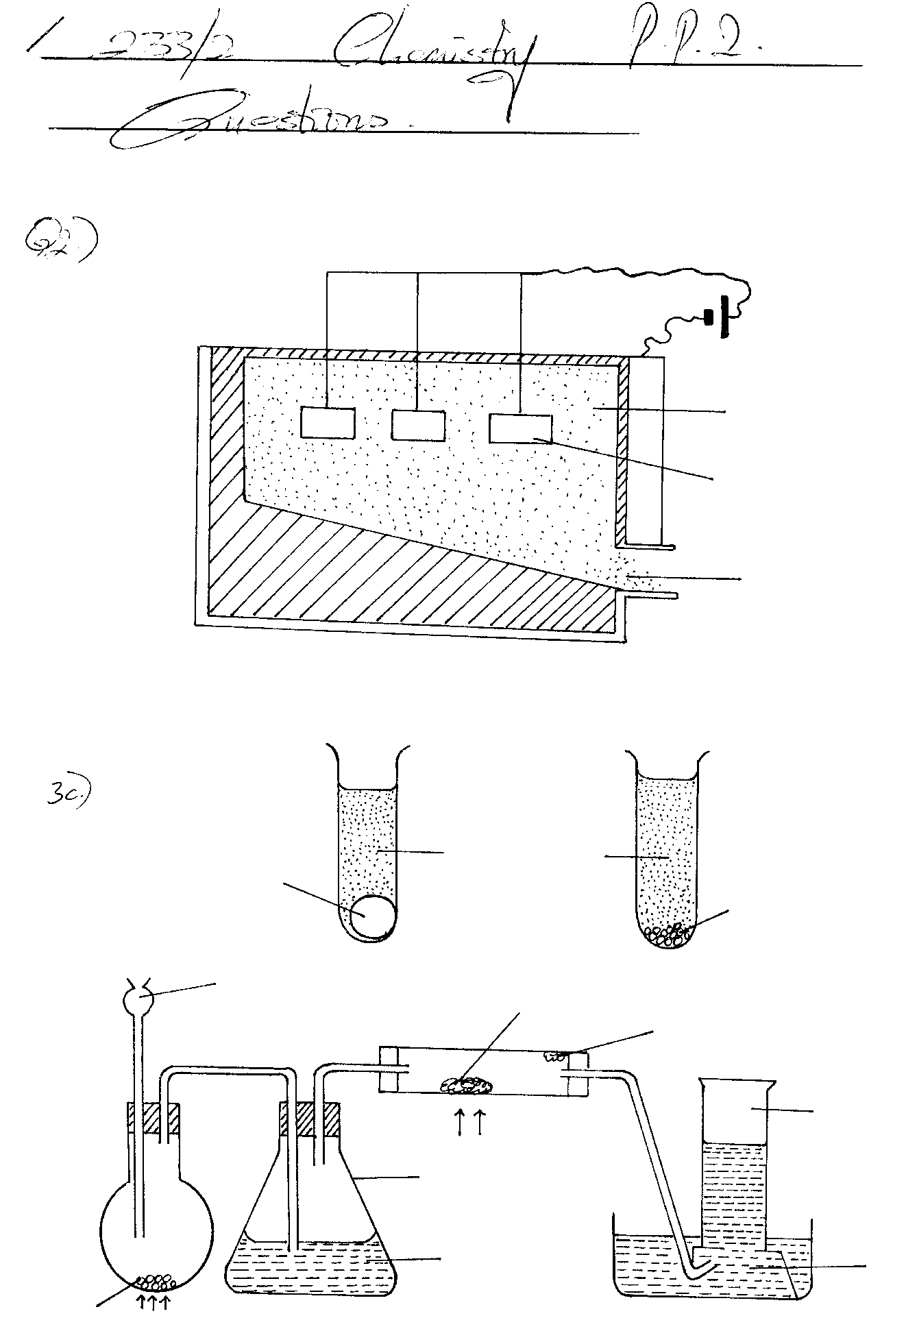

Flask I

water

Salt T

Gas V

Sodium chloride crystals

Conc. Sulphuric (VI) acid

heat

Flask II

Aluminium powder

heat

1. **I**. Name the following
2. Liquid M (½ mark)

……….…………………………………………………………………………….....................

1. Gas V (½ mark)

……….…………………………………………………………………………….....................

**II**. Write the formula of Salt T (1mark)

……….…………………………………………………………………………….....................

b) Write balanced chemical equations for reactions that occur at

i) Flask I (1mark)

……….…………………………………………………………………………….....................

ii) Combustion tube. (1mark)

……….…………………………………………………………………………….....................

c) Name the process that formed salt T as shown in the diagram. (1mark)

……….……………………………………………………………………………....................

d) Sulphuric (VI) acid is used as a drying agent in this experiment. Explain why calcium

oxide is unsuitable for the same purpose in this reaction (2marks)

……….…………………………………………………………………………….....................

……….………………………………………………………………………………………….

e) The water in the trough was found to have a pH of 2.0 at the end of the experiment.

Explain. (1mark)

……….…………………………………………………………………………….....................

……….…………………………………………………………………………….....................

f) Calculate the mass of salt T formed if 480cm3 of hydrogen chloride gas measured at

r.t.p was reacted with aluminium powder. (Al=27, Cl = 35.5, MGV=24dm3) (2marks)

……….…………………………………………………………………………….....................

……….…………………………………………………………………………….....................

……….…………………………………………………………………………….....................

g) In the space provided below, draw a well labelled diagram showing how you would

dissolve hydrogen chloride gas in water. (1mark)

h) A solution of hydrogen chloride in methylbenzene does not react with carbonates.

However, on adding water and then shaking the resulting mixture, there is vigorous

effervescence. Explain the above observation. (2marks)

……….………………………………………………………………………………………….

……….…………………………………………………………………………….....................

……….………………………………………………………………………………………….

i) Using equation, state the observation made when a gas jar containing hydrogen

chloride gas is opened near an open bottle of liquid ammonia. (1mark)

……….…………………………………………………………………………….....................

……….…………………………………………………………………………….....................

5. Name each of the processes described below which takes place when salts are exposed to air for sometime.

(i) Anhydrous copper (II) sulphate becomes wet. (1 mark)

…………………………………………………………………………………………………..

(ii) Common table salt forms an aqueous solution (1 mark)

…………………………………………………………………………………………………..

(iii) Fresh crystals of sodium carbonate Na2CO3.10H20 becomes covered with white powder of formula Na2CO3.H2O (1mark)

…………………………………………………………………………………………………..

(b)Write the formula of the complex ion formed in each of the reactions described below.

(i) Zinc metal dissolves in hot potassium hydroxide solution (1mark)

………………………………………………………………………………………………..……………………………………………………………………………………………………..

(ii) Copper hydroxide dissolves in excess ammonia solution (1mark)

…………………………………………………………………………………………………..…………………………………………………………………………………………………..

(c) A hydrated salt has the following composition by mass. Iron 20.2%, Oxygen 23%, Sulphur 11.5% and water 45.3%. Its relative formula mass is 278. Determine the formula of the hydrated salt. (Fe = 56, S = 32, O = 16, H = 1) (3marks)

……………………………………………………………………………………………………………………………………………………………………………………………………

………………………………………………………………………………………………………………………………………………………………………………………………………………………………………………………………………………………………………

(d) Describe how a solid sample of lead (II) chloride can be prepared using the following reagents:- dilute nitric acid, dilute hydrochloric acid and lead carbonate. (3marks)

…………………………………………………………………………………………………..…………………………………………………………………………………………………..

…………………………………………………………………………………………………..…………………………………………………………………………………………………..

…………………………………………………………………………………………………..

6. A student set-up the apparatus shown below in order to determine the percentage by volume of oxygen in the air. Study it and answer the questions that follow.

**End of experiment**

**Start of experiment**

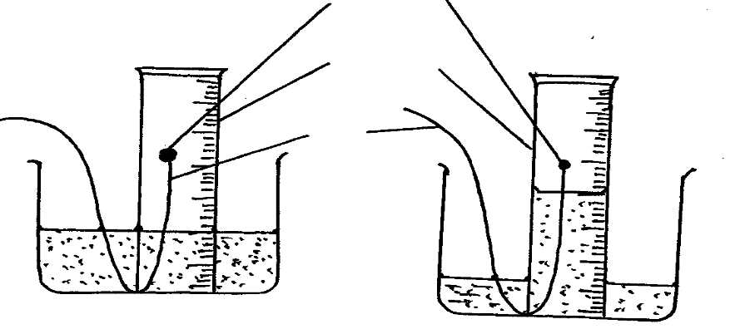

**Phosphorus**

**Measuring**

**cylinder**

**Wire**

Water

(a)(i) State one observations made in the measuring cylinder at the **start** of the experiment.

Explain. (2mks)

……………………………………………………………………………………………………………………………………………………………………………………………………

(ii) The PH of the contents of the beaker at the end of the experiment was found to be 4.

Explain the observation. (2marks)

……………………………………………………………………………………………………………………………………………………………………………………………………

(iii) The volume of air in the measuring cylinder at the end f the experiment was measured.

study the data given below and answer the questions that follow.

-Volume of air at start of the experiment = 30.65 cm3

-Volume of air at the end of the experiment = 24.28 cm3

Determine the percentage volume of oxygen in the air. (2marks) ………………………………………………………………………………………………………………………………………………………………………………………………………………………………………………………………………………………………………

(b)State and explain the observation made when a mixture of zinc powder and copper (II) oxide is heated in a crucible. (2marks)

………………………………………………………………………………………………………………………………………………………………………………………………………………………………………………………………………………………………………

(c) State **two** air pollutants produced by motor vehicles. (1mark)

……………………………………………………………………………………………………………………………………………………………………………………………………

(d) A group of students burnt a piece of magnesium ribbon in air and its ash collected in a

Petri dish. The ash was found to comprise of magnesium Oxide and Magnesium nitride

(i) Write an equation for the reaction leading to formation of the magnesium nitride. (1mk)

…………………………………………………………………………………………………..

(ii) A little water was added to the products in the Petri dish. State and explain the observation made. (2mks)

…………………………………………………………………………………………………..…………………………………………………………………………………………………..

(iii) A piece of **blue** litmus paper was dipped into the solution formed in (b) above. State the observation made. (1mk)

…………………………………………………………………………………………………..

7(a) A compound has an empirical formula **C3H6O** and a relative formula mass of 116.

i) Determine its molecular formula. (H =1, C = 12, O =16) (2 marks)

………………………………………………………………………………………………..……………………………………………………………………………………………………..

ii) Calculate the percentage composition of carbon by mass in the compound. (1 mark)

………………………………………………………………………………………………….…………………………………………………………………………………………………..

(b) Study the scheme below and answer the questions that follow.



**I.** State the conditions for process in step V. (1 mark)

…………………………………………………………………………………………………..

**II.** Name the **reaction** represented by process.

i) Z (1 mark)

…………………………………………………………………………………………………..

ii) L (1mark)

…………………………………………………………………………………………………..

iii) E 1 mark)

…………………………………………………………………………………………………..

iv) N (1 mark)

**III.** Draw and name the structure of the substance.

i) V (1 mark)

…………………………………………………………………………………………………..

ii) P (1 mark)

…………………………………………………………………………………………………..

iii) U (1 mark)

…………………………………………………………………………………………………..