233/1
CHEMISTRY PAPER 1
Time: 2 hours

MOMALICHE 10 CYCLE 2

Name ………………………………… Index Number……………………/………………..
Signature ………………………………..
School………………………………………………………………………………………..
Date …………………/…….………/…………

INSTRUCTIONS TO CANDIDATES
  - Write your name and index no in the spaces provided above.
  - Sign and write the date of exam in the spaces provided above.
  - Answer all the questions in the spaces provided after each.
  - Mathematical tables and silent electronic calculators may be used.
  - All working must be clearly shown where necessary.
  - This paper consists of 12 printed pages. Candidates should check to ensure that all pages are printed as indicated and that no questions are missing.
  - All answers should be written in English.

For Examiner’s Use Only

1 | 2 | 3 | 4 | 5 | 6 | 7 | 8 | 9 | 10 | 11 | 12 | 13 | 14 | 15 | 16

Grand Total
17 | 18 | 19 | 20 | 21 | 22 | 23 | 24 | 25 | 26 | 27 | 28 | 29

- Metal Q displaces metals T and U from their oxides but does not displaces metal R. Metal T displaces U
form its oxide. Arrange the metals according to their reactivity starting with the strongest reducing agent. (1 mark)
……………………………………………………………………………………………………………

……………………………………………………………………………………………………………

- Chlorine gas can be prepared in the laboratory using the following two methods;
Solid substance X and concentrated Hydrochloric acid
Solid substance X, concentrated sulphuric (VI) acid and solid Sodium Chloride.

- Name the solid substance X (1 mark)
……………………………………………………………………………………………………………

……………………………………………………………………………………………………………

- What is role of concentrated sulphuric acid in the reaction? (1 mark)
……………………………………………………………………………………………………………

……………………………………………………………………………………………………………

- State how dry chlorine gas is collected. (1 mark)

……………………………………………………………………………………………………………

……………………………………………………………………………………………………………

- A white crystalline solid Q when heated to forms a brown gas, colourless gas that relights a glowing wooden splint and a yellow residue which turns white on cooling. Aqueous solution of Q forms white precipitate which dissolves excess aqueous ammonia solution to form a colourless solution P.
- Write the name and chemical formulae of complex ion in solution P. (2 marks)

Name;

……………………………………………………………………………………………………..

Chemical formula;
…………………………………………………………………………………………………….

- State the observation made when the aqueous solution of P is reacted with few drops of sodium
hydroxide. (1 mark)
……………………………………………………………………………………………………………

……………………………………………………………………………………………………………

4(a) Define term Lattice energy (1 mark)
………………………………………………………………………………………………………………

…………………………………………………………………………………………………………

b) The reaction between hydrogen gas and oxygen releases energy. A student drew the reaction profile for the reaction between hydrogen gas and oxygen gas.
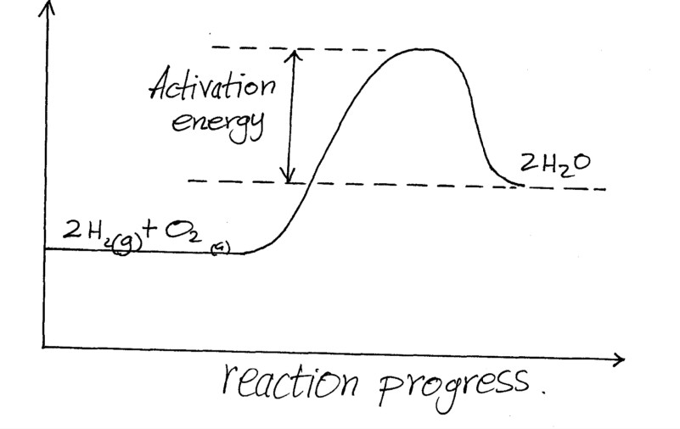
State two errors made when drawing the reaction profile. (2mks)
………………………………………………………………………………………………………………………………………………………………………………………………………………………………………………………………………………………………………………………………………………………………………………

- Ammonia gas is one of the substances recycled in the Solvay process.
- Other than water name another substance that is recycled in the process. (1 marks)
……………………………………………………………………………………………………………
……………………………………………………………………………………………………………

- Write a balanced chemical equation for the reaction that regenerates Ammonia gas in the process.
(1 mark)
……………………………………………………………………………………………………………
……………………………………………………………………………………………………………

- State an industrial use of the only waste product in the Solvay process. (1 mark)
……………………………………………………………………………………………………………

- Lead (II) iodide is a toxic bright yellow solid which was used as a paint pigment known as ‘iodine yellow’. Describe briefly how you would prepare lead (II) iodide in the laboratory starting with lead (II) oxide. (3 marks)
……………………………………………………………………………………………………………………
…………………………………………………………………………………………………………………..
……………………………………………………………………………………………………………………
……………………………………………………………………………………………………………………..
…………………………………………………………………………………………………………………..

- 5.0g of zinc carbonate were allowed to react with 25cm³ of 1M hydrochloric acid until there was no further reaction. Calculate the volume of gas that was formed at s.t.p. (Zn = 65.4, O = 16, C = 12, molar gas volume at s.t.p = 22400 cm³) (3 marks)

- Atoms of element P can be represented as
²³ P . Element P reacts with sulphur to form a yellow solid.

Using dots (•) and crosses (X) to represent electrons, draw the structure of the yellow solid. (S=16).
11
- marks)

- The curve shown below shows the variation of time against temperature for the reaction between
sodium thiosulphate and hydrochloric acid.

Time(s)

Temperature (°C)

  - Explain the shape of the curve. (2 marks)

……………………………………………………………………………………………
  - Other than temperature name one factor that affects the rate of reaction. (1 mark)

…………………………………………………………………………………………….

- Magnesium ribbon was added to a solution of hydrogen chloride in methylbenzene. Another piece of Magnesium ribbon was added to hydrogen chloride in distilled water. State and explain observations made. (2 marks)
……………………………………………………………………………………………………………
…………………………………………………………………………………………………………
…………………………………………………………………………………………………………
- State two differences between luminous and non luminous flame of the Bunsen burner. (2 marks)
……………………………………………………………………………………………………………

……………………………………………………………………………………………………………

…...…………………………………………………………………………………………………………

- A fuel gas contains 50% of hydrogen gas and 44% of carbon (II) oxide by volume. The rest of is incombustible. Calculate the volume of gas that remains at room temperature when the 100 cm³ fuel gas was ignited. (3 marks)

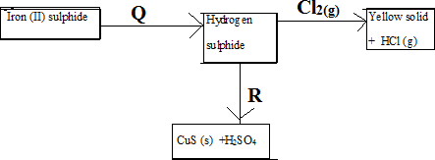
- Study the diagram below and answer the questions that follow.

- Name substances; ( 1 mark)
Q………………………………………………………..
R………………………………………………………..
- Write the equation for the reaction that leads to the formation of the yellow solid. (1 mark)
……………………………………………………………………………………………………………

- Using a chemical test, describe how you would distinguish between hydrogen sulphide and sulphur (IV) oxide. (1 mark)
……………………………………………………………………………………………………………………………………………………………………………………………………………………………………………………………………

- A gas occupies a volume of 400cm³ at 227ºC and 760mmHg.What will be the temperature of the gas when the volume and pressure of the gas is 100cm³ and 380mmHg respectively. (2 marks

- For each of the following experiments, give the observations, and the type of change that
occurs (Physical or chemical) (3 marks)

Experiment | Observation | Type of change
A few drops of concentrated sulphuric acid added to small amounts of sugar
A few crystals of Iodine are heated gently in a test tube
A few crystals of copper (II) Nitrate are heated strongly in a test tube.

- (a) Define solubility of a solute. (1 mark)
……………………………………………………………………………………………………………

……………………………………………………………………………………………………………

b) The solubility of potassium nitrate is 120g/100g of water at 80 ºC and 70g/100g of water at
20ºC.What mass of the salt would crystallize if 80g of potassium nitrate solution saturated at 80 ºC was cooled to 20 ºC
( 2Marks)

- Zinc metal reacted with dilute hydrochloric acid. The gas produced was then passed over heated copper
(II) oxide in a combustion tube.
- State two precautions that must be considered when the gas reacts with copper (II) Oxide in the combustion tube. (2 marks)

- Write a balanced chemical equation between zinc and dilute hydrochloric acid. (1 mark)

- The table below shows ammeter readings recorded when two equimolar solutions were tested separately.

Electrolyte | Current (A)
Dilute Sulphuric (VI) Acid | 7.210
Ethanoic Acid | 4.011
- Explain the difference in the ammeter readings. (2marks)

……………………………………………………………………………………………………………

…………………………………………………………………………………………………………

- Compare the reactivity of equal length of magnesium ribbon with each of the electrolytes. (1 mark)
……………………………………………………………………………………………………………

- Study the scheme below and answer questions that follow
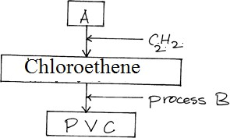

- Identify reagent A. (1mk)
………………………………………………………………………………………………………………
- Name process B (1mk)
………………………………………………………………………………………………………………
- What does PVC stand for? (1mk)
………………………………………………………………………………………………………………
- One of the disadvantages of hard water is wastage of soap.
- State one other disadvantage (1mk)

- The table below shows tests carried out in a sample of water and the results obtained.

Sample | Results | observations
A | Addition of sodium  hydroxide drop wise until excess | Whit precipitate which dissolves in excess
B | Addition of excess ammonia solution | White precipitate
C | Addition of dilute nitric  (V) acid followed by barium chloride | White precipitate
- Identify the anion present in the water sample (1 Mark)
………………………………………………………………………………………………..
- Write an ionic equation for the reaction in C (1 Mark)
………………………………………………………………………………………………

- A piece of sodium was burnt in excess oxygen gas. The product obtained was shaken with water to make a solution.
- Write a balanced equation for reaction between the product formed and water. (1 mark)

……………………………………………………………………………………………………………
…………………………………………………………………………………………………………

- State and explain the observation made when red and blue litmus papers are dipped into the solution.
(2 marks)
……………………………………………………………………………………………………………

…………………………………………………………………………………………………………

- Aluminium chloride and sodium chloride are both chlorides of period 3 elements in the periodic table. Use this information to explain the following observations.
- A solution of Al2Cl6 in water turns blue litmus paper red while that of sodium Chloride does not.
(1½ marks)
……………………………………………………………………………………………………………

…………………………………………………………………………………………………………….

- Sodium chloride has a melting point 801ºC is while Al2Cl6 sublimes 183ºC. (1½ marks)

- The ionization energies of elements A and B are 495.9kJ/mol and 739.9kJ/ mol respectively.
Both elements are in the same group of the periodic table.

- What is ionization energy? (1 mark)
……………………………………………………………………………………………………………

…………………………………………………………………………………………………………

- Compare the reactivity of elements A and B . Explain your answer. (2 marks)
……………………………………………………………………………………………………………

…………………………………………………………………………………………………………

- Study the information given in the table below and answer the questions below.

Bond | Bond energy(kJ/mol)
C-H | 413
H-Cl | 431
C-Cl | 346
Cl-Cl | 244
C – C | 347

- Calculate the enthalpy change for the reaction below.
C2H6 (g) + Cl2 (g) → CH3CH2Cl (g) + HCl (g) (2 marks)

- State a condition required for the reaction in (a) above to take place. (1 mark)

- The diagram below represents a set-up that can be used to obtain nitrogen gas in the laboratory. Use the information
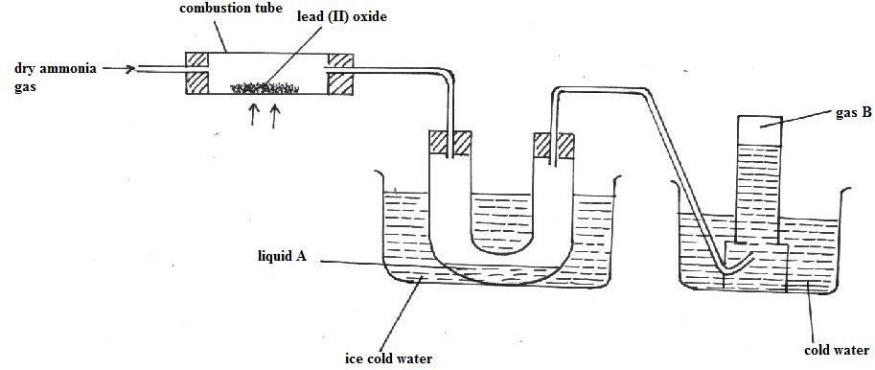
on the diagram to answer the questions that follow

- Describe the chemical test for liquid A. (1 mark)

- What observation is made in the combustion tube during the reaction? (1 mark)
……………………………………………………………………………………………………………
…………………………………………………………………………………………………………
- State two uses of gas B. (1 mark)
……………………………………………………………………………………………………………
…………………………………………………………………………………………………………

- a) State Graham’s law of diffusion. (1mk)
………………………………………………………………………………………………………………
………………………………………………………………………………………………………………
………………………………………………………………………………………………………………
b) 50cm³ of nitrogen (ii) oxide was allowed to diffuse through a porous membrane in 20 seconds. Calculate the time taken by equal volume of carbon (ii) oxide to diffuse through the same membrane. (C=12, N=14, O=16). (2mks)
………………………………………………………………………………………………………………
………………………………………………………………………………………………………………
………………………………………………………………………………………………………………
………………………………………………………………………………………………………………
………………………………………………………………………………………………………………

- Nitrogen (IV) oxide dissolves and reacts with Sodium hydroxide solution to form two salts and water.
- What is the nature of Nitrogen (IV) oxide? {1 mark}

……………………………………………………………………………………………………………

- Write the Ionic equation for the reaction that takes place. {1 mark}
……………………………………………………………………………………………………………

……………………………………………………………………………………………………………

- When powdered brass was reacted with excess dilute sulphuric (VI) acid, a solid residue was left.
- Name the residue. (1 mark)

- Explain why the residue was left. (1 mark)

- State another observation made (1 mark)

- During manufacture of sulphuric (vi) acid, sulphur (iv) oxide is oxidised to sulphur (vi) oxide in the presence of vanadium oxide catalyst as shown below:
The reaction is carried out at a pressure of 3 atmospheres and a temperature of 450⁰C. State and explain the effect on the yield of sulphur (vi) oxide if the reaction is:
- Carried out at 3 atmospheres and 600⁰C. (2mks)
………………………………………………………………………………………………………………
………………………………………………………………………………………………………………
………………………………………………………………………………………………………………
- In absence of a catalyst. (2mks)
………………………………………………………………………………………………………………
………………………………………………………………………………………………………………
………………………………………………………………………………………………………………

