**MID TERM SERIES-TERM 1-2023**

**CHEMISTRY PAPER 1 (233/1)**

**FORM FOUR (4)**

**TIME: 2 HOURS**

**MARKING SCHEME**

**INSTRUCTIONS TO CANDIDATES**

* *Write your* ***name, admission number, date, index number*** *and school in the spaces provided*
* *Answer* ***all*** *the questions in the spaces provided*
* *All working* ***MUST BE*** *clearly shown where necessary*
* *Scientific calculators may be used*
* *Candidates should answer the questions in English*

***FOR EXAMINER’S USE ONLY***

|  |  |  |
| --- | --- | --- |
| **Questions** | ***Maximum score*** | ***Candidate’s score*** |
| **1 – 28** | 80 |  |

1. (a) Mass increases; copper combines with oxygen in air to form copper (II) oxide which has more mass.

(b) Mass decreases; coper (II) nitrate decomposes into copper (II) oxide, nitrogen (IV) oxide and oxygen gas. The nitrogen (IV) oxide and oxygen escape into the atmosphere and the residue has less mass.

1. (a) Graham’s law of diffusion states that at constant temperature and pressure, the rate of diffusion of a gas is inversely proportional to the square root of its density.

(b)

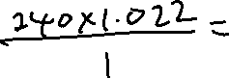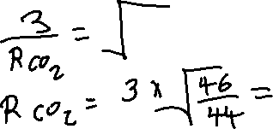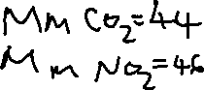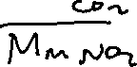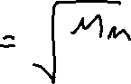

1. (a) U.V. Light

(b)

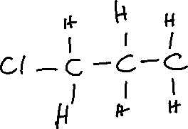

1. Acetylene/ ethyne OR hydrogen
2. C and E. they have the same atomic number.

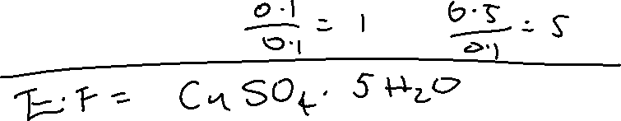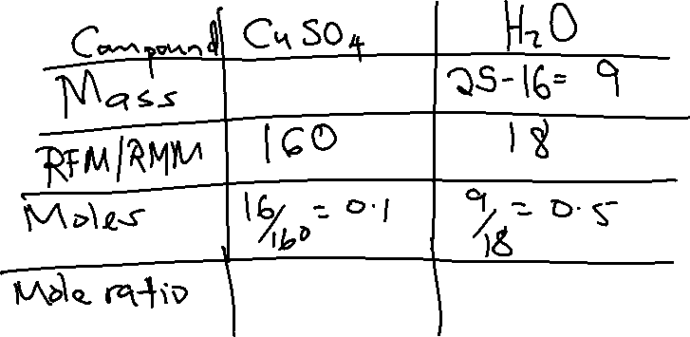

1. (a) III

(b) I or IV. Aluminium oxide is amphoteric.

(c) 1 and IV

1. Sodium chloride has a giant ionic structure with strong ionic bonds between the ions which require a lot of energy to break compared with the weak Van der Waals forces of attraction between the molecules of hydrogen chloride molecules which require less energy to break.
2. i. K

ii. M

iii. L

iv. J

1. (a)
2. Downward delivery / upward displacement of air
3. Upward delivery / downward displacement of air

(b) P is denser than air while Q is less dense than air

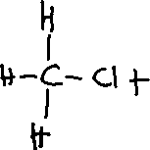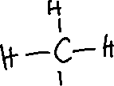

1. (a) There was no heating.

(b) Aluminium forms a layer or aluminium oxide which coats the metal surface preventing further reaction.

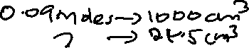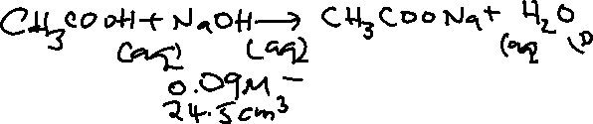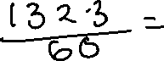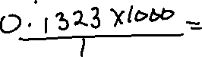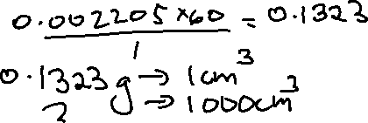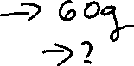

1. (a) Carbon (IV) oxide

(b) C (s) + O2 (g) → CO2 (g) Carbon reacts with oxygen in air to form carbon (IV) oxide.

1. Add water to the mixture and stir thoroughly to dissolve sodium chloride. Filter the mixture to obtain copper (II) oxide as the residue and sodium chloride solution as the filtrate. Heat the filtrate to saturation and allow it to cool to form crystals. Pour out the mother liquor and dry the crystals between filter papers.



1. (i) Sulphur (IV) oxide / oxygen
2. Oxygen / sulphur (IV) oxygen
3. To prevent moisture from entering the apparatus since moisture would quickly dissolve the sulphuric (IV) acid.
4. A brown solution is formed. Chlorine is more reactive than bromine hence it displaces bromide ions from the solution to aqueous bromine.
5. (i) Al2Cl3



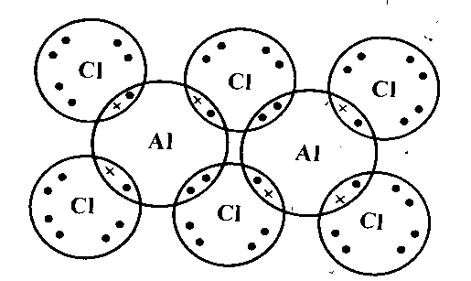



1. 2Mg (s) + O2 (g) → 2MgO (s)
2. (a) Salt bridge

(b) E cell = E reduced – E oxidized

= +0.80 – (-0.13) = +0.93 V

1. (i) S (s) + 6HNO3 (aq) → H2SO4 (aq) + 6 NO2 (g) + H2O (l)

(ii) Concentrated nitric (V) acid

1. - Oxides of nitrogen such as nitrogen (IV) oxide react with rainwater in the atmosphere to form acid rain.

* Nitrates from nitrogenous fertilisers find their way into water bodies causing rapid growth of algae which causes reduction in oxygen content resulting in death of aquatic animals.
* The presence of nitrates in drinking water may cause ill health to humans since the nitrates are converted to carcinogenic compounds.

1. (a)

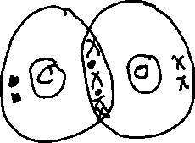

(b)

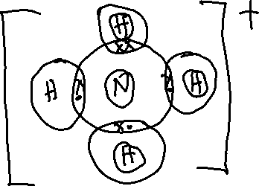

1. Place 2 cm3 of the suspected solutions in separate test tubes. To each test tube add sodium hydroxide solution dropwise until in excess. A pale blue precipitate that is insoluble in excess is formed in the test tube containing a solution with copper (II) ions. A green precipitate that is insoluble in excess sodium hydroxide is formed in the test tube containing a solution with iron (II) ions.
2. (a) A black charred mass is formed. Concentrated sulphuric (VI) acid is a strong dehydrating agent and removes elements of water from the sugar leaving a mass of carbon.

(b) Blue copper (II) sulphate crystals changed to white. Concentrated sulphuric (VI) acid is a strong dehydrating agent and removes the water of crystallisation from the crystals leaving anhydrous copper (II) sulphate.

1. Mass of solution: 100 + 100 = 200 cm3 x 1.0 g/cm3 = 200g

200g / 1000 = 0.2 kg

Enthalpy change = 0.2kg x 4.2 kJkg-1K-1 x 6.85K = 5.754kJ

Moles of sodium hydroxide

1 mole → 1000cm3

? → 100 cm3

(100 x 1)/1000 = 0.1 moles

0.1 moles → 5.754kJ

1 mole → ?

(1 x 5.754) /0.1 = 57.54kJ/mol

= -57.54kJ/mol

1. (a) Residue

(b) solubility of the solid in water

1. SO32-

S + 3(-2) = -2

S – 6 = -2

S = -2 + 6 = +4

1. SO3

S + 3(-2) = 0

S – 6 = 0

S = +6

1. S2O32-

2S + 3 (-2) = -2

2S – 6 = -2

2S = -2 +6

2S = +4

S = +4 /2

S = +2