Name: …………………………………ADM……………Stream………Index No…………
School: ……………………………Candidate’s Sign. …………..............Date: …………….

233/1
CHEMISTRY
PAPER 1
AUGUST 2021
TIME: 2 HOURS

BURAMU 2 JOINT EXAMINATION 2021

Kenya Certificate of Secondary Education (K.C.S.E.)

Chemistry
Paper 1
Marking scheme

INSTRUCTIONS TO THE CANDIDATES:-

- Write your name, admission number, index number and school in the spaces provided.
- Answer all the questions in the spaces provided.
- Mathematical tables and electronic calculators may be used
- All working MUST be clearly shown where necessary.

For Examiner’s Use Only
Question | Maximum score | Candidate’s score
1-28 | 80

1. Two elements R and Q have their ionic configuration 2.8 and 2.8.8. They are found in group six and group 1 respectively in the periodic table. Write down the electronic configuration of their neutral atoms.
(i) R 2.8.6 √ ½ ( ½ marks )

Q 2.8.8.1 √ ( ½ mark )
(ii) Give the formula of the compound formed when R and Q combine. ( 1 mark)
Q₂ R√1
(iii) The compound in (ii) above was dissolved in water. What would be the effect
on a blue litmus paper dipped into resulting solution? Explain. ( 1 mark)
Blue litmus paper changes to red √ ½
Reason: Solution formed is acidic √ ½
2. The following is a chromatogram showing the results obtained after separating two
substances P and T.

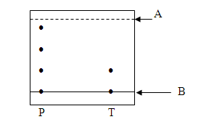

A Solvent front √ ½ ( ½ mark )

B Baseline √ ½ ( ½ mark )
(b) Name a possible solvent which can be used in the above process. ( 1 mark)
Propanone, ethanol √1
(Any one @ 1 mark )
(c ) Which of the two substances is pure? ( 1 mark)
T √1
3. An oxide of metal M contains 59% of metal M and 41% oxygen. Given that the relative formula mass of the oxide is 78, determine its relative molecular formula. (3 marks)
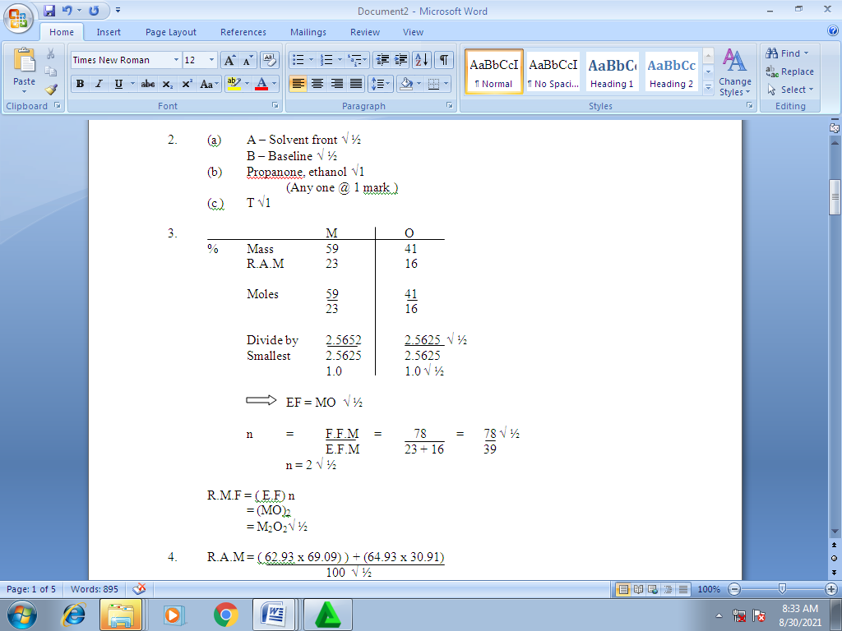
4. The table shows the relative atomic masses and the percentage abundance of the isotopes L₁ and L₂ of the element L.
Isotope | Relative atomic mass | % abundance
L₁ | 62.93 | 69.09
L₂ | 64.93 | 30.91

Calculate the R.A.M of element L. (2 marks )
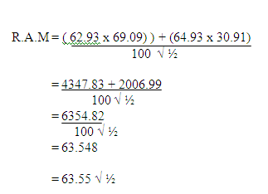
5. Study the flow chart below and answer the questions that follow.
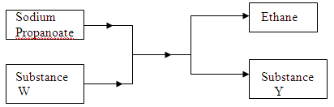
Name substances:
(i) W soda lime√1 (1 mark )

(ii) Y sodium carbonate√1 ( 1 mark)

6. The set up below was used by a student to prepare sulphur (IV) oxide gas in the laboratory. Study it and answer the questions that follow;

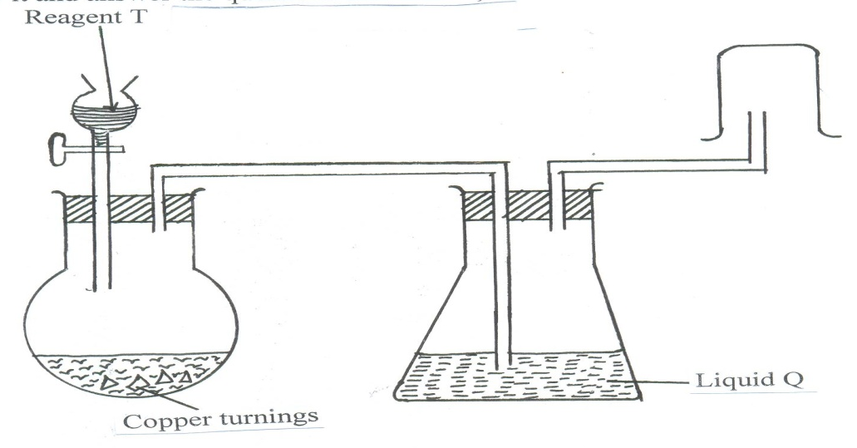

(a) Name: (i) Reagent T Conc. Sulphuric (VI) acid √1 ( 1 mark )

(ii) Liquid Q Conc. Sulphuric (VI) acid √1 (1 mark )
(b) State one mistake in the set-up. ( 1 mark)
Method of collection √1
(c ) What observation is made when sulphur (IV) oxide is passed through potassium
chromate solution? ( 1 mark )
Colour changes from orange to green √1
7. Distinguish between a co-ordinate bond and a covalent bond. (2marks
In co-ordinate bond shared pair of electrons forming the bond is contributed by only one √1 of the atoms while covalent bond, both atoms contribute equal number of electrons √1 to the shared region
8. A student in form 4 was provided with the following polymer.

H H H H H H

C C C C C C

H H H H H H

(a) Name the polymer (Polyethene√1 ( 1 mark)
(b) Draw the structure of the monomer. (1 mark )
H H

C C √1

H H
(c ) Name the type of reaction that take place during the formation of the polymer.(1 mark)
Self-addition reaction √1
9. Describe an experimental procedure that can be used to separate water and oil. (2marks)
  - Put the mixture into the separatory funnel, two layers are formed, the denser liquid below while the lighter liquid above
  - Open the tap to remove most of the lower liquid and close
  - Open the tap again to obtain the interphase and discard
  - Open the tap again to obtain the remaining upper liquid

10. Write equations to show the effect of heat on each of the following.
(a) Sodium hydrogen carbonate. (1 mark)
2NaHCO_{3 (s)} Heat Na₂ CO_{3 (s)} + CO_{2 (g)} + H₂O _{(g)}
(b) Silver nitrate (1 mark)
Ag NO_{3 (s)} Heat Ag _{(s)} + NO_{2 (g)} + O_{2 (g)} √1
(c ) Anhydrous iron (II) sulphate ( 1 mark )
2FeSO_{4 (s)} Heat Fe₂O₃ + 2SO_{2 (g)} + SO_{3 (s)} √1
11. The flow chart below shows some properties of two allotropes of element P.
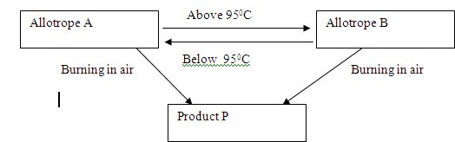

i) Name the allotrope A. (1mk)
Rhombic
ii) W rite an equation to show formation of product P. (1mk)
Monoclinic
iii) What does 95⁰C represent? (1mk)
Transition temperature
12. Starting from calcium carbonate, describe how a solid sample of calcium sulphate can be prepared. (3mks)
React CaCO₃ with dil HNO₃ or HCl✓ ½
- Filter the mixture ✓ ½
- Add a soluble sulphate to the filtrate ✓ ½
- Filter the mixture ✓ ½ the residue is CaSO₄.
- Wash the residue with distilled ✓ ½ H2O and dry ✓ ½

13. The scheme below shows some reaction sequence starting with solid N. Study it and
answer the questions that follow.
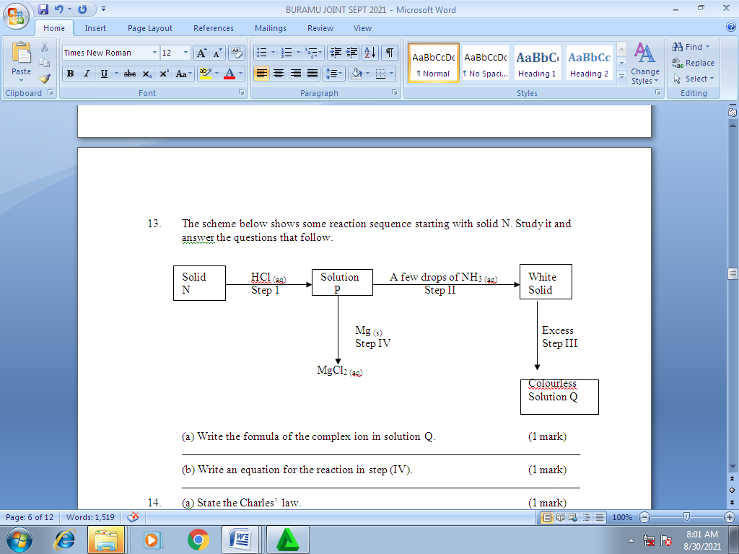
(a) Write the formula of the complex ion in solution Q. (1 mark)
Zn (NH₃)₄²⁺
(b) Write an equation for the reaction in step (IV). (1 mark)
(b) ZnCl_{2 (aq)} + Mg _{(s)} MgCl_{2 (aq)} + Zn _{(s)}√1
14. (a) State the Charles’ law. (1 mark)
At constant pressure, the volume of a fixed mass of a gas is directly proportional to its absolute temperature √1
(b) A certain mass of gas occupies 146dm³ at 291K and 98.31kPa. What will be its
temperature if its volume is reduced to 133dm³ at 101.325 kPa? (2 marks )
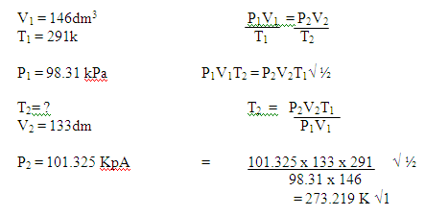
15.The set up below was used by students to collect dry chlorine gas.
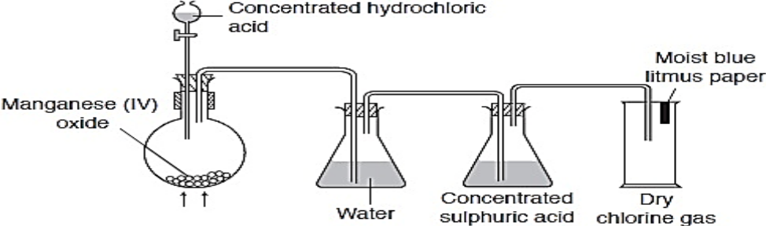
KMnO₄
- Give the function of water in the set up (1mks)
Absorb hydrogen chloride fumes
b) Write an equation for the reaction that produces chlorine gas (1 mark)
MnO2_{(s)} + 4HCl_{(aq)} MnCl₂ _{(aq)} + 2H2O+ Cl_{2(g)}
c) Give another reagent that can be used in the place of potassium manganate.
Potassium dichromate (vi)
16. A student used the set up shown in the diagram in order to study the reaction of some metals with steam. The experiment was carried out for ten minutes.
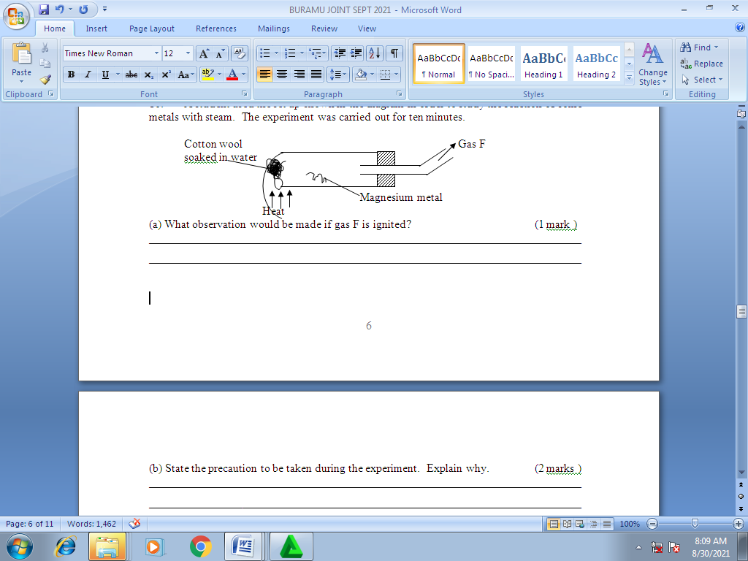
(a) What observation would be made if gas F is ignited? (1 mark )
Blue flame
(b) State the precaution to be taken during the experiment. Explain why. (2 marks )
- Magnesium, should not be heated before cotton wool soaked in water.
- Avoid air trapped in the boiling tube reacting with magnesium metal.
17. Study the information in the table below and answer the questions that follow.
(The letters do not represent the actual symbols of the elements)
Element | Electronic configuration | Ionization energy Kj/mol)
P | 2.2 | 1800
Q | 2.8.2 | 1450
R | 2.8.8.2 | 1150
- What is the general name given to the group in which elements P, Q and R belong?
Alkaline earth metals (1 mark)
(b) Explain why P has the highest ionization energy (1 mark)
P has the smallest atomic radius hence experiences highest nuclear attraction.
(c) Write a balanced chemical equation for the reaction between element Q and water
Q(s) + 2H₂O(aq) Q(OH)₂(aq) +H₂(g) (1mark)
18. The table below shows the electrical conductivity of substance A, B and C
Substance | Solid state | Molten state | Aqueous solution
A | Conducts | Conducts | Not soluble
B | Doesn’t conduct | Conducts | Conducts
C | Doesn’t conduct | Doesn’t conduct | Not soluble

- Which one of the substance is likely to be plastic? (1 mark)
C
- Which of the substances is likely to be sodium chloride? Explain (1 mark)
B, only conducts when ions are set free (molten and aqueous states)
- Give the type of structure and bonding that is present in substance A (1 mark) metallic bond, giant metallic structure

19. Draw a set up that can be used to prepare and collect oxygen gas using hydrogen peroxide and manganese (iv) oxide ( 3marks)

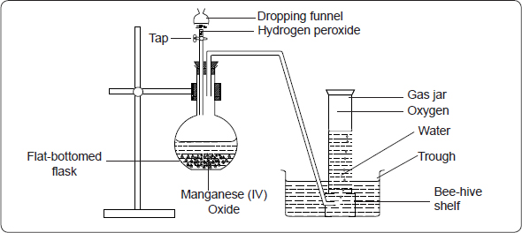

20. The table below shows the P^{H} values of solutions J to N
Solution | J | K | L | M | N
P^{H} | 5 | 13 | 2 | 10 | 7
b) Which solution.
i) Contains the largest concentration of hydroxide ions? (1mk)
K ½ mk
ii) Is likely to be a solution of acetic acid? (1mk)
J ½ mk
b) In the equation below, identify the reagent that acts as an acid in the forward reaction. Give a reason. (2mks)
NH₄⁺_{(aq})+H₂O_{(l)} NH_{3(aq)}+H₃O⁺_{(aq)}
NH4⁺, Proton donor
21. State and explain what would be observed when hydrogen gas is passed over heated copper (II) oxide in a combustion tube. (3mks)
.Black powder turns brown and colourless liquid forms on cooler parts✓1
H₂ reduces CuO to Cu✓1 metal while H₂ is oxidized to water ✓1
22.. The set- up below was used to investigate the rate of diffusion of different gases.
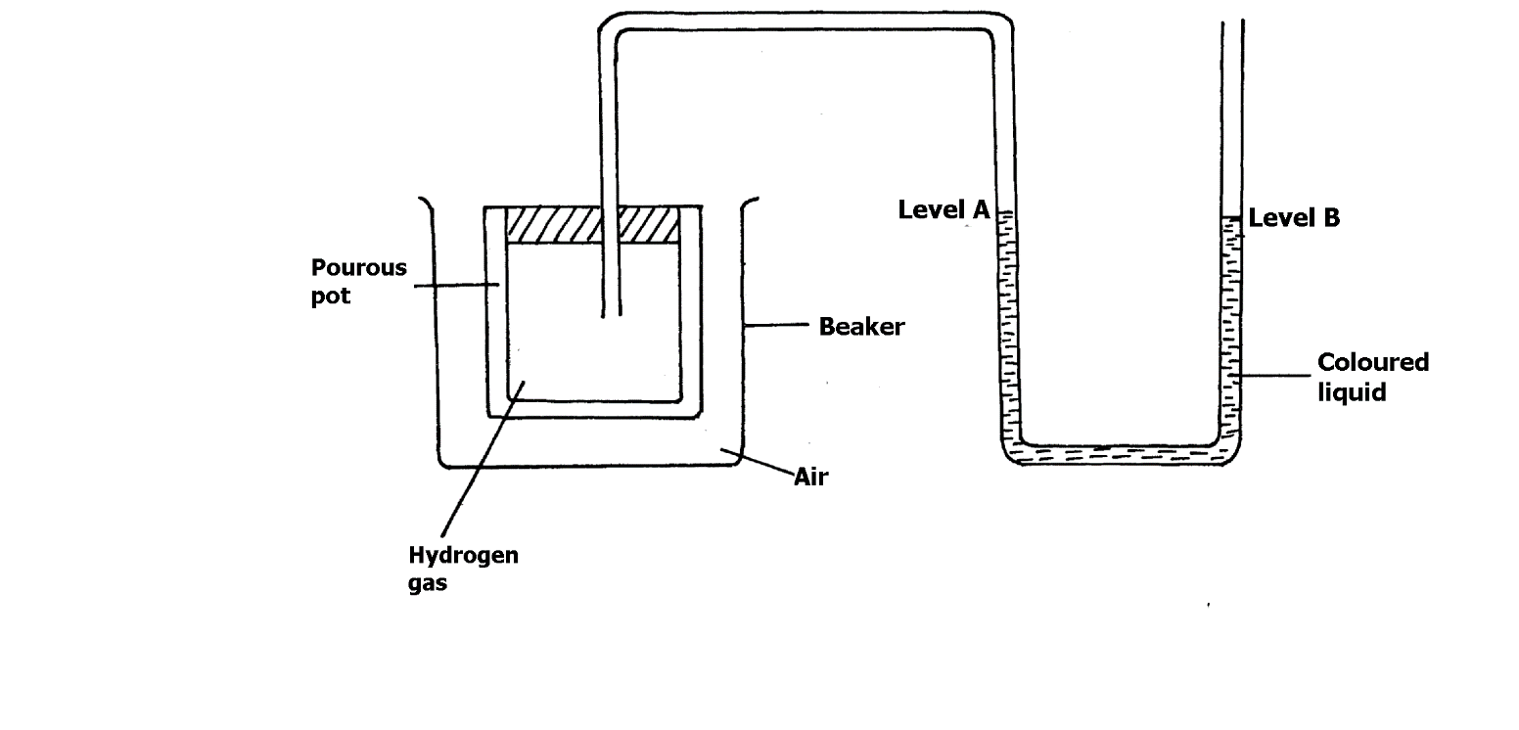
- Explain why a coloured liquid is used in this experiment. (1mk)
Easily viscible✓1
b) State and explain the observation made after 20 minutes. (2mks)
Observation level A rises up ½ while level B fall ½ down. H₂ being lighter / less denser than air diffuses out of the porous pot faster ✓ ½ than the rate which air diffuses into the porous pot. This result to decrease in pressure in the porous pot ✓ ½
23. Study the information in the table below and answer the questions that follow.
Salt Solubility ( g/100g water )
At 30⁰C at 70⁰C
CuSO₄ 28 38
AgNO₃ 79 98
A mixture containing 36g of CuSO₄ and 78g of AgNO₃ in 100g of water at 70⁰C was cooled to 30⁰C.
(a) Which salt crystallized out? Give a reason. (2 marks )
CuSO₄
Only 28g of CuSO₄ can dissolve at 30⁰C or
79g of AgNO₃ can dissolve and only 78g were used at 30⁰C.
(b) Calculate the mass of the salt that crystallized. ( 1 mark)
38g – 28g = 10g
24. (a) Name two cations that are present in hard water. (1 mark)
Magnesium ion
Calcium ion
(b) State two advantages of hard water. (2 marks )
Calcium ions present are used in bone formation.
- Formation of scale in lead pipes prevents wearing out of the pipe.
25. Concentrated nitric (V) acid was added to iron (II) sulphate acidified with dilute sulphuric (VI) acid and the mixture heated. The solution turned from pale green to yellow with evolution of a brown gas.
Explain the observation. (2 marks )
Iron (II) ions which is green are oxidized to iron (III) ions which are yellow.
Nitric (V) acid is reduced to nitrogen (IV) oxide which is brown in colour.
26. (a) What are acid-base indicators? (1 mark)
A substance that has one colour in acidic solution and different colour in a basic solution.
(b) Give two acid-base indicators and state the colour changes in acid and base solutions. (2 marks )
Name of indicator Colour in acid Colour in base

(i) Litmus paper red blue
(ii) (ii) Phenolphthalein colourless pink
27. Calcium oxide can be used to dry ammonia gas.
(a) Explain why calcium oxide is NOT used to dry hydrogen chloride gas. (2 marks )
Calcium oxide is basic hydrochloride gas is acid they will react together.
(b) Name one drying agent for hydrogen chloride gas. (1mark)
Concentrated sulphuric (VI) acid.

28. The diagram below shows a Bunsen burner.
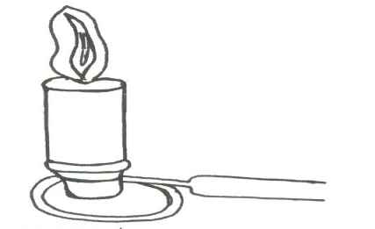
- Explain why it is advisable to Put off a non-luminous flame when not in use (1 mark)
It is not easily seen and very hot hence can accidentally burn the user.

(b) When lighting a Bunsen burner, it is advisable to strike the lighter before switching on the gas, explain why. (1 mark )
To prevent accumulation of the gas that can easily cause a fire outbreak

