Name………………………………………………………. Index No…………………/…….
School……………………………………………………… Candidates Signature………………
Date ………………………………..

233/1
CHEMISTRY
Theory
Paper 1
SEPTEMBER 2021
2 Hours
PRE-MOCK
JOINT EVALUATION TEST - 2021
Kenya Certificate of Secondary Education (K.C.S.E)

INSTRUCTIONS TO CANDIDATES
- Write your name and Index Number in the spaces provided above.
- Sign and write date of examination in the spaces provided above.
- Answer all questions in the spaces provided in the question paper.
- KNEC Mathematical tables and silent non-programmable electronic calculators may be used.
- All workings must be clearly shown where necessary.
- This paper consists of 12 printed pages
- Candidates should check the question paper to ascertain that all the pages are printed as indicated and that no questions are missing.
- Candidates should answer the questions in English.

For Examiners Use Only

1 |  | 2 |  | 3 |  | 4 |  | 5 |  | 6 |  | 7 |  |  | 8 |  | 9 |  | 10 |  | 11 |  | 12 |  | 13 |  |  | 14 |  | 15 | 16
17 |  | 18 |  | 19 |  | 20 |  | 21 |  | 22 |  | 23 |  |  |  |  |  |  |  |  |  |  |  |  | Grand  Total

- Silicon and carbon are both group IV elements. Silicon (IV) oxide is a solid at room temperature which melts at 1973K while carbon (IV) oxide is a gas and melts at 217K. In terms of structure and bonding, explain the difference. (2 marks)
…………………………………………………………………………………………………………
…………………………………………………………………………………………………………
…………………………………………………………………………………………………………
…………………………………………………………………………………………………………
…………………………………………………………………………………………………………
- When sodium carbonate is added to a solution containing Al³⁺_{(aq)} ions, effervescence is observed. Explain (2 marks)
…………………………………………………………………………………………………………
…………………………………………………………………………………………………………
…………………………………………………………………………………………………………
…………………………………………………………………………………………………………
- An element Q can be represented as 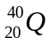 (Q is not the actual symbol of the element)
  - Write the electron configuration of Q (1 Mark)
…………………………………………………………………………………………………….
  - To which group and period does Q belong? (1 Mark)
............................................................................................................................................................
  - Write the formula of the ion of Q. (1 Mark)
………………………………………………………………………………………………………
………………………………………………………………………………………………………
- (a) Sketch a graph demonstrating Charles’ law. (2 Marks)

volume

Temperature/⁰C

(b) A fixed mass of a gas has a volume of 250cm³ at a temperature of 27⁰C and 750mmHg pressure. Calculate the volume the gas would occupy at 42⁰C and 750mmHg. (2 Marks)
………………………………………………………………………………………………………
………………………………………………………………………………………………………
………………………………………………………………………………………………………
………………………………………………………………………………………………………
- The table below shows the trend in ionization energy for elements M, N and L. Use it to answer the questions that follows.
Element | First Ionization energy (kJ)
M | 494
N | 519
L | 418

  - Define ionization energy. (1 Mark)
…………………………………………………………………………………………………………
…………………………………………………………………………………………………………
…………………………………………………………………………………………………………
  - Which element has the smallest atomic radius? (1 Mark)
…………………………………………………………………………………………………………
…………………………………………………………………………………………………………
  - Which is the most reactive element? Explain. (2 Marks)
…………………………………………………………………………………………………………
…………………………………………………………………………………………………………
…………………………………………………………………………………………………………
- Identify acids and bases in the following reaction using Bronsted-Lowry theory. (2 Marks)
NH₄⁺_{(aq)} + OH⁻ _{(aq)} NH_{3(aq)} + H₂O_{(l)}

Acids:……………………………………………………………………………………………………
Bases:……………………………………………………………………………………………………
- (a) State Graham’s law of diffusion. (1 Mark)
…………………………………………………………………………………………………………
…………………………………………………………………………………………………………
…………………………………………………………………………………………………………
…………………………………………………………………………………………………………
…………………………………………………………………………………………………………
(b) 50cm³ of oxygen gas diffused through a porous plug in 80 seconds. How long will it take 100cm³ of carbon (IV) oxide gas to diffuse through the same plug? (3 Marks)
…………………………………………………………………………………………………………
…………………………………………………………………………………………………………
…………………………………………………………………………………………………………
…………………………………………………………………………………………………………
…………………………………………………………………………………………………………
- When hydrogen sulphide gas was bubbled into an aqueous solution of iron (III) chloride, a yellow precipitate was formed.
  - State another observation that was made. (1 Mark)
…………………………………………………………………………………………………………
…………………………………………………………………………………………………………
…………………………………………………………………………………………………………
  - Explain the observation above. (1 Mark)
…………………………………………………………………………………………………………
…………………………………………………………………………………………………………
…………………………………………………………………………………………………………
…………………………………………………………………………………………………………
…………………………………………………………………………………………………………
  - Write an equation for the reaction that took place. (1 Mark)
…………………………………………………………………………………………………………
…………………………………………………………………………………………………………
- Using equations, explain the observations made at the electrodes when an electric current is passed through molten Aluminium oxide. (3 Marks)
…………………………………………………………………………………………………………
…………………………………………………………………………………………………………
…………………………………………………………………………………………………………
…………………………………………………………………………………………………………
…………………………………………………………………………………………………………
- In a titration experiment, a student was provided with the following:-
- Solution R which was 0.408M HCl
- Solution S containing 6.9g of a metal carbonate M₂CO₃ in 250cm³ solution
Upon titration, 24.5cm³ of solution R was required to completely neutralize 25cm³ of solution S. Determine the following.
  - Molarity of solution S (2 Marks)
…………………………………………………………………………………………………………
…………………………………………………………………………………………………………
…………………………………………………………………………………………………………
…………………………………………………………………………………………………………
…………………………………………………………………………………………………………………………………………………………………………………………………………………….
  - Formula mass of M₂CO₃ (2 Marks)
…………………………………………………………………………………………………………
…………………………………………………………………………………………………………
…………………………………………………………………………………………………………
…………………………………………………………………………………………………………
…………………………………………………………………………………………………………
  - Relative atomic mass of M (1 Mark)
…………………………………………………………………………………………………………
…………………………………………………………………………………………………………
…………………………………………………………………………………………………………
…………………………………………………………………………………………………………
- Compounds A and B have the same molecular formula C₃H₆O₂. Compound A liberates carbon (IV) oxide gas on addition of aqueous sodium carbonate while compound B does not. Compound B has a pleasant smell. Name and draw the structural formulae of A and B. (4 Marks)
…………………………………………………………………………………………………………
…………………………………………………………………………………………………………
…………………………………………………………………………………………………………
…………………………………………………………………………………………………………
…………………………………………………………………………………………………………
- The set up below was used by a form 3 student to study the difference in rates of diffusion between ammonia (NH₃) and carbon (IV) oxide(CO₂) gases. Study it and answer the questions that follow.
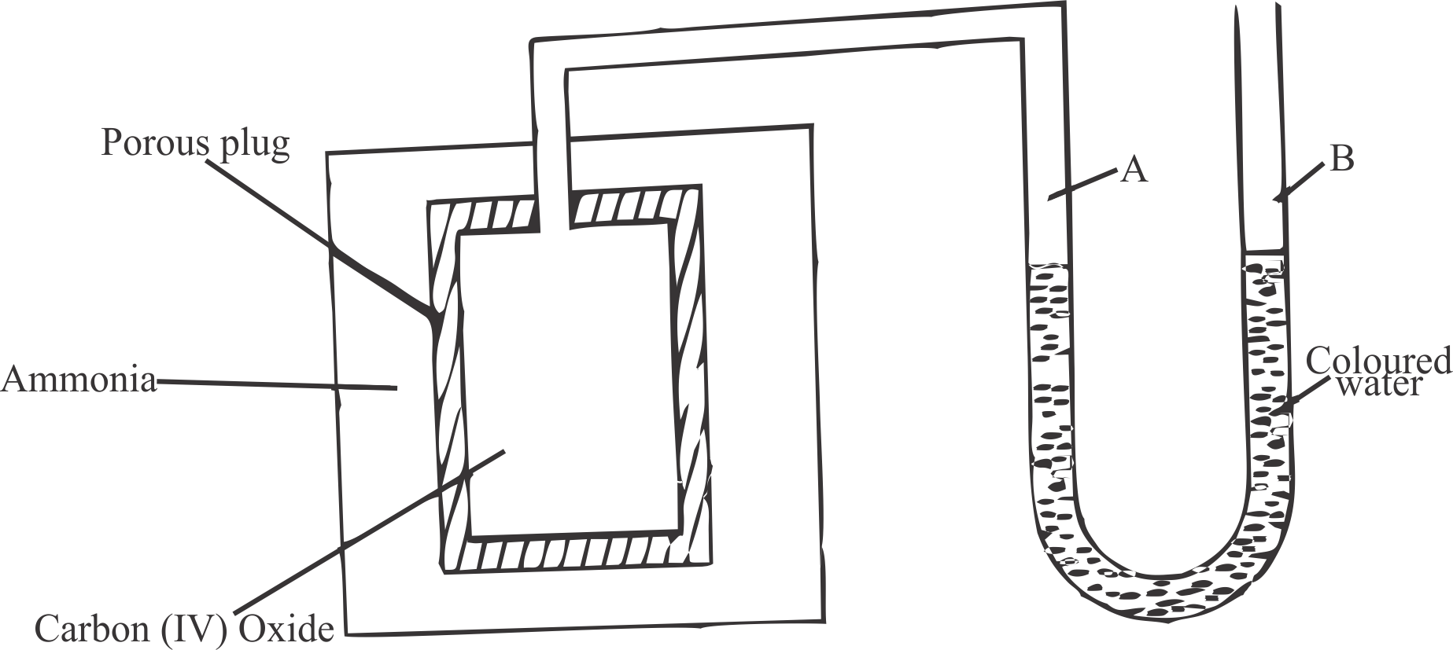
State and explain the observation made on the level of coloured water in the arms A and B on the U tube as the experiment progressed. (3 Marks)
…………………………………………………………………………………………………………
…………………………………………………………………………………………………………
…………………………………………………………………………………………………………
…………………………………………………………………………………………………………
…………………………………………………………………………………………………………
- 2.1g of a compound of carbon and hydrogen burns to form 6.6g of carbon (IV) oxide and 2.7g of water.
- Determine the empirical formula of this compound (C=12, H=1, O=16) (2 Marks)
…………………………………………………………………………………………………………
…………………………………………………………………………………………………………
…………………………………………………………………………………………………………
…………………………………………………………………………………………………………
………………………………………………………………………………………………………………………………………………………………………………………………………………………...
b) Given that the molecular mass of the compound is 42, determine its molecular formula (1 mark)
…………………………………………………………………………………………………………………………………………………………………………………………………………………………………………………………………………………………………………………………………………………………………………………………………………………………………………………………………………………………………………………………………………………………………

- To which group of organic compounds does the compound belong? (1 Mark)
…………………………………………………………………………………………………………
…………………………………………………………………………………………………………
- Study the diagram below and answer the questions that follow.
Solution of a sodium salt
Solid V
Gas W which turns K₂Cr₂O₇ paper from orange to green
BaCl_{2(aq)}
HCl_{(aq)}

  - Name
    - Solid V ………………………………………………………....................... (1 Mark)
    - Gas W ………………………………………………………………………. (1 Mark)
  - Write an equation for reaction between solid V and dilute hydrochloric acid. (2 Marks)
…………………………………………………………………………………………………………
…………………………………………………………………………………………………………
…………………………………………………………………………………………………………
- Starting with solid aluminium sulphate, describe how a solid sample of aluminium hydroxide could be prepared. (3 Marks)
…………………………………………………………………………………………………………
…………………………………………………………………………………………………………
…………………………………………………………………………………………………………
…………………………………………………………………………………………………………
…………………………………………………………………………………………………………
- (a) A burning magnesium ribbon continues to burn in a jar of nitrogen gas but a burning splint is
extinguished. Explain (1 Marks)
…………………………………………………………………………………………………………
…………………………………………………………………………………………………………
…………………………………………………………………………………………………………
(b) Using equations explain what happens when concentrated nitric (V) acid is reacted with wood charcoal. (2 Marks)
…………………………………………………………………………………………………………
…………………………………………………………………………………………………………
…………………………………………………………………………………………………………
…………………………………………………………………………………………………………
…………………………………………………………………………………………………………

- (a) State Gay Lussac’s law. (1 Mark)
…………………………………………………………………………………………………………
…………………………………………………………………………………………………………
…………………………………………………………………………………………………………
(b) 10cm³ of a gaseous hydrocarbon were mixed with 33cm³ of oxygen gas which was in excess. The mixture was exploded and after cooling to room temperature, the residual volume of gas occupied 28cm³. On adding concentrated potassium hydroxide the volume decreased to 8cm³.
Work out the molecular formula of the hydrocarbon (3 Marks)
…………………………………………………………………………………………………………
…………………………………………………………………………………………………………
…………………………………………………………………………………………………………
…………………………………………………………………………………………………………
…………………………………………………………………………………………………………
- (a) What are isotopes? (1 Mark)
…………………………………………………………………………………………………………
…………………………………………………………………………………………………………
…………………………………………………………………………………………………………
(b) Lithium has two isotopes 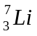and 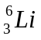 Determine the number of neutrons in . (1 Mark)
…………………………………………………………………………………………………………
…………………………………………………………………………………………………………
…………………………………………………………………………………………………………
…………………………………………………………………………………………………………
(c) If the relative atomic mass of lithium is 6.94. Which of the two isotopes is more abundant. Give a reason. (2 Marks)
…………………………………………………………………………………………………………
…………………………………………………………………………………………………………
…………………………………………………………………………………………………………
…………………………………………………………………………………………………………
………………………………………………………………………………………………………………………………………………………………………………………………………………………………………………………………………………………………………………………………………………………………………………………………………………………………………………………………………………………………………………………………………………………………………………………………………………………………………………………………………………………………………………………………………………………………………………………………………………………………………………………………………………………………………...

- The diagram below represents a set of apparatus used to study properties of chlorine water.
  - Name two components of chlorine water. (1 Mark)
…………………………………………………………………………………………………………
…………………………………………………………………………………………………………
…………………………………………………………………………………………………………
  - Write an equation for the reaction that produces gas W. (1 Mark)
…………………………………………………………………………………………………………
…………………………………………………………………………………………………………
  - The following test was carried out on chlorine water contained in a test tube. A piece of blue flower was dropped in the test tube. Explain why the flower was bleached. (2 Marks)
…………………………………………………………………………………………………………
…………………………………………………………………………………………………………
…………………………………………………………………………………………………………
…………………………………………………………………………………………………………
- The diagram below shows part of a synthetic polymer. Study it and answer the questions that follow.
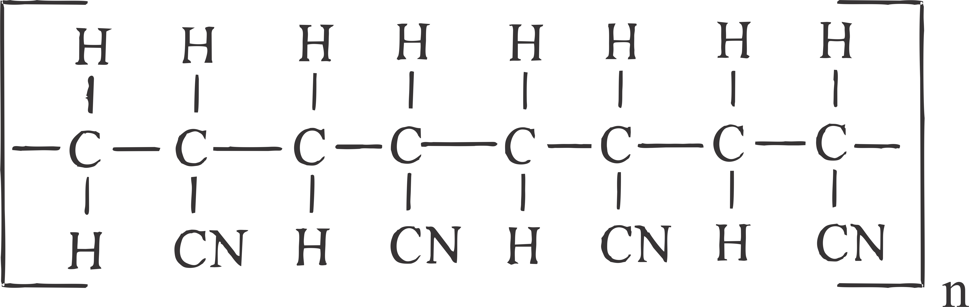
  - Draw the structural formula of the monomer from which the polymer is made. (1 Mark)
…………………………………………………………………………………………………………
…………………………………………………………………………………………………………
…………………………………………………………………………………………………………
…………………………………………………………………………………………………………
…………………………………………………………………………………………………………

  - A sample of the polymer has a molecular mass of 63600. Calculate the number of monomers in the sample. (2 Marks)
…………………………………………………………………………………………………………
…………………………………………………………………………………………………………
…………………………………………………………………………………………………………
…………………………………………………………………………………………………………
…………………………………………………………………………………………………………
  - Methanol has molecular mass of 32 while ethane has a molecular mass of 30. The boiling point of methanol is 65ºC while that of ethane is -89ºC. Explain (2 Marks)
…………………………………………………………………………………………………………
…………………………………………………………………………………………………………
…………………………………………………………………………………………………………
…………………………………………………………………………………………………………
…………………………………………………………………………………………………………
- Study the reaction scheme below and answer the question that follows:-
HCl_{(aq)}
Solid N
Colourless gas that ignites with a pop sound
Excess NH_{3(aq)}
Colourless solution T
Solution Y
White precipitate G
Colourless solution L
White precipitate H
Excess NaOH_{(aq)}
Few drops of Ammonia solution
Few drops of NaOH_{(aq)}

  - Name solid N. (1 Mark)
…………………………………………………………………………………………………………
…………………………………………………………………………………………………………
  - State the observation that would be made if solution Y is mixed with lead (II) nitrate solution. (1 Mark)
…………………………………………………………………………………………………………
…………………………………………………………………………………………………………
…………………………………………………………………………………………………………

  - Write an ionic equation for the formation of the colourless solution T. (1 Mark)
…………………………………………………………………………………………………………
…………………………………………………………………………………………………………
…………………………………………………………………………………………………………
  - Name the ion present in colourless solution L. (1 Mark)
…………………………………………………………………………………………………………
…………………………………………………………………………………………………………
- The setup below was used to prepare dry hydrogen gas. Study it and answer the questions that follow.
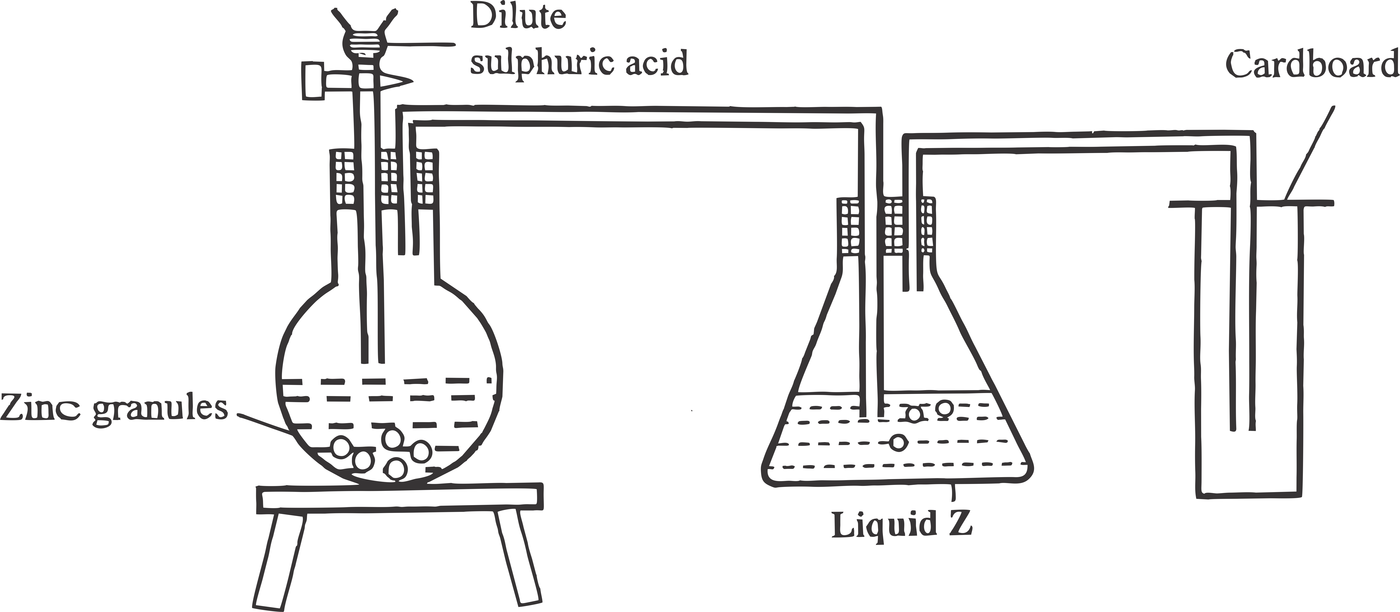
  - Identify one mistake in the setup above. (1 Mark)
…………………………………………………………………………………………………………
…………………………………………………………………………………………………………
  - What is the role of liquid Z? (1 Mark)
…………………………………………………………………………………………………………
…………………………………………………………………………………………………………
…………………………………………………………………………………………………………
  - Using an equation give one chemical property of hydrogen gas. (1 Mark)
…………………………………………………………………………………………………………
…………………………………………………………………………………………………………
…………………………………………………………………………………………………………
- (a) Define solubility. (1 Mark)
…………………………………………………………………………………………………………
…………………………………………………………………………………………………………
…………………………………………………………………………………………………………
(b) In an experiment to determine the solubility of solid W in water at 40ºC, the following results were obtained.
- Mass of empty evaporating dish = 36.2g
- Mass of evaporating dish + saturated solution = 52.4g
- Mass of evaporating dish + dry solid W = 40.4g
Use this data to calculate the solubility of W at 40ºC. (2 Marks)
…………………………………………………………………………………………………………
…………………………………………………………………………………………………………
…………………………………………………………………………………………………………
…………………………………………………………………………………………………………
…………………………………………………………………………………………………………

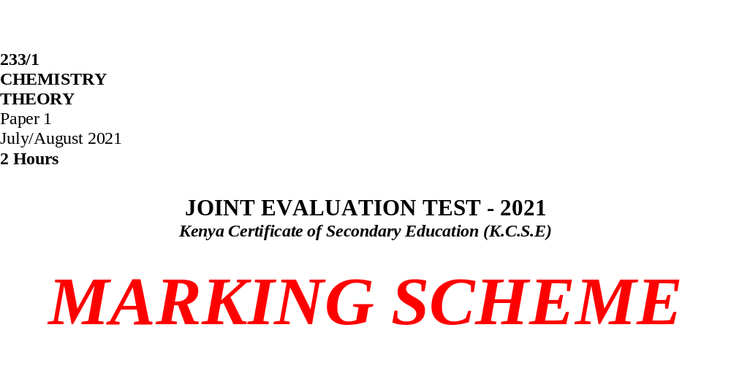

- Silcon and carbon are both group IV elements. Silcon (IV) oxide is a solid at room temperature which melts at 1973K while carbon (IV) oxide is a gas and melts at 217K. In terms od structure and bonding, explain the difference. (2 Marks)
Carbon (IV) oxide has a simple molecular structure with weak van der waals forces which require little energy to break while silcon (IV) oxide has a giant atomic structure with strong covalent bonds which require more energy to break.
- When sodium carbonate is added to a solution containing Al³⁺_{(aq)} effervescence is observed. Explain (2 Marks)
The solution is acidic containing 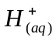 which reacts with the CO₃²⁻
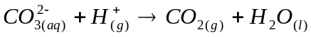

- An element Q can be represented as (Q is not the actual symbol of the element)
  - Write the electron configuration of Q. 2.8.8.2 (1 Mark)
  - To which group and period does Q belong? Group II Period 4 (1 Mark)
  - Write the formula of the ion of Q. 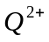 (1 Mark)
- (a) Sketch a graph demonstrating Charles’ law. (2 Marks)
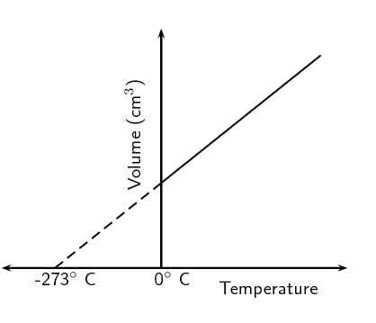
(b) A fixed mass of a gas has a volume of 250cm³ at a temperature of 27ºC and 750mmHg pressure. Calculate the volume the gas would occupy at 42ºC and 750mmHg. (2 Marks)
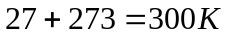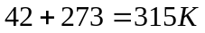
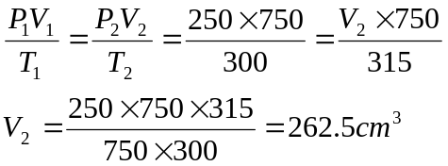
- The table below shows the trend in ionization energy for elements M,N,L. Use it to answer the questions that follows.
Element | First Ionization energy (kJ)
M | 494
N | 519
L | 418

  - Define ionization energy. (1 Mark)
Minimum amount of energy required to remove electron from atom in its gaseous state
  - Which element has the smallest atomic radius? (1 Mark)
N
  - Which is the most reactive element? Explain. (2 Marks)
L-Requires the least energy to lose an electron
- Identify acids and bases in the following reaction using Bronsted-Lowry theory. (2 Marks)
ACID | BASES
NH₄⁺  H₂O | OH⁻  NH₃

- (a) State Graham’s law of diffusion. (1 Mark)
Under the same conditions of temperature and pressure, the rate of diffusion of a gas is inversely proportional to the square root of its density.
(b) 50cm³ of oxygen gas diffused through a porous plug in 80 seconds. How long will it take 100cm³ of carbon (IV) oxide gas to diffuse through the same plug? (3 Marks)
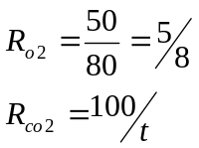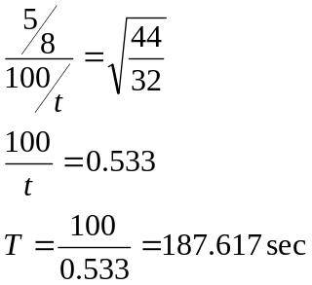
- When hydrogen sulphide gas was bubbled into an aqueous solution of iron (III) chloride, a yellow precipitate was formed.
  - State another observation that was made. (1 Mark)
The yellow solution turns green
  - Explain the observation above. (2 Marks)
Hydrogen sulphide is a reducing agent. It reduces the yellow Fe³⁺ ions to green Fe²⁺. H₂S is oxidized to Sulphur (yellow deposit)
  - Write an equation for the reaction that took place. (1 Mark)
- Using equations, explain the observation made at the electrodes when an electric current is passed through molten Alminium oxide. (3 Marks)
Anode
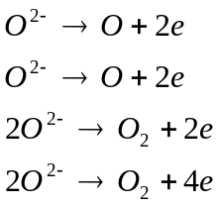Colourless gass that relights a glowing splint
Cathode
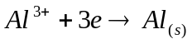 grey solid deposited
- In a titration experiment, a student was provided with the following:-
- Solution R which was 0.408M HCl
- Solution S containing 6.9g of a metal carbonate M₂CO₃ in 250cm³ solution
Upon titration, 24.5cm³ of solution R was required to completely neutralize 25cm³ of solution S. Determine the following.
  - Molarity of solution S (2 Marks)
Moles in 24.5cm³ HCl
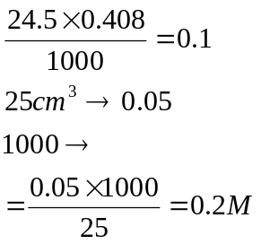
  - Formula mass of M₂CO₃ (2 Marks)
  - Concentration of M₂CO₃ in g/l 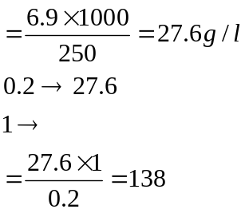
l. Relative atomic mass of M (1 Mark)
M₂CO₃ = 138
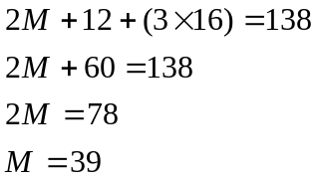
- Compounds A and B have the same molecular formulae C₃H₆O₂. Compound A liberates carbon (IV) oxide gas on addition of aqueous sodium carbonate while compound B does not. Compound B has a pleasant smell. Name and draw the structural formulae of A and B. (4 Marks)

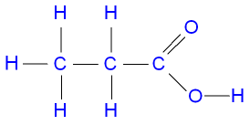Propanoic acid
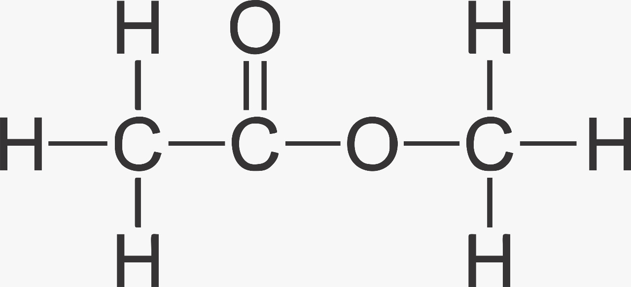Methylethanoate
- The set up below was used by a form 3 student to study the difference in rates of diffusion between ammonia (NH₃) and carbon (IV) oxide gases. Study it and answer the questions that follow.
State and explain the observation made on the level of coloured water in the arms A and B on the U tube as the experiment progressed. (3 Marks)
RMM of NH₃ 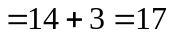
RMM of CO₂ 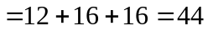
The level of coloured water in arm A of the U-Tube dropped and rose in arm b. Ammonia has lower density that CO₂ as it has a lower RMM and hence it diffused into the porous plug at a higher rate than the rate at which CO₂ diffused out of the porous plug creating a region of higher pressure inside the plug.
- 2.1g of a compound of carbon and hydrogen burns to form 6.6g of carbon (IV) oxide and 2.7g of water.
  - Determine the empirical formulae of this compound (C=12, H-1, O=16) (2 Marks)
RFM of CO₂ 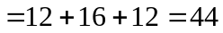
RMM of H₂O 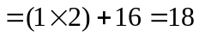
Mass of C 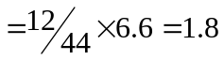
Mass of H 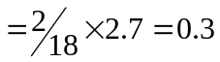

ELEMENT | C | H
Mass in grams | 1.8 | 0.3
R.A.M | 12 | 1
Mole ratio | 0.15 | 0.3
Simplest ratio | 1 | 2
EF = CH₂
  - Given that the molecular mass of the compound is 42, determine its molecular formula
14n =42
n=3
MF (CH₂)₃ = C₃H₆
  - To which group of organic compounds does the compound belong. (1 Mark)
Alkenes
- Study the diagram below and answer the questions that follow.
Solution of a sodium salt
Solid V
Gas W which turns K₂Cr₂O₇ paper orange to green
BaCl_{2(aq)}
HCl_{(aq)}

  - Name
    - Solid V Barium Sulphite (1 Mark)
    - Gas W Sulphur (IV) oxide (1 Mark)
  - Write an equation for reaction between solid V and dilute hydrochloric acid. (2 Marks)
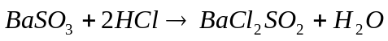
- Starting with aluminium sulphate describe how a solid sample of aluminium hydroxide could be prepared. (3 Marks)
- Add distilled water to aluminium sulphate to dissolve
- Add aqueous ammonium hydroxide to aluminium sulphite solution to precipitate aluminium hydroxide.
- Filter and wash the residue with distilled water
- Dry it between papers
Note: NaOH cannot be used because of the amphoteic Al(OH)₃ will dissolve in excess.
- A burning magnesium ribbon continues to burn in a jar of nitrogen gas but a burning splint is
extinguished. Explain (1 Marks)
Heat produced by the burning magnesium is strong enough to break the triple bond in the nitrogen molecule forming free nitrogen atoms which react with magnesium. Heat produced by burning wooden splint is not strong enough to break the triple bond.
(b) Using equations explain what happens when concentrated nitric (V) acid is heated with wood charcoal. (2 Marks)
- (a) State Gay Lussac’s law. (1 Mark)
When gases combine they do so in volumes that bear a simple ratio to one another and to the products is gaseous, provided that the temperature and pressure are kept constant.
(b) 10cm³ of a gaseous hydrocarbon were mixed with 33cm³ of oxygen gas which was in excess. The mixture was exploded and after cooling to room temperature, the residual volume of gas occupied 28cm³. On adding concentrated potassium hydroxide the volume decreased to 8cm³.
Work out the molecular formular of the hydrocarbon (3 Marks)
1mole x+^{y}/₄ moles x moles ^{y}/₂ moles
1Vol x+^{y}/₄ Vol xVol
10cm³ 25cm³ 20cm³
1 2.5 2
x=2
x+^{y}/₄ = 2.5
y=2

- (a) What are isotopes? (1 Mark)
Atoms of the same element which have the same atomic number but different mass number
(b) Lithium has two isotopes and determine the number of neutrons in . (1 Mark)
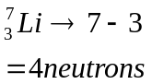
(c) If the relative atomic mass of lithium is 6.94. Which of the two isotopes is most abundant. Give a reason. (2 Marks)
x% | (100-x)%
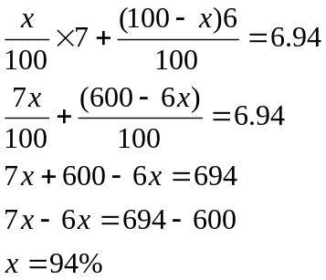 is the most abundant

94% | 6%
- The diagram below represents a set of apparatus used to study properties of chroline water.
  - Name two components of chroline water. (1 Mark)
- Chloric (I) acid
- Hydrochloric acid
  - Write an equation for the reaction that produces gas W. (1 Mark)
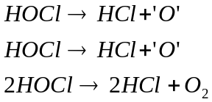
  - The following was carried out on chroline water contained in test tubes. A piece of blue flower was dropped in the test tube. Explain why the flower was bleached. (2 Marks)
- Chloric (I) acid HOCl in water decomposes to form atomic oxygen.
- Atomic Oxygen oxidises the coloured flowers to white hence bleaching the
- The diagram below shows part of a synthetic polymer. Study it and answer the questions that follow.
  - Draw the structural formula of the monomer from which the polymer is made. (1 Mark)

H H
C = C
H CN
  - A sample of the polymer has a molecular mass of 63600. Calculate the number of monomers in the sample. (2 Marks)
RMM of monomer 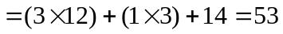
Number of monomers 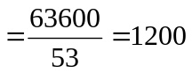
  - Methanol has molecular mass of 32 while ethane has a molecular mass of 30. The boiling point of methanol is 65ºC while that of ethane is -89ºC. Explain (2 Marks)
Ethane molecules only have the weak van der waals farces while methanol have much stronger hydrogen bonds in addition to the van der waals forces.
- Study the reaction scheme below and answer the question that follows:-
  - Name solid N. Zinc metal (1 Mark)
  - State the observation that would be made if solution Y is mixed with lead (II) nitrate solution. (1 Mark)
White precipitate of Lead (II) chloride; dissolves on warming
  - Write ionic equations for the formation of white precipitate G and colourless solution T. (1 Mark)
G 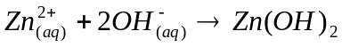
T 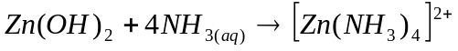
aa) Name the ion present in colourless solution L. (1 Mark)
Tetrahydroxozinc (II) 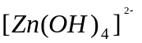
- The setup below was used to prepare dry hydrogen gas. Study it and answer the questions that follow.
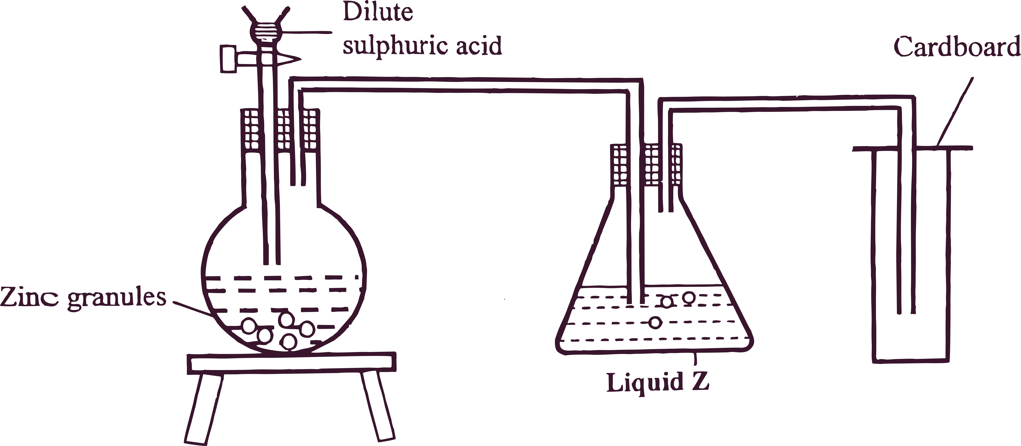
  - Identify one mistake in the setup above. (1 Mark)
Method of collection is incorrect
  - What is the role of liquid Z? (1 Mark)
Absorb moisture / water from hydrogen gas
  - Using an equation give one chemical property of hydrogen gas. (1 Mark)
Burns in oxygen to form water 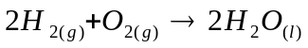
Reducing agent 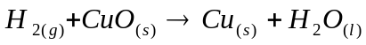
- (a) Define solubility. (1 Mark)
Maximum mass of a solute that can saturate 100g of water at a given temperature
(b) In an experiment to determine the solubility of solid W in water at 40ºC, the following results were obtained.
- Mass of empty evaporating dish = 36.2g
- Mass of evaporating dish + saturated solution = 52.4g
- Mass of evaporating dish + dry solid W = 40.4g
Use this data to calculate the solubility of W at 40ºC. (2 Marks)
Mass saturated solution 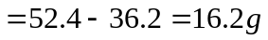
Mass of solute 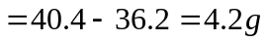
Mass of water 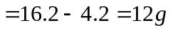
Solubility at 40ºC 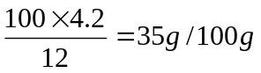 of water

