CHEMISTRY FORM 3
APRIL HOLIDAY ASSIGNMENT 2023
1. The graph below shows the behaviour of a fixed mass of a gas at constant temperature.
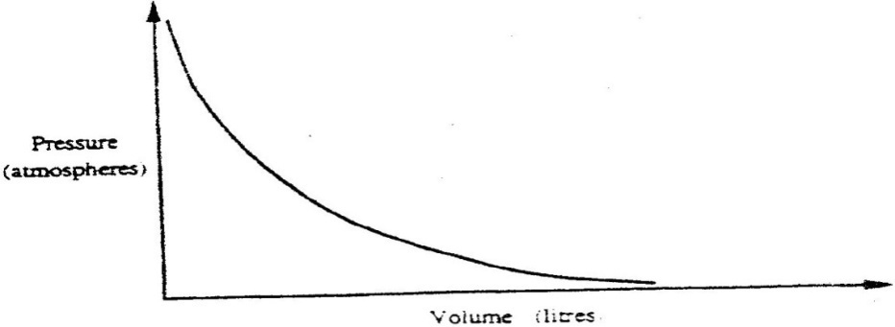

- What is the relationship between the volume and the pressure of the gas? (1mk)

- 3 litres of oxygen gas at one atmosphere pressure were compressed to two
atmospheres at constant temperature. Calculate the volume occupied by the oxygen gas (2mks)
2. When X cm³ of a solution of 0.5M magnesium carbonate was reacted with excess hydrochloric acid 8.4g of carbon (IV) oxide gas was evolved.

- Write the ionic equation for the reaction that took place(1mk)
- Calculate the value of X. (C = 12.0, Mg 24.0; 016.0 (2mks

3 .Using dots (.) and crosses(x) to represent electrons, show bonding in the compounds formed when the following elements react:
a) Sodium and chlorine (2mks)
b) Silicon and chlorine (2mks)
4. Use the information in the table below to answer the questions that follow. (The letters do not represent the actual symbols of the elements)

Element | B | C | D | E | F
Atomic number | 18 | 5 | 3 | 5 | 20
Mass number | 40 | 10 | 7 | 11 | 40

- Which two letters represent the same element? Give a reason. (2marks)

- Give the number of neutrons in an atom of element D (1 mark)
5. When a hydrocarbon was completely burnt in oxygen, 4.2g of carbon (IV) oxide and 1.71 g of water were formed. Determine the empirical formula of the hydrocarbon
(H= 1.0 ; C=12.0 ; 0 = 16.0) (3 mks)
6. The table below shows the relative atomic masses and the percentage abundance of the isotopes L1 and L2 of element L. Calculate the relative atomic mass of L. (3mks)

isotopes | L1 | L2
relative atomic mass | 69.09 | 64.93
percentage abundance | 62.93 | 30.91

8. Study the information in the table below and answer the questions that follow. The letters do not represent the actual symbols of the elements)

Element | Electrical conductivity | Ductility | Action of water
A  B  C | Good  Good  Good | Good  Poor  Good | No reaction  No reaction  Reacts
Select an element which
(a) Is likely to be used in group II of the periodic table. (1mk)
(b) Could be used to make electric cables. (1mk)
(c) Likely to be graphite. (1mk)
9. (a) State the Gay Lussac’s law. (1mk)
(b) 10cm3 of a gaseous hydrocarbon C₂H_{x} required 30cm3 of oxygen for complete combustion .If steam and 20cm3 of carbon (IV) oxide were produced, what is the value of x. (2mk)
10. The diagram below shows the bonding between aluminium chloride and ammonia.
H Cl

H N Al Cl

H Cl

(a)Name the types of bonds that exist in the molecule (1mk)
(b)How many electrons are used for bonding in the molecule? (1mk)
11. The table below gives the number of electrons, protons and neutrons in particles.
Particle | Protons | Electrons | Neutrons
A | 6 | 6 | 6
B | 10 | 10 | 12
C | 12 | 10 | 12
D | 6 | 6 | 8
E | 13 | 10 | 14
F | 17 | 17 | 18
G | 8 | 10 | 8

- Which particle is likely to be a halogen? (1mk)
- What is the mass number of E? (1mk)
- Write the formula of the compound formed when E combines with G.(1mk)
- Name the type of bond formed in (iii)above.(1mk)
- How does the radii of C and E compare? Give a reason (2mk)
- Why would particle B not react with particle D? (1mk)

