ANESTAR SCHOOLS
NAME………………………………………………………ADM………………….CLASS………………….
CHEMISTRY
FORM 3
MID – TERM EXAM – 2022
TIME: 2Hours
Question | Mask
- 30 | 80
Answer all question s in the space provided
- The set up below can be used to prepare oxygen gas. Study it and answer the questions that follows:
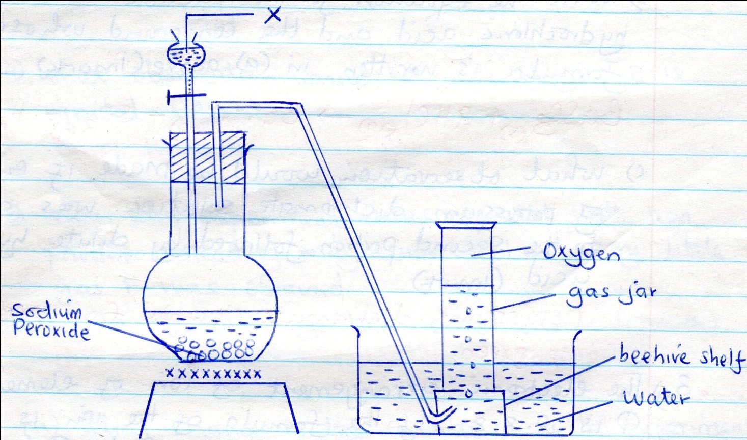
- Identify X (1mks)

- What property of oxygen makes it possible to be collected as shown in the above set up? (1mk)

- State two uses of oxygen (1mks)

- Potassium sulphate solution was prepared and divided into two portions. The first portion gave a white precipitate when reacted with barium nitrate. On addition of dilute hydrochloric acid, the white precipitate disappeared.
- Write the formula of the compound formed as the white precipitate. (1mks)

- Write the equation for the reaction between dilute hydrochloric acid and the compound whose formula is written in (a) above. (1mk)

- What observation would be made if one drop of potassium dichromate solution was added to the second portion followed by dilute hydrochloric acid? (1mks)

- .
- The electronic arrangement of ion of element Q is 2.8.8. If the formula of the ion is Q³⁻ state the group and period to which Q belongs. (1mk)

- Helium, neon and argon belong to group VIII of the periodic table. Give;
- The general name of these elements. (1mk)

- One use of these elements. (1mk)

- A student used the set up shown in the diagram below in order to study the reactions of some metals with steam. The experiment was carried out for ten minutes.
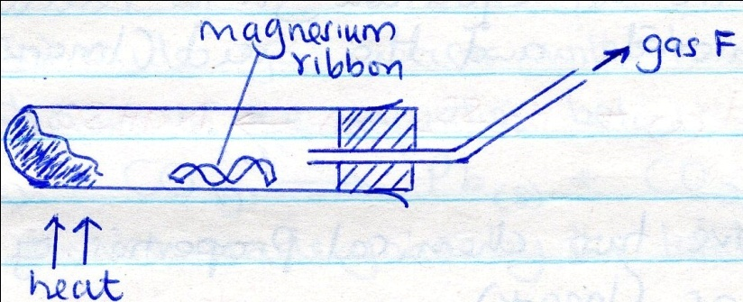
- What observation would be made if gas F is ignited? (1mk)

- When the experiment was repeated with iron powder instead of magnesium ribbon, very little gas F was obtained.
- Give a reason for this observation. (1mk)

- What change in the conditions of the experiment should the student have made in order to increase the volume of gas F produced? (1mk)

- .
- State any two differences between luminous and non – luminous flame. (2mks)

- Explain how the hotness of a Bunsen flame can be increased. (1mk)

- Hydrogen chloride gas can be prepared by reacting sodium chloride and an acid.
- Write an equation for the reaction between sodium chloride and the acid. (1mk)

- Give two chemical properties of hydrogen chloride gas. (1mk)

- State two uses of hydrogen chloride gas. (1mks)

- In an experiment to investigate the conductivity of substances, a student used the set up below.
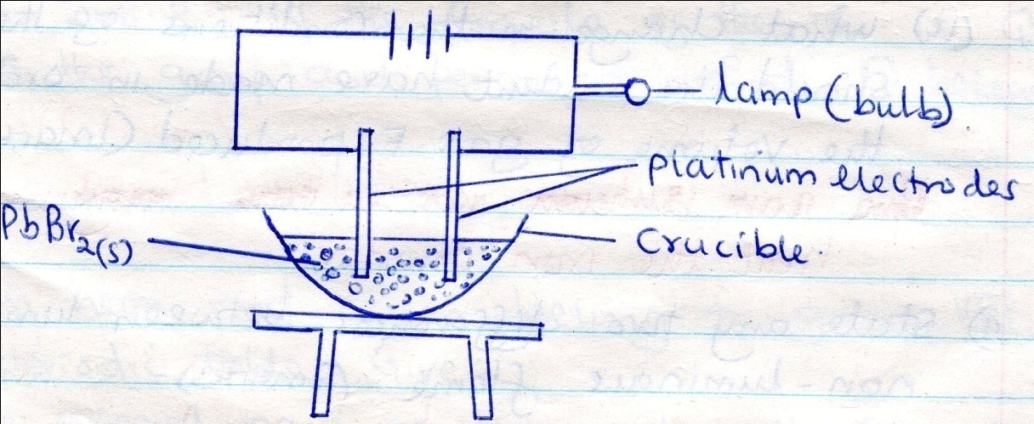

The student noted that the bulb did not light.
- What had been omitted in the set up? (1mk)
- Explain why the bulb light when the omission is collected. (2mks)

- Dry carbon (II) oxide gas reacts with heated lead (II) oxide as shown in the equation below.
PbO_{(s)} + CO_{(g)} Pb _{(s)} + CO_{2 (g)}
- Name the process undergone by the lead (II) oxide. (1mk)

- Give a reason for your answer in (a) above. (1mk)

- Name another gas that can be used to perform the same function as carbon (II) oxide. (1mk)

- The table below gives atomic numbers of elements represented by letter A, B,C, and D.
Element | A | B | C | D
Atomic number | 15 | 16 | 17 | 20
Use the information to answer the questions that follow.
- Name the type of bonding that exist in the compound formed when A and D react. (1mk)

- Select the letter that represents the best oxidizing agent. Give a reason for your answer. (2mks)

- The diagram below represents a relationship between the physical states of matter.

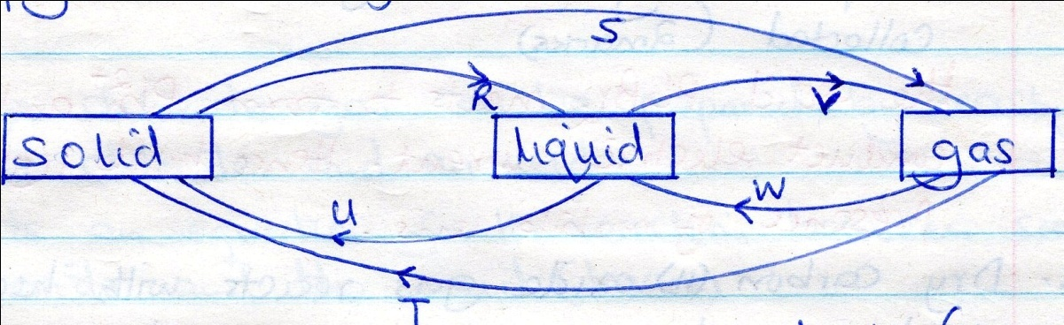

- Identify the process R,V,W and U. (2mks)

- Name one substance which can undergo process represented by letter S and T. (1mk)

- Starting with copper metal, describe how a sample of crystals of copper (II) chloride may be prepared in the laboratory. (3mks)

- .
- State Boyles’ law. (1mk)

- A gas occupies 500cm³ at 20⁰c and 100000pa. what will be its volume at 10⁰c and 101325pa. (3mks)

- Bromine reacts with ethane as shown below
C₂ H₆ + Br₂ C₂ H₅ Br + HBr
- What condition is necessary for this reaction to occur? (1mk)

- Write the structural formula of compound C₂H₅Br in the equation above. (1mk)

- State one major use of hydrogenation process. (1mk)

- Given the following substance; - wood ash, lemon juice, and sodium chloride
- Name one commercial indicator that can be used to show whether wood ash, lemon juice and sodium chloride are acidic, basic or neutral. (1mk)

- Classify the substance in (a) above as acids, bases or neutral (2mks)

- .
- Ammonia gas was passed into water as shown below.
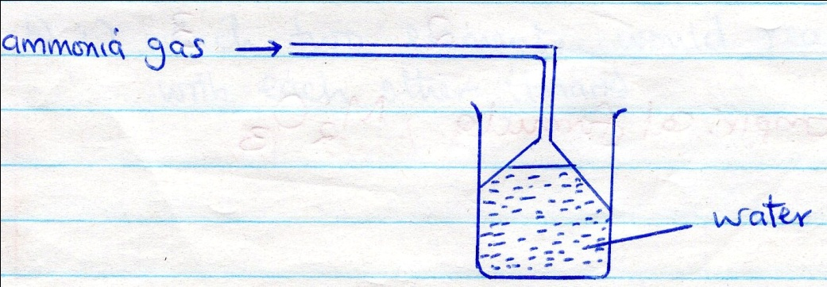

- Explain why the PH of the solution is above 7. (1mk)

- What is the use of the inverted funnel? (1mk)

- Explain why a high temperature is required for nitrogen to react with oxygen. (1mk)

- The data given below was recorded when metal M was completely burnt in air. M is not the actual symbol of the metal. (R.A.M; M =56, O =16)
Mass of empty crucible and lid = 10.24g
Mass of crucible, lid and metal M = 10.352g
Mass of crucible, lid and metal oxide = 10.4g
- Determine the mass of metal M. (1mk)

- Determine the mass of oxygen. (1mk)

- Determine the empirical of the metal oxide. (2mks)

- The structure of methanoic acid is as follows

O
H – C
O - H
- How many bonds have taken part in bonding to form this structure. (1mk)

- How many electrons have taken part in bonding? (1mk)

- When magnesium metal is burnt in air, it reacts with both oxygen and nitrogen gases giving a white ash. Write two equations for the reactions that take place. (2mks)

- The table below gives the atomic numbers of element W, X, Y and Z. the letters are not the actual symbols of the elements.

Element | W | X | Y | Z
Atomic number | 9 | 10 | 11 | 12
- Which one of the elements is least reactive? Explain. (1mk)

- .
- Which two elements would react most vigorously with each other? (1mks)

- Give the formula of the compound formed when the elements in b(i) react. (1mk)

- .
- What is meant by Isomerism? (1mk)

- Give the systemic names of the following organic compounds.
- CH₃ – C(CH₃) (Br) – CH (Br) CH₃ (1mk)

- CH_{3 –} CH - CH CH₂ CH₃ (1mk)

CH₃ CH₃

- ,
- Give a reason why concentrated sulphuric (vi) acid is not used to dry ammonia gas. (1mk)

- Name one suitable drying agent for ammonia gas. (1mk)

- In a laboratory experiment hydrogen gas was passed over heated copper (II) oxide as shown in the diagram below.
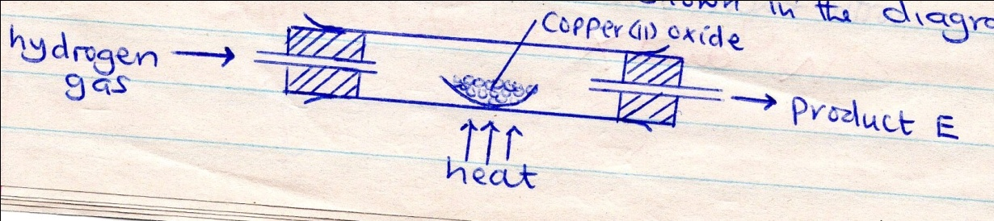
Describe a chemical test that can be used to identify the product E. (2mks)

- State and explain what would happen if a dry red litmus paper was dropped in a gas jar of dry chlorine. (2mks)

- .
- State Graham’s law of diffusion. (1mk)

- The molar masses of gases W and X are 16.0 and 44.0 respectively. If the rate of diffusion of W through a porous material is 12cm³/sec. calculate the rate of diffusion of X through the same material. (2mks)

- The isotopes of oxygen are ¹⁶₁₈O and ¹⁸₈O.
- What are Isotopes? (1mk)

- Determine the number of neutrons in ¹⁸₈O. (1mk)

- When potassium nitrate is heated, it produces potassium nitrite and gas C.
- Identify gas C (1mk)

- Name the type of reaction undergone by potassium nitrate. (1mk)

- Carbon and sulphur exhibit allotropy.
- Name the two allotropes of sulphur. (1mk)

- Which allotrope of carbon is the only non – metal electrical conductor? (1mk)

- When solid A was heated strongly, it gave water and a solid residue. When water was added to the solid residue, the original solid A was formed.
- What name is given to the process described? (1mk)

- Give one example of solid A. (1mk)

- Oleum (H₂S₂O₇) is an intermediate product in the Industrial manufacture of sulphuric (vi) acid.
- How is Oleum converted into sulphuric (vi) acid. (1mk)

- Give one use of sulphuric (vi) acid. (1mk)

- The table below shows the first ionization energy of elements B and C.
Element | Ionisation energy KJmol⁻¹
B | 494
C | 736
What do these values suggest about the reactivity of B compared to that of C? (2mks)

