FORM ONE CHEMISTRY HOLIDAY ASSIGNMENT
NAME............................................................ ADM ................................... CLASS.................

1.Dilute hydrochloric acid can react with calcium carbonate,copper (II) Oxide and magnesium metal to form some products (1 marks)
i) Write the word equation for the above reaction between calcium carbonate and dilute hydrochloric acid (1 marks)
ii) Write the word equation for the above reaction between magnesium metal and dilute hydrochloric acid (1 marks)
iii) Write a word equation for the above reaction between copper II Oxide and dilute hydrochloric acid (1 marks)
2. Name the method that can be used to separate the following
i) Ethanol and water mixture(1mrk)
ii) Kerosene and water mixture(1mrk)
iii) Common salt and iodine mixture (1mrk)
3. In temperate countries,salt is sprayed on roads to melt ice and clear roads but the long term effect on this practice is costly to motorist.
i) Explain the importance of applying the ice(1mrk)
ii) Explain the long term effect of the above practice on cars(1mrk)
4. Air is a mixture of gases. State the air component which supports combustion. (1 mark)
............................................................................................................................................................
5. Air was passed through several reagents as shown below.
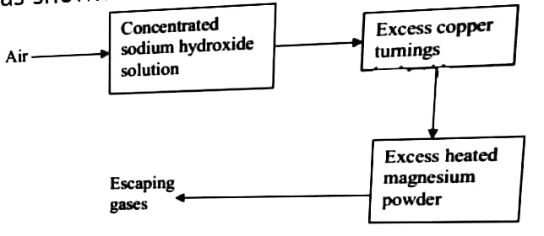
a) Name the air components removed by:
i) Concentrated sodium hydroxide solution (1 mark)
............................................................................................................................................................
ii) Excess heated copper turnings. (1 mark)
............................................................................................................................................................
b) Write a chemical equation for the reaction taking place at chamber with excess heated magnesium powder (1 mark)
............................................................................................................................................................
c) Name one gas which escapes the chamber containing magnesium powder. (1 mark)
............................................................................................................................................................
6. The set-up below can be used to prepare oxygen in the laboratory. Study it carefully and answer questions that follow.
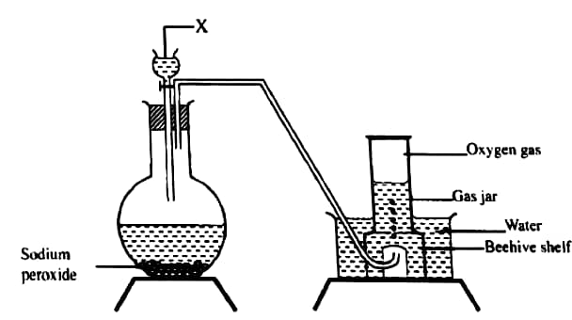
a) Identify substance x. (1 mark)
............................................................................................................................................................
b) Write a balanced chemical equation for the reaction at the round-bottomed flask. (1 mark)
............................................................................................................................................................
c) State and explain the method of gas collection as illustrated in the above set-up. (1 mark)
............................................................................................................................................................
7. Define a catalyst. (1 mark)
............................................................................................................................................................
8.a) What is rust. (1 mark)
............................................................................................................................................................
b) Explain how aluminium paint prevents rusting on iron. (1 mark)

9. The figure below shows an iron bar which supports a bridge. The iron bar is connected to a piece of magnesium metal.
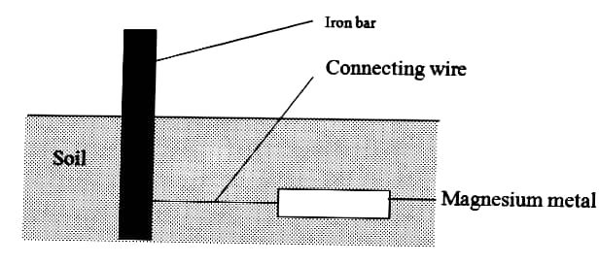
Explain why it is necessary to connect the piece of magnesium metal to the iron bar. (2 marks)
10. Study the set-up in the figure below and then answer the questions that follow.
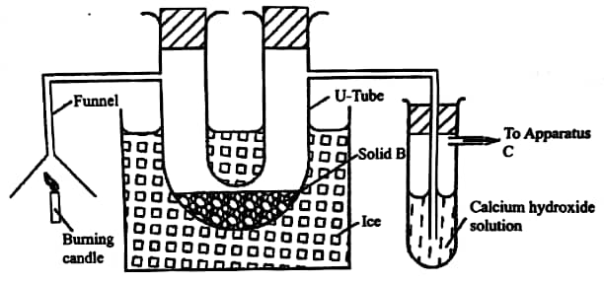
a) At the end of the experiment solid B changed from white to blue. Explain. (2 marks)
............................................................................................................................................................
b) The other product of burning candle formed a white precipitate with calcium hydroxide solution. Write an equation for the reaction. (1 mark)
............................................................................................................................................................
c) State the role of apparatus C. (1 mark)
............................................................................................................................................................

11.a) Name the solution and the catalyst used in preparation of oxygen in the laboratory.
(2 marks)
b) Write a chemical equation for the above reaction. (1 mark)
12. In an experiment to determine the proportion of oxygen in air, copper turnings were packed in excess in a long combustion tube connected to two syringes of 120cm³ in volume. Syringe R contained 120cm³ of air while syringe S was closed and empty as shown below.
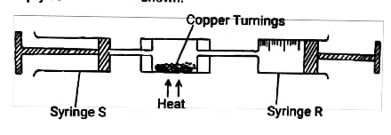
Air was passed over heated turnings slowly and repeatedly until there was no further change. In volume, 95.5 cm³ of air remained in syringe R.
a) Why was copper turnings packed in excess? (1 mark)
b) State one observation made in the combustion tube during the experiment. (1 mark)
c) Write an equation for the reaction which took place in the combustion tube. (1 mark)
d) Determine the percentage of air used up during the reaction. (2 marks)

13. Describe an experiment to show there is increase in mass when magnesium is heated in air.
(2 marks)
14. State one advantage of rusting. (1 mark)
15. Name the substance formed when:
i) Phosphorus smoulders in excess oxygen (1 mark)
ii) Sulphur is heated strongly in a crucible. (1 mark)
16. Study the set-up below and answer the questions that follow. 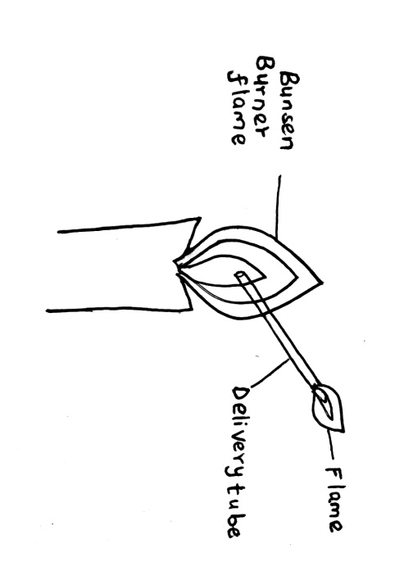
a) What does the experiment demonstrate? (1 mark)
b) Name the type of flame produced in the above set-up. (1 mark)
17. Explain why it is advisable to set Bunsen burner to luminous flame prior to an experiment.
(1 mark)
18. Give a method used to separate a mixture of:
a) chlorophyll and xanthophylls (1mark)
b) sodium chloride and iodine. (1 mark)
c) coloured water and paraffin (1 mark)
18. Write the chemical symbols of the following elements (4 marks)
a) Magnesium
b) Manganese
c) Potassium
d) Cobalt
19. State four safety laboratory rules. (4 marks)
20. a) Define the term drug (1 mark)
b) List four commonly abused drugs that are illegal. (4 marks)
c) State two harmful effects brought about by abuse of drugs (2 marks)
21. State two applications of solvent extraction. (2 marks)
22 Outline three advantages of using glass apparatus in the laboratory. (3 marks)
23. Write the product formed in the following reactions (3 marks)
Carbon and oxygen
Magnesium and oxygen
magnesium and nitrogen
24 Define the following terms: (3 marks)
a). Atom
b). Element
c). Compound
25 A mixture of hexane and water was shaken and left to separate as shown in the diagram below:
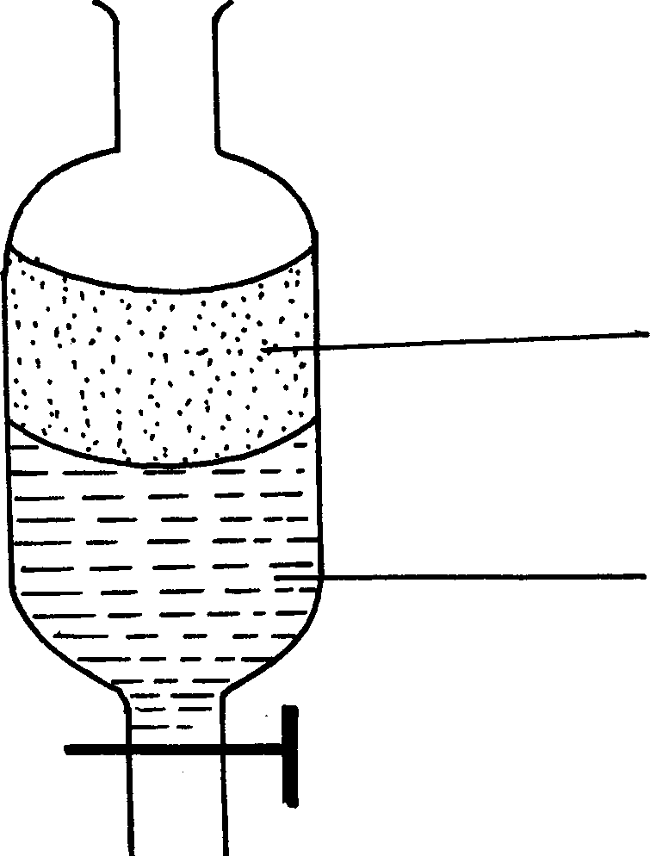

P W

State the identity of;
(i) P ………………………………..…….. (ii) W ………………………………….….
26 The diagrams below are some common laboratory apparatus. Name each apparatus and state its use

Diagram | Name | Use
 | (½mk ) | (½mk)
 | (½mk) | (½mk)

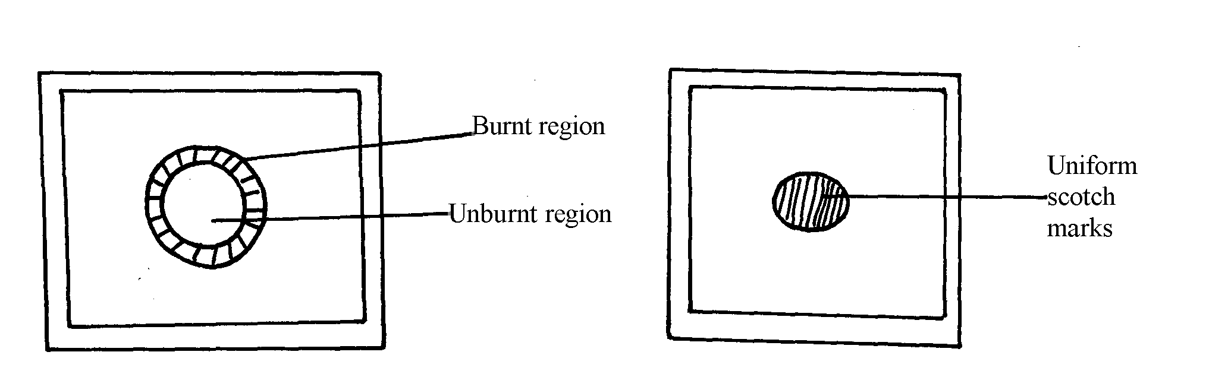
28 The diagram below shows the appearance of two pieces of paper placed in different parts of a non-luminous flame of a Bunsen burner and removed quickly before they caught fire.

  - What do the experiments show about the outer region of the flame

29 The diagram below shows the heating curve of a pure substance. Study it and answer the questions that follow:
Temperature (oC)
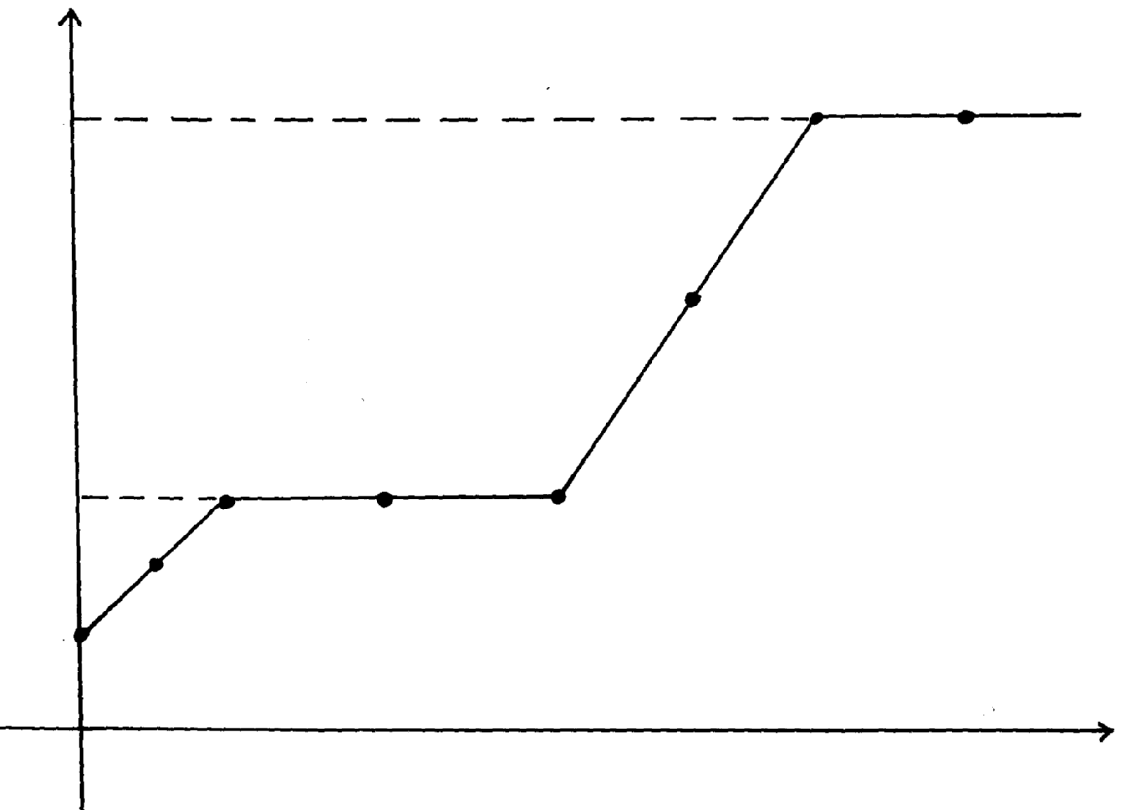
444
D
Z
Y
115
B
X
C
A
Time
  - What physical changes are taking place at points X and Z?
  - Explain what happens to the melting point of sodium chloride added to this substance

30 (a) State two differences between luminous flame and non-luminous flame
(b) It is advisable to set a Bunsen burner to luminous flame prior to an experiment. Explain

29 The diagram below shows the heating curve of a pure substance. Study it and answer the questions that follow:
Temperature (oC)
444
D
Z
Y
115
B
X
C
A
Time
  - What physical changes are taking place at points X and Z?
  - Explain what happens to the melting point of sodium chloride added to this substance

30 (a) State two differences between luminous flame and non-luminous flame
(b) It is advisable to set a Bunsen burner to luminous flame prior to an experiment. Explain
31 The paper chromatography of a plant extract gave the following results:

Solvent | Number of spots
X | 6
Y | 2
Z | 3

  - Which is the most suitable solvent for purifying the extract? Explain
  - Ball pen cannot be used to mark solvent front in the above chromatography. Explain
32 Name the process which takes place when:
  - Solid Carbon (Iv) Oxide (dry ice) changes directly into gas
  - A red litmus paper turns white when dropped into chlorine water
  - Propene gas molecules are converted into a giant molecule
33 A sample of copper turnings was found to be contaminated with copper (II) oxide. Describe how a sample of copper metal can be separated from the mixture
34 Copper (II) oxide and charcoal are black solids. How would you distinguish between the two solids?
35 a) What is chromatography?
b) Give two applications of chromatography

36 The two elements P and R were separately burned in air, the products gave the results recorded in the table below:

ELEMENTS PHYSICAL  STATE AT ROOM TEMPERATURE | P SOLID | R SOLID
Physical states of products | White solid powder only | Colourless gases L and M
Nature of solutions in water | Basic | L strongly acidic M slightly  acidic

  - Suggest the identity of element R. ……………………………………………..……..
  - Describe how the nature of the solutions of the of the oxides were determined

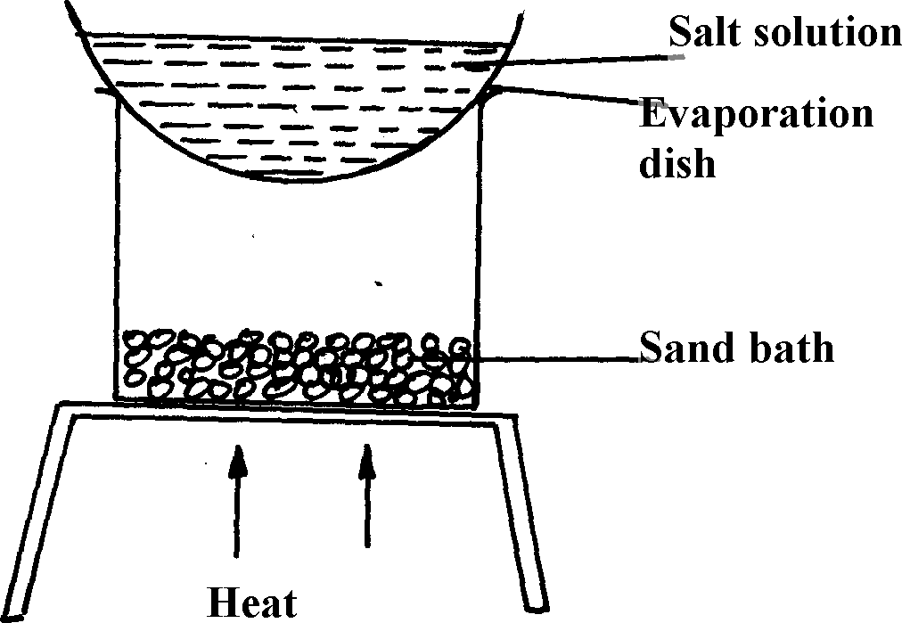
(i) Identify the method above.................................................................................
- Give one of its disadvantages
- Name a mixture which can be separated by the set-up above
- What is meant by melting point and boiling point of a substance?

- The apparatus below were used by a student to study the effect of heat on hydrated copper II sulphate

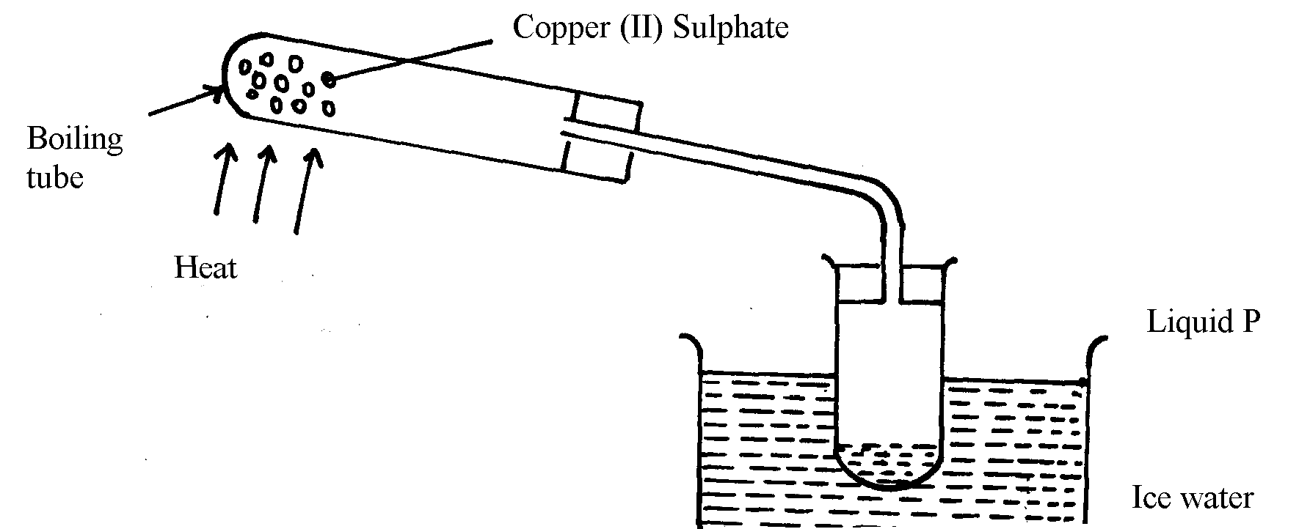

  - What is the role of the ice cold water ……………
(b) Name liquid P …………………………………………………………
(c) What observation is made in the boiling tube

- The table below shows solutions A, B and C are tested and observations records as shown:
Solution | Observations on indicator
A | Methyl orange turns yellow
B | Phenolphthalein turns colourless
C | Litmus turns purple

  - Using the table above, name an acid
  - How does the pH value of 1M potassium hydroxide solution compare with that of 1M aqueous ammonia? Explain
- The information below gives PH values of solutions V, W, X, Y Z

Solution | PH values
V | 2
W | 6.5
X | 11
Y | 14
Z | 4.5
  - Which solution is likely to be:
(i) Calcium hydroxide? ……………………………………………….
(ii) Rain water? ………………………………………………………
  - Which solution would react most vigorously with Zinc carbonate

- a) Complete the table below to show the colour of the given indicator in acidic and basic solutions.
Indicator | Colour in
Methyl Orange | Acidic Solution | Basic Solution
 |  | Yellow
Phenolphthalein | Colourless

b) How does the PH value of 0.1M potassium hydroxide solution compare with that of 0.1M aqueous ammonia? Explain.

- Use the information given below to answer the questions that follow:
Solution | G | H | I | J | K
pH | 1.5 | 6.5 | 13.0 | 7.0 | 8.0

  - Which of the solutions would be used to relieve a stomach upset caused by indigestion?
  - Which solution is likely to be:
    - Dilute sulphuric acid?
    - Sodium hydroxide solution?

- Solid copper (II) oxide is a base although it does not turn litmus paper to blue. Explain

- Below are the pH values of 4 types of medicine represented by letters P, Q, R and S
MEDICINE | pH VALUES
P | 7.0
Q | 5.0
R | 8.0
S | 6.0
- It is not advisable to use S when a patient has indigestion .Explain
- What is the role of chemistry in drug manufacture

- Explain why very little Carbon (IV) oxide gas is evolved when dilute sulphuric (VI) acid is added to lead (II) carbonate
8 . State one commercial use of Calcium Oxide
- The following data gives the pH values of some solutions
Solution | pH
P | 14.0
Q | 6.8
R | 2.5

  - What colour change would occur in solution P on addition of two drops of phenolphthalein indicator?
  - State the pH value of a resulting solution when equal moles of solution P and R react

- In an experiment, ammonia gas was prepared by heating ammonium salt with an alkali. After drying, ammonia gas was collected at room temperature and pressure.
  - What is meant by the term alkali?
  - Explain using physical properties of the gas why ammonia is not collected by downward delivery
- The table shows the colours obtained when some indicators are added to solutions:-
Solution | Blue litmus paper | Indicator W
Distilled water | ………………….. | Colourless
Calcium hydroxide | Blue | Pink
Nitric acid | ………………………… | Colourless

  - Complete the table by filling in the missing colours
  - Identify indicator W

