CHEMISTRY FORM 2 HOLIDAY ASSIGNMENT

1. Air is a mixture of gases. Explain. (2marks)
b) List the components of air. (6marks)
c) Name the method that is used to isolate the components of air on large scale. (1mark)
d) List two reagents that can be used in the laboratory to prepare oxygen gas. (2marks) .
2. A piece of burning sodium was lowered into a gas jar full of oxygen gas
- Write a well balanced equation for the reaction between sodium and oxygen (1mark)

- State the observation made when the product in (a) above was place in water and a red litmus paper placed in the resulting solution. Explain your answer (2 marks)

- Write an equation for the reaction that took place in (b) above. (2marks)
- Give three uses of oxygen gas. (3marks)

3. Write well balanced chemical equations for the following reactions:
a) sodium metal reacting with water. (1mark)
b) zinc metal reacting with dilute hydrochloric acid. (1mark)
c) magnesium oxide reacting with dilute sulphuric acid. (1mark)
d) copper metal burning in air. (1mark)
4.Define the following terms: (4marks)
a) a salt
b). a saturated solution
c) crystallization
d) water of crystallization
5. a) Define a coordinate bond. (1mark)
b) Draw dot and cross diagrams to show bonding in hydronium ion, H₃O⁺. (H = 1, 0 =16)
(3 marks)
6. a) Define the term thermal decomposition. (1mark)
b) write the products formed when the following substances are heated. (4 marks)
i) ammonium carbonate
ii) calcium nitrate
iii) mercury (II) nitrate
iv)sodium nitrate
7.a) define the following terms (3 marks)
i) deliquescence
ii) hygroscopy
iii)efflorescence
b). State three substances that are hygroscopic. (3 marks)
8. a) define the following terms;
i) precipitation reaction (1mark)
ii) spectator ions. (1mark)
b) Write ionic equations for the reaction that occur when the following solutions are mixed: (4 marks)
- Magnesium sulphate and lead nitrate
ii) Lead nitrate and sodium iodide
iii) Potassium chloride and silver nitrate
iv) Copper chloride and sodium carbonate
9. Given copper (II) oxide, dilute hydrochloric acid, sodium carbonate and water. Explain briefly how you can prepare pure copper (II) carbonate. ( 4 marks)
10. Dry hydrogen gas was passed over heated copper (II) oxide in a porcelain boat as shown in the set-up below.
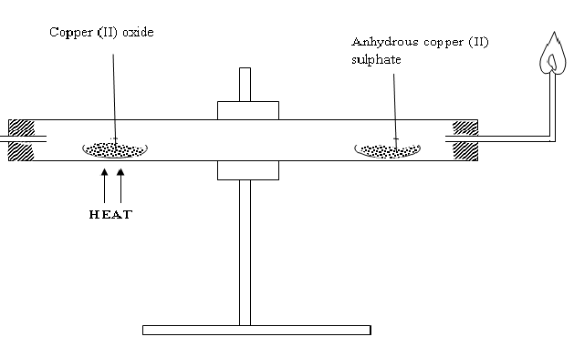

Dry H_{2 (g)} _{(g)(g)}

(a) State three observations made during the experiment. (3 marks)
b) State the chemical process illustrated by the above set-up. (1 mark)
c) During the experiment, excess hydrogen should be burned.
i) explain why excess hydrogen should be burned. (1 mark)
ii) State the colour of the flame of burning hydrogen. (1 marks)
c) state a substance that could be used apart from anhydrous copper (II) sulphate in the above set-up. (1 mark)

11. Name the processes,
a) when sodium carbonate decahydrate crystals are left in an open beaker for some days it turned into a powder. (1 mark)
b) when anhydrous calcium chloride is left in an open beaker a solution is formed. (1 mark)

12. The diagram shows effect of heat on two samples of solid naphthalene. K and L
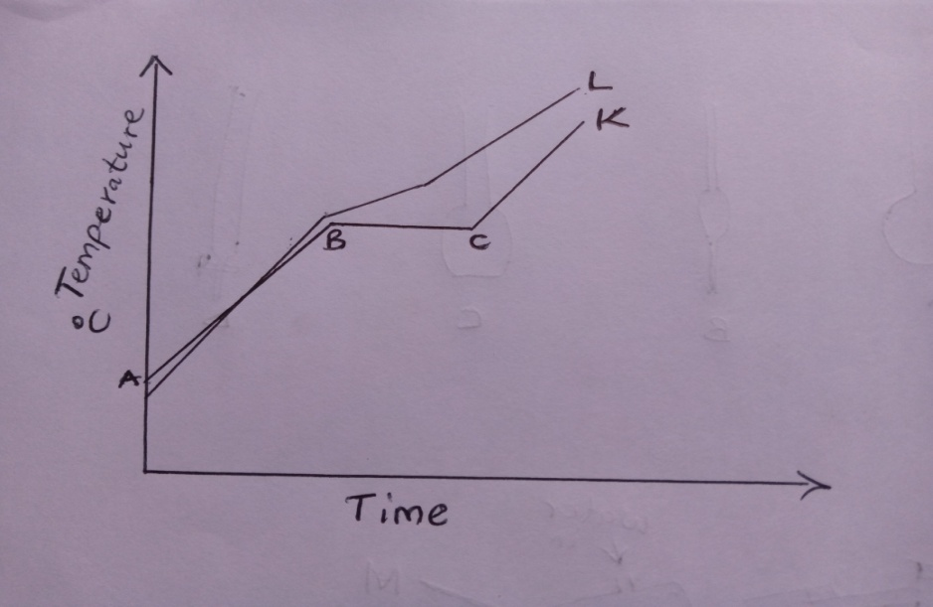
a) State the type of graph shown. ……………………………………………………….. (1mark)
b) Identify the sample that contains pure naphthalene. …………………………………… (1mark)
c) Identify the type of change that takes place between B and C (1mark)
d) Using kinetic theory, explain changes that occur between A and B (2marks)
13. A student accidentally mixed ammonium chloride with sodium chloride. Describe the simple procedure that can be used to obtain the two salts separately. (3marks)

14.The grid below represents the periodic table. Study it and answer the questions that follow. (letters do not represent actual chemical symbols).

 |  |  |  |  |  |  |  |  |  |  |  |  |  |  | V
 | G |  |  |  |  |  |  |  |  | Z
M | Y

a) Place X on the table to show an element that has mass number of 18 and 10 neutrons in its nucleus. (1 mark)

b). Give the electronic configuration of and formula for the most stable ion of element Z. (2 marks)

c) Write the formula for the nitrate of Y. (1 marks)

15. The set up below was used to separate a mixture of ethanol and water.
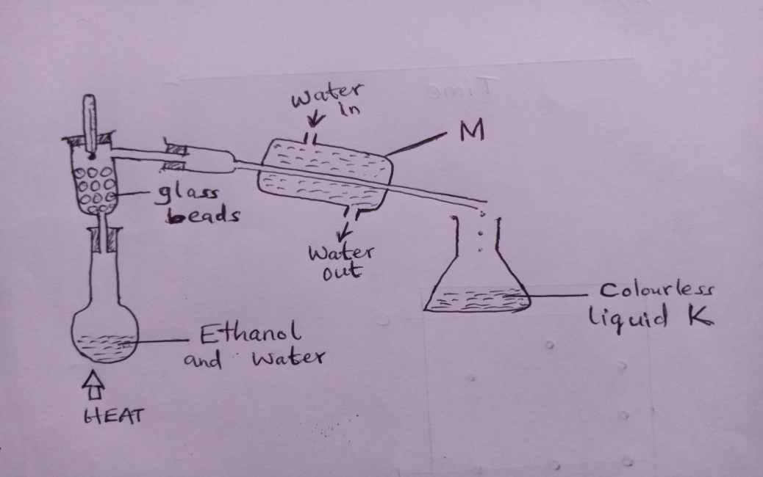
a) Name the process that is demonstrated above. (1mark)
b) Identify one mistake in the setup (1mark)
c) State the role of glass beads. (1mark)

16. Using dots and crosses to represent electrons, show chemical bonding in each of the following. (14 marks)
a) Magnesium chloride
b) Phosphorus (III) chloride.
c) Silane, SiH₄
d) Hydroxonium ion, H₃O⁺
e) Phosphonium ion, PH₄⁺
f) Carbon (Iv) oxide, co₂
g) ozone gas, O₃⁻

