NAME.......................................................................................ADM NO..........
DATE............................. SIGN.............................................
233/1
Chemistry paper 1
2 HRS

Kenya Certificate of Secondary Education 2021

233/1
Chemistry Paper 1
TIME: 2 HRS

INSTRUCTIONS TO CANDIDATES
- Write your name and index number in the spaces provided at the top of this page.
- Answer all the questions in the spaces provided.

1. Chromatography can be used to test for the purity of substances.
Describe one area in everyday life where purity of substances is important (1mark)
.

2. The diagram shows the apparatus used to separate different dyes in food colouring.
A
B

Name the parts labeled A & B (2marks)

3. Describe how a solid sample of copper (II) carbonate can be prepared starting with copper metal. ( 3 marks)

4. The table below describes the reaction of some metals with water.
METAL | REACTION
Calcium | Reacts rapidly with cold water producing many bubbles of gas.
Magnesium | Reacts very slowly with cold water but reacts rapidly with steam.
Rubidium | Reacts very rapidly with cold water producing many bubbles of gas and will explode.
Zinc | Only reacts with steam when in powdered form and heated very strongly.

Arrange these metals in order of their reactivity beginning with the most reactive. (2marks)

5. A student set up an experiment to demonstrate rusting as shown below. He made observations at the start of the experiment and after two weeks.
Iron Wool
Measuring cylinder

Air

Water

State and explain the observations made in the measuring cylinder after two weeks.
(2marks)

6. A student wanted to determine the solubility of potassium nitrate at a certain temperature. He
obtained the following results.
Mass of evaporating dish = 12.72g
Mass of evaporating dish + saturated solution = 34.10g
Mass of evaporating dish + salt = 17.00g
Calculate the solubility of potassium nitrate from the results above. (3 marks )

7. Chlorine gas was bubbled through water for some time. The green yellow solution formed was poured into a long glass tube and placed in the sun as shown in the diagram below .
Gas T
Sun rays
Green yellow solution

- What compounds are in the green yellow solution? (1mk)

- Write an equation to show how gas T is formed (1mk)

- Give one use of chlorine (1mk)

8. A gas occupies 4 litres at 250K and 152mmHg pressure. At what pressure will its volume be halved, if the temperature then is 227⁰C? (3 marks)

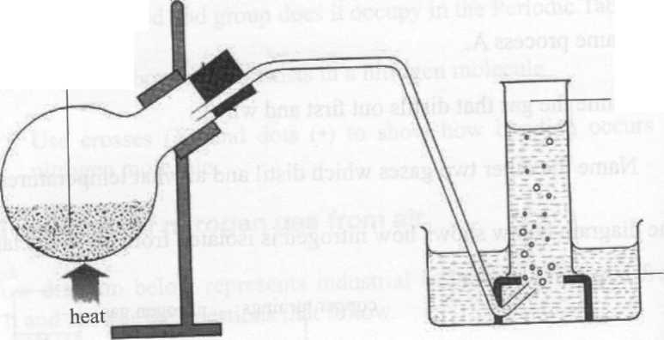
9. The set up below shows the preparation of nitrogen gas in the laboratory. ( 3 marks)
A mixture of ammonium chloride + compound A
nitrogen
water

- Name compound A. ( 1 marks)

- Write an equation for the reaction above. (1 marks)

- Why is ammonium nitrite not heated directly to prepare nitrogen gas? (1 marks)

10. Blue petals were dropped into a gas jar containing sulphur (IV) oxide as show below. ( 4 marks)
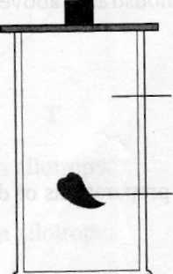
Sulphur (IV) oxide
blue petals

- Which observation was made? (1 marks)

- Which property of sulphur (IV) oxide is exhibited above ?(1 marks)

- Write the equation for the reaction above.(1 marks)

- Explain the observation above. (1mk)

11. (a) State Graham’s law of diffusion. (1mk)

(b) 60cm³ of oxygen diffused through a porous plate in 20 seconds. How long will it take 120cm³
of carbon (iv) oxide gas to diffuse through the same plate under the same conditions?
(C=12 , O=16) (2mk)

12. a) State Hess law. 1mk

b) What happens to the heat energy supplied to a liquid
i) before it starts boiling? 1mk

ii) when it is boiling
1mk

13. The following tests were carried out in 3 separate portions of a colourless solutions S.
 | Test | Observation
i | Adding dil HCL acid to solution S | No observable change
ii | Adding Na₂CO_{3(aq)} to the second portion | A white precipitate is formed
iii | Adding aqueous ammonia to the third portion | A white precipitate which dissolves in excess ammonia

a) From the information in test (i) name one cation which is not present in solution S. 1mk

b) Identify a cation which is likely to be present in solution S. 1mk

c) Write an ionic equation for the reaction which takes place in test (iii) 1mk

14. Zinc metal and hydrochloric acid reacts according to the following equation
Zn_{(s)} + 2HCL_{(aq)} ZnCl_{2(aq)} + H_{2(g)} 2.0g of Zinc metal were reacted with 100cm³ of 0.2M Hydrochloric acid.
a) Determine the reagent that was in excess. (Zn=65.4) 2mks

b) Calculate the total volume of hydrogen gas that was liberated at s.t.p (Zn=65.4, molar gas volume = 22.4 litres at s.t.p. (2mks)

15. Study the diagram below and answer the questions that follow.
NH₄Cl_{(s)}
Energy
Reaction co-ordinate
ΔH₁
ΔH₂
ΔH₃
NH₄ ⁺_{(g)} + Cl⁻_{(g)}
NH₄ ⁺_{(aq)} + Cl⁻_{(g)}

- What do ∆H₁ and ∆H₂ represent. (2marks)

(b) Write an expression to show the relationship between ∆H₁, ∆H₂ and ∆H_{3.} (1mark)

16. Use the information below and answer the questions that follow .The letters are not the actual symbols of the elements.

${ E}_{(aq)}^{2+}$ + 2e
-0.76V

E_{(s)}
$F_{(aq)}^{3+}$ + 3e
-1.66V

F_{(s)}
$G_{(aq)}^{2+}$ + 2e
-0.44V

G_{(s)}

- Calculate the E^{θ} value for the electrochemical cell represented below. (1mark)

F_{(s)}
$$F_{(aq)}^{3+}$$
$$G_{(aq)}^{2+}$$
$$G_{(s)}$$

- Arrange the elements in order of reactivity starting with the least reactive. (1mark)

(c) Explain if it would be advisable to store element G in a solution containing E²⁺ Ions. (1mark)

17. a) Iron is obtained from haematite using a blast furnace shown below. Study it and answer the questions that follow.

Raw materials (Haematite)
Hot Air
Molten iron
Hot air
Slag
230⁰ C
470⁰C
Y 1790⁰C Y

- Four raw materials are required for the production of iron. Three of these are haematite, hot air and coke. Give the name of the fourth raw material and its use. (1 mark)
Name) –

Use –

(ii)Name another Iron ore other than the one shown in the blast furnace. (1 mark)
State one physical property of slag other than density that allows it to be separated from molten Iron as shown in the figure.

17. The graph below shows the amount of calcium carbonate and calcium chloride varying with time in the reaction.
CaCO_{3(s)} + 2HCl_{(aq)} CaCl_{2(aq)} + H₂O + CO_{2(g)}
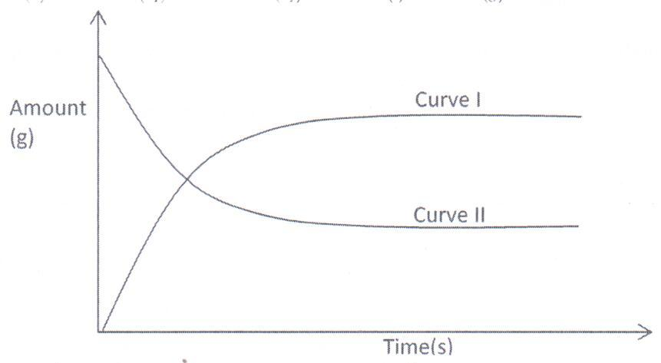

- Which curve shows the amount of calcium chloride varying with time? (1mk)

- Explain why the two curves become horizontal after a given period of time. (1mk)

- Sketch on the graph, how curve II would appear if the experiment was repeated using a more dilute hydrochloric acid solution.
(1mk)

18. Study the flow chart below and answer the questions that follow.
Ethanol
Ethene
U
L
K

Step 1

Step 2 Polymerization
Step 3. Temp. of 150⁰
Nickel catalyst, H₂

- Identify substances: K, U L (1½ marks)

K –
U –
L –

- State the conditions for the reaction in step 1 to occur. (2mks)

- Give one disadvantage of continued use of substances such as U. (½mk)

19. In an experiment to study properties of carbon, a small amount of charcoal is placed in a boiling tube. 5.0cm³ of concentrated nitric acid is added. The mixture is then heated.
- What observations are made? (1mk)

- Write an equation for the reaction that took place in the boiling tube. (1mk)

- What property of carbon is shown in this reaction? (1mk)

20. The peaks below show the mass spectrum of element X.

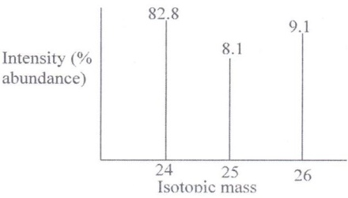

Calculate the relative atomic mass of X. (2mks

21. The equation for the reversible reaction of Bismuth (III) chloride in water is
BiCl_{3(s)} + H₂O_{(l)} BiOCl _{(s)} + 2H⁺_{(aq)} + 2Cl⁻_{(aq)}

- State Le chatelier’s principle (1 mark)

- What would be the effect of adding NaOH pellets to the equilibrium mixture. Explain. (2 marks)

22. Thorium${}_{90}^{232}{Th}$ undergoes two consecutive alpha decays followed by two consecutive beta decays to form the nuclide ${}_{y}^{x}R$. Identify the values of $x$and $y$. (2 marks)

23. The diagram below shows part of Solvay Process.
M
K
N
Brine
with ammonia

Carbon (IV) Oxide

NH₄Cl_{(aq)}

NaHCO₃ _{(s)}

Solid P

Solid llllY

- Name solid P ( 1 Mark)

- State the process taking place in chamber N.
( 1 mark)

- State two uses of calcium chloride which is a by-product in this process. ( 1 mark)

24. Substance L, M, N and P have the following properties.
Substance | M.P. | Solubility in water | Electrical conductivity
 |  |  | Solid state | Liquid state
L | Low | Soluble | Does not | Does not
M | High | Soluble | Does not | Conducts
N | High | Soluble | Conducts | Conducts
P | High | Insoluble | Does not | Does not
- Select the letter which represents a substance which is suitable for making kettle handles (1mk)

.

- Which letter represents a substance which is likely to be sodium chloride? (1mk)

- Name the bond structure and bond type likely to be in L. (1mk)
- Bond structure

(ii) Bond type

25.The table below shows some solutions and their PH values.
Solution | PH value
P | 1.5
Q | 6.0
R | 14.0
S | 8.0
Which of the above solutions.
- Is strongly basic. (1 mark)
- Reacts with sodium carbonate more vigorously. (1 mark)

(c) Is ammonia solution. (1 mark)

26. Write the equation for decomposition of:
- Sodium nitrate. (1 mark)

- Copper (ii) Nitrate (1 mark)

27. The diagram below represents a set-up used to prepare oxygen gas.
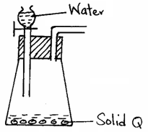

- Name substance Q. (1 mark)

- Complete the set-up to show how oxygen gas is collected. (1 mark)

(c) Write the equation for the reaction that occurs. (1 mark)

28. When an electric current of 0.5A was passed through a molten chloride of J for 32 minutes and 10 seconds, a mass of 0.44g of J was deposited at the cathode. (IF = 96500C).
(a) Calculate the quantity of electricity used. (1 mark)

(b) Determine the value of χ if the ion of metal J is represented as J^{χ+}.
(R.A.M of J = 44). (1 mark)

29. The grid below is part of the periodic table. Study it and answer the questions that follow. The letters are not actual symbols of elements.

A |  |  | D | E |  |  | H | I
B | C |  | M |  | F | G |  | J

- What is the name given to the chemical family of element C? (1 mark)

- Would element B react with J? Explain. (1 mark)

(c) Compare the melting points of B and M. (1 mark)

