CHEMISTRY PAPER 2

233/2
2 Hours

JULY/AUGUST 2021

PRE-MOCK 2021
NAME……………………………………………..………...INDEX NUMBER……………..

CANDIDATE’S SIGNATURE…………….…….…… DATE……………….…………..

INSTRUCTIONS TO CANDIDATES:
- Write your name and index number in the spaces provided above.
- Sign and write the date of examination in the spaces provided.
- Answer all the questions in the spaces provided.
- All working must be clearly shown where necessary.
- Mathematical tables and electronic calculators may be used.
- Candidates should answer the questions in English.

For Examiner’s Use Only:

Question | Maximum score | Candidate’s score
1 | 10
2 | 08
3 | 14
4 | 12
5 | 12
6 | 13
7 | 11
Total | 80

This paper consists of 13 printed pages. Candidates should check to ascertain that all pages are printed as indicated and that no questions are missing.
1. The set-up below was used to prepare and collect gas X. During the experiment cleaned magnesium ribbon was strongly heated before heating the wet glass wool.
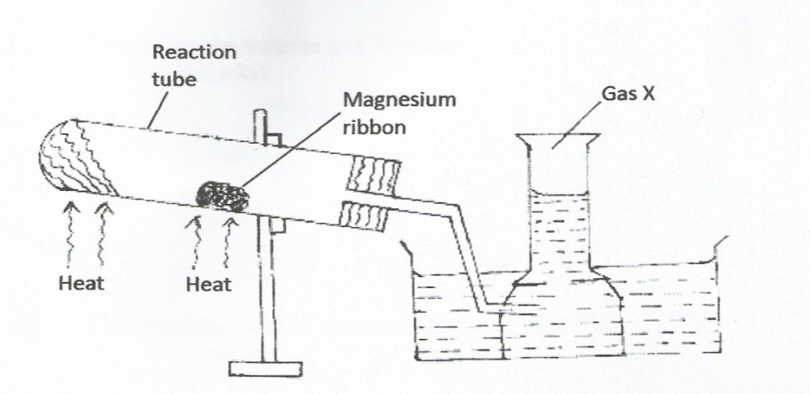

Water

a) Name gas X……………….………………………………………………..…………..……. (1 mark)
b) Why is magnesium ribbon cleaned before it is used? (1 mark) …………………………………………………………………………………………………………………………………………………………………..…………….……………………………………………………………….……………………………………………………………………………………………

c) State one observation that would be made in the reaction tube. (1 mark) …………………………………………………………………………………………………………………………………………………………………..…………….……………………………………………………………….…

d) Write the equation for the reaction in the reaction tube. (1 mark)
……………………………………………………………………………………………………………………………………………………………..…………….……………………………………………………………….……………………………………………….…………………………………………………………………………………

e) State one industrial use of the solid product formed in the reaction tube. (1 mark)
…………………………………………………………………………………………………………………………………………………………………..…………….……………………………………………………………….……………………………………………………………………………………………………………………………

f) What precaution should be taken at the end of experiment? Explain. (2 marks)
……………………………………………………………………………………………………………………………………………………………..…………….…………………………………………………
g) At the end of the experiment 96.0cm³ of gas X were collected at 10°C and 1 atmosphere
pressure. ( molar gas volume = 22.4liters at s.t.p, T =273K at s.t.p, P = 1 atmosphere at s.t.p).
(i) Determine the volume gas X would occupy at s.t.p. (2 marks)
…………………………………………………………………………………………………………………………………………………………………..…………….……………………………………………………………….……………………………………………………………………………………………………………………………
…………………………………………………………………………………………………………………………………………………………………..…………….……………………………………………………………….……………………………………………………………………………………………………………………………

(ii) Calculate the mass of magnesium ribbon used (Mg = 24) (1mark)
…………………………………………………………………………………………………………………………………………………………………..…………….……………………………………………………………….………………………………………………………………………………………………
…………………………………………………………………………………………………………………………………………………………………..…………….……………………………………………………………….……………………………………………………………………………………………………………………………
2. a)The diagram below shows how sulphur is extracted by the Frasch process.

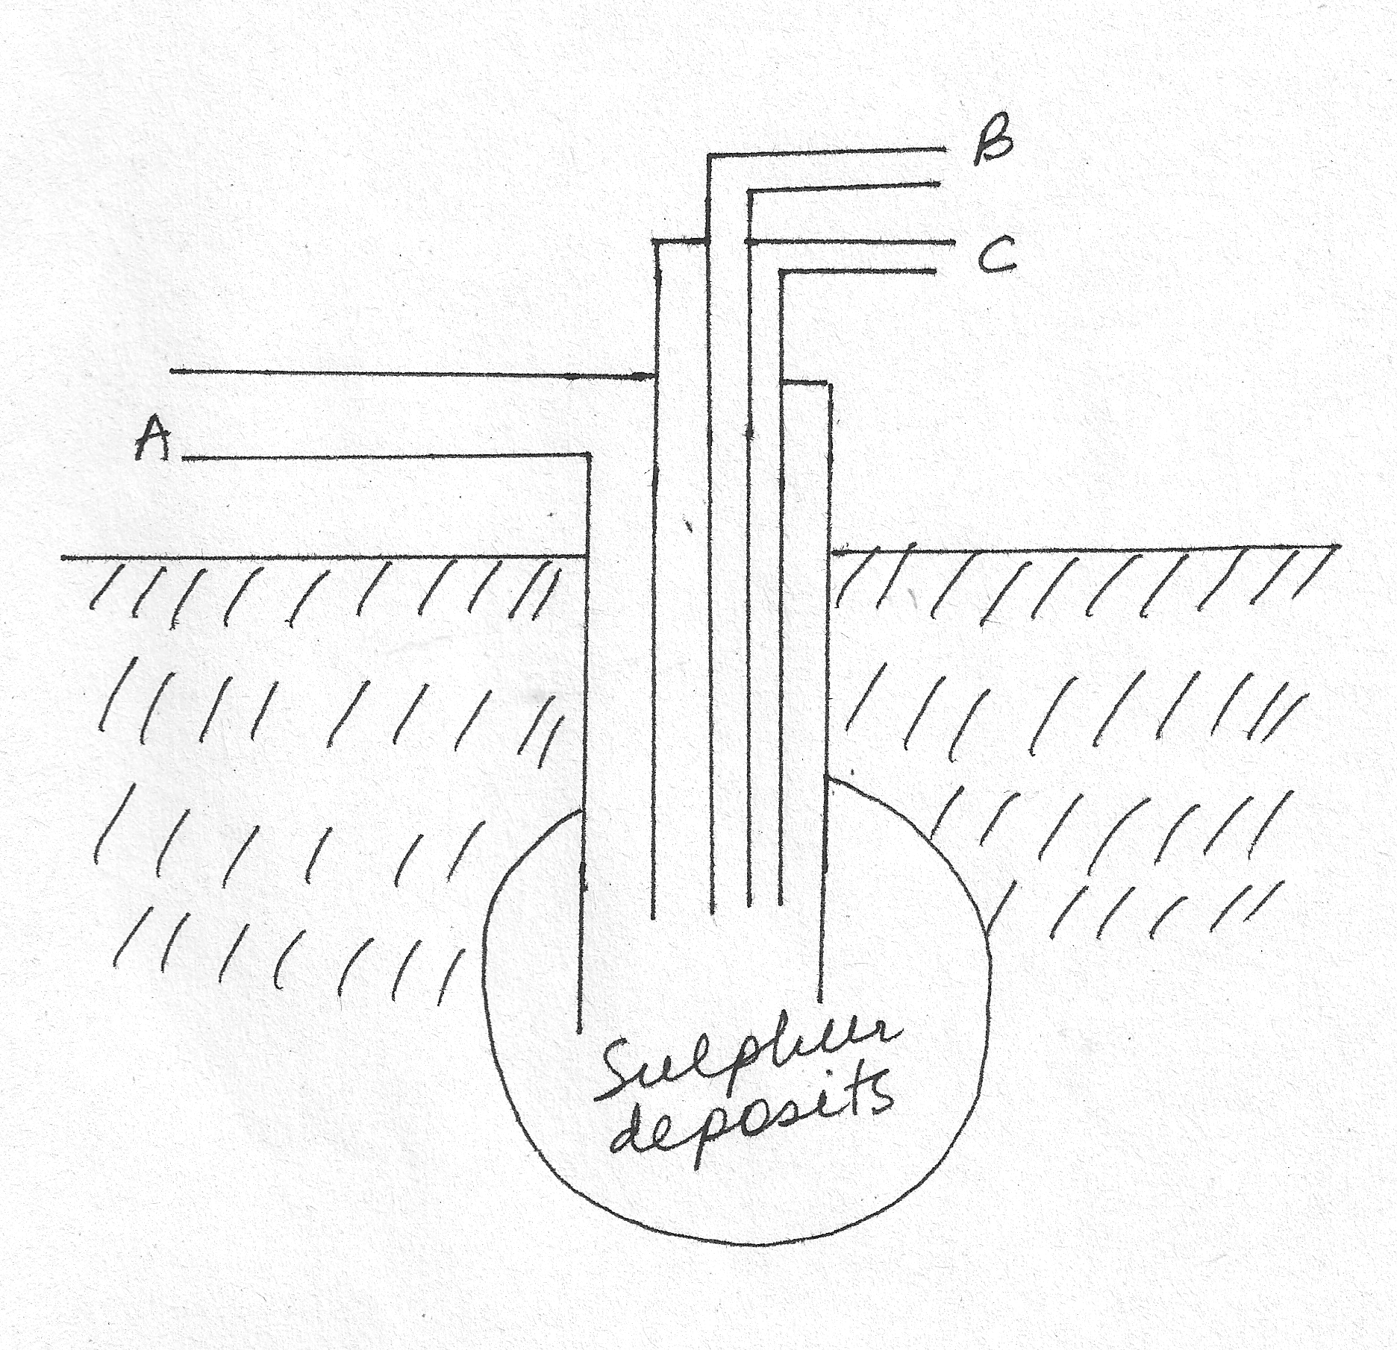
Indicate with arrows (→ or ←) what enters or leaves the tube A, B and C in the diagram above. (3 marks)

b) State two properties of sulphur that enable it to be extracted using the Frasch Process. (1 mark)
…………………………………………………………………………………………………………………………………………………………………..…………….……………………………………………………………….……………………………………………………………………………………………………………………………
c) i) Hydrogen sulphide is prepared by the action of dilute acids on metal sulphides. Explain why the combination of dilute hydrochloric acid and lead sulphide cannot be used to prepare the gas. (2 marks)
…………………………………………………………………………………………………………………………………………………………………..…………….……………………………………………………………….……………………………………………………………………………………………………………………………
…………………………………………………………………………………………………………………………
ii) Hydrogen sulphide is normally collected over warm water but not over cold water. Explain. (1 mark)
…………………………………………………………………………………………………………………………………………………………………..…………….……………………………………………………………….……………………………………………………………………………………………………………………………
iii) State one chemical test for hydrogen sulphide. (1 mark) …………………………………………………………………………………………………………………………………………………………………..…………….……………………………………………………………….……………………………………………………………………………………………………………………………
3. Study the standard electrode potential for the half cells given below and answer the questions that follow. The letters do not represent the actual symbols of the elements.
E ^{θ}volts
N⁺_{(aq)} + e⁻ N_{(g)} -2.92
J⁺_{(aq)} + e⁻ J_{(g)} +0.52
K⁺_{(aq)} + e⁻ ½K_{(g)} 0.00
½ G_{(g)} + e⁻ G⁻_{(aq)} +1.36
M²⁺_{(g)} + 2e⁻ M_{(g)} -0.44
a)(i) Identify the strongest oxidizing agent. Give reason for your answer. (2marks)

…………………………………………………………………………………………………………………………………………………………………..…………….……………………………………………………………….…

(ii) Which two half cells would produce the highest potential difference when combined?
(1mark)
…………………………………………………………………………………………………………………………………………………………………..…………….……………………………………………………………….…

(iii) Explain whether the reaction represented below can take place. (2marks)
M_{(g)}+2N⁺_{(aq)} M²⁺_{(aq)} +2N_{(g)}

…………………………………………………………………………………………………………………………………………………………………..…………….……………………………………………………………….……………………………………………………………………………………………………………………………
…………………………………………………………………………………………………………………………………………………………………..…………….……………………………………………………………….……………………………………………………………………………………………………………………………
b) 100cm³ of 2M sulphuric acid was electrolyzed using the set up represented by the diagram below.
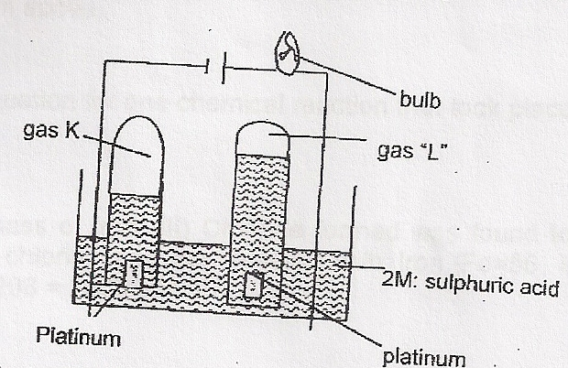

i) Write the equation for the reaction that produces gas “L”. (1mark)

…………………………………………………………………………………………………………………………………………………………………..…………….……………………………………………………………….……………………………………………………………………………………………………………………………
ii) Describe how gas “K” can be identified. (2 marks)

…………………………………………………………………………………………………………………………………………………………………..…………….……………………………………………………………….……………………………………………………………………………………………………………………………

iii) Explain the differences in:
a) The volume of gases produced at the electrodes. (2 marks)
…………………………………………………………………………………………………………………………………………………………………..…………….……………………………………………………………….……………………………………………………………………………………………………………………………
…………………………………………………………………………………………………………………………………………………………………..…………….……………………………………………………………….……………………………………………………………………………………………………………………………

b)Brightness of the bulb if 100cm³ of 2M ethanoic acid is used in place of sulphuric acid. (1mark)
…………………………………………………………………………………………………………………………………………………………………..…………….……………………………………………………………….……………………………………………………………………………………………………………………………
c) A solution of 1.0 M copper II sulphate was electrolyzed using carbon electrodes. A steady current of 2.5 A was passed through the solution for 15 minutes and the mass of copper deposited was determined. Given that 1 mole of copper requires 2 Faradays to be deposited. Calculate the mass of copper deposited after 15 minutes. (3 marks)
(Cu = 63.5, IF = 96,500C)
…………………………………………………………………………………………………………………………………………………………………..…………….……………………………………………………………….……………………………………………………………………………………………………………………………
…………………………………………………………………………………………………………………………………………………………………..…………….……………………………………………………………….……………………………………………………………………………………………………………………………
…………………………………………………………………………………………………………………………………………………………………..…………….……………………………………………………………….……………………………………………………………………………………………………………………………
4. . (a) At. 30ºC, 54g of potassium nitrate were added to 100g of water to make a saturated solution.
Define a saturated solution. (1mark)
…………………………………………………………………………………………………………………………………………………………………..…………….……………………………………………………………….……………………………………………………………………………………………………………………………

b) The table below gives the solubilities of potassium nitrate salt at different temperatures.

Temperature (ºC) | 10 | 20 | 30 | 39 | 45 | 55 | 60
Solubility(g/100g of H₂O) | 19 | 31 | 44 | 60 | 72 | 98 | 120

i) Plot the graph of the solubility of potassium nitrate (y-axis) against temperature. (3marks)

(ii) Use your graph to
I. Determine the solubility of potassium nitrate at 25ºC (1mark)
…………………………………………………………………………………………………………………………………………………………………..…………….……………………………………………………………….……………………………………………………………………………………………………………………………
II. Determine the mass of potassium nitrate that remained undissolved when 80g of potassium nitrate were added to 100cm³ of water and heated to 40ºC. (2marks)
…………………………………………………………………………………………………………………………………………………………………..…………….……………………………………………………………….………………………………………………………………………………………………………………………………………………………………………………………………………………………………………………………………………………………………..…………….……………………………………………………………….…
(c) Determine the molar concentration of potassium nitrate at 25ºC (K = 39, N= 14,O=16, density of water = 1.0g/cm³) (3 marks)
…………………………………………………………………………………………………………………………………………………………………..…………….……………………………………………………………….………………………………………………………………………………………………………………………………………………………………………………………………………………………………………………………………………………………………..…………….……………………………………………………………….……………………………………………………………………………………………………………………………

c) The table below gives the solubilities of potassium bromide and potassium
sulphate at 0ºC and 40ºC.
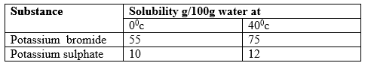

When an aqueous mixture containing 60g of potassium bromide and 7g of potassium sulphate in 100g of water at 40ºC was cooled to 0ºC some crystals were formed.
i) Identify the crystals formed. (1 mark)
…………………………………………………………………………………………………………………………………………………………………..…………….……………………………………………………………….…
ii) Determine the mass of the crystals formed. (1 mark) …………………………………………………………………………………………………………………………………………………………………..…………….……………………………………………………………….……………………………………………………………………………………………………………………………

5. The extraction of aluminum from it s ore takes place in two stages, purification stage and
Electrolys is stage. The diagram below shows the set – up for the electrolysis stage.
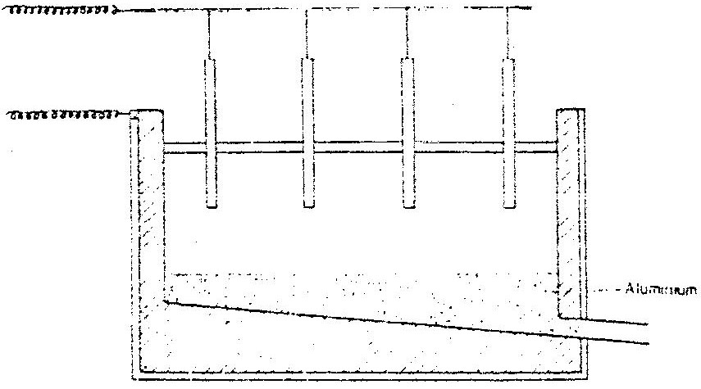

a) i) write the formulae of the ore from which aluminium extracted. (1 mark)

……………………………………………………………………………………..
ii) Name one impurity, which is removed at the purification stage. (1 mark)

……………………………………………………………………………………..
b) i) write ionic equation at each of the following
i) Anode
ii) Cathode
ii) The melting point aluminium oxide is 2015ºC, but electrolysis is carried out between 800 ºC.
i) Why is the electrolysis not carried out at 2015ºC (1 mark)

…………………………………………………………………………………………………………………………………………………………
ii) What is done to lower the temperatures? (1 mark)

……………………………………………………………………………………..……………………………………………………………….…

iii) The aluminium which is produced is tapped off as a liquid. What does this suggest about it smelting point? (1 mark)

6. Study the table below and answer the questions that follow. The letters do not represent the actual symbols of the element.
Formula of ion | Electronic configuration
E²⁺ | 2
D⁻ | 2.8
Cl⁻ | 2.8.8
B³⁺ | 2.8
A²⁺ | 2.8

a) With a reason, select the elements found in:
i) The same group (1½ marks)
………………………………………………………………………………………………….…………………………………………………………………………………………………….…………..……………………………….
ii) Period three (1½ marks)
………………………………………………………………………………………………….………………………………………………………………………………………………………………………………………………….
iii) What is the name given to the group to which element E belongs? (1 mark)
………………………………………………………………………………………………….………………………………………………………………………………………………………………………………………………….

b) With a reason compare the atomic radius of elements B and A. (2 marks)
………………………………………………………………………………………………….……………………………………………………………………………………………………………………………………………………………………………………………………………………………………………………………………………………………………………………………………………………………………………………………………….
c) State two industrial uses of element B. (2 marks)
………………………………………………………………………………………………….………………………………………………………………………………………………………………………………………………………………………………………………………………………………………..………………………………….
d) How does the reactivity of E and A compare? Explain your answer. (2 marks)
………………………………………………………………………………………………….…………………………………………………………………………………………………………………………………………………………………………………………………………………………………………………………………………….
e) Write the formula of the compound formed when D and A react together. (1 mark)
………………………………………………………………………………………………….………………………………………………………………………………………………………………………………………………….
f) What type of bond is formed when element E reacts with oxygen? Give a reason for your answer. (2 marks)
………………………………………………………………………………………………….………………………………………………………………………………………………………………………………………………….
7. a) Describe a chemical test that can be used to distinguish CH₃COOH from CH₃CH₂OH (3 marks)
…………………………………………………………………………………………………………………………………………………………………..…………….……………………………………………………………….………………………………………………………………………………………………………………………………………………………………………………………………………………………………………………………………………………………………..…………….……………………………………………………………….………………………………………………………………………………………………………………………………………………………………………………………………………………………………………………………………………………………………..…………….……………………………………………………………….…

b) Draw and name one isomer of the third member of the homologous series C_{n}H_{2n-2}. (1 mark)
…………………………………………………………………………………………………………………………………………………………………..…………….……………………………………………………………….……………………………………………………………………………………………………………………………
c). Propan-1-ol was subjected to a series of experiments.
I. It was heated with concentrated sulphuric (VI) acid at temperature of 160-180ºC to form gas R in the process called W. Gas R was then subjected to high pressure to form a polymer X.
i) Name gas R. (1mark) …………………………………………………………………………………………………………………………………………………………………..…………….……………………………………………………………….…
ii) What is the name given to process W? (1mark) …………………………………………………………………………………………………………………………………………………………………..…………….……………………………………………………………….…
iii) State one disadvantage of continued use of polymer X. (1mark)
…………………………………………………………………………………………………………………………………………………………………..…………….……………………………………………………………….……………………………………………………………………………………………………………………………
II. Propan-1-ol was converted to propanoic acid in the process Y. The propanoic acid was then reacted with dilute sodium hydroxide solution to form solution C which was heated to saturation and cooled. Crystals of C were obtained. Solid C was added to soda lime and the mixture heated. Ethane gas was collected.
i) Name the process Y. (1mark) …………………………………………………………………………………………………………………………………………………………………..…………….……………………………………………………………….…
ii) Write the equation for the reaction that occurs when solid C is heated with sodalime. (1mark) …………………………………………………………………………………………………………………………………………………………………..…………….……………………………………………………………….……………………………………………………………………………………………………………………………

d) In the presence of U.V light, ethane gas undergoes substitution reaction with chlorine.
i) What is meant by the term substitution reaction? (1 mark)

…………………………………………………………………………………………………………………………………………………………………..…………….……………………………………………………………….……………………………………………………………………………………………………………………………
ii) Give the structural formula and the name of the organic compound formed when equal volumes of ethane and chlorine react together. (1 mark)

…………………………………………………………………………………………………………………………………………………………………..…………….……………………………………………………………….……………………………………………………………………………………………………………………………

THIS IS THE LAST PRINTED PAGE.

