NAME………………………………………………………….CLASS…………ADM………..
CHEMISTRY FORM 3
TERM 2 2022 OPENER EXAM FORM 3
TIME:$2\frac{1}{2}$ HOURS
Instructions:
This paper consists of two sections,EACH section 50 marks.
All working MUST be clearly shown.
FOR EXAMINERS USE ONLY
QUESTIONS | SECTIONS | MAXIMUM | CANDIDATE’S SCORE
1 – 14 | A | 50
15 – 19 | B | 50
TOTAL SCORE |  | 100

SECTION A
- 60 ml of ozone gas diffused through a porous partition in 5 min 10 sec. how many seconds would it take 80 ml of nitrogen (i) oxide to diffuse through the same partition under same condition. ( N=14, O=16) (3mks)

- Below are 3 isotopes of element Neon. Study it and answer the questions that follows.
Ne- 20 90.9%
Ne – 21 0.3%
Ne – 22 8.8%
- What are isotopes (1mk)

- Calculate the relative atomic mass of Neon (3mks)

- 0.28g of Aluminium reacted completely with Oxygen gas. Calculate the volume of oxygen used. [molar gas volume = 24$={dm}^{3}$ Al =27 O = 16] (3mks)

- Using dots (.) and cross(X) diagram, show the bonding in; [C =16 Cl= 17 K = 19 S = 16]
- Potassium Sulphide (1$\frac{1}{2} mks)$

- Carbon tetrachloride (1$\frac{1}{2}mks )$

- During laboratory preparatioin of Oxygen, Manganese (iv) Oxide is added to reagent H.
- Name reagent H. (1mk)

- State the role of Manganese (iv) Oxide in this experiment (1mk)

- Write the chemical equation for the reaction that took place (1mk)

- Salt may be classified as soluble or insoluble salt.
- Select from the following list a pair of compounds that can be used to prepare soluble and insoluble salts.
Nitric acid, lead nitrate, Potassium Nitrate, Barium Oxide, Sodium Chloride
- Soluble salt (1mk)

- Insoluble salt (1mk)

- Describe how a solid sample of copper (ii) nitrate can be prepared in the lab starting with copper metal (3mk)

- (a) State Charles law (1mk)

(b) A gas occupies 300ml at a pressure of 570 mmHg and temperature of -136 degrees Celsius. What would be its volume at stp. (3mks)

- (a) State Gay Lusacs law. (1mk)

- Under certain condition methane react with steam forming carbon (ii) Oxide and Hydrogen. Calculate the total volume of the of gas that would be form when a 100ml of steam react completely with methane (2mks)

- Ammonia and nitric (v) acid are used to manufacture ammonium nitrate. Calculate the amount of nitric (v) acid required to manufacture 1000kg of ammonium nitrate using excess ammonia gas. [N = 14, H = 1, O = 16] (3mks)

- (a) Calculate the number of sodium atomsa present in 40g of sodium metal
[“L” = 6.02 X ${10}^{23}$ Na = 23] (3mks)

(b) Calculate the molarity of sodium hydroxide if 40g of sodium hydroxide was dissolved water to make 500ml of solution. (3mks)

- Describe an experiment to show that group one element reacts with cold water forming an alkaline solution. (3mks)

- Name three methods of gas collection. (3mks)

- (i) Candle wax is mainly compound consisting of the elements. Name the two elements (2mks)

- State one industrial use of hydrogen gas (1mk)

- (a)Write the chemical formula of rust (1mk)

- List 3 methods of prevent rusting (3mks)

SECTION B
- (a) Name two apparatuses that can be used for determining accurate volume in a
laboratory (2marks)
………………………………………………………………………………………………………………………………………………………………………………………………………………………………………………………………………………………………………………………
(b) One of the flames produced by Bunsen burner is the luminous flame
i) Explain why this flame is very bright (1mark )
………………………………………………………………………………………………………………………………………………………………………………………………………………………………………………………………………………………………………………………
ii) State two disadvantages of the luminous flame (2marks)
………………………………………………………………………………………………………………………………………………………………………………………………………………………………………………………………………………………………………………………
(c) Air is usually one of the substances that is considered as a mixture
(i) Identify the two most abundant component of air (2marks)
………………………………………………………………………………………………………………………………………………………………………………………………………………………………………………………………………………………………
(ii) Give two reasons why the air is considered as a mixture (2marks)
………………………………………………………………………………………………………………………………………………………………………………………………………………………………………………………………………………………………
(iii) One of the components of air is carbon (iv) oxide. Describe an experiment that can be used to prove the presence of carbon (iv) oxide in the air (2marks)
………………………………………………………………………………………………………………………………………………………………………………………………………………………………………………………………………………………………………………………………………………………………………………………………………………………………………………………………………………………………

- The grid below forms part of the periodic table. Study it and answer the questions that follow. The letters do not represent the actual symbols of the elements

P

Q
R

S

T
U

V

W
X

Y

Z

M

- Write the general name given to the element P belong. (1mark)

…………………………………………………………………………………………
- An element N has an atomic number of 15. Write down its electronic arrangement and hence fix it in its right position on the grid above. (2marks)

Electronic arrangement …………………………………………………………………………
- Compare the size of the atom of R and that of its ion. Explain your answer. (2marks)
……………………………………………………………………………………………………………………………………………………………………………………………………………............................................................................................................................................................................................................................................................................................................................
- Give the formula of the compound formed between (1mark)

- P and W …………………………………………………………………………

- T and Y …………………………………………………………………………..
- Compare the melting points of element Q and S. Explain (2marks)

………………………………………………………………………………………………………………………………………………………………………………………………………………………………………………………………………………………………………………………
- State the unreactive element in the grid. Give a reason for your answer (2marks)
………………………………………………………………………………………………………………………………………………………………………………………………………………
- Give two advantages that element S has over element Q in making electric cables(2mks)

………………………………………………………………………………………………………………………………………………………………………………………………………………

- Draw (a) dot (.) and cross (x) diagram to represent the bonding in compound formed between T and Y(2 marks)
……………………………………………………………………………………………………………………………………………………………………………………………………………............................................................................................................................................................................................................................................................................................................................……………………………………………………………………………………………………………………………………………………………………………………………………………....
- The chart below represents the main steps in the large-scale manufacture of sodium carbonate.

A
Chamber X Ammoniated brine Solvay
Tower
A

CaCl₂
Heat Chamber Y

Solution C

H₂O _{(l)} Slaker Heat CO₂

B
CO₂
Limestone Kiln
Sodium
carbonate

- Name substances A and B.

A ………………………………………………………… (1 mark )

B ………………………………………………………… ( 1 mark)
(b) Write down the chemical equation leading to formation of C. (1 mark )

……………………………………………………………………………………………………………
(c ) A stream of cold water is made to circulate around chamber X. What does this
suggest about the reaction taking place. (1 mark )

………………………………………………………………………………………………………

(d) Name the process that takes place in chamber Y. (1 mark)

…………………………………………………………………………………………………….
(e) State any 2 by-products recycled in the process. (2 marks)
………………………………………………………………………………………………………………………………………………………………………………………………………………………………
(f) state one use of calcium chloride

1mks
(g) Mention any 2 uses of sodium carbonate. ( 2 mark )

………………………………………………………………………………………………………………………………………………………………………………………………………………………………
- Study the set up below.

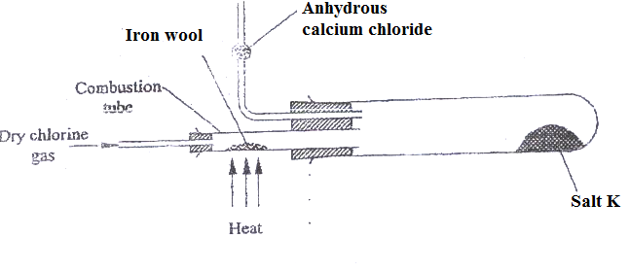
a) Name salt K (1mk)

(b)Write the equation for the reaction for the formation of salt K (1mk)

(c)What property of salt A is exhibited as shown in the experiment.(1mk)

(d)What is the purpose of anhydrous calcium chloride? Explain (2mk)

(e)Name another metal that can be used to produce similar results (1mk)

- The scheme below shows the preparation of a certain salt. Study it and answer the questions that follow
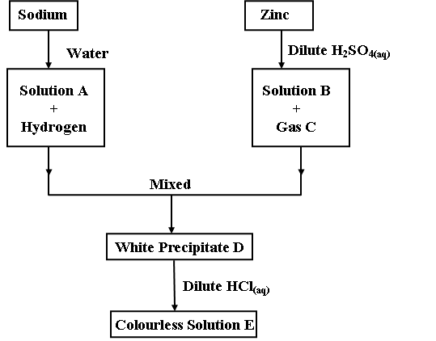
a) Give the name and the formula of the following (2mk)
 | Name | Formula
Solution A
Solution B
b) Give the equation for the;
i) Formation of B and gas C (2mk)
…………………………………………………………………………………………………………………
ii) Formation of solution A and hydrogen gas (1mk)
…………………………………………………………………………………………………………………
c) Describe a chemical test for gas C (2mk)
……………………………………………………………………………………………………………………………………………………………………………………………………………………………………

d) Give two observations made when sodium metal is placed on water (2mk)
i………………………………………………………………………………………………………………
ii………………………………………………………………………………………………………………..
e) Distinguish between anhydrous salt and dry salt (1mk)
…………………………………………………………………………………………………………………………………………………………………………………………………………………………………………………………………………………………………………………………………………………………………………………………………………………………………………………………………………

