MID TERM THREE EXAM 2022
FORM TWO
CHEMISTRY
Answer all questions in the spaces provided
TIME: 2 HRS 15 MINUTES
NAME ……………………………………………………………….ADM……………CLASS…………

1.Name the elements that are present in the following compounds .
i)Sodium nitrate (1 mks)

ii)Aluminium Oxide (1mk)

iii)Zinc sulphate (1mk)

2.Fractional distillation of liquid air is usually used to separate various gaseous mixtures In air. Explain how to;
a)Remove carbon (IV) oxide (1mk)

b)Remove water (1mk)

c)Obtain nitrogen (2mks)

3.Distinguish between ionization energy and
a)Electron affinity of an element (2mks)

b)The grid below represents part of the periodic table. Study it and answer the questions that follow.
A |  |  |  | B |  | C
 | D |  | E |  | F | G
H

i)Select the most reactive metal (Explain. (2mks)

ii)Select an element that can form an ion with a charge of -3 (1mk) …………………………………………….

iii)Select an alkaline earth metal (1mk) ……………………………………………………………………………….
iv)Which group I element has the highest first ionization energy? Explain (2mks)

v)Element A combines with chlorine to form a chloride of A. State the most likely PH value of solution of a chloride A. Explain. (2mks)

4.Explain the meaning of the following terms:-
i)Deliquescence (1mk)

ii)Saturated solution(1mk)

b)Study the flow chart below and answer the questions that follow. (5mks)
Brown gas B colourless gas C
White solid A

White ppt E
Yellow solid D when cold

Colourless solution
i)Identify:-
A:……………………………………………………..…………….……………….
B:…………………………………………………….……………………………
C:…………………………………………………………………………………
D:………………………………………………………………………………….
E:………………………………………………………………………………….
ii)Describe test for colourless gas (1mk)

iii)Write a balanced equation for the formation of B,C and D from solid A (2mks)

5a)Molten magnesium chloride conducts electricity while solid magnesium chloride does not. Explain (2mks)

Using dots (.) and crosses (x), show bonding in
i)Ammomium ion (NH₄⁺) (1mks)

ii)Carbon (II) oxide (2mks)

5.The diagram below shows set-up which was used to investigate the effect of the electricity on molten lead (II) iodide.
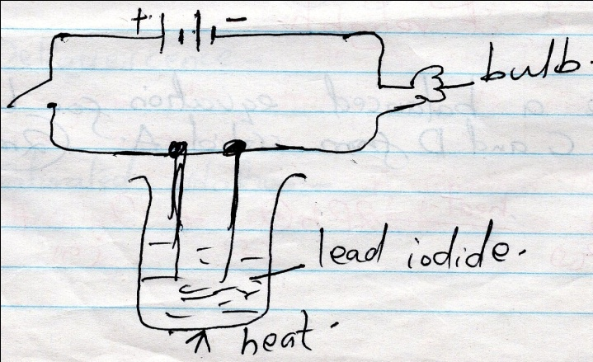
a)Explain what happens to the lead iodide during the electrolysis (3mks)

b)Write equations to show the reaction taking place:-
i)At the cathode (1mk)

ii)At the anode (1mk)
c)Why was it important to carry out the experiment in a fume chamber?(1mk)

6. Brine filtration
Reaction chamber 1
Solid V
Carbon (IV) oxide Liquid x
Reaction chamber 2
Heating limestone

Ca(OH)₂ Sodium carbonate
Reaction chamber 3

Calcium chloride

a)i)Name the three starting materials in the manufacture of sodium carbonate (3mks)

ii)Which substances are recycled in this process (3mks)

iii)Identify the chambers in which recycled substances are regenerated. (3mks)

iv)Name the substance V and X (2mks)

b)Give an equation for the reaction which occurs:-
i)In reaction chamber 1 (1mk)

ii)When solid V is heated (1mk)

iii)In the reaction chamber 3 (1mk)

iv)State one commercial use for sodium carbonate (1mk)

7.a)State two differences between luminous and non-luminous flame (2mks)

b)Explain how the hotness of a Bunsen burner flame can be increased (1mk)

8.a)List three differences between temporary physical changes and temporary chemical changes (3mks)

b)A mixture contains ammonium chloride, copper (II) oxide and sodium chloride. Describe how each of the substances can be obtained from the mixture (3mk)

9.The PH of a sample of soil was found to be 5.0
a)An agricultural officer recommended the addition of calcium oxide in the soil. State two functions of Calcium Oxide in the soil. (2mks)

b)Dilute Sulphuric acid was added to a compound of magnesium P. the solid reacted with the acid to form a colorless solution; Q and a colorless gas R which formed a white precipitate when bubbled through lime water.
a)Name:-
i)Compound P (1mk)…………………………………………………………………………………………………………………………
ii)Solution Q (1mk)……………………………………………………………………………………………………………………………
iii)Colorless gas R (1mk) …………………………………………………………………………………………………………………..
b)Write a chemical equation for the reaction that took place (2mks)

c)State the observations that would be made if a similar compound of calcium was used instead of magnesium. Explain (2mks)

10.State two advantages and two disadvantages of:- (2mks)
a)Rusting

b) The setup below was used to prepare oxygen in the lab

hydrogen peroxide

oxygen gas

solid R

Wate

i)Name solid R (1mk)

ii)Write an equation for the reaction that took place in the flask (2mks)

iii)Give two commercial uses of oxygen gas (2mks)

c)2K_{(s)} + 2nO_{(s)} K2O_{(s)} + Zn _{(s)} (2mks)
Name the reducing and oxiding agents.

11a)State two chemical tests for presence of water (2mks)

b)State what is observed when a small piece of potassium is placed in water. Write a word equation for the reaction (4mks)

c)Describe how hydrogen gas is dried in the lab (2mks)

12.The diagram below shows the relationship between physical states of matter. Use it to answer the questions that follows.
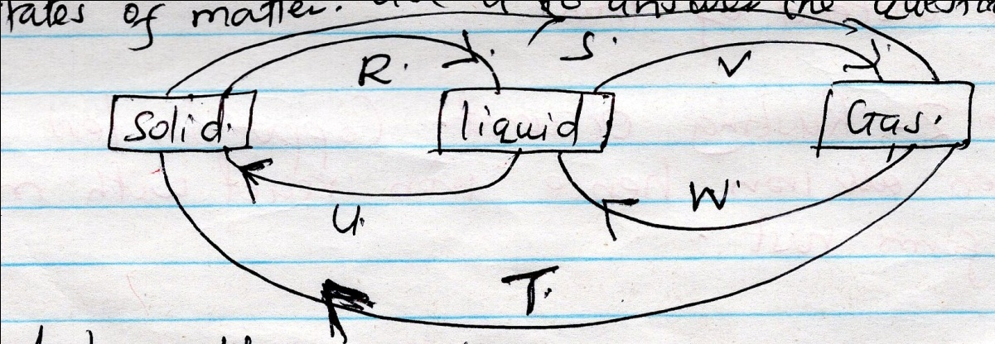
Identify the process (4mks)
R: …………………………………………………………………
V: ……………………………….………………………………..
W: ……………………………………………………………….
U: ………………………………………………………………..
b)Name two substances which undergo the process represented by S and T (2mks)

13.The diagram below represent two iron nails with some parts covered tightly with Zinc and copper respectively. What observations would be made at the exposed points R and Z if the wrapped nails are left in the open for several days. Explain (4mks)
