FORM TWO CHEMISTRY
MID TERM 3 2022
MARKING SCHEME
NAME ……………………………………………………………….ADM……………CLASS…………
1.Name the elements that are present in the following compounds .
i)Sodium nitrate (1 ½ mks)
sodium, nitrogen and oxygen
ii)Aluminium Oxide (1mk)
alluminium and oxygen
iii)Zinc sulphate
zinc, sulphur, oxygen
2.Fractional distillation of liquid air is usually used to separate various gaseous mixtures In air. Explain how to;
a)Remove carborn (IV) oxide (1mk)
by passing it through concentrated sodium hydroxide/potassium hydroxide
b)Remove water (1mk)
cooling to a temperature of -25⁰C
c)Obtain nitrogen (2mks)
cool to -200ºC and carry out fractional distillation to obtain nitrogen
3.Distinguish between ionization energy and
a)Electron affinity of an element (2mks)
ionization energy is the minimum amount of energy required to remove an electron from the outer most energy level of an atom in gaseous state
b)The grid below represents part of the periodic table. Study it and answer the questions that follow.
A |  |  |  |  | B |  | C
 | D |  |  | E |  | F | G
H

i)Select the most active metal (Explain. (2mks)
H- it easily looses electrons because it has a large atomic radius
ii)Select an element that can form an ion with a charge of -3 (1mk) B

iii)Select an alkaline earth metal (1mk) D
iv)Which group I element has the highest first ionization energy? Explain (2mks)
- Has a small atomic radius hence its outer electron is held strongly
v)Element A combines with chlorine to form a chloride of A. State the most likely PH value of solution of a chloride A. Explain. (2mks)
PH 7. The compound ionizes in water to form neutral solution
4.Explain the meaning of the following terms:-
i)Deliquescence – the process by which substances absorb water from the atmosphere to form solutions when exposed
ii)Saturated solution- a solution that cannot dissolve any more solute at a given temperature
b)Study the flow chart below and answer the questions that follow. (5mks)
Brown gas B colourless gas C
White solid A

White ppt E
Yellow solid D when cold

Colourless solution

i)Identify:-
A:- lead nitrate
B:-nitogen (IV) oxide
C:-Oxygen gas
D:-lead (II) oxide
E:Lead (II) chloride
ii)Describe test for colourless gas (1mk)
when a glowing splint is lowered into a gas into a gas jar of C, it relights
iii)Write a balanced equation for the formation of B,C and D from solid A (2mks)
2Pb(NO₃)_{2(s)} heat 2PbO_{(s)} + O_{2(g)} + 4NO2_{(g)}
5a)Molten magnesium chloride conducts electricity while solid magnesium chloride does not. Explain (2mks) -In solid magnesium chloride the ions are in a fixed position hence not mobile while in a molten magnesium chloride, the ions are mobile hence conducts electricity
Using dots (.) and crosses (x), show bonding in
i)Ammomium ion (NH₄⁺) (2mks)
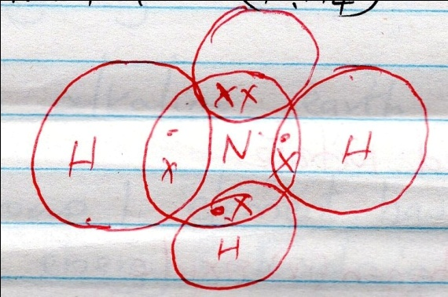

ii)Carbon (II) oxide (2mks)
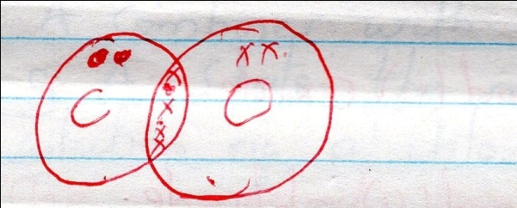
5.The diagram below shows set-up which was used to investigate the effect of the electricity on molten lead (II) iodide.

a)Explain what happens to the lead iodide during the electrolysis (3mks)
leads ion migrate towards the cathode where they are reduced to lead metal while iodide ions migrate towards the anode where it is oxidized to iodine vapour
b)Write equations to show the reaction taking place:-
i)At the cathode (1mk)
Pb²⁺_{(l)} + 2e⁻ Pb_{(s)}
ii)At the anode (1mk)
2I⁻_{(l)} I_{2(g)} +2e⁻
c)Why was it important to carry out the experiment in a fume chamber?
Iodine vapour is poisonous
6. Brine filtration

Solid V
Carbon (IV) oxide Liquid x
Reaction chember
Heating limestone

Ca(OH)₂ Sodium carbonate
Reaction chamber 3

Calcium chloride
a)i)Name the three starting materials in the manufacture of sodium carbonate (3mks)
Brine Ammonia Limestone
ii)Which substances are recycled in this process (3mks)
Ammonia Water Carbon (IV) oxide

iii)Identify the chambers in which recycled substances are regenerated. (3mks)
reaction chamber 3- Ammonia
reaction chamber 2 – Carbon (IV) oxide / water
iv)Name the substance V and X (2mks)
V- sodium hydrogen carbonate
X- Ammonium chloride
b)Give an equation for the reaction which occurs:-
i)In reaction chamber 1 (1mk)
Nacl_{(aq)} + NH3_{(g)} + CO2_{(g)} + H2O _{(l)} NH4cl _{(aq)} + NaHCO3 _{(s)}
ii)When solid V is heated (1mk)
2NaHCO_{3(s) heat} Na₂CO_{3(s)} + H₂O_{(l)} +CO₂ _{(g)}
iii)In the reaction chamber 3 (1mk)
2NH₄CL _{(aq)} + Ca(OH)_{2(aq)} 2NH_{3(g)} + Cacl_{2 (s)} + 2H₂O_{(l)}
iv)State one commercial use for sodium carbonate (1mk)
-water softening
-Glass making
-paper industry
-Making sodium silicate
7.a)State two differences between luminous and non-luminous flame (2mks)

Luminous
Produce soot
Large and weavy
Has four zones
Non- luminous
Doesn’t produce soot
Small and steady
Has three zones
b)Explain how the hotness of a Bunsen burner flame can be increased (1mk)
by keeping the air hole open fully
8.List three differences between temporary physical
a)changes and temporary chemical changes (3mks)

temporary physical
no change in mass
no new substance formed
not accompanied by net
heat change
temporary chemical
there is change in mass
new substance formed
heat energy evolved or absorbed
b)A mixture contains ammonium chloride, copper (II) oxide and sodium chloride. Describe how each of the substances can be obtained from the mixture (3mk)
heat the mixture , ammonium chloride sublimes and is collected as a sublimate
add water into the remaining mixture, stir then filter to obtain copper (II) oxide as the residue and sodium chloride solution as the filtrate; heat the filtrate to saturation to obtain crystals of sodium chloride

9.The PH of a sample of soil was found to be 5.0
a)An agricultural officer recommended the addition of calcium oxide in the soil. State two functions of Calcium Oxide in the soil. (2mks)
to raise soil PH
to add nutrients to the plants
b)Dilute Sulphuric acid was added to a compound of magnesium P. the solid reacted with the acid to form a colorless solution; Q and a colorless gas R which formed a white precipitate when bubbled through lime water.
a)Name:-
i)Compound P (1mk) magnesium carbonate
ii)Solution Q (1mk) magnesium sulphate solution
iii)Colorless gas R (1mk) Carbon (IV) Oxide gas
b)Write a chemical equation for the reaction that took place (2mks)
MgCO_{3(s)} + H₂SO_{4(aq)} MgSO_{4(aq)} + CO_{2(g)}
c)State the observations that would be made if a similar compound of calcium was used instead of magnesium. Explain (2mks)
the reaction will stop after sometime due to production of insoluble calcium sulphate that coats the carbonate preventing further reactions
10.State two advantages and two disadvantages of:- (4mks)
a)Rusting

Advantages
-adds iron to the soil
-it reduces environmental pollution
Disadvantages
Destroys machinery, equipment
Destroys roofs made of iron
b) The setup below was used to prepare oxygen in the lab

hydrogen peroxide

oxygen gas

solid R

Water
i)Name solid R (1mk)
Manganese (IV) Oxide
ii)Write an equation for the reaction that took place in the flask (2mks)
2H₂O_{2(l)} MnO₂ 2H₂O_{(l)} + 2O_{2(g)}
iii)Give two commercial uses of oxygen gas (2mks)
c)2K_{(s)} + 2nO_{(s)} K2O_{(s)} + Zn _{(s)} (2mks)
Name the reducing and oxiding agents.
Reducing agent – potassium
Oxidizing agent – Zinc (II) Oxide
11a)State two chemical tests for presence of water (2mks)
-it turns white unhydrous Copper (II) Sulphate blue
-Turn blue unhydrous Cobalt (II)Chloride paper pink
b)State what is observed when a small piece of potassium is placed in water. Write a word equation for the reaction (4mks)
-it moves about on the surface of water
-it melts into a silvery ball
-there is effervescence
Potassium + Water potassium hydroxide + hydrogen gas
c)Describe how hydrogen gas is dried in the lab (2mks)
-by passing the wet hydrogen through concentrated sulphuric acid or through unhydrous calcium chloride packed in a u - tube
12.The diagram below shows the relationship between physical states of matter. Use it to answer the questions that follows.

gas

liquid

solid

Identify the process (4mks)
R: melting
V: evaporation
W: condensation.
U:freezing
b)Name two substances which undergo the process represented by S and T (2mks)
-Carbon (IV) Oxide
-Benzoic acid
-Iron (III) Chloride
-Ammonium chloride
-Aluminium chloride
13.The diagram below represent two iron nails with some parts covered tightly with Zinc and copper respectively. What observations would be made at the exposed points R and Z if the wrapped nails are left in the open for several days. Explain (4mks)
R Z
Zinc coated part copper coated part

At R no rusting occurred. Zinc is more reactive than iron hence it reacts with moist air instead of iron
At Z rusting occurred. Copper is less reactive than iron hence iron react with moist air to form rust

