NAME………………………………………………………...ADM………………CLASS………….

MID TERM 2 2022
CHEMISTRY
FORM 1
TIME: 1HR 30 MINS
- State two branches of chemistry (2MKS)
………………………………………………………………………………………………………………………………………………….……………………………………………………………………………………………………………………………………………………
- Define each of the following terms (2MKS) a) Matter ………………………………………………………………………………………………………………………………………… b) Conductor
…………………………………………………………………………………………………………………………………………
- Differentiate between a pure substance and a mixture (2Mks)
……………………………………………………………………………………………………………………………………………..
………………………………………………………………………………………………………………………………………………
………………………………………………………………………………………………………………………………………………
- State two factors that determine the choice of the method of separation of mixtures (2mks)
………………………………………………………………………………………………………………………………………………
………………………………………………………………………………………………………………………………………………
- Describe how you can separate a mixture of iodine, salt and sand (3mks)
…………………………………………………………………………………………………………………………………………………………………………………………………………………………………………………………………………………………………………………………………………………………………………………………………………………………………………………………………………………………………………………………………………………………………………….……………………………………………………………………………………………………………………………………………….
- State the use of each of the following laboratory apparatus (3MKS)
- Pipette
……………………………………………………………………………………………………………………………………………….
- Deflagrating spoon
……………………………………………………………………………………………………………………………………………
- Thistle funnel
………………………………………………………………………………………………………………………………………………
- James a form one student wants to measure accurate volume of a solution in the laboratory. State TWO apparatus that James could use. (2MKS)
……………………………………………………………………………………………………………………………………………………………………………………………………………………………………………………………………………………
- A) Name two laboratory apparatus that can be made of glass (2MKS)
……………………………………………………………………………………………………………………………………………..……………………………………………………………………………………………………………………………………………..……………………………………………………………………………………………………………………………………………..
b) State two advantages of apparatus made of glass in chemistry experiments (2MKS)
……………………………………………………………………………………………………………………………………………..……………………………………………………………………………………………………………………………………………..
- A) Draw and name the regions of a luminous flame (3mks)

b) A wooden splint was slipped through a region of a particular flame in the laboratory and was burnt as shown in the diagram below.

- Name the type of flame the splint was slipped through (1mk)
……………………………………………………………………………………………………………………………………………….
- Stating the region explain why the splint was burnt the way it is shown in the diagram (2mks)
………………………………………………………………………………………………………………………………………………………………………………………………………………………………………………………………………………………………
- State one disadvantage of using the above type of flame in the laboratory (1mk)
………………………………………………………………………………………………………………………………………………
………………………………………………………………………………………………………………………………………………
- A) Define the term crystallization (1mk)
………………………………………………………………………………………………………………………………………………………………………………………………………………………………………………………………………………………………………………………………………………………………………………………………………………………………………………
b) State two applications of crystallization (2mks)
………………………………………………………………………………………………………………………………………………………………………………………………………………………………………………………………………………………………………………………………………………………………………………………………………………………………………………
- A) What is solvent extraction (1mk)
………………………………………………………………………………………………………………………………………………………………………………………………………………………………………………………………………………………………………………………………………………………………………………………………………………………………………………
b) Describe how oil is extracted from ground nut seeds (3mks)
………………………………………………………………………………………………………………………………………………………………………………………………………………………………………………………………………………………………………………………………………………………………………………………………………………………………………………………………………………………………………………………………………………………………………………………………………………………………………………………………………………………………………………………………………………
- For each of the following, state the type of change observed (4mks)
- Melting and cooling candle wax ……………………………………………………………………………….
- Heating and cooling zinc oxide ……………………………………………………………………………….
- Burning magnesium in air ……………………………………………………………………………….
- Heating hydrated copper (ii) sulphate ………………………………………………………………………
- Study the diagram below and answer the questions that follow. (5mks)
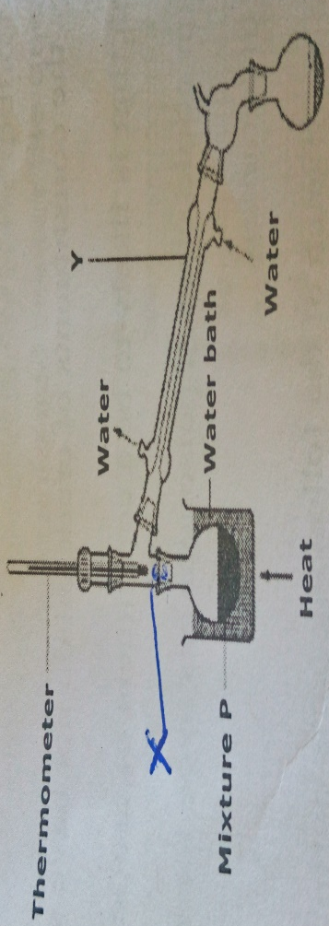
- Name each of the parts X and Y.
………………………………………………………………………………………………………………………………………………………………………………………………………………………………………………………………………………………………………………
- What is the name given to the method used above for the separation of mixture P?
………………………………………………………………………………………………………………………………………………………………………………………………………………………………………………………………………………………………
- State two industrial applications of the method mentioned above.
………………………………………………………………………………………………………………………………………………………………………………………………………………………………………………………………………………………………………………………………………………………………………………………………………………………………………………
- Suppose the mixture P was paraffin and water, which apparatus could have been used to separate them?
………………………………………………………………………………………………………………………………………….....
- State the effect of impurities on (2mks)
- Melting point …………………………………………………………………………………………………………………..
- Boiling point. …………………………………………………………………………………………………………………..
- The diagram below shows the heating curve of pure water. On the same diagram, sketch the graph if water containing impurities was used. (1mks)
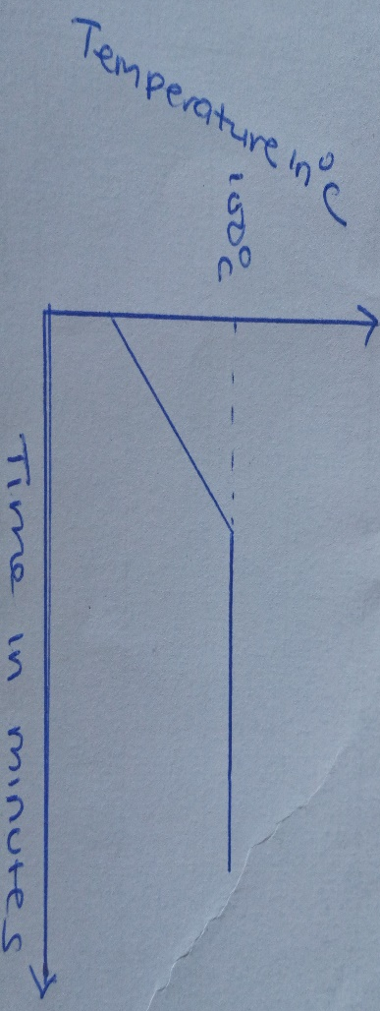
- A) State the kinetic theory of matter (1mk)
……………………………………………………………………………………………………………………………………………………………………………………………………………………………………………………………………………………………………………………………………………………………………………………………………………………………………………….
- By use of a clear (theoretical model) diagram, explain the nature of particles in the three states of matter (3mks)

