PANGANI POST MOCK EXAMINATION
2022
MARKING SCHEME

INSTRUCTIONS TO CANDIDATES

- Write your name and index number in the spaces provided at the top of this page
- Answer ALL questions
- You are required to spend the first 15minutes of the 1 ¾ hours allowed for this paper reading the whole paper carefully before commencing your work.
- Answers must be written in the spa ces provided in the question paper
- Additional pages must not be inserted.

FOR EXAMINERS USE ONLY

Question | Maximum score | Candidate‘s score
1 | 14
2 | 13
3 | 13
Total score | 40

1.You are provided with a specimen labelled K,Using the scapel cut 8 cm of the petiole from the side close to the lamina.cut 2 pieces each measuring 4cm. using a scapel cut a slit halfway through the middle of each piece as shown in the diagram below.
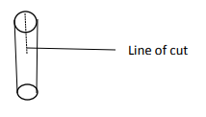
Place one piece in solution labelled A and the other in solution labelled B.Allow the set up to stand for 30 minutes.
a) After 30 minutes remove the pieces and press each gently between the fingers.
(i). Record your observations (2mks)
solution A
>Firm/stiff/hard/rigid
or
>the split curves considerably with the epidermis on the inside circumference and the cortex on the outside circumference.
Solution B
>Soft/flexible/flabby/limber
or
>the split curves slightly with the epidermis on the outside circumference and the cortex on the inside circumference.
(ii) Account for the observations made in the petiole dipped in solution A. (3mks)
Liquid A is hypotonic, cells take in water by osmosis and become turgid.
or
Liquid A is hypotonic; epidermis cells are covered by a cuticle. Hence take in water by osmosis at a very small rate.
Cortical cells have no cuticle hence they take in a lot of water by osmosis and expand, the differential expansion between cortical cells results in a curvature of the slit with the epidermis on the inner circumference.
b) Explain the role of the physiological process identified above in plant nutrition (2mks)
>feeding insectivorous plants
c) State the sub-division to which the plant from which specimen K was obtained belongs. (2mks)
Subdivision Angiospermae/Angiospermatophyta
Reason: Broad leaf
d) State TWO observable features that adapt specimen K for gaseous exchange (2mks)
>It has a broad, flat lamina that offers a large surface area for gaseous exchange.
>It is thin, hence reducing the distance over which diffusion of gases from the atmosphere to the innermost cells takes place.
e) cut a transverse section of the petiole , using a hand lens observe the arrangement of the vascular bundles and make a diagram of the same. (3mks)

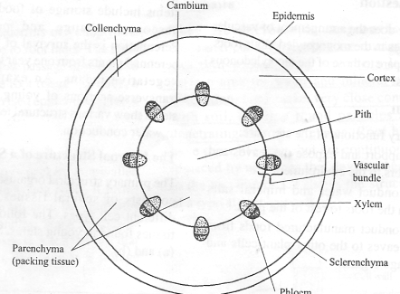

2. You are provided with two bones labelled .Examine them and answer the questions below
a) Giving reasons, identify bones W and Q (4mks)
(i) Identity of bone W
Thoracic vertebra.
Reasons
>Has a long and broad neural spine.
>Short transverse processes
>Presence of demifacets/capitulum and tuberculum for articulating with the ribs.

Identity of bone Q
Rib
Reasons
It is long, flattened and curved
It has tuberculum and capitulum /points of attachment to the thoracic veterbrae.

b) State TWO adaptations of specimen Q (2mks)
It is long, flattened and curved.
It has tuberculum and capitulum /points of attachment to the thoracic veterbrae.

(c) Bone Q and Bone W articulate , draw a diagram showing how the two bones articulate. (5mks)

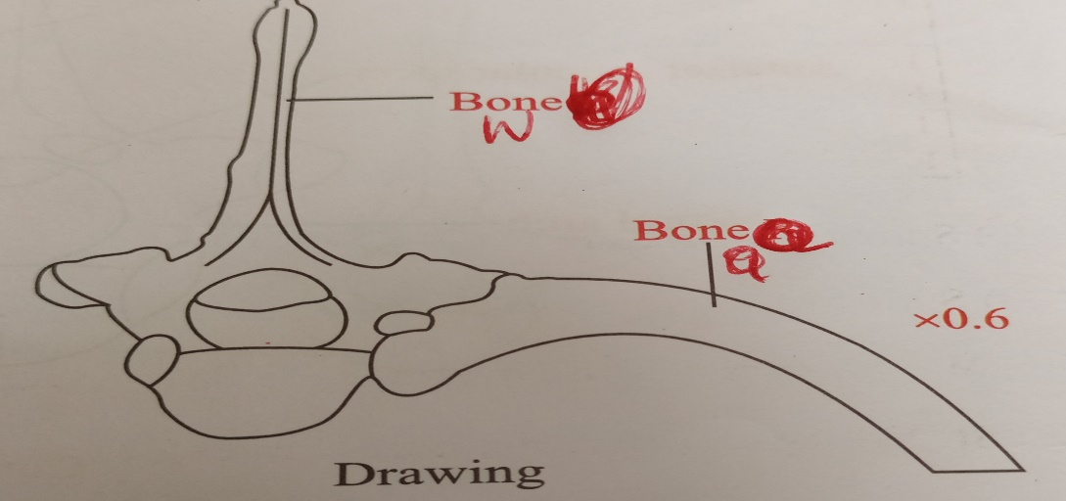

*(d) State the significance of the articulation of the TWO bones. (2mks)
> The articulation provides a surface for breathing
3.The photograph below show stages in cell division.
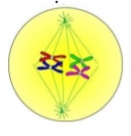X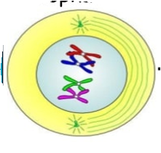 Y 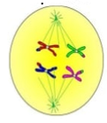Z
a)Name the stages represented by the cells labelled X, Y and Z (3mks)
X –MATAPHASE 1
Y.-PROPHASE 1
Z-ANAPHASE 1
b) State the significance of the above cell division to an organism. (3mks)
1.Results in the formation of gamete cells which are involved in sexual reproduction
2.Maintains the diploid number of chromosomes in the organisms.
3.Source of genetic variations, as it enables mixing of genetic material during crossing over at prophase 1
c) Name TWO regions in higher plants where the above process occurs (2mks)
1.Anthers
2.Ovaries
d) Explain the events that take place in the phase after phase Z. (3mks)
1.The spindle fibers disappear
2.The cell membrane constricts across the middle
3.A nucleolus forms in each new nucleus
……………………………………………………………………………………………………………
e) State the importance of the process taking place in Y in a member of a species (2mk)
1.Exchange of genes resulting to variations.

