PANGANI POST MOCK EXAMINATION
2022
MARKING SCHEME

INSTRUCTIONS TO CANDIDATES
- Write your name, index number and the name of the school in the space provided.
- This paper consists of 2 sections A, and B
- Answer ALL the questions in section A.
- In section B, answer question 6 (Compulsory) and either question 7 or 8 in the spaces provided after question 8.

FOR EXAMINERS USE ONLY
Section | Questions | Maximum Score | Candidates Score
A | 1  2  3  4  5 | 8  8  8  8  8
B | 6  7  8 | 20  20  20
TOTAL SCORE |  | 80

This paper consists of 10 printed pages
Candidates should check the question paper to ensure that all pages are printed as indicated
and no questions are missing
SECTION A.
- (a) Viable seed may not germinate even when provided with favorable condition. State the importance of the above phenomena. (2mks)
-Enables the seed to survive unfavorable conditions.
-It gives time for necessary internal development and maturation to take place.
-it allows time for dispersal by natural agents.
(b) Monocotyledonous plants do not undergo secondary growth. Explain. (2mks)
Monocotyledonous plant lack vascular cambium and cork cambium that are responsible for
Secondary growth.
(c) In the diagram below, a bean seedling was pinned in a horizontal position inside a clinostat.
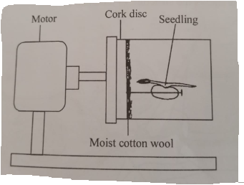
- Explain what you would expect to observe after 48 hours if the clinostat was not rotating. (2mks)
The shoot curved upwards while the root curved downwards. Gravity caused auxins migrate and accumulate on the lower side of the shoot and the root.in the shoot, the high concentration of auxins stimulated more elongation of cells on the lower side causing an upward curvature.in the root, the lower concentration of auxins on the upper side results in more elongation of cells while the higher concentration on the lower side causes inhibition of the cells elongation resulting to a downward curvature.
- Explain what you would expect to observe after 48 hours if the clinostat was rotating slowly. (2mks)
Both the root and the shoot continued to grow horizontally. The rotating clinostat prevents accumulation of auxins on one side. The uniform distribution of auxins brings about uniform growth on all sides of both the shoot and the root.

- (i) Explain the concept of the negative feedback mechanism. (3mks)
A deviation from the normal state of an organism by either an increase above normal or a decrease below normal which causes the body to undergo corrective mechanism in order to reinstate the condition back to normal.
- Study the diagram below and answer the question that follows.
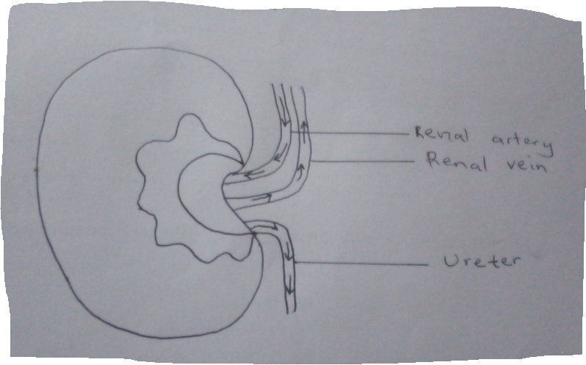
On the organ above, draw a small circle and label it X to show where the adrenal gland is located. (1mk)
- Explain the effect of the hormone secreted by the adrenal gland in blood sugar regulation. (2mks)
Adrenalin prepares the body for an emergency fight or flight by stimulating the liver cells to convert the glycogen to glucose, which is oxidized to release energy necessary for emergency flight or flight.
- Name two diseases that affect organ labeled A. (2mks)
    - Kidney stones.
    - Nephritis.

- The pedigree diagram below show part of a family tree in which the inherited condition of phenylketonuria occurs.
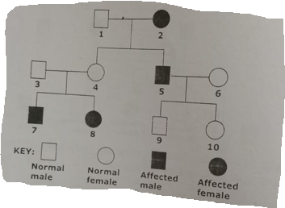
(a) Identify and explain one piece of evidence from this family tree to show that the allele for phenylketonuria is a recessive to allele for the normal condition. (2mks)
Phenotypically normal parents (3 and 4) can give rise to phenylketonuria children (person 7 and 8)
(b) If individual 10 married a man who is the heterozygous for the gene, what is the probability that their first child will be affected? (2mks)
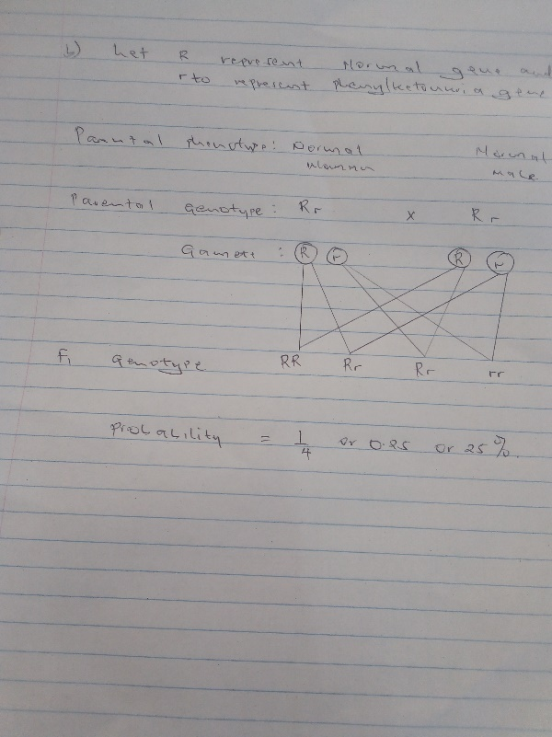

(c) A garden pea plant was crossed with a dwarf garden pea plant and all the offspring’s were tall. Using later T to represent the gene for tallness, determine the genotype of the F₂ if the F1 were test crossed. 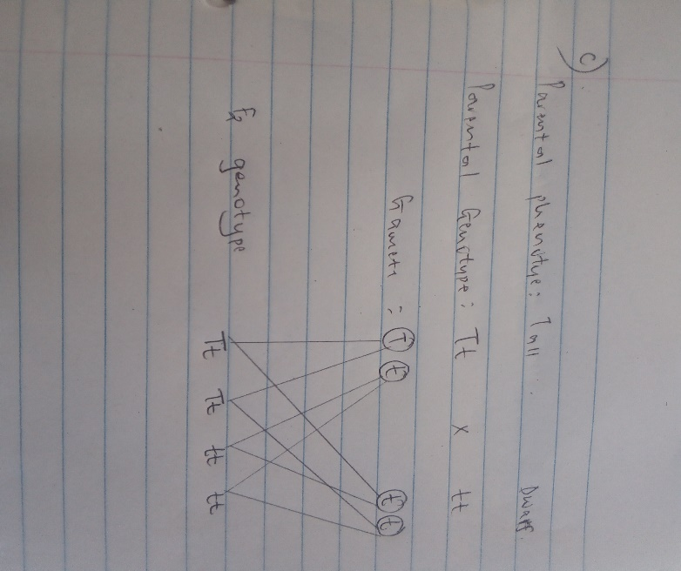 (4mks)

- (i) Distinguish between dentition and dental formula. (2mks)
Dentition refers to the description of type of teeth, their arrangement and specialization while dental formula is the description of the number, type and position of teeth in the jaws of animals.
- The diagram below represents the lower jaw of a mammal.
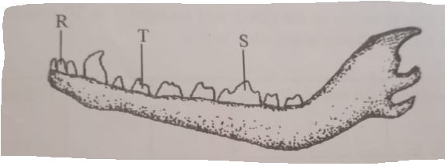
- Name the mode of nutrition of mammal whose jaw is shown. (1mk)
Carnivorous.
- State one structural and one functional difference between the teeth labeled R and T. (2mks)
Structural difference: R - (incisor) is chisel shaped
-One root. while
T-has cusps with sharp edges
-has more than one root.
Functional difference: R is used for gripping and stripping off pieces of flesh close to the bones while T is used for slicing flesh

- ((i) Name the tooth labelled S. (1mk)
Carnassial.
(ii) State how the tooth named in C (i) above is adapted to its function. (2mks)
      - Large and strong for crushing and breaking boned
      - They slide past each other like scissors enabling them to slice and cut the flesh.

- The figure bellow is a cross-section of retinol cells of a mammalian eye.
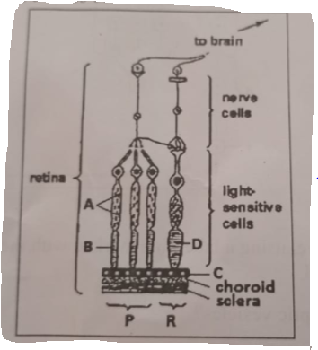
(a) Identify the retinol cells labeled P and R. (2mk)
P-Rods since they has retinal convergence.
R-Cone since it lacks the retinal convergence.
(b) Label each of the parts marked A, B, C and D. (2mks)
A- Mitochondria.
B-outer segment.
C-Retinol cell.
D-outer segment.
(c) Based on the diagram, explain why it takes long for the eye to adjust when one move from a
Lit room to a dark room. (3mks)
In the dark room rods are used to perceive light due to presence of rhodopsin. Immediately one gets to the dark room from lit room,it involves the resynthesis of rhodopsin which occurs slowly.
(d)State structural difference between cell P and cell R. (1mk)
Rod(cell P) | Cone (cell R)
Photochemical pigment is rhodopsin | Photochemical pigment is iodopsin.
Have retinol convergence. | Lacks retinal convergence.
Used for dim light | Used for bright light
Have low visual acquity | Has high visual acquity
Cannot perceive colours | Can perceive colours

SECTION B.

- The pressure in the flow of blood in a mammal was determined at two different vessels; X and Y. The data was taken within a period of 1 minute and was presented as follows.

Time in seconds | Blood pressure in
 | Vessel X | Vessel Y
0 | 160 | 320
10 | 165 | 360
20 | 170 | 320
30 | 180 | 400
40 | 170 | 360
50 | 160 | 320
60 | 160 | 360

(a) Plot the graph of blood pressure in both vessels against time in the same axis. (7mks) 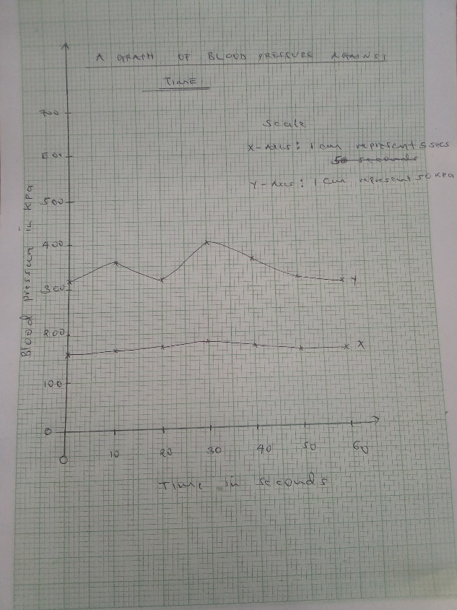

(b) Describe the trend of each curve. (2mks)
Vessel X- pressure is low and remains constant.
Vessel Y- pressure is high, rises and drops within a certain range.
(c) From the graph, suggest the possible identity for:
(i) Blood vessel X. (1mk)
Vein.
(ii) Blood vessel Y. (1mk)
Artery.
(d) Give reason for your answer in (c) (i) and (ii) above. (2mks)
X is a vein because veins have low and constant pressure without pulses while Y is an artery because it has high and low pulses which fluctuates.
(e)Explain a factor that would result in to an increase in blood pressure in both the blood vessels above. (2mks)\
Heartbeat. An increase in heartbeat increases the pressure.
- State two structural differences between the two vessels mentioned in C above. (2mks)
Vessel X | Vessel Y
Wider lumen | Narrow lumen
Thinner muscular walls | Thicker walls
Valves present. | Have no valves.

- Name two diseases of the circulatory system in humans. (2mks)
- Arteriosclerosis.
- Thrombosis.
- Varicose vein.

- Other than, transport of substances state one other function of blood. (1mk)

-Protection against disease causing micro-organism.
-Blood clotting.
-Thermoregulation.
- (a) Discuss the economic importance of bacteria. (10mks)
(b) Discuss the adaptation of Schistosoma mansoni to its survival. (10mks)
- (a) Describe the photosynthetic theory. (10mks)
(b) Describe gaseous exchange in terrestrial plant. (10mks)

7.(a) Some are used to manufacture antibiotic.
Some bacteria are used in fermentation of milk to produce butter/cheese and curing tobacco
Some are used in preparation of vitamin B/ vitamin K.
Some are used in manufacture of synthetic enzymes like amylase.
Some bacteria causes disease in plants and animals.
The bacteria in ruminant secrete cellulase enzyme which aid in digestion of cellulose.
Some bacteria are used in sewage treatment and biogas production.
Some bacteria are used in production of usefull products such as vinegar.
Some saprophytic bacteria cause decomposition of dead organic matter thus releasing nutrients in the ecosystem.
Some bacteria causes food spoilage and food poisoning.
Some bacteria such as the nitrogen fixing bacteria increase soil fertility
Denitrifying bacteria reduce soil fertility/ reducing nitrate in soil decrease crop yield.

(b )-The egg have a hook like structure which raptures the wall of the intestine or bladder
-The egg are laid in large numbers to increase chances of survival.
-The larva has the sucker for attachment onto human skin which it easily digest.
-The adult worms secrete chemicals that nutralise the host’s antibodies.
-The larvae and eggs have the glands that secretes lytic enzyme to soften the tissues of the host for easy penetration.
-The larva are encysted so as to survive harsh environmental condition.
-The larvae has the tail for swimming in the water in search of a suitable host.
-The prolonged association between the male and the female to ensure fertilization takes place.
-it has two host to increase the chances of survival.
-The adult worm is anaerobic and hence can tolerate the low oxygen concentration in the animal tissues.
8.(a) During the day, the chloroplast in the guard cell cell trap light energy for photosynthesis leading to synthesis of glucose which is osmotically active. Glucose in the guard increases the osmotic pressure causing it to gain water by osmosis from the neibouring epidermal cell. This causes the guard cell to bulge outwards leading to opening of the stomata. At night, glucose is converted to starch which is osmotically inactive. This causes the osmotic pressure of the guard cell to drop hence causing the guardcell to lose water by osmosis to the neighboring epidermal cell. The inner and the outer walls shrinks leading to closing of stomata.\

(b) Gaseous exchange takes place in the spongy mesophyll. It involves carbon (iv) oxide and oxygen gas. During the day, carbon (iv) oxide diffuses into air spaces of spongy mesophyll due to concentration gradient from the stomata then carbon (iv) oxide diffuses into photosynthetic cells in a solution form.
During photosynthesis carbon, (iv) oxide is used while oxygen is released. Some oxygen is used in respiration while the rest of oxygen diffuses out of the leaf through the stomata due to concentration gradient.
During the night, oxygen diffuses into the air spaces of spongy mesophyll. Due to concentration gradient, the oxygen dissolves into the film of moisture then diffuses into the cells in solution form and is used in respiration during which carbon (iv) oxide is produced. It then diffuses out of the leaf through the stomata due to concentration gradient.
Some gaseous exchange also takes place through the cuticle and epidermis of young leaves and stems. The epidermis of the root carries out gaseous exchange with the air in the soil.Some plant have breathing roots (pneumatophores) through which gaseous exchange occurs.
Gaseous exchange also occurs through the lenticels found in the older stems. The cork cells at the lenticels are loosely packed to enable exchange of gases between the atmosphere and the cork cells.

