BIOLOGY
FORM THREE
MID-TERM 2 2022

TIME: 1 ¼ HOURS
NAME……………………………………………………ADM NO……………CLASS….
Instructions to candidates
Answer All Questions In The Spaces Provided
- The diagram below represents a nucleus.
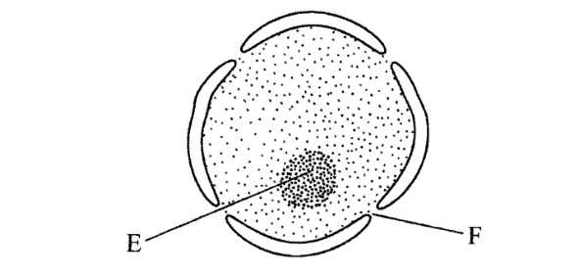

- Name the structures labelled E and F. (2 marks)

b. State the function of F. (1 mark)

- With reference to the nucleus state one difference between an animal and a bacterial cell. (1 mark)

- Name the plant cell organelle:
a. That stores chlorophyll (1 mark)

b. Responsible for intracellular digestion. (1 mark)

3. State two main functions of the vacuole in the amoeba. (2 marks)

4. The figure below shows the structure of a chromosome.
Identify the parts labeled K and J. (2 marks)
K
J

5. The figure below shows a part of female reproductive structure of a plant. Label the marked parts. (3 marks)
C
B
A

A
B
C

6. Below is a diagram of a mature yeast cell.

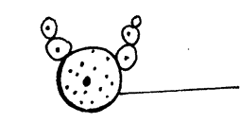
Parent yeast cell
- State the kingdom to which the yeast belongs. (1 mark)

- Name the process illustrated by the cells above. (1 mark)

7. Define the term reproduction (1 mark)

8. Name the two types of cell division ( 2 marks)

9. State three mechanisms that hinder self-pollination (3 marks)

10. Using a well labelled drawing, show the four major parts of a flower (5 marks)

11. Describe the process of double fertilization in flowering plants. (10 marks)

12. Describe the changes that take place in a flower after fertilization: (10 marks)

13. Name four methods of seeds and fruit dispersal (4 marks)

