BIOLOGY, FORM THREE,MID-TERM 2 EXAM 2022.
50 MARKS.
TIME :1 HR;15 MIN.
MARKING SCHEME
Instructions to candidates
ANSWER ALL QUESTIONS IN THE SPACES PROVIDED
- The diagram below represents a nucleus.
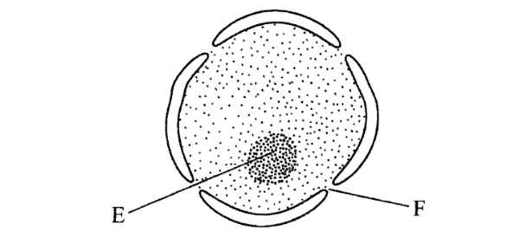

- Name the structures labelled E and F. (2 marks)
E- Nucleolus
F - Nuclear pore/nucleopore
b. State the function of F. (1 mark)
Facilitates movement of materials in and out of the nucleus
- With reference to the nucleus state one difference between an animal and a bacterial cell. (1 mark)
Nuclear material in the bacterial cell is not enclosed Within a membrane /prokaryotic, while in animal cell it is enclosed/ eukaryotic
- Name the plant cell organelle:
a. That stores chlorophyll (1 mark)
Chloroplast
b. Responsible for intracellular digestion. (1 mark)
Lysosome
3. State two main functions of the vacuole in the amoeba. (2 marks)
Feeding (food vacuole)
Osmoregulation (contractile vacuole);
Excretion/removal of wastes
4. The figure below shows the structure of a chromosome.
Identify the parts labeled K and J. (2 marks)
K
J- Chromatids
K- Centromere

5. The figure below shows a part of female reproductive structure of a plant. Label the marked parts. (3 marks)
C
B
A

A – style; B - ovary C. Carpel;

6. Below is a diagram of a mature yeast cell.

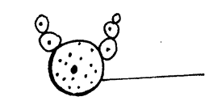
Parent yeast cell
- State the kingdom to which the yeast belongs. (1 mark)
Fungi

- Name the process illustrated by the cells above. (1 mark)
Budding
7. Define the term reproduction (1 mark)
The process by which mature individuals produce offspring
8. Name the two types of cell division ( 2 marks)
Mitosis
Meiosis
9. State three mechanisms that hinder self-pollination (3 marks)
Protandry
Protogyny
Self-sterility
10. Using a well labelled drawing, show the four major parts of a flower (5 marks)
Well labelled structure of a flower.
Drawing=1mrks
Labelling parts; Gynoecium,Androecium, petal, sepal.=4mrks

11. Describe the process of double fertilization in flowering plants. (10 marks)
The pollen grain contains the generative nucleus and a tube nucleus.
When the pollen grain lands on the stigma, it absorbs nutrient and germinates forming a pollen tube. This pollen tube grows through the style pushing its way between the cells, and gets nourishment from these cells.
The tube nucleus occupies the position at the tip of the growing pollen tube.
The generative nucleus follows behind the tube nucleus, and divides to form two male gamete nuclei. The pollen tube enters the ovule through the micropyle.
When the pollen tube penetrates the ovule disintegrates and the pollen tube bursts open leaving a clear way for the male nuclei.
One male nucleus fuses with the egg cell nucleus to form a diploid zygote which develops into an embryo.
The other male gamete nucleus fuses with the polar nucleus to form a triploid nucleus which forms the primary endosperm.

12. Describe the changes that take place in a flower after fertilization: (10 marks)
The integuments develop into seed coat (testa).
The zygote develops into an embryo.
The triploid nucleus develops into an endosperm.
The ovules become seeds.
The ovary develops into a fruit.
The ovary wall develops into pericarp.
The style, dries up and falls off leaving a scar.
The corolla, calyx and stamens dry up and fall off.
In some the calyx persists.

13. Name four methods of seeds and fruit dispersal (4 marks)
Animal
Wind
Water
Self-dispersal

