BUSINESS STUDIES
FORM 4
MID-TERM 2 2022
TIME: 1 ½ HOURS
Name: ……………………………………..…… CLASS…………… ADM.............

- Outline four reasons for collapse of small scale business units. [4mks]

- Highlight four disadvantages of newspaper as a means of advertising. [4mks]

- The following information relates to Maendeleo traders as at 31st Dec. 2009
Capital at the start of the year was ksh. 110 000, the owner bought his personal furniture worth ksh. 50 000 into the business while drawings amounted to ksh. 20 000.
At the end of the year, value for capital was ksh. 280 000
Required: Determine the profit earned during the year. [4mks]

- State four ways in which the government creates an enabling business environment. [4mks]

- Highlight four essential features of an efficient transport system. [4mks]

- Cite four possible causes of unemployment in Kenya. [4mks]

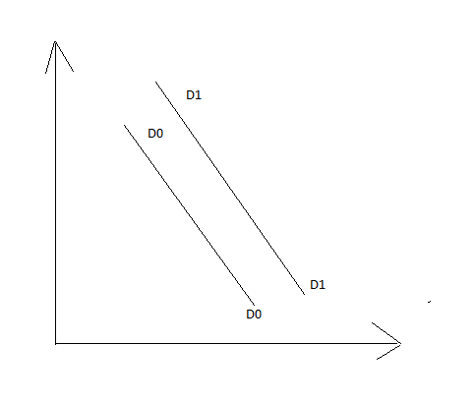
- The following diagram shows a shift in demand curve. Outline four reasons that can lead to this shift. [4mks]

Price
(shs)

Quantity

- The diagram below shows the circular flow of income in a two sector economy.
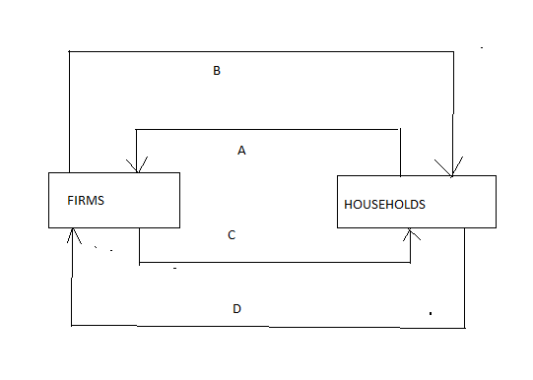

Identify the movements labeled A,B,C and D. [4mks]

- Highlight four sources of public finance. (4mks)
___________________________________________________________________________________________________________________________________________________________________________________________________________________________________________________________________________________________________________________________________
- Highlight four statutory measures used to control inflation as used by the central bank. [4mks]

- Outline four negative effects of inflation. (4mks)
________________________________________________________________________________________________________________________________________________________________________________________________________________________________________________________________________________________________________________________________________

- Outline four requirements that are needed for a smooth functioning of a warehouse (4mks)
____________________________________________________________________________________________________________________________________________________________________________________________________________________________________________________________________________________
- Give two principles of insurance. (2mks)
__________________________________________________________________________________________________________________________________________

