TERM 2 2022 OPENER EXAM FORM 4
FORM FOUR BUSINESS PAPER 2 MARKING SCHEME

1 (a) Factors promoting entrepreneurship in Kenya
- Favorable government policies
- The strength of financial institutions in Kenya
- Infrastructure
- Availability of market for goods and services
- The level and type of education and training
- Presence of role models
- Security and political stability in the country
- The social-cultural practices of the people
- Legal provision or lows that may not enhance entrepreneurship (5x2=10mks)
(b) Explain five advantages of using office machine. (10mks)
- Labor saving reducing wages bill
- Reduce the firms labour- related problems e.g “unrest”
- Work produced is of high quality and more presentable
- Output is standardized
- Speeds up the rate of production
- Helps to improve the level of accuracy
- Enhance s the image of the company
- Lowers the cost of production
2(a) Give five difference between Public Company and public corporation public company Public Corporation
(i) - They are formed by the Company Act (i) - They are formed by the Act of parliament.
(ii) – It is owned by shareholders i.e. ordinary (ii) – Owned by the government
shareholders
(iii) – Able to raise capital through sale of (iii) – Capital is provided by the government.
shares to the public.
(iv) – Board of directors are elected by (iv) - Board of directors are appointed by the
shareholders from among themselves. Government.
(v) – The profit generated are distributed to (v) – It is formed to improve the services to the
shareholders as dividends. ces between a public limited company and a public corporation. (10mks

(b) The following trial balance has extracted from the books of Bishar Retailers on 30th
April, 2006.
 | Dr  shs | Cr  shs
Sales |  | 186,000
Purchases | 115,560
Stock 1.5.2005 | 37,760
Carriage outwards | 3,260
Carriage inwards | 2,340
Returns | 4,400 | 3,550
Motor expenses | 6,640
Rent | 4,560
Salaries and wages | 24,490
General expenses | 12,000
Rates | 1,200
Equipment | 60,000
Machinery | 31,960
Trade debtors | 45,770
Trade creditors |  | 30,450
Bank | 38,760
Cash | 12,000
Drawings | 20,500
Capital | _______ | 128,440
 | 348,440 | 348,440

Stock at 30th April, 2006 was shs 49,980.

Required; i) Prepare Trading, profit and loss Account for the year ended 30th April 2006. (7marks)
ii) Balance as at 30th April 2006. (5marks)

BISHAR RETAIL BUSINESS
TRADING PROFIT AND LOSS A/C
FOR THE PERIOD ENDING 30TH APRIL 2006

Dr |  |  |  |  | Cr
 | Ksh | Ksh |  | Ksh | Ksh
Opening stock |  | 37760 | Sales | 186000
Add purchases | 115560 |  | Less return inwards | 4400
Add carriage inward | 2340 |  | Net sales |  | 181600
 | 117900
Less return outwards | 3550 | 114350
COGAS |  | 152110
Less closing stock |  | 49980
Cost of goods sold |  | 102130
Gross profit c/d |  | 79470
 |  | 181600 |  |  | 181600
 |  |  | Gross profit b/d |  | 79470
Carriage outwards |  | 3260
Motor expenses |  | 6640
Rent |  | 4560
Salary & wages |  | 24470
General expenses |  | 12000
Rates |  | 1200
Net profit c/s |  | 27320
 |  | 79470 |  |  | 79470
 |  |  | Net profit b/d |  | 27320

@entry=½mark,total =7mks

(ii) Balance sheet as at the date. (5mks)

BISHAR RETAIL BUSINESS
BALANCE SHEET
AS AT 30TH APRIL 2006
 | Ksh | Ksh |  | Ksh
Fixed Assets |  |  | Capital + Liabilities
Equipment | 6000 |  | Capital | 128440
Machinery | 24000 | 30000 | Add net profit | 27320
Current Assets |  |  | Less drawings | 20500
Stock | 49980 |  |  | 135260
trade debtors | 45770 |  | Current Liabilities
Bank | 38760 |  | Trade creditors | 30450
Cash | 1200 | 135710
165,710 165,710

3a).Discuss five reasons why a manufacturer may sell directly to consumers. (10marks)
i) Where the customers are concentrated in one place
ii) Customers are close by/Near the market
iii) Requirement by government policy as the government may force a particular manufacturer to sell their products direct to consumers.
iv) If products are produced only on order hence no need for intermediaries
v) Where Production follows customer specification
vi) Manufacturer has adequate financial resources to fund the process of distribution
vi) If the product is perishable/Fragile thus need for less handling

(b) Explain five advantages of using office machine. (10mks)
Advantages of using office machine
- Labor saving reducing wages bill
- Reduce the firms labour- related problems e.g “unrest”
- Work produced is of high quality and more presentable
- Output is standardized
- Speeds up the rate of production
- Helps to improve the level of accuracy
- Enhance s the image of the company
Lowers the cost of production
4. a) Explain five factors which may influence choice of a distribution channel. (10 marks) .
i) Number of potential customers
Where customers are few, the manufacturer may use its own sales force/large number of customers may
use intermediaries.
ii) Geographical concentration of the market, where the market is centralized in a few geographical areas,
direct distribution is okay/less concentrated market may use intermediaries.
iii) Order size
Economical to sell directly for customers who buy in large quantities.
Use intermediaries for customers who buy in small quantities.
iv) Unit value of the product.
Products of high value can be distributed directly due to high risks.
Low value can use intermediaries.
v) Perishability of the product.
Perishable goods distributed through short fast channel to avoid spoilage.
vi) Technical nature of the product.
Good of highly technical nature sold to customers in order to give pre-sale and after sales service.
vii) Financial resources
A producer who is financially strong can afford to distribute directly to consumers
viii) The intermediaries/availability
Different intermediaries perform different functions, hence a firm should select the channel convenient to it to ensure smooth operations.
ix) Competitors
A firm wishing to have its product compete directly with that of a competitor would select a channel that the competitor uses and vice versa.
x) Government policy
Where the government requires a particular channel to be used, the producer will have no choice.
xi) Cost- The distribution channel to be used must be affordable/should allow the manufactures to maximize profits.
b) State and explain five macro environments and the positive effect of each on the performance of a
- business (10 marks
i) Economic environment (favourable): Economic situations that increase consumers’ purchasing power eg low price levels, high consumers income, low interest rates, low levels of inflation and taxes.
ii) Demographic environment: A high population creates a wider market and hence more sales & profits.
iii) Advancement in technology: High levels of know-how and efficient use of tools/equipment lead to better quality goods/services and reduced cost of production.
iv) Legal environment (favourable): Laws and policies made by the government should be favourable eg. Taxation, legislation, ease in licensing etc.
v) Favourable political environment: Political stability leads to peace there by creating a conducive environment for business to thrive.
vi) Favourable cultural environment where customs values and beliefs of the society are for the product, this boosts sales and the business thrive.
vii) Fair competition: This will enable the business cope with the competitors and remain in operation.
(vii)Physical environment (ideal or favourable): Relief, climate, infrastructure, electricity etc when ideal enables the business operate efficiently.

5a) Describe five features of good money. (10 marks)
Five characteristics of good money
- Acceptability: Must be acceptable to everyone for it to be used as a medium of exchange.
- Divisibility: Should be divisible into smaller units without loss of value.
- Scarcity: Should be relatively limited in supply so as to maintain value.
- Cognizability: Should be easy to recognize genuine from fake money.
- Malleability: Should be easy to print or mint but difficult to forge.
- Homogeneity: Money of the same denomination should be uniform in quality and identical.
- Stability in value: Should be able to last for a long time without changing in value so that it maintains credibility and acceptability. If it fluctuates in value, people prefer holding wealth in form of goods.
- Portability: Should be easy and convenient to carry around.
- Durability: Should be able to last for along time without getting torn, defaced or losing shape and texture.
b) On 1st June 2009, MULI ENTERPRISES had cash in hand sh. 87,000 and cash at bank
sh. 250,000.During the month, the following transactions took place.
June 2, Sales (cash) sh. 50,000
3, Paid salaries sh.101, 500 by cheque.
6, Received a cheque for sh. 76,800 from Mwelu after allowing her a cash discount of 4%.
12, Bought office furniture by cheque sh. 85,000
16, Settled Musau’s account of sh. 40,000 in cash, having deducted shs 800 cash discount.
18, Received a cheque for shs 150,000 in respect of cash sales.
21, Paid wages shs 24,000 in cash.
22, Withdrew shs 30,000 from bank for office use.
25, Withdrew shs 5000 cash for private use.
28, Received shs 16500 cash from Kasiva in settlement of her account less shs 660 cash discount.
June 30, Deposited all the money into bank except shs 25,000
Prepare a three column cash book and balance it off. (10marks)
MULI ENTERPRISES
THREE COLUMN CASH BOOK
Date | Details | Disc. Allowed | Cash | Bank | Date | Details | Disc. Received | Cash | Bank
2009 1/6 | Bal b/d |  | 87,000√ | 250,000√ | 2009 2/6 | Salaries |  |  | 101,500√
2/6 | Sales |  | 50,000√ |  | 12/6 | Furniture
6/6 | Mwelu | 3,200√ |  | 76,800 | 16/6 | Musau | 800 | 39,200√
18/6 | Sales |  |  | 150,000 | 21/6 | Wages |  | 2,400√
22/6 | Bank |  | 30,000√ |  | 22/6 | Cash |  |  | 30,000√
28/6 | Kasiva | 660√ | 16,500√ |  | 25/6 | Drawings |  | 5000√
30/6 | Cash | c |  | 90300√ | 30/6 | Bank | c | 90,300√
 |  |  |  |  | 30/6 | Bal c/d |  | 25,000√ | 350,600√
 |  | 3,860 | 183,500 | 567,100 |  |  | 800 | 183,500√ | 567,100√
20 x¹_{/2} = 10marks
6a) Explain five uses of national income statistics to an economy. (10 marks)
Five uses of National income statistics
- They are used to measure the overall economic growth of a country.
- They can be used to compare the standard of living between countries and also compare standards of living of citizens in a country at different times.
- They can be used for planning purposes by the government to ensure proper allocation of resources.
- Entrepreneurs may use the national income statistics to make investment decisions by observing consumption patterns.
- Statistics show the contribution of various sectors and regions to the national income.
(Any 5 well explained @ 2marks = 10marks)

b) With the aid of an appropriate labelled diagram, explain four circumstances under which
supply curve may shift to the right hand side. (10 marks)
b) Circumstances under which supply curve may shift to the right hand side.
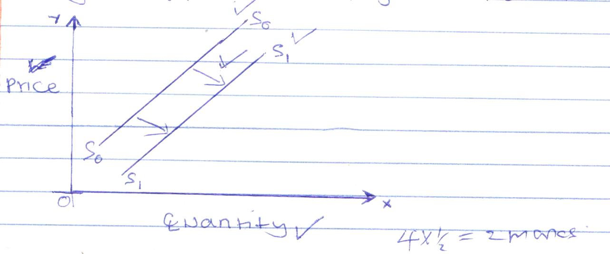
- Improved technology
- Increased supply of inputs
- Decreased cost of production
- Entry of new firms to industry
- Increased government subsidy’s
- Decreased taxation of input
(Any 4 well explained @ 2marks = 8marks)

