NAME…………………………………………
BUSINESS STUDIES
MARKING SCHEME
LANJET 2021
565/2
- a) Measures a country may adopt to increase its volume of export
- Engaging in international trade fair/exhibition to promote the home products
- Devaluation of its own currency to make export cheap
- Lowering taxes on exports to make them cheap
- By diversifying on its exports to increase the market.
- Offering subsidies to firms that are involved in production of export goods
- Reducing the length /procedure for acquiring licenses for exporting products
- Adopting modern technology to export products to make them fashionable/High quality/more attractive to customers
- Offering customs drawbacks – The government refunds either in full or part of custom duty paid on imported raw materials if finished product is exported.
- Lobbying/Negotiate with trading partners for removal of trade restrictions placed on the country’s exports
(Any 5 well explained x2=10marks)
(b)Factors that encourage entrepreneurial development in Kenya
- Improved infrastructure; good roads, adequate security, availability of water, electricitywill encourage entrepreneurial development.
- Favorable government policies such as lessening tax burden by providing tax holidays, providing incentives and simplifying procedures and cost of obtaining relevant legal documents required
- Availability of market for goods and services/Expanding market due to devolution of services
- Increased accessibility to education and training/Expanded capacity to provide training for better skills to entrepreneurs.
- Availability of resources/Increased accessibility to credit from commercial financial institutions and also from the government through government initiated projects like uwezo fund and women enterprise funds.
- Political stability/absence of political chaos/No inter-clan fighting creates a conducive environment for entrepreneurs to venture into varied investments with confidence.
- Favorable natural conditions/enough rainfall for agro-based businesses.
(Any 5 well explained x2=10marks)

2(a) A surgeon set up a clinic in a distant rural centre. The business was closed after six months.
Identify four possible causes for the failure

- Inadequate capital
- Poor working strategies
- Unfavorable government policies
- Insecurity in the area
- Inadequate academic and technical knowledge
- Inadequate business management knowledge
- Inadequate demand market
- Poor record keeping
- Poor customer relations
- Large drawings from firm
- Lack of self discipline and poor moral character
- Poor planning
- Changes in technology
- Changes in business environment
b)
- Uhuru Highway
- Balance Sheet
- As at 31st May 2014
- Fixed assetsKsh.Ksh.
- Equipment 24,000√ Capital 128,440√
- Furniture 6,000√ Add net profit 27,320√
- 30,000 155,760
- Current assetsKsh. Less drawings 20,500√
- Stock 49,980√ 135,260
- Debtors 45,770√ Short term liabilities
- Bank 38,760√ Creditors 30,450√
- Cash 1,200√ 135,710
        - 165,710 165,710
10 ticks @ 1mk= 10mks

3(a) Measures used to solve unemployment cases in Africa.
- Encouraging investment by Private sectors through offering subsidies to increase employment opportunities.
- Use policies that encourage use of labour intensive methods of production.
- Ensure political stability – attract foreign investment into the country.
- Delocalise firms to prevent / reduce urban unemployment brought about by rural-urban migration.
- Encourage use of family planning methods to reduce rapid population growth.
- Provide appropriate education and training methods that equips citizens with relevant skills and knowledge required by firms.
- Increases in Government expenditure to create job employment
- Encourage use of local resources to create employment(5 x 2 = 10mks)
(b) Give five differences between a private limited company and a public corporation.
Public corporation | Private limited company
It is formed by an act of parliament | It is formed under the company’s act
It is not profit – motivated provides services to the general public | It is profite motivated
It is financed by the government | Capital is raised through the sale of share
Board of directors is appointed by the government | Directors are elected by shareholders
Losses are subsidized/ borne by the government | Losses may lead to collapse of business
It is owned by the government | It is owned by shareholders

4 (a) Money transfer facilities provided by the Commercial Banks

- Standing order- Instruction to the bank by the A/C holder to make regular payment to the A/c holder to make regular payment to a name client for an agreed period of time.
- Credit transfer – Method of paying many people using one cheque
- Telegraphic transfer – Method of remitting money fast and safely from one person to another
- Electronic Funds transfer (EFT) – Transferring money from one account to another using computers
- Cheques- Written order by the drawer to the Bank to pay on demand a specified amount of money to the named person on the cheque.
- banker’scheque – Written order by a bank to another to pay a stated amount of money to the payee.

b) Two column cash-book
DR MUSA TRADERS CR
Date | Details | Folio | Cash | Bank | Date | Details | Folio | Cash | Bank
2010  May 1  8  18  20  25  29 | Bal b/d√1  Debtor√½  Sales√½  Bank√½  Debtor√½  Cash√½ | C  C | Sh.  15,000  7,200  30,000  8,000  60,200  42,000 | Sh.  160,450  9,200  10,000  179,650√1  123,450√1 | 2010  May 2  15  16  20  28  29  30  31 | Purchases√½  Creditor√½  Salaries√½  Cash√½  Gen.exp.√½  Bank√½  Electricity√½  Bal c/d√1 | C  C | Sh.  4,200  4,000  10,000  42,000  60,200 | Sh.  5,400  18,300  30,000  2,500  123,450  179,650
Total 10 Marks

5. (a) Causes of B.O.P disequilibrium
- Fill in volume of exports
- Deterioration in the country’s terms of trade
- Increase in volume of imports
- Restrictions by Trading partners
- less capital inflow compared to outflow
- Over-valuation of domestic currency
- Devaluation of currency by a Trading partner

Mention 1mark otherwise 2x10 = 10 marks
(b) Channels of distribution of imported manufactured goods.

- Foreign Manufacturer Agents Wholesaler Retailer Local Consumer.

- Foreign Manufacturer Wholesaler Retailer Local Consumer.
- Foreign Manufacturer Local Consumer.
- Foreign Manufacturer Manufacturer’s Representative Wholesaler
Retailer Local Consumer.

- Foreign Manufacturer Wholesaler Local Consumer.
- Foreign Manufacturer Retailer Local Consumer.
NB. Candidate should mention Foreign Manufacturer and Local Consumer
5 x 2= 10mks
6(a) Functions of the stock-exchange market.
- - It assists investors to buy shares by providing appropriate information to them.
- - It assists shareholders who want to dispose of shares by giving them relevant information.
- It assists companies that need to raise money by floating shares to the public.
- It compiles business information that would be used by interested parties to make decisions on the investment.
- It vets the standard of performance of Company that intends to be quoted in the stock market.
- It sets the prices of shares for the general public investors.
- It list / delists companies that are viable / not viable.
- Generates revenue for the government through taxation.
- Creation of employment.
(5 x 2 = 10mks)
b)
- i) The gross profit
- Gross profit = sales – costs of sales – ½

- 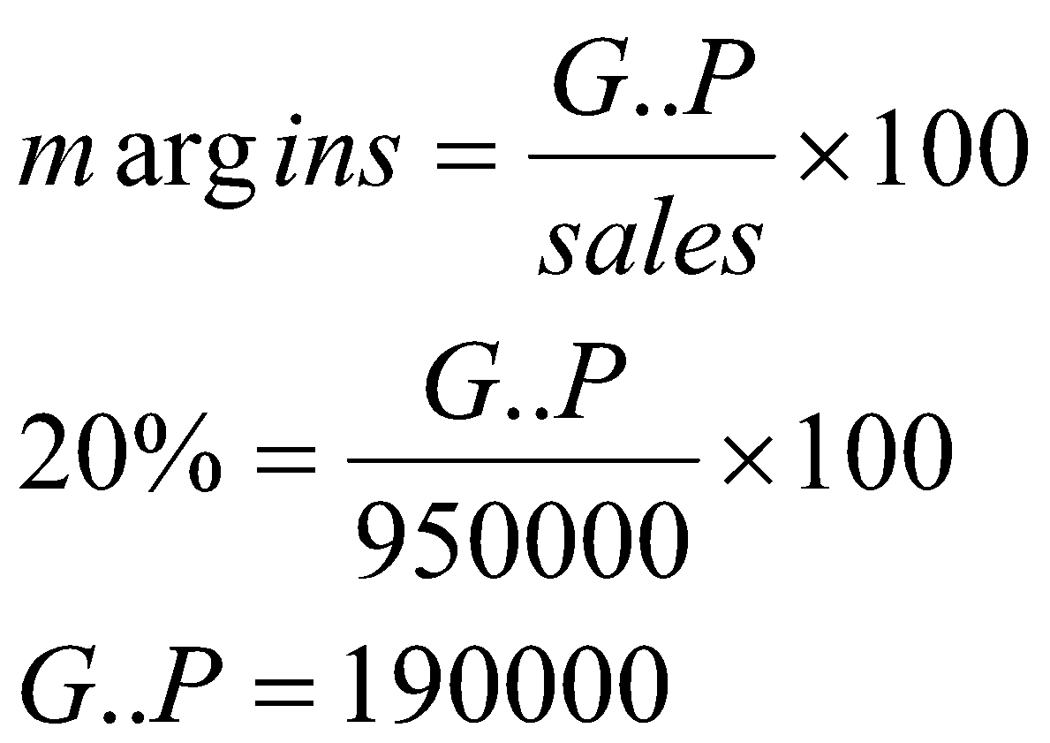 ½
- ii) The opening stock
- C.O.S = O.S + purchase = C.S ½
- C. O. S = sales – G.P
- C.O.S = 950,000 – 190,000 ½
- = 760,000
- O.S = 760,000 – 80,000 + 200,000
- 680,000 + 200,000 = 880,000
- 760,000 = opening stock + 600,000 ½
- 760,000 – 600,000 = O.S ½
- 160,000 = opening stock ½

- iii) Mark up percentage
- Mark- up = 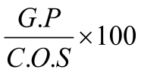 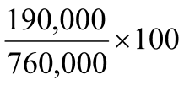
- = 25%

- iv) The net profit = 5% of sales
- N.P 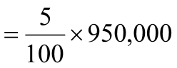 ½
- = 47,500 1 (10x1=10mks

