BUSINESS STUDIES
FORM 4
MID-TERM 2 2022
MARKING SCHEME

- Outline four reasons for collapse of small scale business units. [4mks]
- Poor location
- Insufficient capital
- Stiff competition
Poor management
- Highlight four disadvantages of newspaper as a means of advertising. [4mks]
- Does not cater for illiterate
- Message may be read only once because people are used to newspaper for that particular day.
- May not reach the rural areas where transport system is very poor
Expensive to book a space in the newspaper
- The following information relates to Maendeleo traders as at 31st Dec. 2009
Capital at the start of the year was ksh. 110 000, the owner bought his personal furniture worth ksh. 50 000 into the business while drawings amounted to ksh. 20 000.
At the end of the year, value for capital was ksh. 280 000
Required:Determine the profit earned during the year. [4mks]
- C.C = OC + P + I – D
HENCE : P = CC – OC – I + D
CC + D – OC – I √
P = SHS. [280000+20000
110000-50000√√
=SHS. 140000√

- State four ways in which the government creates an enabling business environment. [4mks]
- Giving economic incentives e.g low taxes, subsidies
- Putting up infrustructures
- Ensuring law and order
- Providing easy credit terms
- Developing social amenities e.g hospitals, school etc
- Enhancing favourable laws and reputations
- Facilitating use of appropriate technology
- Preservation and conservation of natural resources and environment
- Simplifying procedures in starting and running businesses
- Ensuring good governance and political stability

- Highlight four essential features of an efficient transport system. [4mks]
- The way
- The terminal
- Unit of carriage
Method of propulsion
- Cite four possible causes of unemployment in Kenya. [4mks]
- Job selection
- Rapid population growth
- Poor planning and misuse of public resources
- Seasonality of jobs
- Low economic growth
- Technological application
- Poor education systems

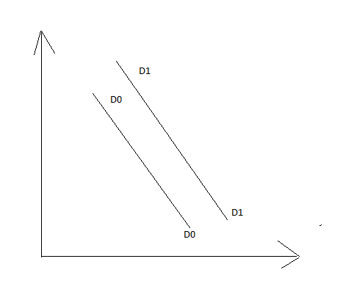
- The following diagram shows a shift in demand curve. Outline four reasons that can lead to this shift. [4mks]

Price
(shs)

Quantity
- Increase in consumer’s level of income
- Positive taste and preference
- Consumer’s expectations in price increase and shortages
- Large population size
- Reduced taxes on the commodities

- The diagram below shows the circular flow of income in a two sector economy.
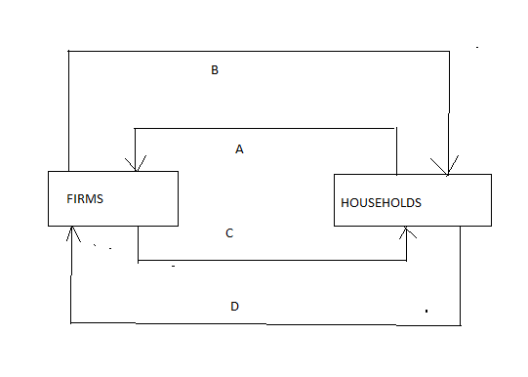

Identify the movements labeled A,B,C and D. [4mks]
A – factors of production
B – payment of factors of production
C – goods and services
D – payments for goods and services

- Sources of public finance- Fines imposed by court on offenders
- Proceedings from sale of government property
- Rent and rates paid for the use of grit property
- Taxes
- Government borrowing
- Dividends and profits earned by the government direct investment
- Highlight four statutory measures used to control inflation as used by the central bank. [4mks]
- Controlling wages and salaries
- Price controls
- Restrictive imports
- Restricting the terms of hire purchase and credit terms of sales.

- Outline four negative effects of inflation. (4mks)
-Reducing on profit
- Wastage of time
- Conflicts between employees and employers
- Loss of creditors
- Discourage savings

- Outline four requirements that are needed for a smooth functioning of a warehouse (4mks)
-Equipment
- Appropriate staff
- Proper building
- Proper recording system
- Appropiate special facilities

