**NAME………………………...........................…………………….. ADM NO…………………… CLASS…………………**

**231/1**

**BIOLOGY PAPER 1**

**FORM FOUR**

**TIME: 2 HOURS.**

**MOMALICHE 2 CYCLE 10**

**INSTRUCTION TO CANDIDATES:**

* Answer all the questions in the spaces provided.
* All questions to be answered in English.
* Read all questions carefully.

**For Examiner’s Use Only**

|  |  |  |
| --- | --- | --- |
| **Questions** | **Maximum Score** | **Candidate’s Score** |
| **1-31** | **80** |  |

1. During a field study. A form one student at a Momaliche School observed the organism below. Name one appropriate tool the student would use to collect the specimen. Give a reason for your answer.

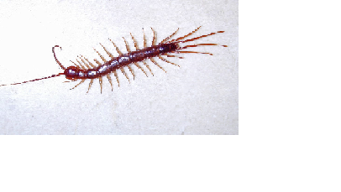 (2 marks)

Apparatus …………………………………………………………………………………………..

Reason ……………………………………………………………………………………………..

1. 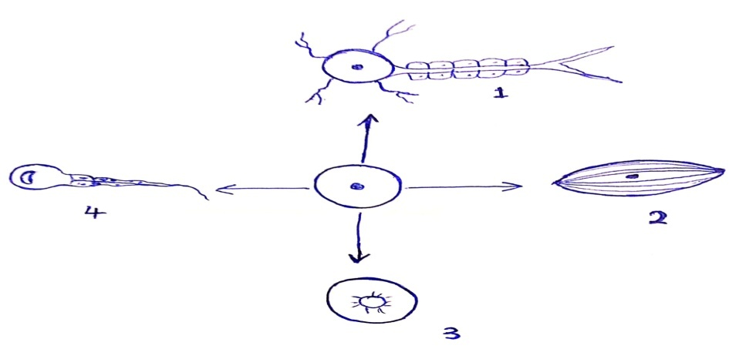The diagram below shows various specialized animal cells modified from the basic animal cell.
2. Name the process represented by the arrows. (1mark)

…………………………………………………………………………………………………………

1. i) Identify cell **1** and **2**. (2 marks)
2. ........………………………………………..……………………………………………………….

2 ………………………………….…………………………………………………………………

1. Explain why a mountain climber has more red blood cells than a person of the same size, age and sex living in low lands (2marks)

………………………………………………………………………………………………………………………………………………………………………………………………………………………………………………………………………………………………………………………

1. A certain organism K was surgically removed from a rat. Later drastic increase in glucose level in the blood was reported but when substance Q was injected into the animal, the whole process was reversed.

Identify:- (2 marks)

1. Organ K …………………………………………………………………………………………..…
2. Substance Q …………………………………………………………..……………………………
3. The diagram below shows a simplified nitrogen cycle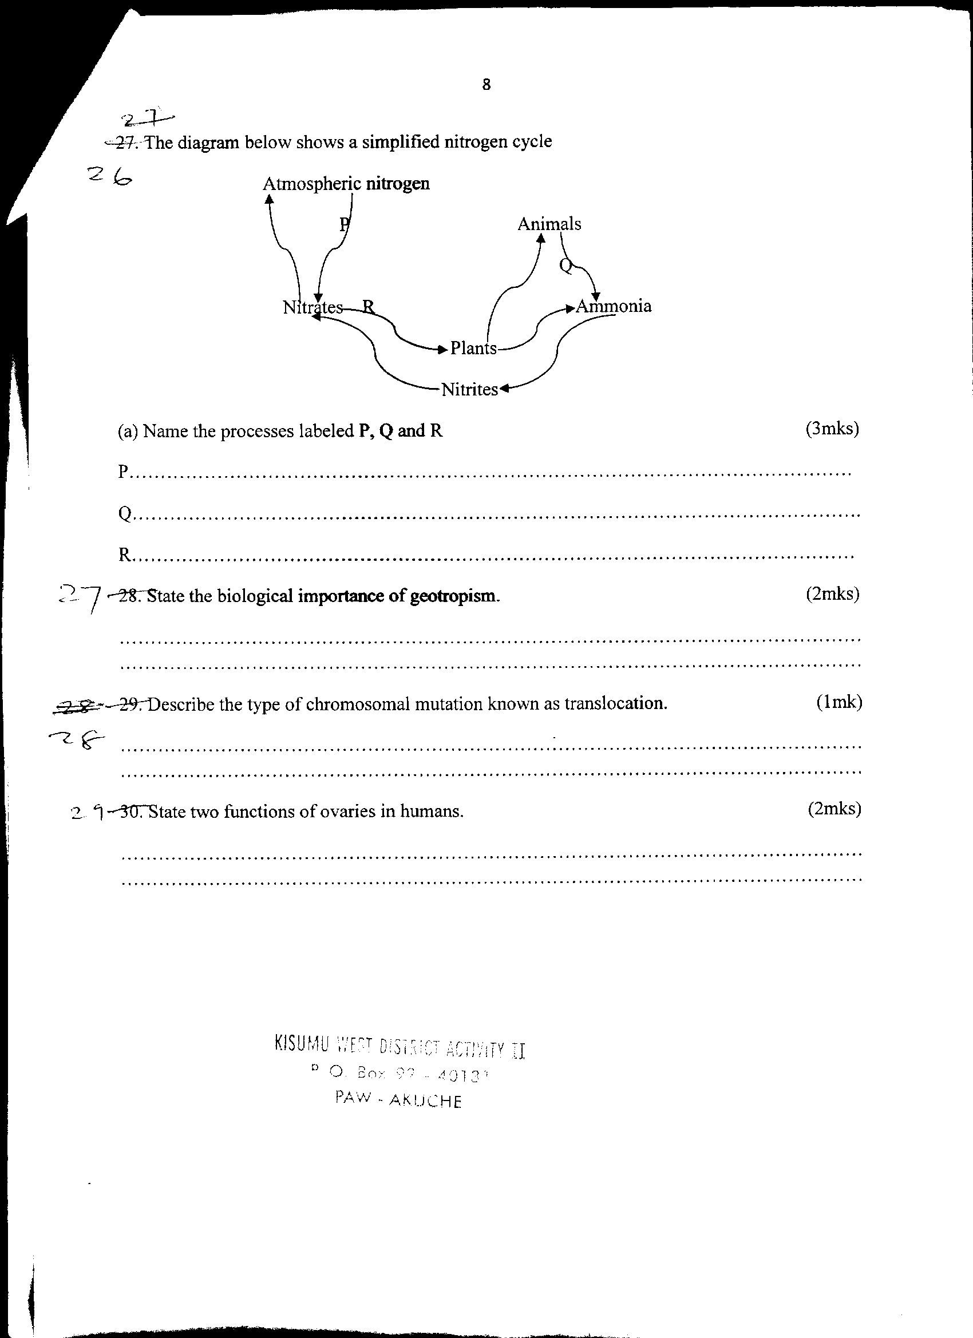

Name the processes labeled **P,Q** and **R** (3 marks)

**P…**……………………………………………………………………………………………

**Q**………………………………………………………………………………………………

**R**……………………………………………………………………………………………….

1. a) Define the term ‘active transport’ (1mark)

……………………………………………………………………………………………………………………………………………………………………………………………………………………

1. Give **TWO** ways in which active transport and diffusion are different. (2marks)

………………………………………………………………………………………………………………………………………………………………………………………………………………………………………………………………………………………………………………………………………………………………………………………………………………………………

1. Give **THREE** factors that increase rate of enzymatic reactions (3marks)

………………………………………………………………………………………………………………………………………………………………………………………………………………………………………………………………………………………………………

1. 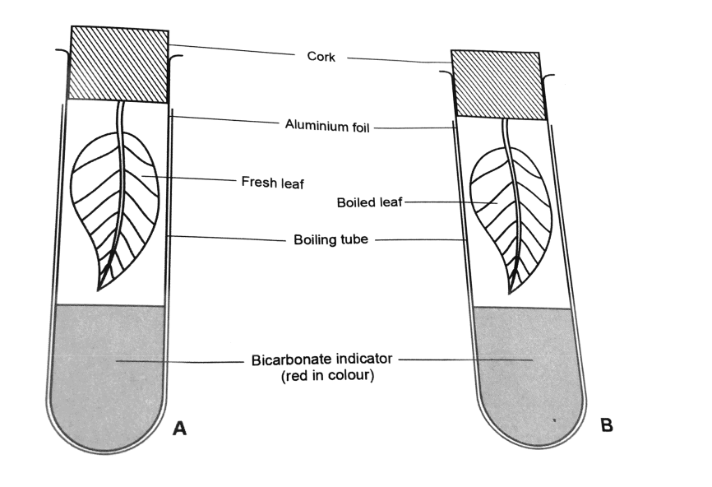The below set ups were used to investigate gaseous exchange. Study them and answer the questions that follow.

i)State the expected result in boiling tube B (1 mark)

……………………………………………………………………………………………………….

ii) Account for the result obtained in boiling tube A (2 marks)

…………………………………………………………………………………………………

…………………………………………………………………………………………………

1. Give a reason why a baby has higher energy requirement than an adult (2marks)

………………………………………………………………………………………………………………………………………………………………………………………………………………………………………………………………………………………………………………………………

1. State the economic importance of the following excretory products from plants (3marks)
2. Papain: ……………………………………………………………………………………………………….
3. Quinine: ……………………………………………………………………………………………………...
4. Colchicine: ………………………………………………………………………………………………….
5. State **three** components of a DNA molecule. (3 marks)

……………………………………………………………………………………………………………………………………………………………………………………………………………………………………………………………………………………………………………………………….

1. The diagram below shows the reproductive structure of a certain plant observed by a form four student at Eagle School during field study.

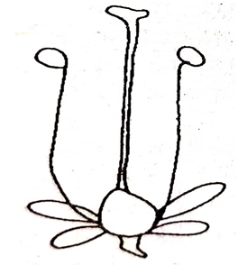

1. Name the mechanism shown by the diagram. (1 mark)

……………………………………………………………………………………………….…………

(ii) State the type of pollination likely to occur on the plant. (1 mark)

……………………………………………………………………………………………….…………

1. State the characteristics of the pollen grain produced by the plant (1 mark)

……………………………………………………………………………………………………………………………………………………………………………………………………………………

1. Explain how the following tissues are adapted to provide mechanical support in plants. (3marks)
2. Parenchyma…………………………………………………………...………………………………

…………………………………………………………………………………………………………

1. Collenchyma……………………………………………………………………………………………

…………………………………………………………………………………………………………

1. Sclerenchyma…………………………………………………………………………………………

…………………………………………………………………………………………………………

1. State **two** main functions of a cell vacuole. (2 marks)

……………………………………………………………………………………………………………………………………………………………………………………………………………………

1. What is meant by the term ‘Binomial nomenclature’? (1 mark)

……………………………………………………………………………………………………………………………………………………………………………………………………………………

16. Consider the following experimental set up used to investigate a physiological process

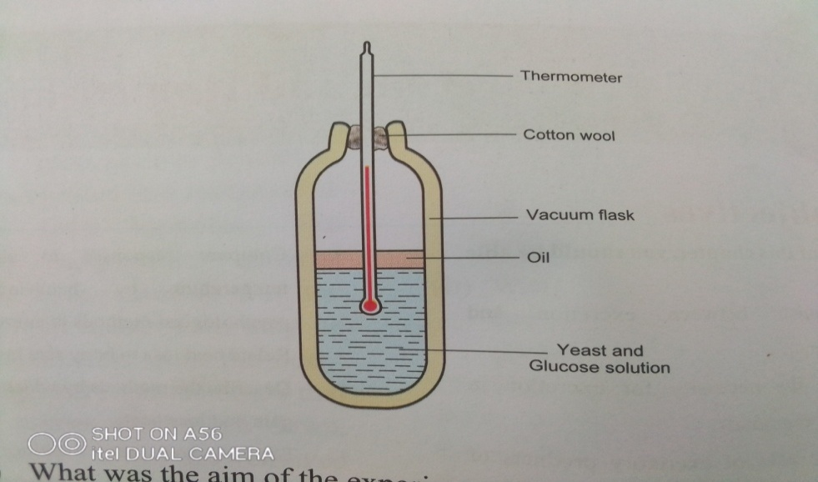

1. What was the aim of the experiment? (1mark)

………………………………………………………………………………………………………

1. Account for the change that will take place in the thermometer (2marks)

………………………………………………………………………………………………………………………………………………………………………………………………………………………………………………………………………………………………………………………

1. Suggest a control for the experiment shown above (1mark)

…………………………………………………………………………………………………………..

1. The diagram below shows the life cycle of a butterfly



(i) Name the type of life cycle shown above. ( 1 mark)

………………………………………...…………………………………………………………………

(ii) State **one** survival value of stage labeled **B** ( 1 mark) ………………………………………...……………………………………………………………………………………………………………………………………………………………………………

(iii) Use the letter symbols to list the various stages in the order they occur. ( 1 mark)

..................................................................................................................................................................

1. The table below shows the number of various teeth in the jaws of an animal

|  |  |  |  |  |
| --- | --- | --- | --- | --- |
|  | **Canines** | **Molars** | **Incisors** | **Premolars** |
| **Lower Jaw** | 2 | 6 | 4 | 4 |
| **Upper Jaw** | 2 | 6 | 0 | 4 |

1. Determine the total number of teeth the animal has (1mark)

………………………………………………………………………………………………………

1. Write down the dental formula of the animal whose teeth are shown on the table above (1mark)

……………………………………………………………………………………………………………………………………………………………………………………………………………………

1. Determine the mode of feeding of the animal represented above (1marks)

………………………………………………………………………………………………………….

1. The diagram below shows the state of a mammalian heart during a stage of cardiac cycle.



1. i) Identify the stage of the cardiac cycle illustrated above. (1 mark)

……………………………………………………………………………...……………………………

ii) Give a reason for your answer in (a) (i) above. (1 mark)

……………………………………………………………………………………………………………………………………………………………………………………………………………………

1. Name the cardiovascular disease associated with the failure of the labelled S to function properly at the back of human leg. (1 mark)

……………………………………………………………………….…………………………………

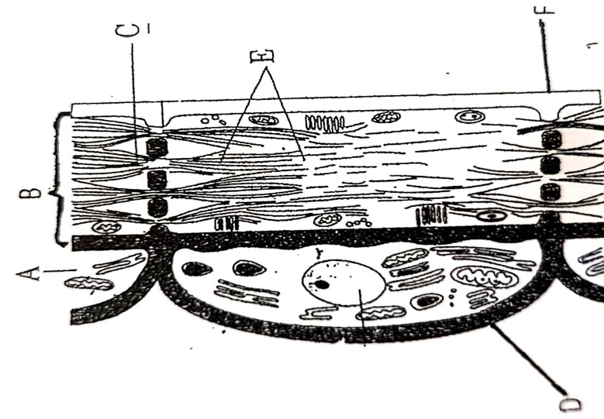

1. Below is a plant tissue structure.
2. i) Name the tissue ……………………………………………………… ( 1mark)
3. State the role of the tissue. (1 mark)

……………………………………………………………….…………………………………

1. Explain how the part labeled D adapt the tissue in performing the role stated in (a) above.(1 mark)

……………………………………………………………………………………………………………………………………………………………………………………………………………………………………………………………………………………………...…………………………………

1. The bar chart below shows the percentage of human population with each type of blood group and percentages of cattle population with and without horns.

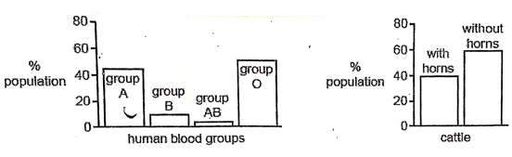

1. Identify the types of variation illustrated by the population in cattle and the blood groups. (1 mark)

…………………………………………………………………………………………………………

b) State **two** factors that causes variations ( 2 marks)

……………………………………………………………………………………………………………………………………………………………………………………………………………………

1. What is eutrophication? (1 mark)

………………………………………………………………………………………………………………………………………………………………………………………………………………………………………………………………………………………………………………………………………………

1. Wild beasts in Tsavo National Park were found to be infected with a lot of ticks. State the trophic level occupied by the following;-
2. Wild beasts (1 mark)

…………………………………………………………………………………………………………...

1. Ticks (1 mark)

…………………………………………………………………………………………………………….

1. What are the advantages of using a coverslip on a microscope slide (2 marks)

………………………………………………………………………………………………………………………………………………………………………………………………………………………………………………………………………………………………………………………………

1. Study the diagram below and use it to answer the questions that follow.

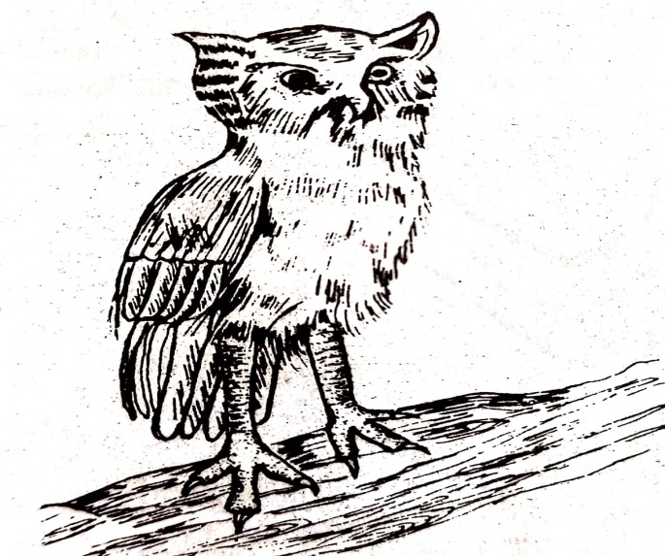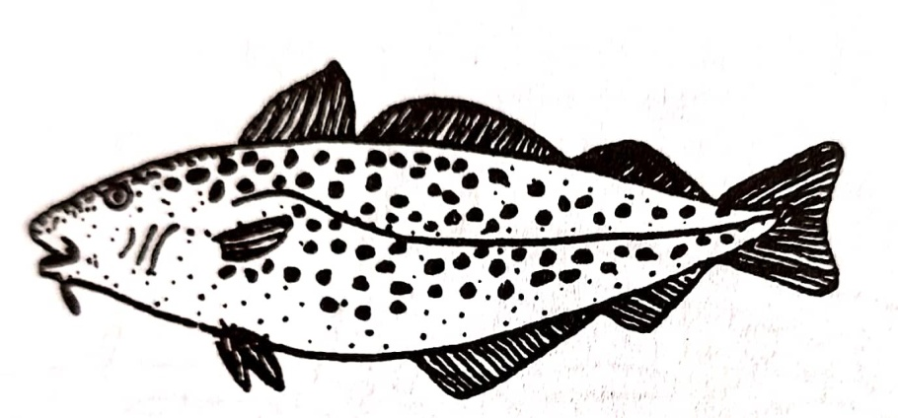

**A B**

1. Using observable features only classify the two organisms in their respective classes.

A ………………………………………………………………………………………… (1 mark)

B ……………………………………………………………………………………….…… (1 mark)

1. Statethe phylum to which the organisms belong. ( 1 mark)

………………………………………………………………………………………………………….

1. The diagrams below represent certain stages of cell division. Study them and answer the questions that follow.

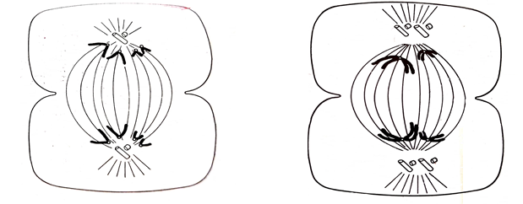

Name the phases of cell division represented by the diagrams below.

A …………………………………………………………………………………………… (1 mark)

B ……………………………………………………………………………………………. (1 mark)

1. Explain why a frog is advantageous both to live on land and water than fish. (1 mark)

……………………………………………………………………………………………………………………………………………………………………………………………………………………………

1. A person consumes a lot of sugar in tea. Briefly explain the feedback mechanism in order to bring the sugar level to norm. (2mks)

………………………………………………………………………………………………………………………………………………………………………………………………………………………………

1. 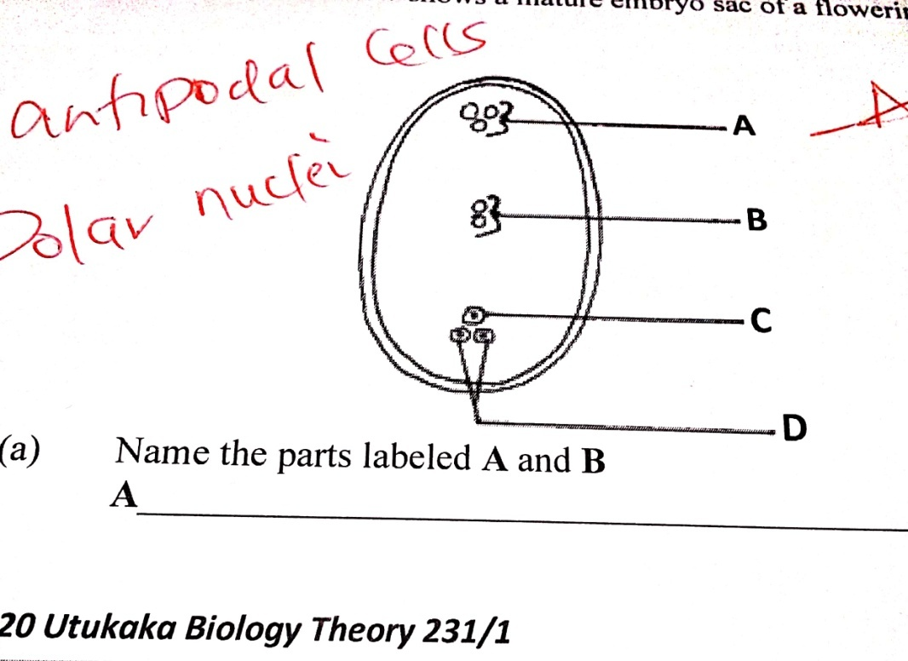The diagram below shows a mature embryo sac of a flowering plant .

a) Name the parts labeled A and B (2mks)

A…………………………………………………………………………..……………………………………

B………………………………………………………………………………..………………………………

b) What is the function of the structure labeled C? (1mk)

………………………………………………………………………………………………………………………………………………………………………………………………………………………………

1. Four cylinders of potato were made and trimmed to the same weight. They were placed in different beakers as shown below.

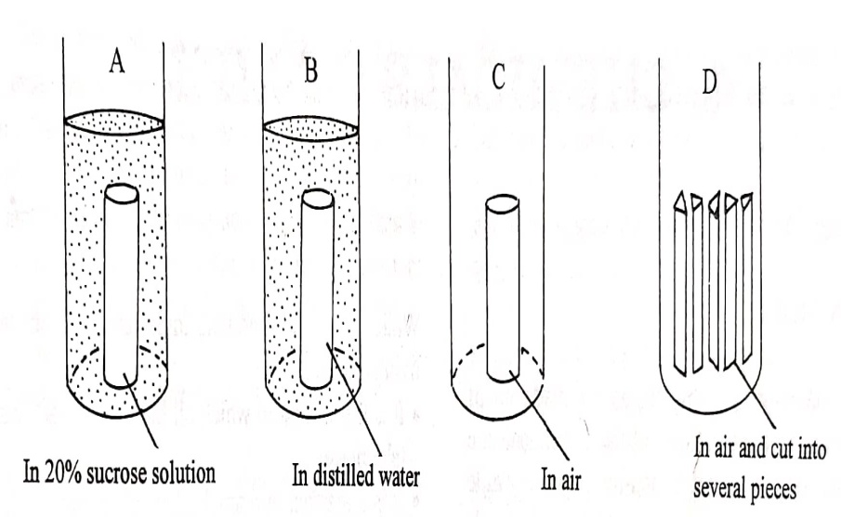

After 48 hours the cylinders were removed, dried using a blotting paper and weighed.

1. Which cylinder would be heaviest and why? (2 marks)

………………………………………………………………………………………………………………………………………………………………………………………………………………………………

b). What difference if any would you expert in the weight of C and D? Give a reason for your answer.(2mks)

………………………………………………………………………………………………………………………………………………………………………………………………………………………………………………………………………………………………………………………………………………

1. Study the genetic chart below showing the inheritance of gene responsible for colour blindness in

a family.



Using letter capital N to represent gene for normal colour vision, write the genotypes of the

following individuals (3marks)

1 ……………………………………………………………………………………………………...

5 ……………………………………………………………………………………………………...

6……………………………………………………………………………………………………...