MID TERM 1 SERIES-TERM 1 -2023
BIOLOGY (233/3)
PAPER 3
TIME: 1 HOUR 45 MIN
NAME …………………….…….…ADMN NO……….………STREAM ……………..……
SCHOOL ……………………………….……. INDEX NO ………………………………

Instructions to candidates
- Write your name, Admission number in the spaces provided above.
- Answer ALL questions in in the spaces provided.
- You are required to spend the first 15 minutes of the 1 ³/₄ hours reading the whole paper carefully before commencing your work.
- This paper consists of 6 printed pages
- Candidates should answer the questions in English

FOR EXAMINER’S USE ONLY:

QUESTION | MAXIMUM SCORE | CANDIDATE’S SCORE
1 | 13
2 | 15
3 | 12
TOTAL | 40

Candidates should check the question paper to ascertain that all the pages are printed as indicated and that no questions are missing

- a). You are provided with a specimen labelled L. Slice off about 2cm² cube from the specimen. Peel it, crush to obtain a paste. Carefully tie one end of the 8cm LONG transparent visking tubing provided. Place the paste and tie the other end to ENSURE THERE IS NO LEAKAGE AT BOTH ENDS OF THE TUBING.
Rinse the outside of the tubing with water. Immerse the tubing with its content in 100ml beaker containing iodine solution. Leave the set up for 20 minutes.

- Record your observations in the table below. (4 marks)

 | Contents inside tubing | Iodine solution  Outside tubing
Before the experiment
After the experiment

- What physiological process is demonstrated by this experiment ? (1 mark)

…………………………………………………………………………………………………………

- Account for the results obtained in (a) above. (3 marks

………………………………………………………………………………………………………….

…………………………………………………………………………………………………………..

…………………………………………………………………………………………………………..
- Name any one part of the human body where a similar physiological process takes place. (1 mark)

…………………………………………………………………………………………………………..

(b) The diagrams below show a type of cell division occurring in animal.
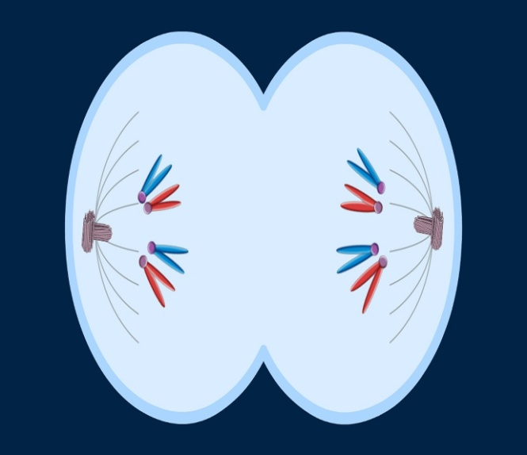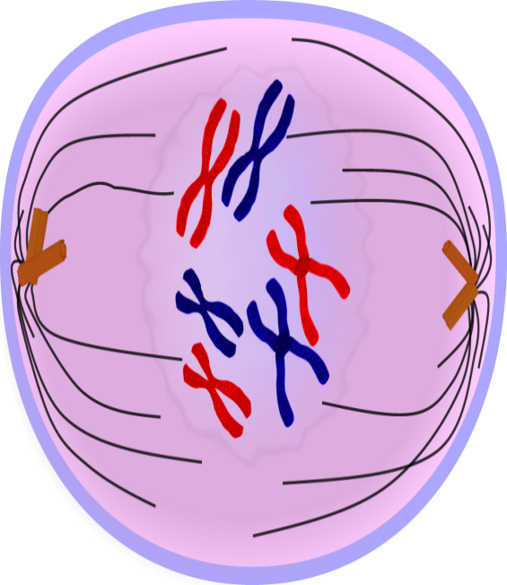
A B

X
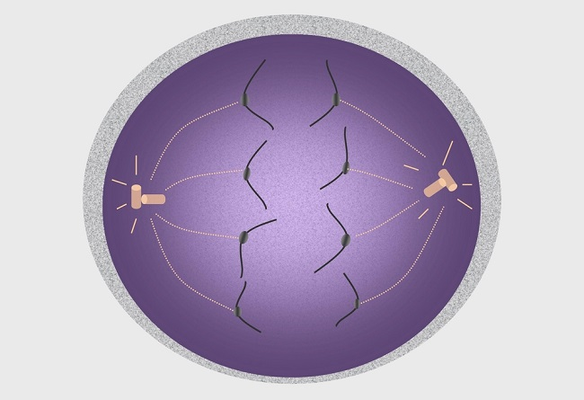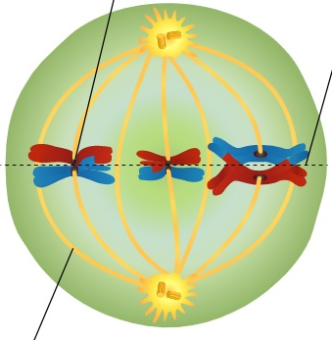
D Y C

(i) Identify stages B and C. (2 marks) B
…………………………………………………………………………………………………
C
…………………………………………………………………………….………………………
- State the functions of the parts labeled X and Y (2marks)
X
…………………………………………………………………………………………….

Y
……………………………………………………………………………………………

- You are provided with specimen Q, R S T and U. Study them to answer the questions below.

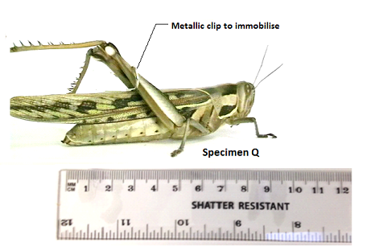.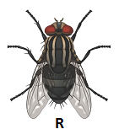
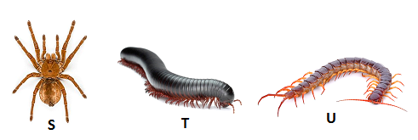

- Work the actual length of specimen T, given that the shatter resistant ruler measures Q from tip of mouth to tip of abdomen. (2 marks)

- A boy immobilised specimen Q and attempted to drown and suffocate it in water by placing its head in water. Using observable features, explain why he couldn’t succeed. (1 mark)

…………………………………………………………………………………………………………….

…………………………………………………………………………………………………………..
- Use the features in order given below and construct a dichotomous key that can be used to identify the specimen above.
Wings, long or short hind limbs, number of legs, antenna. (8 marks)

- State two ways in which specimen Q is adapted to evade its predators in its ecological niche.
(2marks)

…………………………………………………………………………………………………

…………………………………………………………………………………………………

- State two observable differences between the specimen Q and R (2marks)
Specimen Q | Specimen R

- You are provided with a solution L. Using the reagents provided, determine the food
substances in L. Fill in the table below. (12 marks)
FOOD SUBSTANCE | PROCEDURE | OBSERVATION | CONCLUSION

