Name: ………………………………………………… Index No. ………………………….
School: …………………………………… Candidate’s Sign. …………............ Date: .………....................................
231/3
BIOLOGY
PAPER 3
2021
TIME: 2 HOURS

PAVEMENT FORM 4 TRIAL 2 EXAMINATION 2021/2022
Kenya certificate of secondary education (K.C.S.E)
Instructions to candidates
- Write your name, index number in the spaces provided above.
- Answer ALL questions in in the spaces provided.
- You are required to spend the first 15 minutes of the 1 ³/₄ hours reading the whole paper carefully before commencing your work.
- This paper consists of 6 printed pages
- Candidates should answer the questions in English

FOR EXAMINER’S USE ONLY:

QUESTION | MAXIMUM SCORE | CANDIDATE’S SCORE
1 | 16
2 | 11
3 | 13
TOTAL | 40

Candidates should check the question paper to ascertain that all the pages are printed as indicated and that no questions are missing

- You are provided with a specimen labelled Q, use it to answer the questions that follow.

- (i) Sketch a drawing and label the specimen on the space provided. (2 marks)

(iii) Make a transverse section of the specimen and label. (3 marks)

- What type of fruit is specimen Q? (1 mark)
……………………………………………………………………………………………………………………………………………………………………………………………………
- Slice off about 2cm²cube from the specimen. Peel it. Tie one end of the 8cm LONG transparent visking tubing provided. Place the banana cube and tie the other end to ENSURE THERE IS NO LEAKAGE AND BOTH ENDS OF THE TUBING.
Rinse the outside of the tubing with water. Immerse the tubing with its content in 100ml beaker containing iodine solution. Allow standing for 20 minutes.

(i) Record your observations in the table below. (4 marks)

 | Contents inside tubing | Iodine solution  Outside tubing
Before the experiment
After the experiment

(ii) What was the physiological activity under test? (1 mark)

……………………………………………………………………………………………………………………………………………………………………………………………………………………
(ii) Account for the results obtained in c (i) above. (3 marks)
……………………………………………………………………………………………………………………………………………………………………………………………………………………………………………………………………………………………………………………………………………………………………………………………………………………………………………………………………………………………………………………………………………………

- You are provided with specimen Q, R S T and U. Study them to answer the questions below.

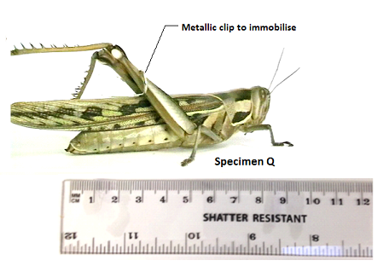.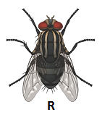
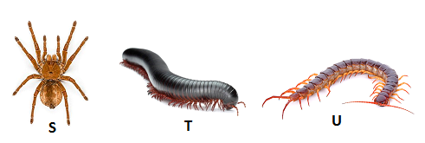
- Work the actual length of specimen T, given that the shatter resistant ruler measures Q from tip of mouth to tip of abdomen. (3 marks)
…………………………………………………………………………………………………………………………………………………………………………………………………………………………………………………………………………………………………………………………………………………………………………………………………………………………………………
- Aboy immobilised specimen Q and attempted to drawn and suffocate it in water by placing its head in water. Using observable features, explain why he couldn’t succeed. (2 marks)
……………………………………………………………………………………………………………………………………………………………………………………………………………………………………………………………………………………………………………………………….
- Use the features in order given below and construct a dichotomous key that can be used to identify the specimen above.
Wings, long or short hind limbs, number of legs, antenna. (8 marks)
…………………………………………………………………………………………………………………………………………………………………………………………………….………………
…………………………………………………………………………………………………………………………………………………………………………………………………….………………
…………………………………………………………………………………………………………………………………………………………………………………………………….………………
…………………………………………………………………………………………………………………………………………………………………………………………………….………………
…………………………………………………………………………………………………………………………………………………………………………………………………….………………
…………………………………………………………………………………………………………………………………………………………………………………………………….………………

- State three ways in which specimen Q is adapted to evade its predators in its ecological niche.
(3 marks)
…………………………………………………………………………………………………………………………………………………………………………………………………….…………………………………………………………………………………………………………………………..
…………………………………………………………………………………………………………………………………………………………………………………………………….…………………………………………………………………………………………………………………………………………………………………………………………………………………………………………………………………………………………….………………………………………………………………………………………………………………………………………………………………………………………………………………………………………………………………………………………………………………………………………………………………………………………………………………………………………………………………………………………………………………………………………………………………………………………………………
- You are provided with two photographs below of maize plant (Zea mays) taken from the school farm.Use them to answer the questions that follow.
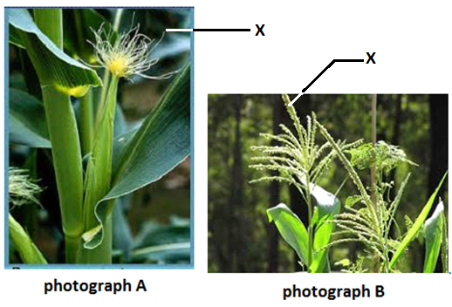

(a) Classify the specimen into Division, Sub-division and Class where it belongs.

Division (1 mark)
…………………………………………………………………………………………………………

Sub-division (1 mark)
………………………………………………………………………………………………………..

Class (1 mark)
………………………………………………………………………………………..…………………

b) Give one reason why you classified it into sub- division above. (1 mark)

…………………………………………………………………………………………………………………………………………………………………………………………………………………..

- What type of leaf arrangement is shown in photograph A above. (1 mark)

…………………………………………………………………………………………………………

- Giving reasons, give the term used to describe the above flower based on the agent of pollination. (1 mark)
………………………………………………………………………………………………………

Reasons (2 marks)
……………………………………………………………………………………………………………………………………………………………………………………………………………………………………………………………………………………………………...........................................................................................................................................................................................................
iii) On the photographs, label where the pollen grain produced and where stigma is likely to be found respectively. (2 marks)

iv) With respect to floral arrangement, what term is used to describe maize plant? (1 mark)

………………………………………………………………………………………………………………………………………………………………………………………………………………………………………………………………………………………………………………………………………………………………………………………………………………………………………………………………………………………………………………………………………………………………………………………………………………………………………………………………………………………………………………………………………………………………………….…………………………………………………………………………………………………………………………………………………………………………………………………………………..

