Name:……………………………………………..…......................Index No……....………… Signature……………….................. Date: ……………......
231/2
BIOLOGY
PAPER 2
(THEORY)
TIME: 2 HOURS
PAVEMENT FORM 4 TRIAL 1 EXAMINATION 2021/2022
Kenya certificate of secondary education (K.C.S.E)

INSTRUCTIONS TO CANDIDATES
- Write your name, school and index number in the spaces provided above.
- This paper consist of TWO sections; A and B.
- Answer all the questions in the section A in the spaces provided.
- In section B answer Question 6(compulsory) and either question 7 or 8 in the space
provided after question 8.
- Check to ascertain that all pages are printed and that no questions are missing.
FOR EXAMINER’S USE ONLY
Section | Question | Maximum  Score | Candidates  Score
A | 1 | 8
 | 2 | 8
 | 3 | 8
 | 4 | 8
 | 5 | 8
B | 6 | 20
 | 7 | 20
 | 8 | 20
Total Score |  | 80

- The diagram below represents human foetus in a uterus.
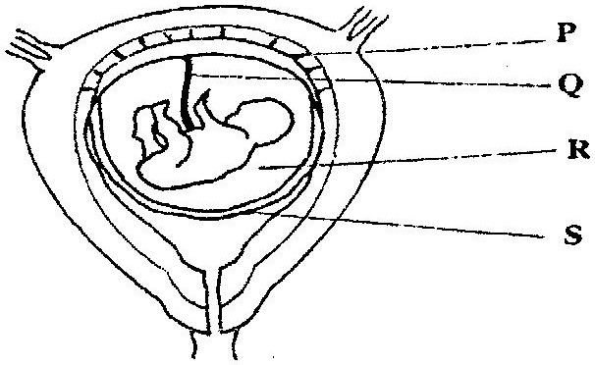

- Name the part labeled S. (1 mark)
………………………………………………………………………………………………………………………………………………………………………………………………………………………………
- i) Name the types of blood vessels found in the structure labeled Q. (2marks)
………………………………………………………………………………………………………………………………………………………………………………………………………………………………
ii) State the differences in composition of blood found in the vessels named in (b) (i) above.
(2marks)
………………………………………………………………………………………………………………………………………………………………………………………………………………………………………………………………………………………………………………………………………………………………………………………………………………………………………………………………
- Name two features that enable the structure labeled P carry out its function. (2marks)
………………………………………………………………………………………………………………………………………………………………………………………………………………………………………………………………………………………………………………………………………………
- State the role of the part labeled R. (1mark)
………………………………………………………………………………………………………………………………………………………………………………………………………………………………
- (a) Explain what happens to excess amino- acids in the liver of humans. (3 marks)
………………………………………………………………………………………………………………………………………………………………………………………………………………………………………………………………………………………………………………………………………………………………………………………………………………………………………………………………………………………………………………………………………………………………………………………………………………………………………………………………………………………………
(b) Which portions of the human nephron are only found in the cortex? (3 marks)
………………………………………………………………………………………………………………………………………………………………………………………………………………………………
(c) (i) What would happen if a person produced less ant -diuretic hormone? (1 mark)
……………………………………………………………………………………………………………………………………………………………………………………………………………………………………………………………………………………………………………………………………………...
(ii) What term is given to the condition described in (c) (i) above (1 mark)
………………………………………………………………………………………………………………………………………………………………………………………………………………………………
- A freshly obtained dandelion stem measuring 5 cm long was split lengthwise to obtain two similar pieces. The pieces were placed in solutions of different concentrations in Petri dishes for 20 minutes. The appearance after 20 minutes is as shown

- Account for the appearance of the pieces in solutions L₁ and L2. (6 marks)
……………………………………………………………………………………………………………………………………………………………………………………………………………………………………………………………………………………………………………………………………………………………………………………………………………………………………………………………………………………………………………………………………………………………………………………………………………………………………………………………………………………………………………………………………………………………………………………………………………………………………………………………………………………………………………………………………………………………………………………………………………………………………………………………………………………………………………………………………………………………………………………………………………………………………………………………………………………………………………………………………………………………………………………..................................................................

- State the significance of the biological process involved in the experiment. (2 marks)
……………………………………………………………………………………………………………………………………………………………………………………………………………………………………………………………………………………………………………………………………………………………………………………………………………………………………………………………………………………………………………………………………………………………………………………………

- The diagrams below illustrate germination in Phaseolus vulgaris. Study the diagrams and answer the questions that follow
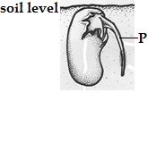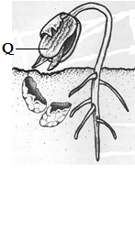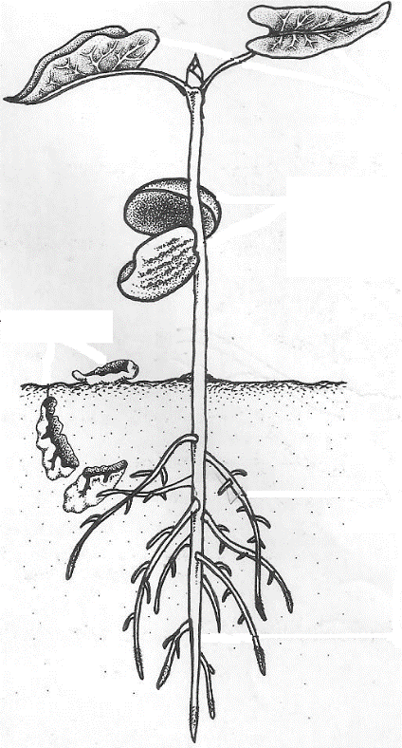
- Identify the parts labeled P and Q (2 marks)

P………………………………………………………………………………………………….

Q………………………………………………………………………………………………….

- (i) Using observable features identify the taxonomic class of Phaseolus vulgaris (1 mark)

……………………………………………………………………………………………………………....................................................................................................................................................................................................
- Give two reasons for your answer in (i) above (2 marks)

…………………………………………………………………………………………………………….......

…………………………………………………………………………………………………………….......

- (i) What type of germination is this? (1 mark)

…………………………………………………………………………………………………………….......

- Explain how the type of germination in (i) above occurs (2 marks)

…………………………………………………………………………………………………………….......

…………………………………………………………………………………………………………….......

- (i) Colour blindness is rare in women. However when a woman has normal colour vision but is a carrier for this trait marries a colour blind man, a colour blind daughter may be born to them. Show how this is possible. (4 marks)
………………………………………………………………………………………………………………………………………………………………………………………………………………………………………………………………………………………………………………………………………………………………………………………………………………………………………………………………………………………………………………………………………………………………………………………………………………………………………………………………………………………………………………………………………………………………………………
(ii) Give two examples of disorders caused by mutant gene located in the chromosomes. (2 marks)
…………………………………………………………………………………………………………..……………………………………………………………………………………………………………………………….
(iii) What do you understand by the term linked genes (2marks)
………………………………………………………………………………………………………………………………………………………………………………………………………………………………………………

SECTION B (40 MKS)
Answer questions 6(compulsory) and either questions 7 or 8
- In an experiment to determine the effect of exercise on the concentration of lactic acid in blood, the following data was obtained. Study the data and use it to answer the questions that follow. The lactic acid concentration was measured before, during and after the exercise.
Time minutes | 0 | 10 | 20 | 25 | 30 | 40 | 50 | 60 | 70 | 80 | 90 | 100
Lactic acid conc. (arbitrary units) | 0.5 | 0.5 | 5 | 13 | 12 | 8 | 6 | 4 | 3 | 2 | 1 | 0.9

- Using a suitable scale, plot a graph of the concentration of lactic acid against time. (6marks)

(b) From the graph you have drawn determine;
(i) The period of exercise. Explain. (2marks)
………………………………………………………………………………………………………………………………………………………………………………………………………………………………………………
(ii) The time when oxygen debt occurred. Explain. (2marks) ………………………………………………………………………………………………………………………………………………………………………………………………………………………………………………
(iii) The duration it took to pay back the oxygen debt. Explain. (2marks).

- On the same set of axes plot a hypothetical curve for oxygen intake during the experiment period of 90
minutes. (2marks)

(d) Why does lactic acid level usually continue to rise in the blood after exercise ceases. (2marks)

………………………………………………………………………………………………………………………………………………………………………………………………………………………………………………
(e) Suggest the two importance of anaerobic respiration to animals. (2marks) …………………………………………………………………………………………………………………………………………………………………………………………………………………………………………….
(d) What is oxygen debt? (2marks)
…………………………………………………………………………………………………………………………………………………………………………………………………………………………………………….
7. Describe the route taken by water from the soil up to the evaporating surface of a plant. (20 marks)
8. Explain how the various abiotic factors may affect plants. (20 marks)
…………………………………………………………………………………………………………………………………………………………………………………………………………………………………………………………………………………………………………………………………………………………………………………………………………………………………………………………………………………………………………………………………………………………………………………………………………………………………………………………………………………………………………………………………………………………………………………………………………………………………………………………………………………………………………………………………………………………………………………………………………………………………………………………………………………………………………………………………………………………………………………………………………………………………………………………………………………………………………………………………………………………………………………………………………………………………………………………………………………………………………………………………………………………………………………………………………………………………………………………………………………………………………………………………………………………………………………………………………………………………………………………………………………………………………………………………………………………………………………………………………………………………………………………………………………………………………………………………………………………………………………………………………………………………………………………………………………………………………………………………………………………………………………………………………………………………………………………………………………………………………………………………………………………………………………………………………………………………………………………………………………………………………………………………………………………………………………………………………………………………………………………………………………………………………………………………………………………………………………………………………………………………………………………………………………………………………………………………………………………………………………………………………………………………………………………………………………………………………………………………………………………………………………………………………………………………………………………………………………………………………………………………………………………………………………………………………………………………………………………………………………………………………………………………………………………………………………………………………………………………………………………………………………………………………………………………………………………………………………………………………………………………………………………………………………………………………………………………………………………………………………………………………………………………………………………………………………………………………………………………………………………………………………………………………………………………………………………………………………………………………………………………………………………………………………………………………………………………………………………………………………………………………………………………………………………………………………………………………………………………………………………………………………………………………………………………………………………………………………………………………………………………………………..…………………………………………………………………………………………………………………………………………………………………………………………………………………………………………………………………………………………………………………………………………………………………………………………………………………………………………………………………………………………………………………………………………………………………………………………………………………………………………………………………………………………………………………………………………………………………………………………………………………………………………………………………………………………………………………………………………………………………………………………………………………………………………………………………………………………………………………………………………………………………………………………………………………………………………………………………………………………………………………………………………………………………………………………………………………………………………………………………………………………………………………………………………………………………………………………………………………………………………………………………………………………………………………………………………………………………………………………………………………………………………………………………………………………………………………………………………………………………………………………………………………………………………………………………………………………………………………………………………………………………………………………………………………………………………………………………………………………………………………………………………………………………………………………………………………………………………………………………………………………………………………………………………………………………………………………………………………………………………………………………………………………………………………………………………………………………………………………………………………

