TERM 1-2023 MID TERM SERIES
FORM 4
PAPER 1
BIOLOGY (MARKING SCHEME)

- a) i) and ii)
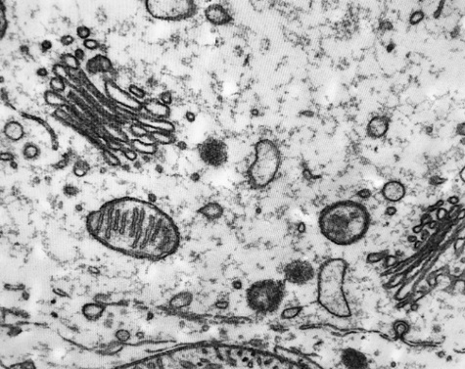
SC
KC
SC
b) Helps in transport of nutrients/enzymes in cells; Enhance exchange of materials between organelles/cells; help in locomotion in some unicellular organisms/amoeba; Help maintain concentration gradient within cell to enhance diffusion;
- a) Lactic;
b) Transported to the liver and converted to glycogen; broken down into Carbon (IV) Oxide and Water in the muscles (when Oxygen becomes available/Repayment of Oxygen Deb)t;
- i) Sertoli cells: Attachment of developing sperm cells; Nourishment of developing sperm cells;
ii) Interstitial cells: Secretion/Production of Androgens/Testosterone;
iii) Regulate Opening and Closing of Stomata to control transpiration/Water loss/gaseous exchange in plants;
- a) The Beam balance tilted towards the right/part with No twig/Water level in the tube containing the twig reduced;
b) The twig gained water from the test tube then lost it via transpiration from the leaves; making the test tube containing a twig to weigh less;
c) No change in the weight of content of both the test tube/Slight tilt towards the right;
- a) Red blood cell/Erythrocyte; rej plural
b) Monera; reject monera/wrong spelling

Guttation | Transpiration
Loss of water from a plant in liquid form | Loss of water from a plant as vapour;
Occurs via hydathodes | Occurs via stomata/cuticle/lenticels;

- a) Cytoplasm/Sap vacuole has shrunk; Plasma membrane is detached from the cell wall;
b) Diffusion;
c) Hypertonic/More concentrated;
- a) Islet of Langerhans; b) Corpus luteum;
- a) Place 1ml of the liquid in a test tube; Add 3 drops of Iodine solution and shake;
Penalise if Range of drops is used, Iodine only is indicated without Solution
b) Brown to Blue Black;
c) Is osmotically inactive (thus can not alter the osmotic pressure of the cells); is insoluble thus can not easily be transported to metabolic sites to be oxidized; Mark any 1
- a) Rhizobium leguminosarum/Rhizobium fredii/Bradyrhizobium japonicum;
Accept Rhizobium spp
b) Convert atmospheric nitrogen to nitrates used by plants in protein synthesis;
- a) 22⁰C; Reject when ⁰Cis missing
b) Low yield since temperature beyond optimum denature enzymes; leading to limited metabolism/growth;
- Wafted/moved/pushed by the ciliary movements; Slight rhythmic muscular contractions in the oviduct wall;
- a) sub-lingual;
b) Has water that dissolves nutrients/moisten food; Has mucus that lubricates food for easy swallowing; Has mineral ions that create conducive alkaline pH for amylase; Has salivary amylase/ptyalin that hydrolyze starch/convert/breakdown starch to maltose; Mark 1st 2
- a) Varicose veins; b) Veins (in the lower limbs);
- a)i) Dd; ii) Dd and dd
b) TGACTTGGCATA;
- a) Most of the right abdominal is occupied by the liver;
b) Releases aldosterone; that influence the kidney/kidney tubules/loop of Henle to reabsorb more Na+ ions into the blood stream;
- a) Transmits malaria/malaria parasites/Plasmodium spp; yet malaria is a leading global killer; Reject Causes Malaria
b) Insecta; c) 3 pairs of legs/6 legs; Body divided into three regions/Has Head, Thorax and Abdomen; Has wings; Mark 1st 2
- a) Gives the embryo enough time to mature; Help the seed overcome harsh environmental conditions;
b) Enhance survival by minimizing competition; Occupy new habitats/colonies;
- a) Have same embryonic origin/Have pentadactyl arrangement of digits;
b) Divergent;
c) Development of adaptations to survive varied habitats;
- 100 X 3 bases; = 300 bases;
- a) Schistosoma haematobium; Schistosoma japonicum; Schistosoma mansoni
b) Freshwater snail/Biomphalaria spp
c) Mag = image length ÷ actual length
= (12mmx1000ߎm) ÷ 100ߎm;
= X120;
- a) i) Glucose
ii) Carbaminohaemoglobin/Hydrogen carbonate ions/dissolved gas; Accept Bicarbonates
b) Stimulate production of anti-B antibodies; leading to agglutination/clumping together of erythrocytes/red blood cells from antigen-antibody reaction that may be fatal/lead to death;
- a) Release ecdysone/molting stimulating hormone; that causes ecdysis/molting;
b) Allows for further growth/development (of the insect);
- a) Create surface on which grass is pressed on for easy cutting by incisors in the lower jaw;
b) i 0/2 c 1/1 pm 2/3 m 3/3 Rej Capital letters/Wrong sequence/Wrong denominators and numerators/Absence of the fraction format
c) Feed on vegetation/cellulose-/fiber-rich material; that require a longer time for processing;
- A male nucleus fuses with the egg cell nucleus; to form a diploid zygote nucleus;
A male nucleus fuses with the polar nuclei; to for a triploid endosperm nucleus;

