FORM 4 ENTRANCE EXAMS 2023

NAME………………………………………ADM NO: …………….CLASS……………

231/3
BIOLOGY
PAPER 3
PRACTICAL
FEBRUARY, 2023
TIME: 1 ¾ HOURS

Kenya Certificate of Secondary Education
231/3
BIOLOGY
PAPER 3
PRACTICAL
FEBRUARY, 2023
TIME: 1 ¾ HOURS

INSTRUCTIONS TO CANDIDATES

- Write your Name, Class and Adm No. in the spaces provided above
- Answer ALL the questions in the spaces provided
FOR EXAMINERS USE ONLY
QUESTION | MAXIMUM SCORE | CANDIDATES SCORE
1 | 19
2 | 12
3 | 9
TOTAL | 40

1.a) You are provided with specimen A
i) Name the fruit type that the specimen belongs to (1mark)

…………………………………………………………………………………………………
ii) Give a reason (1mark)

…………………………………………………………………………………………………
iii) Make a transverse section on specimen A and label the parts. (4marks)

iv) State the type of placentation of fruit A (1mark)
…………………………………………………………………………………………………
b) Squeeze out the juice from the two halves of specimen A into a small beaker. Using part of the juice and the reagents provided only, test for the food substances in the juice. (6marks)

Reagent | Procedure | Observation | Conclusion
DCPIP
Benedict’s Solution

c) Transfer 5ml of lime water in to a test tube. Insert a straw in the lime water in the test tube and blow air in it.

i)State the observation made (1mark)
…………………………………………………………………………………………………
ii)What was the aim of the experiment? (1mark)
…………………………………………………………………………………………………
iii)Account for the observation (2marks)
…………………………………………………………………………………………………
…………………………………………………………………………………………………
iv) What biological process produces the gas being tested in this experiment (1mark)
…………………………………………………………………………………………………
v) What physiological process is involved in the removal of the gas from the body. (1mark)
…………………………………………………………………………………………………
2. The photograph below shows a section of a mammalian kidney and associated vessels. Examine it and answer the questions that follow.
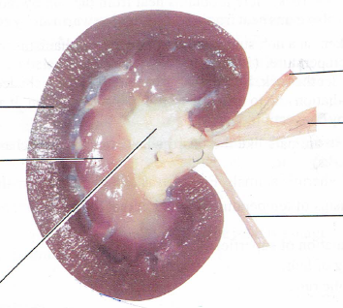
S
T
B
E
D
C

a) To what plane has the section been made (1mark)
…………………………………………………………………………………………………

b) Name the parts B, C, D and E (4 marks)
B …………………………………………………………………………………………
C …………………………………………………………………………………………
D ………………………………………………………………………………………..
E …………………………………………………………………………………………
c) State any two functions of the kidney (2marks)
…………………………………………………………………………………………………………………………………………………………………………………………………
d) Name the part of the nephron found in the structure labelled S (1mark)
…………………………………………………………………………………………………
………………………………………………………………………………………………
e) (i)State the two hormones whose target part is T (2marks)
……………………………………………………………………………………………………………………………………………………………………………………………………

(ii) State the roles of the hormones named in question 2 e) (i) above (2 marks)
……………………………………………………………………………………………………………………………………………………………………………………………………………………………………………………………………………………………………..
……………………………………………………………………………………………….

3. The photographs below represent twigs from various plant species. Study them and answer the questions that follow

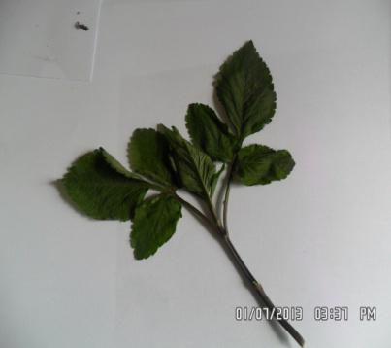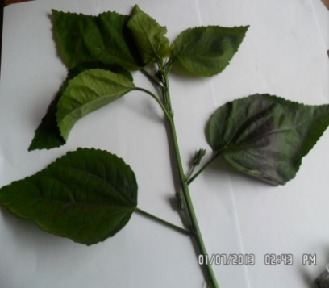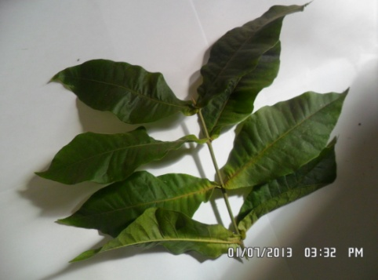
P Q R
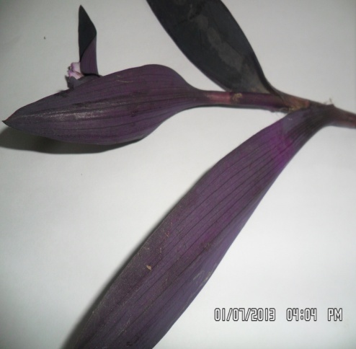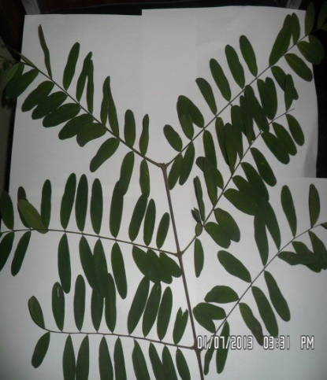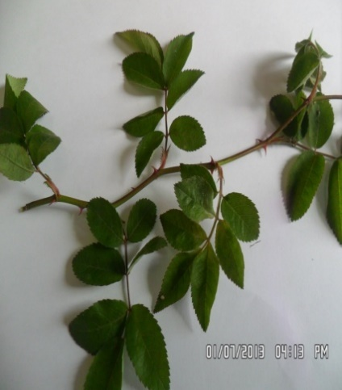
S T U
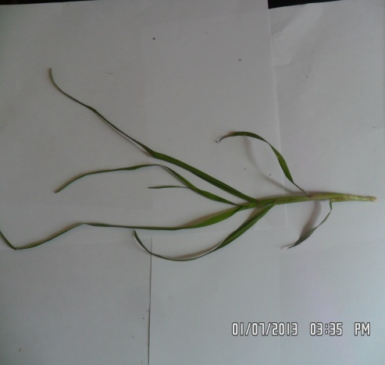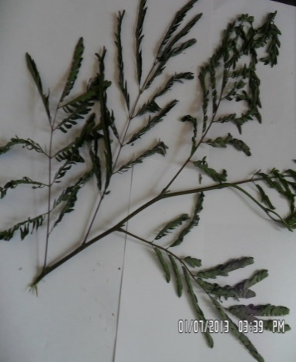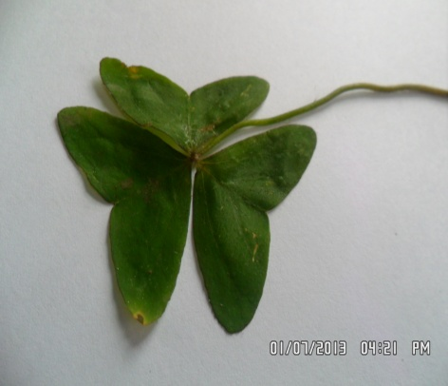
V W X

- Complete the dichotomous key below using observable features (1mk)
1(a) Twigs with simple leaves …………………………………………………. go to 2
(b) Twigs with compound leaves…………………………………………… go to 5
2(a) Leaves with parallel venation…………………………………………. go to 3
(b) Leaves with network venation …………………………………………...go to 4
3(a) leaves purple …………………………………………………………Tradescantia
(b) ……………………………………………………………………… Kikuyu grass
4(a) Leaves with opposite arrangement…………………………………...Verbenaceae
(b)Leaves with alternate arrangement ……………………………………….Hibiscus
5(a) Leaves trifoliate………………………………………………………….... go to 6
(b) Leaves not trifoliate……………………………………………………… go to 7
6(a) Leaves with serrated margin……………………………………… Bidens pilosa
(b) Leaves with lobed margin…………………………………………………. Oxalis
7(a) leaves pinnate ……………………………………………………………go to 8
(b) leaves bipinnate ………………………………………………………. …..Acacia
8(a) Leaflets with rounded apex…………………………………………Papilionaceae
(b) Leaflets with pointed apex…………………………………………………. Rose

- Using the completed dichotomous key identify the twigs and show the steps followed (6mks)

Steps followed Identity
P……………………………………… …………………………………………..
Q……………………………………… ………………………………………….
T……………………………………… ………………………………………….
- With a reason, identify the class to which specimen S belongs. (2mks)
……………………………………………………………………………………………………………………………………………………………………………………

