FORM 4 ENTRANCE EXAMS 2023

NAME………………………………………ADM NO: …………….CLASS……………

231/3
BIOLOGY
PAPER 3
PRACTICAL
FEBRUARY, 2023
TIME: 1 ¾ HOURS

Kenya Certificate of Secondary Education
231/3
BIOLOGY
PAPER 3
PRACTICAL
FEBRUARY, 2023
TIME: 1 ¾ HOURS

INSTRUCTIONS TO CANDIDATES

- Write your Name, Class and Adm No. in the spaces provided above
- Answer ALL the questions in the spaces provided
FOR EXAMINERS USE ONLY
QUESTION | MAXIMUM SCORE | CANDIDATES SCORE
1 | 19
2 | 12
3 | 9
TOTAL | 40

1.a) You are provided with specimen A
i) Name the fruit type that the specimen belongs to (1mark)
Berry;
ii) Give a reason (1mark)
It has two scars;
iii) Make a transverse section on specimen A and label the parts. (4marks)
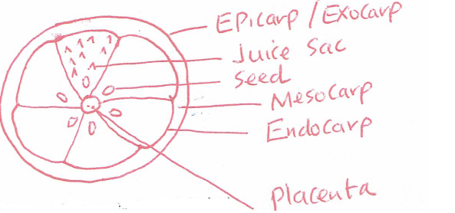

iv) State the type of placentation of fruit A (1mark)
Axile; / Central placentation; Rej. Axial;
b) Squeeze out the juice from the two halves of specimen A into a small beaker. Using part of the juice and the reagents provided only, test for the food substances in the juice. (6marks)

Reagent | Procedure | Observation | Conclusion
DCPIP | To 2ml of DCPIP, add the juice dropwise and shake; | DCPIP is decolourised; | Vitamin C present; (Ascorbic acid present);  Rej; presence;
Benedict’s Solution | To 2ml of the juice, add 2mls of Benedict’s solution, shake to mix and heat to boil; | Colour changes from blue/yellow/ orange/ brown; | Reducing sugar present;

c) Transfer 5ml of lime water in to a test tube. Insert a straw in the lime water in the test tube and blow air in it.

i) State the observation made (1mark)
White precipitate observed in the test tube;
ii) What was the aim of the experiment? (1mark)
To investigate the gas produced during expiration;
iii) Account for the observation (2marks)
Carbon IV oxide produced during expiration; reacted with lime water;
iv) What biological process produces the gas being tested in this experiment (1mark)
Respiration;
v) What physiological process is involved in the removal of the gas from the body. (1mark)
Diffusion;
2. The photograph below shows a section of a mammalian kidney and associated vessels. Examine it and answer the questions that follow.
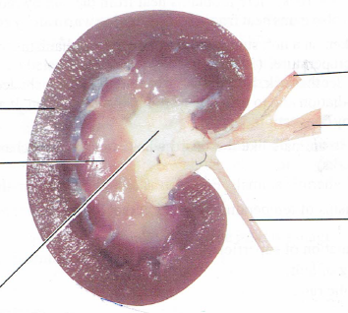
S
T
B
E
D
C

a) To what plane has the section been made (1mark)
Longitudinal;
b) Name the parts B, C, D and E (4 marks)
B Pelvis;
C Renal artery;
D Renal vein;
E Ureter;
c) State any two functions of the kidney (2marks)
Ionic balance; Osmoregulation; Excretion; (any two)
d) Name the part of the nephron found in the structure labelled S (1mark)
Bowman’s capsule; Proximal convoluted tubule; Glomerulus; Distal convoluted tubule;(any one)
e) (i)State the two hormones whose target part is T (2marks)
Antidiuretic hormone (Vasopressin); Aldosterone;
(ii) State the roles of the hormones named in question 2 e) (i) above (2marks)
Antidiuretic hormone (Vasopressin); increases the permeability of the tubule to water;
Aldosterone hormone; reabsorption of mineral ions at the Loop of Henle

3. The photographs below represent twigs from various plant species. Study them and answer the questions that follow

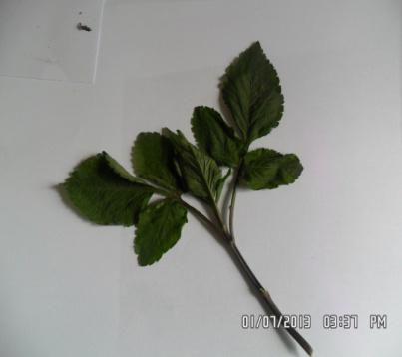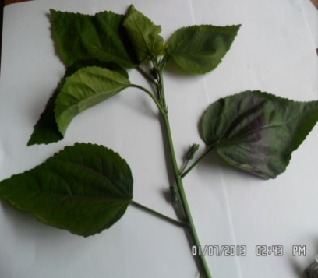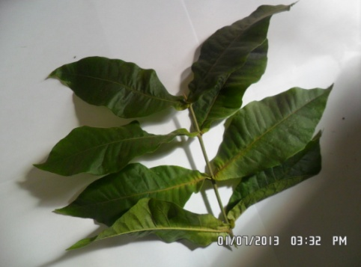
P Q R
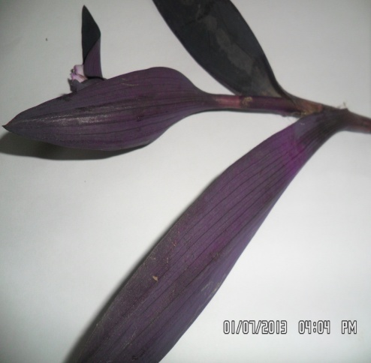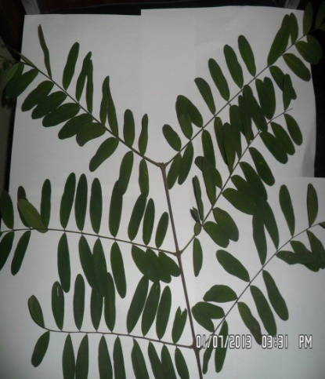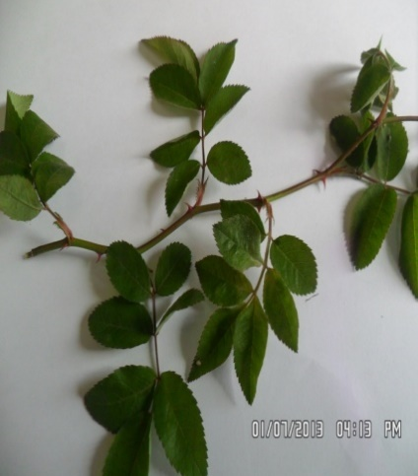
S T U
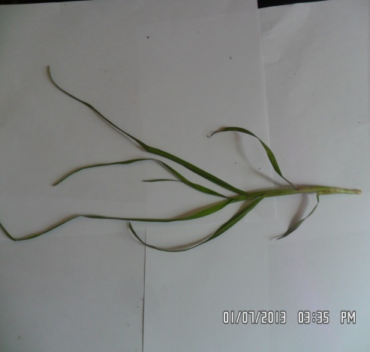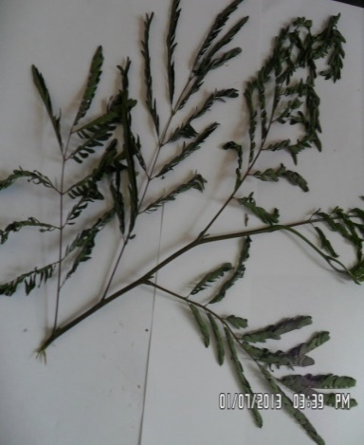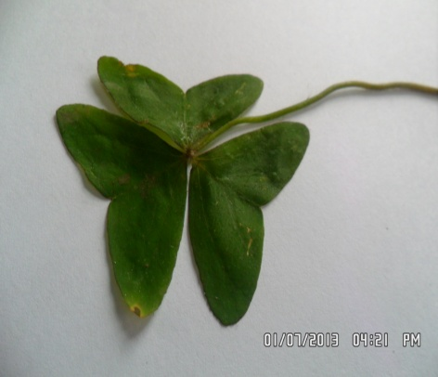
V W X

- Complete the dichotomous key below using observable features (1mark)
1(a) Twigs with simple leaves …………………………………………………. go to 2
(b) Twigs with compound leaves…………………………………………… go to 5
2(a) Leaves with parallel venation…………………………………………. go to 3
(b) Leaves with network venation ………………………………………. go to 4
3(a) Leaves purple……………………………………………………… Tradescantia
(b) Leaves green;……………………………………………… Kikuyu grass
4(a) Leaves with opposite arrangement………………………………… Verbenaceae
(b)Leaves with alternate arrangement ………………………………… Hibiscus
5(a) Leaves trifoliate………………………………………………………….... go to 6
(b) Leaves not trifoliate……………………………………………………… go to 7
6(a) Leaves with serrated margin……………………………………… Bidens pilosa
(b) Leaves with lobed margin………………………………………………. Oxalis
7(a) Leaves pinnate ……………………………………………………………go to 8
(b) Leaves bipinnate ……………………………………………………… Acacia
8(a) Leaflets with rounded apex…………………………………………Papilionaceae
(b) Leaflets with pointed apex……………………………………………. Rose

- Using the completed dichotomous key identify the twigs and show the steps followed (6marks)

Steps followed Identity
P 1b,5a,6a Bidens pilosa
Q 1a,2b,4b Hibiscus
T 1b,5b,7a,8a Papilionaceae
- With a reason, identify the class to which specimen S belongs. (2marks)
Monocotyledonae; parallel venation;

