231/3

BIOLOGY
PRACTICAL
Paper 3

MARKING SCHEME
MARCH/APRIL - 2023
- (i)

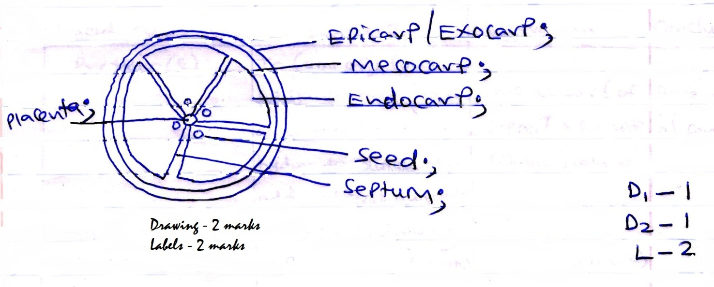
Conditions for a biological drawing
- Continuous outline D1
- No shading 1 mark
- Transverse section – D2 1 mark
Labels
- Labeling line must touch intended structure
- Labeling line must be continuous
- No arrowheads
- No criss-crossing
- Label must be singular if 1 labeling line touches 1 structure
- Any 2 correct labels
(ii) Axile (placentation); (1 mark)

(iii) Parietal;
Marginal;
Basal;
Free central; Mark 1st 2 correctly spelled placentation
(iv)

Food substance | Procedure | Observation | Conclusion
Protein(s) | To (2ml of) food substance, add (equal amount of) sodium hydroxide solution then add copper (II) sulphate solution dropwise;  (1 mark) | Blue colour (of copper (II) sulphate solution) retained;  (1 mark) | Protein(s) absent;  (1 mark)
Non-reducing sugar(s) | To (2ml of) food substance, add (2 drops of) hydrochloric acid, heat, cool; add sodium hydrogen carbonate solution dropwise until fizzing stop. Add (equal amount of) Benedict’s solution then heat/boil/warm/place in hot waterbath;  (2 marks) | Green colour observed;  Yellow/orange/brown;  (1 mark) | Non-reducing sugar(s) present;  (1 mark)

Distribution of marks:
- Food substance column – see correct food substance but do not award marks.
- Procedure – use correct chemical symbols of reagent if words are not used.
- Observation – reject alternative colours.
- Conclusion – correctly spelled food substance and traces of for green colour in non-reducing sugar.

- (a) Growth and development;
Reproduction;
Nutrition; Mark 1st 2

(b) (i) tracheole; Reject wrong spelling but underline plural to allow to mark (ii)

(ii) Ramify body tissues for direct supply to individual cells; thin to reduce diffusion distance; moist walls to dissolve gases (into solution form); lack chitin to permit gaseous exchance;
- Tied to 2(b) (i)
- Mark 1st 3

(c) Phylum: Arthropoda; Reject wrong spelling
External feature:
- Segmented bodies;
- Jointed appendages;
- Exoskeleton;
External features tied to phylum, marks 1st 2

(d) Egg(s) Nymph(s) Adult(s);
Award correct arrows on the diagram.

(e)
Name of hormone | Site of production | Function
Juvenile (hormone); | Corpus allatum | Formation of larval cuticle
Ecdysone | Ptothoracic gland; | Moulting/ecdysis/laying of adult cuticle;

3.
- (a) (5 marks)
Test tube | Observations
 | On placing specimen Y | On introducing a glowing splint
A | - Formation of foam;  - Production of bubbles; | Glowing splint relights/ rekindles;
B | No foam /no bubbles/ effervescence produced | Glowing splint does not relight/ rekindle;

(b) Tied to (a)
- Catalase (enzyme); breakdown hydrogen peroxide; into water and oxygen; (3 marks)
- Boiling denature catase enzyme; (therefore breakdown of hydrogen peroxide hence no oxygen formed) (1 mark)

(c) Control experiment; reject acts as a control experiment.

(d) Name of organ: Liver;
Functions:
- Blood sugar regulation;
- Deamination;
- Thermoregulation;
- Haemoglobin regulation;
- Regulation of plasma proteins;
- Manufacture of red blood cells during foetus stage;
- Formation and elimination of excess cholesterol;
- Storage of blood;
- Storage of vitamins B, C, E, K and mineral; Mark 1st 2

