NAME __________________________________________ SCHOOL ____________________
INDEX NO________________________CANDIDATE’S SIGNATURE __________________
DATE ______________________
231/3

BIOLOGY
PRACTICAL

Paper 3
Time: 1 ¾ hours.
March/April – 2023.

ARISE AND SHINE TRIAL 1 EXAM
Kenya Certificate of Secondary Education (KCSE)

Instructions to the Candidates.
- Write your name and index number in the spaces provided above.
- Sign and write the date of the examination in the spaces provided above.
- Answer all the questions in the spaces provided.
- You are required to spend the first 15 minutes of the 1 ¾ hours allowed for the paper reading the whole paper carefully before commencing your work.
- Additional pages must not be inserted.
- Candidates should check the question paper to ascertain that all the pages are printed as indicated and that no questions are missing.
- Candidates should answer all the questions in English

For Examiner’s Use Only
Question | Maximum Score | Candidate’s Score
1 | 14
2 | 13
3 | 13
Total Score | 40
- You are provided with specimen K. Use it to answer the questions that follow.
- Cut a traverse section of specimen K and draw a well labeled diagram of the cut surface. (4 marks)

- State the type of placentation of specimen K (1 mark)
………………………………………………………………………………………………
- Apart from the placentation named in (ii), name two other form of placentation. (2 marks)
………………………………………………………………………………………………………………………………………………………………………………………………
- Squeeze out the juice from one of the halves of the specimen K and put it in a beaker. Using the reagents provided, carry out test to identify the food substances present in the juice. (7 marks)
Food substance | Procedure | Observation | Conclusion

- The diagram represents organisms in a certain habitat.
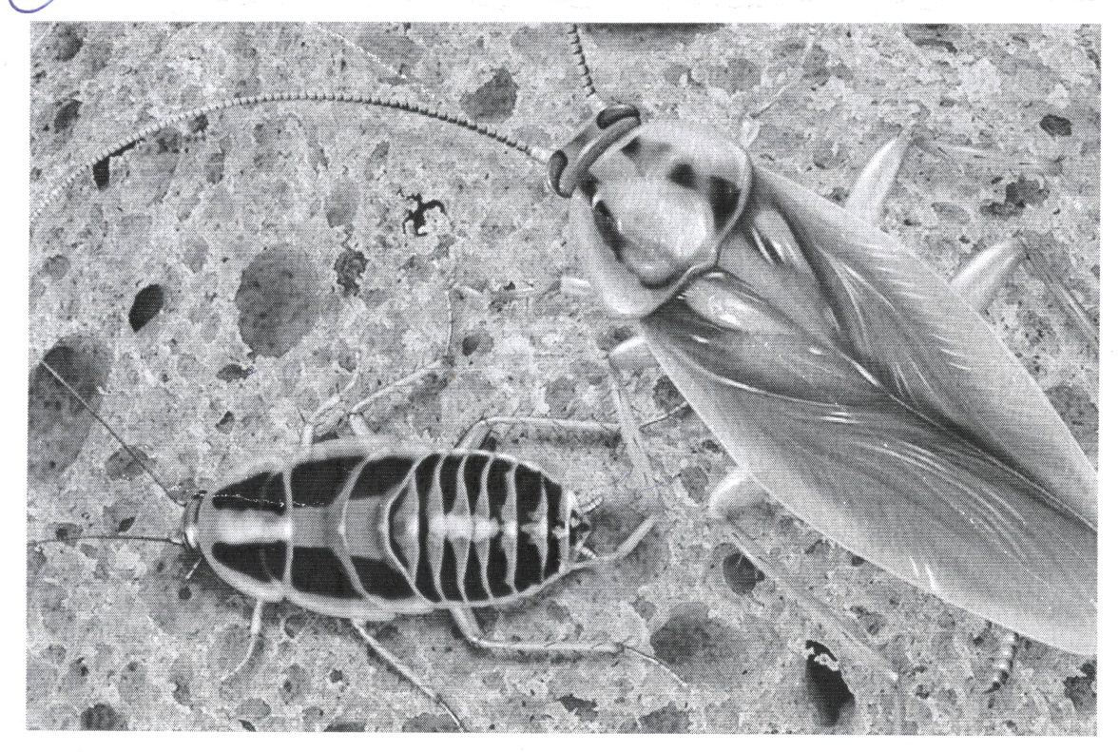
- State two observable characteristics of living things displayed by the organisms. (2 marks)
……………………………………………………………………………………………………………………………………………………………………………………………………
- (i) Name the respiratory surface used by the organism. (1 mark)
…………………………………………………………………………………………………
(ii) State three adaptations of the respiratory surface named in (b) (i) above. (3 marks)
………………………………………………………………………………………………………………………………………………………………………………………………………………………………………………………………………………………………………
- The organism is found in Kingdom Animalia. Giving two external features, identify the phylum to which it belong.

Phylum (1 mark)
………………………………………………………………………………………………
External features (2 marks)
………………………………………………………………………………………………………………………………………………………………………………………………
- By use of arrows, show the life cycle of this organism. (1 mark)

- Complete the table shown below on the hormones, site of production and the functions played by these hormones in metamorphosis. (3 marks)

Name of Hormone Site of Production Function of the Hormone
……………………… Corpus allatum Formation of larval cuticle
Ecdysone ………………… ……………………………

- You are provided with the following:
- \specimen Y
- Hydrogen peroxide
- 2 test tubes in a test tube rack.
- 2 labels
- 10ml measuring cylinder.
- A scalpel.
- 2 wooden splints.
- 100ml beaker.

Procedure
- Label two test tubes A and B.
- Measure 2cm³ of hydrogen peroxide and put in test tube A. Repeat the same procedure for test tube B.
- Cut a small piece of specimen Y to two smaller pieces using a scalpel. Place one of the pieces in test tube A and retain the other piece for the subsequent procedure for test tube B.
- Immediately, introduce a glowing splint into the mouth of the test tube. Record your observations in the table below.
- Put the other piece of specimen Y in an empty 100ml beaker then add 50ml boiling water from a hot water bath maintained at 80⁰C. Leave the set up for 5 minutes
- Remove specimen Y from the boiling water using a pair of forceps and place in test tube B. Immediately, introduce a glowing splint at the mouth of the test tube. Record your observations in the table below.

- Record your observations in this table (5 marks)
Test tube | Observations
 | On placing specimen Y | On introducing a glowing splint
A
B
- Explain your answers in (a) above.
- A (3 marks)
…………………………………………………………………………………………………………………………………………………………………………………………………………………………………………………………………………………………………………………………………………………………………………………………………………………….
- B (1 mark)
…………………………………………………………………………………………………………………………………………………………………………………………………………
- State the role of experimental set up in test tube B. (1 mark)
…………………………………………………………………………………………………………………………………………………………………………………………………………
- Specimen Y is an organ in animals. Name the organ and state two other functions apart from detoxification.
Name of organ (1 mark)
……………………………………………………………………………………………….

Functions (2 marks)
………………………………………………………………………………………………………………………………………………………………………………………………………………………………………………………………………………………………………………………………………………………………………………………………………………………………………………………………………………………………

