BIOLOGY Paper 2 MARKING SCHEME
MARCH/APRIL - 2023

SECTION A – (40 MARKS)
Answer All Questions In This Section In The Spaces Provided.
- (a) Anaerobic respiration / fermentation;
(b) To remove dissolved oxygen gas;
(c) To avoid denaturing of yeast cells;
(d) To prevent entrance of oxygen in the glucose solution;
(e) Formation of white precipitate;
Formation of bubbles;
(f) Increase in temperatures; due to heat energy production during the anaerobic respiration;
(g) Use boiled yeast on glucose;
- (a)
(i)
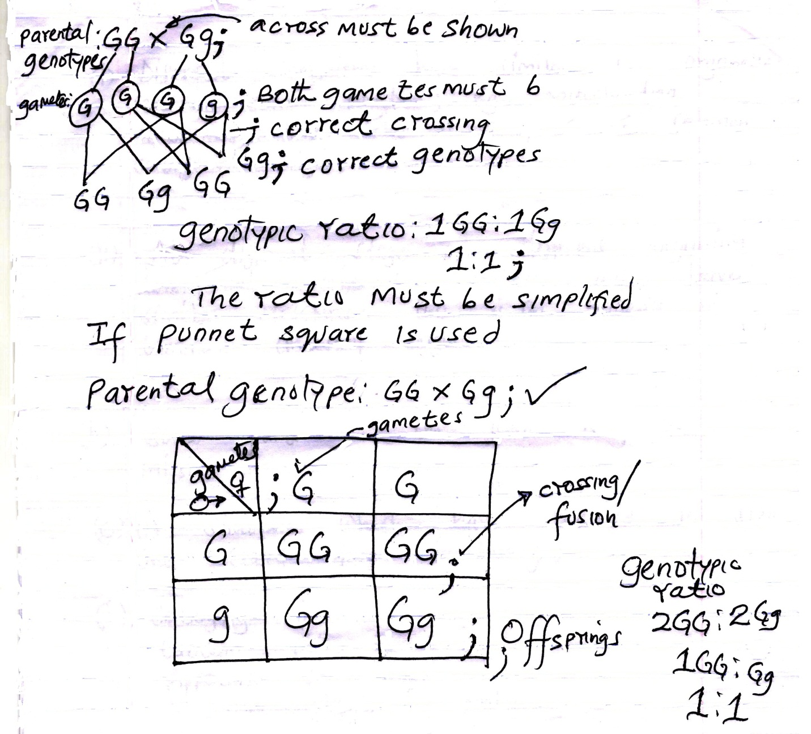
(ii) All offspring have green grains/green coloured grains;

(b) Genetic manipulation to produce desired characteristics/identify desirable genes, alter, isolate and transfer to another organisms;
(c) A situation where offsprings/progeny show characteristics which are superior to either of the parental stock;

- (a) (i) Different organisms have similar cell organelles serving same function; e.g. Mitochondria, ribosomes, DNA. This is a proof of common embryonic origin;

(ii) At different stage of different organism development, different embryos will have similar structure; this is an evidence of common ancestral origin.

(b) Some parts of the fossil may be missing;
(c) (i) Structures which have reduced in size and ceased from functioning;
(ii) Coccyx in man
Caecum in man
Appendix in man
Mammary glands in males
Nictitating eye membrane in man

- (a) (i) Phloem tissue/phloem; Reject if wrongly spelt
(ii) Translocation; a(i)and a(ii)are tied deny (ii) for function if a different structure is named in a(i) which is not phloem. If a(i) is blank and function is correct award.

b)
- Supply nutrients to the sieve tube element;
- Supply energy for translocation due to presence of numerous mitochondria to generate energy for translocation;
- Regulates activities of tube cells/elements;
NB: accept first two only
c) Sugars/glucose;
    - Amino acids;
    - Hormones e.g. auxins;
    - Oils/lipids;
    - Resins;
    - Vitamins; Accept first two only
d) Explain the role of Xylem in plant nutrition;
- Transport water from the roots to the leaf for photosynthesis are a raw material;
- Contain walls which are lignified to expose leaves for trapping sunlight energy for photosynthesis;

(a) (i) Absorb oxygen;
(ii) To find out if light is necessary for germination;
(b) (i) At 4⁰C - temperatures below optimum; enzymes are inactive hence little germination;
At 60⁰C – high temperatures above optimum; denatures enzymes / killed cells / protoplasm hence no germination;
At 35⁰C – Optimum temperatures hence highest percentage of germination;
(ii) Some seeds are not viable;
(c) Water
(i) Activates enzymes, hence allowing them hydrolyze food;
(ii) Medium of chemical reaction;

- (a) (ii) 42 hours;
(iii) M – 1220 ± 20 = 1200 – 1240 = 680 ± 40
N – 540 ± 20 = (520 – 560) Ranges between
(520 – 560); 680 – 720;
Method;
Answer;

(iv) Population (growth) decreases /Acc reduce;
High temperatures kill micro organisms / denature enzymes;
(v) Death rate (of the micro organisms) is higher than the rate of multiplication; due to exhaustion of nutrients / depletion of nutrients;
- Accumulation of toxic wastes/wastes;
- Shortage of oxygen;
- Overcrowding/ shortage of space;
NB: Award for observation first then reasons (3 marks)

(b) When osmotic pressure of the blood increases (beyond the normal osmoreceptors in) the hypothalamus detects this and stimulates the pituitary gland; to secrete /release more antidiuretic hormone/ vasopressin; which makes distal convoluted tubule /kidney tubules more permeable to water; and more water is reabsorbed into the blood; reducing the osmotic pressure to normal level; (Accept the converse, Reject use of Abbreviations. (5 marks)

Or
When osmotic pressure is high;
When there is too much sodium ions in the blood; the adrenal cortex responds by secreting less aldosterone; which causes less sodium ions to be absorbed from the gut into the blood and less sodium ions to be reabsorbed from the kidney tubules into the blood; and more sodium to be reabsorbed from the kidney tubules into the blood; raising the sodium levels;

6 (a) (i) Graph

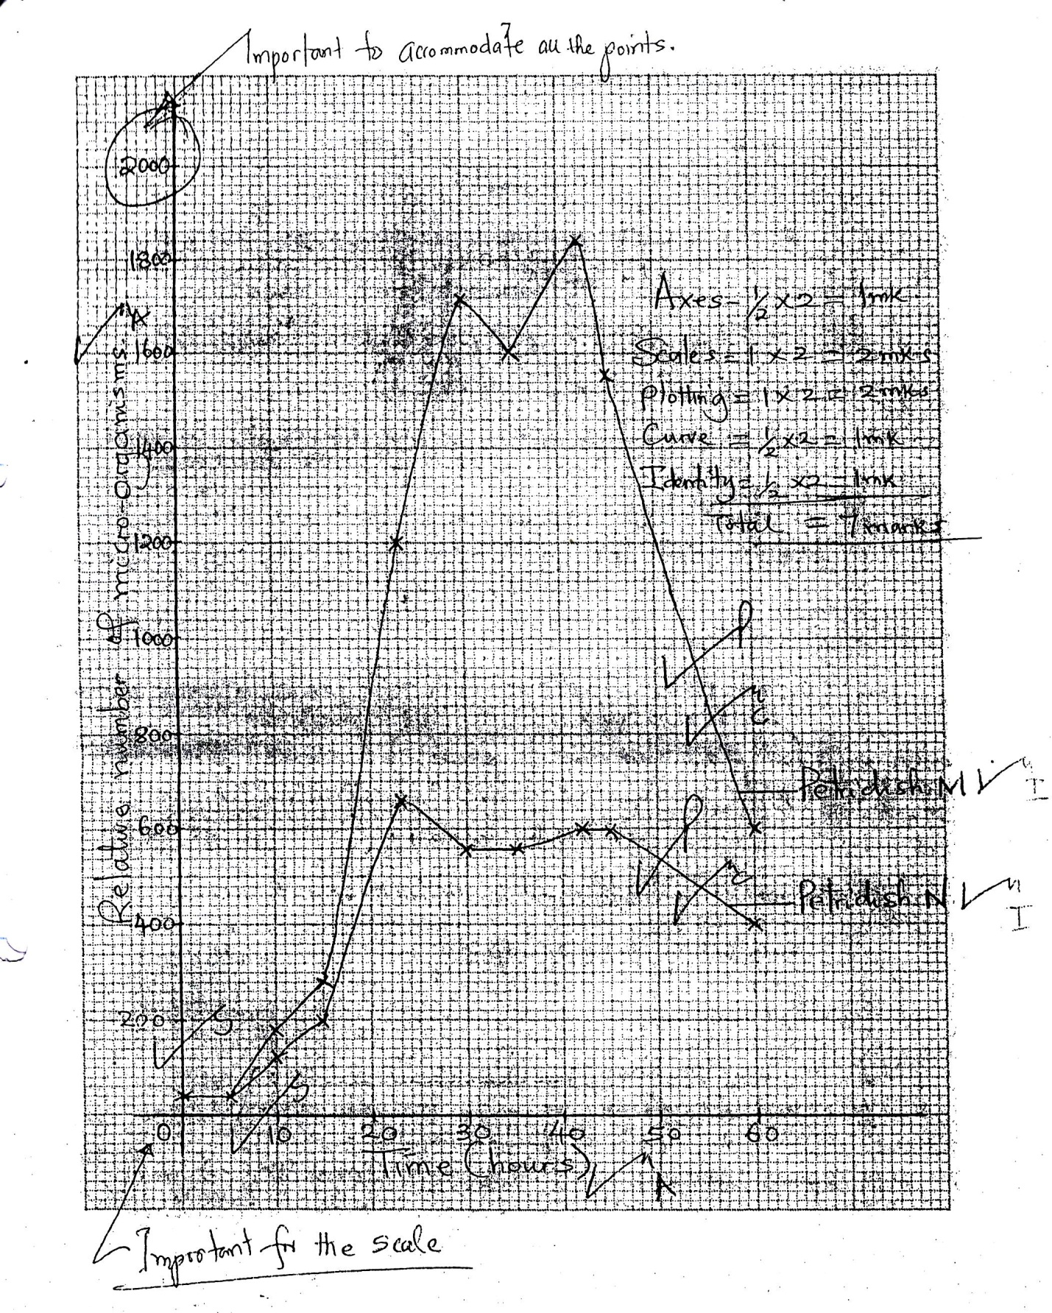

- (a) Budding in yeast
- Part of cellwall softens and extends a projection called a bud;
- Nucleus divides into two;
- One nucleus move into the bud;
- Bud increases in size; cellwall forms between growing bud and parent cell;

Bud is cut off to grow into new organism /yeast organism; (6 marks)
Max 5
NB: accept a drawn well labeled diagram accompanied by explanation;

(b) Economic Importance of bacteria
- Some bacteria are used in making milk products e.g. yoghurt/cheese/fermented milk;
- Some bacteria are used in curing tobacco and fermentation of tea;
- Production of enzymes /vitamin B12/ vitamin K;
- Biogas production /methane;
- Saprophytic bacteria important in decomposition of dead organic matter e.g. compost manure;
- Symbiotic bacteria important in decomposition of dead organic matter in compost manure;
- Cause diseases in man /domestic animals/ plants;
- Some bacteria spoil food /cause food poisoning;
- Some symbiotic bacteria /free living bacteria fix atmospheric nitrogen into nitrates;
- Denitrifying bacteria reduce the nitrate content of the soil lowering its fertility.

(c) Transpiration
- Excretion of excess water in form of water vapour.
Diffusion
- Elimination of carbon (iv) oxide from cellular respiration and excess oxygen from photosynthesis.
Deposition and leaf / flower /fruit fall
- These occur when these structures fall off the plant with deposited excretory substances;
Exudation /guttation
- Excretion of excess water, gases and salts through special pores /hydathodes;
Storage in heartwood
- Some nitrogenous wastes e.g. Tannins /germs/ oil/ resins are stored in the heartwood /dead non-conducive xylem;
- (a)Process of photosynthesis in green plants
Raw materials of photosynthesis are water; and carbon (iv) oxide;
For the process of photosynthesis to take place, it requires light; and chlorophyll; (pigment)
It occurs in the chloroplast; in the leaf
It takes place in two stages:
Light stage /light dependent stage; and dark stage /light independent stage;
(7 marks)
Light stage/light dependent stage occurs in the grana of chloroplasts; chlorophyll molecule traps sunlight energy; for splitting water molecules into oxygen and hydrogen/ photolysis; Light energy
acc/2H₂0 4H + 0₂
chlorophyll

chlorophyll
Water Hydrogen + Oxygen;
Light energy

Hydrogen atoms produced in photolysis enter dark stage; while oxygen is released into the atmosphere and some used by plant for respiration;

Some solar energy traps by chlorophyll is used in formation of Adenosine triphosphate/ATP; This reaction involves conversion of light energy into chemical energy;

Dark stage/Light Independent Stage
It proceeds whether light is present or not; it take place in the stroma; Reject stoma. It involves combination of carbon(iv)oxide with hydrogen atoms; a process known as carbon(iv)oxide fixation; to form simple sugar e.g glucose; it involves a series of enzyme controlled reactions;

The energy required for this process is provided by ATP (Adenosine Triphosphate) from light stage reaction; intermediates products undergoes further chemical reactions to form simple sugars e.g. glucose; some is utilized directly by plant cells while the rest are converted into starch for storage in plant tissues;
Fatty acids and glycerols, amino acids are formed in the dark stage.

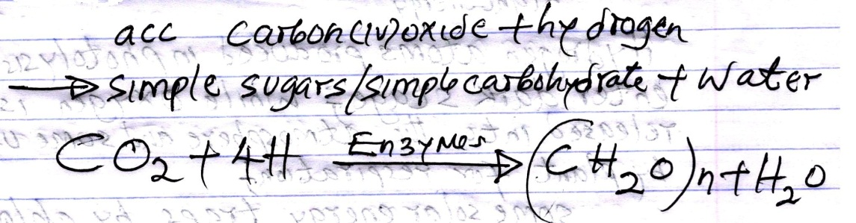

21 max 10

(b) Conditions necessary for germination
- Water;
- Medium for enzymatic activity;
- Hydrolyze /hydrolysis of stored substances into simple substances;
- Medium of transport /Transport hydrolyzed food to region of growth at tip of shoot and root;
- Softens seed testa/coat for emergence of radicle and plumule.
- Act as a solvent / dissolve food substances;
- Activates enzymes hence speed up rate of reaction in the seed; (7 marks)
- Oxygen;
- Oxygen is used for respiration/oxidation of food to release /generate energy; (2 marks)
- Suitable /optimal temperature;
- Temperature above optimum enzymes are denatured; rate of enzyme action during respiration is slowed down; Temperature below optimum enzymes are inactivated slowing down rate of germination;
- Enzymes action/activity is highest when temperature is optimum/ at optimal temperatures; rate oof germination increases;
- Rate of germination increases with increase in temperature upto optimum; (6 marks)
Accept examples of enzymes and food substances they act on and products.

- Enzymes;
- Oxidation of food and breakdown /hydrolysis of food;
- Assist in conservation of hydrolyzed food products into new plant tissues;
(3 marks)
- Viability of seeds; acc viability.
- Seeds whose embryo are alive and healthy can germinate;
- Seeds stored for a long time lose their viability due to depletion of food reserves and destruction of their embryo by pests and diseases and insects; (3 marks)
NB: Accept named examples of enzymes, substrate they hydrolyze and their end products to score for hydrolysis of food.

Examples: Diastase enzyme – hydrolyze carbohydrates into glucose; lipase hydrolyze lipids into fatty acids and glycerol; protease act on proteins to amino acids;

- Hormones; / Gibberellins/ cytokinins;
- Counteract effect of germination inhibitors;

