NAME _________________________________________INDEX NO_____________________ CANDIDATE’S SIGNATURE __________________DATE _____________________________
231/2

BIOLOGY
Paper 2

Time: 2 Hours.
March/April, 2023

ARISE AND SHINE TRIAL EXAMINATION
Kenya Certificate of Secondary Education (KCSE)

Instructions to the Candidates
- Write your name and index number in the spaces provided above.
- Sign and write the date of examination in the spaces provided above.
- This paper consists of TWO sections A and B
- Answer ALL the questions in section A by filling in the spaces provided.
- In section B answer question 6 (compulsory question) and any other one question from the remaining two questions (i.e. 7 or 8) in the spaces provided after question 8.
- Candidates may be penalized for false information or even wrong spellings of technical terms.
- This paper consists of 13 printed pages.
- Candidates should check the question paper to ascertain that all the pages are printed as indicated and that no questions are missing.

For Examiner’s Use Only
Section | Question | Maximum score | Candidate’s Score
A | 1  2  3  4  5 | 8  8  8  8  8
B | 6  7  8 | 20  20  20
 | TOTAL | 80
SECTION A – (40 MARKS)
Answer All Questions In This Section In The Spaces Provided.
- The set up below was used to investigate a certain process.
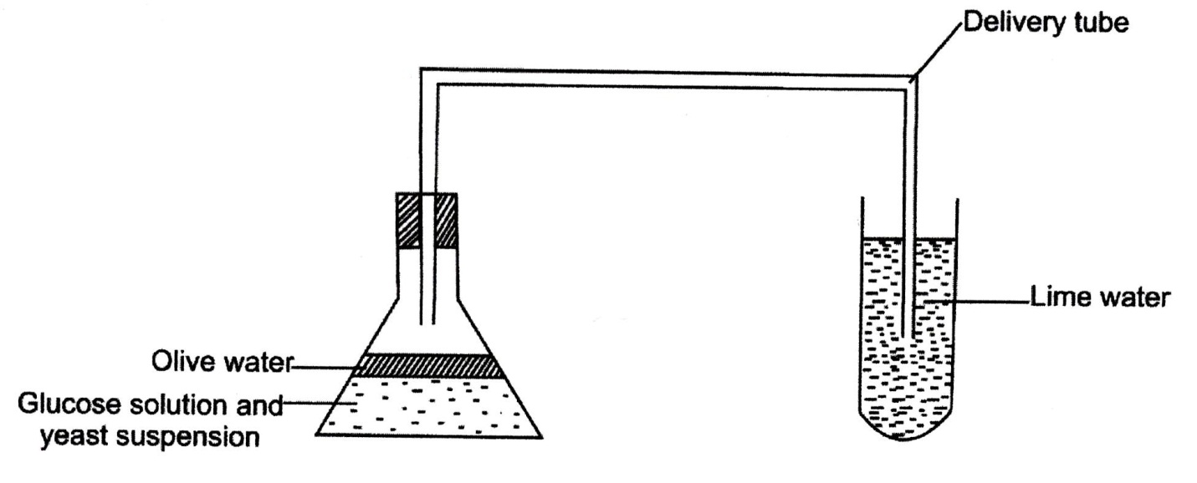
Glucose solution was boiled and olive oil added on top. It was then allowed to cool before the yeast suspension was added.
- Name the biological process being investigated. (1 mark)
………………………………………………………………………………………………..
- Why was the glucose solution boiled? (1 mark)
……………………………………………………………………………………………………………………………………………………………………………………………………
- What is the importance of cooling the glucose solution before adding the yeast? (1 mark)
……………………………………………………………………………………………………………………………………………………………………………………………………
- What is the role of olive oil in the experiment? (1 mark)
……………………………………………………………………………………………………………………………………………………………………………………………………
- What will be observed in the lime water at the end of the experiment? (1 mark)
……………………………………………………………………………………………………………………………………………………………………………………………………
- Suggest what would be observed if a thermometer reading 25⁰C was inserted in the glucose solution with the yeast suspension (2 marks)
………………………………………………………………………………………………………………………………………………………………………………………………………………………………………………………………………………………………………
- Suggest a control experiment for this set up. (1 mark)
……………………………………………………………………………………………………………………………………………………………………………………………………
- In maize the gene for Green colour is dominant to the gene for white colour. A pure breeding maize plant with green grains was crossed with heterozygous plant.
- (i) Using letter G to represent the gene for green colour, work out the genotypic ratio of the offspring. (5 marks)

(ii) State the phenotype of the offspring. (1 mark)
……………………………………………………………………………………………………………………………………………………………………………………………………
- What is genetic engineering? (1 mark)
…………………………………………………………………….………………………………….……………………………………………………………………………………………
- What is meant by hybrid vigour? (1 mark)
……………………………………………………………………………………………………………………………………………………………………………………………………
- (a) Briefly discuss how the following gives evidences on specification:
- Cell biology (2 marks)
………………………………………………………………………………………………………………………………………………………………………………………………………………………………………………………………………………………………………
- Comparative embryology (2 marks)
…………………………………………………………………………………………………………………………………………………………………………………………………………………………………………………………………………………………………………………………………………………………………………………………………………
(b) State one limitation of using fossil records as an evidence of organic evolution. (1 mark)
…………………………………………………………………………………………………
(c) (i) What is meant by the term vestigial structure. (1 mark)
……………………………………………………………………………………………………………………………………………………………………………………………………
(ii) Name two examples of vestigial structures in man. (2 marks)
……………………………………………………………………………………………………………………………………………………………………………………………………
- The diagram below shows a tissue in a plant.
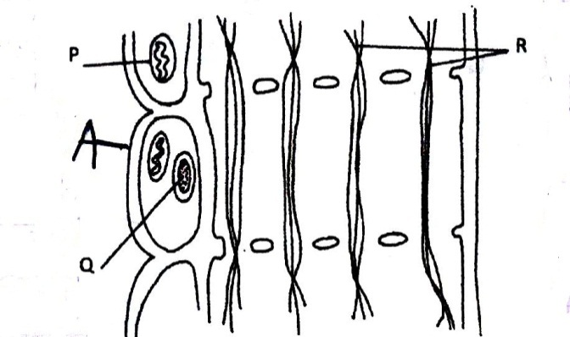
- (i) Identify the tissue shown in the diagram above. (1 mark)
…………………………………………………………………………………………………
(ii) State the function of the tissue shown above. (1 mark)
…………………………………………………………………………………………………
- State two functions of the part labeled A. (2 marks)
……………………………………………………………………………………………………………………………………………………………………………………………………
- Name the two compounds or substances transported by the tissue from the leaf to other parts of the plant. (2 marks)
……………………………………………………………………………………………………………………………………………………………………………………………………
- Explain the role of xylem in plant nutrition. (2 marks)
…………………………………………………………………………………………………………………………………………………………………………………………………….………………………………………………………………………………………………………………………………………………………………………………………………………………………………………………………………………………………………………

- The results in the table below shows the effects of some conditions on seed germination. In each experiment, all other environmental conditions were kept constant except for the one being investigated.
Experiment | Treatment | % Germination
I | Seeds placed in a tightly closed container with pyrogallic acid. | 0
II | - Seeds kept in source of light.  - Seeds kept in dark cupboard. | 96  97
III | - Seeds kept in refrigerator 4⁰C.  - Seeds kept in oven 60⁰C.  - Seeds kept at 35⁰C. | 0.5  0  92
IV | Dry seeds in closed container.  Moist seeds in a closed container. | 0  87

- (i) What was the purpose of pyrogallic acid in experiment (i) (1 mark)
…………………………………………………………………………………………………
(ii) State the aim of the experiment (ii) (1 mark)
…………………………………………………………………………………………………
- (i) Account for the results obtained in experiment set-up (iii) (3 marks)
…………………………………………………………………………………………………………………………………………………………………………………………………………………………………………………………………………………………………………………………………………………………………………………………………………………………………………………………………………………………………………………………………………………………………………………………………………………………………………………………………………………………………………………
(ii) State why 100% germination was not achieved in experiment (ii) and (iv). (1 mark)
……………………………………………………………………………………………………………………………………………………………………………………………………
- Of what biological significance is the condition necessary for germination been investigated by experiment (iv)? (2 marks)
……………………………………………………………………………………………………………………………………………………………………………………………………………………………………………………………………………………………………………………………………………………………………………………………………………………………………………………………………………………………………………

SECTION B – 40 MARKS
Answer Question 6(Compulsory) and Either Question 7 or 8 in the Spaces Provided After Question 8
- (a) An experiment was carried out to investigate the population of a certain micro-organism. Two petri dishes were used. Into the petri dish labeled M 30cm³ of a culture medium was placed while 30cm³ of the same culture was placed in petri dish labeled N. Equal numbers of micro-organisms were introduced in both petri dishes. The set-ups were then incubated at 35⁰C. The number of micro-organisms in each petri dish were determined at equal intervals for a period of 60 hours. The results were as shown in the table below.

Relative number of micro-organisms | M | 40 | 40 | 180 | 280 | 1200 | 1720 | 1600 | 1840 | 1560 | 600
 | N | 40 | 40 | 120 | 200 | 680 | 560 | 560 | 600 | 600 | 400
Time in hours |  | 0 | 5 | 10 |  | 23 | 30 | 35 | 42 | 45 | 60

a) (i) On the same axes draw the graphs of relative number of micro-organisms against time on the grid provided.

(ii) After how many hours was the difference between the two populations greatest? (1 mark)

(iii) Work out the difference between the two populations at 50 hours (2 marks)

(iv) With a reason state the effect on the population of micro-organisms in petri dish M if the temperature was raised to 60⁰C after 20 hours (2 marks)

……………………………………………………………………………………………………………………………………………………………………………………………………
………………………………………………………………………………………………………………………………………………………………………………………………………………………………………………………………………………………………………
(v) Account for the shape of the curve for population in petri dish N between 46 and 59 hours (3 marks)
…………………………………………………………………………………………………………………………………………………………………………………………………………………………………………………………………………………………………………………………………………………………………………………………………………………………………………………………………………………………………………………………………………………………………………………………………………………………………………………………………………………………………………………
b) Explain how the osmotic pressure in the human blood is maintained at normal level
(5 marks)

- (a) Describe how budding takes place in yeast (5 marks)
(b) Discuss the economic importance of bacteria (10 marks)
(c) Describe the methods of excretion in plants (5 marks)

8. (a) Describe the process of photosynthesis in green plant (10 marks)
(b) Explain the various conditions necessary for germination (10 marks)

………………………………………………………………………………………………………………………………………………………………………………………………………………………………………………………………………………………………………………………………………………………………………………………………………………………………………………………………………………………………………………………………………………………………………………………………………………………………………………………………………………………………………………………………………………………………………………………………………………………………………………………………………………………………………………………………………………………………………………………………………………………………………………………………………………………………………………………………………………………………………………………
………………………………………………………………………………………………………………………………………………………………………………………………………………………………………………………………………………………………………………………………………………………………………………………………………………………………………………………………………………………………………………………………………………………………………………………………………………………………………………
………………………………………………………………………………………………………………………………………………………………………………………………………………………………………………………………………………………………………………………………………………………………………………………………………………………………………………………………………………………………………………………………………………………………………………………………………………………………………………
………………………………………………………………………………………………………………………………………………………………………………………………………………………………………………………………………………………………………………………………………………………………………………………………………………………………………………………………………………………………………………………………………………………………………………………………………………………………………………
………………………………………………………………………………………………………………………………………………………………………………………………………………………………………………………………………………………………………………………………………………………………………………………………………………………………………………………………………………………………………………………………………………………………………………………………………………………………………………
………………………………………………………………………………………………………………………………………………………………………………………………………………………………………………………………………………………………………………………………………………………………………………………………………………………………………………………………………………………………………………………………………………………………………………………………………………………………………………
………………………………………………………………………………………………………………………………………………………………………………………………………………………………………………………………………………………………………………………………………………………………………………………………………………………………………………………………………………………………………………………………………………………………………………………………………………………………………………
………………………………………………………………………………………………………………………………………………………………………………………………………………………………………………………………………………………………………………………………………………………………………………………………………………………………………………………………………………………………………………………………………………………………………………………………………………………………………………
………………………………………………………………………………………………………………………………………………………………………………………………………………………………………………………………………………………………………………………………………………………………………………………………………………………………………………………………………………………………………………………………………………………………………………………………………………………………………………
………………………………………………………………………………………………………………………………………………………………………………………………………………………………………………………………………………………………………………………………………………………………………………………………………………………………………………………………………………………………………………………………………………………………………………………………………………………………………………
………………………………………………………………………………………………………………………………………………………………………………………………………………………………………………………………………………………………………………………………………………………………………………………………………………………………………………………………………………………………………………………………………………………………………………………………………………………………………………
………………………………………………………………………………………………………………………………………………………………………………………………………………………………………………………………………………………………………………………………………………………………………………………………………………………………………………………………………………………………………………………………………………………………………………………………………………………………………………
………………………………………………………………………………………………………………………………………………………………………………………………………………………………………………………………………………………………………………………………………………………………………………………………………………………………………………………………………………………………………………………………………………………………………………………………………………………………………………
………………………………………………………………………………………………………………………………………………………………………………………………………………………………………………………………………………………………………………………………………………………………………………………………………………………………………………………………………………………………………………………………………………………………………………………………………………………………………………
………………………………………………………………………………………………………………………………………………………………………………………………………………………………………………………………………………………………………………………………………………………………………………………………………………………………………………………………………………………………………………………………………………………………………………………………………………………………………………
………………………………………………………………………………………………………………………………………………………………………………………………………………………………………………………………………………………………………………………………………………………………………………………………………………………………………………………………………………………………………………………………………………………………………………………………………………………………………………
………………………………………………………………………………………………………………………………………………………………………………………………………………………………………………………………………………………………………………………………………………………………………………………………………………………………………………………………………………………………………………………………………………………………………………………………………………………………………………
………………………………………………………………………………………………………………………………………………………………………………………………………………………………………………………………………………………………………………………………………………………………………………………………………………………………………………………………………………………………………………………………………………………………………………………………………………………………………………
………………………………………………………………………………………………………………………………………………………………………………………………………………………………………………………………………………………………………………………………………………………………………………………………………………………………………………………………………………………………………………………………………………………………………………………………………………………………………………
………………………………………………………………………………………………………………………………………………………………………………………………………………………………………………………………………………………………………………………………………………………………………………………………………………………………………………………………………………………………………………………………………………………………………………………………………………………………………………
………………………………………………………………………………………………………………………………………………………………………………………………………………………………………………………………………………………………………………………………………………………………………………………………………………………………………………………………………………………………………………………………………………………………………………………………………………………………………………………………………………………………………………………………………………………………………………………………………………………………………………………………………………………………………………………………………………………………………………………………………………………………………………………………………………………………………………………………………………………………………………………………………………………………………………………………………………………………………………………………………………………………………………………………………………………………………………………………………………………………………………………………………………………………………………………………………………………………………………………………………………………………………………………………………………………………………………………………………………………………………………………………………………………………………………………………………………………………………………………………………………………………………………………………………………………………………………………………………………………………………………………………………………………………………………………………………………………………………………………………………………………………………………………………………………………………………………………………………………………………………………………………………………………………………………………………………………………………………………………………………………………………………………………………………………………………………………………………………………………………………………………………………………………………………………………………………………………………………………………………………………………………………………………………………………………………………………………………………………………………………………………………………………………………………………………………………………………………………………………………………………………………………………………………………………………………………………………………………………………………………………………………………………………………………………………………………………………………………………………………………………………………………………………………………………………………………………………………………………………………………………………………………………………………………………………………………………………………………………………………………………………………………………………………………………………………………………………………………………………………………………………………………………………………………………………………………………………………………………………………………………………………………………………………………………………………………………………………………………………………………………………………………………………………………………………………………………………………………………………

