NAME________________________________________INDEX NO ___________________
SCHOOL__________________________CANDIDATE’S SIGN ____________________DATE _____________________

231/1

BIOLOGY
Paper 1
Time: 2 Hours.

ARISE AND SHINE EXAMINATION
Kenya Certificate of Secondary Education (K.C.S.E)
FORM 4 TRIAL 1 EXAMINATION -2023

Instructions
- Write your name, Index Number and School in the spaces provided above.
- Sign and write the date of the examination in the spaces provided above.
- Answer all the questions in the spaces provided.
- Additional pages must not be inserted.
- Check the question paper to ascertain that all the pages are printed and that no questions are missing.
- All answers should be written in English

FOR EXAMINER’S USE ONLY
Question | Maximum Score | Candidate’s Score
1-25 | 80

- Name the branch of biology that involves the study of:
(a) Organism for the sake of classifying them (1mark)

…………………………………………………………………………………………………………………………………………………………………………………….

(b) Microscopic organisms. (1 mark)
………………………………………………………………………………………………………………………………………………………………………………………………

- The diagram below represents a plant
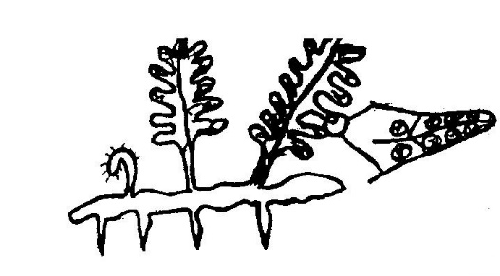
- Name the division to which the plant belongs (1 mark)

………………………………………………………………………………………………

(b). Give three reasons for your answer in (a) above (3 marks)
………………………………………………………………………………………………………………………………………………………………………………………………
………………………………………………………………………………………………
- A student estimating a cell of an onion epidermal cell observed the following on the microscope field of view using a transparent ruler.
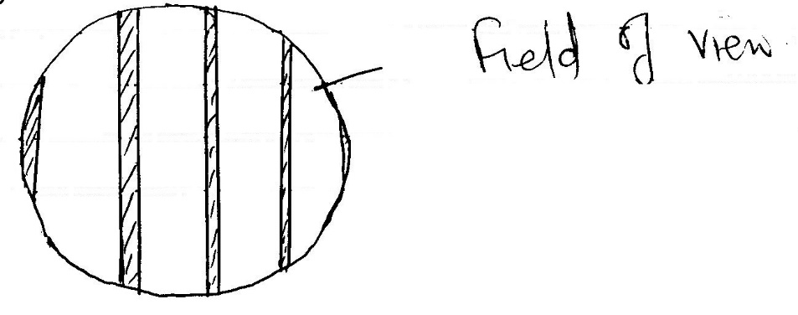
The student identifies 20 cells across the field of view. Calculate the size of the cell in micrometres. (3 marks)
…………………………………………………………………………………………………………………………………………………………………………………………………….
………………………………………………………………………………………………….
4. State the functions of centrioles in a cell. (2 marks)
…………………………………………………………………………………………………

5. Study the flow diagram below
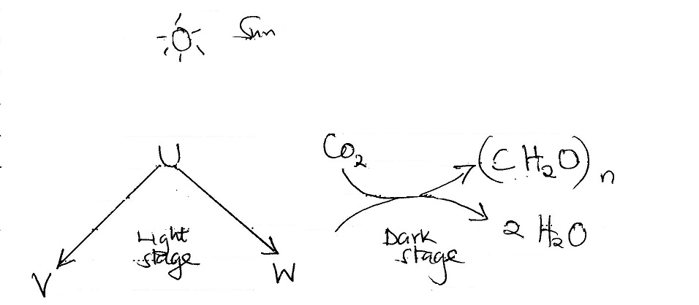
Name the substance U, V and W. (3 marks)
U………………………………………………………………
V ………………………………………………………………
W ……………………………………………………………..
6. (a). State the deficiency diseases of each of the following vitamins. (3 marks)
(i). B₁ ………………………………………………………………….
(ii). B₂ ……………………………………………………………….
(iii). B₆………………………………………………………………..
(b). What is the role of roughage in a diet? (1 mark)
…………………………………………………………………………………………………

- State two differences between osmosis and Active transport. (2 marks)
…………………………………………………………………………………………………
…………………………………………………………………………………………………
…………………………………………………………………………………………………
…………………………………………………………………………………………………
…………………………………………………………………………………………………
…………………………………………………………………………………………………
- In a certain experiment, the following observation was made:
When red blood cell was placed in certain solution, the solution exerted more osmotic pressure leading to cell losing water molecules to become (crenated/shrunk)
(a). What type of solution was the cell placed in respect to the cell’s cytoplasms?
(1 mark)
…………………………………………………………………………………………………

(b). By which physiological process did the cell lose water molecules? (1 mark)
…………………………………………………………………………………………………
(c).Name two substances that make a cell membrane. (2 marks)
…………………………………………………………………………………………………
…………………………………………………………………………………………………
- The diagram below represents a transverse section of a plant part. Study it and answer the questions that follow.
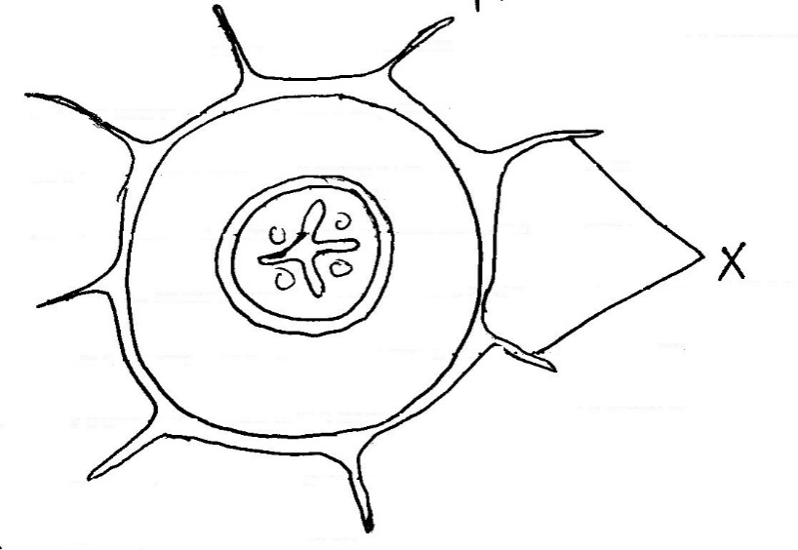
(a). Name the class in which the plant belongs. (1 mark)
…………………………………………………………………………………………………..
(b). Give a reason for answer (a) above. (1 mark)
…………………………………………………………………………………………………..
…………………………………………………………………………………………………
…………………………………………………………………………………………………
(c). State three adaptations for the structure labeled X to their functions. (3 marks)
…………………………………………………………………………………………………
…………………………………………………………………………………………………
…………………………………………………………………………………………………
- State THREE structural differences between arteries and veins in mammals. (3 marks)
…………………………………………………………………………………………………
…………………………………………………………………………………………………
…………………………………………………………………………………………………

- (a). Why does carboxyhaemoglobin lead to death? (3 marks)
………………………………………………………………………………………………
………………………………………………………………………………………………
………………………………………………………………………………………………

(b). Name two gaseous exchange sites in higlier plants. (2 marks)
…………………………………………………………………………………………………
…………………………………………………………………………………………………
- State the importance of the following features in gaseous exchange
- cartilage in the trachea 1 mark)
…………………………………………………………………………………………………

- (ii) Moisture on the surface of the alveoli. (1 marks)
…………………………………………………………………………………………………..

- The equation below shows an oxidation reaction of flow food substances
5C₅₁H₉₈O₆ + 145O₂$→$ ¹⁰²CO₂ + 98H₂O + Energy
- (a) Determine respiratory quotient of the Oxidation of the food substance above (3 marks)
…………………………………………………………………………………
- Identify the food substance. (1 mark)
…………………………………………………………………………………
- (a). A dog weighing 15.2kg requires 216kg while a mouse weighing 50g
Explain. (2 marks)
……………………………………………………………………………………………………………………………………………………………………………………………………
(b). Under what condition is lactic acid formed in human muscles? (1 mark)
…………………………………………………………………………………………………
15. Equal amounts of crushed Irish potato were placed in equal volumes of hydrogen peroxide solution at indicated PH. The volume of the gas produced was measured and recorded as shown in the table below.
(3 marks)
PH | 4.0 | 7.0 | 9.0
Volume of gas (cm³) | 2.7 | 7.0 | 9.0
(a). Name the gas that was produced. (1 mark)
…………………………………………………………………………………………………..
(b). Account for the difference in the volume of the gas produced in PH 4.0 and PH 9.0
(3 marks)
……………………………………………………………………………………………………………………………………………………………………………………………………
……………………………………………………………………………………………………………………………………………………………………………………………………
(c). Name two components of blood that are not present in the glomerular filtrate. (2 marks)
……………………………………………………………………………………………………………………………………………………………………………………………………
(16). Define the following terms (2 marks)
- Entomology
………………………………………………………………………………………………
- Sensitivity
…………………………………………………………………………………………………

(17). Give two examples of continuous variations in humans. (2marks)
……………………………………………………………………………………………………………………………………………………………………………………………………
(18). (a) State the causative agent of the following diseases (2 marks)
(i). Typhoid ………………………………………………………
(ii). Pneumonia …………………………………………………….
(b). State three preventive measures of schistosomiasis in human beings (3 marks)
……………………………………………………………………………………………………………………………………………………………………………………………………………………………………………………………………………………………………….
19. Describe capture-recapture method of estimating population. (3 marks)
……………………………………………………………………………………………………………………………………………………………………………………………………………………………………………………………………………………………………….
…………………………………………………………………………………………………
…………………………………………………………………………………………………
…………………………………………………………………………………………………
…………………………………………………………………………………………………

20. State three advantages of asexual reproduction in organisms. (3 marks)
………………………………………………………………………………………………………………………………………………………………………………………………………………………………………………………………………………………………………
…………………………………………………………………………………………………
…………………………………………………………………………………………………

21.The diagram below shows a phenomenon which occurs during cell division.
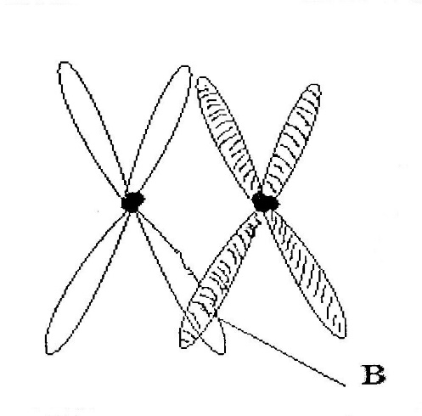
(a). Identify the stage of cell division in which the phenomenon occurs. (1 mark)
…………………………………………………………………………………………………

(b). State the importance of phenomenon taking place in the part labelled B. (2 marks)
…………………………………………………………………………………………………

22. Name the region in plants where the following take place
(a). Primary growth (1 mark)
…………………………………………………………………………………………………
(b). Secondary growth (1 mark)
…………………………………………………………………………………………………

23. State three parameters that can be used to estimate growth in seedlings. (3 marks)
…………………………………………………………………………………………………
…………………………………………………………………………………………………
…………………………………………………………………………………………………
…………………………………………………………………………………………………

24. State three reasons for classifying organism. (3 marks)
…………………………………………………………………………………………………
…………………………………………………………………………………………………
…………………………………………………………………………………………………
…………………………………………………………………………………………………

25. The diagram below represents a transverse section of an ovary from certain flower.
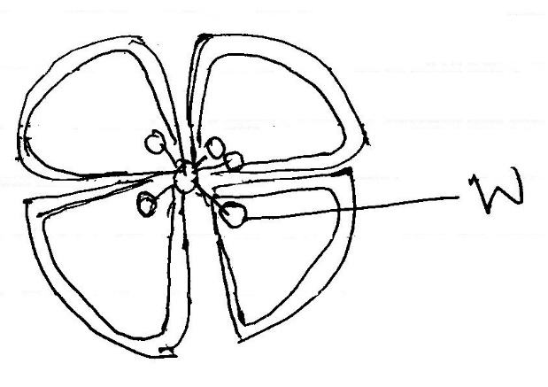
(i) Name the structure labeled W. (1 mark)
…………………………………………………………………………………………………
(ii). Name the type of placentation illustrated in this diagram. (1 mark)
…………………………………………………………………………………………………

