BIOLOGY FORM 1 HOLLIDAY ASSIGNMENT

- State the use of the following apparatus in collecting and observing organisms (3mks)
- Pooter
- Hand lens
- Pitfall trap
- The scientific name for French bean is Phaseolus Vulgaris
- What taxon does the term Phaseolus represent? (1mk)

- State two rules that are followed when giving a scientific name to an organism. (2mks)

- a) What is meant by the term taxonomy (1mk)

- When are two organisms considered to belong to the same species? (2mks)

- Name the branch of biology that deals with the study of zooplanktons. (1mk)

- Mango is known as MANGIFERA INDICA
- Write down the scientific name given above following the acceptable system of naming. (1mk)

- What is the scientific naming system called? (1mk)

- a) What is the formula for calculating linear magnification using a light microscope? (1mk)

(b) State two functions of the following cell organelle.
Nucleolus (1mk)
Centrioles (1mk)
Mitochondrion (1mk)
Chloroplast (1mk)
Golgi body (2mks)
- Give the functions of the following parts of a microscope. (5mks)
Condenser
Fine adjustment knob
Eye piece
Objective lens
Diaphragm

- Define the following terms
- Magnification (1mk)

- Resolution (1mk)

- Give three differences between a plant cell and an animal cell. (3mks)
Plant cell | Animal cell

- The figure below is a diagram of a cell as seen under the light microscope. The microscope’s eye piece lens had a magnification of x10.

A
B
Cell wall
Mg X40

- Name three structures that show that this is a plant cell and not an animal cell. (3mks)

- Name one chemical compound that is only found in the structure labeled A and state its function.
(2mks)

- Explain why the following processes are important during the preparation of temporary slides.
- Staining (1mk)

- Use of a sharp cutting blade. (1mk)

- In a class experiment to establish the size of an onion cell, a learner observed the following on the microscope field of view.

If the student counted 20 cells across the diameter of this field of view, calculate the size of one cell micrometers. (3mks)

- a) List four skills that you develop as you study biology. (4mks)

(b) List three careers that require study of biology. (3mks)

- State two importance of classification of living organisms. (2mks)

- Name five kingdoms of classification and in each case give an example. (5mks)

- Distinguish between heterotrophism and autotrophism. (2mks)

- Name the building blocks of: (2mks)
- Lipids

- Proteins

- An experiment was set up as shown below to investigate a condition necessary for photosynthesis.

- Name the condition being investigated. (1mk)

- What is the role of sodium hydroxide pellets. (1mk)

- Explain the expected results when leaf S and T are tested for starch. (2mks)

- Below is a list of carbohydrates; sucrose, fructose, cellulose, galactose, glycogen, maltose.
- Name two monosaccharide’s (2mks)
- Name two disaccharides (2mks)
- Name two polysaccharides (2mks)
- a) Explain the importance of the following stages in an experiment to test for presence of starch in a leaf.
- Dipping the leaf in hot water. (1mk)
- Boiling the leaf in alcohol methylated spirit. (1mk)
- Adding iodine. (1mk)
- What are the expected results if:
- Starch is present. (1mk)

- Starch is absent (1mk)

- What are the expected results if a variegated leaf is used? (1mk)

- A student set up the experiment shown below to investigate photosynthesis.

- State the aim of the experiment. (1mk)

- Explain why
- Sodium hydrogen carbonate was added to the water. (1mk)

- A water plant was used. (1mk)

- How can a student test for the gas given out? (1mk)

- State two other factors affecting photosynthesis that the experiment can be used to investigate. (2mks)

- Name the cell organelle present in an animal cell but absent in a plant cell. (1mk)

- The diagram below represents a certain physiological process. Study it carefully and answer the questions that follow.
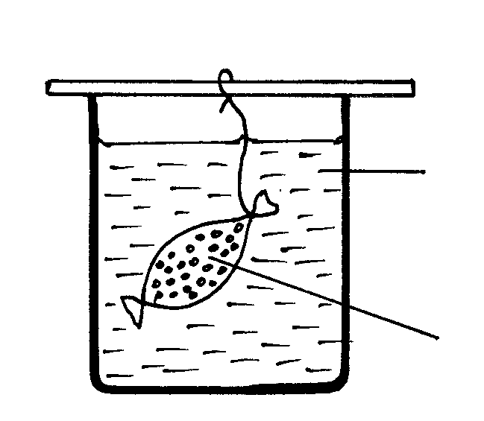
String

Iodine solution
Starch solution
Visking tubing
Beaker

- State the physiological process illustrated above (1mk)

- What will happen to the visking tubing after two hours? (1mk)

- Account for the result in (b) above (3mks)

- Give three factors that affect the physiological process named in (a) above. (3mks)

- State two roles of the physiological process in (a) above in living organisms. (2mks)

- Distinguish between haemolysis and plasmolysis. (2mks)

- Name the elements that form carbohydrates. (3mks)

