231/3
BIOLOGY
PRACTICAL
CONFIDENTIAL INSTRUCTIONS TO SCHOOLS
FORM 4 P3 MARKING SCHEME
- you are provided with specimens J, K and L.
- (i) identify specimen J. (1mk)
Fruit;
(ii)Give a reason for your answer in a) (i) above. (1mk)
Has two scars:
- Using the scalpel provided, carefully make a cross section of specimen J.
- name the type of placentation (1mk)
- extract juice form specimen J and test it for vitamin C. (3mks)
Food tested | Procedure | Observation | Conclusion
Vitamin C | Put DCPIP solution in a test tube then add juice drop by drop as you shake; | DCPIP declorisation; | Vitamin C present;

- complete the table below using the specimens provided. (9mks)
specimen | Agent of dispersal | One adaptation of the specimen
J | Animal; | - Brightly coloured; to attract the animal;  - Fleshy/succulent; to attract the animals;  - Slimy seeds with hard seedcoat; to resist digestion in the animals gut,hence released in feaces in viable state;  - Scented; to attract animals;
K | Animal; | - Has hooks; to attach to the animals fur/clothes;  - Light; hence cannot be detected by the animal and thus be carried far distance;
L | Self explosive mechanism | - Has satures/lines of weakness; in the pod along which they the pod breaks explosively throwing the seeds far away;

(Mark 2mks for the adaptation.)
2. The photographs below represents leaves from different plants.use them to answer the questions that follow.

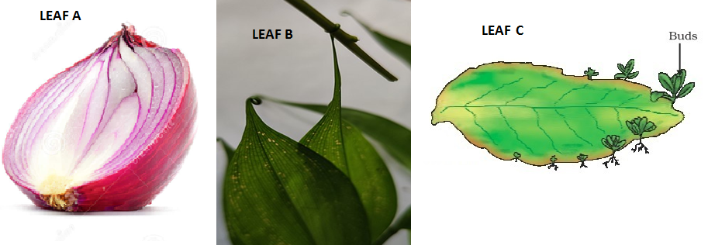

- Each of the leaves A,B and C are modified to perform different functions. With a reason, state the functions. (10mks)
LEAF | FUNCTION | REASON
A | Storage | Succulent/swollen;
B | Photosynthesis | Green in colour;
B | support | Has tendrils
C | Photosynthesis | Its green;
C | reproduction | Has plantlets/buds;

- State the type of evolution that may have led to the emergence of the different leaves shown in leaf A, B and C. (1mk)
Divergent evolution;
- Name the type of evolution structure represented by the leaves above. (1mk)
Homologous structure;
- Name two examples of such structures as named in (b) (ii) above in aves. (2mks)
- Beaks;
- Legs;

3. Below is a photomicrograph of a plant cell. Study it and answer the questions that follow.
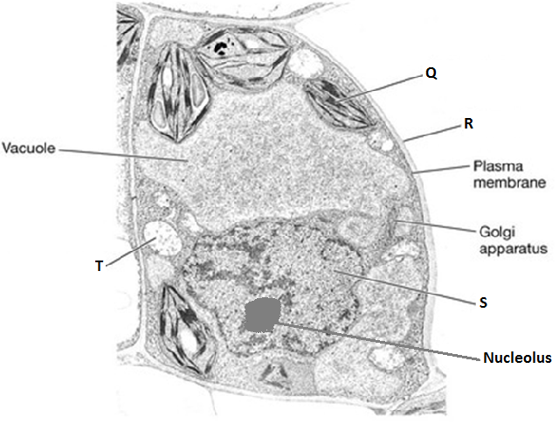

- (i) Label the parts labeled R, S and T. (3mks)
R – Cell wall;
S – Nucleus;
T – Mitochondrion; (rej plural)
ii) Name the chemical compound that constitutes part labeled R above. (1mk)
Cellulose;
- State the function of part labeled
- Q. (1mk)
Site for photosynthesis;
- Nucleolus. (1mk)
Manufacture ribosomes;

- Below is an enlarged micrograph of organelle T.

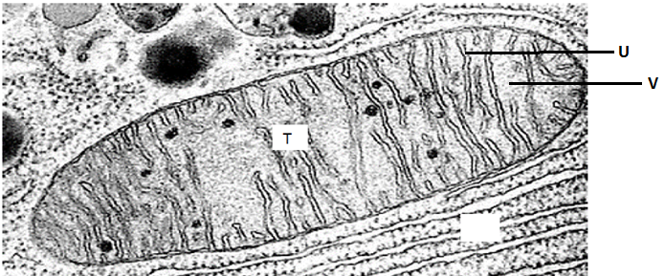
- What is the function of organelle T.? (1mk)
Site for respiration;
- What is the biological significance of having numerous parts U in organelle T.? (1mk)
Increase surface area for attachment of more respiratory enzymes;
- A student observed onion epidermal tissue using a microscope whose field of view was ____________mm in diameter as shown below. Calculate the approximate width of one of the cell. (3mks)


