**Name………………………………………………………………… ADM NO…………………**

**SIGN ……….…… date……….…**

**231/2**

**BIOLOGY**

**FORM 4**

**PAPER 2**

**2 Hours**

**END OF TERM 2 EXAMINATION**

**INSTRUCTIONS TO CANDIDATES**

1. Write your name and admission Number in the spaces provided above.
2. Sign and write date of examination in the spaces provided above.
3. Answer **ALL** questions in the spaces provided.
4. All workings **must** be clearly shown where necessary.

*This paper consists of 9 Printed pages. Candidates should check the question paper to ensure that all the*

*Papers are printed as indicated and no questions are missing*

1. Study the diagram below and use it to answer the questions that follow

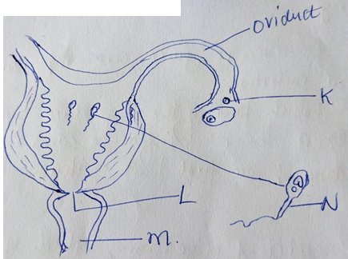

1. (i) Label parts labelled (2mks)

K –

L -

M-

(ii) Through which process is structure labeled K in (a) (i) above produced? (1mk)

(b)How is the cell labeled N adapted to perform its functions. (3mks)

c) Name the hormone that stimulates the production of cell labeled K.at puberty. (1mk)

1. Bile and pancreatic juice are important secretions in animal nutrition.
2. In which part of the digestive system do they exert their influence? (1mk)

(b)(i) For efficient digestion, which of the two secretions should be mixed with the chyme first? (1mk

(ii) Explain your answer (4mks)

1. Explain why an adult does not need to eat too much protein in a meal/diet. (2mks)

,

1. The table below shows the approximate distribution of blood groups in a sample of 100 people in a population.

|  |  |  |  |
| --- | --- | --- | --- |
| **Blood group** | **Frequency** | **Rhesus +ve** | **Rhesus -ve** |
| **A** | **26** | **22** | **4** |
| B | 20 | 18 | 2 |
| AB | 4 | 3 | 1 |
| O | 50 | 42 | 8 |

1. Calculate the percentage of Rhesus negative (Rh-ve) individuals in the population? (1mk)

(b) Account for

(i) The large number of blood group O individuals in a population. (2mks)

(ii) The small number of individuals with blood group AB. (2mks)

(c) The diagram below represents a blood smear on a glass slide.

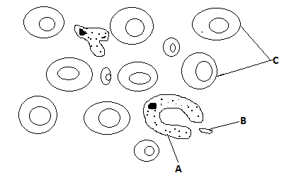

1. State the importance of structure C being large numbers in the blood smear. (1mk)
2. Give a reason why structure C would be found in large numbers in high altitude than in low altitude. (1mk)

(iii) Name the process by which structure A would engulf structure B. (1mk)

4(a). Identify organs B and D in photograph T2 and state the class of organism from which they were obtained. (4mks)

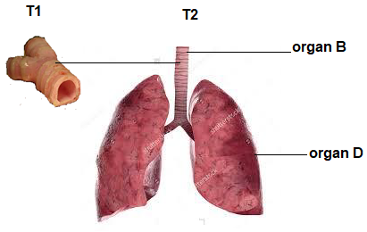

|  |  |  |
| --- | --- | --- |
| ORGAN | IDENTITY | CLASS |
|  |  |  |
|  |  |  |

(b) State the common function of the organs identified in (a) above. (1mk)

(c) Name the parts of the body where B and D in photograph T2 are found. (2mks)

B

D

(d) List the adaptations of D to its functions. (3mks)

(e) Using observable features only, state how B is adapted to its function (2mks)

1. The set apparatus was assembled by a group of students to investigate some physiological process. Glucose solution was boiled and oil added on top of it. The glucose solution was then allowed to cool before yeast was added.



a) i) Give ONE aim of the experiment. (1mk)

ii) Explain observations expected after 24hrs. (2mks)

b) i) Why was the glucose solution boiled before adding the yeast suspension? (1mk)

ii) What was the importance of cooling the glucose solution before adding the yeast? ( 1mk)

(c) In another investigation, a bird was found to use 10 litres of oxygen to give a respiratory

quotient of 0.7 during period of flight.

1. Name the type of food that was being respired by the bird ( 1mk)

1. Determine the amount of carbon (IV) oxide produced during the same flight. (2mk)

1. Mr. Juma has sued Serenity Hospital on grounds that their child was wrongly identified such that they got the wrong one. The child is blood group O. Mr. Juma is blood group AB while Mrs. Juma is heterozygous blood group A.

(a) Work out the possible blood group of their offsprings. (4 marks)

(b) Is Mr. Juma justified in his claims? Explain. (2 mark)

c) State two blood disorders in humans that result from mutation. (2 marks)

1. **SECTION B:**

***Answer question 6 (Compulsory) and either question 7 or 8 in the spaces provided after question 8.***

A Farmer wished to plant certain species of *Erythrina* trees on his farm. However, their seeds normally take time to germinate after sowing. To overcome this problem, he put the seeds in hot water maintained at 50oC.

Batches of 20 seeds were removed at one minute intervals and then planted in trays containing moist soil. After 15 days, the number of seeds that germinated in each tray was counted.

The results obtained were as shown in the table below.

|  |  |  |  |
| --- | --- | --- | --- |
| Batch order | Time intervals(minutes) | Germinated seeds | Percentage of seeds that Germinated. |
| 1st | 0 | 3 |  |
| 2nd | 1 | 3 |  |
| 3rd | 2 | 8 |  |
| 4th | 3 | 15 |  |
| 5th | 4 | 18 |  |
| 6th | 5 | 13 |  |
| 7th | 6 | 10 |  |
| 8th | 7 | 6 |  |
| 9th | 8 | 2 |  |
| 10th | 9 | 0 |  |
| 11th | 10 | 0 |  |

1. Calculate the percentage germination rate for each batch and fill in the table. (5mks)
2. Use your results to plot a graph showing percentage germination against the duration in which the seeds were soaked in hot water. (6mks)
3. From the graph derive the expected number of seeds that would germinate if soaked for 4.5 minutes. (1mk)

1. Using the graph briefly explain the effect of hot water treatment on seed germination of *Erythrina*. (5mks)
2. Explain why there was no germination of seeds soaked in hot water for nine to ten minutes. (1mks)
3. Besides hot water treatment, suggest two other methods that can be used to speed up germination in *Erythrina.* (2mks)

1. Explain the adaptations of parts of the ear in the outer and middle ear. (20 mks)
2. Describe how the kidney Nephron functions. (20 mks)