BIOLOGY FORM 4 APRIL HOLIDAY ASSIGNMENT- APRIL 2023

- A response exhibited by a certain plant tendril is illustrated below:-
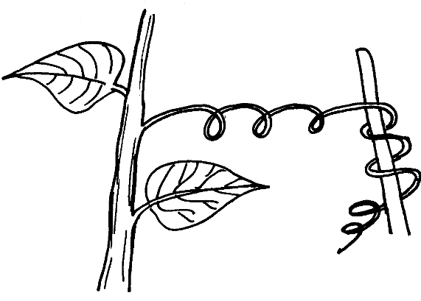

Name the type of response
Removal of the apical bud from a shrub is a practice that results in the development of many
lateral buds which later form branches
(a) Give reasons for the development of lateral branches after the removal of the apical bud
(b) Suggest one application of this practice?
2. In an accident a victim suffered brain injury. Consequently he had loss of memory which
part of the brain was damaged?
3. A person was able to read a book clearly at arm’s length but not at normal reading distance (a) State the eye defect the person suffered from
(b) Why was he unable to read the book clearly at normal distance?
(c) How can the defect be corrected?

- The diagram below represents a simple reflex arc;
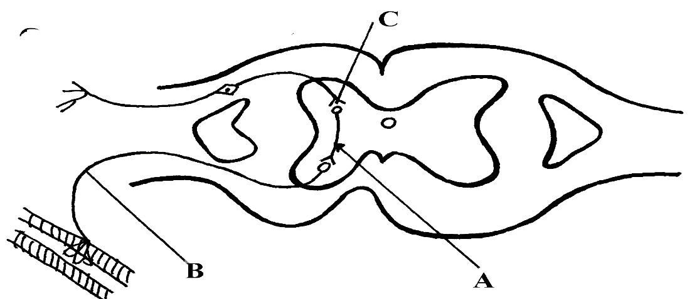

(a) Name the parts labeled A and B
(b) Explain how an impulse is transmitted across the gap labeled C
5. (a) State two functions of a mammalian ear
(b) How is the cochlea suited to its function
6. State one function of potassium ions in the human body.
7. Explain how the following tissues are adapted to provide mechanical support in plants:-
a) Parenchyma
b) Collenchyma . c) Selerenchyma
8. (a) Distinguish between tendons and ligaments
b) State one way through which herbaceous plants achieve support
9. Name the ;
a) i) Material used to strengthen the xylem tissue
ii) Tissue that is removed when the bark of a dicotyledonous plant is ringed
b) State the areas of the plant where translocated materials are taken
10. Give three importance of mammalian skeleton

11. (a) What is the importance of locomotion in animals?
(b) Explain how a bony fish is adapted for movement in its habitat

