NAME ……………………………………..…… DATE ………………ADM NO. ……..

INDEX NO. …………….………….……..….. SIGNATURE ….………..…..………..

231/3
BIOLOGY
PAPER THREE
FORM FOUR
TIME: 1$\frac{3}{4}$ HOURS

OPENER EXAMINATION TERM 3, 2022
Kenya Certificate of Secondary Education

INSTRUCTIONS TO CANDIDATES: -
  - Write your name, Admission number and class in the spaces provided above.
  - Answer all the questions in the spaces provided
  - Candidates should answer the questions in English.

Q1. You are provided with specimen Q
- (i) Identify main part of the specimen (1mk)

(ii) State the functions of the part named in (a) (i) above (2mks)

(b)Using a surgical blade provided, cut a cube of 2cm x 2cm x 2cm; grind; add 3mls of distilled water, stir, then filter the paste. Using the filtrate test the foods present using the reagents provided. (8mks)

Food | Procedure | Observation | conclusion

(c) You are provided with specimen R and S
(i) Write down any two similarities between specimen R and S (2mks)

(ii) Tabulate any two differences between specimen R and S (2mks)
R | S

(ii) Using a blade provide; carefully make transverse section of specimen S.
Make a labelled diagram of the cut section. Label any three parts. (4mks)

(ii) Name the type of placentation (1mk)

2.Study photographs shown below then answer the questions.

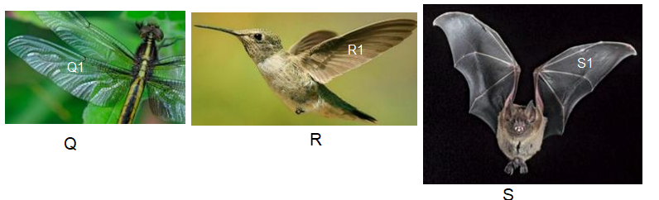
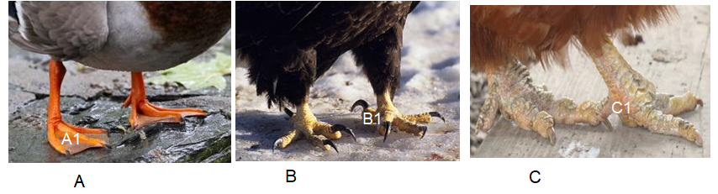

(a) State the type of evolution represented by structures Q1, R1 and S1. (1mk)

b) Explain the type of evolution identified in (a) above. (1mk)

(c) Give the evolution term used to describe structures;

(i) Q1, R1 and S1. (1mk)

(ii)A1, B1 and C1. (1mk)

d). (i) Name classes for organisms labeled Q, R and S.
Q (1mk)

R (1mk)

S (1mk)

(ii) Give two reasons for placing S in the class above (2mks)

e) (i) Suggest the diet of animals B and R.
B
(1mk)

R
(1mk)

(ii) How is beak of animal B adapted to its function? (2mks)

3.Study the photomicrographs of cells below and answer the questions given.
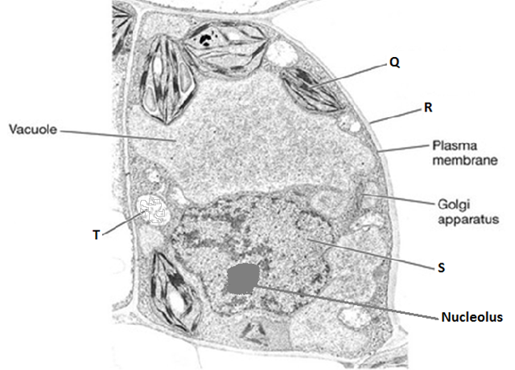

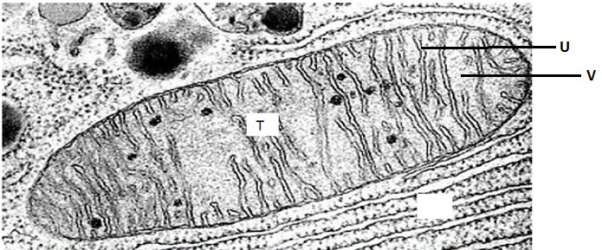
- Name the parts labeled. (3mks)
Q

R

U

- What is the function of
- Organelle Q. (1mk)

- Golgi bodies. (2mks)

- How is organelle T adapted to its function? (1mks)

